Conrad Lewin
CS325
4/3/2016

1) Insertion sort will beat merge sort as long as 8n² is less than the value ofTo determine which value of n will invalidate this inequality, we must find the point of intersection for these two functions.

Plotting both of the resulting functions yields the following:

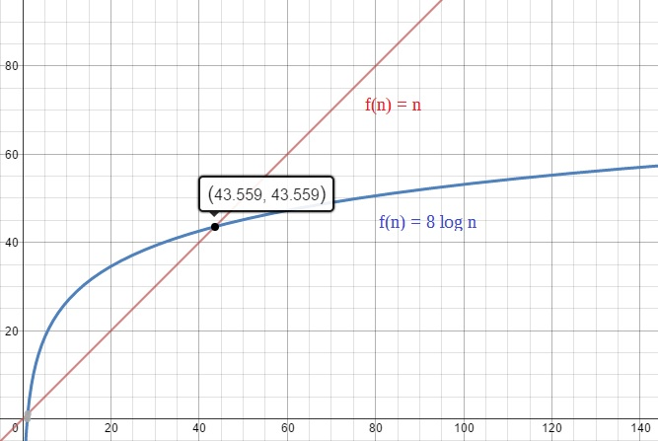
We can see from the graph, that the point of intersection occurs when n is approximately 43.6. Assuming the number of input items cannot be fractional, the effective input size in which merge sort beats insertion sort can be understood to be the ceiling of 43.6 orIn this case, then, insertion sort will be more effective than merge sort for all

2) A functionthat can accomplish a task of a given size n within a particular time frame t in microseconds can be expressed as

Considerand t is 1 second. To determine the largest value of ncan solve within t, we must find the value of n that equals the value of t.

Thus, the largest size problem a functioncan tackle in 1 second isThe same principle applies for other values ofand t:

1 second = 10⁶ microseconds
1 minute = 6e+7 microseconds
1 hour = 3.6e+9 microseconds
1 day = 8.64e+10 microseconds
1 month = 2.628e+12 microseconds
1 year = 3.154e+13 microseconds
1 century = 3.154e+15 microseconds

 | 1 second | 1 minute | 1 hour | 1 day | 1 month | 1 year | 1 century

3) Use mathematical induction to show that when n is an exact power of 2, the solution of the recurrence

is

Base Case:
From the definition ofwe can see that the base case occurs when n = 2 or when k = 1. Thus,

In this case when n = 2,and this satisfies the definition of

Inductive Hypothesis:
The inductive hypothesis is included in the definition of namely that for all powers of 2 greater than 2,

Inductive Case:
Using substitution, algebra and the rules of logarithms,

Having proved both the base case and the inductive step, the original supposition holds.

4a)

The numerator will always be larger than the denominator and so as n grows it will approach infinity, thus

4b)

The growth factor forwill form the upper bound ofso as n grows the end behavior of will approach infinity. Thus

4c)

As n grows both the numerator and the denominator will be the same number, and so will always approach 1, thus

4d)

Since e is larger than 2, as n grows large, the growth factor of the numerator will not be bound by the value of the denominator. Thus,

4e)

As n grows, both functions will grow at a constant rate. Thus,

4f)

will grow faster thenand defines the bound for f(n). Thus,

4g)

Forwill grow faster thanThus,

4h)

Forwill grow faster thanThus,

5) One method for finding a sum x of two numbers p and q in an array S that achieves a complexity of Θ(n log n) involves dividing the algorithm into two parts, namely sorting the array and then summing pairs of integers until either x is found or all relevant pairings have been exhausted. The complexity of each individual part cannot exceed a complexity of Θ(n log n). Since the most apparent solution for summing pairs involves, at worst, iterating over each number in the array, this part of the algorithm will be bound by O(n). This fact necessitates the need for a sorting algorithm that is tightly bound by Θ(n log n) so that the overall complexity of the given algorithm will be Θ(n log n) + O(n) = Θ(n log n). Some candidates for such a sort include quickSort, mergeSort and heapSort. The following psuedocode uses mergeSort to achieve this end.

Psuedocode:
SumPairs(S, x)
mergeSort(S)

j ← 0
k ← S.length – 1

while j != k
sum ← S[j] + S[k]
if sum < x
j ← j + 1
else if sum > x
k ← k – 1
else
return S[j], S[k]

return NIL

Explanation:
Once the array is sorted, two index values j and k are set to point to the beginning and the end of the array respectively. A while loop is then executed to sum the values stored at the current indices pointed to by j and k, terminating when either S[j] + S[k] = x or j = k. The while loop begins by calculating the sum and then performs a comparison of this sum with x. If the sum is less then x, then j is incremented by 1, if the sum is greater than x, then k is incremented by 1 and if the sum is equal to x, then both S[j] and S[k] are returned. In the event that the loop is allowed to terminate before reaching its return statement, NIL is returned to indicate that there are no pairs in S whose sum is x.

Sample implementation:
Let set S = {12, 3, 4, 15, 11, 7} and x = 20

step 1) S = {3, 4, 7, 11, 12, 15}
step 2) j = 0, k = 5
step 3.1) Enter while loop
a) 0 != 5
b) 3 + 15 = 18
c) 18 < 20
d) j = 1, k = 5
3.2) Enter while loop
a) 1 != 5
b) 4 + 15 = 19
c) 19 < 20
d) j = 2, k = 5
3.3) Enter while loop
a) 2 != 5
b) 7 + 15 = 22
c) 22 > 20
d) j = 2, k = 4
3.2) Enter while loop
a) 2 != 4
b) 7 + 12 = 19
c) 19 < 20
d) j = 3, k = 4
3.3) Enter while loop
a) 3 != 4
b) 11 + 12 = 22
c) 22 > 20
d) j = 3, k = 3
3.4) Loop test fails, 4 != 4 is false. Loop exits.
4) Return NIL

6a) Ifandthen

Proof:
By the definition ofand for and some constant c_{j}. We must show that

Assuming we can add to both sides of the inequality without affecting the meaning of the signs. Thus,

Sinceis in the set ofwe can substituteforand determine whether or not there is a constant that maintains the truth of the inequality

Thus, letso that

By the definition ofit follows that sinceand are in the sets of andrespectively, multiplying each function by the largest possible constant c₃ will produce a result that is inevitably greater than or equal to the sum of the functionsandin which only one of those functions is multiplied by c₃.

6b) Ifand, then
Proof:
By the definition ofand for and some constant c_{j}. We must show that However, consider this example:

LetandEach function is an asymptotically positive polynomial function of degree 1, therefore both functions areand in turn are polynomially bounded by Thus, by substitution and basic algebra,

Although c_{j} is constant, it is not given, and so it is conceivable that c₂ will not always be greater than c₁. Since bothandare bound bythe inequality can be further demystified as such:

Now it is clear that anywill invalidate the truth of the inequality. This is a counter example to the original supposition, thus proving it false.

6c)

It follows from the definition of Big Theta that

It is obvious from this inequality that no matter which is the max, ifthenwill be less than or equal to the quantityThe left side of the inequality, however, requires a constant that is less than 1 but greater than or equal to 0. Thus, ifthen

holds true. Therefore, the original supposition is true for alland Otherwise, ifthen
7a) Code for iterative and recursive algorithms for calculating the Fibonacci Sequence:

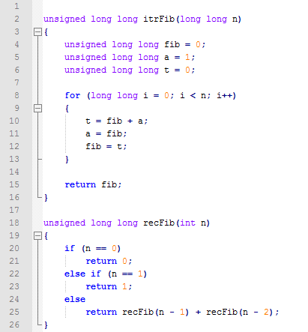

7b - c) Run times for each algorithm:

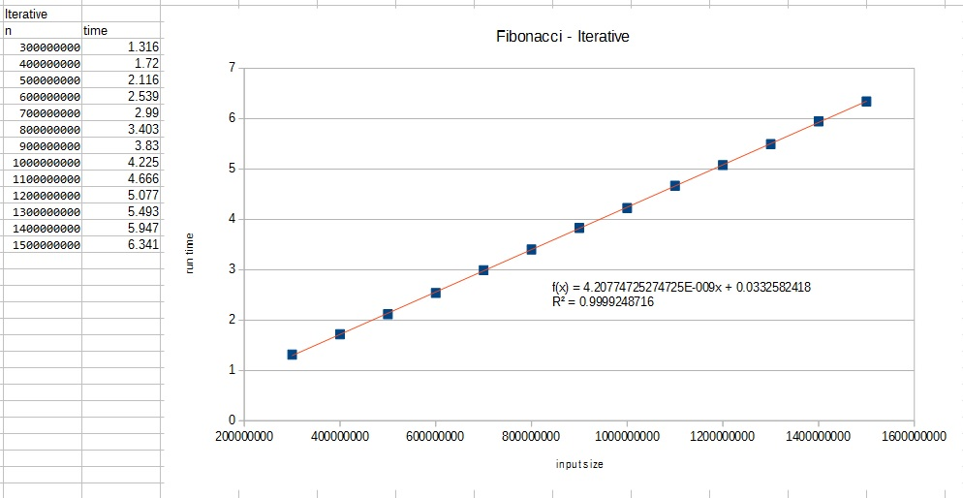

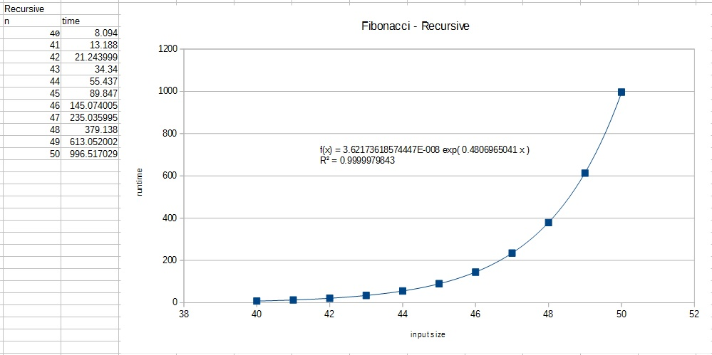

7d) The function that best fits the iterative solution is linear in nature, that iswhile the recursive algorithm is best defined by an exponential function or The iterative algorithm is the most efficient solution with the linear equation tied to the given input sizes equal to

The difference in run times for each algorithm lies in the manner in which each procedure calculates the sequence. The iterative solution uses a for loop that performs three constant time operations n number of times, that isOn the other hand, the recursive solution must perform several redundant recursive calls in order to achieve the same result. This can most easily be seen by examining a section of the recursion tree:

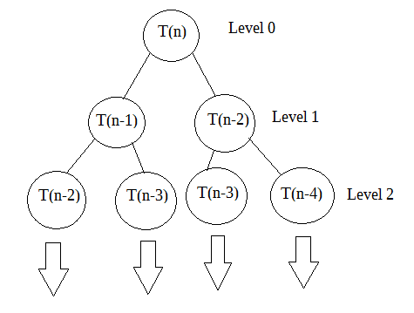

Each node represents the recursive call in the algorithm’s final return statement, and, since two calls are made with each return, the nodes in each level of the tree indicates how many calls must be resolved before the procedure exits. There are 2^{i} nodes at each level of the tree where i is the value of the relevant level, thus 2^{k}, where k is the height of the tree, recursive calls must be made to complete the algorithm, including a constant addition operation. In this way, the recursive algorithm to compute n Fibonacci numbers is

