CSC 423 Project 4

Part A:

1.

title education income women prestige

1 gov.administrators 13.11 12351 11.16 68.8

2 general.managers 12.26 25879 4.02 69.1

3 accountants 12.77 9271 15.70 63.4

4 purchasing.officers 11.42 8865 9.11 56.8

5 chemists 14.62 8403 11.68 73.5

6 physicists 15.64 11030 5.13 77.6

7 biologists 15.09 8258 25.65 72.6

8 architects 15.44 14163 2.69 78.1

9 civil.engineers 14.52 11377 1.03 73.1

10 mining.engineers 14.64 11023 0.94 68.8

11 surveyors 12.39 5902 1.91 62.0

12 draughtsmen 12.30 7059 7.83 60.0

13 computer.programers 13.83 8425 15.33 53.8

14 economists 14.44 8049 57.31 62.2

15 psychologists 14.36 7405 48.28 74.9

16 social.workers 14.21 6336 54.77 55.1

17 lawyers 15.77 19263 5.13 82.3

18 librarians 14.15 6112 77.10 58.1

19 vocational.counsellors 15.22 9593 34.89 58.3

20 ministers 14.50 4686 4.14 72.8

21 university.teachers 15.97 12480 19.59 84.6

22 primary.school.teachers 13.62 5648 83.78 59.6

23 secondary.school.teachers 15.08 8034 46.80 66.1

24 physicians 15.96 25308 10.56 87.2

25 veterinarians 15.94 14558 4.32 66.7

26 osteopaths.chiropractors 14.71 17498 6.91 68.4

27 nurses 12.46 4614 96.12 64.7

28 nursing.aides 9.45 3485 76.14 34.9

29 physio.therapsts 13.62 5092 82.66 72.1

30 pharmacists 15.21 10432 24.71 69.3

31 medical.technicians 12.79 5180 76.04 67.5

32 commercial.artists 11.09 6197 21.03 57.2

33 radio.tv.announcers 12.71 7562 11.15 57.6

34 athletes 11.44 8206 8.13 54.1

35 secretaries 11.59 4036 97.51 46.0

36 typists 11.49 3148 95.97 41.9

37 bookkeepers 11.32 4348 68.24 49.4

38 tellers.cashiers 10.64 2448 91.76 42.3

39 computer.operators 11.36 4330 75.92 47.7

40 shipping.clerks 9.17 4761 11.37 30.9

41 file.clerks 12.09 3016 83.19 32.7

42 receptionsts 11.04 2901 92.86 38.7

43 mail.carriers 9.22 5511 7.62 36.1

44 postal.clerks 10.07 3739 52.27 37.2

45 telephone.operators 10.51 3161 96.14 38.1

46 collectors 11.20 4741 47.06 29.4

47 claim.adjustors 11.13 5052 56.10 51.1

48 travel.clerks 11.43 6259 39.17 35.7

49 office.clerks 11.00 4075 63.23 35.6

50 sales.supervisors 9.84 7482 17.04 41.5

51 commercial.travellers 11.13 8780 3.16 40.2

52 sales.clerks 10.05 2594 67.82 26.5

53 newsboys 9.62 918 7.00 14.8

54 service.station.attendant 9.93 2370 3.69 23.3

55 insurance.agents 11.60 8131 13.09 47.3

56 real.estate.salesmen 11.09 6992 24.44 47.1

57 buyers 11.03 7956 23.88 51.1

58 firefighters 9.47 8895 0.00 43.5

59 policemen 10.93 8891 1.65 51.6

60 cooks 7.74 3116 52.00 29.7

61 bartenders 8.50 3930 15.51 20.2

62 funeral.directors 10.57 7869 6.01 54.9

63 babysitters 9.46 611 96.53 25.9

64 launderers 7.33 3000 69.31 20.8

65 janitors 7.11 3472 33.57 17.3

66 elevator.operators 7.58 3582 30.08 20.1

67 farmers 6.84 3643 3.60 44.1

68 farm.workers 8.60 1656 27.75 21.5

69 rotary.well.drillers 8.88 6860 0.00 35.3

70 bakers 7.54 4199 33.30 38.9

71 slaughterers.1 7.64 5134 17.26 25.2

72 slaughterers.2 7.64 5134 17.26 34.8

73 canners 7.42 1890 72.24 23.2

74 textile.weavers 6.69 4443 31.36 33.3

75 textile.labourers 6.74 3485 39.48 28.8

76 tool.die.makers 10.09 8043 1.50 42.5

77 machinists 8.81 6686 4.28 44.2

78 sheet.metal.workers 8.40 6565 2.30 35.9

79 welders 7.92 6477 5.17 41.8

80 auto.workers 8.43 5811 13.62 35.9

81 aircraft.workers 8.78 6573 5.78 43.7

82 electronic.workers 8.76 3942 74.54 50.8

83 radio.tv.repairmen 10.29 5449 2.92 37.2

84 sewing.mach.operators 6.38 2847 90.67 28.2

85 auto.repairmen 8.10 5795 0.81 38.1

86 aircraft.repairmen 10.10 7716 0.78 50.3

87 railway.sectionmen 6.67 4696 0.00 27.3

88 electrical.linemen 9.05 8316 1.34 40.9

89 electricians 9.93 7147 0.99 50.2

90 construction.foremen 8.24 8880 0.65 51.1

91 carpenters 6.92 5299 0.56 38.9

92 masons 6.60 5959 0.52 36.2

93 house.painters 7.81 4549 2.46 29.9

94 plumbers 8.33 6928 0.61 42.9

95 construction.labourers 7.52 3910 1.09 26.5

96 pilots 12.27 14032 0.58 66.1

97 train.engineers 8.49 8845 0.00 48.9

98 bus.drivers 7.58 5562 9.47 35.9

99 taxi.drivers 7.93 4224 3.59 25.1

100 longshoremen 8.37 4753 0.00 26.1

101 typesetters 10.00 6462 13.58 42.2

102 bookbinders 8.55 3617 70.87 35.2

2.

title education Education Women rating log_income sqrt_income

1 gov.administrators 13.11 12351 11.16 68.8 9.421492 111.13505

2 general.managers 12.26 25879 4.02 69.1 10.161187 160.86951

3 accountants 12.77 9271 15.70 63.4 9.134647 96.28603

4 purchasing.officers 11.42 8865 9.11 56.8 9.089866 94.15413

5 chemists 14.62 8403 11.68 73.5 9.036344 91.66788

6 physicists 15.64 11030 5.13 77.6 9.308374 105.02381

7 biologists 15.09 8258 25.65 72.6 9.018938 90.87354

8 architects 15.44 14163 2.69 78.1 9.558388 119.00840

9 civil.engineers 14.52 11377 1.03 73.1 9.339349 106.66302

10 mining.engineers 14.64 11023 0.94 68.8 9.307739 104.99048

11 surveyors 12.39 5902 1.91 62.0 8.683047 76.82448

12 draughtsmen 12.30 7059 7.83 60.0 8.862059 84.01786

13 computer.programers 13.83 8425 15.33 53.8 9.038959 91.78780

14 economists 14.44 8049 57.31 62.2 8.993303 89.71622

15 psychologists 14.36 7405 48.28 74.9 8.909911 86.05231

16 social.workers 14.21 6336 54.77 55.1 8.754003 79.59899

17 lawyers 15.77 19263 5.13 82.3 9.865941 138.79121

18 librarians 14.15 6112 77.10 58.1 8.718009 78.17928

19 vocational.counsellors 15.22 9593 34.89 58.3 9.168789 97.94386

20 ministers 14.50 4686 4.14 72.8 8.452335 68.45436

21 university.teachers 15.97 12480 19.59 84.6 9.431883 111.71392

22 primary.school.teachers 13.62 5648 83.78 59.6 8.639057 75.15318

23 secondary.school.teachers 15.08 8034 46.80 66.1 8.991438 89.63258

24 physicians 15.96 25308 10.56 87.2 10.138876 159.08488

25 veterinarians 15.94 14558 4.32 66.7 9.585896 120.65654

26 osteopaths.chiropractors 14.71 17498 6.91 68.4 9.769842 132.28001

27 nurses 12.46 4614 96.12 64.7 8.436850 67.92643

28 nursing.aides 9.45 3485 76.14 34.9 8.156223 59.03389

29 physio.therapsts 13.62 5092 82.66 72.1 8.535426 71.35825

30 pharmacists 15.21 10432 24.71 69.3 9.252633 102.13716

31 medical.technicians 12.79 5180 76.04 67.5 8.552560 71.97222

32 commercial.artists 11.09 6197 21.03 57.2 8.731821 78.72103

33 radio.tv.announcers 12.71 7562 11.15 57.6 8.930891 86.95976

34 athletes 11.44 8206 8.13 54.1 9.012621 90.58697

35 secretaries 11.59 4036 97.51 46.0 8.303009 63.52952

36 typists 11.49 3148 95.97 41.9 8.054523 56.10704

37 bookkeepers 11.32 4348 68.24 49.4 8.377471 65.93937

38 tellers.cashiers 10.64 2448 91.76 42.3 7.803027 49.47727

39 computer.operators 11.36 4330 75.92 47.7 8.373323 65.80274

40 shipping.clerks 9.17 4761 11.37 30.9 8.468213 69.00000

41 file.clerks 12.09 3016 83.19 32.7 8.011687 54.91812

42 receptionsts 11.04 2901 92.86 38.7 7.972811 53.86093

43 mail.carriers 9.22 5511 7.62 36.1 8.614501 74.23611

44 postal.clerks 10.07 3739 52.27 37.2 8.226573 61.14736

45 telephone.operators 10.51 3161 96.14 38.1 8.058644 56.22277

46 collectors 11.20 4741 47.06 29.4 8.464003 68.85492

47 claim.adjustors 11.13 5052 56.10 51.1 8.527539 71.07742

48 travel.clerks 11.43 6259 39.17 35.7 8.741776 79.11384

49 office.clerks 11.00 4075 63.23 35.6 8.312626 63.83573

50 sales.supervisors 9.84 7482 17.04 41.5 8.920255 86.49855

51 commercial.travellers 11.13 8780 3.16 40.2 9.080232 93.70165

52 sales.clerks 10.05 2594 67.82 26.5 7.860956 50.93133

53 newsboys 9.62 918 7.00 14.8 6.822197 30.29851

54 service.station.attendant 9.93 2370 3.69 23.3 7.770645 48.68265

55 insurance.agents 11.60 8131 13.09 47.3 9.003439 90.17206

56 real.estate.salesmen 11.09 6992 24.44 47.1 8.852522 83.61818

57 buyers 11.03 7956 23.88 51.1 8.981682 89.19641

58 firefighters 9.47 8895 0.00 43.5 9.093245 94.31331

59 policemen 10.93 8891 1.65 51.6 9.092795 94.29210

60 cooks 7.74 3116 52.00 29.7 8.044305 55.82114

61 bartenders 8.50 3930 15.51 20.2 8.276395 62.68971

62 funeral.directors 10.57 7869 6.01 54.9 8.970686 88.70738

63 babysitters 9.46 611 96.53 25.9 6.415097 24.71841

64 launderers 7.33 3000 69.31 20.8 8.006368 54.77226

65 janitors 7.11 3472 33.57 17.3 8.152486 58.92368

66 elevator.operators 7.58 3582 30.08 20.1 8.183677 59.84981

67 farmers 6.84 3643 3.60 44.1 8.200563 60.35727

68 farm.workers 8.60 1656 27.75 21.5 7.412160 40.69398

69 rotary.well.drillers 8.88 6860 0.00 35.3 8.833463 82.82512

70 bakers 7.54 4199 33.30 38.9 8.342602 64.79969

71 slaughterers.1 7.64 5134 17.26 25.2 8.543640 71.65194

72 slaughterers.2 7.64 5134 17.26 34.8 8.543640 71.65194

73 canners 7.42 1890 72.24 23.2 7.544332 43.47413

74 textile.weavers 6.69 4443 31.36 33.3 8.399085 66.65583

75 textile.labourers 6.74 3485 39.48 28.8 8.156223 59.03389

76 tool.die.makers 10.09 8043 1.50 42.5 8.992557 89.68277

77 machinists 8.81 6686 4.28 44.2 8.807771 81.76796

78 sheet.metal.workers 8.40 6565 2.30 35.9 8.789508 81.02469

79 welders 7.92 6477 5.17 41.8 8.776013 80.47981

80 auto.workers 8.43 5811 13.62 35.9 8.667508 76.22992

81 aircraft.workers 8.78 6573 5.78 43.7 8.790726 81.07404

82 electronic.workers 8.76 3942 74.54 50.8 8.279443 62.78535

83 radio.tv.repairmen 10.29 5449 2.92 37.2 8.603187 73.81734

84 sewing.mach.operators 6.38 2847 90.67 28.2 7.954021 53.35729

85 auto.repairmen 8.10 5795 0.81 38.1 8.664751 76.12490

86 aircraft.repairmen 10.10 7716 0.78 50.3 8.951051 87.84077

87 railway.sectionmen 6.67 4696 0.00 27.3 8.454466 68.52737

88 electrical.linemen 9.05 8316 1.34 40.9 9.025937 91.19210

89 electricians 9.93 7147 0.99 50.2 8.874448 84.53993

90 construction.foremen 8.24 8880 0.65 51.1 9.091557 94.23375

91 carpenters 6.92 5299 0.56 38.9 8.575273 72.79423

92 masons 6.60 5959 0.52 36.2 8.692658 77.19456

93 house.painters 7.81 4549 2.46 29.9 8.422663 67.44627

94 plumbers 8.33 6928 0.61 42.9 8.843326 83.23461

95 construction.labourers 7.52 3910 1.09 26.5 8.271293 62.52999

96 pilots 12.27 14032 0.58 66.1 9.549096 118.45674

97 train.engineers 8.49 8845 0.00 48.9 9.087608 94.04786

98 bus.drivers 7.58 5562 9.47 35.9 8.623713 74.57882

99 taxi.drivers 7.93 4224 3.59 25.1 8.348538 64.99231

100 longshoremen 8.37 4753 0.00 26.1 8.466531 68.94200

101 typesetters 10.00 6462 13.58 42.2 8.773694 80.38657

102 bookbinders 8.55 3617 70.87 35.2 8.193400 60.14150

3.

*Model 1 (rating ~ education + Education):*

Call:

lm(formula = rating ~ education + Education, data = PrestigeT)

Residuals:

Min 1Q Median 3Q Max

-19.4040 -5.3308 0.0154 4.9803 17.6889

Coefficients:

Estimate Std. Error t value Pr(>|t|)

(Intercept) -6.8477787 3.2189771 -2.127 0.0359 *

education 4.1374444 0.3489120 11.858 < 2e-16 ***

Education 0.0013612 0.0002242 6.071 2.36e-08 ***

---

Signif. codes: 0 ‘***’ 0.001 ‘**’ 0.01 ‘*’ 0.05 ‘.’ 0.1 ‘ ’ 1

Residual standard error: 7.81 on 99 degrees of freedom

Multiple R-squared: 0.798, Adjusted R-squared: 0.7939

F-statistic: 195.6 on 2 and 99 DF, p-value: < 2.2e-16

Regression equation: rating = 0.0013612Education + 4.1374444education – 6.8477787

*Model 2 (rating ~ education + log_income):*

Call:

lm(formula = rating ~ education + log_income, data = PrestigeT)

Residuals:

Min 1Q Median 3Q Max

-17.0346 -4.5657 -0.1857 4.0577 18.1270

Coefficients:

Estimate Std. Error t value Pr(>|t|)

(Intercept) -95.1940 10.9979 -8.656 9.27e-14 ***

education 4.0020 0.3115 12.846 < 2e-16 ***

log_income 11.4375 1.4371 7.959 2.94e-12 ***

---

Signif. codes: 0 ‘***’ 0.001 ‘**’ 0.01 ‘*’ 0.05 ‘.’ 0.1 ‘ ’ 1

Residual standard error: 7.145 on 99 degrees of freedom

Multiple R-squared: 0.831, Adjusted R-squared: 0.8275

F-statistic: 243.3 on 2 and 99 DF, p-value: < 2.2e-16

Regression equation: rating = 11.4375log_income + 4.0020education – 95.1940

*Model 3 (rating ~ education + sqrt_income):*

Call:

lm(formula = rating ~ education + sqrt_income, data = PrestigeT)

Residuals:

Min 1Q Median 3Q Max

-16.2402 -5.1954 -0.3229 4.2815 17.9898

Coefficients:

Estimate Std. Error t value Pr(>|t|)

(Intercept) -18.17457 3.13510 -5.797 8.06e-08 ***

education 3.91380 0.33209 11.785 < 2e-16 ***

sqrt_income 0.29018 0.03933 7.379 5.01e-11 ***

---

Signif. codes: 0 ‘***’ 0.001 ‘**’ 0.01 ‘*’ 0.05 ‘.’ 0.1 ‘ ’ 1

Residual standard error: 7.349 on 99 degrees of freedom

Multiple R-squared: 0.8212, Adjusted R-squared: 0.8175

F-statistic: 227.3 on 2 and 99 DF, p-value: < 2.2e-16

Regression equation: 0.29018sqrt_income + 2.91380education – 18.17457

After comparing, model 2 has the largest Adjusted R-squared value.

4.

My final decision is model 2.

Residual analysis:

Residual Plot(education):

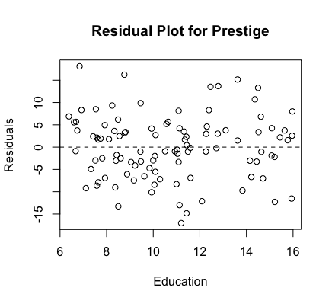

Unbiased and homoscedastic.

Residual Plot (Log of Income):

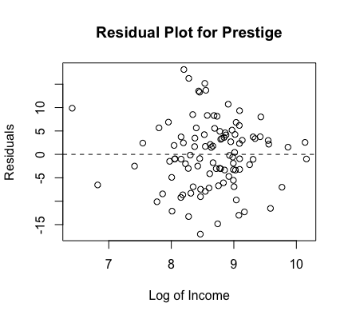

Unbiased and homoscedastic.

Residual Plot (Predicted):

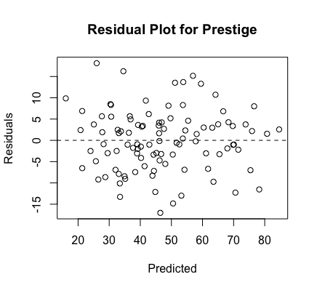

Unbiased and homoscedastic.

Normal Plot:

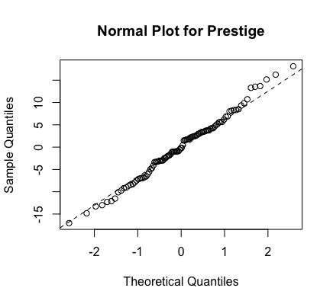

Normal.

F-test:

i.

H0: β1 = β2 = , ... , = βp-1 = 0

H1:βj ≠ 0 for some j

ii.

F = 243.3

iii.

DFE = n – p = 102 – 3 = 99, DFM = 3 – 1 = 2, confidence interval is [0, 3.08824]

iv.

243.3∉ [0, 3.08824], so reject H0.

v.

p-value < 2.2e-16

Cross Validation:

PRESS = 5381.418, Residual = 5053.639, PRESS < Residual * 1.5 = 7580.4585. This model could be used to predict future data.

So model 2 is the best model to predict the Prestige.

Part B:

1, 2.

temp pressure yield

1 240 140 20.2780

2 240 140 21.6640

3 250 140 39.5081

4 250 140 36.7495

5 260 140 44.2690

6 260 140 41.3140

7 240 145 35.5518

8 240 145 38.2407

9 250 145 51.3980

10 250 145 52.9325

11 260 145 55.6464

12 260 145 53.6590

13 240 150 40.9179

14 240 150 35.5873

15 250 150 51.4475

16 250 150 48.8527

17 260 150 50.6999

18 260 150 51.5019

3.

print(t)

-1 -1 0 0 1 1 -1 -1 0 0 1 1 -1 -1 0 0 1 1

print(p)

-1 -1 -1 -1 -1 -1 0 0 0 0 0 0 1 1 1 1 1 1

4.

Call:

lm(formula = yield ~ t + tt + p + pp + tp, data = Response)

Residuals:

Min 1Q Median 3Q Max

-2.4070 -1.1720 0.1176 1.0131 2.9236

Coefficients:

Estimate Std. Error t value Pr(>|t|)

(Intercept) 51.9295 0.8945 58.057 4.50e-16 ***

t 8.7375 0.4899 17.835 5.29e-10 ***

tt -6.0372 0.8486 -7.115 1.22e-05 ***

p 6.2687 0.4899 12.795 2.36e-08 ***

pp -7.6722 0.8486 -9.041 1.05e-06 ***

tp -2.2430 0.6000 -3.738 0.00283 **

---

Signif. codes: 0 ‘***’ 0.001 ‘**’ 0.01 ‘*’ 0.05 ‘.’ 0.1 ‘ ’ 1

Residual standard error: 1.697 on 12 degrees of freedom

Multiple R-squared: 0.9813, Adjusted R-squared: 0.9734

F-statistic: 125.6 on 5 and 12 DF, p-value: 6.21e-10

The regression model is: yield = 8.7375t – 6.0372t2 + 6.2687p – 7.6722p2 -2.2430tp + 51.9295

5.

