CSC 352 / 452: Database Programming

assignment #2 (60 Points)

**CSC 352/452-501: Due on Tuesday, 7/25/2017 at 11:59PM**

**CSC 352/452-510: Due on Wednesday, 7/26/2017 at 11:59PM**

Unless prior arrangements are made, homework turned in late will not be accepted. However, homework turned in within 24 hours late will be graded at 50% credit.

**Please note that only TEXT files will be accepted. All other file types (e.g., DOC, DOCX, RTF, PDF, JPG, or ZIP) will be rejected. In D2L, only the most recent submission is kept.**

* If you modified the DEPARTMENT and EMPLOYEE tables created in Assignment #1, you need to delete and re-populate them.
* **Joins are NOT recommended.** (Please do not try to use complicated joins to get the results. You can use multiple PL/SQL statements to get the results easily.)
* Any hard-coded value, which is from the department table or employee table, is not allowed in your programs. (e.g., IF v_dname = 'IT' then ……)
* You are not allowed to create temporary tables, views, functions, or procedures.
* Explicit cursors are **NOT** allowed in your programs.
* The EXCEPTION Section is **NOT** allowed in your programs.
* Please review your assignment file before submitting it to make sure you have the correct one. It is your responsibility to upload the correct assignment file.

**1) (CSC 352 - 30 points | CSC 452 – 20 points)**

Based on the DEPARTMENT and EMPLOYEE tables created in Assignment #1, write a **PL/SQL anonymous block** that accepts an employee ID from the user input and displays 1) the employee’s name, job title, hire date, and total pay (salary + commission), 2) his/her manager’s name, job title, hire date, and total pay (salary + commission), 3) the **name** and location of the department where the employee works, 4) the number of employees in the department where the employee works, and 5) the number of employees in the **company**.

* You will receive 0 points if you submit more than **one** PL/SQL program.
* If the employee ID from the user input is not in the EMPLOYEE table (EMPLOYEE_ID), your program displays a message telling the user that the employee ID is not in the table.
* Your program must display the total pay with a dollar ($) sign, a comma, and two decimal places (e.g., $1,234.56).
* The hire date must be displayed in the DD-MON-YYYY format (4-digit year).
* If the employee does not have a manager, the manager’s name, job title, hire date and total pay must be shown as “N/A”.
* If the employee does not belong to any department, the name and location of the department must be shown as “N/A”, and the number of employees in the department must be shown as “0”.
* You will lose 5 points if your output does not have “User Input:”, “My Output:”, “------- Employee -------”, “------- Manager -------”, “------- Department -------”, or “------- Company -------” in your output.
* To avoid complicating issues, you can assume that the user always enters input from keyboard that consists only of the digits 0 through 9 and Enter.

Example:

ACCEPT p_1 PROMPT 'Please enter the employee ID:'

DECLARE

-- *Your statements*

BEGIN

-- *Your statements*

END;

*(This question should take less than 40 minutes to solve.)*

Please test your program. The output of your program must match the following:

Case 1)

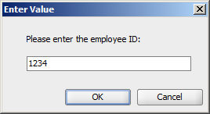

Output:

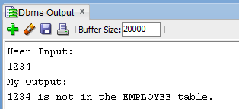

Case 2)

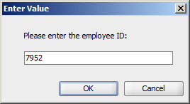

Output:

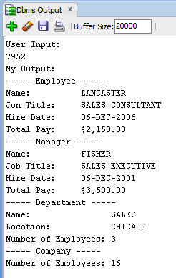

Case 3)

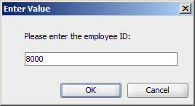

Output:

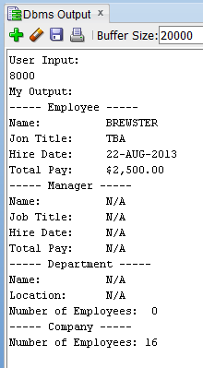

Case 4)

……

**2) (CSC 352 - 30 points | CSC 452 – 25 points)**

Based on the DEPARTMENT and EMPLOYEE tables created in Assignment #1, write a **PL/SQL anonymous block** that accepts a **department name** from the user input and displays a) the department ID of that department, b) the location of that department, c) the number of employees in that department, d) the number of employees in that department whose hire date is after 31-DEC-2004, e) the average total pay (salary + commission) for that department, f) the number of employees in that department whose total pay (salary + commission) is less than the average total pay (salary + commission) for that department, and g) the number of employees in that department whose total pay (salary + commission) is less than the average total pay (salary + commission) of all employees in the **company**.

* You will receive 0 points if you submit more than **one** PL/SQL program.
* If the department name from the user input is not in the DEPARTMENT table (DEPARTMENT_NAME), your program displays a message telling the user that the department name is not in the table.
* Department name is not case sensitive (e.g., SALES = Sales). You will lose 5 points if you do not use the UPPER (or LOWER) function in your program.
* Your program must display the average total pay (salary + commission) with a dollar ($) sign, a comma, and two decimal places (e.g., $1,234.56).
* You will lose 5 points if your output does not have “User Input:” or “My Output:”.

*(This question should take less than 50 minutes to solve.)*

Please test your program. The output of your program must match the following:

Case 1)

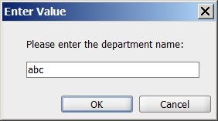

Output:

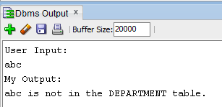

Case 2)

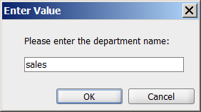

Output:

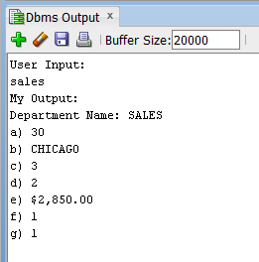

Case 3)

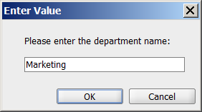

Output:

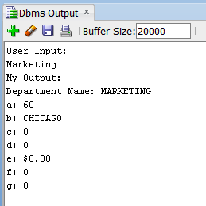

**3) (CSC 452 only - 15 points)**

Based on the EMPLOYEE table created in Assignment #1, write a **PL/SQL anonymous block** that displays the number of employees earned salaries in each of the following ranges: $0.00 - $499.99, $500.00 - $999.99, $1000.00 - $1499.99, …, $9500.00 - $9999.99. You can only use **ONE** SELECT-INTO statement in your program.

* You will receive 0 points if you submit more than **one** PL/SQL program.
* You will lose 10 points if you use more than **one** SELECT-INTO statement in your program.
* You will lose 10 points if you use more than **five** local variables in your program.
* Oracle collection is not allowed.

For example, you will receive 0 points if you use v_sal := sal_range (500.00, 1000.00, 1500.00, …, 10000.00)..

Hint: FOR idx IN 0..19 LOOP … SELECT … INTO … FROM …; … END LOOP;

Creating cleanly formatted output is a common programming requirement. The format of your output must match mine EXACTLY. If your output does not match mine EXACTLY, you will lose some points.

*(This question should take less than 30 minutes to solve.)*

Please test your program. The output of your program must match the following:

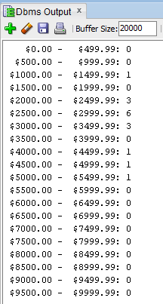

**Please submit a text file containing all the source codes to D2L by the due date.**

**Optional Question**

**Just for fun (no credit, no extra credit, no need to submit, just for if you are a curious person and like database programming).**

In a bug tracking database, there is a table called BUGS. The table has several columns: BUG_ID, REPORTED_DATE, DESCRIPTION, PRIORITY, ASSIGNED_TO, CLOSED_DATE, and NOTE.

Create and populate the BUGS table.

CREATE TABLE bugs

(

BUG_ID NUMBER PRIMARY KEY,

REPORTED_DATE DATE NOT NULL,

DESCRIPTION VARCHAR2(20),

PRIORITY NUMBER(2),

ASSIGNED_TO VARCHAR2(10),

CLOSED_DATE DATE,

NOTE VARCHAR2(20)

);

INSERT INTO BUGS VALUES (1230, '25-APR-14', NULL, 3, 'Team 3', '28-APR-14', NULL);

INSERT INTO BUGS VALUES (1231, '29-APR-14', NULL, 1, 'Team 1', '29-APR-14', NULL);

INSERT INTO BUGS VALUES (1232, '03-MAY-14', NULL, 1, 'Team 1', '03-MAY-14', NULL);

INSERT INTO BUGS VALUES (1233, '03-MAY-14', NULL, 1, 'Team 3', '08-MAY-14', NULL);

INSERT INTO BUGS VALUES (1234, '04-MAY-14', NULL, 2, 'Team 5', '15-MAY-14', NULL);

INSERT INTO BUGS VALUES (1235, '04-MAY-14', NULL, 2, 'Team 1', NULL, NULL);

INSERT INTO BUGS VALUES (1236, '05-MAY-14', NULL, 1, 'Team 2', '06-MAY-14', NULL);

INSERT INTO BUGS VALUES (1237, '05-MAY-14', NULL, 3, 'Team 3', '10-MAY-14', NULL);

INSERT INTO BUGS VALUES (1238, '09-MAY-14', NULL, 4, 'Team 5', '16-MAY-14', NULL);

INSERT INTO BUGS VALUES (1239, '09-MAY-14', NULL, 5, 'Team 6', NULL, NULL);

INSERT INTO BUGS VALUES (1240, '12-MAY-14', NULL, 5, 'Team 2', '30-MAY-14', NULL);

INSERT INTO BUGS VALUES (1241, '12-MAY-14', NULL, 1, 'Team 1', '20-MAY-14', NULL);

INSERT INTO BUGS VALUES (1242, '13-MAY-14', NULL, 4, 'Team 4', '25-MAY-14', NULL);

INSERT INTO BUGS VALUES (1243, '14-MAY-14', NULL, 4, 'Team 3', '01-JUN-14', NULL);

INSERT INTO BUGS VALUES (1244, '14-MAY-14', NULL, 2, 'Team 4', '25-MAY-14', NULL);

INSERT INTO BUGS VALUES (1245, '20-MAY-14', NULL, 2, 'Team 4', NULL, NULL);

INSERT INTO BUGS VALUES (1246, '22-MAY-14', NULL, 2, 'Team 4', '25-MAY-14', NULL);

INSERT INTO BUGS VALUES (1247, '25-MAY-14', NULL, 2, 'Team 1', '29-MAY-14', NULL);

INSERT INTO BUGS VALUES (1248, '30-MAY-14', NULL, 1, 'Team 1', '01-JUN-14', NULL);

INSERT INTO BUGS VALUES (1249, '05-JUN-14', NULL, 1, 'Team 2', '07-JUN-14', NULL);

COMMIT;

“Open Bugs” - A bug is considered open on a given day if (1) its “REPORTED_DATE” is on or before that day, and (2) its “CLOSED_DATE” is on or after that day (or is unknown (NULL)). For example, we have 5 open bugs on 5/5/2014.

Write a **PL/SQL anonymous block** that generates a report to show the number of open bugs from 5/1/2014 through 5/31/2014. At the end of the report, the maximum number of open bugs on a single day is displayed. Assume that there were no open bugs on 4/30/2014.

The output of your program should match the following:

Date Number of Open Bugs

01-MAY-14 0

02-MAY-14 0

03-MAY-14 2

04-MAY-14 3

05-MAY-14 5

06-MAY-14 5

07-MAY-14 4

08-MAY-14 4

09-MAY-14 5

10-MAY-14 5

11-MAY-14 4

12-MAY-14 6

13-MAY-14 7

14-MAY-14 9

15-MAY-14 9

16-MAY-14 8

17-MAY-14 7

18-MAY-14 7

19-MAY-14 7

20-MAY-14 8

21-MAY-14 7

22-MAY-14 8

23-MAY-14 8

24-MAY-14 8

25-MAY-14 9

26-MAY-14 6

27-MAY-14 6

28-MAY-14 6

29-MAY-14 6

30-MAY-14 6

31-MAY-14 5

---------------------------------------

The maximum number of open bugs on a single day is 9.

There were 9 open bugs on 14-MAY-14.

There were 9 open bugs on 15-MAY-14.

There were 9 open bugs on 25-MAY-14.