CSC 352/452: Database Programming

Mid-term Exam   
(300 Points)

**CSC 352/452-501: Due on Sunday, 8/6/2017 at 11:59PM**

**CSC 352/452-510: Due on Monday, 8/7/2017 at 11:59PM**

**Late exams will not be accepted or graded.**

**(No lecture and office hours on Thursday, 8/3/2017)**

* **The mid-term exam is a take-home exam.  You can use any of your class notes and readings to complete the exam. You may not consult in any form with any other person while doing this take-home exam.**
* **Please submit a text file containing all your answers to D2L by the due date. All other file types (e.g., DOC, DOCX, RTF, PDF, JPG, or ZIP) will be rejected. In D2L, only the most recent submission is kept.**
* **Please do not include the original questions in your file.**
* **Please review your assignment file before submitting it to make sure you have the correct one. It is your responsibility to upload the correct assignment file.**
* **Do not wait until the last day to submit your file! Submit ahead in case of unforeseen circumstances such as a computer crash or illness. There are no exceptions to the deadline.**

**Part I (CSC 352 and CSC 452 - 120 points)**

There are a total of 12 questions. Each question is worth 10 points.

* Please read each question carefully and choose the correct answer.
* Each question has one correct answer. You will receive 0 points if you submit more than one answer in any format (e.g., Q5: A, False).
* Please submit your answers in the following format:

Part I: Q1: A, Q2: B, Q3: C, …

**Please do not include the original questions.**

*(This part should take less than 20 minutes to finish.)*

**Assume that the tab1 table exists in the underlying database.**

Q1. Consider the following SELECT-INTO statement in a PL/SQL block. What happens if there is **NO** row satisfying the WHERE condition?

......

SELECT COUNT(*)

INTO v_n

FROM tab1

WHERE col_15 > 10 OR col_20 > 10;

......

A. The SELECT-INTO statement executes successfully.

B. A NO_DATA_FOUND exception is raised.

C. A TOO_MANY_ROWS exception is raised.

D. A ZERO_DIVIDE exception is raised.

Q2. In which section of a PL/SQL block is a WHEN TOO_MANY_ROWS THEN statement allowed (The TOO_MANY_ROWS is a predefined exception for ORA-01422)?

A. DECLARATION

B. EXECUTION

C. EXCEPTION

D. All of the above

Q3. Evaluate the following CASE statement:

CASE v_input

WHEN 10 THEN v_out := 100; v_input := 30;

WHEN 20 THEN v_out := 202; v_input := 40;

WHEN 30 THEN v_out := 606; v_input := 50;

WHEN 40 THEN v_out := 410; v_input := 60;

WHEN 50 THEN v_out := 881;

ELSE v_out := 991;

END CASE;

If v_input is 20, which value would be assigned to v_out?

A. 100

B. 202

C. 410

D. 606

E. 881

F. 991

G. None of the above

Q4. In the DECLARATION section of a PL/SQL block, you declare these variables:

v_room_100, v_room_200 VARCHAR2(15);

Why does this statement cause an error?

A. The NOT NULL keyword is missing.

B. The size (15) of the data type VARCHAR2 cannot be specified.

C. Multiple variables cannot be declared in the same statement.

D. A default value must be assigned to each variable.

E. All of the above.

Q5. PL/SQL records of the same declared type can be compared for equality by using the equality operator (=).

DECLARE

TYPE t_type IS RECORD (p_id NUMBER, p_age NUMBER);

v_a t_type;

v_b t_type;

BEGIN

......

IF v_a = v_b THEN

DBMS_OUTPUT.PUT_LINE('v_a = v_b');

ELSE

DBMS_OUTPUT.PUT_LINE('v_a != v_b');

END IF;

END;

A. TRUE

B. FALSE

Q6. What is the value of v_found_flag when the following PL/SQL block is executed successfully?

DECLARE

v_n NUMBER;

v_found_flag BOOLEAN;

BEGIN

SELECT COUNT(*)

INTO v_n

FROM tab1

WHERE col_99 > 0;

v_found_flag := SQL%FOUND;

END;

A. The value is always NULL.

B. The value is NULL if and only if the tab1 table is empty.

C. The value is NULL if and only if the tab1 table is not empty.

D. The value is always FALSE.

E. The value is FALSE if and only if the tab1 table is empty.

F. The value is FALSE if and only if the tab1 table is not empty.

G. The value is always TRUE.

H. The value is TRUE if and only if the tab1 table is empty.

I. The value is TRUE if and only if the tab1 table is not empty.

Q7. Which guideline relates to a CURSOR FOR Loop?

FOR v_idx IN cursor_name LOOP

statement1;

statement2;

......

END LOOP;

A. The user must explicitly declare the v_idx in the DECLARATION section.

B. The cursor must return at least one row.

C. It does not require a FETCH statement.

D. All of the above

Q8. Evaluate the following CURSOR statement:

DECLARE

CURSOR c_1 (p_max_num NUMBER(3) := 500) IS

SELECT col_1, col_2, col_3

FROM tab1

WHERE col1_5 = p_max_num;

Why will this statement cause an error?

A. The default value (500) cannot be assigned to the p_max_num parameter.

B. The size (3) of the p_max_num parameter cannot be specified.

C. The SELECT statement is missing the INTO clause.

D. All of the above.

Q9. In a PL/SQL block, when a variable is declared as NOT NULL, you must initialize the variable when it is declared.

A. TRUE

B. FALSE

Q10. Evaluate the following PL/SQL block:

DECLARE

CURSOR c_1 IS

SELECT col_1, col_3

FROM tab1

ORDER BY c1;

v_rec c_1%ROWTYPE;

BEGIN

OPEN c_1;

LOOP

FETCH c_1 INTO v_rec;

EXIT WHEN v_rec.col_1 >= 100 OR

v_rec.col_1 <= -50 OR

c_1%NOTFOUND;

......

DBMS_OUTPUT.PUT_LINE(v_rec%ROWCOUNT);

DBMS_OUTPUT.PUT_LINE(v_rec.col_3);

......

END LOOP;

CLOSE c_1;

END;

Why will the above block cause a syntax error?

A. The DBMS_OUTPUT.PUT_LINE(v_rec.col_3)statement is illegal.

B. The DBMS_OUTPUT.PUT_LINE(v_rec%ROWCOUNT)statement is illegal.

C. The EXIT-WHEN statement is illegal.

D. The FETCH statement is illegal.

E. The %ROWTYPE attribute can only be used in reference to actual tables.

Q11. An exception will be raised in the DECLARATIONsection of the block BL_20. To which of the following section will the exception propagate?

<<BL_10>>

DECLARE

v_4 NUMBER;

v_5 NUMBER;

BEGIN

v_4 := 10;

v_5 := v_4 + 80;

<<BL_20>>

DECLARE

v_3 NUMBER := 90;

**v_4 NUMBER := v_3 / (v_3 - v_5);**

-- Run-time error, propagate to?

BEGIN

v_3 := v_3 * v_4 + 1;

v_4 := v_3 + v_4;

EXCEPTION

WHEN OTHERS THEN

DBMS_OUTPUT.PUT_LINE('ERROR (BL_20)!');

END BL_20;

v_4 := v_4 * v_4;

<<BL_30>>

DECLARE

v_2 NUMBER := 0;

v_5 NUMBER := v_4;

BEGIN

......

EXCEPTION

WHEN OTHERS THEN

DBMS_OUTPUT.PUT_LINE('ERROR (BL_30)!');

END BL_30;

<<BL_40>>

DECLARE

v_1 NUMBER := 3;

BEGIN

......

EXCEPTION

WHEN OTHERS THEN

DBMS_OUTPUT.PUT_LINE('ERROR (BL_40)!');

END BL_40;

......

EXCEPTION

WHEN OTHERS THEN

DBMS_OUTPUT.PUT_LINE('ERROR (BL_10)!');

END BL_10;

A1. The BL_10 block’s DECLARATION section

A2. The BL_10 block’s EXECUTION section

A3. The BL_10 block’s EXCEPTION section

B1. The BL_20 block’s DECLARATION section

B2. The BL_20 block’s EXECUTION section

B3. The BL_20 block’s EXCEPTION section

C1. The BL_30 block’s DECLARATION section

C2. The BL_30 block’s EXECUTION section

C3. The BL_30 block’s EXCEPTION section

D1. The BL_40 block’s DECLARATION section

D2. The BL_40 block’s EXECUTION section

D3. The BL_40 block’s EXCEPTION section

E. None of the above

Q12. How many rows will be inserted into the tab1 table after the following PL/SQL block has been executed successfully (no runtime error)?

DECLARE

v_count NUMBER := 1;

v_1 NUMBER := 1;

BEGIN

DELETE FROM tab1;

COMMIT;

FOR i IN REVERSE 6..11 LOOP

INSERT INTO tab1 VALUES (i, i*2, i+3);

END LOOP;

SELECT COUNT(*)

INTO v_count

FROM tab1;

FOR i IN 3..v_count + 11 LOOP

INSERT INTO tab1 VALUES (i, i+10, i+20);

END LOOP;

INSERT INTO tab1 VALUES (99, 205, 306);

SELECT COUNT(*)

INTO v_1

FROM tab1;

WHILE v_1 >= 7 LOOP

IF v_1 = 10 OR v_1 = 25 OR v_1 = 35 OR v_1 = 45 THEN

INSERT INTO tab1 VALUES (v_1*20, v_1*30, v_1*40);

ELSE

v_1 := v_1 - 1;

END IF;

v_1 := v_1 - 2;

END LOOP;

FOR i IN 2..48 LOOP

IF i = 4 OR i = 16 OR i= 32 OR i = 48 THEN

INSERT INTO tab1 VALUES (i*20, i*30, i*40);

END IF;

INSERT INTO tab1 VALUES (i*21, i*31, i*41);

END LOOP;

INSERT INTO tab1 VALUES (616, 222, 243);

INSERT INTO tab1 VALUES (77, 88, 99);

INSERT INTO tab1 VALUES (77, 88, 55);

INSERT INTO tab1 VALUES (66, 88, 99);

INSERT INTO tab1 VALUES (66, 88, 91);

COMMIT;

END;

A. 75

B. 76

C. 77

D. 78

E. 79

F 80

**Part II (CSC 352 and CSC 452 - 180 points)**

**If there is a syntax error anywhere in your program, you will receive 0 points for the program.**

* You are not allowed to create/use temporary tables/views/functions/procedures/triggers.
* If you modified the DEPARTMENT and EMPLOYEE tables created in Assignment #1, you need to delete and re-populate them.
* The Exception section in your program is optional.

**1) (CSC 352 and CSC 452 - 60 points)**

XYZ Airlines Inc. keeps track of its employees in its Human Resources database. The TAB_EMPLOYEE table contains basic employee information. The EMPLOYEE_TYPE field indicates whether an employee is a full-time (FT) or part-time (PT) employee. The EMPLOYEE_STATUS field indicates whether an employee is in an active (AC) or inactive (IN) work status. The structure of the table is shown below along with some sample records:

**TAB_EMPLOYEE**

|  |  |  |  |  |  |
| --- | --- | --- | --- | --- | --- |
| **EMPLOYEE_ID** | **LAST_NAME** | **FIRST_NAME** | **HIRE_DATE** | **EMPLOYEE_TYPE** | **EMPLOYEE_STATUS** |
| **VARCHAR2(7) PK** | **VARCHAR2(30)** | **VARCHAR2(30)** | **DATE** | **CHAR(2)** | **CHAR(2)** |
| 0A11000 | Smith | Ryan | 04-MAY-90 | FT | IN |
| 0A11170 | Brown | Dean | 01-DEC-92 | PT | AC |
| 0A12010 | Fisher | Jane | 12-FEB-95 | FT | IN |
| 0A12080 | Brewster | Andre | 28-JUL-98 | FT | AC |
| 0A13190 | Clark | Dan | 04-APR-01 | PT | AC |
| 0A13500 | Jackson | Tyler | 01-NOV-05 | FT | AC |
| 0A14000 | Miller | Mary | 11-JAN-08 | FT | AC |
| 0A14100 | Jackson | Peter | 08-AUG-11 | PT | IN |
| 0A14200 | Smith | Ryan | 08-DEC-12 | FT | AC |

An employee (full-time employee as well as part-time employee) can be a pilot. In this case, the information related to pilots is kept inside a separate table TAB_PILOT as shown below:

**TAB_PILOT**

|  |  |
| --- | --- |
| **EMPLOYEE_ID** | **PILOT_TYPE** |
| **VARCHAR2(7) PK, FK** | **VARCHAR2(100)** |
| 0A11170 | Commercial pilot |
| 0A12010 | Airline transport pilot |
| 0A13500 | Airline transport pilot |

For example, Andre Brewster is a full-time employee and is not a pilot while Tyler Jackson is a full-time employee and is also a pilot. On the other hand, Dean Brown is a part-time employee and is also a pilot. However, Dan Clark is a part-time employee but is not a pilot.

Create and populate the TAB_EMPLOYEE and TAB_PILOT tables by using the following SQL statements.

CREATE TABLE TAB_EMPLOYEE

(

employee_id VARCHAR2(7) PRIMARY KEY,

last_name VARCHAR2(30) NOT NULL,

first_name VARCHAR2(30) NOT NULL,

hire_date VARCHAR2(30) NOT NULL,

employee_type CHAR(2) NOT NULL,

employee_status CHAR(2) NOT NULL

);

/

INSERT INTO TAB_EMPLOYEE VALUES ('0A11000', 'Smith', 'Ryan', '04-MAY-90','FT', 'IN');

INSERT INTO TAB_EMPLOYEE VALUES ('0A11170', 'Brown', 'Dean', '01-DEC-92','PT', 'AC');

INSERT INTO TAB_EMPLOYEE VALUES ('0A12010', 'Fisher', 'Jane', '12-FEB-95','FT', 'IN');

INSERT INTO TAB_EMPLOYEE VALUES ('0A12080', 'Brewster', 'Andre', '28-JUL-98','FT', 'AC');

INSERT INTO TAB_EMPLOYEE VALUES ('0A13190', 'Clark', 'Dan', '04-APR-01','PT', 'AC');

INSERT INTO TAB_EMPLOYEE VALUES ('0A13500', 'Jackson', 'Tyler', '01-NOV-05','FT', 'AC');

INSERT INTO TAB_EMPLOYEE VALUES ('0A14000', 'Miller', 'Mary', '11-JAN-08','FT', 'AC');

INSERT INTO TAB_EMPLOYEE VALUES ('0A14100', 'Jackson', 'Peter', '08-AUG-11','PT','IN');

INSERT INTO TAB_EMPLOYEE VALUES ('0A14200', 'Smith', 'Ryan', '08-DEC-12','FT','AC');

COMMIT;

/

CREATE TABLE TAB_PILOT

(

employee_id VARCHAR2(7) PRIMARY KEY,

pilot_type VARCHAR2(100) NOT NULL,

CONSTRAINT fk_employee_pilot FOREIGN KEY (employee_id)

REFERENCES TAB_EMPLOYEE(employee_id)

);

/

INSERT INTO TAB_PILOT VALUES ('0A11170', 'Commercial pilot');

INSERT INTO TAB_PILOT VALUES ('0A12010', 'Airline transport pilot');

INSERT INTO TAB_PILOT VALUES ('0A13500', 'Airline transport pilot');

COMMIT;

/

Write a **PL/SQL anonymous block** that accepts a **last name** (LAST_NAME) from the user input and displays employee’s information (employee_id, last_name, first_name, hire_date, employee_status, employee_type, and pilot_type). Sort your output in ascending order by the name (last_name, first_name) and hire_date.

* If the last name is **NOT** in the TAB_EMPLOYEE table (LAST_NAME), your program displays information about **ALL** employees.
* If the last name is in the TAB_EMPLOYEE table (LAST_NAME), your program displays the corresponding employee’s information. We have duplicate names in the TAB_EMPLOYEE table.
* The name is not case sensitive (e.g., Jackson = JACKSON). You will lose 10 points if you do not use the UPPER (or LOWER) function in your program.
* The employee_type (“FT” or “PT”) must be displayed as “Full-Time” or “Part-Time” in your output. You will lose 10 points if you fail to do so.
* The employee_status (“AC” or “IN”) must be displayed as “Active” or “Inactive” in your output. You will lose 10 points if you fail to do so.
* If an employee is not a pilot, the pilot type is shown as “N/A” in your output.
* You will lose 10 points if the title lines are missing in your output.
* You will lose 10 points if your output is not in the correct format (e.g., wrong order of columns).
* You can only use the TAB_EMPLOYEE and TAB_PILOT tables. You will receive 0 points if you use other tables.
* You will receive 0 points if you submit more than **one** PL/SQL program.

*(This question should take less than 45 minutes to solve.)*

Test your program. You must ensure that the output of your program matches the following sample output:

Case 1)

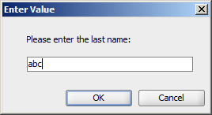

Output:

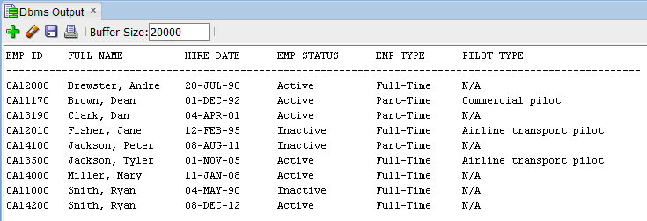

Case 2)

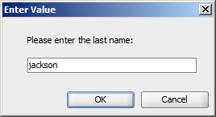

Output:

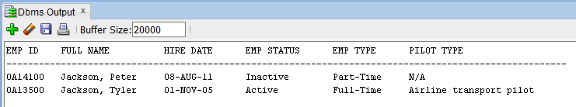

Case 3)

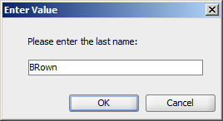

Output:

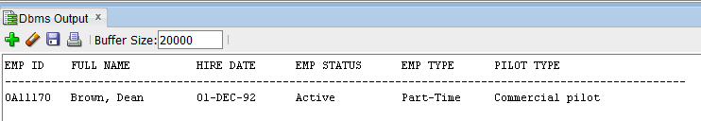

Case 4)

……

**2) (CSC 352 and CSC 452 - 60 points)**

The TAB_BIRTHDAY table consists of every day of the year, from January 1 to December 31, along with a ranking based on how many babies were born in the United States on that date between 1973 and 1999. Rank 1 is the most popular, rank 2 is the next most popular, and so forth.

Create and populate the TAB_BIRTHDAY table by using the following SQL statements.

CREATE TABLE tab_birthday

(BIRTHDAY_MONTH NUMBER,

BIRTHDAY_DAY NUMBER,

BIRTHDAY_RANK NUMBER);

/

INSERT INTO tab_birthday

SELECT * FROM **hchen**.tab_birthday;

/

COMMIT;

/

SELECT COUNT(*) FROM tab_birthday;

/

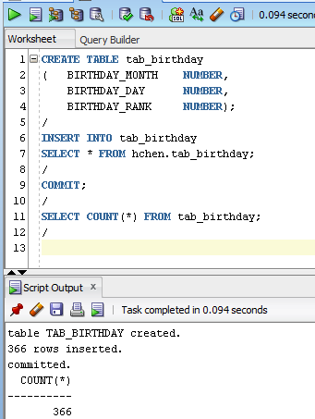

Please make sure that there are 366 rows in your TAB_BIRTHDAY table.

You cannot change the definition of the TAB_BIRTHDAY table. You will receive 0 points if you use different table names, column names, or data types.

In the TAB_BIRTHDAY table, you can find that September 16 is the most popular birthday (rank = 1) and February 29 is the least popular birthday (rank = 366). Excluding leap years, December 25 is the least popular birthday (rank = 365).

**========================= Begin (2a) CSC 352 only ========================**

**2a) (CSC 352 only)**

Write a PL/SQL anonymous block that accepts an integer ***n*** (***n = 1 or n = 2***) from the user input and 1) displays the most popular birthdays along with the ranks for each month if the user input is 1 (*n = 1*), or 2) displays the least popular birthdays along with the ranks for each month if the user input is 2 (*n = 2*). Sort your output in ascending order by months.

* You will lose 10 points if the title lines are missing in your output.
* You will lose 10 points if your output is not in the correct format. For example, you must display the birthdays and ranks for the same month in one line.
* Each day-rank pair must be displayed in the DD/RRR format (2-digit day and 3-digit rank) (e.g., 08/012).
* You may hard-corded values of months (e.g., FOR idx IN 1..12 LOOP).
* If you have hard coded the birthdays or ranks (e.g., DBMS_OUPT.PUT_LINE('1 20/ 240')) in your PL/SQL block, you will receive 0 points.
* To avoid complicating issues, you can assume that the user always enters input from keyboard that consists only of the digits 0 through 9 and Enter.
* **This question can be solved without using cursors.**
* You will receive 0 points if you submit more than **one** PL/SQL program.

*(This question should take less than 45 minutes to solve.)*

Test your program. You must ensure that the output of your program matches the following output (one month per line):

Case 1)

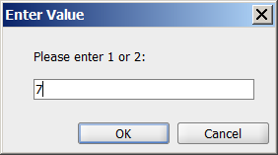

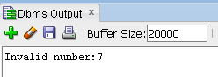

Case 2)

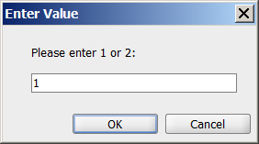

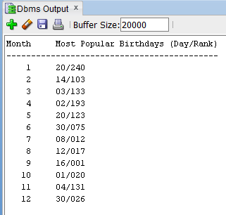

Case 3)

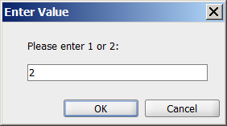

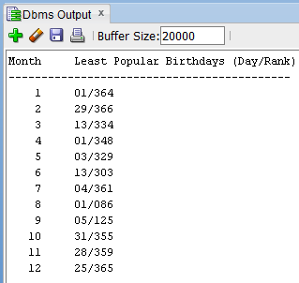

**========================== End (2a) CSC 352 only ========================**

**========================== Begin (2b) CSC 452 only =======================**

**2b) (CSC 452 only)**

Write a PL/SQL anonymous block that accepts an integer ***n*** (***n = 1 or n = 2***) from the user input and 1) displays five (5) most popular birthdays along with the ranks for each month if the user input is 1 (*n = 1*), or 2) displays five (5) least popular birthdays along with the ranks for each month if the user input is 2 (*n = 2*). Sort your output in ascending order by months, and then most/least popular birthdays.

* You will lose 10 points if the title lines are missing in your output.
* You will lose 10 points if your output is not in the correct format. For example, you must display the birthdays and ranks for the same month in one line.
* Each day-rank pair must be displayed in the DD/RRR format (2-digit day and 3-digit rank) (e.g., 03/088).
* You may hard-corded values of months (e.g., FOR idx IN 1..12 LOOP).
* If you have hard coded the birthdays or ranks (e.g., DBMS_OUPT.PUT_LINE('1 <20/240> <14/260>')) in your PL/SQL block, you will receive 0 points.
* To avoid complicating issues, you can assume that the user always enters input from keyboard that consists only of the digits 0 through 9 and Enter.
* **This question can be solved without using cursors.**
* You will receive 0 points if you submit more than **one** PL/SQL program.

*(This question should take less than 60 minutes to solve.)*

Test your program. You must ensure that the output of your program matches the following output (one month per line):

Case 1)

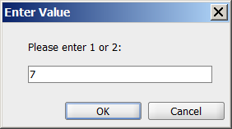

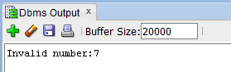

Case 2)



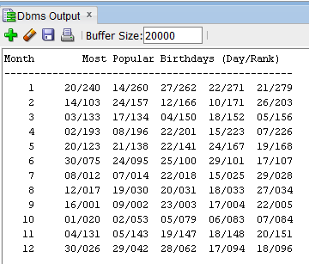

Case 3)



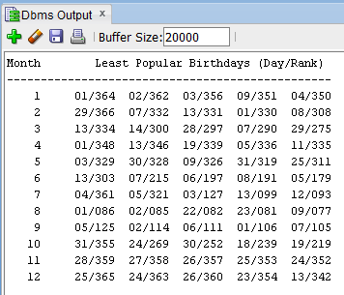

**========================== End (2b) CSC 452 only =======================**

**3) (CSC 352 and CSC 452 - 60 points)**

**========================= Begin (3a) CSC 352 only ========================**

**3a) (CSC 352 only)**

Based on the tables created in Assignment #1, write a **PL/SQL program** that accepts an employee ID from the user input and displays 1) the employee's name, job title, hire date, salary, manager name (If the given employee does not have a manger, the manager name is shown as “------” in your output.), and department name (If the given employee does not belong to any department, the department name is shown as “------” in your output.), and 2) all employees (alone with their job titles, hire dates, and salary) who work in the same department as the given employee **and** were hired **before** the given employee (or “NO OUTPUT”). Sort your output by the employee name.

* Hard coding (e.g., IF v_emp_id = 7596 THEN v_1 := ...) will receive 0 points.
* You will lose 10 points if the title lines are missing in your output.
* You will lose 10 points if your output is not in the correct format.
* Your program must display the salary with a dollar ($) sign, a comma, and two decimal places (e.g., $1,234.56).
* You will receive 0 points if you submit more than **one** PL/SQL program.

To avoid complicating issues, you can assume that the user always enters input from keyboard that consists only of the digits 0 through 9 and Enter.

*(This question should take less than 60 minutes to solve.)*

Test your program. You must ensure that the output of your program matches the following sample output:

Case 1)

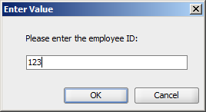

Output:

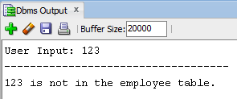

Case 2)

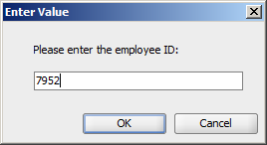

Output:

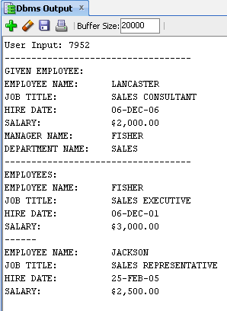

Case 3)

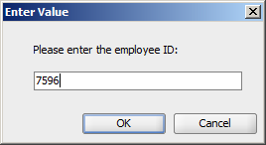

Output:

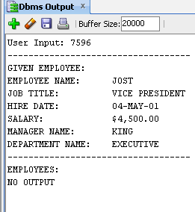

Case 4)

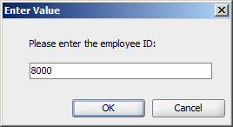

Output:

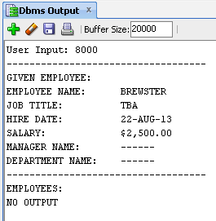

**========================= End (3a) CSC 352 only =========================**

**========================= Begin (3b) CSC 452 only ========================**

**3b) (CSC 452 only)**

Based on the tables created in Assignment #1, write a **PL/SQL anonymous block** that performs the following tasks.

a) Find all employees who were hired on the days of the week on which the **highest** number of employees were hired.

b) For each employee found in the previous step, display the following items in the output of your program:

* His/her hire date, name, job title, and salary.
* The total number of employees who report to him/her directly. (For example, you can find that there are 3 employees who report to Jost directly, Jones, Smith, and Wilson.)
* The department name that he/she works. If the employee does not belong to any department, the department name is shown as “------” in your output.
* His/her manager name and salary. If the employee does not have a manager, the manager name and salary are shown as “------” in your output.

Sort your output by days of the week (Monday, Tuesday, …, Friday), the hire date, and employee name.

* You will lose 10 points if the title lines are missing in your output.
* You will lose 10 points if your output is not in the correct format.
* Your program must display the salary with a dollar ($) sign, a comma, and two decimal places (e.g., $1,234.56).
* Hard coding (e.g., IF v_day = 'Thursday' OR v_day = 'Friday' OR v_max_num = 4 THEN …) will receive 0 points.
* You will receive 0 points if you submit more than **one** PL/SQL program.

Hints:

(1) TO_CHAR(hire_date, 'Day')

(2) TRIM(TO_CHAR(hire_date, 'Day'))

(3) TRIM(TO_CHAR(hire_date, 'D')

(4) GROUP BY TO_CHAR(hire_date, 'Day')

*(This question should take less than 60 minutes to solve.)*

**The output of your program must match the following:**

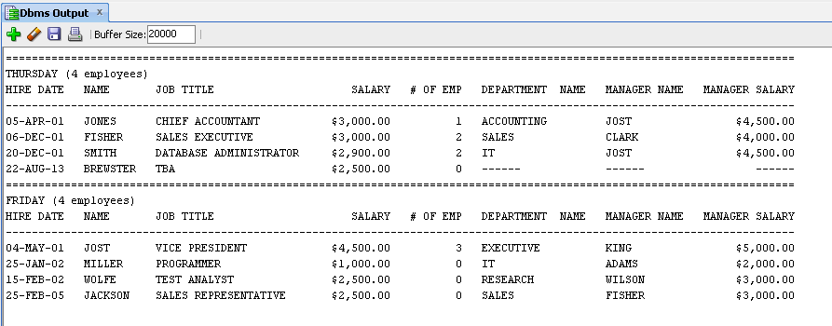

**========================= End (3b) CSC 452 only ========================**