Assignment2

Part1:

Four tables AUTHORS, BOOKS, PUBLISHERS, WRITE

In table AUHTORS, the Primary Key I set is ID(Authors).

In table BOOKS, the Primary Key I set is ISBN, the Foreign Key I set is ID(Publishers) and it is linked with the ID(Publishers) in table PUBLISHERS.

In table PUBLISHERS, the Primary Key I set is ID(Publishers).

In table WRITE, the Primary Keys I set is ID(Authors) and ISBN, the Foreign Keys I set are ID(Authors) linked with ID(Authors) in table AUHTORS and ISBN linked with ISBN in table BOOKS.

The relationship between them is like the following images.

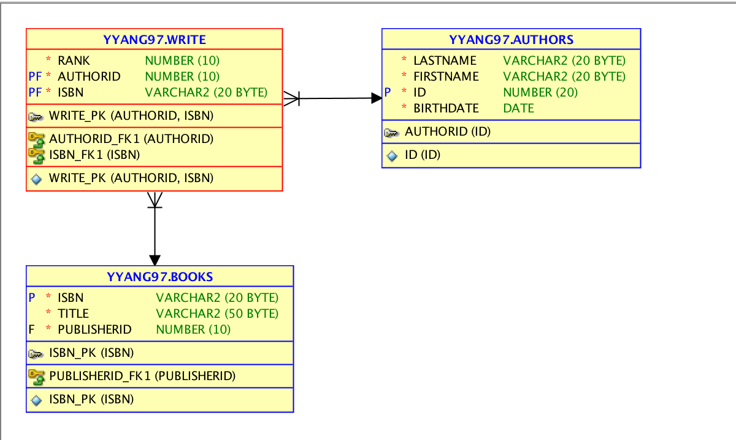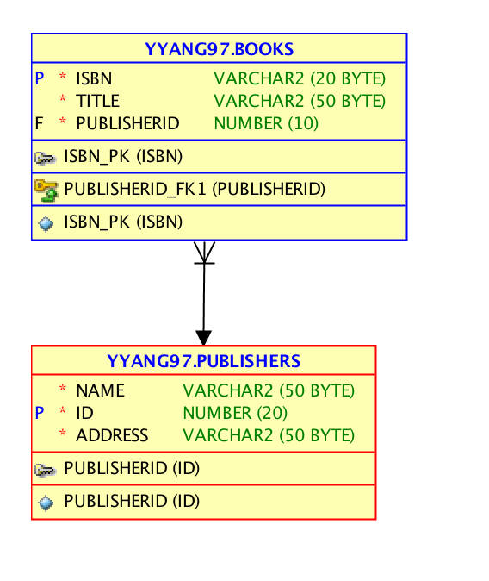

Part 2:

The code in the assignment2.sql bond with this .doc in the same .zip file.

Part 3:

The code in the assignment2part3.sql bond with this .doc in the same .zip file.

Extra Credits:

1. Code:

SELECT FIRSTNAME, LASTNAME, ID

FROM AUTHORS

WHERE FIRSTNAME LIKE '%e%';

1. Code:

SELECT NAME, ADDRESS, ID

FROM PUBLISHERS

WHERE ID >= 17

ORDER BY ID ASC;