**M-***σ* **RELATIONS ACROSS SPACE AND TIME**

Garofalo et al. showed that the evolution of galaxies significantly differs in terms of the M-σ relation, whether the active galactic nucleus (AGN) being jetted or non-jetted. The reason is that **jets** are stronger feedback mechanisms for the velocity dispersion than **accretion disc winds** driven by the SMBH. By the time, galaxies without jets show a constantly growing mass of the SMBH followed by a linear proportional increase of velocity dispersion in the bulb. In jetted AGNs the SMBH increases its mass more rapidly for about 108 years with relatively low increase of velocity dispersion. This is followed by a phase of quite slow growth of the SMBH-mass but strong increase of velocity dispersion.   
This might be crucial for our mini-project as the M-σ relation of jetted AGNs depends on their age. We do not know yet if the data will allow us to distinguish these types to take this into account.

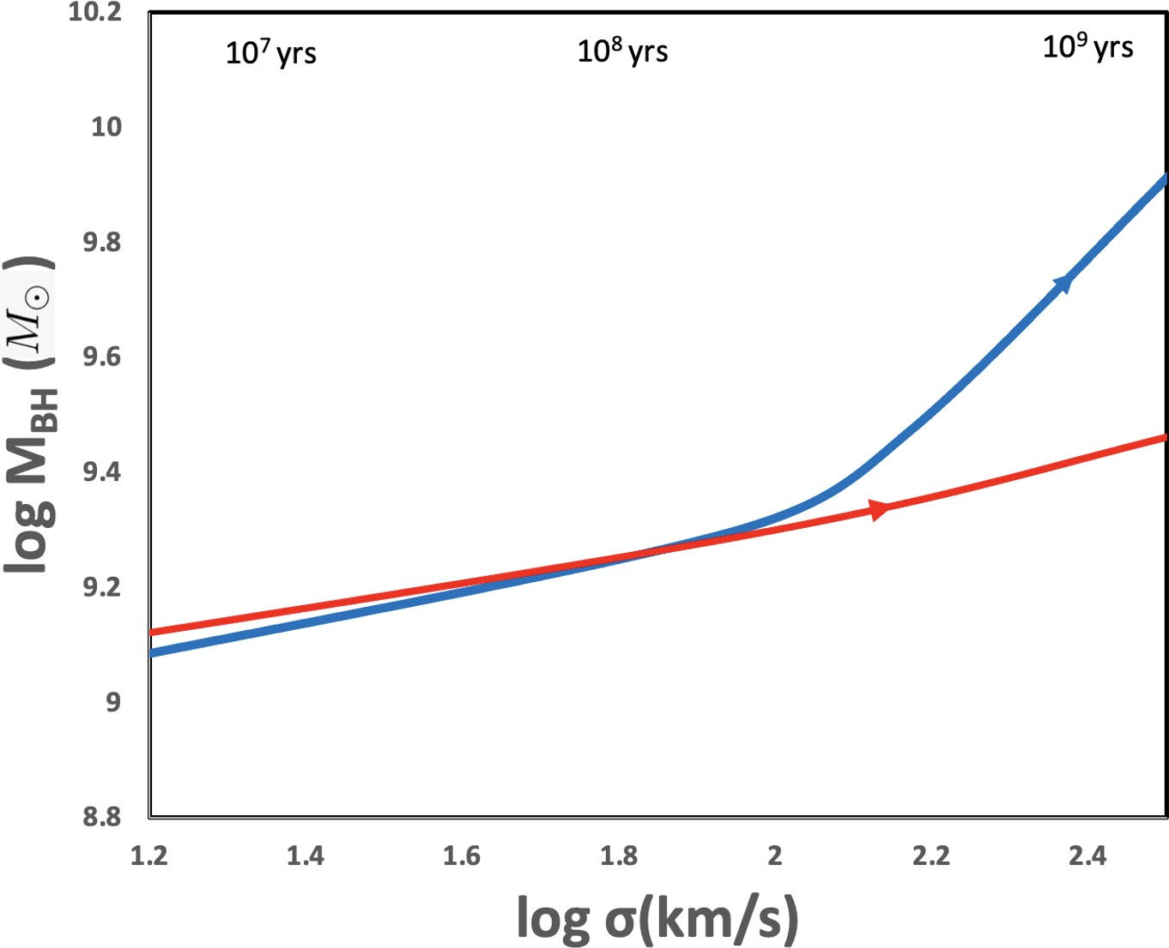

**Figure 6.** Theoretical M-*σ* paths.   
Blue line: Radio quiet quasars (RQQ).   
Red path: Radio loud quasars (RLQ).