**SUMMARY**

THE *M*–*σ* AND *M*–*L* RELATIONS IN GALACTIC BULGES AND DETERMINATIONS OF THEIR INTRINSIC SCATTER

Gültekin et al. (2009)

The M-sigma relation represents an empirical correlation between the mass of a (supermassive) black hole (MBH) and the velocity dispersion (σ) of stars in the bulge region of a galaxy. This suggests that the MBH is closely related to the dynamical processes in the galaxy bulge on the base of a strong interaction, which may be expressed as a mathematical formula:  
**log(MBH/M⊙)=α+β.log(σ/200 km/s)**.

1. **Correlation and modeling of the M-σ relation**: Analyzing a data set of 49 records of values for MBH and σ Gültekin et al. calculated parameters α and β as α = 8.12±0.08 and β = 4.24±0.41.
2. **Investigation of intrinsic scatter**: A central goal of the study is to analyze the intrinsic scatter in the M-σ relation. Elliptical galaxies are found to have lower intrinsic scatter (ɛ0 = 0.31±0.06), indicating that they lie closer to the ridge line of the relation than spiral galaxy types. In contrast, spiral galaxies show a larger scatter, possibly due to measurement errors or unconsidered dynamical effects.
3. **Investigation of the M-L relation**: The M-L relation, which connects the MBH with the luminosity of the galaxy bulge, shows a higher scatter compared to the M-σ relation. The formula for the calculation here is: log(MBH/M⊙)=α+β.log(LV/1011L⊙,V) with the parameters α = 8.95±0.11, β = 1.11±0.18 and an intrinsic scatter of ɛ0 = 0.38±0.09. The luminosity alone seems less suitable for predicting the MBH mass, as it is more strongly influenced by other galactic properties.
4. **Model proof by a simulation data sample**: Culling the data sample according to the resolution of the black hole’s sphere of influence biases the relations to larger mean masses, larger slopes, and incorrect intrinsic residuals. This is demonstrated by a series of simple Monte Carlo experiments on a synthetic M–σ data set.

**ACTIONS**

Starting our work, we converted the dataset given in the paper to a form able to get processed by Python and data analysis tools. Visualizing the distribution of MBH andσ came first separating 2 types of Galaxies (elliptical an spiral).  
The mean for MBH is 2,1x108 for E-type galaxies, and 3,3x107 for S-type. The mean for σ is 210 km/s for E-type galaxies, and 155 km/s for S-type.

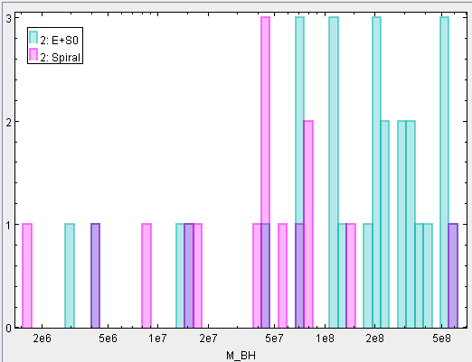 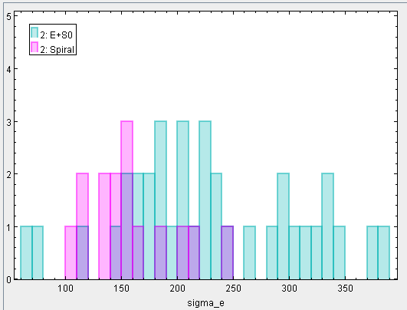

We also investigated the MBH/σ ratio, which shows a bit similarity to a log-normal distribution, especially for the E-Type galaxies.

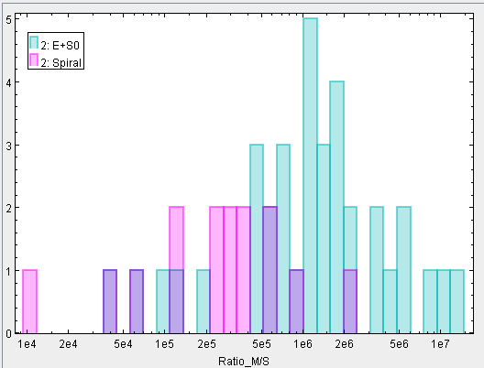 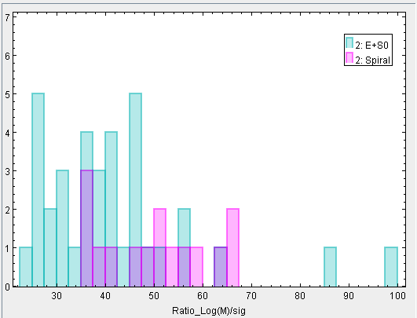

Bringing the M-σ relation into a 2D-plot, we got the impression of a linear relation on logarithmic axes as suggested by the paper. Displaying with linear axes, it turns out that E-type galaxies show apparently different α and β parameter compared with S-type-galaxies.

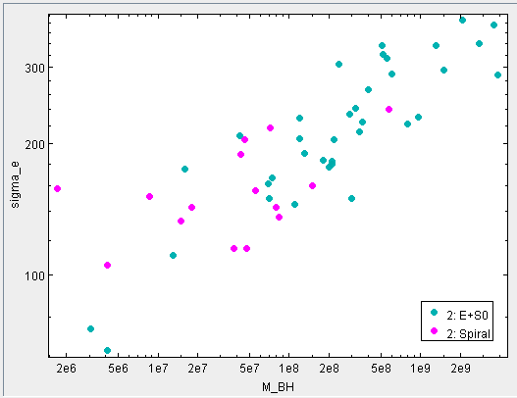 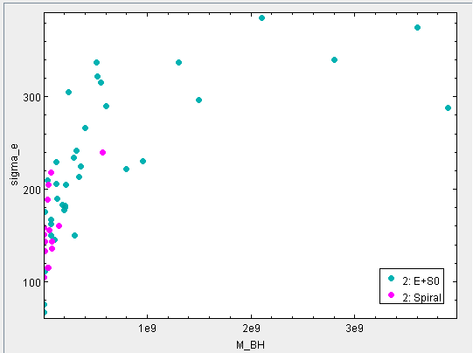

Analyzing the MBH/σ ratio against the MBH, this fact got verified as even very heavy BH do not lead to a greater σ than 330 km/s (right: logarithmic axes).

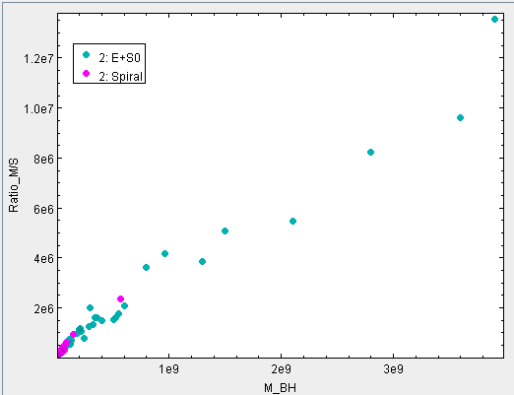 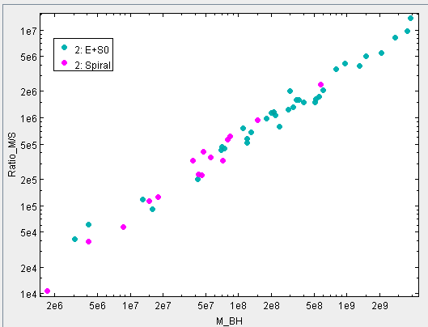

Being not really satisfied by the quite small number of records in the data, we were looking for other sources. At the AGN Catalogue (<https://wwwmpa.mpa-garching.mpg.de/SDSS/DR4/Data/agncatalogue.html>) there is a sample of 88,178 records of measured galaxies, most of them containing processable values for MBH and σ.  
First we needed to eliminate records with zero-values and those that showed overflow-values, so 87,769 records were ready to get analyzed.

The distribution of MBH and σ show both a log-normal distribution. The mean of the MBH is 6,5x1010, the mean for σ is 170 km/s.

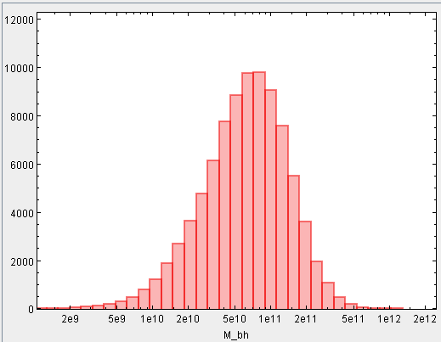 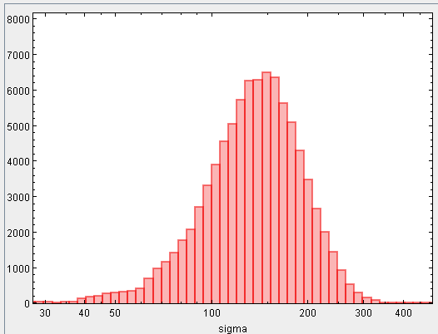

Plotting the M-σ relation we see a significant difference compared with the data set from Gültekin et al. This is mainly caused by much higher values for MBH. The average difference-factor is 104 which is quite a lot. We do not dare any explanation for this difference for the moment.

Additionally, the ADS data set seams not reliable at low and high σ. The original data contained many records having 0 or 600 for σ. The first is impossible and therefore missing data and the second is probably the upper limit of the measurement system.

The plot also shows a strange distribution of values for σ below 90 km/s. This also suggests technical limits of the measurement systems.

Due to the large number of remaining, reliable data and the small number of small galaxies the data give a clear proof of the M-σ relation and its scatter.

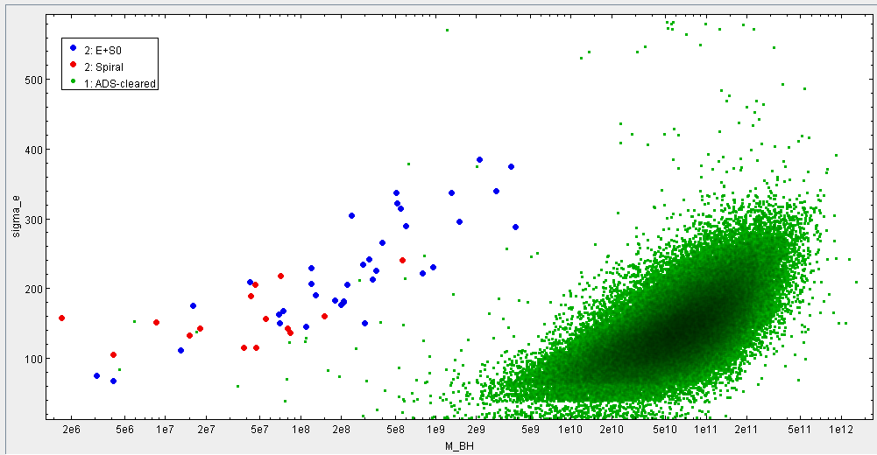

Trying to apply the Gültekin formular (log(MBH) and log(σ/200)), the bias still appears evident.  
Assuming a linear fit for the logarithmic relation can be found for each sample, the rise of the best fit straight would be significantly different.

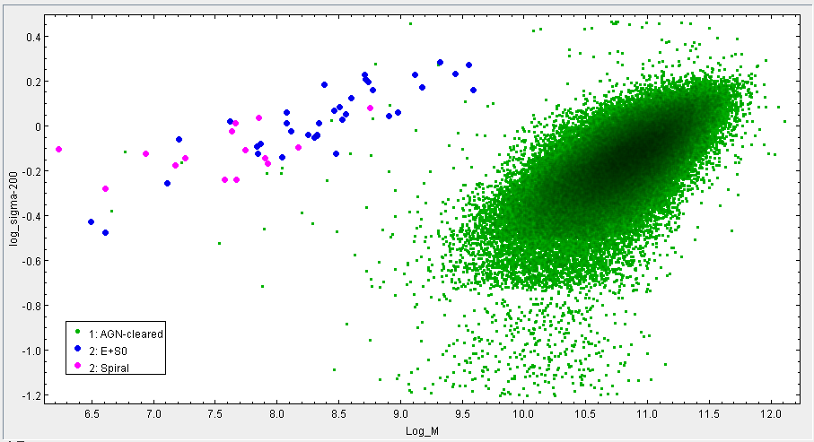

For the AGN data, the distribution of the log(MBH)/σ ratio appears as nearly perfect log-normal.

