Formstack QA Analyst Assignment Test Plan
Submit completed tests and debug.log files to: Angel Garbarino argarbarino@gmail.com
Version tested: 0.0.1
Test environment: Local Environment using MAMP.

Test Setup
To set up, install MAMP or similar local server environment tool using Apache, PHP server. MAMP is compatible with macOS or Windows operating systems.
Next steps:
- Fork the https://github.com/Monkeychip/qa_assignment github repository.
- Clone the repository to your local machine.
- Save the clone of the repository in your htdocs on your local machine.
- Launch MAMP and make sure the Apache server is running.
- In your brower’s, type the following url: http://localhost/qa_assignment/cURLrequest.php
- You should now a webpage with some instructions and form.
- You are now ready to run through the test.
You should see the following: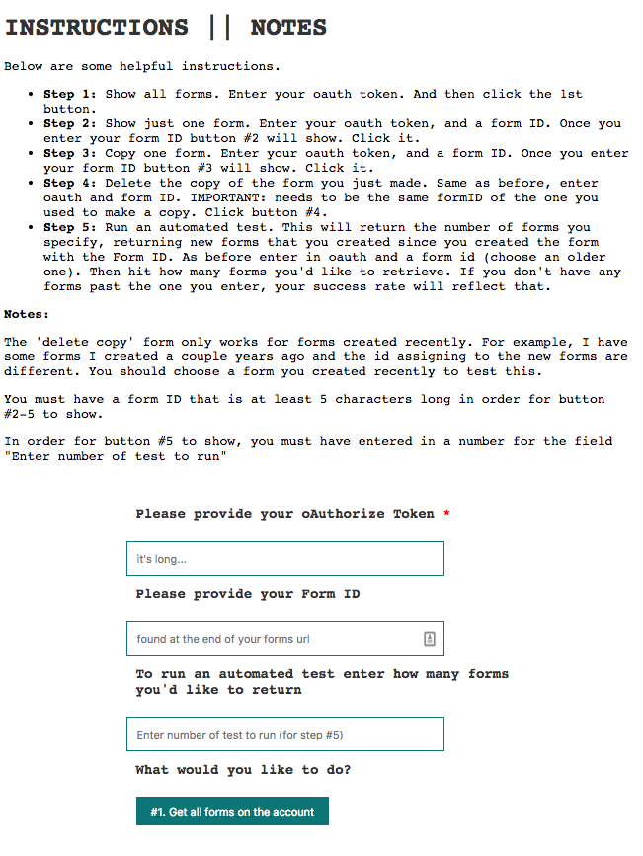

Tests
Each test will produce Request URL, Request Query String, Response Code, and Response (JSON). For each test you will need your Formstack’s oAuth token. YOu can access this under your User Dashbaord - API https://www.formstack.com/admin/apiKey/main
Test #1: Get all Specific Forms on the Account
To run this test, enter your oAuth token into the first form field. Then click button #1 “Get all forms on the Account”.
Expect: Response Code 200 with a full list of your Formstack account forms.
If Fail: double check your oAuth, and confirm that there are forms in your Formstack account. Run again.
Pass/Fail.
Test #2: Get Specific Form on the Account
To run this test, enter your oAuth token into the first form field. Then enter your form ID into the second field ‘Please Provide your Form ID’. Your Form ID can be found at the end of your forms URL. It should be greater than 5 numbers long. Once you enter your form ID the option to run ‘just get the one form’ will appear. Click that button.
Expect: Response Code 200 with the JSON results of just that one form.
If Fail: double check your oAuth, and your Form ID. Confirm these are correct, and run again.
Pass/Fail.
Test #3: Copy a Specific Form on the Account
Repeat Test #2 instructions. Once you enter your form ID the option to run ‘copy that one form’ will appear. Click that button.
Expect: Response Code 201 with results confirming you have copied the form. Confirm by checking your Formstack Account that you see the original form + a copy.
If Fail: double check your oAuth, and your Form ID. Confirm these are correct, and run again.
Pass/Fail.
Test #4: Delete the Copied Form
Repeat Test #2 instructions. Make sure that the Form ID is the exact same form ID as the one you entered in Test #3. Once you enter your form ID the option to run ‘delete that copied form’ will appear. Click that button.
Expect: Response Code 200 with results confirming you have deleted the form. Confirm by checking your Formstack Account that you see the original form, but no longer the copy you made in Test #3.
If Fail: double check your oAuth, and your Form ID. Confirm these are correct, and run again.
Pass/Fail.
Test #5: Run an Automated Test
This test will run Test #2 (return specific form), by increasing form IDs from the Form ID given. It will run this Test the number of times you specify. Enter oAuth Token. Enter a Form ID that has forms created after it’s creation. Enter a number of times you want to run the test. If you enter 3, you will return the original form, plus the two forms created right after it was created. Once you enter the number of times you would like to run the test, you will see the option to ‘run an automated test’. Click that button.
Expect: Response Code 200 with a Success Rate. The Success rate confirms out of the x number of test how many forms were returned. If you entered 3 for your test number, but you only had one form created since the Form ID you entered, your success will be 2 out of 3 or 66.7%.
If Fail: double check your oAuth, and your Form ID. Confirm these are correct, and run again.
Pass/Fail.

Final Steps
Once you are done testing, email link of forked repository with any dubug.log files to argarbarino@gmail.com.

