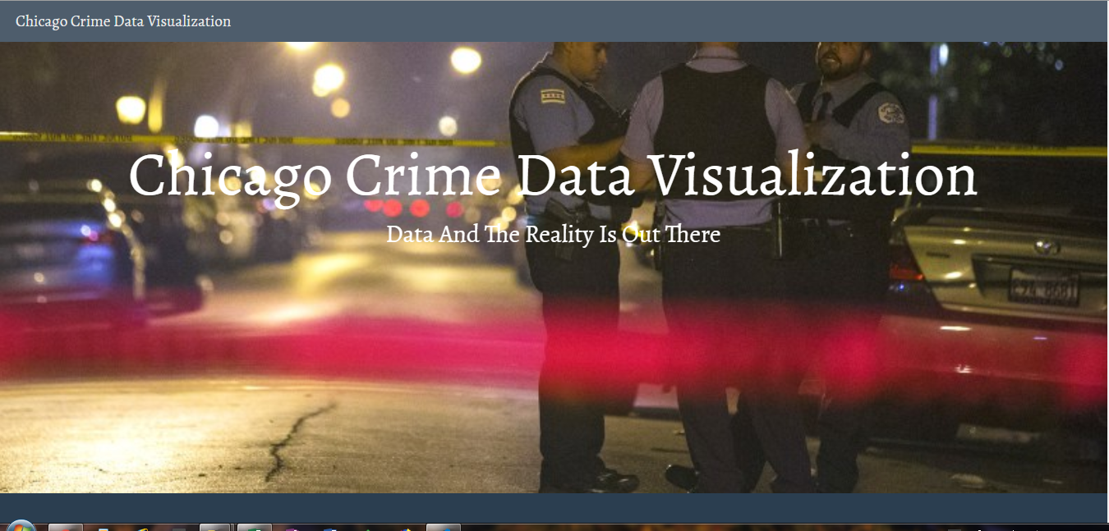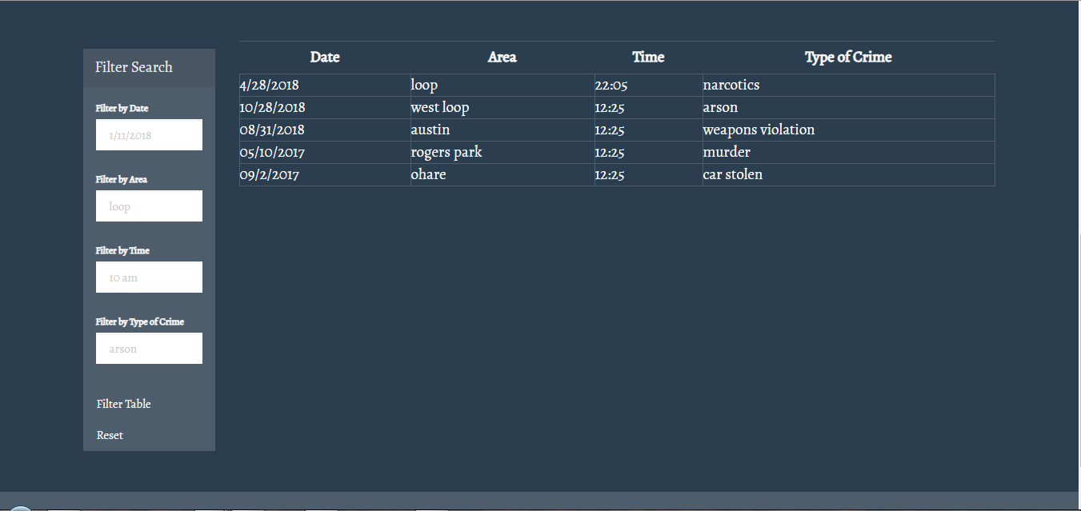

Our team will create a Web site that will be interactive for the user to display crime data in Chicago. By Chicago we mean the city and its community areas.

Using this data, we plan to create an interactive scatter plot with six or eight different crimes categories (arson, burglary, weapons, car theft etc) against each other plotted over the time duration of the data and accumulative total count of that particular crime. Each of the circle will have a pop-up tip for detailed information on that presentation.

We will pull data from:

<https://data.cityofchicago.org/Public-Safety/Crimes-2001-to-present/ijzp-q8t2>

<https://api1.chicagopolice.org/clearpath/documentation>

<https://data.cityofchicago.org/resource/6zsd-86xi.json> (We can use the id of “community_area” number to convert it to a neighborhood name, for

example in this json data if the community_area is 2 it translates to “West Ridge”)

Community_area definition - <https://en.wikipedia.org/wiki/Community_areas_in_Chicago>

Or - <https://www.cityofchicago.org/content/dam/city/depts/doit/general/GIS/Chicago_Maps/Citywide_Maps/Community_Areas_W_Numbers.pdf>

We will change the filter and grid display to an interactive scatter plot:

