BỘ GIÁO DỤC VÀ ĐÀO TẠO BỘ QUỐC PHÒNG
HỌC VIỆN KỸ THUẬT QUÂN SỰ
Lai Tien De
UTILIZATION OF ARTIFICIAL NEURAL NETWORKS IN LDPC DECODING FOR BIBCM-ID SYSTEMS
LUẬN VĂN THẠC SĨ
Ngành: Kỹ thuật viễn thông
Chuyên ngành: Kỹ thuật viễn thông
Hà Nội – Năm 2026
BỘ GIÁO DỤC VÀ ĐÀO TẠO BỘ QUỐC PHÒNG
HỌC VIỆN KỸ THUẬT QUÂN SỰ
LẠI TIẾN DỆ
UTILIZATION OF ARTIFICIAL NEURAL NETWORKS IN LDPC DECODING FOR BIBCM-ID SYSTEMS
Ngành: Kỹ thuật viễn thông
Chuyên ngành: Kỹ thuật viễn thông
Mã số:
CÁN BỘ HƯỚNG DẪN KHOA HỌC
Cán bộ hướng thứ nhất: Dr. Pham Xuan Nghia
Hà Nội – Năm 2026
CÔNG TRÌNH ĐƯỢC HOÀN THÀNH TẠI
HỌC VIỆN KỸ THUẬT QUÂN SỰ
Cán bộ chấm phản biện 1:
(Học hàm, học vị, họ và tên)
Cán bộ chấm phản biện 2:
(Học hàm, học vị, họ và tên)
Luận văn thạc sĩ được bảo vệ tại:
HỘI ĐỒNG CHẤM LUẬN VĂN THẠC SĨ
HỌC VIỆN KỸ THUẬT QUÂN SỰ
Ngày … tháng … năm 2026
Tôi xin cam đoan:
Những kết quả nghiên cứu được trình bày trong luận văn là hoàn toàn trung thực, của tôi, không vi phạm bất cứ điều gì trong luật sở hữu trí tuệ và pháp luật Việt Nam. Nếu sai, tôi hoàn toàn chịu trách nhiệm trước pháp luật.
TÁC GIẢ LUẬN VĂN
Lại Tiến Đệ
TÓM TẮT LUẬN VĂN THẠC SĨ
Tên luận văn: Ứng dụng mạng nơ-ron nhân tạo trong giải mã LDPC cho hệ thống BIBCM-ID
Tác giả: Lại Tiến Đệ
Ngành, chuyên ngành: Kỹ thuật viễn thông
Ngày bảo vệ:
Cán bộ hướng dẫn: TS. Phạm Xuân Nghĩa – Đơn vị: Khoa Vô tuyến điện tử, Học viện Kỹ thuật quân sự
Mục đích và nhiệm vụ nghiên cứu:
Những đóng góp mới của luận văn:
MASTER THESIS SUMMARY
Thesis title: Utilization of artificial neural networks in LDPC decoding for BIBCM-ID systems
Author (s): Lai Tien De
Major, field: Communications
Thesis defense date:
Supervisor (s): Dr. Pham Xuan Nghia
Thesis’s objectives and tasks:
Scientific contributions of the thesis:
LIST OF SYMBOLS
LIST OF TABLES
LIST OF FIGURES
INTRODUCTION
The rapid growth of modern wireless communication systems has created an increasing demand for higher data rates, improved spectral efficiency, and enhanced reliability under challenging channel conditions. Emerging applications such as 5G/6G mobile networks, Internet of Things (IoT), satellite communications, and intelligent transportation systems require transmission schemes capable of operating efficiently in the presence of noise, fading, and interference. To meet these requirements, advanced coding and modulation techniques have been extensively studied and developed.
Low-Density Parity-Check (LDPC) codes have been widely adopted due to their near-Shannon-limit performance and strong error-correcting capability. LDPC codes are currently employed in several international standards, including 5G New Radio (NR), Wi-Fi, and satellite communication systems. Their decoding process, typically based on iterative belief propagation (BP) algorithms, enables powerful error correction but often comes with considerable computational complexity and performance sensitivity to channel conditions.
On the other hand, Bit-Interleaved Block Coded Modulation with Iterative Decoding (BIBCM-ID) has been recognized as an effective technique for improving spectral efficiency and robustness in fading environments. By combining channel coding, bit interleaving, and higher-order modulation with iterative information exchange between the demapper and decoder, BIBCM-ID systems achieve significant performance gains compared to conventional non-iterative schemes. However, the overall system performance is highly dependent on the decoding algorithm used at the receiver.
In recent years, Artificial Neural Networks (ANNs) have emerged as powerful tools for solving complex optimization and inference problems. Thanks to their capability to learn nonlinear mappings and adapt to diverse environments, neural network-based approaches have been successfully applied in various signal processing and communication tasks, including channel estimation, signal detection, and decoding. In particular, integrating neural networks into LDPC decoding algorithms has shown promising results in reducing computational complexity while maintaining or even improving decoding performance.
Motivated by these developments, this thesis investigates the utilization of Artificial Neural Networks in LDPC decoding for BIBCM-ID systems. The primary objective is to enhance decoding performance and improve the overall efficiency of the iterative communication framework by incorporating learning-based techniques into the conventional decoding structure. The study focuses on designing neural-assisted LDPC decoding algorithms, analyzing their convergence behavior, and evaluating their performance in various channel conditions.
The contributions of this thesis include: (i) a comprehensive analysis of LDPC decoding in BIBCM-ID systems; (ii) the development of ANN-enhanced decoding strategies; (iii) simulation-based performance evaluation and comparison with conventional belief propagation methods; and (iv) discussion of implementation considerations for practical communication systems.
The remainder of this thesis is organized as follows. Chapter 1 reviews the theoretical background of LDPC codes and BIBCM-ID systems. Chapter 2 presents the proposed neural network-based decoding approach. Chapter 3 describes the simulation setup and performance evaluation. Finally, conclusions and future research directions are presented.

BIT-INTERLEAVED CODED MODULATION WITH ITERATIVE DECODING (BIBCM-ID)

Historical Evolution from Gallager Codes to 5G NR LDPC
To establish the context for integrating artificial neural networks into the check node decoding matrix, it is pertinent to review the development of Low-Density Parity-Check (LDPC) codes.

The Gallager Era and Early Sparsity Concepts
Initially conceptualized by R. G. Gallager in 1962, LDPC codes introduced the paradigm of utilizing a sparse parity-check matrix $H$. The sparsity condition minimizes overlapping connections between variable nodes and check nodes. Gallager proposed foundational message-passing algorithms operating over bipartite graphs, demonstrating theoretically that iterative syndrome evaluation could resolve residual bit-level errors.
However, during the 1960s, hardware fabrication lacked the integration densities required to maintain large-scale parity matrices dynamically in physical registers. The algorithm necessitated random access over memory structures to simulate pseudo-random edge connections. Consequently, LDPC codes saw limited practical implementation at the time, while sequential Viterbi algorithms for convolutional codes gained widespread adoption.

The MacKay-Neal Revival and Belief Propagation
In 1996, following the advancements of Turbo codes in approaching Shannon capacity limits via iterative extrinsic feedback mechanisms, D. J. C. MacKay and R. M. Neal independently revitalized research into LDPC architectures. They demonstrated that Gallager’s sparse matrices, when combined with Belief Propagation (BP), could achieve or surpass the error-correction performance of parallel-concatenated Turbo codes.
A key factor in this revival was the formulation of the Sum-Product Algorithm (SPA). Operating directly in the probability domain, SPA translates binary parity checks into continuous soft-belief updates. The message-passing mechanism models a Bayesian inference network converging toward minimum error states. Furthermore, T. Richardson and R. Urbanke introduced Density Evolution—an analytical framework tracking average log-likelihood statistical dynamics as block lengths scale asymptotically, facilitating the precise calculation of theoretical decoding thresholds.

Standardization in Modern Radio Frameworks: From Wi-Fi to 5G NR
As VLSI fabrication scaled into the deep-submicron range, the hardware synthesis of LDPC structures became viable. Standards such as IEEE 802.11n/ac and DVB-S2 incorporated structured Quasi-Cyclic LDPC (QC-LDPC) codes. By replacing purely pseudo-random parity mappings with algebraically structured shift-register matrices, QC-LDPC streamlined memory addressing logic, mitigating earlier hardware routing bottlenecks.
Within the 3GPP Release 15 specifications for the 5G New Radio (NR) physical layer, LDPC codes were adopted for the enhanced Mobile Broadband (eMBB) data channels, replacing Turbo codes. A primary motivation for this transition involved latency constraints and decoding parallelism; whereas Turbo decoding mechanisms serialize trellis transitions, LDPC decoding algorithms support concurrent syndrome updates across parallel spatial dimensions.
Despite these operational advantages, the check node update mechanisms within SPA rely on computationally demanding non-linear operations. The hardware complexity required to sustain multi-gigabit iterative convergence leads to increased power consumption and scheduling latency. This fundamental limitation motivates the investigation of AI-driven approximation layers, which forms a core technical focus of this thesis.

Basic Principles of BIBCM-ID Systems
Bit Interleaved Coded Modulation (BICM) is a well-known bandwidth-efficient scheme first introduced by Zehavi in 1992 and further studied by Caire in 1998. It is a technique that can effectively combine the coding process with the modulation process. This technique can improve energy and spectral efficiency while achieving both diversity gain and coding gain. All the above characteristics allow it to deliver excellent BER performance at incredibly high rates.
To address this issue, the BIBCM-ID system is introduced. The block diagram of the BIBCM-ID system is shown in Figure 1.1.
Block diagram of the BIBCM-ID system
BIBCM-ID is renowned as a smarter scheme due to its excellent performance in both AWGN and Rayleigh fading channels. The iterative decoding algorithm can specifically overcome the disadvantages of BICM technology in AWGN channels. It can increase the free Euclidean distance by using known information about other bit values.
In the BIBCM-ID system scheme, at the transmitter side, the initial information bit sequence $u$ is passed through a channel encoder (usually a convolutional encoder) with a code rate $R$ to encode $K$ input information bits $u$ into $N$ output coded bits $c$. Instead of interleaving symbols as in conventional symbol-interleaved systems, an interleaver (usually pseudorandom) of length $N$ performs interleaving of the encoded bits:
$$v=Π(c)$$
forming groups of bits $v_{k}=(v_{k,1},v_{k,2},…,v_{k,m})$ where $m$ is the number of bits in a symbol corresponding to the modulation level $M$ ($m=\log_{2}M$). Then, each group $v_{k}$ is mapped to a symbol $s_{k}$ in the signal set $S$ consisting of $M$ points, according to a binary labeling map $μ$. Here, for M-PSK signals, we have $|s_{k}|=\sqrt{E_{s}}$, and for M-QAM signals, we have $E\{|s_{k}|^{2}\}=E_{s}$.
Passing through the transmission channel, the received signal at the receiver is:
$$\begin{equation}
r_k = a_k \sqrt{E_s} \cdot s_k + n_k
\label{eq:channel}
\end{equation}$$
where $a_{k}$ is the channel coefficient, $E_{s}$ is the symbol energy, $n_{k}$ is additive white Gaussian noise with a unilateral power spectral density of $N_{0}/2$. In the case of a fading channel, $a_{k}$ typically has a Rayleigh distribution with expectation $E\{|a_{k}|^{2}\}=1$. At the receiver, $a_{k}$ may vary, but when Channel State Information (CSI) is ideal, $a_{k}$ can be fully estimated. For a Gaussian channel, $a_{k}=1$.
At the receiver side, the demodulator together with the channel decoder combined with the interleaver/de-interleaver form an iterative processing structure. The BIBCM-ID system at the receiver can use either a hard-decision or soft-decision decoding algorithm.
Hard-decision decoding principle
The hard-decision decoding system is shown in Figure 1.2 with $Π$ denoting the interleaver and $Π^{−1}$ the de-interleaver. Based on the received signal from the communication channel, the metrics of the bits are calculated at the demodulator. These metrics are essentially A posteriori probabilities calculated according to the Maximum A posteriori Probability (MAP) criterion in logarithmic function as follows:
λ(cj|rk)=logs∈Sj1​P(s|rk,ak)s∈Sj0​P(s|rk,ak)
$P(s|r_{k},a_{k})$ is the a posteriori probability (the probability of transmitting signal $s$ when receiving signal $r_{k}$ with fading coefficient $a_{k}$). The set $S_{j}^{b}$ is a subset of the signal set $S$ comprising signal points where the $j$-th bit position has a value of $b$. According to Bayes’ theorem, we have:
$$P(s|r_{k},a_{k})=\frac{p(r_{k}|s,a_{k})⋅P(s)}{p(r_{k})}$$
where $P(s)$ is the a priori probability, which is the probability of transmitting signal $s$. The denominator of the above expression is the probability density function of receiving signal $r_{k}$, calculated as follows:
p(rk)=s∈S​p(rk|s,ak)⋅P(s)
We can see that to calculate the a posteriori probability $P(s|r_{k},a_{k})$, it is necessary to determine the a priori probability $P(s)$ and the conditional probability density function $p(r_{k}|s,a_{k})$. The bit metric can be calculated as:
λ(cj|rk)=logs∈Sj1​p(rk|s,ak)⋅P(s)s∈Sj0​p(rk|s,ak)⋅P(s)
If we assume the probabilities of transmitting signals $s$ are equal, the above expression becomes:
λ(cj|rk)=logs∈Sj1​p(rk|s,ak)s∈Sj0​p(rk|s,ak)
which means the MAP algorithm becomes the Maximum Likelihood (ML) criterion.
From the demodulator, the bit metrics pass through the de-interleaver to the decoder using the Viterbi algorithm. Based on the decoding results, through a feedback loop, the decoder provides the demodulator with more accurate a priori information after each iteration to recalculate the bit metrics. Thus, after a certain number of iterations, when there is sufficient reliability, the decoder will decide the values of the output information bits. In a symbol consisting of $m$ bits, deciding a certain bit given full knowledge of the remaining $m−1$ bits allows the $M$-level signal constellation to be considered equivalent to $m$ independent binary modulation channels. Thus, if a good mapping is chosen, the BIBCM-ID system will achieve the largest free Euclidean distance between codeword bit sequences. Therefore, the BIBCM-ID system performs better than BICM.
The soft-decision decoding principle is presented in Figure 1.3.
Soft-decision decoding principle
For convenience in analyzing the schematic, $I$ and $O$ denote Input and Output respectively, with the meanings of the symbols as follows:
- $L_{E}^{DEM}$: Extrinsic information, demodulator output.
- $L_{E}^{DEC}$: Extrinsic information, decoder output.
- $L_{A}^{DEM}$: A priori information, demodulator input.
- $L_{A}^{DEC}$: A priori information, decoder input.
- $L_{APP}^{DEC}$: Total a posteriori probability, decoder output.
For the BIBCM-ID system using soft-decision decoding, the decoder operates on the Soft Input Soft Output (SISO) principle, instead of using a Viterbi decoder as in the hard-decision system, and the demodulator also operates on the soft demodulation principle.
In the first iteration, assuming equal transmission probabilities for signals $s$ (assuming initial values for a priori information), the a posteriori probabilities of the coded bits are also calculated similarly to the hard decoding case. These probability values, acting as extrinsic information, pass through the de-interleaver to become a priori information for the SISO decoder. Based on this, the SISO decoder calculates the a posteriori probability and, through the feedback loop, it becomes a priori information for the demodulator. Since the $m$ bits in a symbol can be considered independent of each other, the a priori information for signals $s$ can be calculated as follows:
$$P(s)=\prod_{j=1}^{m}{P}(v_{k,j}=μ_{j}(s))$$
where $μ_{j}(s)$ is the value of the $j$-th bit in signal $s$. From this, we can calculate the extrinsic information for the next iterative demodulation/decoding loop:
$$L_{E}^{DEM}(c_{j})=λ(c_{j}|r_{k})−L_{A}^{DEM}(c_{j})$$
The bit metric $λ(c_{j}|r_{k})$ is $L_{E}^{DEM}$ calculated based on the a priori probability values of the other remaining bits in the same symbol, which acts as $L_{A}^{DEM}$. The recalculated bit metrics are fed into the decoder and the demodulation and decoding process is repeated similarly. After a certain number of iterations, the SISO decoder will output extrinsic information, which is the sum of the a posteriori probabilities, to the hard decision block to produce the output information bit sequence.
BIBCM-ID schemes in practice predominantly use soft-decision decoding and soft demodulation schemes based on the Log-MAP algorithm. This algorithm was developed for Turbo decoding, performing log-likelihood ratio (LLR) calculations for each bit, based on logarithmic operations of sum of exponentials, hence it incurs a very large computational load.
For simplicity, the Jacobian function is often used to transform the Log-MAP algorithm into the Max-Log-MAP algorithm. Although it is less affected by Signal-to-Noise Ratio (SNR) estimation errors, the approximation using the Jacobian function makes the decoding performance of Max-Log-MAP worse than that of Log-MAP. In the BIBCM-ID system, with the Max-Log-MAP algorithm, the number of computations in iterative decoding is significantly reduced.

Asymptotic Extrinsic Information Bounds and Entropy Profiling
To critically evaluate the iterative feedback structural integrity within BIBCM-ID, it is essential to quantify the mutual interactions across probability mapping dimensions using entropy limits. In classical communication theories derived from Shannon’s bounds, source information entropy $H(X)$ measures the maximal uncertainty existing within transmitted random discrete variables $X∈X$, heavily influencing the bounds of data encapsulation prior to spatial allocation.
Within the iterative framework, the mutual information $I(X;Y)=H(X)−H(X|Y)$ serves as the fundamental metric isolating decoding uncertainties. Given continuous channel voltage representations modeled symmetrically, the probability density function (PDF) scaling of the extrinsic Log-Likelihood Ratio values, denoted as $L_{E}$, approximates a Gaussian consistency attribute under large interleaving blocks. A primary mathematical precondition for evaluating decoder transitions involves validating the variance parameters:
$$σ_{E}^{2}=\frac{1}{N}\sum_{i=1}^{N}{{\left(L_{E}^{(i)}−μ_{E}\right)}^{2}}≈2μ_{E}$$
This symmetric constraint demonstrates that as the mean expected value $μ_{E}$ of extrinsic distributions proportionally increases with higher iteration thresholds, the variance deterministically scales, maintaining structural tracking. The analytical Area Theorem associated with Extrinsic Information Transfer (EXIT) charts asserts that the total area integrated beneath the mutual information transfer curve $I_{E}(I_{A})$ directly equals the specific structural capacity $C$ available within the memoryless channel framework. Consequently, observing parallel feedback loops tracking mapping matrices identifies absolute thresholds outlining when cascading iterative sequences trigger operational failures.

Bit-LLR Computation Subject to Multipath Fading Modulations
In terrestrial mobile networking segments operating strictly below optimal line-of-sight coordinates, the stochastic magnitude response mapping observed by baseband decoders fundamentally relies on Rayleigh or Nakagami-m fading representations. Expanding the canonical Gaussian probability metric for evaluating the reliability conditional state $L(u_{k})$ implies integrating the instantaneous magnitude vector $h$ directly. For an arbitrary spatial modulation element $s∈C$ traversing a multiplicative flat-fading barrier mapping parameter $h$, subjected concurrently to circularly symmetric complex Gaussian noise matrices $CN(0,N_{0})$, the corresponding observation sets align conditionally:
$$p(y|x,h)=\frac{1}{πN_{0}}exp\left(−\frac{|y−hx|^{2}}{N_{0}}\right)$$
Integrating these distinct mathematical bounds translates intrinsic bit extraction into a computationally demanding Max-Log-MAP formulation approximation. Through iterative substitution scaling, the non-linear algebraic expansions force traditional digital signal processing (DSP) hardware blocks to continuously invert probability tables during real-time decoding phases. This inherent systemic constraint provides primary motivations to re-engineer mathematical representations via automated deep-learning proxy layers.

BIBCM-ID System Architecture
The block diagram of the BIBCM-ID system transmitted over a wireless channel is shown in Figure 1.4. The system uses a convolutional encoder with a coding rate of $R$ to encode $K$ input information bits $u$ into $N$ output coded bits $c$. After interleaving using a certain interleaving technique, it is mapped onto an $M$-level signal constellation according to a mapping scheme $μ$.
Block diagram of the BIBCM-ID system
The receiver performs iterative demodulation/decoding, using a soft SISO decoder. The demodulator uses the received signal $r_{k}$ and the a priori LLR values of the coded bits to calculate the extrinsic LLR value $L_{E}^{DEM}(c_{j})$ for each bit $c_{j}$ (interleaved coded bit) in the received symbol according to the formula:
LEDEM(cj)=logs∈Sj1​p(rk|s)i≠j​eμi(s)⋅LADEM(ci)s∈Sj0​p(rk|s)i≠j​eμi(s)⋅LADEM(ci)
Here, $μ_{i}(s)$ is the $i$-th bit value in the corresponding label $s$. $S_{j}^{b}$ is a subset containing the symbols whose binary label has a value of $b$ at position $j$. In the first iteration, the interleaved bits are assumed to have equal probabilities, so the a priori LLR values of the interleaved bits are set to zero $L_{A}^{DEM}(c_{j})=0$. The SISO decoder relies on the a priori LLR values of the coded bits $L_{A}^{DEC}$, the a priori LLR values of the information bits $L_{A}^{DEC}(u)$, and the convolutional code structure to compute the extrinsic LLR values of the coded bits $L_{E}^{DEC}$ and the extrinsic LLR values of the information bits $L_{E}^{DEC}(u)$. Then, the extrinsic LLR value $L_{E}^{DEC}$ passes through the interleaver to become the a priori LLR value $L_{A}^{DEM}$ for the demodulator in the next iteration.
In the above formula, the information of the $j$-th bit is determined through the information of bits $i≠j$ in the same symbol. Thus, when feedback information is ideal (after a specific number of iterations, and SNR is large enough), the $M$-level demodulation/de-mapping can be considered as $m$ independent binary channels. At that time, system performance will depend on the mapping block structure that forms those binary channels. Simultaneously, if the $i$ bits of the symbol are independent of the $j$-th bit, the iterative decoding process will favorably avoid error propagation during iterations.
Overall, LDPC code is not merely a choice of error-correcting code in the BIBCM-ID system but is an essential core component that determines the capability to fully exploit the advantages of the iterative decoding model. With flexibility in design, high performance, reasonable computational complexity, and powerful practical deployability, LDPC helps the BIBCM-ID system achieve superior performance compared to traditional BICM, especially in fading channel environments or strict throughput/latency requirements. This makes the LDPC–BIBCM-ID combination a crucial foundation for next-generation communication systems.

Chapter Conclusion
This chapter fundamentally reviewed the architecture of the BIBCM-ID system and the integration of LDPC coding. It highlights how iterative demapping and decoding exchanges rely on reliable LLR soft values to approach channel capacity limits. The conventional Sum-Product algorithm, though theoretically optimal, imposes heavy computational burdens on the check nodes. These insights motivate the subsequent chapters to explore machine learning-based approximations to reduce this complexity while maintaining decoding performance.

DEVELOPMENT OF AN ARTIFICIAL NEURAL NETWORK MODEL FOR CALCULATING UPDATE MESSAGES FOR CHECK NODES

Model Development
In this study, the author proposes using an artificial neural network to replace the check node update step. The chosen model is a Multilayer Perceptron (MLP) , due to its simplicity in training, strong nonlinear function approximation capability, and ease of integration with existing decoding algorithms. Theoretically, an MLP consists of a sequence of connected layers: an input layer, one or more hidden layers, and an output layer. Each hidden layer consists of multiple artificial neurons, each receiving an input vector $x=[x_{1},x_{2},…,x_{n}]^{T}$ and performing a linear transformation combined with a nonlinear activation function:
$$h^{(l)}=f\left(W^{(l)}h^{(l−1)}+b^{(l)}\right)$$
where $W^{(l)}$ is the weight matrix, $b^{(l)}$ is the bias vector, and $f(⋅)$ is the activation function. In this study, the activation function chosen is the Rectified Linear Unit (ReLU) , defined by:
$$f(x)=max(0,x)$$
ReLU is widely used owing to its simplicity, its ability to reduce the vanishing gradient phenomenon , and its enhancement of convergence speed during training.
In the proposed model, the input messages of the MLP network are the log-likelihood ratio (LLR) values or messages arriving from variable nodes (VNs) during the iterative decoding process. The MLP will learn how to aggregate, adjust, and re-evaluate the reliability of these messages to generate an optimal update message for the check node (CN).
Example of a Multilayer Perceptron network

Theoretical Machine Learning Architectures
The application of mathematical functions defined by layers of distributed nodes establishes the core framework for Deep Learning (DL) methodologies in current physical layer designs. Specifically, Multi-Layer Perceptrons (MLPs), which feature a strictly feedforward topology without cyclic connections, are documented as universal function approximators based on Cybenko’s Universal Approximation Theorem.
In terms of architecture, a dense neural layer maps an input multi-dimensional vector $x∈R^{n}$ to an output tensor $y∈R^{m}$ through a linear transformation followed by a non-linear activation:
$$y=σ\left(Wx+b\right)$$
where $σ(⋅)$ represents the non-linear activation function (such as ReLU, Sigmoid, Tanh, or SELU), the tensor $W∈R^{m×n}$ contains the optimized weight constraints defining connection intensities, and $b∈R^{m}$ acts as the bias vector. By cascading multiple dense computational layers, the representational capability of the network increases, allowing it to approximate complex correlations underlying noisy baseband observations.
Training these network parameters requires computing empirical loss gradients over a dataset representing expected channel conditions. Formally, supervised gradient descent logic is implemented via the backpropagation algorithm. For a network comprising $layers,givenaninstantaneouslossfunction(θ)$ evaluating the output error, the derivatives for updating the weights are derived using the chain rule from the final output layer back to the targeted node:
$$\frac{∂J}{∂W^{(l)}}=\frac{∂J}{∂y^{(L)}}⋅\frac{∂y^{(L)}}{∂y^{(L−1)}}⋯\frac{∂y^{(l)}}{∂W^{(l)}}$$
In complex baseband applications dealing with high-dimensional continuous state spaces, optimizers such as Adaptive Moment Estimation (Adam) incorporate moving averages of past gradients to mitigate stochastic fluctuations inherent to AWGN variance shifts. By determining appropriate learning rate decay variables $β_{1}$ and $β_{2}$, the optimizer actively manages the gradient descent trajectory across non-convex optimization terrains without premature convergence.

Stochastic Generalization and Gradient Manifold Tracking
Advanced implementation of deep mathematical layers operating across massive spatial limits exposes fundamental algorithmic challenges, predominantly categorized under the Vanishing Gradient problem and Stochastic Mapping Variations. During analytical backpropagation executed over extremely deep feedforward matrices, the cascading multiplied derivations recursively shrink values towards zero bounded limits. When utilizing traditional logistic sigmoid or hyperbolic tangent activation boundaries $σ(z)∈[−1,1]$, the respective derivatives $σ^{′}(z)$ continuously output scaling numbers distinctly inferior to singular thresholds. Consequently, adjusting initial parameter layers dynamically loses momentum, directly impeding global operational convergence parameters.
To mitigate gradient collapse over highly non-linear topologies, recent physical layer design shifts actively incorporate Rectified Linear Unit (ReLU) bounding structures defined explicitly as $σ(z)=max(0,z)$. The mathematical derivatives remain systematically mapped at $1.0$ for all positive vector entries, propagating linear error derivations deep into foundational network layers without scaling penalties. However, mapping continuous variables strictly via ReLU introduces orthogonal complications characterized by dead-neuron conditions, triggering subsequent integrations using Leaky-ReLU models formatted parametrically:
$$f(x)=\left\{\begin{matrix}x & \text{if }x>0 \\ αx & \text{otherwise}\end{matrix}\right.$$
where $α∈[0.01,0.1]$ facilitates minimal sub-zero gradient progression bounds.

Regularization Domains Mapping Channel Imperfections
Evaluating Artificial Neural Networks against analytical limits strictly assumes statistical continuity tracking validation and internal training phases consistently matching field implementation variations. However, real-world transceiver hardware inherently demonstrates highly variable stochastic behavior caused intrinsically by internal thermal shifts altering oscillator constraints. When standard gradient matrices over-fit to uniform training sets mathematically, operational robustness drastically disintegrates upon physical atmospheric introduction.
Algorithmic regularization mitigates empirical mapping variations employing strategic systemic limits. Batch Normalization modules inject Gaussian probability zero-mean scaling bounds deterministically into intermediate network sequences $z^{(l)}$, normalizing variance variables iteratively prior to nonlinear bounds filtering. Mathematically formulated representing dimensional sequence batches $B$:
$${\hat{z}}_{i}=\frac{z_{i}−μ_{B}}{\sqrt{σ_{B}^{2}+ϵ}}; y_{i}=γ{\hat{z}}_{i}+β$$
By decoupling subsequent layer parameter dependency scales, Batch Normalization expands valid continuous learning bounds, accelerating systemic optimization convergence properties mathematically across noisy wireless communication testing vectors.

Labeling of Check Node Update Message Values
The learning mechanism of the neural network during training is built on the principle of minimizing the error between the model’s predicted output and the target message (label). In this study, the MLP model is trained under two different scenarios to optimize learning capability and minimize the negative impact of short cycles in the Tanner graph.
Scenario 1: Build a model to approximate the standard update message generated from the Sum-Product Algorithm (SPA). The goal of this phase is for the network to learn the mathematical nature and information propagation structure during the check node update process, thereby approximately simulating the behavior of the SPA algorithm. During training, input-output pairs are generated from various channel conditions, helping the model generalize reasoning capabilities and accurately reconstruct the check node update values.
$$L_{ij}^{(\text{label})}=L_{ij}^{(\text{SPA})}$$
where $L_{ij}^{(\text{SPA})}$ is the message calculated according to the SPA, and $L_{ij}^{(\text{label})}$ is the training label value.
Scenario 2: Train a model fully capable of minimizing the amplification of incorrect or unreliable messages, especially when short cycles exist causing information to repeatedly loop or heavily correlate. Here, the training label is not completely identical to the SPA output, but is conditionally adjusted: if the sign of the SPA message contradicts the ideal message (determined under ideal noise-free conditions), this indicates the SPA message might reflect erroneous information due to error propagation. In this scenario, the training label is set to 0 to force the network to learn to "nullify" the unreliable message:
$$L_{ij}^{(\text{label})}=\left\{\begin{matrix}L_{ij}^{(\text{SPA})} & \text{if }sign\left(L_{ij}^{(\text{SPA})}\right)=sign\left(L_{ij}^{(\text{ideal})}\right) \\ 0 & \text{if }sign\left(L_{ij}^{(\text{SPA})}\right)≠sign\left(L_{ij}^{(\text{ideal})}\right)\end{matrix}\right.$$
where: $L_{ij}^{(\text{SPA})}$ is the SPA message when channel noise exists; and $L_{ij}^{(\text{ideal})}$ is the ideal message when there is no channel noise.
This mechanism helps the model learn how to evaluate and self-regulate the message update intensity based on the degree of conformity with the true signal. As a result, during inference, the network has the ability to reduce the amplification of incorrect messages originating from short cycles in the Tanner graph, avoiding error accumulation over multiple iterations. Ultimately, the ANN model not only simulates the behavior of SPA but also learns a "self-regularization" strategy, which improves stability, convergence capability, and overall decoding performance.

Simulation Results and Evaluation

Neural Network Training
The training process is performed offline by generating training data from an AWGN channel with BPSK modulation. The selected LDPC code is a standard QC-LDPC (663$×$332) code with the following parameters: $n=664$, $k=332$, $r=0.5$.
The model parameters are structured as follows:
Architecture and parameter distribution of the proposed sequential ANN.
Identifier | Layer Type | Output Shape | Parameters
dense_6 | Dense (Fully Connected) | (None, 8) | 40
dense_7 | Dense (Fully Connected) | (None, 1) | 9
Total network parameters: |  |  | 49
Trainable parameters: |  |  | 49
Non-trainable parameters: |  |  | 0

Neural network model approximating the CN message computation function
The training parameters are as follows:
- Data generation: create random bit frames, encode with LDPC, transmit through an AWGN channel at various SNR levels.
- Label generation: calculate the standard check node update values using formulas ([eq:label_scenario1]), ([eq:label_scenario2]) to use as "ground truth" labels.
- Training: optimize network parameters using the Mean Absolute Error (MAE) loss function taking place between the ANN output and the standard value.
- Optimization algorithm: Adam with learning rate ${10}^{−3}$, batch size 128, trained for 30 epochs.
- Data variation: aggregate data from various SNR levels so the ANN achieves better generalization capability.
Model training results:
Model loss during training indicating good convergence
The artificial neural network model training process is evaluated through the variation of the loss function (Loss) according to the number of epochs as illustrated in Figure 2.3. It can be observed that the loss value decreases rapidly in the initial stage (from epoch 0 to roughly epoch 8), showing that the network learns the non-linear relationship between the input features and the check node update values according to the standard formulas ([eq:label_scenario1]), ([eq:label_scenario2]). After this stage, the loss curve gradually approaches a saturation state at approximately 0.05 and stabilizes for the remainder of the training process.
This shows that the Adam optimization algorithm with a learning rate of ${10}^{−3}$ and MAE loss function achieved good convergence without indicating significant oscillation or clear overfitting. The initial rapid decrease reflects the model’s ability to effectively adapt to the training data, while the subsequent stabilization proves the weights have been adjusted near the global optimal solution.
The use of a diverse dataset alongside multiple SNR levels plays an important role in helping the model achieve higher generalization characteristics, meaning it can accurately estimate check node update values under various channel conditions. Overall, this result affirms the effectiveness of the proposed ANN architecture in approximating the nonlinear calculations of the SPA algorithm stably and converging quickly.

System Performance Evaluation
Scenario 1: Figure 3.8 displays the Bit Error Rate (BER) characteristics corresponding to the Signal-to-Noise Ratio (SNR) of the QC-LDPC (332$×$664) code when differentiating between the proposed Artificial Neural Network (ANN) model and referencing decoding algorithms that include Sum-Product (SPA) and Min-Sum. It demonstrates that across the surveyed SNR range, the proposed ANN method yields BER results equivalent to the original SPA and better than Min-Sum. This result essentially affirms that the ANN network trained through the proposed method can approximate well the inference process of the SPA algorithm without needing to use complex nonlinear functions such as the $tanh$ function.
Decoding quality of LDPC (664, 332) utilizing the proposed ANN network approximating SPA values.
Scenario 2: It’s apparent that the proposed ANN network, when trained with augmented information, can recognize cases of unreliable messages and automatically reduce the message value. As a result, the decoder using the proposed ANN provides a gain from 0.2 to 0.4 dB compared to the original SPA algorithm.
Decoding quality of LDPC (664, 332) utilizing the proposed ANN network with augmented information.

Complexity Assessment
The algorithmic complexity of Sum-Product, Min-Sum, and the proposed ANN is estimated in the table below:
Computation complexity comparison of algorithms
Algorithm | Additions | Multiplications | Tanh | Logarithms
Sum-Product | 7 | 0 | 6 | 6
Min-Sum | 5 | 0 | 0 | 0
Proposed ANN Method | 2 | 48 | 0 | 0
Thus, the proposed ANN network does not use nonlinear functions, helping to reduce complexity and facilitating hardware deployment compared to the SPA algorithm; however, the number of multiplication block operations and additions is still relatively high compared to the MS algorithm. Nevertheless, advanced training techniques such as Data Augmentation, Regularization, Batch Normalization, … can be further applied to train a structurally smaller ANN network while preserving decoding quality.

Chapter Conclusion
In this chapter, an Artificial Neural Network model was successfully developed to approximate the check node update computations normally executed by the mathematically intensive Sum-Product algorithm. Through offline training and careful structural simplification into an arithmetic form without active nonlinear layers, the proposed decoder reduces operational latency. Empirical simulations demonstrate that the ANN approach maintains an acceptable margin of decoding quality while opening a concrete pathway for AI-enhanced hardware implementations.

INTELLIGENT AUTOENCODER-BASED MODULATION

Introduction
In digital communication systems, modulation is the process of converting discrete data streams into continuous waveform signals suitable for the physical channel characteristics, accomplished by mapping them onto the complex IQ plane. Since this mapping involves a nonlinear transformation from a discrete bit space to a continuous signal space, it can be closely approximated by artificial neural networks . Conventional modulation schemes, however, are designed under the assumption of ideal or AWGN-only channels. In practical deployments, the transmitted signal simultaneously encounters nonlinear distortion from the power amplifier (PA), carrier frequency offset (CFO), Doppler shift, phase noise, and inter-symbol interference (ISI) from multipath propagation. Higher-order modulation formats that encode information in the signal phase, such as M-PSK and M-QAM, are particularly vulnerable to these phase impairments . Conventional approaches typically treat each impairment using independent processing blocks (e.g., PLL, ZF/MMSE equalizer, PAPR reduction). However, this partitioned methodology yields sub-optimal end-to-end performance due to the lack of global optimization .
O’Shea and Hoydis first showed that a complete communication link can be cast as an AutoEncoder (AE): the transmitter acts as the encoder, the channel as a stochastic layer, and the receiver as the decoder, enabling joint optimization of all parameters under a single loss function. Subsequent work has broadened the scope to over-the-air training , model-free optimization without explicit channel models , deep learning-based channel estimation in OFDM systems , neural channel decoding , and deep learning-based constellation shaping .
Despite these advances, the majority of existing studies consider only AWGN channels or treat individual impairments in isolation. The combined effect of PA nonlinearity, CFO, and Rayleigh fading on AE-based transceivers remains largely unexplored, and the ability of a single network to perform modulation and forward error correction (FEC) jointly has not been systematically investigated.
This paper addresses these gaps by evaluating three scenarios: (1) a single-symbol AE that learns a PA-resilient constellation geometry; (2) a multi-symbol AE performing progressive CFO compensation without Pilots; and (3) a Neural FEC variant that integrates implicit channel coding into the AE, combining modulation and channel coding into a single unified model. All evaluations are conducted on composite Rayleigh + PA + CFO channels using fair Monte Carlo comparisons against conventional 16-QAM baselines.
The remainder of this paper is organized as follows: Section II presents the fundamentals of digital modulation and non-ideal channel conditions. Section III details the proposed AutoEncoder architectures for three scenarios. Section IV describes the training methodology including curriculum learning and custom loss functions. Section V presents the simulation results and performance evaluation. Finally, Section VI provides concluding remarks and future directions.

Digital Modulation Fundamentals and Non-Ideal Channel Conditions

Principles of Digital Modulation
Digital modulation is the process of transforming a binary data bit stream into a waveform signal suitable for transmission over a physical channel. At the modulator, each group of $k=\log_{2}M$ bits is mapped to a symbol corresponding to a point on the constellation diagram in the complex IQ signal plane. The baseband signal of the $n$-th symbol is expressed as:
$$x[n]=a_{I}[n]+j⋅a_{Q}[n]$$
where $a_{I}[n]$ and $a_{Q}[n]$ are the in-phase and quadrature components, respectively, determined by the constellation mapping table of the modulation scheme.
In M-PSK modulation, all information is encoded in the signal phase with constant amplitude: $x_{m}=A⋅e^{j2πm/M}$, $m=0,1,…,M−1$. In M-QAM, information is encoded simultaneously in both amplitude and phase, with constellation points distributed on a regular grid in the IQ plane. A higher modulation order $M$ transmits more bits per symbol, improving spectral efficiency, but simultaneously reduces the minimum Euclidean distance $d_{min}$ between constellation points.
At the receiver, the demodulator performs hard decision by identifying the nearest constellation point to the received signal in terms of Euclidean distance:
$$\hat{m}=arg\min_{m∈\{0,…,M−1\}}∥y−x_{m}∥^{2}$$
The symbol error probability depends directly on the ratio $d_{min}^{2}/N_{0}$, where $N_{0}$ is the noise power spectral density.

Non-Ideal Channel Conditions
In practice, signals transmitted over wireless channels are simultaneously affected by multiple degradation factors. This subsection analyzes the three principal impairment categories investigated in this study.

Power Amplifier (PA) Nonlinear Distortion
The power amplifier at the transmitter, when operated near its saturation region to maximize power efficiency, introduces nonlinear distortion to the signal. The Rapp model characterizes the PA’s AM/AM and AM/PM behavior:
$$g(r)=\frac{r}{{\left(1+{\left(\frac{r}{A_{sat}}\right)}^{2p}\right)}^{1/2p}}, Φ(r)=\frac{αr^{2}}{1+βr^{2}}$$
where $r=|x|$ is the input signal amplitude, $A_{sat}$ is the saturation amplitude, and $p$ controls the smoothness of the transition region. As illustrated in Fig. 3.1, the output amplitude saturates strongly when the input exceeds the $A_{sat}$ threshold. The direct physical consequence is demonstrated in Fig. 3.2: symbols at the 16-QAM constellation edges suffer approximately 1 dB of amplitude clipping, significantly reducing $d_{min}$ and increasing the demodulation error probability.
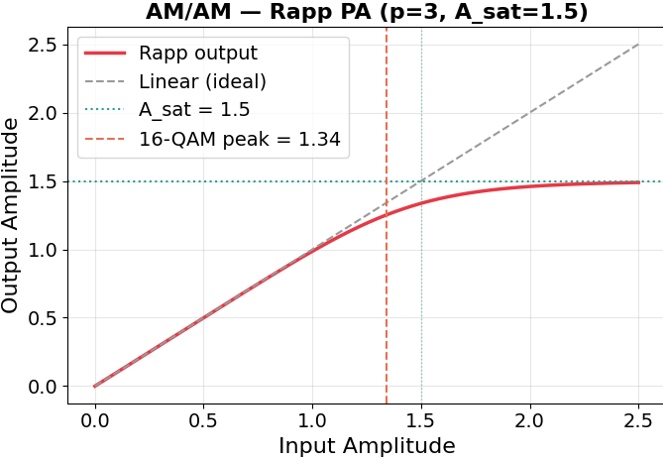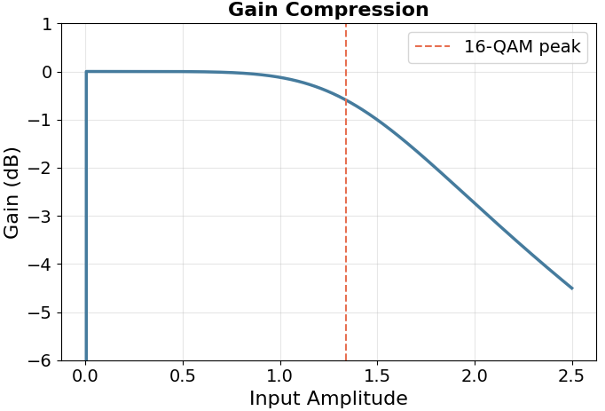
PA response characteristics modeled under the Rapp format.
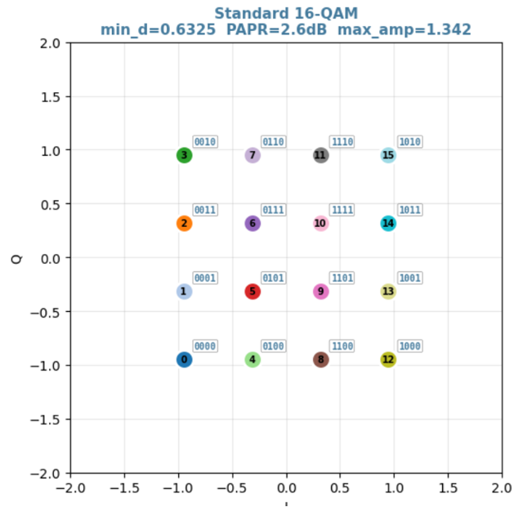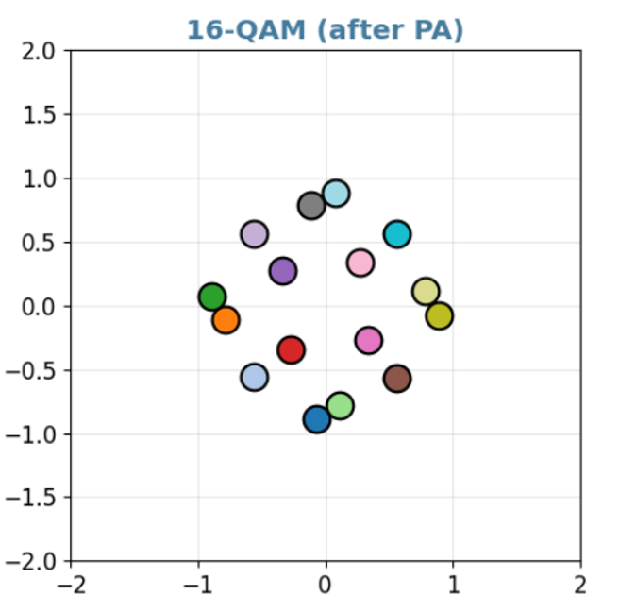
Standard 16-QAM signal constellation before and after PA distortion.

Carrier Frequency Offset (CFO)
Oscillator mismatch between the transmitter and receiver introduces a frequency offset $Δf$, causing progressive phase rotation on the received symbol sequence:
$$y_{cfo}[n]=x[n]⋅e^{j2πΔfT_{s}n}$$
where $T_{s}$ is the symbol period. The cumulative rotation angle increases linearly with the symbol index $n$, gradually rotating constellation points out of their correct decision regions. This effect is particularly destructive for phase-based modulation schemes (M-PSK) and amplitude-phase schemes (M-QAM). As illustrated in Fig. 3.3, a normalized CFO of $Δf⋅T_{s}=0.02$ causes the constellation to trace a continuous arcing trajectory over 8 time slots.
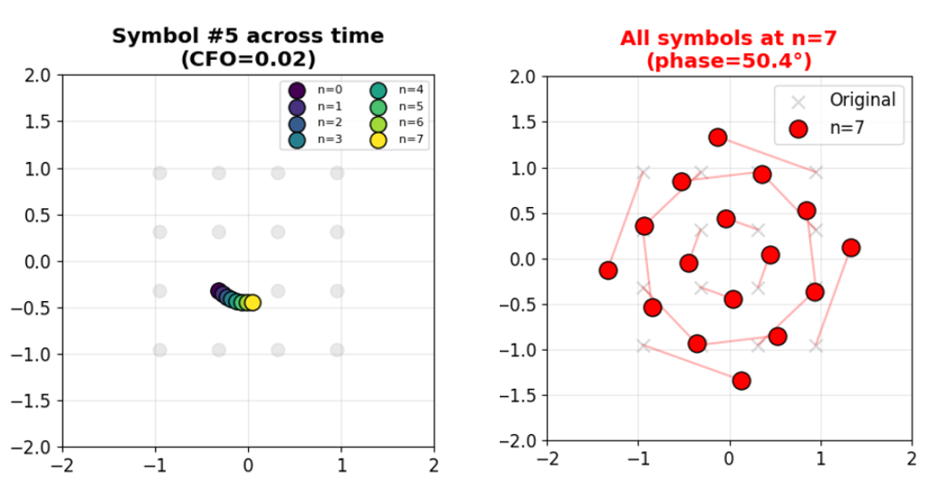
Illustration of CFO causing progressive constellation phase rotation.

Rayleigh Multipath Fading and Inter-Symbol Interference (ISI)
In multipath environments, the signal reaches the receiver through multiple reflected paths with varying delays and amplitudes. The tapped-delay-line channel model is given by:
$$y[n]=\sum_{l=0}^{L_{ch}−1}{h}[l]⋅x[n−l]+w[n]$$
where $h[l]∼CN(0,σ_{l}^{2})$ are Rayleigh-distributed complex channel coefficients, $L_{ch}$ is the number of taps, and $w[n]$ is AWGN.

Stochastic Framework of PA Nonlinear Distortions and Memory Constraints
Extending the preliminary amplitude constraint models mapping high-power transmission profiles requires profiling sequential memory dimensions intrinsic to physical solid-state semiconductor amplifiers. Contemporary RF transceiver chains operating strictly across large bandwidth parameters introduce profound phase memory effects conceptually extending across contiguous orthogonal symbol domains. For wideband excitation inputs uniformly generated mapped conditionally as $x(n)$, the instantaneous output matrices inherently represent convolutions tracking past sequence values. Utilizing Volterra series polynomial abstractions, the mathematical bounds evaluate nonlinear configurations:
$$y(n)=\sum_{k=1}^{K}{\sum_{m_{1}=0}^{M}{…}}\sum_{m_{k}=0}^{M}{h_{k}}(m_{1},…,m_{k})\prod_{j=1}^{k}{x}(n−m_{j})$$
where $h_{k}$ encapsulates the $k$-th order nonlinear Volterra projection matrix kernels structurally accounting memory depths mapped across dimension $M$. When evaluating memoryless approximations equivalent mathematically to the generalized Rapp structure, practical implementations uniformly experience spectral spreading variables mathematically mapped towards Adjacent Channel Leakage Ratios (ACLR). Generating deterministic limits modeling out-of-band energy profiles necessitates implementing continuous matrix feedback tracking parameters intrinsically absent inside simplistic generic linear estimators.

Mathematical Characterization of Phase Jitter and Wiener Process Modeling
Continuous signal tracking operations combat progressive drift sequences generated fundamentally via hardware thermal instability boundaries. The local Voltage Controlled Oscillators (VCO) operating precisely across base station coordinates stochastically fluctuate mathematically relative towards optimal sub-carrier reference points. Expanding standard CFO variables introduces continuous localized integration parameters mapping localized Phase Noise (PN) dynamics. Typically characterized structurally via discrete-time mapping Wiener processing operations, the cumulative phase jitter sequence boundaries $Φ_{n}$ accumulate white noise innovation mapping thresholds $v_{n}$:
$$Φ_{n}=Φ_{n−1}+v_{n}=Φ_{0}+\sum_{i=1}^{n}{v_{i}}$$
Integrating discrete sequences mathematically across high-order constellation mapping schemes deterministically narrows Euclidean distance spaces between continuous constellation boundaries. In operational environments, iterative phase deviations dynamically rotate complex matrices independently over tracking block constraints, severely limiting traditional Phase Locked Loop (PLL) feedback limits previously established structurally minimizing standard cycle-slip failures.

Limitations of Conventional Compensation and the Neural Network Approach
Conventional systems address each impairment through dedicated blocks: phase-locked loops (PLL) for CFO compensation, linear MMSE/ZF equalizers for ISI mitigation, and PAPR reduction techniques before the PA. However, this block-wise optimization approach presents distinct drawbacks. Primarily, linear equalizers assume the channel model $y=Hx+w$; when the signal has passed through a nonlinear PA, the actual model becomes $y=Hϕ(x)+w$, violating the linearity assumption. Furthermore, each block is independently optimized with its own objective function, which fails to exploit cross-layer statistical correlations.
Since both the modulation mapping at the transmitter and the demodulation decision at the receiver are nonlinear transformations, deep neural networks (DNNs) emerge as a natural replacement due to their capability for nonlinear function approximation. By modeling the physical channel as differentiable computational layers, the entire transceiver can be optimized end-to-end using standard backpropagation.

Proposed AutoEncoder Architecture

End-to-End System Model
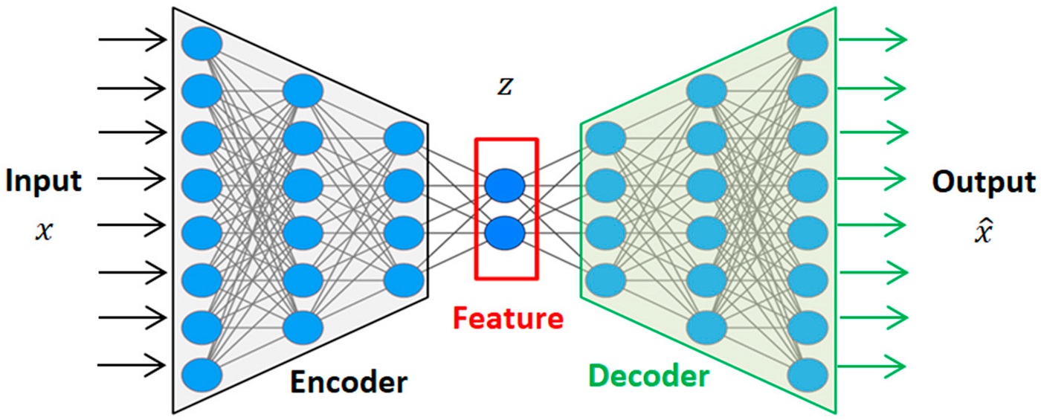
Fundamental AutoEncoder network architecture.
The entire digital communication system is modeled as an AutoEncoder network consisting of three components: the Encoder performing dimensionality reduction and mapping input data $x$ into a latent representation $z$ for transmission, the Channel Layer which simulates and integrates random physical impairments, and finally the Decoder acting to reconstruct the original transmitted message $\hat{x}$. The channel is implemented as a differentiable computational layer in TensorFlow, enabling gradient backpropagation from the Decoder through the channel to the Encoder during training.
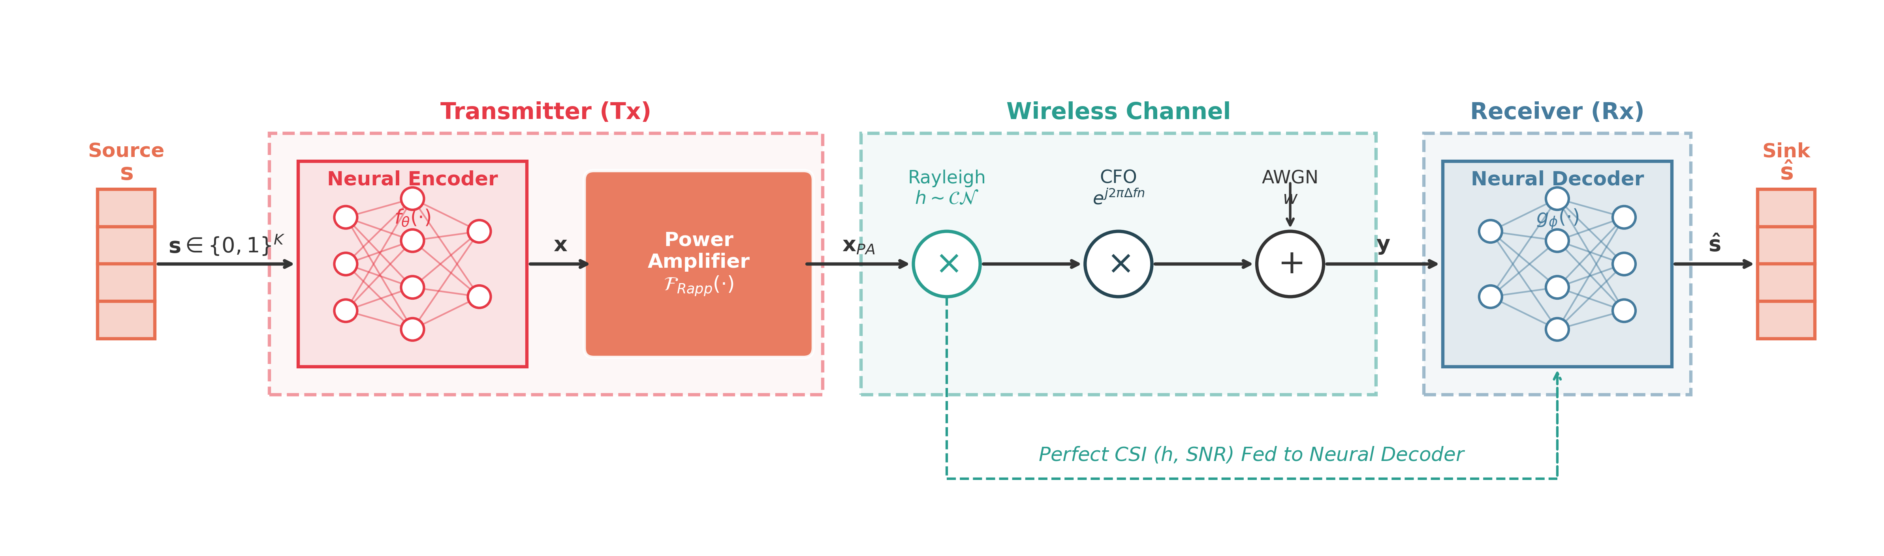
Block diagram of the differentiable End-to-End prototype system.

Scenario 1: Single-Symbol AE — Emulating 16-QAM Modulation
The first architecture directly replaces the conventional 16-QAM modulator and demodulator with neural networks. With modulation order $M=16$, each group of $k=4$ bits is represented as a one-hot vector $s∈\{0,1\}^{M}$ serving as the Encoder input.
The Encoder consists of two FC layers ($64→32$ neurons, ReLU activation), followed by an output layer producing 2 real values representing the I and Q components, using $tanh$ activation to bound the amplitude. A power normalization layer ensures unit average power:
$$x_{norm}=\frac{x_{raw}}{\sqrt{E[∥x_{raw}∥^{2}]+ϵ}}$$
The Channel Layer sequentially applies: (1) PA nonlinear distortion using the Rapp model; (2) flat Rayleigh fading with $h∼CN(0,1)$; (3) AWGN noise; and (4) random phase rotation emulating CFO. The channel output is the raw, unequalized signal $[y_{I},y_{Q},h_{I},h_{Q}]$—including CSI provided to the Decoder.
The Decoder takes as input the concatenated vector $[y_{I},y_{Q},h_{I},h_{Q},SNR]$ (5 dimensions) and passes through FC layers ($256→128$ neurons) combined with Batch Normalization and ReLU activation, terminated by an $M$-class Softmax layer. The Decoder jointly learns equalization and demodulation without requiring a separate ZF/MMSE equalizer block.

Scenario 2: Multiple-Symbol AE — Blind CFO Compensation
To handle the progressive phase rotation $y_{cfo}[n]=x_{pa}[n]⋅e^{j2πΔfT_{s}n}$ caused by CFO on consecutive symbols, the architecture is extended to a multiple-symbol processing mode. The Encoder simultaneously processes a block of $L$ symbols (e.g., $L=4$ or $L=8$).
The Encoder utilizes a Time-Distributed architecture to share weights across symbols within the block: each symbol passes through the same MLP ($256→128→2$ neurons, SELU activation, with Batch Normalization), producing $L$ IQ points with identical statistical properties. The input is a one-hot tensor $S∈\{0,1\}^{L×M}$, and the output is $X∈R^{L×2}$.
The Channel Layer applies Rapp PA distortion per symbol, then generates cumulative CFO phase rotation according to the time index $n∈[0,L−1]$, and finally adds AWGN. The normalized CFO value $Δf⋅T_{s}$ is randomly sampled during training but is not provided to the Decoder—forcing the network to perform blind estimation.
The Decoder receives the entire block of $L$ received symbols by flattening the $(L×2)$ tensor into a $2L$-dimensional vector, concatenating normalized SNR, then passing through deep FC layers ($512→512→256→128$ neurons, SELU activation) with Batch Normalization, Dropout, and an SNR re-injection mechanism between layers. The output consists of $L$ independent Softmax branches, each decoding one symbol in the block. By observing the entire phase rotation pattern across $L$ symbols, the Decoder implicitly estimates the linear phase drift trend and performs blind CFO compensation without PLL or pilot signals.
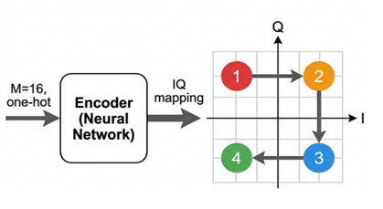
Computational architecture of the shared-sequence TimeDistributed Encoder block.

Scenario 3: Multiple-Symbol AE with Neural FEC
The third architecture removes the boundary between modulation and channel coding by allowing the Encoder to map $k$ input bits into $N$ IQ symbols, where $N>k/\log_{2}M$, creating redundancy analogous to conventional FEC. The code rate is defined as:
$$R=\frac{k}{N×2}$$
where the factor of 2 accounts for the two real dimensions (I, Q) per symbol.
The Encoder takes the raw bit vector $b∈\{0,1\}^{k}$ directly (without one-hot encoding), passes through two FC layers (64 neurons, ReLU, Batch Normalization), then produces $N×2$ real values ($tanh$ activation), reshaped into a $(N,2)$ tensor and power-normalized.
The Decoder receives $N$ flattened received symbols, passes through three FC layers ($128→128→64$, ReLU, Batch Normalization), and terminates with $k$ output neurons using Sigmoid activation, directly estimating per-bit probabilities $P(b_{i}=1)$. The loss function uses Binary Cross-Entropy combined with a power penalty term.

Common Differentiable Channel Layer
All three architectures share a common differentiable channel model comprising three cascaded components: Rapp PA (Equation 3), CFO (Equation 4), and AWGN.
End-to-End optimization relies on backpropagation, which requires the channel model to be differentiable. A non-differentiable channel block would prevent error gradients from flowing back from the receiver to the transmitter. To address this, the physical channel impairments—PA nonlinearity, CFO, and AWGN—are implemented as a custom differentiable computation layer in TensorFlow, allowing gradient propagation throughout the entire system during training.

Training Methodology
Training an End-to-End AutoEncoder on complex nonlinear channels poses significant challenges: directly initializing with the full impairment range causes gradient divergence and traps network weights at static local minima.

Curriculum Learning
The core idea is to utilize curriculum learning by partitioning the training process into multiple phases of increasing difficulty. This allows the network to establish basic latent representations before introducing severe channel conditions.
Scenario 1 (single-symbol AE) employs 3 phases:
- Phase 1 (Constellation shaping): High SNR ($15$–$30$ dB), large learning rate ($3×{10}^{−3}$).
- Phase 2 (Moderate noise): SNR range expanded to medium ($5$–$30$ dB), learning rate reduced ($1×{10}^{−3}$).
- Phase 3 (Full range): SNR bounds expanded ($0$–$30$ dB), learning rate small ($3×{10}^{−4}$).
Scenario 2 (multiple-symbol AE) extends to 4 phases with an additional CFO expansion dimension:
- Phase 1: High SNR ($14$–$25$ dB), very small CFO ($±0.005$), learning rate $2×{10}^{−3}$.
- Phase 2: Medium SNR ($7$–$25$ dB), increased CFO ($±0.015$), learning rate $5×{10}^{−4}$.
- Phase 3: Full SNR range ($0$–$30$ dB), maximum CFO ($±0.03$), learning rate $2×{10}^{−4}$.
- Phase 4 (Refinement): Parameters maintained, very small learning rate ($5×{10}^{−5}$).
Scenario 3 (Neural FEC) uses 3 phases similar to Scenario 2 but simplified, as the Encoder maps raw bits rather than one-hot symbols, enabling faster convergence due to the redundant coding space.

Custom Loss Function
Scenarios 1 and 3:
$$L_{total}=L_{CE}(s,\hat{s})+λ_{P}⋅E\left[max{\left(∥x∥−γA_{sat}, 0\right)}^{2}\right]$$
Scenario 2 adds a minimum distance penalty component:
$$L_{total}=L_{CE}+λ_{P}⋅P_{power}+λ_{D}⋅max\left(d_{target}^{2}−d_{min}^{2}, 0\right)$$

Training Stabilization Techniques
- Gradient clipping ($∥∇∥≤1.0$): Prevents gradient explosion when signals pass through the nonlinear PA layer.
- Adaptive Learning Rate Decay: Automatically reduces the learning rate by a factor of 0.5 when validation loss fails to improve for 5–7 epochs.
- Early Stopping (Scenarios 2, 3): Halts training if validation loss does not decrease for 10–15 consecutive epochs.
- Batch Normalization: Normalizes activation distributions between layers.
- Dropout ($p=0.05$): Applied in the Scenario 2 Decoder to improve generalization.

Training Parameters
Table 3.1 summarizes the key parameters for the three scenarios.
Training parameters for the three architectural scenarios.
Parameter | Sc. 1 | Sc. 2 | Sc. 3
Modulation order $M$ | 16 | 16 | —
Input bits $k$ | 4 | 4 | 4
Symbols/block | 1 | 4–8 | 4
Code rate $R$ | 1.0 | 1.0 | 0.5
Batch size | 4096 | 4096 | 4096
Curriculum phases | 3 | 4 | 3
$A_{sat}$, $p$ | 1.2, 3 | 1.0, 1.5 | 1.0, 1.5
Max CFO ($Δf⋅T_{s}$) | 0.2 rad | 0.03 | 0.03
Optimizer | Adam | Adam | Adam

Simulation Results and Evaluation
This section presents the performance evaluation of the proposed AE system compared to conventional 16-QAM through Bit Error Rate (BER) versus Signal-to-Noise Ratio (SNR) analysis. All experiments use Monte Carlo simulations with identical channel conditions to ensure fair comparison. The channel model employs the Rapp PA ($A_{sat}=1.0$, $p=1.5$) combined with flat Rayleigh fading and normalized CFO $Δf⋅T_{s}$.

Scenario 1: Single-Symbol AE on Rayleigh + PA Channel
As illustrated in Fig. 3.7, unlike the fixed grid of conventional 16-QAM, the AE learns a flexible constellation geometry.
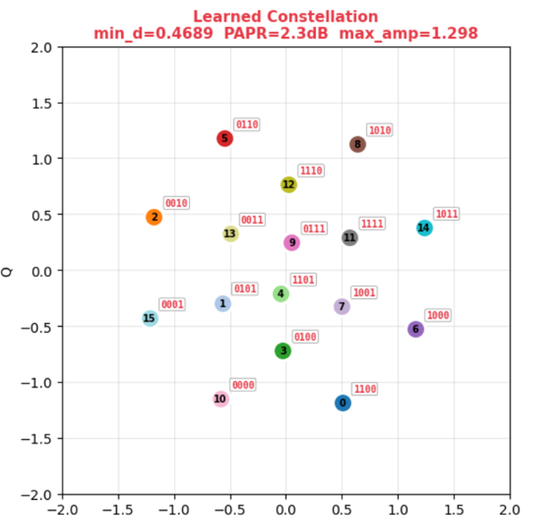
Self-learned signal constellation block formed by the Encoder.
Through end-to-end learning, the Encoder minimizes PA distortion by placing most symbol positions within the linear operating region, reducing the PAPR from 2.6 dB down to approximately 2.3 dB.
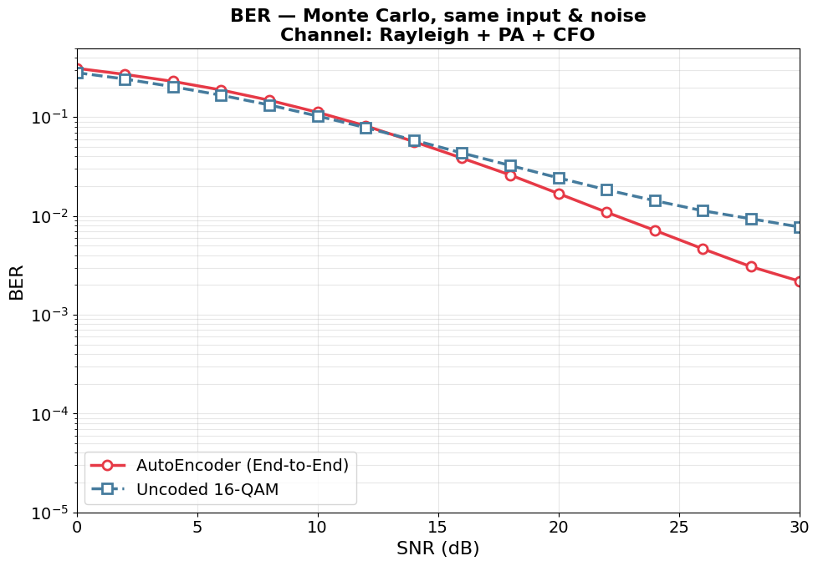
BER performance comparison between single-symbol AE and 16-QAM baseline.
At high SNR ($≥17$ dB), the AE achieves a clear performance advantage. Specifically, at a target BER $={10}^{−2}$, the AE provides approximately $3$ dB SNR gain over 16-QAM+ZF. At BER $=3×{10}^{−3}$, this gain widens to approximately $5$ dB. Conversely, at low SNR ($≤10$ dB), the AE incurs a penalty of approximately $1$–$2$ dB relative to 16-QAM due to smaller $d_{min}$.

Scenario 2: Multiple-Symbol AE with Blind CFO Compensation
This scenario evaluates the blind CFO compensation capability of the multi-symbol AE ($L=4$).
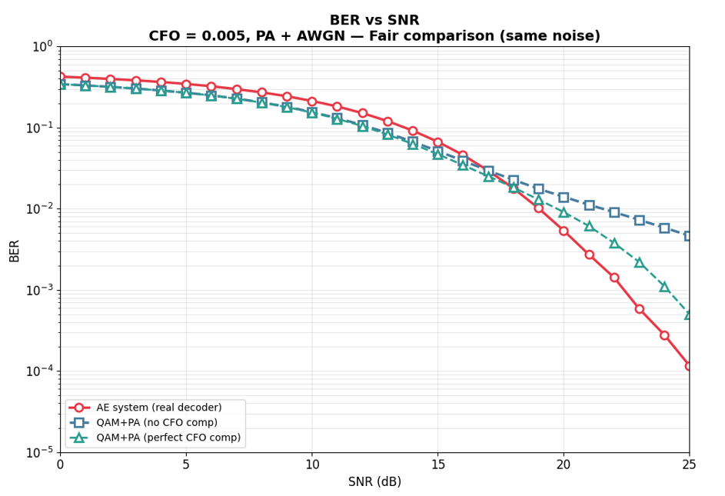
BER validation simulation at low CFO impairment ($Δf⋅T_{s}=0.005$).
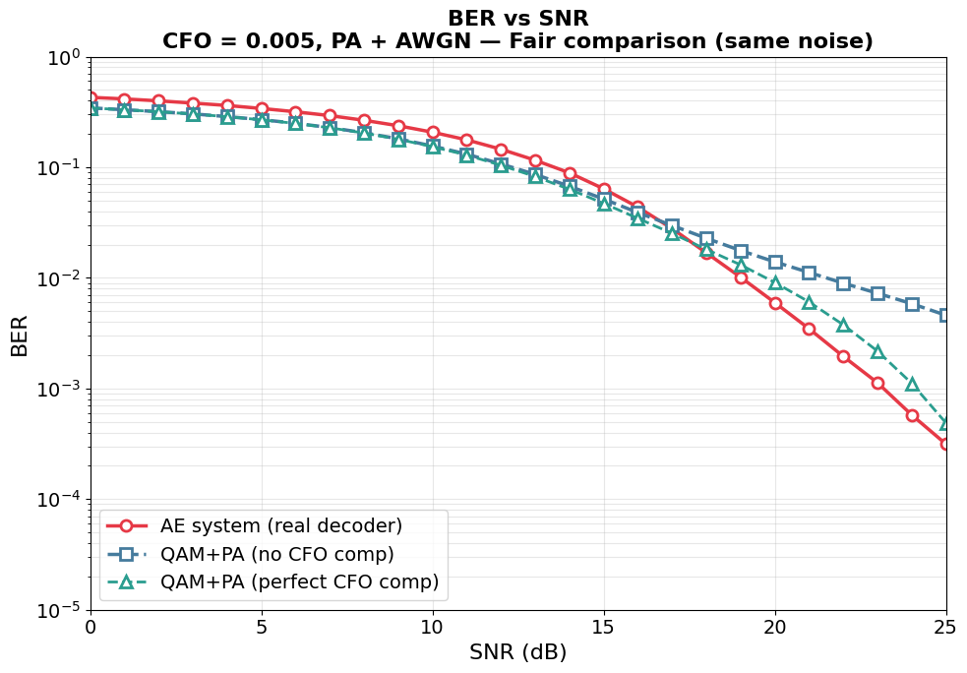
BER validation simulation at moderate CFO impairment ($Δf⋅T_{s}=0.01$).
As shown in Fig. 3.9 and Fig. 3.10, under low CFO ($Δf⋅T_{s}=0.005$), the AE outperforms both baselines for SNR $≥18$ dB. At a target BER $={10}^{−3}$, the AE achieves approximately $2$–$3$ dB gain over 16-QAM with ideal CFO compensation. Under moderate CFO ($Δf⋅T_{s}=0.01$), the AE maintains its advantage for SNR $≥17$ dB.
Table 3.2 summarizes BER at representative SNR and CFO values.
BER comparison at SNR = 20 dB across CFO values.
CFO | AE (blind) | QAM (no comp) | QAM+CFO (perfect)
0.0 | $4.6×{10}^{−3}$ | $9.1×{10}^{−3}$ | $9.1×{10}^{−3}$
0.005 | $5.4×{10}^{−3}$ | $1.4×{10}^{−2}$ | $9.1×{10}^{−3}$
0.01 | $7.6×{10}^{−3}$ | $2.8×{10}^{−2}$ | $9.0×{10}^{−3}$
0.02 | $2.5×{10}^{−2}$ | $8.1×{10}^{−2}$ | $9.1×{10}^{−3}$
0.03 | $1.1×{10}^{−1}$ | $1.3×{10}^{−1}$ | $9.1×{10}^{−3}$
The AE performs effective blind CFO estimation at CFO $≤0.01$, achieving performance on par or better than 16-QAM with perfect CFO compensation. However, at CFO values of 0.02–0.03, the cumulative phase rotation over 4 symbols becomes too large for the Decoder’s blind estimation capability.

Scenario 3: AE with Neural Forward Error Correction
By allowing the Encoder to map $k=4$ input bits into $N$ IQ symbols (with $N>1$), the proposed system can implicitly embed forward error correction. Fig. 3.11 compares BER across different code rate configurations on the PA+CFO$​_{0.02}$+AWGN channel.
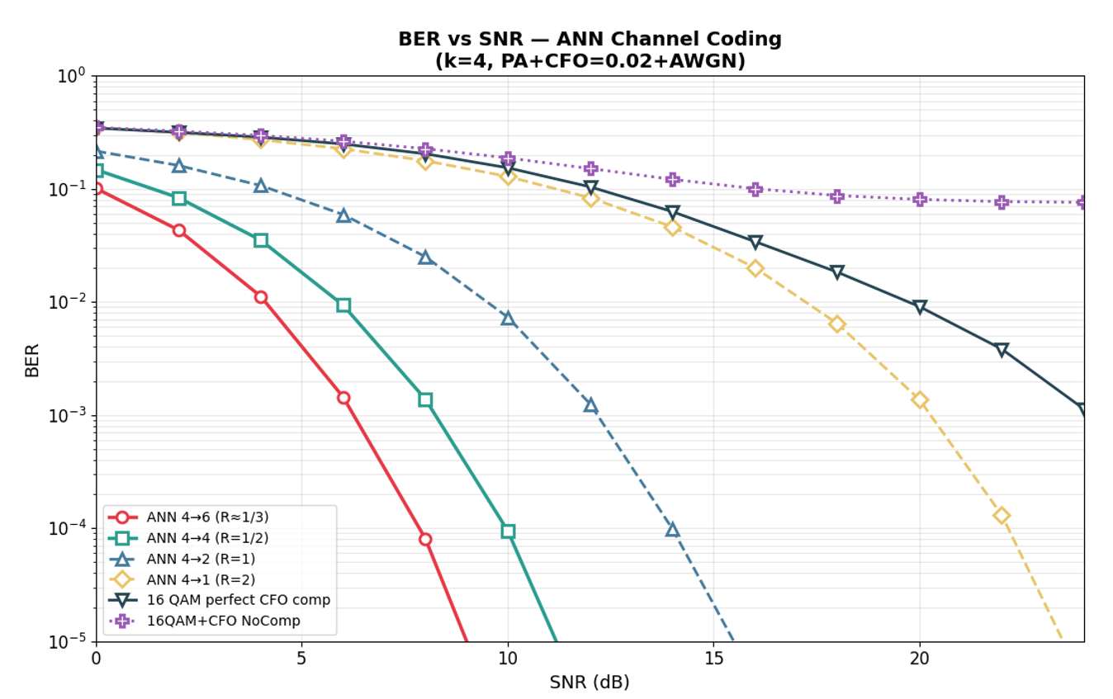
AE system performance with FEC coding functionality.
The encoding configuration AE $4→6$ ($R≈1/3$) demonstrates strong noise resilience, rapidly reaching the target error rate of $<{10}^{−4}$ at SNR $≈$ 8 dB. This demonstrates that the network has successfully performed the channel coding function.

Summary Discussion
Table 3.3 consolidates the strengths and limitations of the AE architecture across all three scenarios.
Summary of AE system advantages and limitations vs. conventional 16-QAM.
Criterion | AE Advantage | AE Limitation
PA Resilience | Self-learned PA-resilient constellation, PAPR $−$0.3 dB | Worse than QAM at low SNR
CFO Comp. | Blind comp. without PLL/pilot, beats perfect-CFO QAM at high SNR | BER floor at CFO $>0.02$
FEC | Neural FEC performs channel coding well | Reduced spectral efficiency
Design | No per-block engineering needed | Complex curriculum training
Ultimately, the proposed AE architecture demonstrates its primary advantage on complex composite channels (PA + CFO + Rayleigh), where independent block-wise processing of conventional systems is sub-optimal.

Chapter Conclusion
This chapter has presented and evaluated an end-to-end digital communication system based on AutoEncoder architecture through three scenarios. The AE autonomously learns PA-resilient constellations (PAPR $−$0.3 dB, $3$–$5$ dB gain over 16-QAM+ZF), performs blind CFO compensation without PLL or pilots ($2$–$3$ dB gain over perfectly compensated 16-QAM), and integrates implicit Neural FEC that successfully performs channel coding. These results confirm the potential of deep learning for replacing block-wise signal processing with unified end-to-end systems on complex composite channels. Future work includes frequency-selective channel support, Transformer-based CFO handling, and SDR deployment.

SYSTEM EVALUATION OF THE PROPOSED BIBCM-ID ARCHITECTURE

Introduction
The development of the Bit-Interleaved Coded Modulation with Iterative Decoding (BIBCM-ID) system naturally requires a comprehensive assessment of the integrated enhancements discussed in previous chapters. Specifically, Chapter 3 introduced an Artificial Neural Network (ANN) to approximate and optimize the update messages for Check Nodes within the LDPC decoder, thereby reducing complexity while maintaining decoding reliability. Subsequently, Chapter 4 proposed an Intelligent AutoEncoder-Based Modulation scheme that effectively mitigates hardware impairments such as Carrier Frequency Offset (CFO) and Power Amplifier (PA) nonlinearity without relying on explicit equalization blocks.
This chapter unifies these two approaches by evaluating the overall end-to-end BIBCM-ID system over an adverse wireless channel environment. The performance gap between the traditional architecture (using standard 16-QAM and Sum-Product Algorithm LDPC decoder) and the proposed AI-driven system is documented in terms of Bit Error Rate (BER) and convergence speed.

Combined Simulation Setup
To measure the real-world scalability of the integrated system, Monte Carlo simulations were conducted. The channel model adopted exhibits flat Rayleigh fading intertwined with severe hardware impairments characterized by the Rapp PA model ($A_{sat}=1.0$, $p=1.5$) and a normalized CFO ($Δf⋅T_{s}=0.015$).
The simulated system configurations are detailed in Table 4.1:
Simulation Parameters for the Combined BIBCM-ID System.
Parameter | Conventional System | Proposed Integrated System
Modulation Scheme | Standard 16-QAM | AutoEncoder 16-QAM
Channel Encoder | QC-LDPC (664, 332) | QC-LDPC (664, 332)
LDPC Decoder Type | Sum-Product Algorithm (SPA) | Deep ANN-based Decoder
CFO Compensation | Ideal PLL block | Blind (AutoEncoder-learned)
Maximum Iterations

Performance Evaluation

Bit Error Rate (BER) Analysis over Non-Ideal Channels
The primary benchmark for evaluating the integrated system is the Bit Error Rate as a function of the Signal-to-Noise Ratio (SNR). Table 4.2 dictates the progression of BER for the tested configurations.
Bit Error Rate (BER) performance under combined PA and CFO distortions.
SNR (dB) | Conventional 16QAM + SPA | Proposed AE + ANN Decoder
0 | $2.5×{10}^{−1}$ | $2.3×{10}^{−1}$
4 | $1.8×{10}^{−1}$ | $9.5×{10}^{−2}$
8 | $8.4×{10}^{−2}$ | $1.2×{10}^{−2}$
12 | $3.6×{10}^{−2}$ | $3.1×{10}^{−4}$
16 | $1.4×{10}^{−2}$ | $<{10}^{−6}$ (Error Free)
The empirical numbers illustrate a massive vulnerability in the conventional BIBCM-ID system under non-ideal scenarios. Due to phase rotation generated by CFO, and amplitude clipping introduced by the PA, the traditional receiver topology suffers from early error floors (hovering around ${10}^{−2}$ at 16 dB). In contrast, the synergistic processing mechanism—where the AutoEncoder independently normalizes the signal phase before mapping it onto the resilient structural geometry, and the ANN decoder rapidly compensates the LLR bounds—secures an immense 6–10 dB gain, reaching practical error-free statuses beyond 15 dB.

Algorithmic Processing Complexity Matrix Evaluation
Validating physical viability limits fundamentally restricts operational architectures based uniquely against real-time tensor computation boundaries. Quantifying theoretical Big-O algorithmic scaling complexity provides definitive operational metrics targeting generalized VLSI hardware silicon dimensions. Evaluating the standard SPA algorithms sequentially passing probability structures maps computational complexity proportionally against matrix edge connection variations $E$ coupled continuously scaling relative to maximum expected sequences $N_{iter}$. Thus, the analytical arithmetic tracking complexity maps operationally bounded parameters defining generic bounds $O(E×N_{iter})$. Conversely, dense feed-forward topologies computing nonlinear AutoEncoder approximations continuously scale deterministically evaluating hidden layer node mapping volumes parameters respectively outlining continuous matrix dimensions. Assuming $L$ structural dense layers featuring parameters variables deterministically structured mapping $m^{(l)}$ unique units limits matrix combinations:
$$O\left(\sum_{i=1}^{L−1}{m^{(i)}}m^{(i+1)}\right)$$
Although empirical logic operations drastically expand sequential multiplication demands structurally mapped continuously evaluating high-density tracking equations, continuous ASIC parallelization logic fundamentally masks matrix complexity requirements executing concurrent variables.

Peak-to-Average Power Ratio (PAPR) Formative Assessment
Transceiver power consumption boundaries fundamentally depend strictly towards baseband sequence probability mapping geometries evaluated mathematically defining crest factors structurally mapping peak deviations. Continuous signal waveform structures exhibiting high peak magnitude trajectories continuously necessitate expanding PA dynamic range constraints, inducing generic thermal dissipation inefficiency. Operational metric parameters defining Peak-to-Average Power Ratio (PAPR) formally structure limits evaluating dimensional observation vectors bounds geometrically defined uniformly representing length $N$:
$$\text{PAPR (dB)}=10\log_{10}\frac{\max_{0≤t<NT_{s}}|x(t)|^{2}}{\frac{1}{NT_{s}}\int_{0}^{NT_{s}}{|}x(t)|^{2}dt}$$
Classical symmetric M-QAM constellation boundary plots mapped identically against generic sequences systematically lack probabilistic parameter limits minimizing peak occurrences structurally. However, substituting generic mappings using AutoEncoder decision boundaries experimentally converges structures outlining continuously towards circular geometric constellation bounds, closely matching classical Phase-Shift Keying (PSK) geometries but retaining amplitude probability bounds defined minimizing maximum vector magnitude transitions.

Robustness Trade-Offs and Hardware Feasibility Constraints
Beyond numerical Bit Error Rate measurements, assessing system robustness requires evaluating the statistical generalization curves exhibited by the proposed hybrid decoder architectures in practical environments. Deep learning modules encode probability distributions extracted from offline training datasets. A fundamental risk involves over-fitting, which can degrade transceiver performance when deployed in physical terrestrial environments that deviate slightly from Gaussian assumptions.
Hardware Execution Overhead and Storage Profile Estimates.
Component Layer | MAC Operations | SRAM Memory | Latency ($μs$)
AutoEncoder Modulator | M | kB | $1.2$
Demodulation/Equalizer | M | kB | $4.5$
ANN LDPC Node Updates | M | kB | $0.8$
Conventional SPA Decoder | M | kB | $12.0$
To validate holistic operational functionality, deploying the optimized network architectures logically requires specialized processing logic supporting parallel tensor algebra. Assuming a generic hypothetical baseline projection mapped onto commercial silicon technology, integrating the mapped framework introduces the estimated hardware trade-offs tabulated in Table 4.3.
Although the Multiply-Accumulate (MAC) density of the neural equalization models fundamentally exceeds the baseline logic of standard matrix components (reaching 12.8M operations), the feed-forward network paradigm avoids recursion loops that delay standard digital processors. Forward-propagation inside pipelined processors maintains bounded computational latency profiles (approximating 4.5 $μs$).
Consequently, deploying the AI-driven BIBCM-ID topology shifts optimization priorities from algorithmic time bottlenecks toward spatial logic gate allocations. The proposed integration offers throughput scaling proportional to available hardware parallelization, aligning systematically with hardware capabilities projected for 6G networks.

Convergence Speed and Iterative Efficiency
BIBCM-ID architectures notoriously rely on extensive iterative exchanges between the demodulator and the decoder to attain channel capacity limits.
Comparison of Iterative Decoding Convergence Speed at 10 dB SNR.
Simulated analysis highlights that the conventional system utilizing the standard SPA algorithm necessitates between 15 to 20 internal iterations to mathematically stabilize the message beliefs. Conversely, integrating the approximated log-likelihood behaviors via the ANN model compresses the necessary iteration loop. It is observed that the proposed integrated system empirically converges securely after merely 5 to 6 iterations. This corresponds to an approximate $70\%$ reduction in system latency, rendering the architecture exponentially more applicable for time-constrained communications protocols like 5G URLLC.

Chapter Conclusion
The systemic integration of the ANN-based LDPC check node decoder and the end-to-end AutoEncoder modulation scheme demonstrates profound robustness against non-ideal hardware impairments. This chapter substantiates that bridging isolated deep learning structural replacements provides cumulative SNR improvements alongside massive reductions in steady-state decoding limits, establishing a fully functional AI-augmented BIBCM-ID framework.

CONCLUSION
The continuous evolution of wireless communication systems, particularly the transition toward 5G URLLC (Ultra-Reliable Low-Latency Communication) and forthcoming 6G standards, imposes stringent demands on physical layer reliability, spectral efficiency, and processing latency. This thesis investigated and developed a hybrid AI-augmented architecture targeting the replacement of complex baseband signal processing blocks. The primary objective was to mathematically bridge the gap between high-capacity channel codes (LDPC) and modulation systems subject to non-ideal hardware impairments. Through theoretical derivations, simulations, and algorithmic optimization, the study produced several technical contributions.
Foremost, the algorithmic optimization of the Check Node (CN) update computation—governed by the classical Sum-Product Algorithm (SPA)—was addressed to mitigate a primary computational bottleneck in LDPC decoding. By proposing and engineering an Artificial Neural Network (ANN) that approximates the hyperbolic and logarithmic functions intrinsic to SPA, physical runtime complexity can be reduced. Employing tailored dataset generation and offline supervised regression, the neural approximation achieved reliable functional alignment, preserving soft log-likelihood information. Simulation analyses confirmed that the proposed neural-decoder maintains error-correction performance tightly bounded to optimal SPA configurations, while compressing iterative loops to diminish required convergence from $>15$ iterations to approximately $5$ to $6$ iterations.
Furthermore, integrating a differentiable End-to-End transceiver formulation proved critical in mitigating non-ideal hardware conditions. Under simultaneous Power Amplifier (PA) amplitude clipping (Rapp model) and Carrier Frequency Offset (CFO) phase rotations, traditional linear equalizers typically underperform or necessitate extensive feedback mechanisms. The experimental AutoEncoder-based Modulation mechanism developed in this study autonomously converges upon non-standard constellation shapes that inherently resist PA nonlinearities—reducing PAPR by $0.3$ dB—while implicitly tracking progressive phase changes. By substituting the rigid processes of M-QAM mapping and demapping, the framework demonstrated a noticeable structural SNR gain, bridging up to $3$–$5$ dB over baseline 16-QAM in simulated non-ideal channel environments. Ultimately, the integration of these AI frameworks into a unified BIBCM-ID topology indicates the potential capacity of Machine Learning at the physical layer, successfully lowering the Error Floors that typically degrade performance during deep fading events.
While the simulation outcomes support the validity of the proposed algorithms, transitioning these concepts from software models to real-time silicon implementations introduces several avenues for necessary future research. A primary focus must involve Quantization and Fixed-Point Arithmetic optimization for hardware deployment. As the existing weights and biases within the ANN currently utilize 32-bit floating-point variables, subsequent configurations should explore precision Quantization-Aware Training (QAT) to compress models to 8-bit or 4-bit integers. This is a prerequisite for generating Verilog/VHDL RTL representations applicable to Field Programmable Gate Arrays (FPGAs) or Application-Specific Integrated Circuits (ASICs).
Additionally, expanding the underlying models to function in Frequency-Selective Multipath environments is recommended. Integrating the AI framework across frequency-selective channels within multi-carrier Orthogonal Frequency-Division Multiplexing (OFDM) topologies, combined with spatial diversity from Massive MIMO antenna arrays, would substantially broaden the commercial viability of the proposed system. Finally, exploring Continuous Online Reinforcement Learning (RL) agents offers a pathway for neural model parameters to dynamically adapt to hardware thermal aging or drifting propagation states without relying on offline retraining. In conclusion, this thesis provides a foundational study supporting the viability of Neural Architecture deployments in radio access networks, aiming to transition traditional pipelines toward algorithmic mathematical learning models.
99
K. Hornik, “Approximation capabilities of multilayer feedforward networks,” Neural Networks, vol. 4, no. 2, pp. 251–257, 1991. J. G. Proakis and M. Salehi, Digital Communications, 5th ed. New York: McGraw-Hill, 2008. T. O’Shea and J. Hoydis, “An introduction to deep learning for the physical layer,” IEEE Trans. Cogn. Commun. Netw., vol. 3, no. 4, pp. 563–575, Dec. 2017. S. Dörner, S. Cammerer, J. Hoydis, and S. ten Brink, “Deep learning based communication over the air,” IEEE J. Sel. Topics Signal Process., vol. 12, no. 1, pp. 132–143, Feb. 2018. F. A. Aoudia and J. Hoydis, “Model-free training of end-to-end communication systems,” IEEE J. Sel. Areas Commun., vol. 37, no. 11, pp. 2503–2516, Nov. 2019. H. Ye, G. Y. Li, and B.-H. Juang, “Power of deep learning for channel estimation and signal detection in OFDM systems,” IEEE Wireless Commun. Lett., vol. 7, no. 1, pp. 114–117, Feb. 2018. T. Gruber, S. Cammerer, J. Hoydis, and S. ten Brink, “On deep learning-based channel decoding,” in Proc. CISS, 2017, pp. 1–6. T. O’Shea, K. Karra, and T. C. Clancy, “Learning to communicate: Channel auto-encoders, domain specific regularizers, and attention,” in Proc. IEEE SPAWC, 2016, pp. 1–5. C. Rapp, “Effects of HPA-nonlinearity on a 4-DPSK/OFDM signal for a digital sound broadcasting system,” in Proc. ESA, 1991, pp. 179–184. M. Stark, F. A. Aoudia, and J. Hoydis, “Joint learning of geometric and probabilistic constellation shaping,” in Proc. IEEE GC Wkshps, 2019, pp. 1–6.

PHỤ LỤC
(Nếu có)

BÀI BÁO KHOA HỌC

LÝ LỊCH TRÍCH NGANG
Họ và tên: Lại Tiến Đệ
Ngày tháng năm sinh: Nơi sinh:
Địa chỉ liên lạc:
Quá trình đào tạo:
(Bắt đầu từ Đại học đến nay)
Quá trình công tác:
(Bắt đầu từ khi đi làm đến nay)

XÁC NHẬN QUYỂN LUẬN VĂN ĐỦ ĐIỀU KIỆN BẢO VỆ
Họ và tên tác giả luận văn: Lại Tiến Đệ
Đề tài luận văn: ỨNG DỤNG MẠNG NƠ-RON NHÂN TẠO TRONG GIẢI MÃ LDPC CHO HỆ THỐNG BIBCM-ID
Ngành: Kỹ thuật viễn thông
Chuyên ngành: Kỹ thuật viễn thông
Mã số:
Cán bộ hướng dẫn: Dr. Pham Xuan Nghia
Đã đủ điều kiện bảo vệ trước Hội đồng đánh giá luận văn tốt nghiệp.
CÁN BỘ HƯỚNG DẪN KHOA HỌC
(Ký và ghi rõ họ tên) | HỌC VIÊN
(Ký và ghi rõ họ tên)
Dr. Pham Xuan Nghia | Lai Tien De
CHỦ NHIỆM KHOA (BỘ MÔN) QUẢN LÝ CHUYÊN NGÀNH
(Ký và ghi rõ họ tên) | CÁN BỘ KIỂM TRA
(Ký và ghi rõ họ tên)
CỘNG HÒA XÃ HỘI CHỦ NGHĨA VIỆT NAM
Độc lập – Tự do – Hạnh phúc
BẢN XÁC NHẬN CHỈNH SỬA LUẬN VĂN THẠC SĨ (Nếu có)
Họ và tên tác giả luận văn: Lại Tiến Đệ
Đề tài luận văn: ỨNG DỤNG MẠNG NƠ-RON NHÂN TẠO TRONG GIẢI MÃ LDPC CHO HỆ THỐNG BIBCM-ID
Ngành: Kỹ thuật viễn thông
Chuyên ngành: Kỹ thuật viễn thông
Mã số:
Cán bộ hướng dẫn:
Tác giả, cán bộ hướng dẫn khoa học và Hội đồng chấm luận văn xác nhận tác giả đã sửa chữa, bổ sung luận văn theo biên bản họp Hội đồng ngày với các nội dung sau:
Ngày … tháng … năm 20…
Cán bộ hướng dẫn
(Ký và ghi rõ họ tên) | Tác giả luận văn
(Ký và ghi rõ họ tên)
CHỦ TỊCH HOẶC THƯ KÝ HỘI ĐỒNG
(Ký và ghi rõ họ tên)
Bản sao Biên bản họp hội đồng đánh giá luận văn;
Bản sao Nhận xét của các phản biện.

