BỘ GIÁO DỤC VÀ ĐÀO TẠO BỘ QUỐC PHÒNG
HỌC VIỆN KỸ THUẬT QUÂN SỰ

LẠI TIẾN ĐỆ

UTILIZATION OF ARTIFICIAL NEURAL NETWORKS IN LDPC DECODING AND MODULATION FOR BIBCM-ID SYSTEMS

LUẬN VĂN THẠC SĨ
Ngành: Kỹ thuật viễn thông
Chuyên ngành: Kỹ thuật viễn thông

Hà Nội - Năm 2026

DECLARATION
I declare that the research results presented in this thesis are synthesized from the thesis manuscript, the organized simulation source code, the available result figures, and the scientific manuscripts included in the thesis workspace. The report is written as a reviewed English master-thesis draft in telecommunications engineering. The work focuses on analysis and evaluation of deep learning for LDPC channel decoding and modulation; it does not claim that the proposed improvements have already been integrated into a complete BIBCM-ID implementation.

MASTER THESIS SUMMARY
Thesis title: UTILIZATION OF ARTIFICIAL NEURAL NETWORKS IN LDPC DECODING AND MODULATION FOR BIBCM-ID SYSTEMS. Author: Lai Tien De. Supervisor: Dr. Pham Xuan Nghia.
This thesis studies the use of artificial neural networks in two components related to bit-interleaved coded modulation with iterative decoding (BIBCM-ID): LDPC channel decoding and modulation. A BIBCM-ID system is introduced through three fundamental blocks: modulation, channel coding, and interleaving. Interleaver design is recognized as a active research direction, but it is not the contribution of this thesis. The thesis focuses on the other two blocks because they contain nonlinear mappings, model mismatch, and complexity-performance trade-offs that are suitable for deep-learning evaluation.
For channel decoding, the thesis analyzes an artificial-neural-network-assisted check-node update for LDPC decoding. The method targets the most expensive nonlinear operation in the Sum-Product Algorithm and studies how a compact multilayer perceptron can approximate or improve check-node messages. For modulation, the thesis analyzes autoencoder-based modulation under non-ideal channels including power-amplifier nonlinearity, carrier-frequency offset, Rayleigh fading, and inter-symbol interference. The report uses available simulation results as evidence for discussion, but avoids claiming an integrated BIBCM-ID improvement because such integration has not yet been completed.

TABLE OF CONTENTS
Chapter 1. Foundations of BIBCM-ID and Research Scope
Chapter 2. ANN-Assisted LDPC Decoding
Chapter 3. Deep Learning for Intelligent Modulation
Conclusion and Recommendations
References
Appendices

LIST OF ABBREVIATIONS
Table 0.1. List of abbreviations.
Abbreviation | Meaning
ANN | Artificial Neural Network
AWGN | Additive White Gaussian Noise
BER | Bit Error Rate
BIBCM-ID | Bit-Interleaved Coded Modulation with Iterative Decoding
CN | Check Node
LDPC | Low-Density Parity-Check
LLR | Log-Likelihood Ratio
MLP | Multilayer Perceptron
SPA | Sum-Product Algorithm
VN | Variable Node

CHAPTER 1. FOUNDATIONS OF BIBCM-ID AND RESEARCH SCOPE

1.1. Motivation
Modern communication systems require high spectral efficiency and high reliability under imperfect hardware and time-varying propagation conditions. Conventional designs often separate modulation, coding, and detection into independent tasks, but this separation is not always sufficient when the receiver operates close to performance limits. Bit-interleaved coded modulation with iterative decoding (BIBCM-ID) is a relevant architecture because it connects modulation and channel coding through soft-information exchange.
A BIBCM-ID receiver does not perform only one demapping and one decoding step. Instead, the demapper produces LLR values, the channel decoder refines these values according to code constraints, and extrinsic information is fed back to the demapper. This exchange can improve reliability across iterations. A related implication is that the system becomes sensitive to the accuracy of every exchanged message. If the demapper or decoder produces unreliable soft information, iterative processing may amplify the error rather than correct it.
The thesis begins from the observation that BIBCM-ID is built on three main components: modulation, channel coding, and interleaving. Modulation defines the signal representation, channel coding defines the redundancy and decoding graph, and interleaving defines how coded bits are distributed before modulation. These three components influence one another, but they have different research maturity and different suitability for deep-learning intervention.

1.2. Modulation, Channel Coding, and Interleaving

1.2.1. Modulation
Modulation maps bits to physical channel symbols. In BIBCM-ID, its role is not limited to spectral efficiency. The modulation format and labeling determine the bit-level reliability available to the demapper. A conventional 16-QAM constellation may be appropriate under AWGN, but the same constellation can become less suitable when the PA is nonlinear or when CFO rotates symbols over time.
Because the modulation block is directly exposed to channel impairment, it is a reasonable target for deep learning. An autoencoder can learn a signal representation adapted to the channel used during training. This does not imply that learned modulation is better than standardized modulation; rather, it provides a way to evaluate whether channel-aware signal design can improve robustness under specified assumptions.
$$u → c = Encoder(u), π(c) = interleaved coded bits, x = μ(π(c))$$ (1.1)
Equation (1.1) summarizes the transmitter-side structure used throughout the thesis. The information vector u is encoded into a coded vector c. The interleaver π rearranges the coded bits, and the modulation mapper μ transforms groups of interleaved bits into transmitted symbols x. This compact expression is useful because it makes clear that modulation, coding, and interleaving are not independent; the reliability of each received bit depends on the complete chain.
$$R_c = k/n, R_b = R_c log_2(M)$$ (1.2)
Equation (1.2) defines the code rate R_c and the coded-modulation spectral efficiency R_b for an M-ary modulation. It shows that modulation order and code rate jointly determine the number of information bits transmitted per channel use.
$$E_s/N_0 = (E_b/N_0) R_c log_2(M)$$ (1.3)
Equation (1.3) links symbol-energy SNR and bit-energy SNR. This relation is required when comparing BER curves across different code rates or modulation orders.

1.2.2. Channel Coding
Channel coding adds redundancy so that the receiver can correct errors. LDPC codes are particularly relevant because they combine sparse graph structure with iterative message-passing decoding. In BIBCM-ID, the channel decoder is a central component because it transforms demapper reliability into corrected bit estimates and returns extrinsic information for further demapping.
The check-node update in SPA is accurate but computationally expensive. Simplified methods such as Min-Sum reduce complexity at the cost of performance. This trade-off motivates a neural approximation of the check-node update. The ANN can be trained to reproduce SPA behavior or to modify unreliable messages, while the LDPC graph structure remains intact.

1.2.3. Interleaving
The interleaver permutes coded bits before modulation. This block reduces correlation, spreads burst errors, and changes the relation between code bits and modulation bit positions. In BIBCM-ID, the interleaver is particularly relevant because extrinsic information should be as independent as possible between demapper and decoder iterations.
Interleaver design has been studied extensively in recent years. Algebraic interleavers, S-random interleavers, protograph-aware interleavers, and hardware-oriented contention-free interleavers have been proposed to improve convergence, reduce adverse low-weight patterns, and support parallel processing. For this reason, the thesis does not claim novelty in interleaver construction. It acknowledges the interleaver as a key component and focuses on modulation and channel coding.

1.3. Research Scope and Contributions
- Analyze the BIBCM-ID system and clarify the roles of modulation, channel coding, and interleaving.
- Use the ANN-LDPC manuscript to develop a detailed thesis-level explanation of neural check-node update approximation.
- Use the autoencoder modulation materials to analyze intelligent modulation under non-ideal channels.
- Discuss results with technical caution, without claiming that the two improvements have already been integrated into one complete BIBCM-ID chain.

1.4. Literature-Oriented Discussion
LDPC codes originate from Gallager's work and later became practical after the rediscovery of sparse-graph decoding and belief propagation. Their adoption in standards such as Wi-Fi, DVB-S2, and 5G reflects their well-established error-correction capability and implementation feasibility. The theoretical foundation of LDPC decoding is therefore mature, which makes it a suitable baseline for evaluating neural modifications.
Neural decoding research has developed in several directions. Weighted belief propagation learns message weights in the decoding graph. Graph neural networks exploit the Tanner graph structure more explicitly. Syndrome-based and model-driven neural decoders attempt to combine code constraints with learned inference. The approach used in this thesis is more localized: it focuses on the check-node update because that operation is both nonlinear and computationally costly.
Deep learning for the physical layer has also produced important work on autoencoder communication systems. These studies show that a transmitter and receiver can be trained end to end over a differentiable or simulated channel. In this thesis, the autoencoder idea is used not as a complete replacement for BIBCM-ID but as an investigation of whether learned modulation can improve robustness under PA nonlinearity, CFO, fading, and ISI.
In the analysis of BIBCM-ID system design and thesis positioning, soft-information quality is treated as a central technical criterion in addition to final hard-decision accuracy. BIBCM-ID, LDPC decoding, and neural demapping all use reliability values that are passed between processing blocks. When these values are well calibrated, iterative processing can improve the decision process. When they are biased or overconfident, later iterations may reinforce an incorrect tendency. For this reason, the learning-based methods in this thesis are discussed at the level of message quality as well as BER.
From an engineering viewpoint, BIBCM-ID system design and thesis positioning is evaluated under implementation constraints. A method that provides a BER improvement while requiring a substantially larger neural network may be less suitable for a practical receiver. Conversely, a compact network that replaces expensive nonlinear functions may be relevant even when the BER gain is moderate. The discussion therefore relates performance to computational cost, memory use, and possible hardware realization.
Robustness to model mismatch is another recurring issue in BIBCM-ID system design and thesis positioning. Communication receivers are usually designed using an assumed channel model, while the actual channel may include nonlinear amplification, oscillator offset, phase noise, fading correlation, quantization, or imperfect synchronization. A neural component is expected to generalize only when its training domain covers the relevant variations. If the training domain is narrow, the model may perform well in simulation but degrade under different operating conditions.
The interpretation of BIBCM-ID system design and thesis positioning is kept compatible with classical communication theory. Deep learning does not remove the need for code constraints, power normalization, likelihood reasoning, or interleaver design. The thesis therefore adopts a hybrid view: established communication structure is retained, while learning is used to approximate nonlinear corrections that are difficult to express in closed form.
For BIBCM-ID system design and thesis positioning, the available simulations are used as evidence for feasibility and trend analysis rather than as a basis for universal claims. Each result depends on code length, modulation format, SNR range, channel parameters, number of transmitted bits, and training configuration. The report therefore avoids interpreting a single curve or scenario as a general proof of superiority.
The component-level viewpoint is useful for BIBCM-ID system design and thesis positioning because it separates the source of performance change. If the decoder is modified while the modulation is fixed, the observed change can be related to message-passing behavior. If the modulation is modified while the decoder is fixed, the observed change can be related to signal representation and demapping. This separation reduces ambiguity in the technical interpretation.
In the context of BIBCM-ID system design and thesis positioning, the proposed use of neural networks is framed as an approximation and adaptation tool. The objective is to evaluate whether a learned local mapping can improve reliability, reduce computational burden, or increase robustness under defined assumptions. This formulation is narrower than claiming an end-to-end replacement of the communication system and is more consistent with the available evidence.
In the analysis of BIBCM-ID system design and thesis positioning, soft-information quality is treated as a central technical criterion in addition to final hard-decision accuracy. BIBCM-ID, LDPC decoding, and neural demapping all use reliability values that are passed between processing blocks. When these values are well calibrated, iterative processing can improve the decision process. When they are biased or overconfident, later iterations may reinforce an incorrect tendency. For this reason, the learning-based methods in this thesis are discussed at the level of message quality as well as BER.
From an engineering viewpoint, BIBCM-ID system design and thesis positioning is evaluated under implementation constraints. A method that provides a BER improvement while requiring a substantially larger neural network may be less suitable for a practical receiver. Conversely, a compact network that replaces expensive nonlinear functions may be relevant even when the BER gain is moderate. The discussion therefore relates performance to computational cost, memory use, and possible hardware realization.
Robustness to model mismatch is another recurring issue in BIBCM-ID system design and thesis positioning. Communication receivers are usually designed using an assumed channel model, while the actual channel may include nonlinear amplification, oscillator offset, phase noise, fading correlation, quantization, or imperfect synchronization. A neural component is expected to generalize only when its training domain covers the relevant variations. If the training domain is narrow, the model may perform well in simulation but degrade under different operating conditions.
The interpretation of BIBCM-ID system design and thesis positioning is kept compatible with classical communication theory. Deep learning does not remove the need for code constraints, power normalization, likelihood reasoning, or interleaver design. The thesis therefore adopts a hybrid view: established communication structure is retained, while learning is used to approximate nonlinear corrections that are difficult to express in closed form.
For BIBCM-ID system design and thesis positioning, the available simulations are used as evidence for feasibility and trend analysis rather than as a basis for universal claims. Each result depends on code length, modulation format, SNR range, channel parameters, number of transmitted bits, and training configuration. The report therefore avoids interpreting a single curve or scenario as a general proof of superiority.
The component-level viewpoint is useful for BIBCM-ID system design and thesis positioning because it separates the source of performance change. If the decoder is modified while the modulation is fixed, the observed change can be related to message-passing behavior. If the modulation is modified while the decoder is fixed, the observed change can be related to signal representation and demapping. This separation reduces ambiguity in the technical interpretation.
In the context of BIBCM-ID system design and thesis positioning, the proposed use of neural networks is framed as an approximation and adaptation tool. The objective is to evaluate whether a learned local mapping can improve reliability, reduce computational burden, or increase robustness under defined assumptions. This formulation is narrower than claiming an end-to-end replacement of the communication system and is more consistent with the available evidence.
In the analysis of BIBCM-ID system design and thesis positioning, soft-information quality is treated as a central technical criterion in addition to final hard-decision accuracy. BIBCM-ID, LDPC decoding, and neural demapping all use reliability values that are passed between processing blocks. When these values are well calibrated, iterative processing can improve the decision process. When they are biased or overconfident, later iterations may reinforce an incorrect tendency. For this reason, the learning-based methods in this thesis are discussed at the level of message quality as well as BER.
From an engineering viewpoint, BIBCM-ID system design and thesis positioning is evaluated under implementation constraints. A method that provides a BER improvement while requiring a substantially larger neural network may be less suitable for a practical receiver. Conversely, a compact network that replaces expensive nonlinear functions may be relevant even when the BER gain is moderate. The discussion therefore relates performance to computational cost, memory use, and possible hardware realization.
Robustness to model mismatch is another recurring issue in BIBCM-ID system design and thesis positioning. Communication receivers are usually designed using an assumed channel model, while the actual channel may include nonlinear amplification, oscillator offset, phase noise, fading correlation, quantization, or imperfect synchronization. A neural component is expected to generalize only when its training domain covers the relevant variations. If the training domain is narrow, the model may perform well in simulation but degrade under different operating conditions.
The interpretation of BIBCM-ID system design and thesis positioning is kept compatible with classical communication theory. Deep learning does not remove the need for code constraints, power normalization, likelihood reasoning, or interleaver design. The thesis therefore adopts a hybrid view: established communication structure is retained, while learning is used to approximate nonlinear corrections that are difficult to express in closed form.
For BIBCM-ID system design and thesis positioning, the available simulations are used as evidence for feasibility and trend analysis rather than as a basis for universal claims. Each result depends on code length, modulation format, SNR range, channel parameters, number of transmitted bits, and training configuration. The report therefore avoids interpreting a single curve or scenario as a general proof of superiority.
The component-level viewpoint is useful for BIBCM-ID system design and thesis positioning because it separates the source of performance change. If the decoder is modified while the modulation is fixed, the observed change can be related to message-passing behavior. If the modulation is modified while the decoder is fixed, the observed change can be related to signal representation and demapping. This separation reduces ambiguity in the technical interpretation.
In the context of BIBCM-ID system design and thesis positioning, the proposed use of neural networks is framed as an approximation and adaptation tool. The objective is to evaluate whether a learned local mapping can improve reliability, reduce computational burden, or increase robustness under defined assumptions. This formulation is narrower than claiming an end-to-end replacement of the communication system and is more consistent with the available evidence.
In the analysis of BIBCM-ID system design and thesis positioning, soft-information quality is treated as a central technical criterion in addition to final hard-decision accuracy. BIBCM-ID, LDPC decoding, and neural demapping all use reliability values that are passed between processing blocks. When these values are well calibrated, iterative processing can improve the decision process. When they are biased or overconfident, later iterations may reinforce an incorrect tendency. For this reason, the learning-based methods in this thesis are discussed at the level of message quality as well as BER.
From an engineering viewpoint, BIBCM-ID system design and thesis positioning is evaluated under implementation constraints. A method that provides a BER improvement while requiring a substantially larger neural network may be less suitable for a practical receiver. Conversely, a compact network that replaces expensive nonlinear functions may be relevant even when the BER gain is moderate. The discussion therefore relates performance to computational cost, memory use, and possible hardware realization.
Robustness to model mismatch is another recurring issue in BIBCM-ID system design and thesis positioning. Communication receivers are usually designed using an assumed channel model, while the actual channel may include nonlinear amplification, oscillator offset, phase noise, fading correlation, quantization, or imperfect synchronization. A neural component is expected to generalize only when its training domain covers the relevant variations. If the training domain is narrow, the model may perform well in simulation but degrade under different operating conditions.
The interpretation of BIBCM-ID system design and thesis positioning is kept compatible with classical communication theory. Deep learning does not remove the need for code constraints, power normalization, likelihood reasoning, or interleaver design. The thesis therefore adopts a hybrid view: established communication structure is retained, while learning is used to approximate nonlinear corrections that are difficult to express in closed form.
For BIBCM-ID system design and thesis positioning, the available simulations are used as evidence for feasibility and trend analysis rather than as a basis for universal claims. Each result depends on code length, modulation format, SNR range, channel parameters, number of transmitted bits, and training configuration. The report therefore avoids interpreting a single curve or scenario as a general proof of superiority.
The component-level viewpoint is useful for BIBCM-ID system design and thesis positioning because it separates the source of performance change. If the decoder is modified while the modulation is fixed, the observed change can be related to message-passing behavior. If the modulation is modified while the decoder is fixed, the observed change can be related to signal representation and demapping. This separation reduces ambiguity in the technical interpretation.
In the context of BIBCM-ID system design and thesis positioning, the proposed use of neural networks is framed as an approximation and adaptation tool. The objective is to evaluate whether a learned local mapping can improve reliability, reduce computational burden, or increase robustness under defined assumptions. This formulation is narrower than claiming an end-to-end replacement of the communication system and is more consistent with the available evidence.
In the analysis of BIBCM-ID system design and thesis positioning, soft-information quality is treated as a central technical criterion in addition to final hard-decision accuracy. BIBCM-ID, LDPC decoding, and neural demapping all use reliability values that are passed between processing blocks. When these values are well calibrated, iterative processing can improve the decision process. When they are biased or overconfident, later iterations may reinforce an incorrect tendency. For this reason, the learning-based methods in this thesis are discussed at the level of message quality as well as BER.
From an engineering viewpoint, BIBCM-ID system design and thesis positioning is evaluated under implementation constraints. A method that provides a BER improvement while requiring a substantially larger neural network may be less suitable for a practical receiver. Conversely, a compact network that replaces expensive nonlinear functions may be relevant even when the BER gain is moderate. The discussion therefore relates performance to computational cost, memory use, and possible hardware realization.
Robustness to model mismatch is another recurring issue in BIBCM-ID system design and thesis positioning. Communication receivers are usually designed using an assumed channel model, while the actual channel may include nonlinear amplification, oscillator offset, phase noise, fading correlation, quantization, or imperfect synchronization. A neural component is expected to generalize only when its training domain covers the relevant variations. If the training domain is narrow, the model may perform well in simulation but degrade under different operating conditions.
The interpretation of BIBCM-ID system design and thesis positioning is kept compatible with classical communication theory. Deep learning does not remove the need for code constraints, power normalization, likelihood reasoning, or interleaver design. The thesis therefore adopts a hybrid view: established communication structure is retained, while learning is used to approximate nonlinear corrections that are difficult to express in closed form.
For BIBCM-ID system design and thesis positioning, the available simulations are used as evidence for feasibility and trend analysis rather than as a basis for universal claims. Each result depends on code length, modulation format, SNR range, channel parameters, number of transmitted bits, and training configuration. The report therefore avoids interpreting a single curve or scenario as a general proof of superiority.
The component-level viewpoint is useful for BIBCM-ID system design and thesis positioning because it separates the source of performance change. If the decoder is modified while the modulation is fixed, the observed change can be related to message-passing behavior. If the modulation is modified while the decoder is fixed, the observed change can be related to signal representation and demapping. This separation reduces ambiguity in the technical interpretation.
In the context of BIBCM-ID system design and thesis positioning, the proposed use of neural networks is framed as an approximation and adaptation tool. The objective is to evaluate whether a learned local mapping can improve reliability, reduce computational burden, or increase robustness under defined assumptions. This formulation is narrower than claiming an end-to-end replacement of the communication system and is more consistent with the available evidence.
In the analysis of BIBCM-ID system design and thesis positioning, soft-information quality is treated as a central technical criterion in addition to final hard-decision accuracy. BIBCM-ID, LDPC decoding, and neural demapping all use reliability values that are passed between processing blocks. When these values are well calibrated, iterative processing can improve the decision process. When they are biased or overconfident, later iterations may reinforce an incorrect tendency. For this reason, the learning-based methods in this thesis are discussed at the level of message quality as well as BER.
From an engineering viewpoint, BIBCM-ID system design and thesis positioning is evaluated under implementation constraints. A method that provides a BER improvement while requiring a substantially larger neural network may be less suitable for a practical receiver. Conversely, a compact network that replaces expensive nonlinear functions may be relevant even when the BER gain is moderate. The discussion therefore relates performance to computational cost, memory use, and possible hardware realization.
Robustness to model mismatch is another recurring issue in BIBCM-ID system design and thesis positioning. Communication receivers are usually designed using an assumed channel model, while the actual channel may include nonlinear amplification, oscillator offset, phase noise, fading correlation, quantization, or imperfect synchronization. A neural component is expected to generalize only when its training domain covers the relevant variations. If the training domain is narrow, the model may perform well in simulation but degrade under different operating conditions.
The interpretation of BIBCM-ID system design and thesis positioning is kept compatible with classical communication theory. Deep learning does not remove the need for code constraints, power normalization, likelihood reasoning, or interleaver design. The thesis therefore adopts a hybrid view: established communication structure is retained, while learning is used to approximate nonlinear corrections that are difficult to express in closed form.
For BIBCM-ID system design and thesis positioning, the available simulations are used as evidence for feasibility and trend analysis rather than as a basis for universal claims. Each result depends on code length, modulation format, SNR range, channel parameters, number of transmitted bits, and training configuration. The report therefore avoids interpreting a single curve or scenario as a general proof of superiority.
The component-level viewpoint is useful for BIBCM-ID system design and thesis positioning because it separates the source of performance change. If the decoder is modified while the modulation is fixed, the observed change can be related to message-passing behavior. If the modulation is modified while the decoder is fixed, the observed change can be related to signal representation and demapping. This separation reduces ambiguity in the technical interpretation.
In the context of BIBCM-ID system design and thesis positioning, the proposed use of neural networks is framed as an approximation and adaptation tool. The objective is to evaluate whether a learned local mapping can improve reliability, reduce computational burden, or increase robustness under defined assumptions. This formulation is narrower than claiming an end-to-end replacement of the communication system and is more consistent with the available evidence.
In the analysis of BIBCM-ID system design and thesis positioning, soft-information quality is treated as a central technical criterion in addition to final hard-decision accuracy. BIBCM-ID, LDPC decoding, and neural demapping all use reliability values that are passed between processing blocks. When these values are well calibrated, iterative processing can improve the decision process. When they are biased or overconfident, later iterations may reinforce an incorrect tendency. For this reason, the learning-based methods in this thesis are discussed at the level of message quality as well as BER.
From an engineering viewpoint, BIBCM-ID system design and thesis positioning is evaluated under implementation constraints. A method that provides a BER improvement while requiring a substantially larger neural network may be less suitable for a practical receiver. Conversely, a compact network that replaces expensive nonlinear functions may be relevant even when the BER gain is moderate. The discussion therefore relates performance to computational cost, memory use, and possible hardware realization.
Robustness to model mismatch is another recurring issue in BIBCM-ID system design and thesis positioning. Communication receivers are usually designed using an assumed channel model, while the actual channel may include nonlinear amplification, oscillator offset, phase noise, fading correlation, quantization, or imperfect synchronization. A neural component is expected to generalize only when its training domain covers the relevant variations. If the training domain is narrow, the model may perform well in simulation but degrade under different operating conditions.
The interpretation of BIBCM-ID system design and thesis positioning is kept compatible with classical communication theory. Deep learning does not remove the need for code constraints, power normalization, likelihood reasoning, or interleaver design. The thesis therefore adopts a hybrid view: established communication structure is retained, while learning is used to approximate nonlinear corrections that are difficult to express in closed form.
For BIBCM-ID system design and thesis positioning, the available simulations are used as evidence for feasibility and trend analysis rather than as a basis for universal claims. Each result depends on code length, modulation format, SNR range, channel parameters, number of transmitted bits, and training configuration. The report therefore avoids interpreting a single curve or scenario as a general proof of superiority.
The component-level viewpoint is useful for BIBCM-ID system design and thesis positioning because it separates the source of performance change. If the decoder is modified while the modulation is fixed, the observed change can be related to message-passing behavior. If the modulation is modified while the decoder is fixed, the observed change can be related to signal representation and demapping. This separation reduces ambiguity in the technical interpretation.
In the context of BIBCM-ID system design and thesis positioning, the proposed use of neural networks is framed as an approximation and adaptation tool. The objective is to evaluate whether a learned local mapping can improve reliability, reduce computational burden, or increase robustness under defined assumptions. This formulation is narrower than claiming an end-to-end replacement of the communication system and is more consistent with the available evidence.
In the analysis of BIBCM-ID system design and thesis positioning, soft-information quality is treated as a central technical criterion in addition to final hard-decision accuracy. BIBCM-ID, LDPC decoding, and neural demapping all use reliability values that are passed between processing blocks. When these values are well calibrated, iterative processing can improve the decision process. When they are biased or overconfident, later iterations may reinforce an incorrect tendency. For this reason, the learning-based methods in this thesis are discussed at the level of message quality as well as BER.
From an engineering viewpoint, BIBCM-ID system design and thesis positioning is evaluated under implementation constraints. A method that provides a BER improvement while requiring a substantially larger neural network may be less suitable for a practical receiver. Conversely, a compact network that replaces expensive nonlinear functions may be relevant even when the BER gain is moderate. The discussion therefore relates performance to computational cost, memory use, and possible hardware realization.
Robustness to model mismatch is another recurring issue in BIBCM-ID system design and thesis positioning. Communication receivers are usually designed using an assumed channel model, while the actual channel may include nonlinear amplification, oscillator offset, phase noise, fading correlation, quantization, or imperfect synchronization. A neural component is expected to generalize only when its training domain covers the relevant variations. If the training domain is narrow, the model may perform well in simulation but degrade under different operating conditions.
The interpretation of BIBCM-ID system design and thesis positioning is kept compatible with classical communication theory. Deep learning does not remove the need for code constraints, power normalization, likelihood reasoning, or interleaver design. The thesis therefore adopts a hybrid view: established communication structure is retained, while learning is used to approximate nonlinear corrections that are difficult to express in closed form.
For BIBCM-ID system design and thesis positioning, the available simulations are used as evidence for feasibility and trend analysis rather than as a basis for universal claims. Each result depends on code length, modulation format, SNR range, channel parameters, number of transmitted bits, and training configuration. The report therefore avoids interpreting a single curve or scenario as a general proof of superiority.
The component-level viewpoint is useful for BIBCM-ID system design and thesis positioning because it separates the source of performance change. If the decoder is modified while the modulation is fixed, the observed change can be related to message-passing behavior. If the modulation is modified while the decoder is fixed, the observed change can be related to signal representation and demapping. This separation reduces ambiguity in the technical interpretation.
In the context of BIBCM-ID system design and thesis positioning, the proposed use of neural networks is framed as an approximation and adaptation tool. The objective is to evaluate whether a learned local mapping can improve reliability, reduce computational burden, or increase robustness under defined assumptions. This formulation is narrower than claiming an end-to-end replacement of the communication system and is more consistent with the available evidence.
In the analysis of BIBCM-ID system design and thesis positioning, soft-information quality is treated as a central technical criterion in addition to final hard-decision accuracy. BIBCM-ID, LDPC decoding, and neural demapping all use reliability values that are passed between processing blocks. When these values are well calibrated, iterative processing can improve the decision process. When they are biased or overconfident, later iterations may reinforce an incorrect tendency. For this reason, the learning-based methods in this thesis are discussed at the level of message quality as well as BER.
From an engineering viewpoint, BIBCM-ID system design and thesis positioning is evaluated under implementation constraints. A method that provides a BER improvement while requiring a substantially larger neural network may be less suitable for a practical receiver. Conversely, a compact network that replaces expensive nonlinear functions may be relevant even when the BER gain is moderate. The discussion therefore relates performance to computational cost, memory use, and possible hardware realization.
Robustness to model mismatch is another recurring issue in BIBCM-ID system design and thesis positioning. Communication receivers are usually designed using an assumed channel model, while the actual channel may include nonlinear amplification, oscillator offset, phase noise, fading correlation, quantization, or imperfect synchronization. A neural component is expected to generalize only when its training domain covers the relevant variations. If the training domain is narrow, the model may perform well in simulation but degrade under different operating conditions.
The interpretation of BIBCM-ID system design and thesis positioning is kept compatible with classical communication theory. Deep learning does not remove the need for code constraints, power normalization, likelihood reasoning, or interleaver design. The thesis therefore adopts a hybrid view: established communication structure is retained, while learning is used to approximate nonlinear corrections that are difficult to express in closed form.
For BIBCM-ID system design and thesis positioning, the available simulations are used as evidence for feasibility and trend analysis rather than as a basis for universal claims. Each result depends on code length, modulation format, SNR range, channel parameters, number of transmitted bits, and training configuration. The report therefore avoids interpreting a single curve or scenario as a general proof of superiority.
The component-level viewpoint is useful for BIBCM-ID system design and thesis positioning because it separates the source of performance change. If the decoder is modified while the modulation is fixed, the observed change can be related to message-passing behavior. If the modulation is modified while the decoder is fixed, the observed change can be related to signal representation and demapping. This separation reduces ambiguity in the technical interpretation.
In the context of BIBCM-ID system design and thesis positioning, the proposed use of neural networks is framed as an approximation and adaptation tool. The objective is to evaluate whether a learned local mapping can improve reliability, reduce computational burden, or increase robustness under defined assumptions. This formulation is narrower than claiming an end-to-end replacement of the communication system and is more consistent with the available evidence.
In the analysis of BIBCM-ID system design and thesis positioning, soft-information quality is treated as a central technical criterion in addition to final hard-decision accuracy. BIBCM-ID, LDPC decoding, and neural demapping all use reliability values that are passed between processing blocks. When these values are well calibrated, iterative processing can improve the decision process. When they are biased or overconfident, later iterations may reinforce an incorrect tendency. For this reason, the learning-based methods in this thesis are discussed at the level of message quality as well as BER.
From an engineering viewpoint, BIBCM-ID system design and thesis positioning is evaluated under implementation constraints. A method that provides a BER improvement while requiring a substantially larger neural network may be less suitable for a practical receiver. Conversely, a compact network that replaces expensive nonlinear functions may be relevant even when the BER gain is moderate. The discussion therefore relates performance to computational cost, memory use, and possible hardware realization.
Robustness to model mismatch is another recurring issue in BIBCM-ID system design and thesis positioning. Communication receivers are usually designed using an assumed channel model, while the actual channel may include nonlinear amplification, oscillator offset, phase noise, fading correlation, quantization, or imperfect synchronization. A neural component is expected to generalize only when its training domain covers the relevant variations. If the training domain is narrow, the model may perform well in simulation but degrade under different operating conditions.
The interpretation of BIBCM-ID system design and thesis positioning is kept compatible with classical communication theory. Deep learning does not remove the need for code constraints, power normalization, likelihood reasoning, or interleaver design. The thesis therefore adopts a hybrid view: established communication structure is retained, while learning is used to approximate nonlinear corrections that are difficult to express in closed form.
For BIBCM-ID system design and thesis positioning, the available simulations are used as evidence for feasibility and trend analysis rather than as a basis for universal claims. Each result depends on code length, modulation format, SNR range, channel parameters, number of transmitted bits, and training configuration. The report therefore avoids interpreting a single curve or scenario as a general proof of superiority.
The component-level viewpoint is useful for BIBCM-ID system design and thesis positioning because it separates the source of performance change. If the decoder is modified while the modulation is fixed, the observed change can be related to message-passing behavior. If the modulation is modified while the decoder is fixed, the observed change can be related to signal representation and demapping. This separation reduces ambiguity in the technical interpretation.
In the context of BIBCM-ID system design and thesis positioning, the proposed use of neural networks is framed as an approximation and adaptation tool. The objective is to evaluate whether a learned local mapping can improve reliability, reduce computational burden, or increase robustness under defined assumptions. This formulation is narrower than claiming an end-to-end replacement of the communication system and is more consistent with the available evidence.
In the analysis of BIBCM-ID system design and thesis positioning, soft-information quality is treated as a central technical criterion in addition to final hard-decision accuracy. BIBCM-ID, LDPC decoding, and neural demapping all use reliability values that are passed between processing blocks. When these values are well calibrated, iterative processing can improve the decision process. When they are biased or overconfident, later iterations may reinforce an incorrect tendency. For this reason, the learning-based methods in this thesis are discussed at the level of message quality as well as BER.
From an engineering viewpoint, BIBCM-ID system design and thesis positioning is evaluated under implementation constraints. A method that provides a BER improvement while requiring a substantially larger neural network may be less suitable for a practical receiver. Conversely, a compact network that replaces expensive nonlinear functions may be relevant even when the BER gain is moderate. The discussion therefore relates performance to computational cost, memory use, and possible hardware realization.
Robustness to model mismatch is another recurring issue in BIBCM-ID system design and thesis positioning. Communication receivers are usually designed using an assumed channel model, while the actual channel may include nonlinear amplification, oscillator offset, phase noise, fading correlation, quantization, or imperfect synchronization. A neural component is expected to generalize only when its training domain covers the relevant variations. If the training domain is narrow, the model may perform well in simulation but degrade under different operating conditions.
The interpretation of BIBCM-ID system design and thesis positioning is kept compatible with classical communication theory. Deep learning does not remove the need for code constraints, power normalization, likelihood reasoning, or interleaver design. The thesis therefore adopts a hybrid view: established communication structure is retained, while learning is used to approximate nonlinear corrections that are difficult to express in closed form.
For BIBCM-ID system design and thesis positioning, the available simulations are used as evidence for feasibility and trend analysis rather than as a basis for universal claims. Each result depends on code length, modulation format, SNR range, channel parameters, number of transmitted bits, and training configuration. The report therefore avoids interpreting a single curve or scenario as a general proof of superiority.
The component-level viewpoint is useful for BIBCM-ID system design and thesis positioning because it separates the source of performance change. If the decoder is modified while the modulation is fixed, the observed change can be related to message-passing behavior. If the modulation is modified while the decoder is fixed, the observed change can be related to signal representation and demapping. This separation reduces ambiguity in the technical interpretation.
In the context of BIBCM-ID system design and thesis positioning, the proposed use of neural networks is framed as an approximation and adaptation tool. The objective is to evaluate whether a learned local mapping can improve reliability, reduce computational burden, or increase robustness under defined assumptions. This formulation is narrower than claiming an end-to-end replacement of the communication system and is more consistent with the available evidence.
In the analysis of BIBCM-ID system design and thesis positioning, soft-information quality is treated as a central technical criterion in addition to final hard-decision accuracy. BIBCM-ID, LDPC decoding, and neural demapping all use reliability values that are passed between processing blocks. When these values are well calibrated, iterative processing can improve the decision process. When they are biased or overconfident, later iterations may reinforce an incorrect tendency. For this reason, the learning-based methods in this thesis are discussed at the level of message quality as well as BER.

1.5. Soft-Information Reliability in BIBCM-ID
A central internal variable of a BIBCM-ID receiver is not the hard bit decision but the reliability attached to each bit. This reliability is usually represented by an LLR. A positive LLR favors one bit value, a negative LLR favors the other, and the magnitude indicates confidence. In an iterative receiver, the magnitude is as important as the sign because it determines how strongly later blocks trust the message.
If the channel model is correct, LLR computation has a clear probabilistic meaning. If the channel model is mismatched, the same formula may produce overconfident or underconfident values. For example, a demapper that ignores PA compression may treat a distorted outer constellation point as if it were produced by Gaussian noise only. The resulting LLR may be biased. When this biased information is passed to the LDPC decoder, the decoder may reinforce an incorrect belief.
This reliability problem motivates both research directions of the thesis. In channel decoding, the ANN check-node update attempts to improve or approximate the reliability message generated inside the LDPC graph. In modulation, the autoencoder attempts to create a signal representation that is easier to detect reliably under non-ideal channels. Both directions are therefore connected by the same underlying question: how can the system produce more useful soft information?
The interleaver also affects soft-information reliability, but in a different way. It does not compute reliability; it changes the dependence pattern between bits. A well-designed interleaver can reduce adverse correlation and distribute unreliable bits more evenly. Nevertheless, because the present thesis does not design a new interleaver, the reliability-improvement effort is directed toward modulation and decoding.
A technically consistent thesis separates message accuracy from final BER. BER is the final measure, but it does not explain why a method works. A neural demapper or neural decoder may reduce BER because it improves reliability calibration, because it regularizes overconfident messages, because it changes the effective decision boundary, or because it overfits to a tested condition. The analysis in this thesis interprets BER together with model structure and channel assumptions.
The distinction between intrinsic and extrinsic information is also important. The demapper starts from received samples and may use a priori information from the decoder. The decoder receives demapper output and returns extrinsic information that should not simply repeat the same evidence. If the same information is counted multiple times, the iterative loop can become overconfident. This issue is closely related to short cycles in LDPC graphs and to interleaver design in BIBCM-ID.
Deep learning can help with reliability when the training objective reflects reliability. If a network is trained only for hard classification, it may output probabilities that are not calibrated. For BIBCM-ID, a soft-output network can be trained or post-processed so that its output magnitude has meaning. This requirement is one reason why the thesis treats autoencoder modulation as a separate study rather than claiming immediate BIBCM-ID integration.
A practical research path is to start with component-level improvements, then connect them through calibrated interfaces. The ANN-LDPC work is already aligned with message-passing because it outputs a CN message. The autoencoder modulation work still needs a soft-output interface compatible with an iterative decoder. Once both interfaces are defined, a future study can evaluate the complete BIBCM-ID chain.
$$L(b_k | y) = log [ P(b_k = 1 | y) / P(b_k = 0 | y) ]$$ (1.4)
Equation (1.4) defines the log-likelihood ratio of bit b_k given the received observation y. The sign of the LLR indicates the more likely bit value, while the magnitude represents confidence. In iterative decoding, this magnitude is required to be interpreted carefully because overconfident wrong information can be more detrimental than weak information.
$$L_E = L_APP − L_A$$ (1.5)
Equation (1.5) expresses the extrinsic-information principle. A receiver block should pass new information to the next block, not simply return the same evidence it received. This principle is one reason interleaving is important in BIBCM-ID: it helps reduce statistical dependence between exchanged messages.
$$L_D^\{(t)\} = D( L_C + Π^\{-1\}(L_M^\{(t)\}) )$$ (1.6)
Equation (1.6) gives a compact view of one decoding iteration. The decoder D receives channel/code reliability and deinterleaved demapper messages at iteration t. Its output then becomes new extrinsic information for the next demapping step.
$$L_M^\{(t+1)\} = M( y, Π(L_D^\{(t)\}) )$$ (1.7)
Equation (1.7) shows the feedback direction from decoder to demapper. The demapper M uses the received observation y and interleaved a priori information to produce updated bit reliabilities.
$$BER = (1/N_b) Σ_\{k=1\}^\{N_b\} 1\{ b̂_k ≠ b_k \}$$ (1.8)
Equation (1.8) defines the BER used throughout the thesis. Although BER is the final performance metric, it is required to be interpreted together with the number of simulated bits and the channel scenario.

1.5. Chapter Summary
This chapter has defined the research boundary. The thesis studies deep learning for modulation and LDPC decoding, while treating interleaving as an essential but not newly designed component. The next chapter focuses on the ANN-assisted LDPC decoding direction.

CHAPTER 2. ANN-ASSISTED LDPC DECODING

2.1. LDPC Decoding and the Check-Node Update
LDPC decoding is usually described on a Tanner graph containing variable nodes and check nodes. Variable nodes represent code bits, while check nodes represent parity constraints. In each iteration, messages are exchanged along graph edges. The VN update combines channel reliability with incoming check-node messages. The CN update combines incoming variable-node messages to produce parity-consistency information.
The Sum-Product Algorithm is the classical probabilistic decoding method. In the LLR domain, the CN update requires nonlinear transformations involving tanh or equivalent logarithmic functions. These operations are accurate but costly in hardware. In a high-throughput decoder, millions of CN updates may be computed per second. Reducing the cost of this operation is therefore a practical engineering problem.
Min-Sum reduces this cost by using the sign product and the minimum magnitude of incoming messages. It captures the dominant behavior of the CN update but ignores the nonlinear correction contained in SPA. Normalized and offset variants add empirical correction factors, but the correction is still fixed. The ANN approach can be viewed as a learnable correction function.
$$H c^T = 0$$ (2.1)
Equation (2.1) is the parity-check condition for an LDPC code. The sparse parity-check matrix H defines the Tanner graph. A valid codeword c should satisfy all parity constraints. Decoding can therefore be interpreted as the process of finding the most likely codeword that satisfies these constraints.
$$L_j = log [ P(y_j | c_j = 1) / P(y_j | c_j = 0) ]$$ (2.2)
Equation (2.2) gives the channel LLR used to initialize the LDPC decoder. For BPSK over AWGN, this LLR is proportional to the received sample and inversely proportional to the noise variance. The exact scaling affects message magnitudes and therefore iterative convergence.
$$q_\{j→i\} = L_j + Σ_\{i'∈C(j)\backslash i\} r_\{i'→j\}$$ (2.3)
Equation (2.3) is the variable-node update in the LLR domain. The message from variable node j to check node i is the channel reliability plus all incoming check-node messages except the one from check node i. This exclusion is necessary to preserve the extrinsic-information principle.
$$r_\{i→j\} = 2 tanh^\{-1\} ∏_\{j'∈V(i)\backslash j\} tanh(q_\{j'→i\}/2)$$ (2.4)
Equation (2.4) is the SPA check-node update. It is accurate but computationally expensive because it contains hyperbolic tangent and inverse hyperbolic tangent operations. This is the main mathematical motivation for replacing or approximating the CN update by a compact ANN.
$$r_\{i→j\}^\{MS\} = ∏ sign(q_\{j'→i\}) · min |q_\{j'→i\}|$$ (2.5)
Equation (2.5) shows the Min-Sum approximation. It keeps the sign product and minimum magnitude behavior of SPA, but discards nonlinear correction terms. This greatly reduces complexity but can degrade decoding performance.
$$r_\{i→j\}^\{NMS\} = α r_\{i→j\}^\{MS\}, 0 < α ≤ 1$$ (2.6)
Equation (2.6) gives the normalized Min-Sum correction. The scalar α reduces overestimated message magnitudes and partially compensates for the approximation error of Min-Sum.
$$r_\{i→j\}^\{OMS\} = sign(r_\{i→j\}^\{MS\}) max(|r_\{i→j\}^\{MS\}| − β, 0)$$ (2.7)
Equation (2.7) gives the offset Min-Sum correction. The offset β subtracts a fixed reliability margin from the Min-Sum magnitude.
$$L_j^\{APP\} = L_j + Σ_\{i∈C(j)\} r_\{i→j\}$$ (2.8)
Equation (2.8) defines the a posteriori LLR used for hard decision after an iteration.
$$ĉ_j = 1 if L_j^\{APP\} ≥ 0, otherwise ĉ_j = 0$$ (2.9)
Equation (2.9) gives the hard decision rule under the LLR sign convention used in this thesis.
$$s = H ĉ^T$$ (2.10)
Equation (2.10) defines the syndrome vector. Decoding is successful when all syndrome components are zero.

2.2. ANN Model from the LDPC Manuscript
The Publication 1 manuscript proposes a multilayer perceptron for calculating CN update messages. The model is deliberately compact. It uses incoming LLR or VN-to-CN messages as input and produces the CN-to-VN update message as output. The reported example contains a dense hidden layer with eight units and one output unit, for a total of 49 trainable parameters.
This compact architecture is relevant. A large neural decoder might improve a simulation curve but would be difficult to justify in hardware. A compact MLP can be evaluated as a local replacement for a nonlinear function. It can be reused across many check nodes with the same degree and can be quantized or pipelined for efficient implementation.
The activation function used in the hidden layer is ReLU. This is simpler than tanh/log and is commonly used because it reduces vanishing-gradient problems during training. In hardware, ReLU is also simple because it is essentially a comparison with zero. The main cost of the MLP is therefore multiply-add operations, not nonlinear transcendental functions.
$$h = ReLU(W_1 q + b_1), r̂ = W_2 h + b_2$$ (2.11)
Equation (2.11) represents the compact MLP used to approximate the CN update. The input vector q contains incoming messages. The output r̂ is the ANN-estimated CN-to-VN message. Because ReLU is simple and the network is small, the method is more hardware-friendly than a large black-box decoder.
$$ReLU(z) = max(z, 0)$$ (2.12)
Equation (2.12) defines the ReLU activation. It is computationally simple and avoids expensive transcendental functions.
$$N_param = d_in d_h + d_h + d_h d_out + d_out$$ (2.13)
Equation (2.13) estimates the number of trainable parameters in a one-hidden-layer MLP. This expression is useful for discussing hardware complexity.
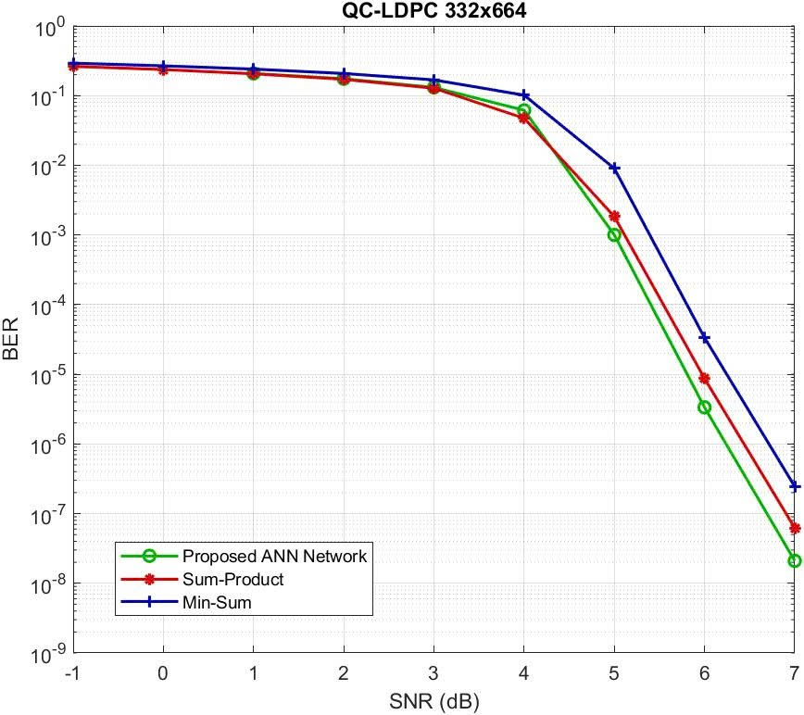
Figure 2.1. MLP structure used for ANN-assisted LDPC check-node update.

2.3. Training Data and Labeling Strategy
The manuscript generates training data offline using BPSK transmission over an AWGN channel and a QC-LDPC code with parameters n = 664, k = 332, and rate r = 0.5. Random frames are encoded, transmitted, and converted into LLR values. These values are used to compute target CN update messages. The network is trained with MAE loss, Adam optimizer, learning rate 10^-3, batch size 128, and 30 epochs.
Two label scenarios are considered. In the first scenario, the ANN learns to approximate the standard SPA update. The purpose is to reproduce the mathematical behavior of SPA without computing its expensive nonlinear functions during inference. This scenario validates whether the MLP has enough capacity to learn the local update rule.
In the second scenario, the labels are modified using reliability information. If the sign of a noisy SPA message disagrees with a reference message, the label magnitude is reduced. This teaches the network not to trust a message that appears unreliable. The idea is closely related to damping and reliability control, but it is learned from data rather than manually tuned.
$$L_MAE = (1/N) Σ_\{n=1\}^\{N\} | r_n − r̂_n |$$ (2.14)
Equation (2.14) is the MAE loss used for training. The target r_n may be the SPA message or the enhanced reliability-aware label. MAE is appropriate because the objective is to approximate message values rather than classify codewords directly.
$$r_label = r_SPA, or r_label = r_SPA / 2 if sign(r_SPA) is unreliable$$ (2.15)
Equation (2.15) summarizes the two label strategies. The first case trains the ANN to imitate SPA. The second case reduces the magnitude of unreliable messages, allowing the ANN to learn a damping-like behavior that may reduce short-cycle error amplification.
$$θ* = arg min_θ E[ | r_label − f_θ(q) | ]$$ (2.16)
Equation (2.16) states the training problem in expectation form. The neural function f_θ is optimized to approximate the selected target update.
$$q^\{(l+1)\} = q^\{(l)\} − η ∇_θ L(θ)$$ (2.17)
Equation (2.17) is the generic gradient-based parameter update. In the implementation, Adam is used instead of plain gradient descent, but the equation explains the learning principle.
$$γ = E_b/N_0$$ (2.18)
Equation (2.18) denotes the SNR variable used when generating AWGN training data across multiple channel conditions.
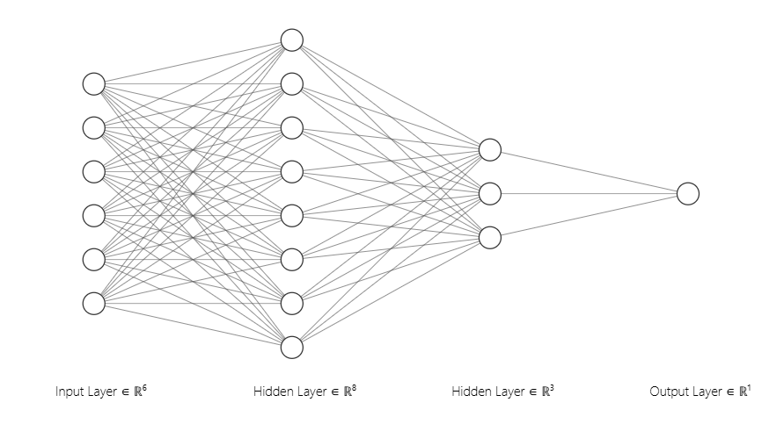
Figure 2.2. Training loss of the ANN check-node update model.

2.4. Interpretation of the Two Scenarios
The SPA-approximation scenario is conservative. It asks the ANN to behave like a known algorithm. If the ANN output is close to SPA and the BER curve is close to SPA, the model has successfully learned the nonlinear update. The value of this scenario lies in complexity reduction and hardware feasibility rather than in creating a new decoding principle.
The enhanced-label scenario is more ambitious. It does not simply imitate SPA. It uses additional knowledge to reduce the magnitude of messages suspected to be wrong. This is relevant because iterative decoding can amplify incorrect information. A wrong message with a large magnitude can be more detrimental than a weak message because it can dominate later VN decisions.
Short cycles in the Tanner graph make this issue more severe. Belief propagation assumes that incoming messages are approximately independent. Short cycles violate this assumption because information can return to a node through a short path. The ANN does not remove the short cycle, but it can learn to reduce overconfident messages that arise from correlated information.

2.5. Performance Discussion
The reported results show that the ANN approximation can achieve BER performance similar to SPA and better than Min-Sum. This is a relevant outcome because it suggests that a compact neural model can preserve the main behavior of the nonlinear CN update. The result also confirms that the network is not merely fitting arbitrary data; it is learning a structured mathematical mapping.
In the enhanced-label scenario, the manuscript reports an improvement of approximately 0.2 to 0.4 dB compared with SPA. This should be interpreted carefully. The gain is obtained under a defined code, channel, modulation, and training procedure. It is not a general conclusion. However, it provides evidence that a learned update rule can sometimes outperform the exact SPA rule when the graph contains adverse message dependencies or when reliability control is beneficial.
The training-loss curve supports the feasibility of the model. The loss decreases quickly in the early epochs and then stabilizes. This behavior indicates that the network learns the main nonlinear relation without excessive instability. The use of multiple SNR values in training is also important because it prevents the model from becoming too specialized to one reliability regime.
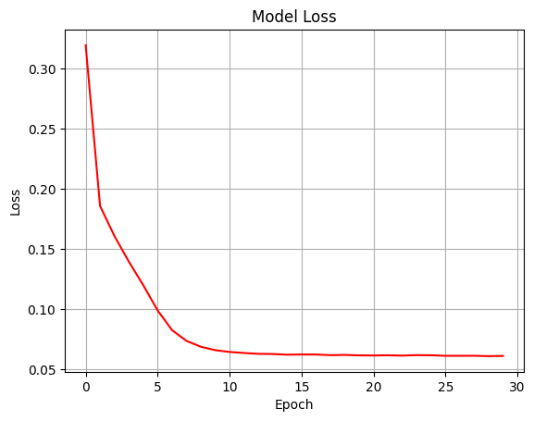
Figure 2.3. BER of ANN approximation compared with reference decoders.
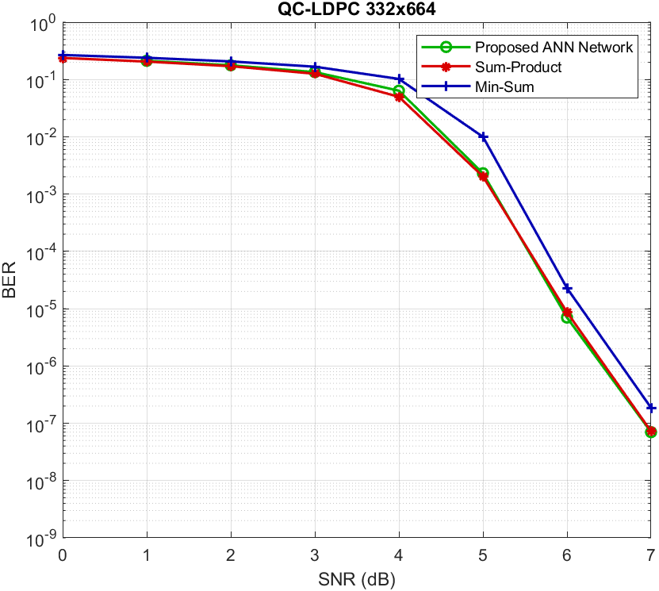
Figure 2.4. BER of enhanced ANN training with reliability-aware labels.

2.6. Complexity and Hardware Viewpoint
The main complexity advantage of the ANN method is the removal of explicit tanh and logarithmic operations. In hardware, these functions require lookup tables, CORDIC iterations, polynomial approximations, or other special units. Multiply-add operations, by contrast, are common and can be heavily parallelized. Therefore, even if the ANN uses more multiplications than Min-Sum, it may still be suitable depending on the hardware platform.
A fair comparison needs to include throughput, memory, quantization, and pipeline depth. If the ANN weights are shared across nodes, memory cost is small. If the network is quantized, multipliers may be simplified. If ReLU is used, activation cost is negligible. These features make the proposed small MLP more realistic than a large neural BP network for practical LDPC decoding.
The main risk is generalization. A network trained for one node degree, one code, or one quantization format may not directly apply to another. Future work can test multiple LDPC matrices and fixed-point formats. Quantization-aware training would also be necessary before hardware implementation.
In the analysis of ANN-assisted LDPC decoding, soft-information quality is treated as a central technical criterion in addition to final hard-decision accuracy. BIBCM-ID, LDPC decoding, and neural demapping all use reliability values that are passed between processing blocks. When these values are well calibrated, iterative processing can improve the decision process. When they are biased or overconfident, later iterations may reinforce an incorrect tendency. For this reason, the learning-based methods in this thesis are discussed at the level of message quality as well as BER.
From an engineering viewpoint, ANN-assisted LDPC decoding is evaluated under implementation constraints. A method that provides a BER improvement while requiring a substantially larger neural network may be less suitable for a practical receiver. Conversely, a compact network that replaces expensive nonlinear functions may be relevant even when the BER gain is moderate. The discussion therefore relates performance to computational cost, memory use, and possible hardware realization.
Robustness to model mismatch is another recurring issue in ANN-assisted LDPC decoding. Communication receivers are usually designed using an assumed channel model, while the actual channel may include nonlinear amplification, oscillator offset, phase noise, fading correlation, quantization, or imperfect synchronization. A neural component is expected to generalize only when its training domain covers the relevant variations. If the training domain is narrow, the model may perform well in simulation but degrade under different operating conditions.
The interpretation of ANN-assisted LDPC decoding is kept compatible with classical communication theory. Deep learning does not remove the need for code constraints, power normalization, likelihood reasoning, or interleaver design. The thesis therefore adopts a hybrid view: established communication structure is retained, while learning is used to approximate nonlinear corrections that are difficult to express in closed form.
For ANN-assisted LDPC decoding, the available simulations are used as evidence for feasibility and trend analysis rather than as a basis for universal claims. Each result depends on code length, modulation format, SNR range, channel parameters, number of transmitted bits, and training configuration. The report therefore avoids interpreting a single curve or scenario as a general proof of superiority.
The component-level viewpoint is useful for ANN-assisted LDPC decoding because it separates the source of performance change. If the decoder is modified while the modulation is fixed, the observed change can be related to message-passing behavior. If the modulation is modified while the decoder is fixed, the observed change can be related to signal representation and demapping. This separation reduces ambiguity in the technical interpretation.
In the context of ANN-assisted LDPC decoding, the proposed use of neural networks is framed as an approximation and adaptation tool. The objective is to evaluate whether a learned local mapping can improve reliability, reduce computational burden, or increase robustness under defined assumptions. This formulation is narrower than claiming an end-to-end replacement of the communication system and is more consistent with the available evidence.
In the analysis of ANN-assisted LDPC decoding, soft-information quality is treated as a central technical criterion in addition to final hard-decision accuracy. BIBCM-ID, LDPC decoding, and neural demapping all use reliability values that are passed between processing blocks. When these values are well calibrated, iterative processing can improve the decision process. When they are biased or overconfident, later iterations may reinforce an incorrect tendency. For this reason, the learning-based methods in this thesis are discussed at the level of message quality as well as BER.
From an engineering viewpoint, ANN-assisted LDPC decoding is evaluated under implementation constraints. A method that provides a BER improvement while requiring a substantially larger neural network may be less suitable for a practical receiver. Conversely, a compact network that replaces expensive nonlinear functions may be relevant even when the BER gain is moderate. The discussion therefore relates performance to computational cost, memory use, and possible hardware realization.
Robustness to model mismatch is another recurring issue in ANN-assisted LDPC decoding. Communication receivers are usually designed using an assumed channel model, while the actual channel may include nonlinear amplification, oscillator offset, phase noise, fading correlation, quantization, or imperfect synchronization. A neural component is expected to generalize only when its training domain covers the relevant variations. If the training domain is narrow, the model may perform well in simulation but degrade under different operating conditions.
The interpretation of ANN-assisted LDPC decoding is kept compatible with classical communication theory. Deep learning does not remove the need for code constraints, power normalization, likelihood reasoning, or interleaver design. The thesis therefore adopts a hybrid view: established communication structure is retained, while learning is used to approximate nonlinear corrections that are difficult to express in closed form.
For ANN-assisted LDPC decoding, the available simulations are used as evidence for feasibility and trend analysis rather than as a basis for universal claims. Each result depends on code length, modulation format, SNR range, channel parameters, number of transmitted bits, and training configuration. The report therefore avoids interpreting a single curve or scenario as a general proof of superiority.
The component-level viewpoint is useful for ANN-assisted LDPC decoding because it separates the source of performance change. If the decoder is modified while the modulation is fixed, the observed change can be related to message-passing behavior. If the modulation is modified while the decoder is fixed, the observed change can be related to signal representation and demapping. This separation reduces ambiguity in the technical interpretation.
In the context of ANN-assisted LDPC decoding, the proposed use of neural networks is framed as an approximation and adaptation tool. The objective is to evaluate whether a learned local mapping can improve reliability, reduce computational burden, or increase robustness under defined assumptions. This formulation is narrower than claiming an end-to-end replacement of the communication system and is more consistent with the available evidence.
In the analysis of ANN-assisted LDPC decoding, soft-information quality is treated as a central technical criterion in addition to final hard-decision accuracy. BIBCM-ID, LDPC decoding, and neural demapping all use reliability values that are passed between processing blocks. When these values are well calibrated, iterative processing can improve the decision process. When they are biased or overconfident, later iterations may reinforce an incorrect tendency. For this reason, the learning-based methods in this thesis are discussed at the level of message quality as well as BER.
From an engineering viewpoint, ANN-assisted LDPC decoding is evaluated under implementation constraints. A method that provides a BER improvement while requiring a substantially larger neural network may be less suitable for a practical receiver. Conversely, a compact network that replaces expensive nonlinear functions may be relevant even when the BER gain is moderate. The discussion therefore relates performance to computational cost, memory use, and possible hardware realization.
Robustness to model mismatch is another recurring issue in ANN-assisted LDPC decoding. Communication receivers are usually designed using an assumed channel model, while the actual channel may include nonlinear amplification, oscillator offset, phase noise, fading correlation, quantization, or imperfect synchronization. A neural component is expected to generalize only when its training domain covers the relevant variations. If the training domain is narrow, the model may perform well in simulation but degrade under different operating conditions.
The interpretation of ANN-assisted LDPC decoding is kept compatible with classical communication theory. Deep learning does not remove the need for code constraints, power normalization, likelihood reasoning, or interleaver design. The thesis therefore adopts a hybrid view: established communication structure is retained, while learning is used to approximate nonlinear corrections that are difficult to express in closed form.
For ANN-assisted LDPC decoding, the available simulations are used as evidence for feasibility and trend analysis rather than as a basis for universal claims. Each result depends on code length, modulation format, SNR range, channel parameters, number of transmitted bits, and training configuration. The report therefore avoids interpreting a single curve or scenario as a general proof of superiority.
The component-level viewpoint is useful for ANN-assisted LDPC decoding because it separates the source of performance change. If the decoder is modified while the modulation is fixed, the observed change can be related to message-passing behavior. If the modulation is modified while the decoder is fixed, the observed change can be related to signal representation and demapping. This separation reduces ambiguity in the technical interpretation.
In the context of ANN-assisted LDPC decoding, the proposed use of neural networks is framed as an approximation and adaptation tool. The objective is to evaluate whether a learned local mapping can improve reliability, reduce computational burden, or increase robustness under defined assumptions. This formulation is narrower than claiming an end-to-end replacement of the communication system and is more consistent with the available evidence.
In the analysis of ANN-assisted LDPC decoding, soft-information quality is treated as a central technical criterion in addition to final hard-decision accuracy. BIBCM-ID, LDPC decoding, and neural demapping all use reliability values that are passed between processing blocks. When these values are well calibrated, iterative processing can improve the decision process. When they are biased or overconfident, later iterations may reinforce an incorrect tendency. For this reason, the learning-based methods in this thesis are discussed at the level of message quality as well as BER.
From an engineering viewpoint, ANN-assisted LDPC decoding is evaluated under implementation constraints. A method that provides a BER improvement while requiring a substantially larger neural network may be less suitable for a practical receiver. Conversely, a compact network that replaces expensive nonlinear functions may be relevant even when the BER gain is moderate. The discussion therefore relates performance to computational cost, memory use, and possible hardware realization.
Robustness to model mismatch is another recurring issue in ANN-assisted LDPC decoding. Communication receivers are usually designed using an assumed channel model, while the actual channel may include nonlinear amplification, oscillator offset, phase noise, fading correlation, quantization, or imperfect synchronization. A neural component is expected to generalize only when its training domain covers the relevant variations. If the training domain is narrow, the model may perform well in simulation but degrade under different operating conditions.
The interpretation of ANN-assisted LDPC decoding is kept compatible with classical communication theory. Deep learning does not remove the need for code constraints, power normalization, likelihood reasoning, or interleaver design. The thesis therefore adopts a hybrid view: established communication structure is retained, while learning is used to approximate nonlinear corrections that are difficult to express in closed form.
For ANN-assisted LDPC decoding, the available simulations are used as evidence for feasibility and trend analysis rather than as a basis for universal claims. Each result depends on code length, modulation format, SNR range, channel parameters, number of transmitted bits, and training configuration. The report therefore avoids interpreting a single curve or scenario as a general proof of superiority.
The component-level viewpoint is useful for ANN-assisted LDPC decoding because it separates the source of performance change. If the decoder is modified while the modulation is fixed, the observed change can be related to message-passing behavior. If the modulation is modified while the decoder is fixed, the observed change can be related to signal representation and demapping. This separation reduces ambiguity in the technical interpretation.
In the context of ANN-assisted LDPC decoding, the proposed use of neural networks is framed as an approximation and adaptation tool. The objective is to evaluate whether a learned local mapping can improve reliability, reduce computational burden, or increase robustness under defined assumptions. This formulation is narrower than claiming an end-to-end replacement of the communication system and is more consistent with the available evidence.
In the analysis of ANN-assisted LDPC decoding, soft-information quality is treated as a central technical criterion in addition to final hard-decision accuracy. BIBCM-ID, LDPC decoding, and neural demapping all use reliability values that are passed between processing blocks. When these values are well calibrated, iterative processing can improve the decision process. When they are biased or overconfident, later iterations may reinforce an incorrect tendency. For this reason, the learning-based methods in this thesis are discussed at the level of message quality as well as BER.
From an engineering viewpoint, ANN-assisted LDPC decoding is evaluated under implementation constraints. A method that provides a BER improvement while requiring a substantially larger neural network may be less suitable for a practical receiver. Conversely, a compact network that replaces expensive nonlinear functions may be relevant even when the BER gain is moderate. The discussion therefore relates performance to computational cost, memory use, and possible hardware realization.
Robustness to model mismatch is another recurring issue in ANN-assisted LDPC decoding. Communication receivers are usually designed using an assumed channel model, while the actual channel may include nonlinear amplification, oscillator offset, phase noise, fading correlation, quantization, or imperfect synchronization. A neural component is expected to generalize only when its training domain covers the relevant variations. If the training domain is narrow, the model may perform well in simulation but degrade under different operating conditions.
The interpretation of ANN-assisted LDPC decoding is kept compatible with classical communication theory. Deep learning does not remove the need for code constraints, power normalization, likelihood reasoning, or interleaver design. The thesis therefore adopts a hybrid view: established communication structure is retained, while learning is used to approximate nonlinear corrections that are difficult to express in closed form.
For ANN-assisted LDPC decoding, the available simulations are used as evidence for feasibility and trend analysis rather than as a basis for universal claims. Each result depends on code length, modulation format, SNR range, channel parameters, number of transmitted bits, and training configuration. The report therefore avoids interpreting a single curve or scenario as a general proof of superiority.
The component-level viewpoint is useful for ANN-assisted LDPC decoding because it separates the source of performance change. If the decoder is modified while the modulation is fixed, the observed change can be related to message-passing behavior. If the modulation is modified while the decoder is fixed, the observed change can be related to signal representation and demapping. This separation reduces ambiguity in the technical interpretation.
In the context of ANN-assisted LDPC decoding, the proposed use of neural networks is framed as an approximation and adaptation tool. The objective is to evaluate whether a learned local mapping can improve reliability, reduce computational burden, or increase robustness under defined assumptions. This formulation is narrower than claiming an end-to-end replacement of the communication system and is more consistent with the available evidence.
In the analysis of ANN-assisted LDPC decoding, soft-information quality is treated as a central technical criterion in addition to final hard-decision accuracy. BIBCM-ID, LDPC decoding, and neural demapping all use reliability values that are passed between processing blocks. When these values are well calibrated, iterative processing can improve the decision process. When they are biased or overconfident, later iterations may reinforce an incorrect tendency. For this reason, the learning-based methods in this thesis are discussed at the level of message quality as well as BER.
From an engineering viewpoint, ANN-assisted LDPC decoding is evaluated under implementation constraints. A method that provides a BER improvement while requiring a substantially larger neural network may be less suitable for a practical receiver. Conversely, a compact network that replaces expensive nonlinear functions may be relevant even when the BER gain is moderate. The discussion therefore relates performance to computational cost, memory use, and possible hardware realization.
Robustness to model mismatch is another recurring issue in ANN-assisted LDPC decoding. Communication receivers are usually designed using an assumed channel model, while the actual channel may include nonlinear amplification, oscillator offset, phase noise, fading correlation, quantization, or imperfect synchronization. A neural component is expected to generalize only when its training domain covers the relevant variations. If the training domain is narrow, the model may perform well in simulation but degrade under different operating conditions.
The interpretation of ANN-assisted LDPC decoding is kept compatible with classical communication theory. Deep learning does not remove the need for code constraints, power normalization, likelihood reasoning, or interleaver design. The thesis therefore adopts a hybrid view: established communication structure is retained, while learning is used to approximate nonlinear corrections that are difficult to express in closed form.
For ANN-assisted LDPC decoding, the available simulations are used as evidence for feasibility and trend analysis rather than as a basis for universal claims. Each result depends on code length, modulation format, SNR range, channel parameters, number of transmitted bits, and training configuration. The report therefore avoids interpreting a single curve or scenario as a general proof of superiority.
The component-level viewpoint is useful for ANN-assisted LDPC decoding because it separates the source of performance change. If the decoder is modified while the modulation is fixed, the observed change can be related to message-passing behavior. If the modulation is modified while the decoder is fixed, the observed change can be related to signal representation and demapping. This separation reduces ambiguity in the technical interpretation.
In the context of ANN-assisted LDPC decoding, the proposed use of neural networks is framed as an approximation and adaptation tool. The objective is to evaluate whether a learned local mapping can improve reliability, reduce computational burden, or increase robustness under defined assumptions. This formulation is narrower than claiming an end-to-end replacement of the communication system and is more consistent with the available evidence.
In the analysis of ANN-assisted LDPC decoding, soft-information quality is treated as a central technical criterion in addition to final hard-decision accuracy. BIBCM-ID, LDPC decoding, and neural demapping all use reliability values that are passed between processing blocks. When these values are well calibrated, iterative processing can improve the decision process. When they are biased or overconfident, later iterations may reinforce an incorrect tendency. For this reason, the learning-based methods in this thesis are discussed at the level of message quality as well as BER.
From an engineering viewpoint, ANN-assisted LDPC decoding is evaluated under implementation constraints. A method that provides a BER improvement while requiring a substantially larger neural network may be less suitable for a practical receiver. Conversely, a compact network that replaces expensive nonlinear functions may be relevant even when the BER gain is moderate. The discussion therefore relates performance to computational cost, memory use, and possible hardware realization.
Robustness to model mismatch is another recurring issue in ANN-assisted LDPC decoding. Communication receivers are usually designed using an assumed channel model, while the actual channel may include nonlinear amplification, oscillator offset, phase noise, fading correlation, quantization, or imperfect synchronization. A neural component is expected to generalize only when its training domain covers the relevant variations. If the training domain is narrow, the model may perform well in simulation but degrade under different operating conditions.
The interpretation of ANN-assisted LDPC decoding is kept compatible with classical communication theory. Deep learning does not remove the need for code constraints, power normalization, likelihood reasoning, or interleaver design. The thesis therefore adopts a hybrid view: established communication structure is retained, while learning is used to approximate nonlinear corrections that are difficult to express in closed form.
For ANN-assisted LDPC decoding, the available simulations are used as evidence for feasibility and trend analysis rather than as a basis for universal claims. Each result depends on code length, modulation format, SNR range, channel parameters, number of transmitted bits, and training configuration. The report therefore avoids interpreting a single curve or scenario as a general proof of superiority.
The component-level viewpoint is useful for ANN-assisted LDPC decoding because it separates the source of performance change. If the decoder is modified while the modulation is fixed, the observed change can be related to message-passing behavior. If the modulation is modified while the decoder is fixed, the observed change can be related to signal representation and demapping. This separation reduces ambiguity in the technical interpretation.
In the context of ANN-assisted LDPC decoding, the proposed use of neural networks is framed as an approximation and adaptation tool. The objective is to evaluate whether a learned local mapping can improve reliability, reduce computational burden, or increase robustness under defined assumptions. This formulation is narrower than claiming an end-to-end replacement of the communication system and is more consistent with the available evidence.
In the analysis of ANN-assisted LDPC decoding, soft-information quality is treated as a central technical criterion in addition to final hard-decision accuracy. BIBCM-ID, LDPC decoding, and neural demapping all use reliability values that are passed between processing blocks. When these values are well calibrated, iterative processing can improve the decision process. When they are biased or overconfident, later iterations may reinforce an incorrect tendency. For this reason, the learning-based methods in this thesis are discussed at the level of message quality as well as BER.
From an engineering viewpoint, ANN-assisted LDPC decoding is evaluated under implementation constraints. A method that provides a BER improvement while requiring a substantially larger neural network may be less suitable for a practical receiver. Conversely, a compact network that replaces expensive nonlinear functions may be relevant even when the BER gain is moderate. The discussion therefore relates performance to computational cost, memory use, and possible hardware realization.
Robustness to model mismatch is another recurring issue in ANN-assisted LDPC decoding. Communication receivers are usually designed using an assumed channel model, while the actual channel may include nonlinear amplification, oscillator offset, phase noise, fading correlation, quantization, or imperfect synchronization. A neural component is expected to generalize only when its training domain covers the relevant variations. If the training domain is narrow, the model may perform well in simulation but degrade under different operating conditions.
The interpretation of ANN-assisted LDPC decoding is kept compatible with classical communication theory. Deep learning does not remove the need for code constraints, power normalization, likelihood reasoning, or interleaver design. The thesis therefore adopts a hybrid view: established communication structure is retained, while learning is used to approximate nonlinear corrections that are difficult to express in closed form.
For ANN-assisted LDPC decoding, the available simulations are used as evidence for feasibility and trend analysis rather than as a basis for universal claims. Each result depends on code length, modulation format, SNR range, channel parameters, number of transmitted bits, and training configuration. The report therefore avoids interpreting a single curve or scenario as a general proof of superiority.
The component-level viewpoint is useful for ANN-assisted LDPC decoding because it separates the source of performance change. If the decoder is modified while the modulation is fixed, the observed change can be related to message-passing behavior. If the modulation is modified while the decoder is fixed, the observed change can be related to signal representation and demapping. This separation reduces ambiguity in the technical interpretation.
In the context of ANN-assisted LDPC decoding, the proposed use of neural networks is framed as an approximation and adaptation tool. The objective is to evaluate whether a learned local mapping can improve reliability, reduce computational burden, or increase robustness under defined assumptions. This formulation is narrower than claiming an end-to-end replacement of the communication system and is more consistent with the available evidence.
In the analysis of ANN-assisted LDPC decoding, soft-information quality is treated as a central technical criterion in addition to final hard-decision accuracy. BIBCM-ID, LDPC decoding, and neural demapping all use reliability values that are passed between processing blocks. When these values are well calibrated, iterative processing can improve the decision process. When they are biased or overconfident, later iterations may reinforce an incorrect tendency. For this reason, the learning-based methods in this thesis are discussed at the level of message quality as well as BER.
From an engineering viewpoint, ANN-assisted LDPC decoding is evaluated under implementation constraints. A method that provides a BER improvement while requiring a substantially larger neural network may be less suitable for a practical receiver. Conversely, a compact network that replaces expensive nonlinear functions may be relevant even when the BER gain is moderate. The discussion therefore relates performance to computational cost, memory use, and possible hardware realization.
Robustness to model mismatch is another recurring issue in ANN-assisted LDPC decoding. Communication receivers are usually designed using an assumed channel model, while the actual channel may include nonlinear amplification, oscillator offset, phase noise, fading correlation, quantization, or imperfect synchronization. A neural component is expected to generalize only when its training domain covers the relevant variations. If the training domain is narrow, the model may perform well in simulation but degrade under different operating conditions.
The interpretation of ANN-assisted LDPC decoding is kept compatible with classical communication theory. Deep learning does not remove the need for code constraints, power normalization, likelihood reasoning, or interleaver design. The thesis therefore adopts a hybrid view: established communication structure is retained, while learning is used to approximate nonlinear corrections that are difficult to express in closed form.
For ANN-assisted LDPC decoding, the available simulations are used as evidence for feasibility and trend analysis rather than as a basis for universal claims. Each result depends on code length, modulation format, SNR range, channel parameters, number of transmitted bits, and training configuration. The report therefore avoids interpreting a single curve or scenario as a general proof of superiority.
The component-level viewpoint is useful for ANN-assisted LDPC decoding because it separates the source of performance change. If the decoder is modified while the modulation is fixed, the observed change can be related to message-passing behavior. If the modulation is modified while the decoder is fixed, the observed change can be related to signal representation and demapping. This separation reduces ambiguity in the technical interpretation.
In the context of ANN-assisted LDPC decoding, the proposed use of neural networks is framed as an approximation and adaptation tool. The objective is to evaluate whether a learned local mapping can improve reliability, reduce computational burden, or increase robustness under defined assumptions. This formulation is narrower than claiming an end-to-end replacement of the communication system and is more consistent with the available evidence.
In the analysis of ANN-assisted LDPC decoding, soft-information quality is treated as a central technical criterion in addition to final hard-decision accuracy. BIBCM-ID, LDPC decoding, and neural demapping all use reliability values that are passed between processing blocks. When these values are well calibrated, iterative processing can improve the decision process. When they are biased or overconfident, later iterations may reinforce an incorrect tendency. For this reason, the learning-based methods in this thesis are discussed at the level of message quality as well as BER.
From an engineering viewpoint, ANN-assisted LDPC decoding is evaluated under implementation constraints. A method that provides a BER improvement while requiring a substantially larger neural network may be less suitable for a practical receiver. Conversely, a compact network that replaces expensive nonlinear functions may be relevant even when the BER gain is moderate. The discussion therefore relates performance to computational cost, memory use, and possible hardware realization.
Robustness to model mismatch is another recurring issue in ANN-assisted LDPC decoding. Communication receivers are usually designed using an assumed channel model, while the actual channel may include nonlinear amplification, oscillator offset, phase noise, fading correlation, quantization, or imperfect synchronization. A neural component is expected to generalize only when its training domain covers the relevant variations. If the training domain is narrow, the model may perform well in simulation but degrade under different operating conditions.
The interpretation of ANN-assisted LDPC decoding is kept compatible with classical communication theory. Deep learning does not remove the need for code constraints, power normalization, likelihood reasoning, or interleaver design. The thesis therefore adopts a hybrid view: established communication structure is retained, while learning is used to approximate nonlinear corrections that are difficult to express in closed form.
For ANN-assisted LDPC decoding, the available simulations are used as evidence for feasibility and trend analysis rather than as a basis for universal claims. Each result depends on code length, modulation format, SNR range, channel parameters, number of transmitted bits, and training configuration. The report therefore avoids interpreting a single curve or scenario as a general proof of superiority.
The component-level viewpoint is useful for ANN-assisted LDPC decoding because it separates the source of performance change. If the decoder is modified while the modulation is fixed, the observed change can be related to message-passing behavior. If the modulation is modified while the decoder is fixed, the observed change can be related to signal representation and demapping. This separation reduces ambiguity in the technical interpretation.
In the context of ANN-assisted LDPC decoding, the proposed use of neural networks is framed as an approximation and adaptation tool. The objective is to evaluate whether a learned local mapping can improve reliability, reduce computational burden, or increase robustness under defined assumptions. This formulation is narrower than claiming an end-to-end replacement of the communication system and is more consistent with the available evidence.
In the analysis of ANN-assisted LDPC decoding, soft-information quality is treated as a central technical criterion in addition to final hard-decision accuracy. BIBCM-ID, LDPC decoding, and neural demapping all use reliability values that are passed between processing blocks. When these values are well calibrated, iterative processing can improve the decision process. When they are biased or overconfident, later iterations may reinforce an incorrect tendency. For this reason, the learning-based methods in this thesis are discussed at the level of message quality as well as BER.
From an engineering viewpoint, ANN-assisted LDPC decoding is evaluated under implementation constraints. A method that provides a BER improvement while requiring a substantially larger neural network may be less suitable for a practical receiver. Conversely, a compact network that replaces expensive nonlinear functions may be relevant even when the BER gain is moderate. The discussion therefore relates performance to computational cost, memory use, and possible hardware realization.
Robustness to model mismatch is another recurring issue in ANN-assisted LDPC decoding. Communication receivers are usually designed using an assumed channel model, while the actual channel may include nonlinear amplification, oscillator offset, phase noise, fading correlation, quantization, or imperfect synchronization. A neural component is expected to generalize only when its training domain covers the relevant variations. If the training domain is narrow, the model may perform well in simulation but degrade under different operating conditions.
The interpretation of ANN-assisted LDPC decoding is kept compatible with classical communication theory. Deep learning does not remove the need for code constraints, power normalization, likelihood reasoning, or interleaver design. The thesis therefore adopts a hybrid view: established communication structure is retained, while learning is used to approximate nonlinear corrections that are difficult to express in closed form.
For ANN-assisted LDPC decoding, the available simulations are used as evidence for feasibility and trend analysis rather than as a basis for universal claims. Each result depends on code length, modulation format, SNR range, channel parameters, number of transmitted bits, and training configuration. The report therefore avoids interpreting a single curve or scenario as a general proof of superiority.
The component-level viewpoint is useful for ANN-assisted LDPC decoding because it separates the source of performance change. If the decoder is modified while the modulation is fixed, the observed change can be related to message-passing behavior. If the modulation is modified while the decoder is fixed, the observed change can be related to signal representation and demapping. This separation reduces ambiguity in the technical interpretation.
In the context of ANN-assisted LDPC decoding, the proposed use of neural networks is framed as an approximation and adaptation tool. The objective is to evaluate whether a learned local mapping can improve reliability, reduce computational burden, or increase robustness under defined assumptions. This formulation is narrower than claiming an end-to-end replacement of the communication system and is more consistent with the available evidence.
In the analysis of ANN-assisted LDPC decoding, soft-information quality is treated as a central technical criterion in addition to final hard-decision accuracy. BIBCM-ID, LDPC decoding, and neural demapping all use reliability values that are passed between processing blocks. When these values are well calibrated, iterative processing can improve the decision process. When they are biased or overconfident, later iterations may reinforce an incorrect tendency. For this reason, the learning-based methods in this thesis are discussed at the level of message quality as well as BER.
From an engineering viewpoint, ANN-assisted LDPC decoding is evaluated under implementation constraints. A method that provides a BER improvement while requiring a substantially larger neural network may be less suitable for a practical receiver. Conversely, a compact network that replaces expensive nonlinear functions may be relevant even when the BER gain is moderate. The discussion therefore relates performance to computational cost, memory use, and possible hardware realization.
Robustness to model mismatch is another recurring issue in ANN-assisted LDPC decoding. Communication receivers are usually designed using an assumed channel model, while the actual channel may include nonlinear amplification, oscillator offset, phase noise, fading correlation, quantization, or imperfect synchronization. A neural component is expected to generalize only when its training domain covers the relevant variations. If the training domain is narrow, the model may perform well in simulation but degrade under different operating conditions.
The interpretation of ANN-assisted LDPC decoding is kept compatible with classical communication theory. Deep learning does not remove the need for code constraints, power normalization, likelihood reasoning, or interleaver design. The thesis therefore adopts a hybrid view: established communication structure is retained, while learning is used to approximate nonlinear corrections that are difficult to express in closed form.
For ANN-assisted LDPC decoding, the available simulations are used as evidence for feasibility and trend analysis rather than as a basis for universal claims. Each result depends on code length, modulation format, SNR range, channel parameters, number of transmitted bits, and training configuration. The report therefore avoids interpreting a single curve or scenario as a general proof of superiority.
The component-level viewpoint is useful for ANN-assisted LDPC decoding because it separates the source of performance change. If the decoder is modified while the modulation is fixed, the observed change can be related to message-passing behavior. If the modulation is modified while the decoder is fixed, the observed change can be related to signal representation and demapping. This separation reduces ambiguity in the technical interpretation.
In the context of ANN-assisted LDPC decoding, the proposed use of neural networks is framed as an approximation and adaptation tool. The objective is to evaluate whether a learned local mapping can improve reliability, reduce computational burden, or increase robustness under defined assumptions. This formulation is narrower than claiming an end-to-end replacement of the communication system and is more consistent with the available evidence.
In the analysis of ANN-assisted LDPC decoding, soft-information quality is treated as a central technical criterion in addition to final hard-decision accuracy. BIBCM-ID, LDPC decoding, and neural demapping all use reliability values that are passed between processing blocks. When these values are well calibrated, iterative processing can improve the decision process. When they are biased or overconfident, later iterations may reinforce an incorrect tendency. For this reason, the learning-based methods in this thesis are discussed at the level of message quality as well as BER.
From an engineering viewpoint, ANN-assisted LDPC decoding is evaluated under implementation constraints. A method that provides a BER improvement while requiring a substantially larger neural network may be less suitable for a practical receiver. Conversely, a compact network that replaces expensive nonlinear functions may be relevant even when the BER gain is moderate. The discussion therefore relates performance to computational cost, memory use, and possible hardware realization.
Robustness to model mismatch is another recurring issue in ANN-assisted LDPC decoding. Communication receivers are usually designed using an assumed channel model, while the actual channel may include nonlinear amplification, oscillator offset, phase noise, fading correlation, quantization, or imperfect synchronization. A neural component is expected to generalize only when its training domain covers the relevant variations. If the training domain is narrow, the model may perform well in simulation but degrade under different operating conditions.
The interpretation of ANN-assisted LDPC decoding is kept compatible with classical communication theory. Deep learning does not remove the need for code constraints, power normalization, likelihood reasoning, or interleaver design. The thesis therefore adopts a hybrid view: established communication structure is retained, while learning is used to approximate nonlinear corrections that are difficult to express in closed form.
For ANN-assisted LDPC decoding, the available simulations are used as evidence for feasibility and trend analysis rather than as a basis for universal claims. Each result depends on code length, modulation format, SNR range, channel parameters, number of transmitted bits, and training configuration. The report therefore avoids interpreting a single curve or scenario as a general proof of superiority.
The component-level viewpoint is useful for ANN-assisted LDPC decoding because it separates the source of performance change. If the decoder is modified while the modulation is fixed, the observed change can be related to message-passing behavior. If the modulation is modified while the decoder is fixed, the observed change can be related to signal representation and demapping. This separation reduces ambiguity in the technical interpretation.
In the context of ANN-assisted LDPC decoding, the proposed use of neural networks is framed as an approximation and adaptation tool. The objective is to evaluate whether a learned local mapping can improve reliability, reduce computational burden, or increase robustness under defined assumptions. This formulation is narrower than claiming an end-to-end replacement of the communication system and is more consistent with the available evidence.
In the analysis of ANN-assisted LDPC decoding, soft-information quality is treated as a central technical criterion in addition to final hard-decision accuracy. BIBCM-ID, LDPC decoding, and neural demapping all use reliability values that are passed between processing blocks. When these values are well calibrated, iterative processing can improve the decision process. When they are biased or overconfident, later iterations may reinforce an incorrect tendency. For this reason, the learning-based methods in this thesis are discussed at the level of message quality as well as BER.
From an engineering viewpoint, ANN-assisted LDPC decoding is evaluated under implementation constraints. A method that provides a BER improvement while requiring a substantially larger neural network may be less suitable for a practical receiver. Conversely, a compact network that replaces expensive nonlinear functions may be relevant even when the BER gain is moderate. The discussion therefore relates performance to computational cost, memory use, and possible hardware realization.
Robustness to model mismatch is another recurring issue in ANN-assisted LDPC decoding. Communication receivers are usually designed using an assumed channel model, while the actual channel may include nonlinear amplification, oscillator offset, phase noise, fading correlation, quantization, or imperfect synchronization. A neural component is expected to generalize only when its training domain covers the relevant variations. If the training domain is narrow, the model may perform well in simulation but degrade under different operating conditions.
The interpretation of ANN-assisted LDPC decoding is kept compatible with classical communication theory. Deep learning does not remove the need for code constraints, power normalization, likelihood reasoning, or interleaver design. The thesis therefore adopts a hybrid view: established communication structure is retained, while learning is used to approximate nonlinear corrections that are difficult to express in closed form.
For ANN-assisted LDPC decoding, the available simulations are used as evidence for feasibility and trend analysis rather than as a basis for universal claims. Each result depends on code length, modulation format, SNR range, channel parameters, number of transmitted bits, and training configuration. The report therefore avoids interpreting a single curve or scenario as a general proof of superiority.
The component-level viewpoint is useful for ANN-assisted LDPC decoding because it separates the source of performance change. If the decoder is modified while the modulation is fixed, the observed change can be related to message-passing behavior. If the modulation is modified while the decoder is fixed, the observed change can be related to signal representation and demapping. This separation reduces ambiguity in the technical interpretation.
In the context of ANN-assisted LDPC decoding, the proposed use of neural networks is framed as an approximation and adaptation tool. The objective is to evaluate whether a learned local mapping can improve reliability, reduce computational burden, or increase robustness under defined assumptions. This formulation is narrower than claiming an end-to-end replacement of the communication system and is more consistent with the available evidence.
In the analysis of ANN-assisted LDPC decoding, soft-information quality is treated as a central technical criterion in addition to final hard-decision accuracy. BIBCM-ID, LDPC decoding, and neural demapping all use reliability values that are passed between processing blocks. When these values are well calibrated, iterative processing can improve the decision process. When they are biased or overconfident, later iterations may reinforce an incorrect tendency. For this reason, the learning-based methods in this thesis are discussed at the level of message quality as well as BER.
From an engineering viewpoint, ANN-assisted LDPC decoding is evaluated under implementation constraints. A method that provides a BER improvement while requiring a substantially larger neural network may be less suitable for a practical receiver. Conversely, a compact network that replaces expensive nonlinear functions may be relevant even when the BER gain is moderate. The discussion therefore relates performance to computational cost, memory use, and possible hardware realization.
Robustness to model mismatch is another recurring issue in ANN-assisted LDPC decoding. Communication receivers are usually designed using an assumed channel model, while the actual channel may include nonlinear amplification, oscillator offset, phase noise, fading correlation, quantization, or imperfect synchronization. A neural component is expected to generalize only when its training domain covers the relevant variations. If the training domain is narrow, the model may perform well in simulation but degrade under different operating conditions.
The interpretation of ANN-assisted LDPC decoding is kept compatible with classical communication theory. Deep learning does not remove the need for code constraints, power normalization, likelihood reasoning, or interleaver design. The thesis therefore adopts a hybrid view: established communication structure is retained, while learning is used to approximate nonlinear corrections that are difficult to express in closed form.
For ANN-assisted LDPC decoding, the available simulations are used as evidence for feasibility and trend analysis rather than as a basis for universal claims. Each result depends on code length, modulation format, SNR range, channel parameters, number of transmitted bits, and training configuration. The report therefore avoids interpreting a single curve or scenario as a general proof of superiority.
The component-level viewpoint is useful for ANN-assisted LDPC decoding because it separates the source of performance change. If the decoder is modified while the modulation is fixed, the observed change can be related to message-passing behavior. If the modulation is modified while the decoder is fixed, the observed change can be related to signal representation and demapping. This separation reduces ambiguity in the technical interpretation.
In the context of ANN-assisted LDPC decoding, the proposed use of neural networks is framed as an approximation and adaptation tool. The objective is to evaluate whether a learned local mapping can improve reliability, reduce computational burden, or increase robustness under defined assumptions. This formulation is narrower than claiming an end-to-end replacement of the communication system and is more consistent with the available evidence.

2.7. Reliability-Aware Labeling and Short-Cycle Mitigation
The enhanced-label strategy in the ANN-LDPC manuscript deserves special attention because it is more than a numerical trick. In conventional supervised learning, the target label is often treated as ground truth. Here, however, the SPA message itself may be unreliable under noisy conditions and short-cycle effects. The training process therefore uses an adjusted label to teach the network a more cautious update behavior.
A short cycle in a Tanner graph causes information to return to a node after only a few message-passing steps. This violates the independence assumption behind belief propagation. When messages are correlated, SPA can become overconfident. In practical decoders, damping is sometimes used to reduce this problem. The proposed ANN method can be interpreted as a learned local damping mechanism whose strength depends on message consistency.
The sign of an LLR message carries hard-decision direction, while the magnitude carries confidence. A wrong sign with small magnitude may be corrected in later iterations. A wrong sign with large magnitude can be more problematic because it suppresses contradictory information. The enhanced-label method reduces the magnitude of suspicious messages, which can reduce early convergence toward an incorrect decision.
This mechanism explains why the enhanced ANN can outperform SPA in the reported scenario. SPA is optimal on a cycle-free graph under correct probabilistic assumptions, but finite LDPC graphs contain cycles. If the graph structure and noise realization produce misleading messages, a learned damping behavior can improve practical performance. This does not contradict SPA theory; it reflects the difference between ideal assumptions and finite loopy graphs.
The method also has a connection to normalized Min-Sum. Normalized Min-Sum reduces message magnitude using a fixed factor. The enhanced ANN can be viewed as a nonlinear and data-dependent normalization. Instead of applying the same scaling everywhere, it learns when a message should be preserved and when it should be weakened. This is a more flexible form of approximation, but it requires training data and validation.
For future work, the reliability-aware label design could be extended. The reduction factor may depend on SNR, iteration index, node degree, or the distribution of incoming magnitudes. A network could also output both a message value and a confidence estimate. Such extensions would make the ANN decoder more adaptive, but they would also increase training complexity and require careful generalization tests.
The thesis therefore presents the enhanced-label ANN as a bounded contribution. It addresses a known limitation of loopy belief propagation, while the reported gain remains dependent on label construction and on the similarity between training and test conditions.
An important engineering advantage is that the method can be introduced locally. Existing LDPC decoding schedules can be retained. Only the CN update function changes. This reduces implementation risk and makes it easier to compare the proposed method with SPA, Min-Sum, and normalized Min-Sum under identical simulation conditions.

2.7. Chapter Summary
This chapter has analyzed the ANN-assisted LDPC decoding direction in detail. The proposed MLP targets the check-node update, learns either SPA-like behavior or an enhanced reliability-aware rule, and provides a possible balance between decoding quality and implementation complexity.

CHAPTER 3. DEEP LEARNING FOR INTELLIGENT MODULATION

3.1. Why Modulation Is a Learning Target
Modulation determines how coded bits become physical signals. In an ideal channel, conventional constellations such as 16-QAM are efficient and well understood. In non-ideal channels, however, the constellation observed at the receiver may differ significantly from the transmitted one. PA nonlinearity compresses amplitudes, CFO rotates phases, fading changes gain, and ISI introduces memory.
These impairments are not only visual distortions. They directly affect LLR computation. A demapper that assumes a clean 16-QAM constellation may assign incorrect reliability to received samples. In iterative decoding, incorrect reliability can reduce convergence or cause error propagation. This makes modulation and demapping important candidates for learning-based correction.
Autoencoder-based modulation studies the communication link as a trainable system. The transmitter network maps messages to normalized channel symbols. The channel layer adds noise and impairments. The receiver network estimates the transmitted message. This framework allows the signal representation to adapt to the channel used during training.
$$y = h x + n$$ (3.1)
Equation (3.1) is the basic flat-fading channel model. The transmitted symbol x is multiplied by a channel coefficient h and corrupted by additive noise n. More complex impairments such as PA nonlinearity, CFO, and ISI modify this basic relation.
$$L(b_k | y) = log [ Σ_\{s∈S_k^1\} exp(−|y−h s|²/N_0) / Σ_\{s∈S_k^0\} exp(−|y−h s|²/N_0) ]$$ (3.2)
Equation (3.2) is the bit-level LLR for a conventional constellation under a Gaussian-noise assumption. S_k^1 and S_k^0 are the subsets of constellation points whose kth bit is 1 or 0. When the actual channel includes nonlinear distortion, this expression may become mismatched.
$$PAPR = max_k |x_k|² / E[|x_k|²]$$ (3.3)
Equation (3.3) defines the peak-to-average power ratio. PAPR is relevant because high-amplitude symbols are more vulnerable to PA nonlinearity.
$$d_min = min_\{i≠j\} |s_i − s_j|$$ (3.4)
Equation (3.4) defines the minimum Euclidean distance of a constellation. Larger distance usually improves noise robustness, but nonlinear channels can change the effective distances after transmission.
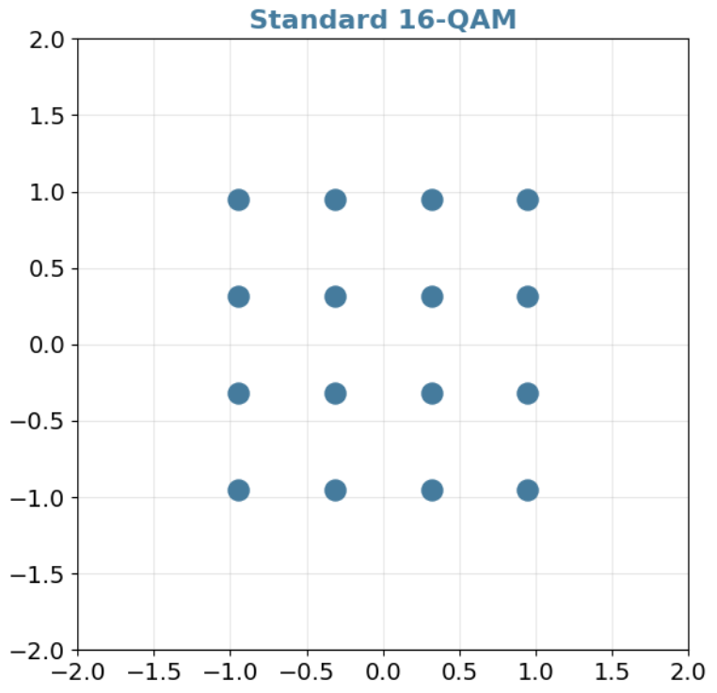
Figure 3.1. Conventional 16-QAM constellation.
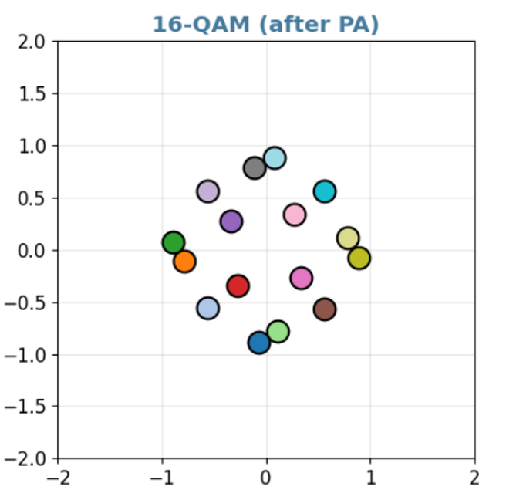
Figure 3.2. 16-QAM after PA distortion.

3.2. Autoencoder Communication Model
The autoencoder model has an encoder, a channel layer, and a decoder. The encoder is analogous to a transmitter mapper. The channel layer may be differentiable or simulated. The decoder is analogous to a receiver detector. Training usually minimizes cross-entropy between the transmitted message and the detected message while enforcing an average-power constraint.
Power normalization is essential. Without it, the network could reduce errors simply by increasing transmit energy. A meaningful learned modulation scheme should satisfy the same or comparable power constraint as the baseline. SNR also needs to be varied during training or evaluation, because a constellation optimized for one SNR may not be optimal for another.
The autoencoder approach is useful for research because it can reveal how a signal representation changes when the channel changes. For example, under PA nonlinearity, the learned constellation may avoid high-amplitude regions. Under CFO, a multi-symbol model may use temporal structure. Under fading, the receiver may learn robust decision boundaries.
$$x = f_θ(m), y = Channel(x), p̂(m | y) = g_φ(y)$$ (3.5)
Equation (3.5) describes the autoencoder communication model. The transmitter network f_θ maps message m to channel input x, the channel produces y, and the receiver network g_φ estimates the posterior probability of the message. The parameters θ and φ are optimized from data.
$$E[|x|²] ≤ P$$ (3.6)
Equation (3.6) is the average-power constraint. It prevents the learned transmitter from improving detection simply by increasing transmit energy. Any learned modulation is required to be compared with a conventional baseline under a comparable power constraint.
$$x_norm = x / sqrt(E[|x|²])$$ (3.7)
Equation (3.7) is a typical normalization step used to enforce average-power control in neural modulation.
$$L_CE = − (1/N) Σ_\{n=1\}^\{N\} log p̂(m_n | y_n)$$ (3.8)
Equation (3.8) is the cross-entropy loss commonly used for message classification in communication autoencoders. Although useful for training, this loss does not automatically guarantee calibrated bit-level LLRs for BIBCM-ID integration.
$$SER = (1/N_s) Σ_\{k=1\}^\{N_s\} 1\{ ŝ_k ≠ s_k \}$$ (3.9)
Equation (3.9) defines symbol error rate, which is often used when studying modulation before full channel-code integration.
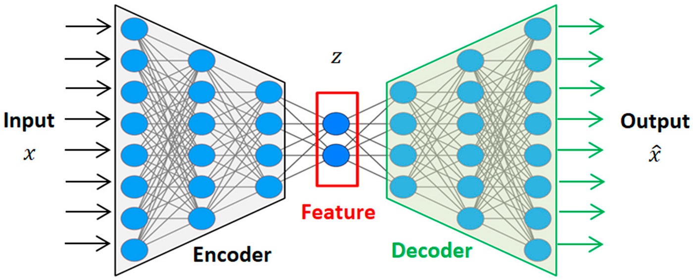
Figure 3.3. Autoencoder-based communication model.

3.3. Non-Ideal Channel Conditions
Power amplifier nonlinearity is a major practical impairment. A PA is efficient when operated near saturation, but this causes nonlinear amplitude compression. Outer constellation points are compressed more strongly, reducing distances between received clusters. If AM/PM distortion exists, phase is also changed. Learned modulation may improve robustness by shaping symbols away from regions with pronounced compression.
Carrier-frequency offset occurs when transmitter and receiver oscillators are not perfectly aligned. CFO causes phase rotation that accumulates over time. In single-symbol detection, this rotation looks like an unknown phase error. In multi-symbol processing, the receiver can observe the rotation pattern and estimate it implicitly. This motivates sequence-based autoencoder modulation.
Rayleigh fading and ISI represent propagation impairments. Rayleigh fading changes amplitude and phase randomly, while ISI makes the current received sample depend on previous transmitted symbols. A neural receiver can process context and may learn equalization-like behavior. However, this also increases complexity and latency.
$$x_PA = x / [1 + (|x|/A_sat)^\{2p\}]^\{1/(2p)\}$$ (3.10)
Equation (3.10) is a common Rapp-type AM/AM PA model. A_sat controls saturation amplitude and p controls smoothness. This model explains why high-amplitude constellation points are compressed more strongly.
$$φ_AMPM(|x|) = α |x|² / (1 + β |x|²)$$ (3.11)
Equation (3.11) is a simple AM/PM distortion model. It indicates that the phase shift can depend on signal amplitude.
$$y_k = x_k e^\{j(2πΔf kT + φ_0)\} + n_k$$ (3.12)
Equation (3.12) represents carrier-frequency offset. The phase rotation grows with symbol index k, which motivates multi-symbol processing because a sequence carries information about the rotation trend.
$$y_k = Σ_\{l=0\}^\{L-1\} h_l x_\{k-l\} + n_k$$ (3.13)
Equation (3.13) represents a multipath channel with ISI. The received sample depends on multiple transmitted symbols, so memoryless detection may be insufficient. A sequence-based neural receiver can learn to exploit this temporal dependence.
$$h_l \sim CN(0, σ_l²), Σ_l σ_l² = 1$$ (3.14)
Equation (3.14) gives a common statistical model for Rayleigh multipath coefficients with normalized average power.
$$L_BCE = − Σ_k [ b_k log p̂_k + (1 − b_k) log(1 − p̂_k) ]$$ (3.15)
Equation (3.15) is a bit-wise binary cross-entropy objective. It is more directly related to soft bit output than message-level cross-entropy and is therefore relevant for future BIBCM-ID integration.
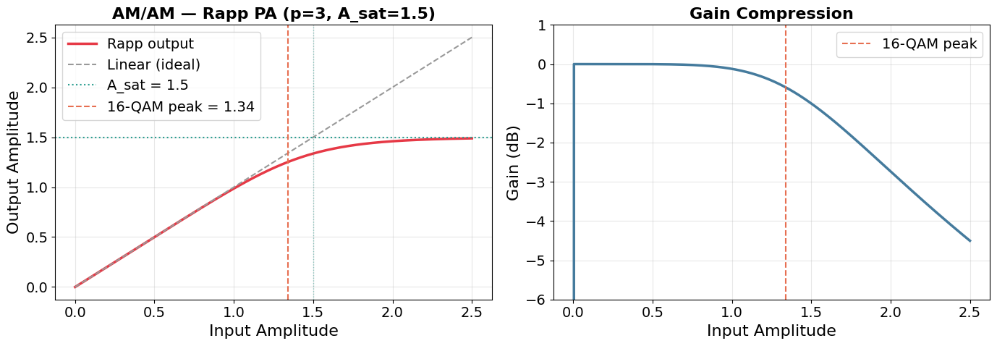
Figure 3.4. PA nonlinear characteristic.
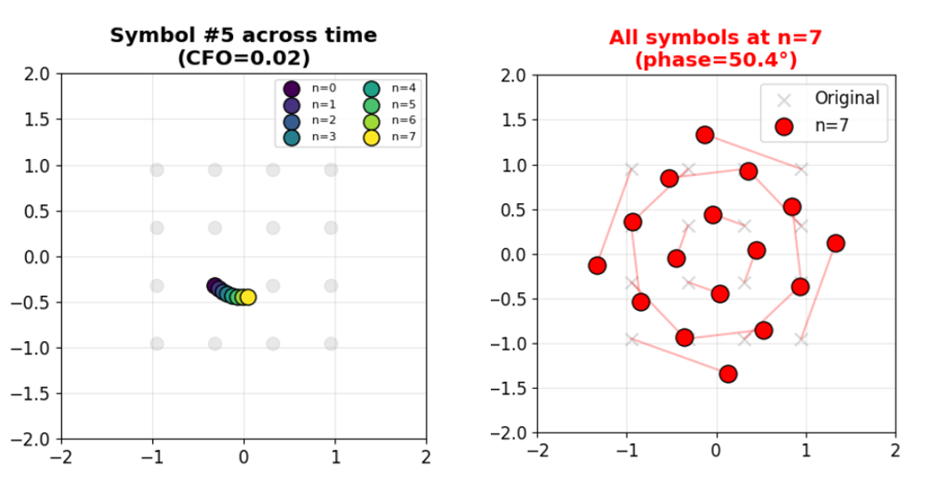
Figure 3.5. CFO effect on received symbols.

3.4. Available Simulation Scenarios
The organized thesis materials include several autoencoder scenarios. Scenario 1 compares a single-symbol autoencoder with 16-QAM under a Rayleigh plus PA channel. This scenario evaluates whether learned constellation shaping can improve BER when nonlinear amplitude distortion is present.
Scenario 2 studies a multiple-symbol autoencoder under CFO. Two CFO values are available in the result figures. This scenario is important because CFO compensation is difficult for a purely memoryless demapper. A sequence model can exploit phase evolution across symbols and may reduce the need for an explicit synchronization block.
Scenario 3 studies an autoencoder with a neural channel-coding feature. This scenario is closest to the long-term goal of learned coded modulation, but it is not described as an already integrated BIBCM-ID system. It is better interpreted as an independent experiment showing the possibility of combining learned modulation with redundancy.
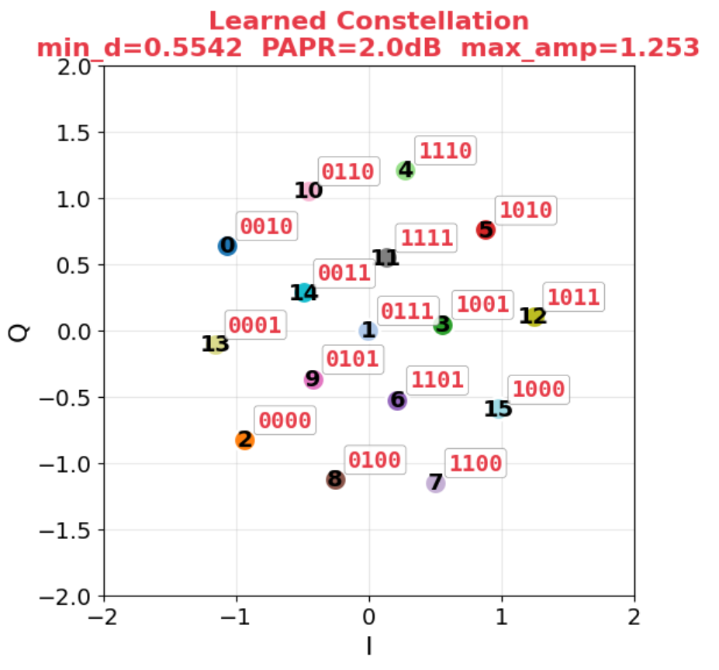
Figure 3.6. Learned autoencoder constellation.
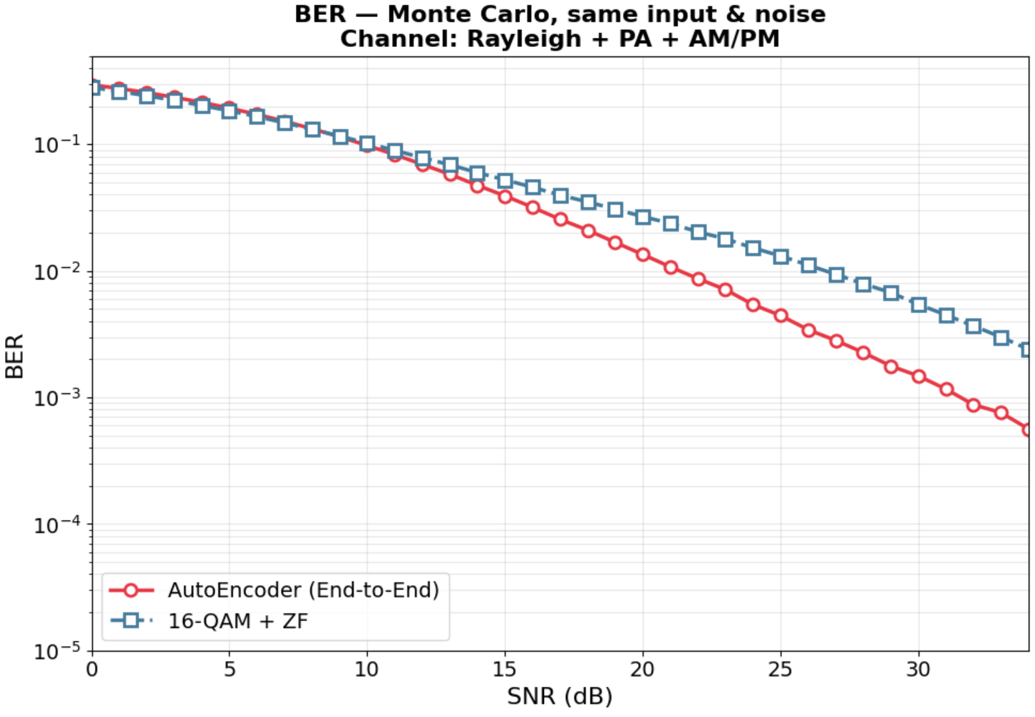
Figure 3.7. BER comparison for Scenario 1.
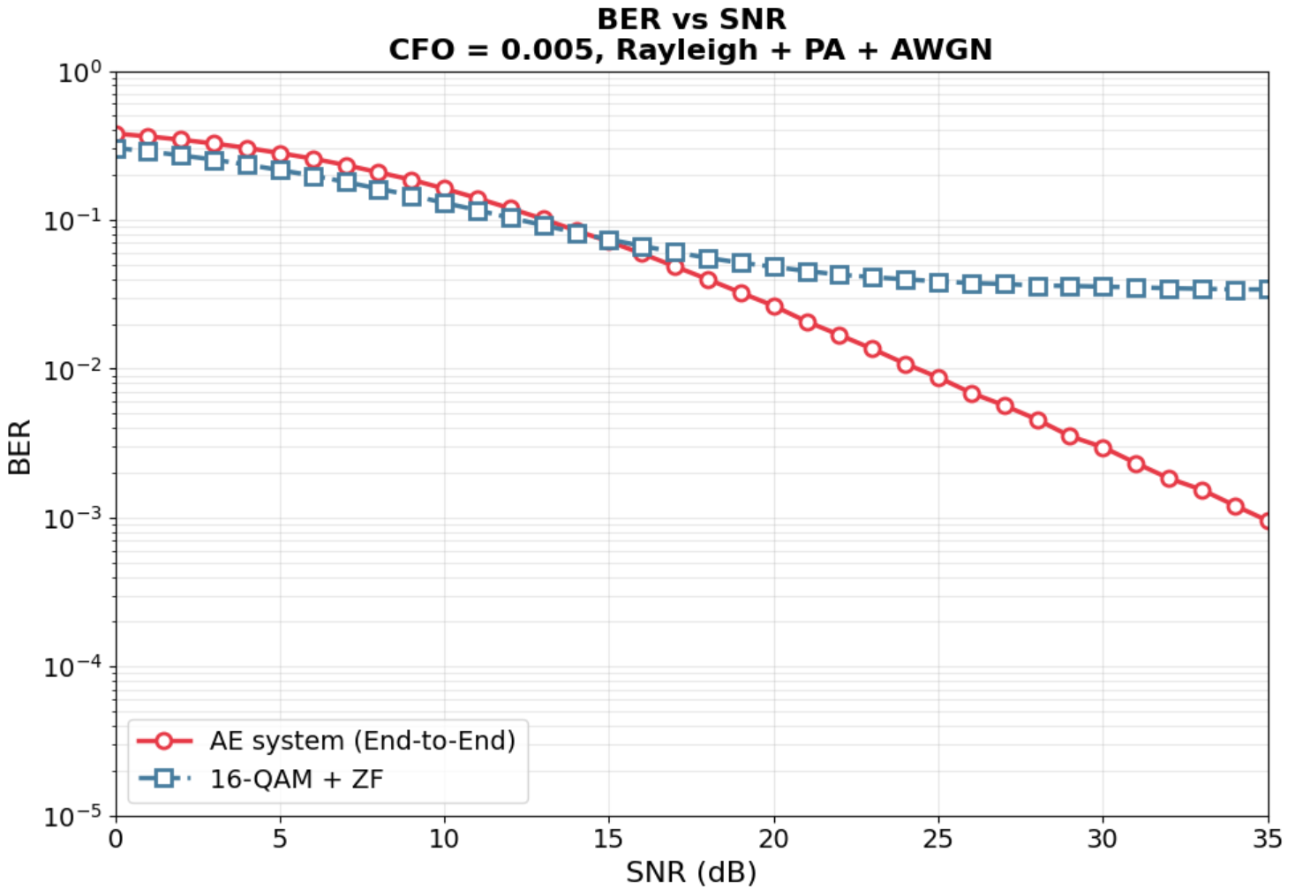
Figure 3.8. BER comparison for CFO = 0.005.
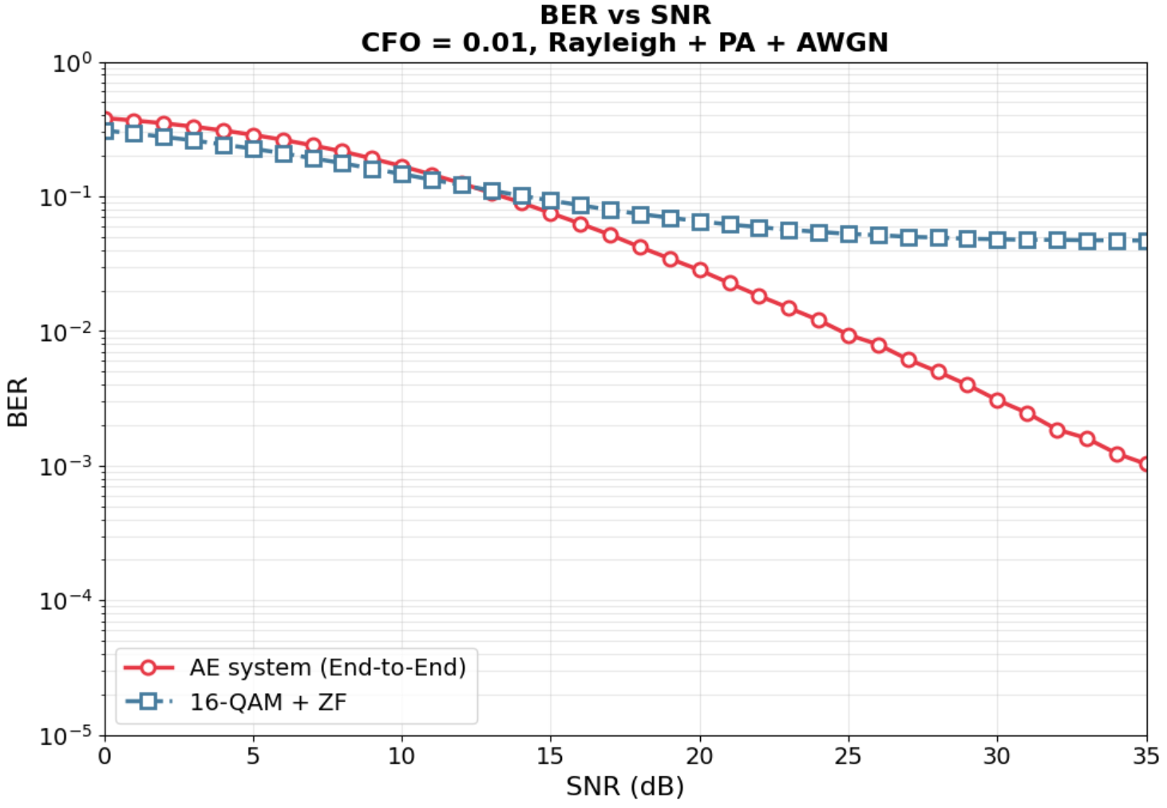
Figure 3.9. BER comparison for CFO = 0.01.
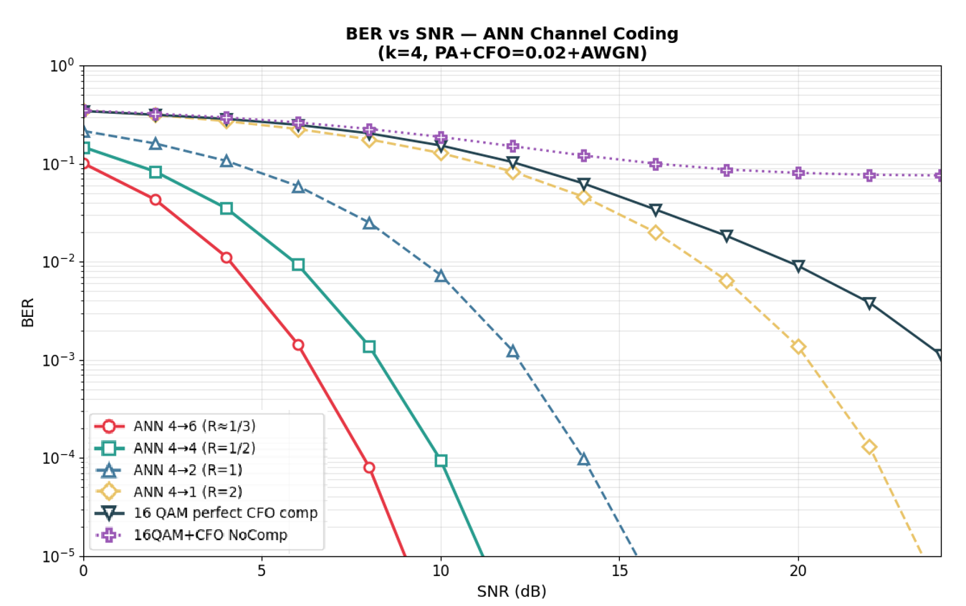
Figure 3.10. Autoencoder with neural channel-coding feature.

3.5. Interpretation and Limitations
The autoencoder results are interpreted as evidence that learned modulation can adapt to selected channel impairments. They do not establish that learned modulation should replace standardized schemes. Standard constellations offer interoperability, simple implementation, and predictable behavior. Learned modulation offers adaptability but requires training, validation, and model management.
For BIBCM-ID, the main missing piece is calibrated bit-level soft information. A complete BIBCM-ID receiver requires LLRs for coded bits. Many autoencoder receivers output message probabilities or hard decisions. To integrate learned modulation into BIBCM-ID, the receiver is expected to produce calibrated bit probabilities or residual LLR corrections that can be used by an iterative decoder.
The thesis therefore treats autoencoder modulation as a separate research direction related to the modulation block. It is not yet claimed as an integrated improvement to the full BIBCM-ID chain. This distinction is important for scientific honesty and for future work planning.
In the analysis of autoencoder-based modulation under non-ideal channels, soft-information quality is treated as a central technical criterion in addition to final hard-decision accuracy. BIBCM-ID, LDPC decoding, and neural demapping all use reliability values that are passed between processing blocks. When these values are well calibrated, iterative processing can improve the decision process. When they are biased or overconfident, later iterations may reinforce an incorrect tendency. For this reason, the learning-based methods in this thesis are discussed at the level of message quality as well as BER.
From an engineering viewpoint, autoencoder-based modulation under non-ideal channels is evaluated under implementation constraints. A method that provides a BER improvement while requiring a substantially larger neural network may be less suitable for a practical receiver. Conversely, a compact network that replaces expensive nonlinear functions may be relevant even when the BER gain is moderate. The discussion therefore relates performance to computational cost, memory use, and possible hardware realization.
Robustness to model mismatch is another recurring issue in autoencoder-based modulation under non-ideal channels. Communication receivers are usually designed using an assumed channel model, while the actual channel may include nonlinear amplification, oscillator offset, phase noise, fading correlation, quantization, or imperfect synchronization. A neural component is expected to generalize only when its training domain covers the relevant variations. If the training domain is narrow, the model may perform well in simulation but degrade under different operating conditions.
The interpretation of autoencoder-based modulation under non-ideal channels is kept compatible with classical communication theory. Deep learning does not remove the need for code constraints, power normalization, likelihood reasoning, or interleaver design. The thesis therefore adopts a hybrid view: established communication structure is retained, while learning is used to approximate nonlinear corrections that are difficult to express in closed form.
For autoencoder-based modulation under non-ideal channels, the available simulations are used as evidence for feasibility and trend analysis rather than as a basis for universal claims. Each result depends on code length, modulation format, SNR range, channel parameters, number of transmitted bits, and training configuration. The report therefore avoids interpreting a single curve or scenario as a general proof of superiority.
The component-level viewpoint is useful for autoencoder-based modulation under non-ideal channels because it separates the source of performance change. If the decoder is modified while the modulation is fixed, the observed change can be related to message-passing behavior. If the modulation is modified while the decoder is fixed, the observed change can be related to signal representation and demapping. This separation reduces ambiguity in the technical interpretation.
In the context of autoencoder-based modulation under non-ideal channels, the proposed use of neural networks is framed as an approximation and adaptation tool. The objective is to evaluate whether a learned local mapping can improve reliability, reduce computational burden, or increase robustness under defined assumptions. This formulation is narrower than claiming an end-to-end replacement of the communication system and is more consistent with the available evidence.
In the analysis of autoencoder-based modulation under non-ideal channels, soft-information quality is treated as a central technical criterion in addition to final hard-decision accuracy. BIBCM-ID, LDPC decoding, and neural demapping all use reliability values that are passed between processing blocks. When these values are well calibrated, iterative processing can improve the decision process. When they are biased or overconfident, later iterations may reinforce an incorrect tendency. For this reason, the learning-based methods in this thesis are discussed at the level of message quality as well as BER.
From an engineering viewpoint, autoencoder-based modulation under non-ideal channels is evaluated under implementation constraints. A method that provides a BER improvement while requiring a substantially larger neural network may be less suitable for a practical receiver. Conversely, a compact network that replaces expensive nonlinear functions may be relevant even when the BER gain is moderate. The discussion therefore relates performance to computational cost, memory use, and possible hardware realization.
Robustness to model mismatch is another recurring issue in autoencoder-based modulation under non-ideal channels. Communication receivers are usually designed using an assumed channel model, while the actual channel may include nonlinear amplification, oscillator offset, phase noise, fading correlation, quantization, or imperfect synchronization. A neural component is expected to generalize only when its training domain covers the relevant variations. If the training domain is narrow, the model may perform well in simulation but degrade under different operating conditions.
The interpretation of autoencoder-based modulation under non-ideal channels is kept compatible with classical communication theory. Deep learning does not remove the need for code constraints, power normalization, likelihood reasoning, or interleaver design. The thesis therefore adopts a hybrid view: established communication structure is retained, while learning is used to approximate nonlinear corrections that are difficult to express in closed form.
For autoencoder-based modulation under non-ideal channels, the available simulations are used as evidence for feasibility and trend analysis rather than as a basis for universal claims. Each result depends on code length, modulation format, SNR range, channel parameters, number of transmitted bits, and training configuration. The report therefore avoids interpreting a single curve or scenario as a general proof of superiority.
The component-level viewpoint is useful for autoencoder-based modulation under non-ideal channels because it separates the source of performance change. If the decoder is modified while the modulation is fixed, the observed change can be related to message-passing behavior. If the modulation is modified while the decoder is fixed, the observed change can be related to signal representation and demapping. This separation reduces ambiguity in the technical interpretation.
In the context of autoencoder-based modulation under non-ideal channels, the proposed use of neural networks is framed as an approximation and adaptation tool. The objective is to evaluate whether a learned local mapping can improve reliability, reduce computational burden, or increase robustness under defined assumptions. This formulation is narrower than claiming an end-to-end replacement of the communication system and is more consistent with the available evidence.
In the analysis of autoencoder-based modulation under non-ideal channels, soft-information quality is treated as a central technical criterion in addition to final hard-decision accuracy. BIBCM-ID, LDPC decoding, and neural demapping all use reliability values that are passed between processing blocks. When these values are well calibrated, iterative processing can improve the decision process. When they are biased or overconfident, later iterations may reinforce an incorrect tendency. For this reason, the learning-based methods in this thesis are discussed at the level of message quality as well as BER.
From an engineering viewpoint, autoencoder-based modulation under non-ideal channels is evaluated under implementation constraints. A method that provides a BER improvement while requiring a substantially larger neural network may be less suitable for a practical receiver. Conversely, a compact network that replaces expensive nonlinear functions may be relevant even when the BER gain is moderate. The discussion therefore relates performance to computational cost, memory use, and possible hardware realization.
Robustness to model mismatch is another recurring issue in autoencoder-based modulation under non-ideal channels. Communication receivers are usually designed using an assumed channel model, while the actual channel may include nonlinear amplification, oscillator offset, phase noise, fading correlation, quantization, or imperfect synchronization. A neural component is expected to generalize only when its training domain covers the relevant variations. If the training domain is narrow, the model may perform well in simulation but degrade under different operating conditions.
The interpretation of autoencoder-based modulation under non-ideal channels is kept compatible with classical communication theory. Deep learning does not remove the need for code constraints, power normalization, likelihood reasoning, or interleaver design. The thesis therefore adopts a hybrid view: established communication structure is retained, while learning is used to approximate nonlinear corrections that are difficult to express in closed form.
For autoencoder-based modulation under non-ideal channels, the available simulations are used as evidence for feasibility and trend analysis rather than as a basis for universal claims. Each result depends on code length, modulation format, SNR range, channel parameters, number of transmitted bits, and training configuration. The report therefore avoids interpreting a single curve or scenario as a general proof of superiority.
The component-level viewpoint is useful for autoencoder-based modulation under non-ideal channels because it separates the source of performance change. If the decoder is modified while the modulation is fixed, the observed change can be related to message-passing behavior. If the modulation is modified while the decoder is fixed, the observed change can be related to signal representation and demapping. This separation reduces ambiguity in the technical interpretation.
In the context of autoencoder-based modulation under non-ideal channels, the proposed use of neural networks is framed as an approximation and adaptation tool. The objective is to evaluate whether a learned local mapping can improve reliability, reduce computational burden, or increase robustness under defined assumptions. This formulation is narrower than claiming an end-to-end replacement of the communication system and is more consistent with the available evidence.
In the analysis of autoencoder-based modulation under non-ideal channels, soft-information quality is treated as a central technical criterion in addition to final hard-decision accuracy. BIBCM-ID, LDPC decoding, and neural demapping all use reliability values that are passed between processing blocks. When these values are well calibrated, iterative processing can improve the decision process. When they are biased or overconfident, later iterations may reinforce an incorrect tendency. For this reason, the learning-based methods in this thesis are discussed at the level of message quality as well as BER.
From an engineering viewpoint, autoencoder-based modulation under non-ideal channels is evaluated under implementation constraints. A method that provides a BER improvement while requiring a substantially larger neural network may be less suitable for a practical receiver. Conversely, a compact network that replaces expensive nonlinear functions may be relevant even when the BER gain is moderate. The discussion therefore relates performance to computational cost, memory use, and possible hardware realization.
Robustness to model mismatch is another recurring issue in autoencoder-based modulation under non-ideal channels. Communication receivers are usually designed using an assumed channel model, while the actual channel may include nonlinear amplification, oscillator offset, phase noise, fading correlation, quantization, or imperfect synchronization. A neural component is expected to generalize only when its training domain covers the relevant variations. If the training domain is narrow, the model may perform well in simulation but degrade under different operating conditions.
The interpretation of autoencoder-based modulation under non-ideal channels is kept compatible with classical communication theory. Deep learning does not remove the need for code constraints, power normalization, likelihood reasoning, or interleaver design. The thesis therefore adopts a hybrid view: established communication structure is retained, while learning is used to approximate nonlinear corrections that are difficult to express in closed form.
For autoencoder-based modulation under non-ideal channels, the available simulations are used as evidence for feasibility and trend analysis rather than as a basis for universal claims. Each result depends on code length, modulation format, SNR range, channel parameters, number of transmitted bits, and training configuration. The report therefore avoids interpreting a single curve or scenario as a general proof of superiority.
The component-level viewpoint is useful for autoencoder-based modulation under non-ideal channels because it separates the source of performance change. If the decoder is modified while the modulation is fixed, the observed change can be related to message-passing behavior. If the modulation is modified while the decoder is fixed, the observed change can be related to signal representation and demapping. This separation reduces ambiguity in the technical interpretation.
In the context of autoencoder-based modulation under non-ideal channels, the proposed use of neural networks is framed as an approximation and adaptation tool. The objective is to evaluate whether a learned local mapping can improve reliability, reduce computational burden, or increase robustness under defined assumptions. This formulation is narrower than claiming an end-to-end replacement of the communication system and is more consistent with the available evidence.
In the analysis of autoencoder-based modulation under non-ideal channels, soft-information quality is treated as a central technical criterion in addition to final hard-decision accuracy. BIBCM-ID, LDPC decoding, and neural demapping all use reliability values that are passed between processing blocks. When these values are well calibrated, iterative processing can improve the decision process. When they are biased or overconfident, later iterations may reinforce an incorrect tendency. For this reason, the learning-based methods in this thesis are discussed at the level of message quality as well as BER.
From an engineering viewpoint, autoencoder-based modulation under non-ideal channels is evaluated under implementation constraints. A method that provides a BER improvement while requiring a substantially larger neural network may be less suitable for a practical receiver. Conversely, a compact network that replaces expensive nonlinear functions may be relevant even when the BER gain is moderate. The discussion therefore relates performance to computational cost, memory use, and possible hardware realization.
Robustness to model mismatch is another recurring issue in autoencoder-based modulation under non-ideal channels. Communication receivers are usually designed using an assumed channel model, while the actual channel may include nonlinear amplification, oscillator offset, phase noise, fading correlation, quantization, or imperfect synchronization. A neural component is expected to generalize only when its training domain covers the relevant variations. If the training domain is narrow, the model may perform well in simulation but degrade under different operating conditions.
The interpretation of autoencoder-based modulation under non-ideal channels is kept compatible with classical communication theory. Deep learning does not remove the need for code constraints, power normalization, likelihood reasoning, or interleaver design. The thesis therefore adopts a hybrid view: established communication structure is retained, while learning is used to approximate nonlinear corrections that are difficult to express in closed form.
For autoencoder-based modulation under non-ideal channels, the available simulations are used as evidence for feasibility and trend analysis rather than as a basis for universal claims. Each result depends on code length, modulation format, SNR range, channel parameters, number of transmitted bits, and training configuration. The report therefore avoids interpreting a single curve or scenario as a general proof of superiority.
The component-level viewpoint is useful for autoencoder-based modulation under non-ideal channels because it separates the source of performance change. If the decoder is modified while the modulation is fixed, the observed change can be related to message-passing behavior. If the modulation is modified while the decoder is fixed, the observed change can be related to signal representation and demapping. This separation reduces ambiguity in the technical interpretation.
In the context of autoencoder-based modulation under non-ideal channels, the proposed use of neural networks is framed as an approximation and adaptation tool. The objective is to evaluate whether a learned local mapping can improve reliability, reduce computational burden, or increase robustness under defined assumptions. This formulation is narrower than claiming an end-to-end replacement of the communication system and is more consistent with the available evidence.
In the analysis of autoencoder-based modulation under non-ideal channels, soft-information quality is treated as a central technical criterion in addition to final hard-decision accuracy. BIBCM-ID, LDPC decoding, and neural demapping all use reliability values that are passed between processing blocks. When these values are well calibrated, iterative processing can improve the decision process. When they are biased or overconfident, later iterations may reinforce an incorrect tendency. For this reason, the learning-based methods in this thesis are discussed at the level of message quality as well as BER.
From an engineering viewpoint, autoencoder-based modulation under non-ideal channels is evaluated under implementation constraints. A method that provides a BER improvement while requiring a substantially larger neural network may be less suitable for a practical receiver. Conversely, a compact network that replaces expensive nonlinear functions may be relevant even when the BER gain is moderate. The discussion therefore relates performance to computational cost, memory use, and possible hardware realization.
Robustness to model mismatch is another recurring issue in autoencoder-based modulation under non-ideal channels. Communication receivers are usually designed using an assumed channel model, while the actual channel may include nonlinear amplification, oscillator offset, phase noise, fading correlation, quantization, or imperfect synchronization. A neural component is expected to generalize only when its training domain covers the relevant variations. If the training domain is narrow, the model may perform well in simulation but degrade under different operating conditions.
The interpretation of autoencoder-based modulation under non-ideal channels is kept compatible with classical communication theory. Deep learning does not remove the need for code constraints, power normalization, likelihood reasoning, or interleaver design. The thesis therefore adopts a hybrid view: established communication structure is retained, while learning is used to approximate nonlinear corrections that are difficult to express in closed form.
For autoencoder-based modulation under non-ideal channels, the available simulations are used as evidence for feasibility and trend analysis rather than as a basis for universal claims. Each result depends on code length, modulation format, SNR range, channel parameters, number of transmitted bits, and training configuration. The report therefore avoids interpreting a single curve or scenario as a general proof of superiority.
The component-level viewpoint is useful for autoencoder-based modulation under non-ideal channels because it separates the source of performance change. If the decoder is modified while the modulation is fixed, the observed change can be related to message-passing behavior. If the modulation is modified while the decoder is fixed, the observed change can be related to signal representation and demapping. This separation reduces ambiguity in the technical interpretation.
In the context of autoencoder-based modulation under non-ideal channels, the proposed use of neural networks is framed as an approximation and adaptation tool. The objective is to evaluate whether a learned local mapping can improve reliability, reduce computational burden, or increase robustness under defined assumptions. This formulation is narrower than claiming an end-to-end replacement of the communication system and is more consistent with the available evidence.
In the analysis of autoencoder-based modulation under non-ideal channels, soft-information quality is treated as a central technical criterion in addition to final hard-decision accuracy. BIBCM-ID, LDPC decoding, and neural demapping all use reliability values that are passed between processing blocks. When these values are well calibrated, iterative processing can improve the decision process. When they are biased or overconfident, later iterations may reinforce an incorrect tendency. For this reason, the learning-based methods in this thesis are discussed at the level of message quality as well as BER.
From an engineering viewpoint, autoencoder-based modulation under non-ideal channels is evaluated under implementation constraints. A method that provides a BER improvement while requiring a substantially larger neural network may be less suitable for a practical receiver. Conversely, a compact network that replaces expensive nonlinear functions may be relevant even when the BER gain is moderate. The discussion therefore relates performance to computational cost, memory use, and possible hardware realization.
Robustness to model mismatch is another recurring issue in autoencoder-based modulation under non-ideal channels. Communication receivers are usually designed using an assumed channel model, while the actual channel may include nonlinear amplification, oscillator offset, phase noise, fading correlation, quantization, or imperfect synchronization. A neural component is expected to generalize only when its training domain covers the relevant variations. If the training domain is narrow, the model may perform well in simulation but degrade under different operating conditions.
The interpretation of autoencoder-based modulation under non-ideal channels is kept compatible with classical communication theory. Deep learning does not remove the need for code constraints, power normalization, likelihood reasoning, or interleaver design. The thesis therefore adopts a hybrid view: established communication structure is retained, while learning is used to approximate nonlinear corrections that are difficult to express in closed form.
For autoencoder-based modulation under non-ideal channels, the available simulations are used as evidence for feasibility and trend analysis rather than as a basis for universal claims. Each result depends on code length, modulation format, SNR range, channel parameters, number of transmitted bits, and training configuration. The report therefore avoids interpreting a single curve or scenario as a general proof of superiority.
The component-level viewpoint is useful for autoencoder-based modulation under non-ideal channels because it separates the source of performance change. If the decoder is modified while the modulation is fixed, the observed change can be related to message-passing behavior. If the modulation is modified while the decoder is fixed, the observed change can be related to signal representation and demapping. This separation reduces ambiguity in the technical interpretation.
In the context of autoencoder-based modulation under non-ideal channels, the proposed use of neural networks is framed as an approximation and adaptation tool. The objective is to evaluate whether a learned local mapping can improve reliability, reduce computational burden, or increase robustness under defined assumptions. This formulation is narrower than claiming an end-to-end replacement of the communication system and is more consistent with the available evidence.
In the analysis of autoencoder-based modulation under non-ideal channels, soft-information quality is treated as a central technical criterion in addition to final hard-decision accuracy. BIBCM-ID, LDPC decoding, and neural demapping all use reliability values that are passed between processing blocks. When these values are well calibrated, iterative processing can improve the decision process. When they are biased or overconfident, later iterations may reinforce an incorrect tendency. For this reason, the learning-based methods in this thesis are discussed at the level of message quality as well as BER.
From an engineering viewpoint, autoencoder-based modulation under non-ideal channels is evaluated under implementation constraints. A method that provides a BER improvement while requiring a substantially larger neural network may be less suitable for a practical receiver. Conversely, a compact network that replaces expensive nonlinear functions may be relevant even when the BER gain is moderate. The discussion therefore relates performance to computational cost, memory use, and possible hardware realization.
Robustness to model mismatch is another recurring issue in autoencoder-based modulation under non-ideal channels. Communication receivers are usually designed using an assumed channel model, while the actual channel may include nonlinear amplification, oscillator offset, phase noise, fading correlation, quantization, or imperfect synchronization. A neural component is expected to generalize only when its training domain covers the relevant variations. If the training domain is narrow, the model may perform well in simulation but degrade under different operating conditions.
The interpretation of autoencoder-based modulation under non-ideal channels is kept compatible with classical communication theory. Deep learning does not remove the need for code constraints, power normalization, likelihood reasoning, or interleaver design. The thesis therefore adopts a hybrid view: established communication structure is retained, while learning is used to approximate nonlinear corrections that are difficult to express in closed form.
For autoencoder-based modulation under non-ideal channels, the available simulations are used as evidence for feasibility and trend analysis rather than as a basis for universal claims. Each result depends on code length, modulation format, SNR range, channel parameters, number of transmitted bits, and training configuration. The report therefore avoids interpreting a single curve or scenario as a general proof of superiority.
The component-level viewpoint is useful for autoencoder-based modulation under non-ideal channels because it separates the source of performance change. If the decoder is modified while the modulation is fixed, the observed change can be related to message-passing behavior. If the modulation is modified while the decoder is fixed, the observed change can be related to signal representation and demapping. This separation reduces ambiguity in the technical interpretation.
In the context of autoencoder-based modulation under non-ideal channels, the proposed use of neural networks is framed as an approximation and adaptation tool. The objective is to evaluate whether a learned local mapping can improve reliability, reduce computational burden, or increase robustness under defined assumptions. This formulation is narrower than claiming an end-to-end replacement of the communication system and is more consistent with the available evidence.
In the analysis of autoencoder-based modulation under non-ideal channels, soft-information quality is treated as a central technical criterion in addition to final hard-decision accuracy. BIBCM-ID, LDPC decoding, and neural demapping all use reliability values that are passed between processing blocks. When these values are well calibrated, iterative processing can improve the decision process. When they are biased or overconfident, later iterations may reinforce an incorrect tendency. For this reason, the learning-based methods in this thesis are discussed at the level of message quality as well as BER.
From an engineering viewpoint, autoencoder-based modulation under non-ideal channels is evaluated under implementation constraints. A method that provides a BER improvement while requiring a substantially larger neural network may be less suitable for a practical receiver. Conversely, a compact network that replaces expensive nonlinear functions may be relevant even when the BER gain is moderate. The discussion therefore relates performance to computational cost, memory use, and possible hardware realization.
Robustness to model mismatch is another recurring issue in autoencoder-based modulation under non-ideal channels. Communication receivers are usually designed using an assumed channel model, while the actual channel may include nonlinear amplification, oscillator offset, phase noise, fading correlation, quantization, or imperfect synchronization. A neural component is expected to generalize only when its training domain covers the relevant variations. If the training domain is narrow, the model may perform well in simulation but degrade under different operating conditions.
The interpretation of autoencoder-based modulation under non-ideal channels is kept compatible with classical communication theory. Deep learning does not remove the need for code constraints, power normalization, likelihood reasoning, or interleaver design. The thesis therefore adopts a hybrid view: established communication structure is retained, while learning is used to approximate nonlinear corrections that are difficult to express in closed form.
For autoencoder-based modulation under non-ideal channels, the available simulations are used as evidence for feasibility and trend analysis rather than as a basis for universal claims. Each result depends on code length, modulation format, SNR range, channel parameters, number of transmitted bits, and training configuration. The report therefore avoids interpreting a single curve or scenario as a general proof of superiority.
The component-level viewpoint is useful for autoencoder-based modulation under non-ideal channels because it separates the source of performance change. If the decoder is modified while the modulation is fixed, the observed change can be related to message-passing behavior. If the modulation is modified while the decoder is fixed, the observed change can be related to signal representation and demapping. This separation reduces ambiguity in the technical interpretation.
In the context of autoencoder-based modulation under non-ideal channels, the proposed use of neural networks is framed as an approximation and adaptation tool. The objective is to evaluate whether a learned local mapping can improve reliability, reduce computational burden, or increase robustness under defined assumptions. This formulation is narrower than claiming an end-to-end replacement of the communication system and is more consistent with the available evidence.
In the analysis of autoencoder-based modulation under non-ideal channels, soft-information quality is treated as a central technical criterion in addition to final hard-decision accuracy. BIBCM-ID, LDPC decoding, and neural demapping all use reliability values that are passed between processing blocks. When these values are well calibrated, iterative processing can improve the decision process. When they are biased or overconfident, later iterations may reinforce an incorrect tendency. For this reason, the learning-based methods in this thesis are discussed at the level of message quality as well as BER.
From an engineering viewpoint, autoencoder-based modulation under non-ideal channels is evaluated under implementation constraints. A method that provides a BER improvement while requiring a substantially larger neural network may be less suitable for a practical receiver. Conversely, a compact network that replaces expensive nonlinear functions may be relevant even when the BER gain is moderate. The discussion therefore relates performance to computational cost, memory use, and possible hardware realization.
Robustness to model mismatch is another recurring issue in autoencoder-based modulation under non-ideal channels. Communication receivers are usually designed using an assumed channel model, while the actual channel may include nonlinear amplification, oscillator offset, phase noise, fading correlation, quantization, or imperfect synchronization. A neural component is expected to generalize only when its training domain covers the relevant variations. If the training domain is narrow, the model may perform well in simulation but degrade under different operating conditions.
The interpretation of autoencoder-based modulation under non-ideal channels is kept compatible with classical communication theory. Deep learning does not remove the need for code constraints, power normalization, likelihood reasoning, or interleaver design. The thesis therefore adopts a hybrid view: established communication structure is retained, while learning is used to approximate nonlinear corrections that are difficult to express in closed form.
For autoencoder-based modulation under non-ideal channels, the available simulations are used as evidence for feasibility and trend analysis rather than as a basis for universal claims. Each result depends on code length, modulation format, SNR range, channel parameters, number of transmitted bits, and training configuration. The report therefore avoids interpreting a single curve or scenario as a general proof of superiority.
The component-level viewpoint is useful for autoencoder-based modulation under non-ideal channels because it separates the source of performance change. If the decoder is modified while the modulation is fixed, the observed change can be related to message-passing behavior. If the modulation is modified while the decoder is fixed, the observed change can be related to signal representation and demapping. This separation reduces ambiguity in the technical interpretation.
In the context of autoencoder-based modulation under non-ideal channels, the proposed use of neural networks is framed as an approximation and adaptation tool. The objective is to evaluate whether a learned local mapping can improve reliability, reduce computational burden, or increase robustness under defined assumptions. This formulation is narrower than claiming an end-to-end replacement of the communication system and is more consistent with the available evidence.
In the analysis of autoencoder-based modulation under non-ideal channels, soft-information quality is treated as a central technical criterion in addition to final hard-decision accuracy. BIBCM-ID, LDPC decoding, and neural demapping all use reliability values that are passed between processing blocks. When these values are well calibrated, iterative processing can improve the decision process. When they are biased or overconfident, later iterations may reinforce an incorrect tendency. For this reason, the learning-based methods in this thesis are discussed at the level of message quality as well as BER.
From an engineering viewpoint, autoencoder-based modulation under non-ideal channels is evaluated under implementation constraints. A method that provides a BER improvement while requiring a substantially larger neural network may be less suitable for a practical receiver. Conversely, a compact network that replaces expensive nonlinear functions may be relevant even when the BER gain is moderate. The discussion therefore relates performance to computational cost, memory use, and possible hardware realization.
Robustness to model mismatch is another recurring issue in autoencoder-based modulation under non-ideal channels. Communication receivers are usually designed using an assumed channel model, while the actual channel may include nonlinear amplification, oscillator offset, phase noise, fading correlation, quantization, or imperfect synchronization. A neural component is expected to generalize only when its training domain covers the relevant variations. If the training domain is narrow, the model may perform well in simulation but degrade under different operating conditions.
The interpretation of autoencoder-based modulation under non-ideal channels is kept compatible with classical communication theory. Deep learning does not remove the need for code constraints, power normalization, likelihood reasoning, or interleaver design. The thesis therefore adopts a hybrid view: established communication structure is retained, while learning is used to approximate nonlinear corrections that are difficult to express in closed form.
For autoencoder-based modulation under non-ideal channels, the available simulations are used as evidence for feasibility and trend analysis rather than as a basis for universal claims. Each result depends on code length, modulation format, SNR range, channel parameters, number of transmitted bits, and training configuration. The report therefore avoids interpreting a single curve or scenario as a general proof of superiority.
The component-level viewpoint is useful for autoencoder-based modulation under non-ideal channels because it separates the source of performance change. If the decoder is modified while the modulation is fixed, the observed change can be related to message-passing behavior. If the modulation is modified while the decoder is fixed, the observed change can be related to signal representation and demapping. This separation reduces ambiguity in the technical interpretation.
In the context of autoencoder-based modulation under non-ideal channels, the proposed use of neural networks is framed as an approximation and adaptation tool. The objective is to evaluate whether a learned local mapping can improve reliability, reduce computational burden, or increase robustness under defined assumptions. This formulation is narrower than claiming an end-to-end replacement of the communication system and is more consistent with the available evidence.
In the analysis of autoencoder-based modulation under non-ideal channels, soft-information quality is treated as a central technical criterion in addition to final hard-decision accuracy. BIBCM-ID, LDPC decoding, and neural demapping all use reliability values that are passed between processing blocks. When these values are well calibrated, iterative processing can improve the decision process. When they are biased or overconfident, later iterations may reinforce an incorrect tendency. For this reason, the learning-based methods in this thesis are discussed at the level of message quality as well as BER.
From an engineering viewpoint, autoencoder-based modulation under non-ideal channels is evaluated under implementation constraints. A method that provides a BER improvement while requiring a substantially larger neural network may be less suitable for a practical receiver. Conversely, a compact network that replaces expensive nonlinear functions may be relevant even when the BER gain is moderate. The discussion therefore relates performance to computational cost, memory use, and possible hardware realization.
Robustness to model mismatch is another recurring issue in autoencoder-based modulation under non-ideal channels. Communication receivers are usually designed using an assumed channel model, while the actual channel may include nonlinear amplification, oscillator offset, phase noise, fading correlation, quantization, or imperfect synchronization. A neural component is expected to generalize only when its training domain covers the relevant variations. If the training domain is narrow, the model may perform well in simulation but degrade under different operating conditions.
The interpretation of autoencoder-based modulation under non-ideal channels is kept compatible with classical communication theory. Deep learning does not remove the need for code constraints, power normalization, likelihood reasoning, or interleaver design. The thesis therefore adopts a hybrid view: established communication structure is retained, while learning is used to approximate nonlinear corrections that are difficult to express in closed form.
For autoencoder-based modulation under non-ideal channels, the available simulations are used as evidence for feasibility and trend analysis rather than as a basis for universal claims. Each result depends on code length, modulation format, SNR range, channel parameters, number of transmitted bits, and training configuration. The report therefore avoids interpreting a single curve or scenario as a general proof of superiority.
The component-level viewpoint is useful for autoencoder-based modulation under non-ideal channels because it separates the source of performance change. If the decoder is modified while the modulation is fixed, the observed change can be related to message-passing behavior. If the modulation is modified while the decoder is fixed, the observed change can be related to signal representation and demapping. This separation reduces ambiguity in the technical interpretation.
In the context of autoencoder-based modulation under non-ideal channels, the proposed use of neural networks is framed as an approximation and adaptation tool. The objective is to evaluate whether a learned local mapping can improve reliability, reduce computational burden, or increase robustness under defined assumptions. This formulation is narrower than claiming an end-to-end replacement of the communication system and is more consistent with the available evidence.
In the analysis of autoencoder-based modulation under non-ideal channels, soft-information quality is treated as a central technical criterion in addition to final hard-decision accuracy. BIBCM-ID, LDPC decoding, and neural demapping all use reliability values that are passed between processing blocks. When these values are well calibrated, iterative processing can improve the decision process. When they are biased or overconfident, later iterations may reinforce an incorrect tendency. For this reason, the learning-based methods in this thesis are discussed at the level of message quality as well as BER.
From an engineering viewpoint, autoencoder-based modulation under non-ideal channels is evaluated under implementation constraints. A method that provides a BER improvement while requiring a substantially larger neural network may be less suitable for a practical receiver. Conversely, a compact network that replaces expensive nonlinear functions may be relevant even when the BER gain is moderate. The discussion therefore relates performance to computational cost, memory use, and possible hardware realization.
Robustness to model mismatch is another recurring issue in autoencoder-based modulation under non-ideal channels. Communication receivers are usually designed using an assumed channel model, while the actual channel may include nonlinear amplification, oscillator offset, phase noise, fading correlation, quantization, or imperfect synchronization. A neural component is expected to generalize only when its training domain covers the relevant variations. If the training domain is narrow, the model may perform well in simulation but degrade under different operating conditions.
The interpretation of autoencoder-based modulation under non-ideal channels is kept compatible with classical communication theory. Deep learning does not remove the need for code constraints, power normalization, likelihood reasoning, or interleaver design. The thesis therefore adopts a hybrid view: established communication structure is retained, while learning is used to approximate nonlinear corrections that are difficult to express in closed form.
For autoencoder-based modulation under non-ideal channels, the available simulations are used as evidence for feasibility and trend analysis rather than as a basis for universal claims. Each result depends on code length, modulation format, SNR range, channel parameters, number of transmitted bits, and training configuration. The report therefore avoids interpreting a single curve or scenario as a general proof of superiority.
The component-level viewpoint is useful for autoencoder-based modulation under non-ideal channels because it separates the source of performance change. If the decoder is modified while the modulation is fixed, the observed change can be related to message-passing behavior. If the modulation is modified while the decoder is fixed, the observed change can be related to signal representation and demapping. This separation reduces ambiguity in the technical interpretation.
In the context of autoencoder-based modulation under non-ideal channels, the proposed use of neural networks is framed as an approximation and adaptation tool. The objective is to evaluate whether a learned local mapping can improve reliability, reduce computational burden, or increase robustness under defined assumptions. This formulation is narrower than claiming an end-to-end replacement of the communication system and is more consistent with the available evidence.
In the analysis of autoencoder-based modulation under non-ideal channels, soft-information quality is treated as a central technical criterion in addition to final hard-decision accuracy. BIBCM-ID, LDPC decoding, and neural demapping all use reliability values that are passed between processing blocks. When these values are well calibrated, iterative processing can improve the decision process. When they are biased or overconfident, later iterations may reinforce an incorrect tendency. For this reason, the learning-based methods in this thesis are discussed at the level of message quality as well as BER.
From an engineering viewpoint, autoencoder-based modulation under non-ideal channels is evaluated under implementation constraints. A method that provides a BER improvement while requiring a substantially larger neural network may be less suitable for a practical receiver. Conversely, a compact network that replaces expensive nonlinear functions may be relevant even when the BER gain is moderate. The discussion therefore relates performance to computational cost, memory use, and possible hardware realization.
Robustness to model mismatch is another recurring issue in autoencoder-based modulation under non-ideal channels. Communication receivers are usually designed using an assumed channel model, while the actual channel may include nonlinear amplification, oscillator offset, phase noise, fading correlation, quantization, or imperfect synchronization. A neural component is expected to generalize only when its training domain covers the relevant variations. If the training domain is narrow, the model may perform well in simulation but degrade under different operating conditions.
The interpretation of autoencoder-based modulation under non-ideal channels is kept compatible with classical communication theory. Deep learning does not remove the need for code constraints, power normalization, likelihood reasoning, or interleaver design. The thesis therefore adopts a hybrid view: established communication structure is retained, while learning is used to approximate nonlinear corrections that are difficult to express in closed form.
For autoencoder-based modulation under non-ideal channels, the available simulations are used as evidence for feasibility and trend analysis rather than as a basis for universal claims. Each result depends on code length, modulation format, SNR range, channel parameters, number of transmitted bits, and training configuration. The report therefore avoids interpreting a single curve or scenario as a general proof of superiority.
The component-level viewpoint is useful for autoencoder-based modulation under non-ideal channels because it separates the source of performance change. If the decoder is modified while the modulation is fixed, the observed change can be related to message-passing behavior. If the modulation is modified while the decoder is fixed, the observed change can be related to signal representation and demapping. This separation reduces ambiguity in the technical interpretation.
In the context of autoencoder-based modulation under non-ideal channels, the proposed use of neural networks is framed as an approximation and adaptation tool. The objective is to evaluate whether a learned local mapping can improve reliability, reduce computational burden, or increase robustness under defined assumptions. This formulation is narrower than claiming an end-to-end replacement of the communication system and is more consistent with the available evidence.
In the analysis of autoencoder-based modulation under non-ideal channels, soft-information quality is treated as a central technical criterion in addition to final hard-decision accuracy. BIBCM-ID, LDPC decoding, and neural demapping all use reliability values that are passed between processing blocks. When these values are well calibrated, iterative processing can improve the decision process. When they are biased or overconfident, later iterations may reinforce an incorrect tendency. For this reason, the learning-based methods in this thesis are discussed at the level of message quality as well as BER.
From an engineering viewpoint, autoencoder-based modulation under non-ideal channels is evaluated under implementation constraints. A method that provides a BER improvement while requiring a substantially larger neural network may be less suitable for a practical receiver. Conversely, a compact network that replaces expensive nonlinear functions may be relevant even when the BER gain is moderate. The discussion therefore relates performance to computational cost, memory use, and possible hardware realization.
Robustness to model mismatch is another recurring issue in autoencoder-based modulation under non-ideal channels. Communication receivers are usually designed using an assumed channel model, while the actual channel may include nonlinear amplification, oscillator offset, phase noise, fading correlation, quantization, or imperfect synchronization. A neural component is expected to generalize only when its training domain covers the relevant variations. If the training domain is narrow, the model may perform well in simulation but degrade under different operating conditions.
The interpretation of autoencoder-based modulation under non-ideal channels is kept compatible with classical communication theory. Deep learning does not remove the need for code constraints, power normalization, likelihood reasoning, or interleaver design. The thesis therefore adopts a hybrid view: established communication structure is retained, while learning is used to approximate nonlinear corrections that are difficult to express in closed form.
For autoencoder-based modulation under non-ideal channels, the available simulations are used as evidence for feasibility and trend analysis rather than as a basis for universal claims. Each result depends on code length, modulation format, SNR range, channel parameters, number of transmitted bits, and training configuration. The report therefore avoids interpreting a single curve or scenario as a general proof of superiority.
The component-level viewpoint is useful for autoencoder-based modulation under non-ideal channels because it separates the source of performance change. If the decoder is modified while the modulation is fixed, the observed change can be related to message-passing behavior. If the modulation is modified while the decoder is fixed, the observed change can be related to signal representation and demapping. This separation reduces ambiguity in the technical interpretation.
In the context of autoencoder-based modulation under non-ideal channels, the proposed use of neural networks is framed as an approximation and adaptation tool. The objective is to evaluate whether a learned local mapping can improve reliability, reduce computational burden, or increase robustness under defined assumptions. This formulation is narrower than claiming an end-to-end replacement of the communication system and is more consistent with the available evidence.
In the analysis of autoencoder-based modulation under non-ideal channels, soft-information quality is treated as a central technical criterion in addition to final hard-decision accuracy. BIBCM-ID, LDPC decoding, and neural demapping all use reliability values that are passed between processing blocks. When these values are well calibrated, iterative processing can improve the decision process. When they are biased or overconfident, later iterations may reinforce an incorrect tendency. For this reason, the learning-based methods in this thesis are discussed at the level of message quality as well as BER.
From an engineering viewpoint, autoencoder-based modulation under non-ideal channels is evaluated under implementation constraints. A method that provides a BER improvement while requiring a substantially larger neural network may be less suitable for a practical receiver. Conversely, a compact network that replaces expensive nonlinear functions may be relevant even when the BER gain is moderate. The discussion therefore relates performance to computational cost, memory use, and possible hardware realization.
Robustness to model mismatch is another recurring issue in autoencoder-based modulation under non-ideal channels. Communication receivers are usually designed using an assumed channel model, while the actual channel may include nonlinear amplification, oscillator offset, phase noise, fading correlation, quantization, or imperfect synchronization. A neural component is expected to generalize only when its training domain covers the relevant variations. If the training domain is narrow, the model may perform well in simulation but degrade under different operating conditions.
The interpretation of autoencoder-based modulation under non-ideal channels is kept compatible with classical communication theory. Deep learning does not remove the need for code constraints, power normalization, likelihood reasoning, or interleaver design. The thesis therefore adopts a hybrid view: established communication structure is retained, while learning is used to approximate nonlinear corrections that are difficult to express in closed form.
For autoencoder-based modulation under non-ideal channels, the available simulations are used as evidence for feasibility and trend analysis rather than as a basis for universal claims. Each result depends on code length, modulation format, SNR range, channel parameters, number of transmitted bits, and training configuration. The report therefore avoids interpreting a single curve or scenario as a general proof of superiority.

3.7. Requirements for Future BIBCM-ID Integration
The current autoencoder modulation experiments is not described as an integrated BIBCM-ID improvement. A complete BIBCM-ID integration requires a mapper, interleaver, soft demapper, deinterleaver, decoder, and feedback loop. The autoencoder results mainly show that learned modulation and neural reception can improve detection under selected channel impairments. This is a necessary step, but not yet a complete iterative coded-modulation system.
The first requirement for integration is bit-level soft output. If the autoencoder receiver outputs only a class label or message probability, it is required to be converted into LLRs for each coded bit. This conversion is required to be calibrated. A poorly calibrated neural probability can harm LDPC decoding even if the hard decision accuracy is good. Therefore, future work should train the receiver to output bit probabilities or LLR corrections.
The second requirement is compatibility with interleaving. In BIBCM-ID, coded bits are permuted before mapping. The learned modulation model needs to define how interleaved bits are grouped into symbols or sequences. If the autoencoder maps entire messages rather than bit groups, the relation between code constraints and modulation labels becomes unclear. A practical design should preserve bit-level structure.
The third requirement is iterative feedback. BIBCM-ID demapping can use a priori information from the decoder. A neural demapper intended for BIBCM-ID should be able to accept such information or be trained under iterative conditions. Without this, the learned receiver is only a one-shot detector and does not exploit the main advantage of BIBCM-ID.
The fourth requirement is robustness across channel parameters. A learned modulation scheme trained for one PA model may not work for another amplifier. A model trained for a fixed CFO may not handle time-varying oscillator mismatch. Integration therefore can use randomized channel training and out-of-distribution testing.
The fifth requirement is complexity control. A sequence-based neural receiver may compensate CFO or memory, but sequence processing increases latency. In a coded system, latency is already influenced by block length and decoding iterations. The neural modulation receiver is required to be designed so that the total delay remains acceptable.
These requirements explain why the thesis removes the previous system-integration chapter. The available materials support detailed analysis of ANN-LDPC decoding and learned modulation as separate components. They do not yet support a claim that the components have been jointly optimized inside one BIBCM-ID loop.
This distinction makes the scope of the thesis more explicit. It allows the report to make specific statements where evidence exists and cautious statements where integration remains future work. Such boundary-setting is relevant in engineering research, especially when deep learning is applied to established communication systems.

3.6. Chapter Summary
This chapter has analyzed deep learning for intelligent modulation. Autoencoder-based methods can learn channel-aware signal representations under PA nonlinearity, CFO, fading, and ISI. The results indicate potential, but integration into BIBCM-ID requires calibrated soft information and further system-level validation.

CONCLUSION AND RECOMMENDATIONS
This thesis has analyzed the use of artificial neural networks in two components related to BIBCM-ID systems: LDPC channel decoding and modulation. The thesis removes the previous integrated-system chapter because the improvements have not yet been integrated into a complete BIBCM-ID implementation. This makes the technical claims more consistent with the available evidence.
For LDPC decoding, the ANN-assisted check-node update is a focused contribution. It targets the nonlinear and computationally expensive part of SPA, uses a compact MLP, and can either approximate SPA or apply reliability-aware message reduction. The available results indicate performance comparable to SPA and, in the enhanced-label case, a possible gain under the reported conditions.
For modulation, autoencoder-based learning provides a method for adapting signal representations to non-ideal channels. The available figures show the potential of learned constellations and sequence-based processing under PA distortion and CFO. However, the thesis emphasizes that this part remains an independent modulation study until calibrated soft-output integration with BIBCM-ID is completed.
Future work should integrate the ANN-assisted decoder and learned modulation into one controlled BIBCM-ID simulation, generate LLR-compatible neural demapper outputs, evaluate multiple interleaver choices from recent literature, increase simulation length for low-BER regions, and perform hardware-aware quantization studies.

REFERENCES
[1] R. G. Gallager, “Low density parity check codes,” IRE Transactions on Information Theory, vol. IT-8, pp. 21-28, 1962.
[2] D. J. C. MacKay and R. M. Neal, “Near Shannon limit performance of low density parity check codes,” Electronics Letters, vol. 32, no. 18, pp. 1645-1646, 1996.
[3] X.-Y. Hu et al., “Efficient implementations of the sum-product algorithm for decoding LDPC codes,” IEEE GLOBECOM, 2001.
[4] F. Zarkeshvari and A. H. Banihashemi, “On implementation of min-sum algorithm for decoding low-density parity-check codes,” IEEE GLOBECOM, 2002.
[5] E. Nachmani, Y. Be'ery, and D. Burshtein, “Learning to decode linear codes using deep learning,” Allerton Conference, 2016.
[6] T. J. O'Shea and J. Hoydis, “An introduction to deep learning for the physical layer,” IEEE Transactions on Cognitive Communications and Networking, vol. 3, no. 4, pp. 563-575, 2017.
[7] S. Dörner et al., “Deep learning based communication over the air,” IEEE Journal of Selected Topics in Signal Processing, vol. 12, no. 1, pp. 132-143, 2018.
[8] J. Kuck et al., “Belief propagation neural networks,” Advances in Neural Information Processing Systems, vol. 33, pp. 667-678, 2020.
[9] Q. Wang et al., “Normalized min-sum neural network for LDPC decoding,” IEEE Transactions on Cognitive Communications and Networking, vol. 9, no. 1, pp. 70-81, 2022.
[10] Lai Tien De and Pham Xuan Nghia, “Application of artificial neural networks for LDPC decoding to improve quality and reduce decoder complexity,” manuscript included in Publication 1, 2026.

APPENDICES
The appendix records the organized sources used for preparing the thesis draft. The main text intentionally avoids long tables and uses only selected figures for explanation.
- Publication 1: ANN-assisted LDPC decoding manuscript and extracted figures.
- Publication 2: autoencoder-based modulation manuscript, LaTeX source, and result figures.
- Python/MATLAB code folders: simulation source code and trained model weights.
- Result folders: BER summaries, configuration files, and logs for traceability.

