A Different Title

May 09, 2019

## Reversible R Markdown Document

This is an example Reversible R Markdown document.

You can use things like inline RPLACEHOLDER comments and they will be restored.

You can use code chunks to generate output and they will be restored:

summary(cars)

## speed dist   
## Min. : 4.0 Min. : 2.00   
## 1st Qu.:12.0 1st Qu.: 26.00   
## Median :15.0 Median : 36.00   
## Mean :15.4 Mean : 42.98   
## 3rd Qu.:19.0 3rd Qu.: 56.00   
## Max. :25.0 Max. :120.00

## Inline text

RPLACEHOLDER

You can include calculations inline like so: 2 plus 3 equals 5. Even empty inline chunks RPLACEHOLDER will be stored and marked with hidden text in the Word document.

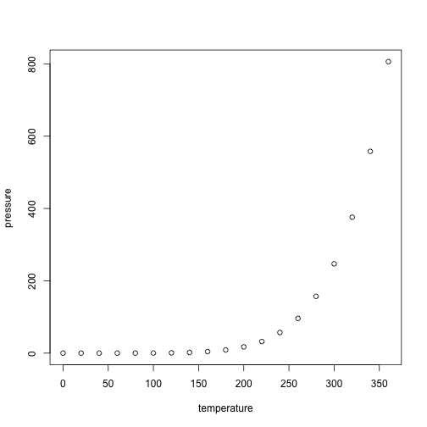

RPLACEHOLDER