My Title

Created 2019-05-09

## Reversible R Markdown Document

This is an example Reversible R Markdown document. It will preserve code elements for restoration in your final .docx file.

You can use things like inline RPLACEHOLDER comments.

You can use code chunks to generate output and they will be restored:

summary(cars)

## speed dist   
## Min. : 4.0 Min. : 2.00   
## 1st Qu.:12.0 1st Qu.: 26.00   
## Median :15.0 Median : 36.00   
## Mean :15.4 Mean : 42.98   
## 3rd Qu.:19.0 3rd Qu.: 56.00   
## Max. :25.0 Max. :120.00

## Inline text

RPLACEHOLDER

You can include calculations inline like so: 2 plus 3 equals 5. Even empty inline chunks RPLACEHOLDER will be stored and marked with hidden text in the Word document.

## Chunks with plots

You can of course also embed plots, for example:

plot(pressure)

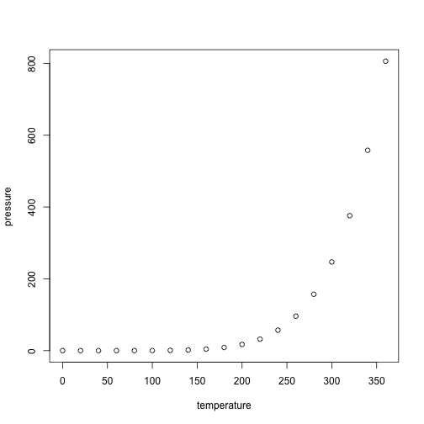

RPLACEHOLDER