Cairo University  
Faculty of Computers and Information



**CS251**

**Software Engineering I**

Software Design

F3A

Software Requirements Specifications

Amany AbdEl-Aal

Amira Khaled

Aya Mohammed

Fatma Ahmed

12 -2016

Contents

Team 3

Document Purpose and Audience 3

System Models 3

I. Class diagrams 3

Important Algorithm 5

II. Sequence diagrams 5

Class - Sequence Usage Table 7

Ownership Report 8

Policy Regarding Plagiarism: 8

References 8

Authors 8

# Team

|  |  |  |  |
| --- | --- | --- | --- |
| **ID** | **Name** | **Email** | **Mobile** |
| 20140201 | Fatma Ahmed | [0fatma.ahmed@gmail.com](mailto:0fatma.ahmed@gmail.com) | 01147084811 |
| 20140075 | Amira khaled | [amiraKhaled35@gmail.com](mailto:amiraKhaled35@gmail.com) | 01127018549 |
| 20140069 | Amany Abd El-Aal | [Amanya.sultan@outlook.com](mailto:Amanya.sultan@outlook.com) | 01224102660 |
| 20140089 | Aya mohamed | Ayakenawy7@gmail.com | 01060928079 |

# Document Purpose and Audience

* **This document about sequence diagram and class diagram to 3 use cases(sign up as a teacher ,play game as student and create game as teacher)that is phase 2 of project of software to educational game.**
* **my target audience to read this document is my TA.**

# System Models

## I. Class diagrams

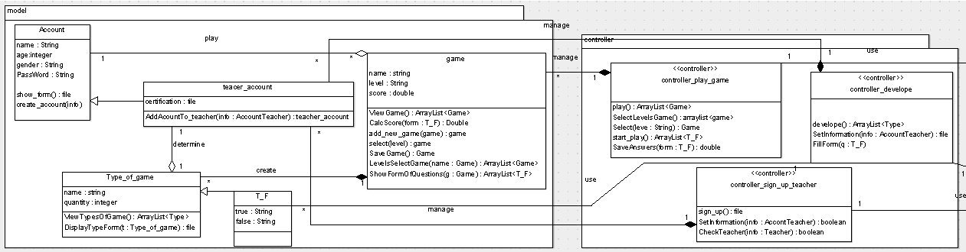

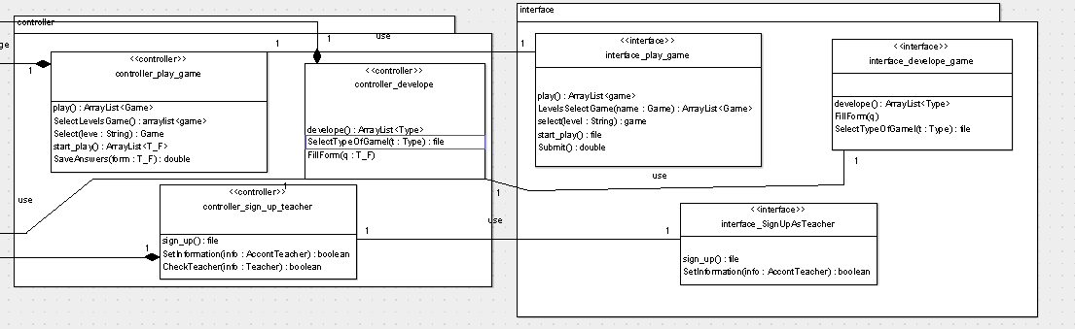

**Classes and its description**

| **Class ID** | **Class Name** | **Description & Responsibility** |
| --- | --- | --- |
| 1 | account | 1)Show form  " to fill information of registration "  2)create account(info) |
| 2 | Teacher_account | 1)Add account to teacher |
| 3 | Type_of_game | 1. View Types Of Game 2. Display Type Form |
| 4 | T_F | 1. Have attributes of format of game |
| 5 | game | 1. View Game 2. Select level "available level to choose from it" 3. Save Game "after teacher develop it" 4. Calculate Score "after student finish 80%of the determine game" 5. Levels Select Game "take his choice that he make it" 6. Show Form Of Questions "to student start play and answer it" 7. Add new game" after teacher save the game that he developed it" |
| 6 | Controller  _play_game | 1. play 2. Select Levels Game 3. Return selected game 4. Start play 5. Save answers |
| 7 | controller_develope | 1. develop 2. Fill Form " write the question of the game by true or false" |
| 8 | Controller  _sign_up_teacher | 1. Sign up 2. Set Information "to registration" 3. Check Teacher "if information is valid or not" |
| 9 | interface_play_game | 1. play 2. Levels Select Game 3. Start play 4. Submit "to answer the game and return his score if he exceed 80% 5. Select level |
| 10 | interface_develope_game | 1. develop 2. Fill Form |
| 11 | interface_SignUpAsTeacher | 1. Sign up 2. Set Information |

## 

## II. Sequence diagrams

Play game (1)

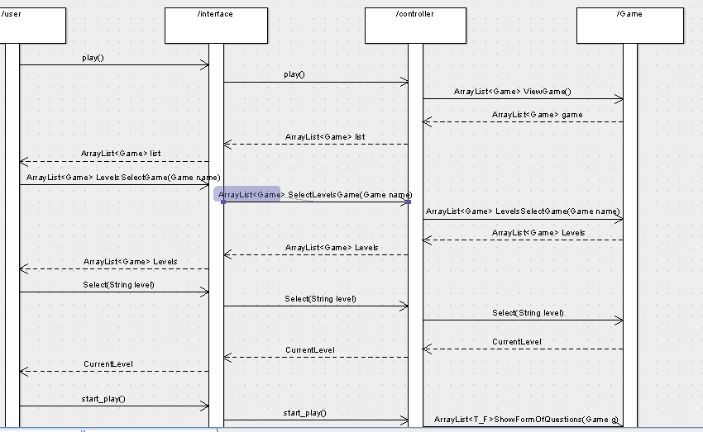

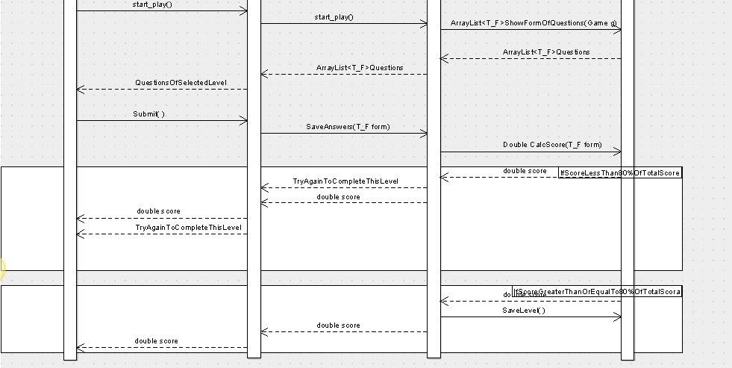

SignUpAsTeacher(2)

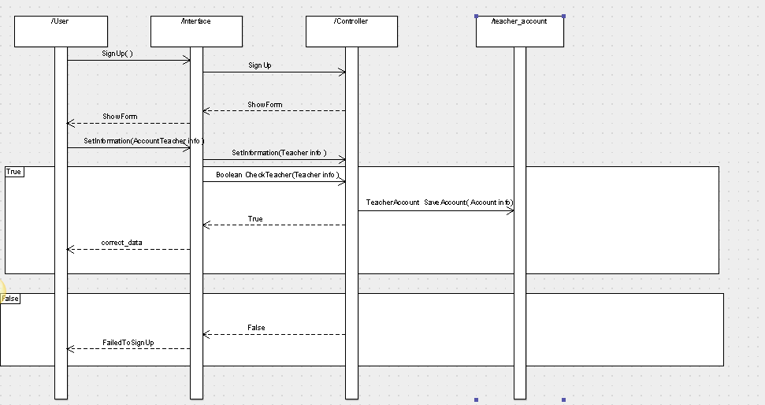

Develop game (3)

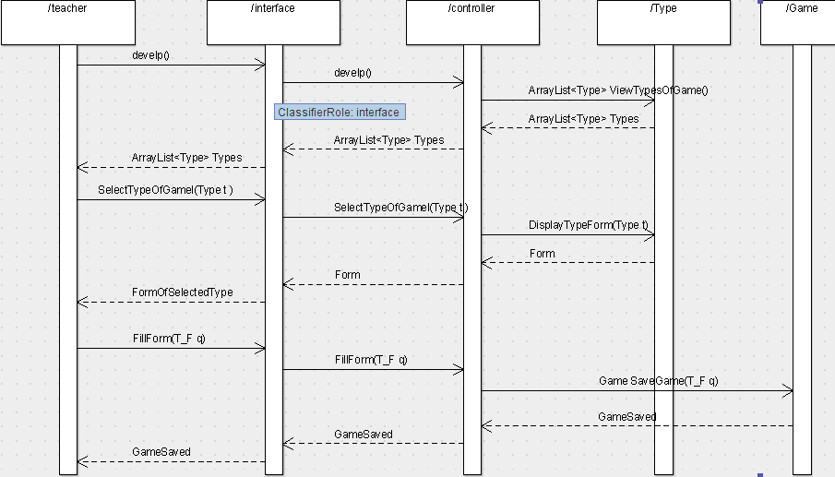

### Class - Sequence Usage Table

| **Class Name** | **Sequence Diagrams** | | **Overall used methods** |
| --- | --- | --- | --- |
| Account | 1 | | showForm |
| Teacher_account | 2 | | saveAccount |
| Type_of_game | 3 | | viewTypeOfGame , DisplayTypeForm |
| T_F | 3 | |  |
| game | 1,3 | | ViewGame , LevelSelectGame ,  Select , ShowFormOfQuestions  , ClacScore , SaveLevel |
| Controller_play_game | 1 | | Play , selectLevelsGame ,Select ,  Start_play , saveAnswers |
| Controller_develop | 3 | | Develop , SelectTypeOfGame ,  FillForm |
| Controller_sign_up_teacher | | 2 | Signup,setInformation,  checkTeacher |
| Interface_play_game | 1 | | Play , levelSelectGame , Select , Start_play , submit |
| Interface_signupAsTeacher | 2 | | Sign_up,setInformation |
| Interface_develop_game | 3 | | Develop , FillForm , SelectTypeOfGame , |

## GitHub link

# References

* http://www.mhhe.com/engcs/compsci/pressman/graphics/Pressman5sepa/common/cs1/design.pdf

# Authors

* (Edited by Mohamed Samir)