Cairo University  
Faculty of Computers and Information



**CS251**

**Software Engineering I**

Software Design

F3A

Software Requirements Specifications

Amany AbdEl-Aal

Amira Khaled

Aya Mohammed

Fatma Ahmed

12 -2016

Contents

Team 3

Document Purpose and Audience 3

System Models 3

I. Class diagrams 3

Important Algorithm 5

II. Sequence diagrams 5

Class - Sequence Usage Table 7

Ownership Report 8

Policy Regarding Plagiarism: 8

References 8

Authors 8

# Team

|  |  |  |  |
| --- | --- | --- | --- |
| **ID** | **Name** | **Email** | **Mobile** |
| 20140201 | Fatma Ahmed | [0fatma.ahmed@gmail.com](mailto:0fatma.ahmed@gmail.com) | 01147084811 |
| 20140075 | Amira khaled | [amiraKhaled35@gmail.com](mailto:amiraKhaled35@gmail.com) | 01127018549 |
| 20140069 | Amany Abd El-Aal | [Amanya.sultan@outlook.com](mailto:Amanya.sultan@outlook.com) | 01224102660 |
| 20140089 | Aya mohamed | Ayakenawy7@gmail.com | 01060928079 |

# Document Purpose and Audience

* **This document about sequence diagram and class diagram to 3 use cases(sign up as a teacher ,play game as student and create game as teacher)that is phase 2 of project of software to educational game.**
* **my target audience to read this document is my TA.**

# System Models

## I. Class diagrams

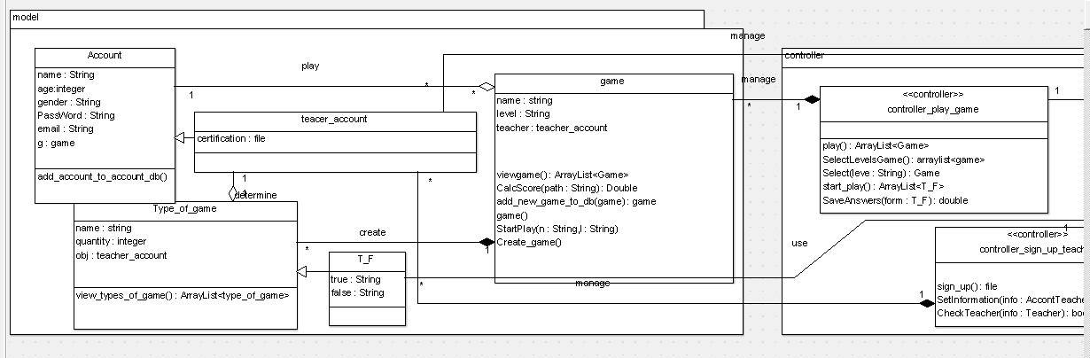

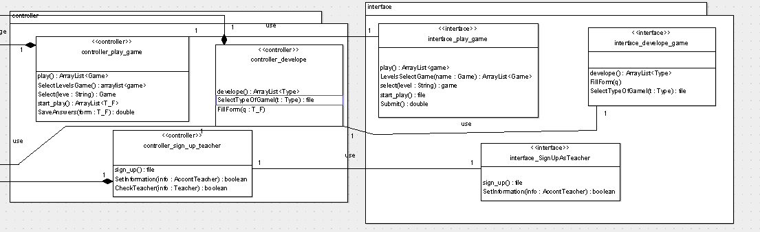

**Classes and its description**

| **Class ID** | **Class Name** | **Description & Responsibility** |
| --- | --- | --- |
| 1 | account | 1)add_account_to_db  To add the account to database |
| 2 | Teacher_account | Have attribute to verify the teacher |
| 3 | Type_of_game | 1)view_types_of_game()  To display to user the type of game available on site |
| 4 | T_F | 1. Have attributes of format of game |
| 5 | game | 1)viewgame()  To display the game with its levels  2)StartPlay()  To start playing  3)CalcScore(String path)  To calculate score for user (student ,teacher,..)  4)game()  Default constructor  5)Create_game()  To allow teacher to add its game with new questions  6)add_new_game_to_db()  To add the new game to database |
| 6 | Controller  _play_game | 1. play 2. Select Levels Game 3. Return selected game 4. Start play 5. Save answers |
| 7 | controller_develope | 1. develop 2. Fill Form " write the question of the game by true or false" |
| 8 | Controller  _sign_up_teacher | 1. Sign up 2. Set Information "to registration" 3. Check Teacher "if information is valid or not" |
| 9 | interface_play_game | 1. play 2. Levels Select Game 3. Start play 4. Submit "to answer the game and return his score if he exceed 80% 5. Select level |
| 10 | interface_develope_game | 1. develop 2. Fill Form |
| 11 | interface_SignUpAsTeacher | 1. Sign up 2. Set Information |

## 

## II. Sequence diagrams

Play game (1)

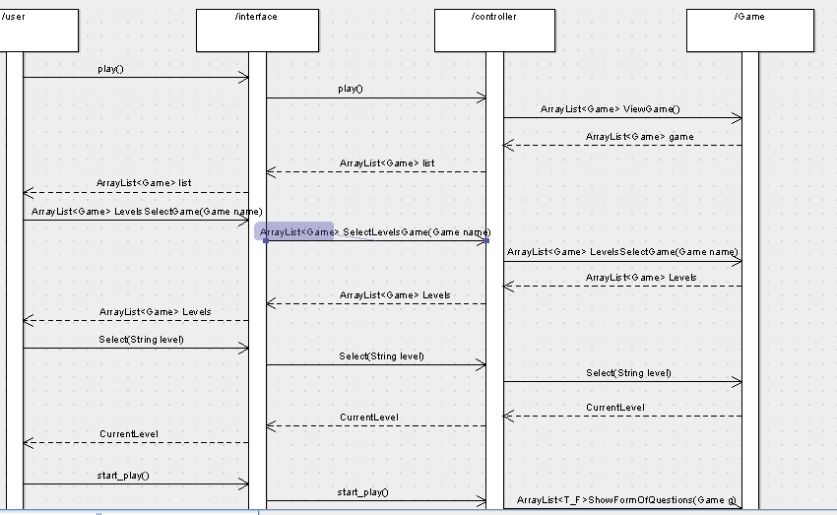

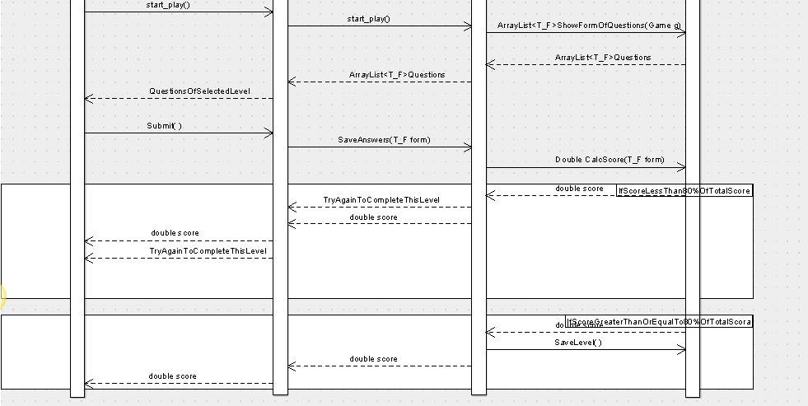

SignUpAsTeacher(2)

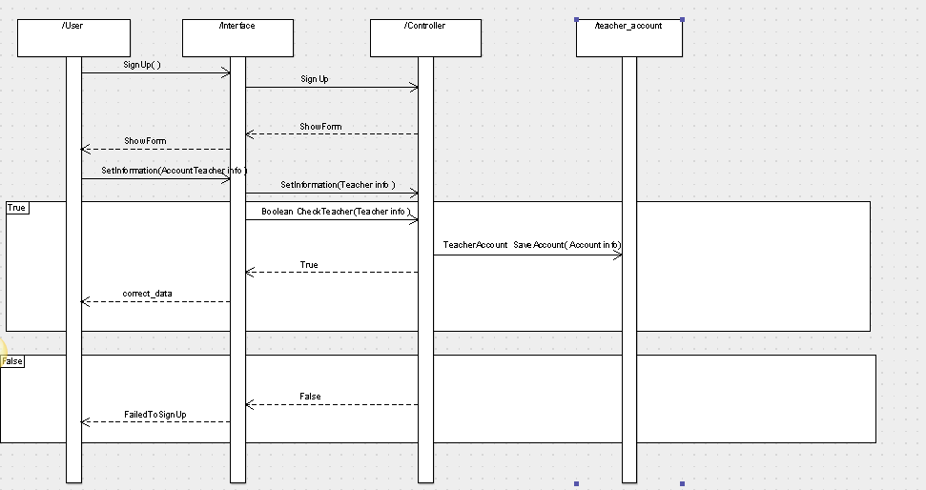

Develop game (3)

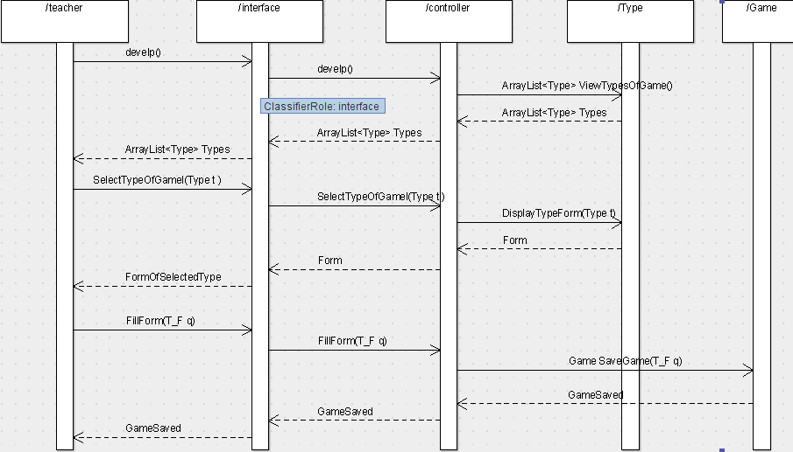

### Class - Sequence Usage Table

| **Class Name** | **Sequence Diagrams** | | **Overall used methods** |
| --- | --- | --- | --- |
| Account | 1 | | showForm |
| Teacher_account | 2 | | saveAccount |
| Type_of_game | 3 | | viewTypeOfGame , DisplayTypeForm |
| T_F | 3 | |  |
| game | 1,3 | | ViewGame , LevelSelectGame ,  Select , ShowFormOfQuestions  , ClacScore , SaveLevel |
| Controller_play_game | 1 | | Play , selectLevelsGame ,Select ,  Start_play , saveAnswers |
| Controller_develop | 3 | | Develop , SelectTypeOfGame ,  FillForm |
| Controller_sign_up_teacher | | 2 | Signup,setInformation,  checkTeacher |
| Interface_play_game | 1 | | Play , levelSelectGame , Select , Start_play , submit |
| Interface_signupAsTeacher | 2 | | Sign_up,setInformation |
| Interface_develop_game | 3 | | Develop , FillForm , SelectTypeOfGame , |

## GitHub link

# References

* http://www.mhhe.com/engcs/compsci/pressman/graphics/Pressman5sepa/common/cs1/design.pdf

# Authors

* (Edited by Mohamed Samir)