Cairo University  
Faculty of Computers and Information



**CS251**

**Software Engineering I**

F3A

Software Requirements Specifications

Amany AbdEl-Aal

Amira Khaled

Aya Mohammed

Fatma Ahmed

5/11/2016

Contents

Team 3

Document Purpose and Audience 3

scenario 3

Introduction 4

Software Purpose 4

Software Scope 4

Requirements 4

Functional Requirements 4

Non Functional Requirements 4

System Models 5

Use Case Model 5

Use Case Tables 5

Ownership Report 15

# 

# Team

|  |  |  |  |
| --- | --- | --- | --- |
| **ID** | **Name** | **Email** | **Mobile** |
| 20140201 | Fatma Ahmed | [0fatma.ahmed@gmail.com](mailto:0fatma.ahmed@gmail.com) | 01147084811 |
| 20140069 | Amany Abd El-Aal | [Amanya.sultan@outlook.com](mailto:Amanya.sultan@outlook.com) | 01224102660 |
| 20140075 | Amira Khaled Hassanin | [amiraKhaled35@gmail.com](mailto:amiraKhaled35@gmail.com) | 01127018549 |
| 20140089 | Aya Mohamed Mohamed | [Ayakenawy7@gmail.com](mailto:Ayakenawy7@gmail.com) | 01060928079 |

# Document Purpose and Audience

* **This document describes the software requirements for a game-based educational platform.**
* **It’s intended for the owner of the project and other developers.**

# Scenario

The system is introducing games to understand specific concepts of different levels of math i.e. (math1, math2, math3). It support to try playing game or sign in by your account that you have created as a teacher or student the system verify your entering user name and password. If you create account as a teacher you have to have certifications online. The student and teacher have this functions they can play game, rate game from 1 to 5 *, share any data, send complain (technical complain) to system, change setting like changing of design color or update personal information, chatting with specific activate account and download game except unavailable new game (doesn’t take enough rate), if you are a teacher you have extra function like modify game belongs to another teacher if and only if he gives you the permission and develop a new game. system is Usability simple to use, Reliability support no failure or crash in system, Reality which means introduce right education, Availability of system should working 24 per hours, Performance according to short response time, Security of every account access by only user account and password, has Constraints rules of game and has Privacy that means any teacher can modify another game if and only if owner of game give him permission.

# Introduction

## Software Purpose

**1. To let students gain more information in different, easy and funny ways about specific field they were chosen.**

**2. Supply teachers with new tools and features to help them adding their own game.**

## Software Scope

* **This is web application software for education (math).**
* **The structure of game is multiple choice, voice interaction and complete sentences.**

# Requirements

## Functional Requirements

* **Start game: - The user will select which section s/he will play (Math1, Math2 and Math3).**
* **Create account: - Set personal information to let the system identify.**
* **Check teacher: - if user as a teacher check specific information.**
* **Play game: - Play available levels that the system determined from the evaluation test.**
* **Rate game: - To rate performance of the game depended on playing the game.**
* **Share: - To share game and score of game with others.**
* **Send complain: - If the user faces any problem, then s/he will able to send a report about it.**
* **Change setting: - Can control his/her profile settings.**
* **Chat: - chatting with anyone has account.**
* **Download: - Downloading the game on his/her platform.**
* **Develop: - teacher creates game.**
* **Modify: - teacher can modifies game.**
* **Verification: - confirm user’s account.**

## Non Functional Requirements

* **Usability: - simple to use.**
* **Reliability: - no failure or crash in system.**
* **Reality: - introduce right education.**
* **Availability: - system is working 24 hours.**
* **Performance: - short response time.**
* **Security: - every account access by only user account and password.**
* **Constraints: - rules of game.**
* **Privacy: - any teacher can modify another game if and only if owner of game give him permission.**

|  |  |
| --- | --- |
|  | **Details** |
| **Performance** | * **Withdraw operation will be done within 20 second** |
| **Scalability** | * **System should be able to support up to 1000 simultaneous game players.** |

# System Models

## Use Case Model

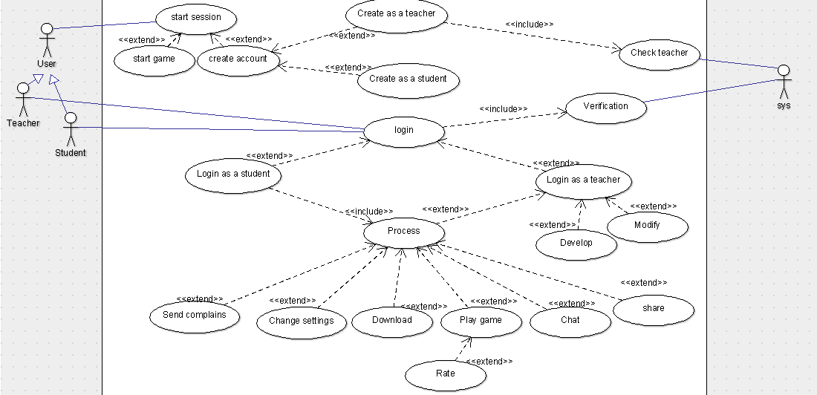

## Use Case Tables

|  |  |  |
| --- | --- | --- |
| Use Case ID: | 1 | |
| Use Case Name: | Start game | |
| Actors: | User (Teacher, Student, Guest) | |
| Pre-conditions: | Start session | |
| Post-conditions: | Get score | |
| Flow of events: | **User Action** | **System Action** |
| 1- Select game. |  |
|  | 2- Open available levels of selected game. |
| 3- Select desired level. |  |
|  | 4- Open selected level. |
| 5- Play game |  |
|  |  | 6- Calculate score. |
| Exceptions: | **User Action** | **System Action** |
|  |  |
|  |  |
| Includes: |  | |
| Notes and Issues: |  | |

|  |  |  |
| --- | --- | --- |
| Use Case ID: | 2 | |
| Use Case Name: | Create account. | |
| Actors: | User (New visitor). | |
| Pre-conditions: | Start session. | |
| Post-conditions: | Account created. | |
| Flow of events: | **User Action** | **System Action** |
| 1- Choose create account. |  |
|  | 2- Create as a student or as a teacher? |
| 3- Select his/her choice. |  |
|  | 4- Open form of s/he selected. |
| 5- Fill his/her personal information that is required. |  |
|  | 6- Submit. |  |
|  |  | 7- Account created. |
| Exceptions: | **User Action** | **System Action** |
| 1- User enter invalid field. |  |
|  | 2- Display error message. |
| Includes: |  | |
| Notes and Issues: |  | |

|  |  |  |
| --- | --- | --- |
| Use Case ID: | 3 | |
| Use Case Name: | Check teacher. | |
| Actors: | System | |
| Pre-conditions: | Create account as a teacher. | |
| Post-conditions: | Teacher account created. | |
| Flow of events: | **User Action** | **System Action** |
| 1- User pressed submit button. |  |
|  | 2- System verifies user data.  3- Teacher account created. |
| Exceptions: | **User Action** | **System Action** |
| 1- User data entered as a teacher isn’t correct. |  |
|  | 2- Data entered is invalid and not identified.  3- System rejects the registered teacher. |
| Includes: |  | |
| Notes and Issues: |  | |

|  |  |  |
| --- | --- | --- |
| Use Case ID: | 4 | |
| Use Case Name: | Login | |
| Actors: | User (Teacher, Student). | |
| Pre-conditions: | Has an account. | |
| Post-conditions: | Account opened. | |
| Flow of events: | **User Action** | **System Action** |
| 1- User Enter username and Password. |  |
|  | 2- System Verifies user data |
| Exceptions: | **User Action** | **System Action** |
| 1- User Enter invalid username or Password. |  |
|  | 2- Entered data is invalid and not identified.  3- System rejects login. |
| Includes: |  | |
| Notes and Issues: |  | |

|  |  |  |
| --- | --- | --- |
| Use Case ID: | 5 | |
| Use Case Name: | Share. | |
| Actors: | User (Student, Teacher). | |
| Pre-conditions: | Login. | |
| Post-conditions: | Data shared. | |
| Flow of events: | **User Action** | **System Action** |
| 1- User Share data (Game link, Game level). |  |
|  | 2- List web sites that can shared data above. |
|  | 3- Select the desired web site. |  |
|  |  | 4. Data shared. |
| Includes: |  | |
| Notes and Issues: |  | |

|  |  |  |
| --- | --- | --- |
| Use Case ID: | 7 | |
| Use Case Name: | Chat. | |
| Actors: | User (Teacher, Student). | |
| Pre-conditions: | Login. | |
| Post-conditions: | Successful Communication. | |
| Flow of events: | **User Action** | **System Action** |
| 1- User press chat. |  |
|  | 2- List available people within her/his network. |
| 3- Choose the one s/he wanted. |  |
|  | 4- Open chat window of selected person. |
| Exceptions: | **User Action** | **System Action** |
| 1- User select deactivated account. |  |
|  | 2- The selected account had deactivated. |
| Includes: |  | |
| Notes and Issues: |  | |

|  |  |  |
| --- | --- | --- |
| Use Case ID: | 8 | |
| Use Case Name: | Play game. | |
| Actors: | User (Teacher, student). | |
| Pre-conditions: | Login. | |
| Post-conditions: | Change in score. | |
| Flow of events: | **User Action** | **System Action** |
| 1- Play game. |  |
|  | 2- System Save score. |
| Exceptions: | **User Action** | **System Action** |
| 1- User exit before end of game. |  |
|  | 2- Score won’t change. |
| Includes: |  | |
| Notes and Issues: |  | |

|  |  |  |
| --- | --- | --- |
| Use Case ID: | 9 | |
| Use Case Name: | Download. | |
| Actors: | User (Teacher, Student). | |
| Pre-conditions: | Login. | |
| Post-conditions: | Game downloaded. | |
| Flow of events: | **User Action** | **System Action** |
| 1- User selects game. |  |
|  | 2- Downloading.  3- Game downloaded. |
| Exceptions: | **User Action** | **System Action** |
| 1- Select non available game to download. |  |
|  | 2- Not available to download. |
| Includes: |  | |
| Notes and Issues: |  | |

|  |  |  |
| --- | --- | --- |
| Use Case ID: | 10 | |
| Use Case Name: | Change setting. | |
| Actors: | User (student, teacher). | |
| Pre-conditions: | Login. | |
| Post-conditions: | Information changed. | |
| Flow of events: | **User Action** | **System Action** |
| 1- Select the field that wants to change. |  |
| 2- Fill new data. |  |
| 3- Save. |  |
|  | 4- changed done. |
|
| Exceptions: | **User Action** | **System Action** |
| 1- he filled invalid data according to fields’ constraints. |  |
|  | 2-not valid. |
| Includes: |  | |
| Notes and Issues: |  | |

|  |  |  |
| --- | --- | --- |
| Use Case ID: | 11 | |
| Use Case Name: | Rate. | |
| Actors: | User (student, teacher). | |
| Pre-conditions: | Play game. | |
| Post-conditions: | Rate changed. | |
| Flow of events: | **User Action** | **System Action** |
| 1-Enter rate. |  |
|  | 2- change rate of game. |
| Includes: |  | |
| Notes and Issues: |  | |

|  |  |  |
| --- | --- | --- |
| Use Case ID: | 12 | |
| Use Case Name: | Send complain. | |
| Actors: | User (student, teacher). | |
| Pre-conditions: | Login. | |
| Post-conditions: | Complain send to system. | |
| Flow of events: | **User Action** | **System Action** |
| 1-s/he enters complain. |  |
|  | 2- receive complain. |
| Includes: |  | |
| Notes and Issues: |  | |

|  |  |  |
| --- | --- | --- |
| Use Case ID: | 13 | |
| Use Case Name: | Modify. | |
| Actors: | User (teacher). | |
| Pre-conditions: | Login as a teacher. | |
| Post-conditions: | Modify game. | |
| Flow of events: | **User Action** | **System Action** |
| 1- select game. |  |
|  | 2- accepted to modify. |
| 3-teacher start to modify. |  |
|  | 4- game modified . |
| Includes: |  | |
| Notes and Issues: | If owner of game not accept to modify the system will prevent the modify. | |

|  |  |  |
| --- | --- | --- |
| Use Case ID: | 14 | |
| Use Case Name: | Create game | |
| Actors: | User(teacher) | |
| Pre-conditions: | Login as a teacher. | |
| Post-conditions: | Create a game. | |
| Flow of events: | **User Action** | **System Action** |
| 1- Select tool to create game. |  |
|  | 2- Make this tool available. |
| 3- Create game. |  |
|  | 4- Save game. |
| Exceptions: | **User Action** | **System Action** |
| 1- Use memory higher than determined size. |  |
|  | 2-not valid. |
| Includes: |  | |
| Notes and Issues: |  | |

# Ownership Report

All team members think together.