# EU 22 Software Engineering

ECUE Computer Projects

Language: Python (other)

“Image recognition with corrosion marks in industrial environments”

**Business**

DI Africa, Republic of Mauritius, [www.di-africa.com](http://www.di-africa.com/), provides international technical assistance, meaning that we send engineers and technicians to our customers' industrial sites. Our core business is *oil & gas* in Africa and their sites are often offshore platforms. We also intervene in other sectors such as mining, energy, nuclear power, construction or heavy industry in the broad sense or on other continents. We have been in existence since November 2019 and are currently located in Mauritius and Gabon, with other countries being opened. Two miners, including myself, are co-founders.

**Contact**

Bertrand Duvivier

[+41 797 861 999](callto:+41%20797%20861%20999)

[bduvivier@di-africa.com](mailto:bduvivier@di-africa.com)

**The topic**

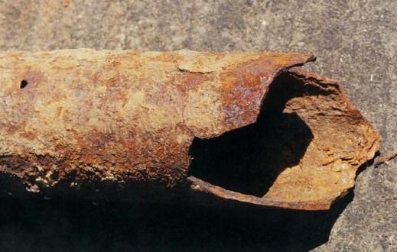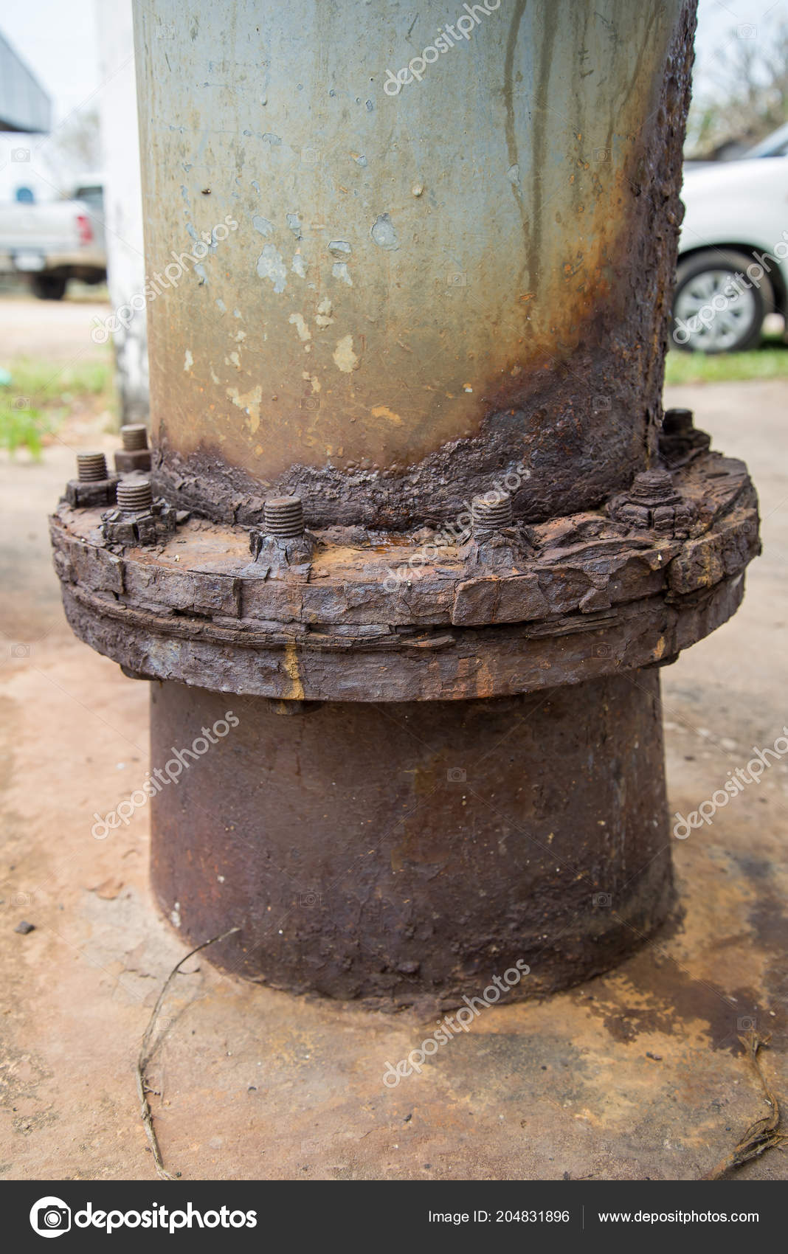It concerns the digitization of object recognition in industrial environments. The objective is to identify corroded structures or objects in an industrial and/or natural environment, such as:

* bridges and structures
* industrial equipment
* vehicles/planes/boats/trains, etc.
* large metal structures
* etc.

**Technologies**

The preferred language is Python with machine learning libraries like Tensorflow or other libraries to offer. The machine-learning technologies we propose to use are convolution neural networks but all other techniques will be tested.

From a methodological point of view, it is first of all to acquire a batch of photos on the Web and to characterize - presence or not - corrosion. The method of image acquisition is not specified, it is left to the discretion of the team knowing that an automatic or semi-automatic method would be preferred. The photo batch must be tagged “corroded” or “healthy” and the metadata must be accessible.

The next step is to create or train an image analysis algorithm to detect the presence of corrosion on a given object.

Several features are expected in this project:

* colour and texture corrosion detection
* 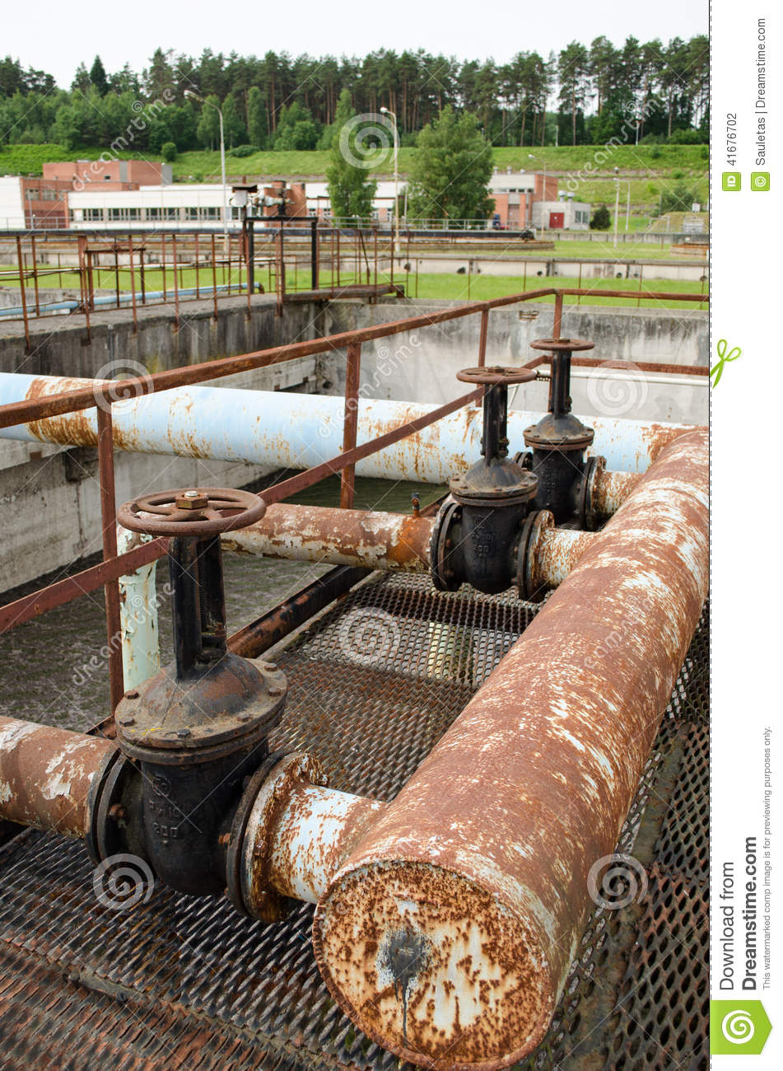Classification is the identification of the “class”, in other words the category, to which the image belongs. An image may have only one class of "corroded" or "not corroded". For example, corrosion can be established by a threshold of the *colour corrosion/colour* ratio above a threshold (for example 1%) and the absence of corrosion by a ratio below that threshold.
* Tagging *is a classification task but at a higher level of accuracy. This will make it possible to recognize the presence of several concepts or objects within an image. It is therefore possible to assign one or more tags to a particular image:*
  + severe corrosion: color ratio corrosion/ generic color *> 50%*
  + important corrosion: color ratio corrosion/ generic color *> 20%*
  + light corrosion: color ratio corrosion/ generic color *> 1%*

The group of students will also be asked to try out several machine learning approaches or even more traditional approaches to image processing in order to be able to choose the one most suited to the recognition of this type of images.