**Functions and Features (Rushaun)**

1. **Developed the Player Character and the Lives System.**
2. **Made the Scripts for the Player Character, including Player Movement and Jumping.**
3. **Made the Button Scripts and Text for the Gamestates; GamePause, GameWin, GameLose, Gameplay, Instructions.**
4. **Made the Goal GameObject and the Script.**
5. **Checked for Collision with the Goal GameObject and Player.**
6. **Made the UI Buttons for the Pause Menu.**

**User Acceptance Test (Rushaun)**

|  |  |  |  |  |  |  |
| --- | --- | --- | --- | --- | --- | --- |
| Test Case ID | Description | Input | Expected Result | Actual Result | Status | Remark |
| 1 | Player moves to the left direction | While “A” key is push | Player moves to the left | Player moves to the left | Pass | N/A |
| 2 | Player moves to the right direction | While “D” key is push | Player moves to the right | Player moves to the right | Pass | N/A |
| 3 | Player jumps from the ground | While “W” key is push | Player goes up in air and comes back down | Player jumps in the air and comes back down | Pass | N/A |
| 4 | When the player dies | When health reaches 0 or below | Player will play the death animations and lose screen will appear after | Player’s death animation plays and the Lose Screen becomes visible | Pass | N/A |
| 5 | When the player got hit | When player took any health damage | Player was knockback and/or hurt | Player gets hurt and is knocked back | Pass | N/A |
| 6 | When player collect items | Player collider with trigger items | Player deletes the item | Player deletes the item | Pass | N/A |
| 7 | When all items are collected | Player collides with items | Goal will appear at the end of the level | Goal appears at the end of the level. | Pass | N/A |
| 8 | When the player reached to the goal | Player collides with the goal | Win menu will appear | Win menu appears | Pass | N/A |

**Branches and Merges (Rushaun)**

**Unity Test Runner (Rushaun)**

**Functions and Features (Foo Yu Feng)**

1. **Added Features of knockback for players.**
2. **Added 4 New Functions of gamestats: GamePause, GamePlay, GameWin, GameLost.**
3. **Added the enemy: Slime.**
4. **Added functions of picking up items like crystals.**
5. **Added functions of player’s health and damage taken.**
6. **Added functions of player’s ground checker to allow players to have proper animations and different friction physic in air and ground.**
7. **Added functions of scoring points.**
8. **Added functions for audios playing.**
9. **Added feature of camera slowing moving towards the player.**
10. **Added functions of sprites changing animation based on conditions. (such as player jumping, or enemy moving, this script was made for multipurpose.)**
11. **Optimize colliders functions to work with certain colliders so each trigger is in their own layer of physics, this means enemies have another wall that the player can pass through, but enemy cannot.**
12. **Optimize everyone’s script to use FixUpdate(), as this is more of a consistent gameplay upon further testing.**

**User Acceptance Test (Foo Yu Feng)**

|  |  |  |  |  |  |  |
| --- | --- | --- | --- | --- | --- | --- |
| Test Case ID | Description | Input | Expected Result | Actual Result | Status | Remark |
| 1 | Player moves to the left direction | While “A” key is push | Player moves to the left | Player moves to the left | Pass | Nil |
| 2 | Player moves to the right direction | While “D” key is push | Player moves to the right | Player moves to the right | Pass | Nil |
| 3 | Player jumps from the ground | While “Space” key is push | Player goes up in air and comes back down | Player goes up in air and comes back down | Pass | Nil |
| 4 | When the player dies | When health reaches 0 or below | Player will play the death animations and lose screen will appear after | Player will play the death animations and lose screen will appear after | Pass | Nil |
| 5 | When the player got hit | When player took any health damage | Player was knockback and/or hurt | Player was knockback and/or hurt | Pass | Nil |
| 6 | When player collect items | Player collider with trigger items | Player deletes the item | Player deletes the item | Pass | Nil |
| 7 | When all items are collected | Player collides with items | Goal will appear at the end of the level | Goal will appear at the end of the level | Pass | Nil |
| 8 | When the player reached to the goal | Player collides with the goal | Win menu will appear | Win menu will appear | Pass | Nil |

**Branches and Merges (Foo Yu Feng)**

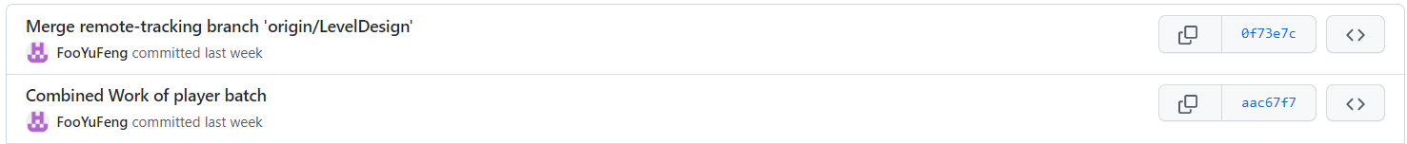 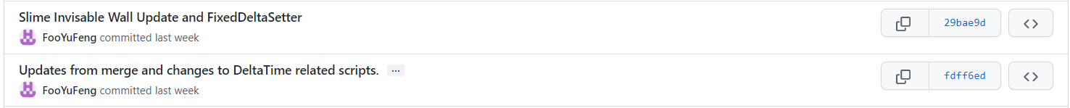     

**Unity Test Runner (Foo Yu Feng)**

**Functions and Features (Oliver)**

1. **Added Level Design**
2. **Added features Spikes and Lazers**
3. **Coded functions for the Lazers to spin**
4. **Added 2D Collider on platform so player can stand on it**
5. **Created Trigger Boxes in Lava and Spikes**
6. **Added functions of Lazers shooting**
7. **Changed background color to fit the color of background map**
8. **Added gems around the map**
9. **Added/Coded flag at the end of the map after collecting gems**

**User Acceptance Test (Oliver)**

|  |  |  |  |  |  |  |
| --- | --- | --- | --- | --- | --- | --- |
| Test Case ID | Description | Input | Expected Result | Actual Result | Status | Remark |
| 1 | Player moves to the left direction | While the “A” key is push | Player moves to the left | Player moves left and slides | Pass | Nil |
| 2 | Player moves to the right direction | While the “D” key is push | Player moves to the right | Player moves right and slides | Pass | Nil |
| 3 | Player jumps from the ground | While “Space” key is push | Player goes up in air and comes back down | Player jumps | Pass | Nil |
| 4 | When the player dies | When health reaches 0 or below | Player will play the death animations and lose screen will appear after | Yes player dies when health reaches 0 | Pass | Nil |
| 5 | When the player got hit | When player touches spikes/lava/slimes | Player was knockback and loses one health | Player takes knockback | Pass | Nil |
| 6 | When player collect gems | Player in trigger box of gem | Gem deletes | Gem deletes | Pass | Nil |
| 7 | When all gems are collected | If gem in map = 0 | Goal will appear at the end of the level | Gem collected | Pass | Nil |
| 8 | When the player reached to the goal | Player collides with the goal | Win menu will appear | Game Wins | Pass | Nil |

**Branches and Merges (Oliver)**

**Unity Test Runner (Oliver)**

