**IOT Based Vehicle Tracking and Management System**

Monoget Saha and Md. Asaf-uddowla Golap

Institute of Information and Communication technology

Khulna University of Engineering & Technology (KUET)

Khulna 9203, Bangladesh

monoget1@gmail.com, asaf.golap@iict.kuet.ac.bd

**ABSTRACT**

This project aims to introduce a low-cost and customization IOT Based Vehicle Tracking and Management System to address the limitations in existing real-time tracking solutions. Especially, my system ensures immediate, precise real-time connectivity to make critical decisions from moment to moment. Moreover, it significantly reduces real-time tracking solution cost by utilizing the Raspberry Pi and cost-effective IOT devices without compromising efficiency, which is the key to the accessibility of the system. The other functionality that the platform offers is the highly customized analytical system to help access data and find the best route. The immediate response from the protocol integration guarantees an instant and secure mechanism to reach the emergency. Moreover, the system does include the Geo-fencing feature that provides a highly customized security measure for the system and dataset. Lastly, focusing on user access control makes the system highly secure and prevents data access issues and privacy. Thus, IOT Based Vehicle Tracking and Management System would deliver affordable vehicle monitoring solutions across industries.

**Keywords- Vehicle Tracking; Cost-effective; Geo-fencing; Security;**

1. **INTRODUCTION**

This proposed project intends the current vehicle tracking systems as there are several deficiencies in the current systems. In most cases, the information is not updated in time which makes it less efficient in terms of the real-time connection of information. In such systems related to security and emergency response, real-time data is required thus such initiatives have not been effective. In the current systems, these applications are proprietary and cannot be completely customized to fit the specific needs of all organizations. The lack of data analytics in the current tracking systems does not provide the required level of information on the optimal routes or resource allocation.

IOT Based Vehicle Tracking and Management System: The most fundamental part of our project, this system’s key point of differentiation is its pinpoint real-time connectivity with vehicles outside the office. As a result, the sending of data is accurate to the second, which is essential in situations where time is of the essence to make a decision or respond [1].

The cost-effectiveness of our system made possible through Raspberry Pi and web based software, is noteworthy [2]. The elimination of prohibitive initial costs that come with proprietary hardware and software licenses means that our financial feasibility expands the potential reach of advanced vehicle tracking systems. In addition, the proposed system is able to do more than simple tracking. It provides a lot of statistical data on user routes and consumption rates of fuel. Thus this will improve the overall efficiency of transportation management [3].

Moreover, the system’s real-time connectivity during urgent situations enables immediate response and smooth connection with emergency services and security processes. Such an ability to address a broad spectrum of urgent scenarios efficiently is enabled by the system’s quality of its functional ability [4]. Geo-fencing and cost monitoring integrated into our system also provide an additional layer of convenience. For instance, geo-fencing enables the user to set virtual boundaries and receive an alert or have the action triggered when the vehicle enters or exits the area. At the same time, parameters and tracking of fuel consumption and operational costs, alongside route optimization, enables data-driven decision-making through which cost and accessibility are provided [5].

Therefore, I was able to present a fully developed IOT Based Vehicle Tracking and Management System that eliminates the mentioned weaknesses and responds to the growing need for affordable and applicable monitoring solutions in various industries. More specifically, the system’s advanced properties concerned the cost-effectiveness efficiency, and security of the following applications [6].

1. **MATERIALS AND EXPERIMENT PROCEDURE**
2. **Architecture**

An important method of data collection from vehicles is the use of Raspberry Pi. The presented system uses the GPS module to interface with the Raspberry Pi via a data connection. The GPS module collects location data from satellites. After processing the data, it is transmitted over the internet to a web server. The vehicle data is then available for users through a web-based interface. The data can also be securely monitored using a GPS tracker [7]. The data is processed and securely transmitted through the internet to the web server, where it is processed and stored. Users can view and analyze the data using various applications that allow data visualization. During the entire process, measures are implemented to improve security and protect data integrity. It enables smooth data flow and tracking of location data, which can be used for decision-making and other purposes such as user interaction. See Figure-1 below for better visualization.

Figure-1: System Architecture.

1. **Hardware**

The hardware architecture of our research project is intended to form an incisive IOT Based Vehicle and Management System using Raspberry Pi as the processed-base unit to process and conduct the whole process of handling data. Connecting a GPS module, for instance, the NEO-6M Module, enables accurate closed-loop processing of data, and this enables one to easily locate the position and the state of the other vehicle as well [8]. See Figure-2 above for the installation of Raspberry software.

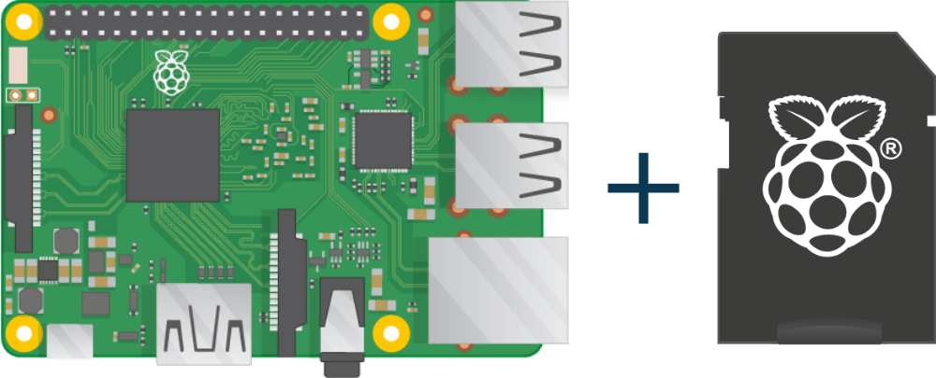

Figure-2: Software Installation.

Stable power is assured for uninterrupted operation through the use of power banks. The option of a Wi-Fi or modem internet connection ensures that there is a steady link to the web server and that the software, among other applications, receives real-time updates. The effective use of the GPIO pins links and controls the software, wirelessly, mainly the display units [9].

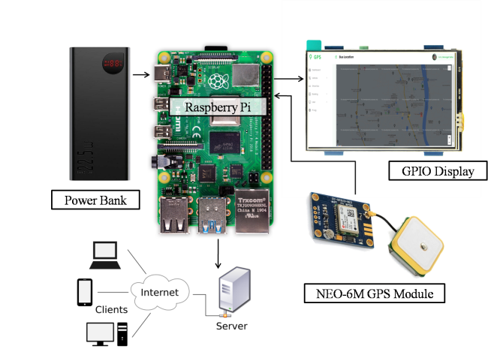

Figure-3: Hardware Configuration.

Most importantly, serial communication or UART is connected from the Raspberry Pi to the GPS module, allowing the flow of data essential for live tracking. This precision of hardware setup has been well detailed in a technical specification document, Figure-3, which shows the following setup summary. The above setup demonstrates preciseness, compatibility, and live data gathering, core attributes in the successful establishment of an effective vehicle tracking system [10].

1. **Operating system and software’s**

In deploying the Real-time IOT Based Vehicle Tracking and Management System, the first step is configuring the single-board computer, Raspberry Pi. Through the supplied peripherals, including a keyboard and a mouse, the Raspbian operating system is installed and the computer started [11]. Secondly, Step 2 makes the Raspberry Pi ready to operate by connecting the GPS module to it using the GPIO pins. By loading the required drivers and setting the required serial communication, the system is configured to initialize and load the GPS data.

Step 3 covers internet connection, with the possibility to use Wi-Fi or Ethernet to connect the Raspberry Pi. It requires configuring the network so that there are no interruptions in the internet connection. Step 4 contains coding for the Raspberry Pi, which is the foundation for data transfer with the selected communication protocols, such as HTTP.

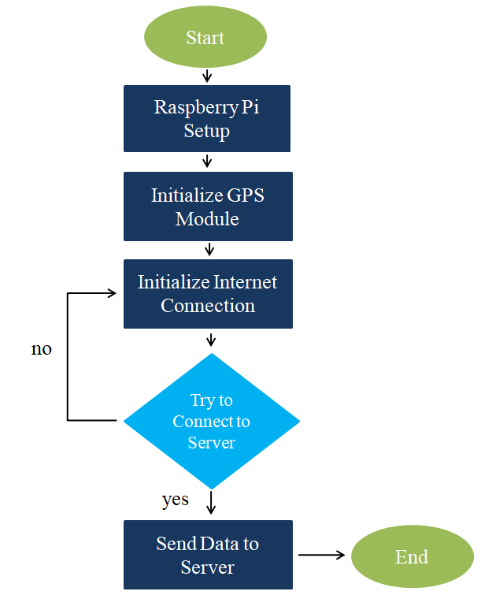

Figure-4: Flow chart of send data from Raspberry Pi to server.

Thus, in Step 5, the GPS module starts giving the location data. This data is later read from the GPS module via the serial that was used to create the connection initially. In Step 6, the raw GPS data is processed and formatted. This may involve cleaning noise, and converting the data to coordinates, hence making the data reusable. In Figure-4 we show the flow chart of our full process of collecting data and sending it to the server.

Last but not least is step 7, sending the formatted GPS data to the server. This may involve packaging the data into a form that can be transmitted and using the available internet to send the data to a remote server, which may be a cloud. The seven steps together describe how a Raspberry Pi can be connected with a GPS module to track a vehicle or send data [12].

1. **Web Integration**
2. **Development**

The development of a web-based user interface for IOT Based Vehicle Tracking and Management System is the main target of this document. Server-side scripting was performed using Python and PHP, while HTML, CSS, and JavaScript were employed for the front-end. The flowchart Figure-5 below depicts the fundamental components of this project, beginning with the dynamic map display to the end-user. The development process included the following activities: configuring * the Nginx web server, installing PHP as the server-side scripting language, and using PHP scripts to process and retrieve data. Before the MySQL database, PHP is used to establish a secure connection between the database and Nginx, which makes it possible to retrieve data securely. In this step, PHP utilizes scripts that query the database and retrieve the latest GPS information collected from the monitored vehicle before converting it into a structured format and plotting map markers created dynamically from HTML, CSS, and Bootstrap styles. Finally, the users access the tracking webpage and monitor the system, interacting with the dynamic map through their web browser and receiving real-time information.

1. **System Integration and Database Connectivity**

Below emphasis is on the foundational steps required for system integration and database connectivity. Step 1: Server Setup comprises a configuration of Nginx web server for efficient operation. This builds PHP scripts to pre-execute operations, like read and write data. Step 2: Database Design and Connect illustrates how a secure MySQL database connection is made by either end-user or device using credentials and access controls. Step 3: Retrieve Vehicle Data concentrates on PHP scripts that use a database connection to get the most recent saved GPS data. The Format Data, step 4, refers to the conversion of raw GPS data to a formatted view to which the Mapping action can connect. Generate Dynamic Map Marker, step 5, refers to the technique by which HTML, CSS, and Bootstrap assist in the development of the interactive map reflecting the vehicle’s current position through the GPS system. Therefore, these two categories provide the reader with insight into the basic components upon which the whole system is constructed, thus guaranteeing a secure connection of data as well as swift processing to maximize user experience.

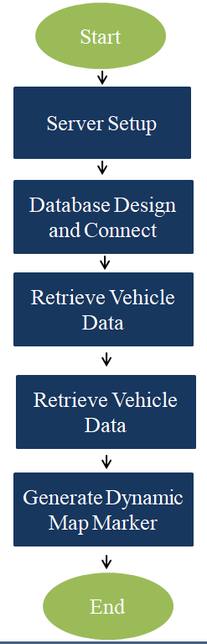

Figure-5: Flow chart of server to Show Dynamic Map to user.

1. **RESULTS**

Below are the expected outcomes of the project on the development of an IOT Based Vehicle Tracking and Management System: A real-time vehicle tracking facility that helps the user to monitor his vehicles’ real-time locations instantly. Integration of real-time GPS tracking and distance calculation will help to provide exact and up-to-the-minute information about vehicle location and distance traveled.

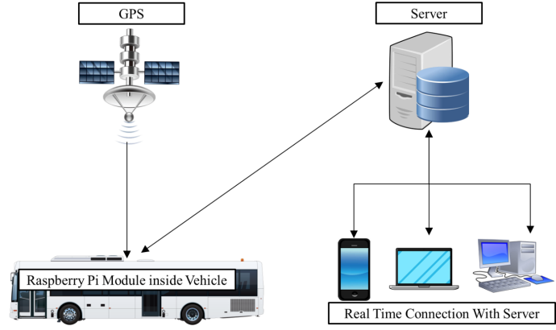

Figure-6: Vehicle tracking system.

The integration of GPS and GCEs will help to provide exact and up-to-the-minute information about the vehicle location and distance traveled. Implementation of requisition time tracking, driver SMS alert, and geo-fencing implementation to make requisition time tracking for scheduling and resourcing, SMS alerts for drivers and authorities, and Geo-fencing for enhanced security.

Additionally, the project will ensure the data is continuously done backed up and archived for future reference. Archiving the data will ensure the system maintains its integrity and reliability. In summary, the anticipated outcomes include the collective integration of various features and functionalities to ensure the development of a reliable and efficient vehicle monitoring management system.

Lastly, the system is expected to enhance organizations’ capabilities to access meaningful and informed insights. By tracking fuel usage, controlling who accesses the system, and generating detailed reports, the firms will make informed decisions regarding managing costs, ensuring sustainable environment climate conditions, and maximizing vehicle utility.

1. **FUTURE WORK**

The development of the vehicle tracking and management system for future projects is an ongoing process meant to build on the existing technology for enhanced capabilities. The projects are geared toward embracing current technology, creating a better user experience working in collaboration with industry players, becoming sustainable, and protecting the systems from cyber security threats. The following are our future goals:

1. Advanced Technologies Integration

2. IoT for Vehicle Health Monitoring

3. User Interface and Mobile Access

4. Cyber security Measures

5. Enhanced Reporting and Analytics

6. User Training and Support

Besides, making our dream a reality depends on leading-edge technologies which can be combined into one unified approach address to tomorrow 's transport sector. It may be possible to achieve maximum efficiency by merging machine learning and artificial intelligence in the central routing optimization system plus analytical forecasting.

Moreover, Internet of Things gear will constantly monitor the health parameters of the vehicle, giving instant feedback on performance data and thereby reducing maintenance costs through timely troubleshooting to ensure optimal performance for the entire process. As a result, in both maintaining standards and convenience for consumers, the system will be accessible via those best practices of the industry which include working with stakeholders, established procedures and carbon footprint tracking.

Emphasizing innovation, safety, and end-user satisfaction, our commitment runs from robust cyber security measures and acceptance of industry trend directions right down to yet another user-exported document on how passengers can avoid spending a lot of time or effort getting into the train.

1. **CONCLUSION**

In the future development of IOT Based Vehicle Tracking and Management System, technology integration, user experience and sustainability will undoubtedly receive further uplift as conceptualized by it. Mobile applications and machine learning, up-to-date techniques such as IoT: These ground-breaking ideas are used to achieve real-time monitoring and operation efficiency. Neither compromise with industry standards nor any dilution of quality is permissible. With a staunch concentration on cyber security, there is a benefit for reliability. Once the system is put into operation, an appropriate response to user feedback, makes it continually improve and according to the developing trend. This system is a dynamic solution to meet the evolving demands of efficient and sustainable vehicle tracking and management.

**REFERENCES**

[1] K. Shruthi, P. Ramaprasad, R. Ray, M. A. Naik, and S. Pansari, “Design of an anti-theft vehicle tracking system with a smartphone application,” in Proceedings of the IEEE International Conference on Information Processing (ICIP), December 2015, pp. 755-760.

[2] J. Xiao and H. Feng, “A Low-Cost Extendable Framework For Embedded Smart Car Security System,” in Proceedings of the International Conference on Networking, Sensing and Control, Okayama, 2009, pp. 829-833.

[3] G. J. Hussain and T. S. Reddy, “Advanced Anti-Theft ATM Security using Raspberry Pi,” International Research Journal of Engineering and Technology, vol. 03, no. 08, August 2016.

[4] P. A. Shinde and Y. B. Mane, “Advanced vehicle monitoring and tracking system based on Raspberry Pi,” in Proceedings of the IEEE 9th International Conference on Intelligent Systems and Control (ISCO), 2015.

[5] M. Gao, T. Zhu, X. Wan, and Q. Wang, “Analysis of travel time patterns in urban using taxi GPS data,” in Proceedings of the 2013 IEEE Green Computing and Communications (GreenCom) and Internet of Things (iThings/CPSCom) and IEEE Cyber, Physical and Social Computing, 2013, pp. 512-517.

[6] S. Jain, A. Vaibhav, and L. Goyal, “Raspberry Pi based interactive home automation system through E-mail,” in Proceedings of the IEEE International Conference on Optimization, Reliability, and Information Technology (ICROIT), February 2014, pp. 277-280.

[7] B. Hull, V. Bychkovsky, Y. Zhang, K. Chen, M. Goraczko, A. Miu, E. Shih, H. Balakrishnan, and S. Madden, “Cartel: A distributed mobile sensor computing system,” in ACM SenSys, 2006.

[8] Z. Liu, A. Zhang, and S. Li, “Vehicle anti-theft tracking system based on the Internet of things,” in Proceedings of the IEEE International Conference on Vehicular Electronics and Safety (ICVES), July 2013, pp. 48-52.

[9] R. B. Thompson, “Global positioning system: the mathematics of GPS receivers,” Mathematics Magazine, vol. 71, no. 4, 1998, pp. 260-269.

[10] V. Nalavade et al., “An Intelligent automobile Anti-Theft Tracking and Calamity Detection System Based on IoT using RASPBERRY PI For Real-Time Applications,” International Journal of Advanced Research in Science and Engineering, vol. 6, no. 11, November 2017.

[11] I. F. Akyildiz et al., “The evolution to 4G cellular systems: LTE-Advanced,” Physical Communication, pp. 217-244, March 2010.

[12] M. Schwartz, “Mobile wireless communications,” Cambridge University Press, 2004.