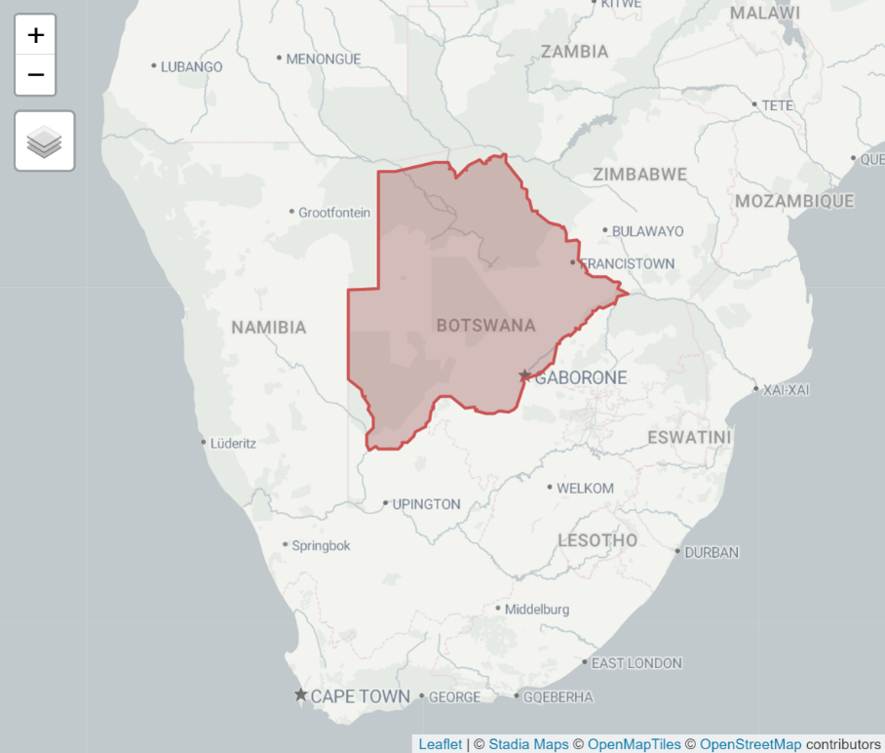

**Botswana - Towards A Sustainable Future[1]**

Chris Yong Hong Sen

**Introduction**

The Republic of Botswana is a landlocked country bordering Namibia, Zambia, Zimbabwe, and South Africa. As COVID-19 was a marker for a shift in trade behaviour, subsequent analysis in this report will be focusing on trends from 2020.

Botswana’s **primary sources of energy** consist of coal, oil, and biofuel, each contributing higher proportions of Botswana energy sources as seen in figure 1. Notably, renewable resources have accounted for ~2% of primary energy supply, excluding imported electricity, both pre and post COVID-19. The transport sector accounts for 80% of oil usage, the business sector for 91% of coal, while households for 75% of biofuels (African Energy Commission, 2025).

**Figure 1**: *Botswana Energy Sources from 2018 to 2022[2]*

Meanwhile, Botswana’s **secondary energy source** is electricity. From figure 2, observe that electricity generation has increased by 18% from 2020 to 2022, with coal accounting for at least 96% of the overall electricity supply during this period. In addition, electricity production in the developing African country is ~3 times more than the average of that across the African region in 2022 (International Energy Agency , 2025).

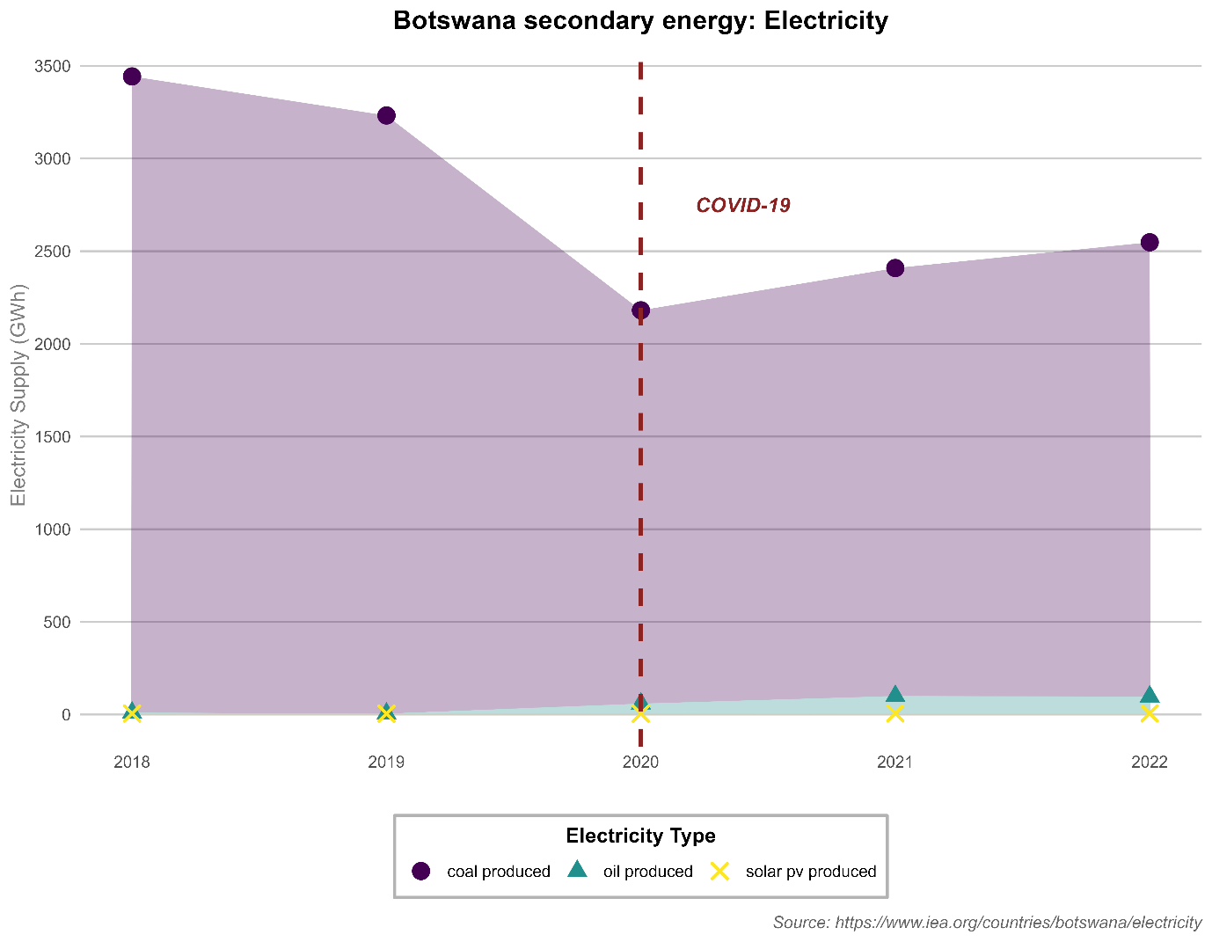

**Figure 2**: *Botswana electricity supply from 2018 to 2022[3]*

To address high coal reliance, the Ministry of Finance would be recommending a three-pronged methodology.

**Prong-1**: Rapid Utility-Scale Solar Photovoltaic Expansion

**Prong-2**: Smart Workers Programme

**Prong-3**: Sustainable Energy Transitioning

**Prong-1: Rapid Utility-Scale Solar Photovoltaic Expansion**

**Motivation**

Prong 1 is the most important prong to accomplish. The ministry of finance would be aggressively pushing for more utility-scale Solar Photovoltaic (PV) systems. It aims to reduce the high carbon footprint from coal-produced electricity which accounts for 53% of total CO2 emissions in Botswana, or in absolute terms, 4 Mt CO2 emitted in 2022.

Botswana sees an average Global Horizontal Irradiance (GHI) of 2225kWh/m2. Towards the southwest regions of Kgalagadi district, Botswana, the highest GHI’s can be observed in figure 3. Then, in central and north Botswana (Ghanzi and Nagamiland district respectively), parts of Kweneng and Southern district, and the remaining of Kgalagadi district, GHI ranges between 2,200 to 2,300kWh/m2.

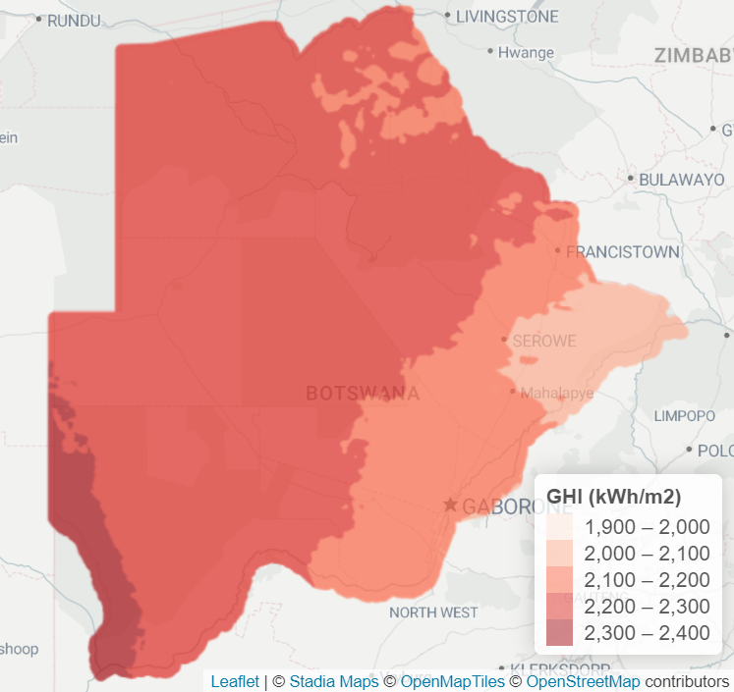

**Figure 3**: Botswana average yearly GHI*[4]*

These levels are higher than California with average GHI of 1967.1kWh/m2 (The World Bank; International Finance Corporation, 2025). However, California achieved 31% of generated electricity from solar energy (Choose Energy, 2025), whereby Botswana only achieved ~0.2%[5]. This shows major underutilization and significant untapped potential in harnessing solar energy for generating electricity.

From figure 4, we can observe that total the power industry accounts for the bulk of actual CO2 emissions. The power industry is solely comprised of Morupule B power plant, which is responsible for 99.3% of the total power generation (Sunday Standard Reporter, 2022). We can also observe that total CO2 emissions attributed to Morupule B had been steadily increasing COVID-19, suggesting increase in demand in electricity

Should coal continue to dominate the source of electricity production, coupled with increasing electricity demand, Botswana will continue seeing increased CO2 emissions. This sets the country at a severe disadvantage in an increasingly carbon conscious globe, falling behind in potential trade-agreements and investments that favour low emissions, which could be harmful to long-term economy.

**Figure 4**: *Botswana CO2 emissions (million tons) by industry from 2018 to 2022[6]*

**Recommendation**

Prong 1 will take place across ten years. Year 1 to 5 will see the construction of four 0.5GWh solar farms in Kgalagadi district (highest GHI region) in the first year. Year 6 to 8 will then anticipate for a horizontal scaling within these solar farms to 1.5GWh, and the opening of two new 0.5GWh solar farm in Ghanzi district. In Year 10, all solar farms should be operating at 1.5GWh with battery systems to account for intermittency in sunlight.

Since coal takes the lion share in producing electricity, we can expect an immediately high return of investment. Chile, similar to Botswana in GHI range and having a middle-income economy, has made remarkable strides in solar energy utilization over the past decade. Following the initial $198m USD investment in 2012, Chile experienced a bull season in solar derived electricity. From table 1, we can observe that Chile’s electricity generated from the sun at least doubled until 2016.

**Table 1**: Chile solar-derived electricity generated per year *[7]*

**Prong-2: Smart Workers Programme**

**Motivation**

With the implementation of prong-1, workers employed in Morupule B coal power plant would begin to face skill obsolescence. With the country gearing towards an increasingly green energy producer, these workers might find themselves unemployed due to lack of demand for their skills. It is likely that skills obtained from mining are not transferable to renewables, as solar-related employment require training. Should the radical and aggressive transition towards solar energy reap high benefits for our government, it is likely that coal related employment would diminish quickly. This potential wave of unemployment is not uncommon. In Kentucky America, 6000 coal miners were laid off around April 2020, showcasing the dim and sudden reality of job obsolescence (Viner, 2020).

Laying off coal miners would worsen the average unemployment level, currently at a high level of 26% (Mpako & Ndoma, 2024). Furthermore, the median yearly salary of a coal miner is P 275,000 as of 2025, double the median Botswana salary (Payscale, Inc, 2025; World Salaries, 2025). Rural households and middle-income households, accounting at least 27% of the overall population, would be hit hardest as coal miners are often the sole breadwinner in such circumstances, driving families into greater poverty. Unemployment also puts a strain on the government as more funds have to be directed towards housing and government benefits for increasing rural population.

In more dire cases, union strikes could occur if coal miners grow anxious and dissent towards imminent job cut offs. Union strikes are not unprecedented in the African region. Recently in 2022, more than 23,000 employees were not satisfied with their wages, which began a 3 year long strike against the United National Transport Union and Transnet (UNTU). The strike in 2022 caused the mining companies an estimate of R815M/$43M USD a day (Bloomberg, 2025).

**Recommendation**

The Smart Workers Program will happen concurrently with prong-1 (Rapid Solar PV Expansion). By collaborating with leading solar provider Scatec ASA and the Clean Energy Research Centre at the University of Botswana, we are encouraging workers to participate in an optional, fully funded, 6-12 months solar energy-related vocational training programme. During this period, they will learn critical skills needed in the new renewable conscious economy, with specific training in (but not limited to) …

1. Technician track: Utility-scale Solar PV Installation and Maintenance (6 months)
2. Design and Architecture track: Solar System Engineering (12 months)

Vocational training programmes for clean energy transitions has also been implemented in other African countries. South Africa has implemented the Just Energy Transition Partnership (JETP) which already assisted 910 workers that faced difficulties in transition from high-carbon-footprint-related roles during a pilot program, of which more than half were women (Federal Ministry for Economic Cooperation and Development, 2025). 1245 jobs have been created since 2022 in Botswana’s Morupule Coal Mines (Botswana Television , 2024). Given that South Africa and Botswana both have high coal reliance in electricity production (84.1% coal-produced electricity in 2022), JETP provides a credible blueprint that is regionally relevant targeting these 1245 individuals (and more).

**Prong-3: Sustainable Energy Transitioning**

**Motivation**

This prong aims to tap into 196 trillion cubic feet (tcf) of untapped Coal Bed Methane (CBM) in Botswana, potentially a, potentially reducing CO2 emissions by 16% compared to coal emissions (International Renewable Energy Agency, 2021; Wang, et al., 2024).

Seasons of power shortages has been common in Botswana since the opening of P7.4 billion/$540MM USD Morupule B – Botswana’s coal-fired power plants. To address the short-term demand of power, the landlocked country heavily relies on South Africa’s Eskom on imported power (U.S. Department of Commerce, 2024; Seitshiro, 2021). Furthermore, the energy department is aiming towards erecting a 615MW coal-powered power plant for a reliable domestic source of energy (Africa Digest News, 2025).

Unfortunately, these second-rate decisions are likely unsustainable.

Eskom determines electricity-related tariffs using Multi-Year Price Determination (MYPD) methodology, which resulted in the average tariffs to increase by 450%, while inflation rate was only 98% during the same period, suggesting that tariffs had become exorbitant (BusinessTech, 2023). The power shortages from Morupule B would force the Botswana government to adhere to the high tariffs imposed by Eskom. Then again, Eskom also faces frequent blackouts (Nguyen, 2023), rendering imported power volatile and unreliable for Botswana. Therefore, this emphasizes the importance of increasing self-reliance in power generation through diversifying energy sources for electricity generation beyond renewables.

**Recommendation**

Prong-3 will also follow a ten year phase. The first 3 years will be a pilot program, a 10MW CBM power plant will be opened. During this phase, 200 coal workers will be repurposed and trained to operate and maintain the CBM power plant, Furthermore, prong-3 will see the collaboration with Gas Detection Systems Africa (GDSA) in procuring methane monitoring technology. This is crucial as methane is released during CBM desorption stage, which is at least 28 times more harmful than CO2 (Zhu, Du, Zhang, Yu, & Liu, 2024; United States Environmental Protection Agency, 2025). During year 4 and 5, the 10MW CBM power plant will be fully operational with 200 trained workers and evaluate the pilot programme. With a successful pilot program, year 6 to 10 will see the deployment of smaller purposed CBM power plants across Botswana to reduce reliance on a single power plant (like Morupule B).

CBM implementation will follow world-leading city of Queensland, Australia, where the conversion of CBM to liquified natural gas so popular that it is a major industry. With every big industry comes new jobs and foreign investment in the billions (Towler, et al., 2016).

Since Botswana has very high proven CBM, there is good potential for a booming industry in CBM like Queensland, Australia. With high unemployment as explained under prong-2’s recommendation section, the industry could provide jobs both directly and indirectly to thousands of the unemployed, which would benefit those from rural households the most. Furthermore, with the entire globe transitioning to cleaner energy sources, and developed countries employing CBM like Australia, China and USA, this would provide longer-term job security in a relevant industry.

**Conclusion**

Paving the roadmap towards creating just and clean electricity infrastructure for Botswana presents an excellent opportunity to reframe the existing failure energy sector into one that is resilient and sustainable.

While prong-1 (Utility-Scale Solar PV Expansion) aims to follow global eco-friendlier trends in a radical manner, the responsible development of prong-3 (Sustainable Energy Transitioning, with CBM as a transitional fuel) helps to diversify Botswana’s energy supply to reduce uncertainty and ensures that electricity supply is consistently flowing. To ensure that green transitioning does not leave on-the-ground stakeholders behind, prong-2 (Smart Workers Programme) actively trains these populations to be highly employable in future green industries. Altogether, the 3-pronged methodology provides a pragmatic, realistic, and holistic approach to transitioning to greener infrastructure.

# Bibliography

Africa Digest News. ( 25 March, 2025). *Botswana Plans 615MW Coal Plant Amid Power Supply Concerns.* Retrieved from Renewable Energy News: https://renewableenergynews.co.ke/botswana-plans-615mw-coal-plant-amid-power-supply-concerns/

African Energy Commission. (2025). *African Countries - Botswana.* Retrieved from African Energy Commission Web site: https://au-afrec.org/botswana

Bloomberg. (15 Apr, 2025). *South Africa faces crippling strike.* Retrieved from BusinessTech Web site: https://businesstech.co.za/news/business/820959/south-africa-faces-crippling-strike/

Botswana Press Agency. (04 Feb , 2016). *Morupule B cost P7 billion.* Retrieved from Daily News Botswana: https://dailynews.gov.bw/news-detail/25917

Botswana Television . (8 August, 2024). CITIZEN-OWNED COMPANIES IN MINING OPERATIONS. *CITIZEN-OWNED COMPANIES IN MINING OPERATIONS*. Gaborone, South-East District, Botswana : Botswana Television . Retrieved from https://www.facebook.com/watch/live/?ref=watch_permalink&v=723686999882962

BusinessTech. (30 Aug , 2023). *Crazy Eskom price hikes in South Africa – how tariffs have changed since load shedding started*. Retrieved from A. BusinessTech Web site: https://businesstech.co.za/news/energy/714614/crazy-eskom-price-hikes-in-south-africa-how-tariffs-have-changed-since-load-shedding-started/

Choose Energy. (9 April, 2025). *Solar Energy Generation by State Report April 2025.* Retrieved from Choose Energy Web site: https://www.chooseenergy.com/solar-energy/solar-energy-production-by-state/

Federal Ministry for Economic Cooperation and Development. (March, 2025). *Just Energy Transition Partnership (JETP) with South Africa.* Retrieved from A. Federal Ministry for Economic Cooperation and Development Web site: https://www.bmz.de/resource/blob/246476/factsheet-jetp-southafrica-en.pdf

International Energy Agency . (2025). *Botswana Energy supply.* Retrieved from International Energy Agency Web site: https://www.iea.org/countries/botswana/energy-mix

International Renewable Energy Agency. (2021). *RENEWABLES READINESS ASSESSMENT BOTSWANA.* Abu Dhabi: International Renewable Energy Agency. Retrieved from https://www.irena.org/-/media/Files/IRENA/Agency/Publication/2021/Aug/IRENA_RRA_Botswana_2021.pdf

Mpako, A., & Ndoma, S. (4 Jul , 2024). *AD818: Young Batswana more educated, less employed, less politically engaged than their elders.* Retrieved from Afrobarometer Web sie: https://www.afrobarometer.org/publication/ad818-young-batswana-more-educated-less-employed-less-politically-engaged-than-their-elders/

Nguyen, L. (14 June, 2023). *Understanding the Energy Crisis in South Africa*. Retrieved from A. Earth.Org Web site: https://earth.org/energy-crisis-south-africa/

Payscale, Inc. (2025). *Average Mining Engineer Salary in Botswana.* Retrieved from Pay Scale Web site: https://www.payscale.com/research/BW/Job=Mining_Engineer/Salary

Seitshiro, K. (19 October, 2021). *2024: The year of resurrection for Morupule B*. Retrieved from https://www.sundaystandard.info/2024-the-year-of-resurrection-for-morupule-b/

Sunday Standard Reporter. (8 November , 2022). *Morupule B falters, sends the nation in darkness.* Retrieved from Sunday Standard Web site: https://www.sundaystandard.info/morupule-b-falters-sends-the-nation-in-darkness/

The World Bank; International Finance Corporation. (2025). *California.* Retrieved from Global Solar Atlas Web site: https://globalsolaratlas.info/map?c=36.315125,-119.003906,5&s=36.7783,-119.4179&m=site

Towler, B., Firouzi, M., Underschultz, J., Rifkin, W., Garnett, A., Schultz, H., . . . Witt, K. (2016). An overview of the coal seam gas developments in Queensland. *Journal of Natural Gas Science and Engineering*, 249-271. Retrieved from https://www-sciencedirect-com.libproxy1.nus.edu.sg/science/article/pii/S1875510016300853?

U.S. Department of Commerce. (28 February, 2024). *Botswana Country Commercial Guide*. Retrieved from A. International Trade Administration Web site: https://www.trade.gov/country-commercial-guides/botswana-energy

United States Environmental Protection Agency. (3 March, 2025). *Importance of Methane*. Retrieved from A. United States Environmental Protection Agency Web site: https://www.epa.gov/gmi/importance-methane

Viner, K. (29 May, 2020). *The collapse of coal: pandemic accelerates Appalachia job losses.* Retrieved from The Guardian Web site: https://www.theguardian.com/us-news/2020/may/29/coal-miners-coronavirus-job-losses

Wang, H., Shen, J., Gao, J., Wang, W., Zhu, L., Gu, Y., & Wang, T. (2024). Cost estimation of Non-CO2 greenhouse gas emissions reduction- A bottom-up analysis of coal-bed methane extraction and utilization in Shanxi, China. *Energy*, Volume 309. doi:https://doi.org/10.1016/j.energy.2024.133007

World Salaries. (2025). *Average Salary in Botswana for 2025.* Retrieved from World Salaries Web site: https://worldsalaries.com/average-salary-in-botswana/

Zhu, Q., Du, X., Zhang, T., Yu, H., & Liu, X. (2024). Investigation into the variation characteristics and influencing factors of coalbed methane gas content in deep coal seams. *Sci Rep, 18813*, 14. doi:https://doi.org/10.1038/s41598-024-66011-2

1. Code for map and figure drawing’s available at my github: <https://github.com/Monoji77/Botswana_Energy>
2. **Figure** is drawn in RStudio using data from <https://www.iea.org/countries/botswana/energy-mix>
3. **Figure** is drawn in RStudio using data from <https://www.iea.org/countries/botswana/electricity>
4. **Figure** is drawn in RStudio using data from https://solargis.com/resources/ free-maps-and-gis-data
5. Refer to github analysis script files for 0.2% derivation
6. **Figure** is drawn in RStudio using data from <https://www.iea.org/countries/botswana/emissions>
7. **Figure** is drawn in RStudio using data from <https://www.iea.org/countries/botswana/renewables>