SMART INDIA HACKATHON 2026
KISANSETU
Connecting Farmers to Better Markets
SIH Problem Statement 26132 | Strengthening market linkages and price discovery for farmers

Purpose
Final pre-coding master documentation consolidating the SIH problem understanding, independent research, team concept, six-slide pitch, product decisions, MVP scope, architecture direction and build workflow.

Item | Finalized direction
Document type | Consolidated pre-coding / MVP master document
Reference date | 6 September 2026
Primary scope | Rapid solo prototype for internal SIH preparation
Geography for pilot concept | Maharashtra
Initial crop scope | 1-2 crops
Primary users | Farmer/FPO and Buyer
Supporting roles | Transport/Logistics and Admin/Verifier

Core product thesis
Turn fragmented market signals into an explainable, actionable selling or buying decision.
This document is intentionally implementation-oriented. It is not a claim that every capability described is production-ready before the prototype deadline.

Contents
1. Executive Summary
2. Source Set and Document Roles
3. Consolidated Problem Definition
4. Existing Ecosystem and Competitive Context
5. Users and User Journeys
6. Consolidated Product Definition
7. MVP Scope and Priorities
8. Screen Map and Feature Specification
9. Data Model
10. Data Strategy: Real vs Simulated
11. Recommendation and Net-Realisation Logic
12. Technical Architecture and Backend Modules
13. Keypad-Phone / SMS-First Accessibility Concept
14. Six-Slide Pitch Alignment
15. Risks, Constraints and Guardrails
16. Solo Development Workflow in Antigravity
17. Build Order and Definition of Done
18. Final Product Statement and Handover
Appendix A. Source Comparison Matrix
Appendix B. PPT Reference Screens
Appendix C. Source Notes and References

1. Executive Summary
KisanSetu is the proposed solution for Smart India Hackathon 2026 Problem Statement 26132, “Strengthening market linkages and price discovery for farmers.” The consolidated project direction treats the problem as a market-intelligence, matching and coordination problem rather than a simple mandi-price application.
The team concept defines KisanSetu as a multi-channel platform connecting individual farmers, FPOs and verified buyers. Smartphone users are expected to use an app/web interface, while keypad-phone users are intended to access essential actions through structured SMS/IVR. The platform is designed to connect market information, buyer demand, quality, costs, offers, logistics and payment status into one transparent transaction journey.
The independent research adds a critical constraint: many requested capabilities already exist in some form in e-NAM, Agmarknet, APMCs, FPO networks and private agri-market platforms. Therefore, the strongest prototype differentiator is not another marketplace. It is an explainable decision layer that helps a farmer understand where, when and to whom to sell after considering realistic net realization and transaction risk.
Final working thesis
KisanSetu should take fragmented market, demand, quality, logistics and trust signals and convert them into a ranked, explainable selling opportunity, then support the farmer or FPO through offer, logistics and payment states.

What is fixed for the prototype
- Problem statement: SIH26132, market linkages and price discovery for farmers.
- Product identity: KisanSetu, “Connecting Farmers to Better Markets.”
- Primary market sides: Farmer/FPO and Buyer.
- Core differentiator: decision support rather than price display alone.
- Core economic concept: gross value minus known/estimated costs equals estimated net realization.
- Accessibility principle: one backend, multiple access modes, including keypad-phone SMS/IVR.
- Prototype narrative: one complete farmer-to-buyer transaction, not a collection of disconnected screens.
- Pilot framing: Maharashtra-focused demonstration with 1-2 crops and controlled demo data where live data is unavailable.

2. Source Set and Document Roles
This master document consolidates three layers of project material: the team’s chronological project documentation, the independent pre-build research report, and the current six-slide KisanSetu presentation. The attached PPT screenshots are treated as the visual pitch source.
Source | Role in the final workflow | What it contributes
Team chronological documentation | Existing project decisions | Solution vision, role definitions, workflow, technical direction, feasibility, risks, MVP phases, data model and final project vision.
Independent research report | Critical product analysis | Problem interpretation, existing-system context, competitive gap, P0/P1/P2 prioritization, real-vs-simulated data strategy and solo-prototype guardrails.
Six-slide PPT | Public-facing promise | The exact six-slide narrative, visual positioning, technology claims, impact claims, research references and the “decision, not just price” message.

How to use the sources
The chronological document tells us what the team has already decided; the research report tells us what deserves priority and what should be avoided; the PPT tells us what the prototype must be able to support credibly.

3. Consolidated Problem Definition
The core problem is not simply that farmers lack access to a price. Market information already exists in multiple forms. The harder problem is converting fragmented information into a reliable, economically sensible action.

3.1 Current decision environment
Information / action | Typical available source | Why it is insufficient alone
Mandi prices | APMC / Agmarknet / e-NAM | Headline price does not directly reveal the best net outcome for a particular farmer or lot.
Buyer access | Local traders, e-NAM, private networks | The farmer may not know which buyer currently fits crop, quantity, quality and timing.
Quality | Mandi inspection / buyer requirements / lot data | Quality differences make simple price comparison unreliable.
Logistics | Local transporters / ad-hoc arrangements | Distance and transport cost can erase price differences.
Storage / timing | Local facilities / farmer decision | Liquidity and perishability can force a near-term sale.
Trust / payment | Relationships / transaction history | The highest nominal offer may not be the safest or fastest settlement.

3.2 The actual product question
Farmer question
“Given my crop, quantity, quality, location and urgency, where, when and to whom should I sell, and what will I realistically receive after relevant costs?”

This reframing is the basis for KisanSetu. It gives the platform a reason to exist above existing market-price infrastructure instead of competing directly with it.

4. Existing Ecosystem and Competitive Context
Existing system / participant | What it already does well | Implication for KisanSetu
APMC / Mandi | Physical trading, local buyer access, market operations and inspection. | Acts as part of the real market rail; does not by itself provide the complete digital decision layer.
Agmarknet / OGD | Daily commodity and market-price information, including price and market context. | Strong candidate data foundation for market intelligence.
e-NAM | Electronic trading, price discovery, lots, quality, payments and logistics support across participating mandis. | A generic digital marketplace is not novel; KisanSetu must show a clear additional decision layer.
FPO / FPC ecosystem | Aggregation of supply and collective market access. | FPOs are an economic coordination mechanism, not simply another dashboard.
Private agri marketplaces | Buyer/seller linkage, negotiation, quality, logistics, payments and settlement. | Transaction enablement alone is not enough differentiation.
Local intermediaries | Fast information, relationships and transaction familiarity. | Digital adoption must be simpler and more trustworthy, not merely more digital.

4.1 Strategic gap
- Not another mandi-price app. Price visibility is already widely available.
- Not an e-NAM clone. Auctions, lots, quality and payments already exist in major parts of the ecosystem.
- Not just a buyer directory. The platform should rank fit rather than dump a list of buyers.
- Not just a digital auction screen. The value is the decision before and around the transaction.
- Instead: a decision layer + matching layer + lightweight transaction layer that can sit above fragmented market signals.
Differentiation in one line
From market information to the best actionable selling option.

4.2 Source discrepancy that must be resolved before final presentation
The six-slide PPT shows “1,522 e-NAM-linked markets” as a checked September 2026 figure, while the chronological documentation and independent research cite 1,656 integrated mandis in 2026 and additional participation figures from 2026 releases. These numbers should not be mixed casually. Before a final judging presentation, the team must choose one current figure and verify it against the cited primary source used on the references slide.
Presentation guardrail
Do not hard-code disputed current statistics into the prototype UI. Keep them in the pitch/reference layer, with date and source attribution.

5. Users and User Journeys
Role | Primary objective | Prototype importance
Farmer | Sell produce at the best realistic outcome. | Primary UX and primary demo path.
FPO / FPC | Aggregate supply and obtain stronger buyer access. | Farmer-side aggregation mode.
Buyer | Source reliable quantity and quality for a required delivery window. | Second primary UX / demand side.
Transport / logistics | Move produce between origin and destination at known cost/time. | Supporting workflow; can be simulated.
Admin / verifier | Maintain trust, verification, governance and dispute records. | Supporting trust workflow.

5.1 Farmer journey
1. Login or assisted access.
2. Create a produce lot: crop, quantity, quality/grade, location and sale/availability window.
3. View market prices, arrivals and demand context.
4. View ranked selling options with gross value, estimated logistics, estimated net realization and trust indicators.
5. Open the recommended buyer/market and inspect why it was ranked highly.
6. Accept, reject or negotiate an offer.
7. Track logistics, delivery and payment status.

5.2 FPO journey
1. Register as an FPO and manage basic member/supply data.
2. Aggregate multiple farmer lots into a consolidated lot.
3. Compare buyer demand that fits the aggregated quantity and quality.
4. Compare offers and choose accept, negotiate or split.
5. Track the transaction to delivery/payment.

5.3 Buyer journey
1. Register and complete verification fields.
2. Post structured demand: commodity, quantity, grade, destination, delivery window and target offer.
3. Browse or receive ranked matching lots.
4. Inspect lot details and quality evidence.
5. Make an offer and track acceptance/order status.
6. Coordinate logistics and settlement status.

5.4 SMS / keypad-phone journey
1. One-time registration links identity and phone number.
2. Farmer sends a structured command such as SELL 2000 TOMATO.
3. Backend identifies the farmer, parses the request and retrieves market/buyer signals.
4. System estimates costs and net realization.
5. System replies with concise options and a buyer code or request-more-details action.
6. Farmer can reply by SMS using a compact command pattern.

6. Consolidated Product Definition
The final product concept is a farmer-centric market intelligence and transaction-enablement platform. It does not attempt to replace agricultural market infrastructure. Instead, it organizes relevant signals and adds decision support around them.

6.1 Four functional pillars
Pillar | Purpose | Prototype outcome
Market intelligence | Aggregate relevant price, arrival and demand signals. | A single contextual market view for the farmer/FPO.
Supply-demand matching | Match lots to buyers using crop, quantity, grade, location and timing. | Ranked buyer/market opportunities.
Net realization + guidance | Estimate effective economics after logistics and other known costs. | Explainable ranking with visible assumptions.
Transaction + trust | Carry the user from offer through logistics, delivery and payment states. | End-to-end transaction timeline.

Design principle
The farmer should see a decision, not a data dump. The interface should expose the reasons behind the recommendation.

6.2 Final conceptual flow
Step | System action | Farmer-facing result
1. Lot | Capture crop + quantity + grade + location + availability. | Structured sale opportunity.
2. Market | Retrieve relevant market prices/arrivals/trends. | Context for the decision.
3. Demand | Find buyer demand compatible with the lot. | Shortlist of viable buyers.
4. Economics | Estimate gross value and costs. | Expected net realization.
5. Recommendation | Score options and explain ranking. | Best current option + reasons.
6. Offer | Open buyer profile; accept/negotiate/reject. | Commercial decision.
7. Fulfilment | Track logistics/delivery/payment states. | Transparent transaction.

7. MVP Scope and Priorities
MVP rule
Build one strong vertical slice. Do not try to digitize the entire agricultural market before the internal demo.

Priority | Feature | Reason | Implementation stance
P0 | Farmer/FPO onboarding + lot creation | Creates the real-world input. | Must work end to end.
P0 | Market intelligence | Shows the data foundation. | Real price data where practical; demo data otherwise.
P0 | Buyer demand + matching | Demonstrates market linkage. | Rule-based matching first.
P0 | Net realization | Main differentiating decision layer. | Transparent formula with assumptions.
P0 | Explainable recommendation | Turns information into action. | Score and show “why”.
P0 | Offer / acceptance flow | Makes the platform transactional. | Fully clickable/functional in prototype.
P1 | Logistics estimate | Adds economic realism. | Scenario-based simulation acceptable.
P1 | Quality / grade detail | Improves trust and buyer fit. | Structured fields; evidence upload optional.
P1 | Payment status + timeline | Completes lifecycle. | Simulated transaction state.
P2 | Dispute / grievance | Useful governance layer. | Basic record/status only.
P2 | Advanced forecast / ML | Nice-to-have after core flow. | Do only after core is stable.
P2 | Large external integrations | High risk under deadline. | Avoid unless verified and easy.

8. Screen Map and Feature Specification
The screen map below translates the product concept into an implementation boundary. It intentionally distinguishes must-have screens from supporting or simulated screens.

8.1 Shared / entry screens
Screen | Purpose | Priority | Key actions
Landing / Product intro | Explain KisanSetu value quickly. | P1 | Enter platform, view how it works.
Role selection / registration | Choose farmer, FPO or buyer. | P0 | Create profile, basic location and contact data.
Login | Secure access. | P0 | Role-aware login.
Demo / SMS simulator entry | Demonstrate keypad-phone route. | P1 | Open simulated SMS flow.

8.2 Farmer screens
Screen | Purpose | Key UI/data | Priority
Farmer Dashboard | Current status and recommended action. | Active lot, recommendation, offers, transaction timeline. | P0
Create Lot | Create a structured sale lot. | Crop, variety, quantity, grade, location, harvest/availability. | P0
Market Intelligence | Show price + arrivals + nearby opportunities. | Market cards, chart, source/date, price range, demand. | P0
Recommendation | Explain ranked options. | Score, gross, costs, net, buyer fit, trust, reasons. | P0
Buyer Details | Inspect buyer before accepting. | Verification, demand, location, reliability history. | P0
Offers | Compare and decide. | Offer price, quantity, status, expiry/notes. | P0
Order / Payment Timeline | Track fulfilment. | Offer accepted, logistics, delivery, payment. | P1
SMS Simulator | Show keypad-phone equivalent journey. | Command input, backend response, action buttons. | P1

8.3 FPO screens
Screen | Purpose | Key UI/data | Priority
FPO Dashboard | Aggregated view of supply and demand. | Members, open lots, matching demand, offers. | P1
Aggregate Lot | Combine farmer lots. | Member lots, combined quantity, average/grade status. | P1
Demand Matching | Find buyers for aggregate lots. | Crop, quantity, grade, destination, timing. | P1
Offer Comparison | Choose or negotiate. | Offer value, logistics, buyer trust. | P1

8.4 Buyer screens
Screen | Purpose | Key UI/data | Priority
Buyer Dashboard | Demand and matching overview. | Open demands, matched lots, active orders. | P0
Post Demand | Define procurement need. | Crop, quantity, grade, destination, deadline, target price. | P0
Browse Lots | Discover compatible supply. | Filters and ranked lots. | P0
Lot Details | Inspect seller/FPO lot. | Quantity, quality, location, availability, seller info. | P0
Make Offer | Submit price and quantity. | Offer form, notes, validity. | P0
Buyer Orders | Track accepted transactions. | Delivery and payment states. | P1

8.5 Admin / supporting screens
- Buyer verification queue: approve or flag profiles for the demo.
- Market-data management: source, timestamp, commodity and price records.
- Basic dispute/grievance record: reason, evidence placeholder, status.
- System activity: transaction and audit history view.

9. Data Model
The team documentation proposes a compact relational model around users, profiles, lots, demands, offers, orders, payments and audit/grievance. For a rapid JavaScript prototype, the implementation can use MongoDB collections or an equivalent relational schema without changing the conceptual model.
Entity | Core fields | Key relationships
User | id, role, name, phone, email, location, verificationStatus | Owns profile; creates lots/demands; acts in transactions.
FarmerProfile | userId, language, farm/FPO relation, crop interests | Attached to Farmer user.
FPO | id, name, location, members, verification | Aggregates farmer lots.
BuyerProfile | userId, business type, location, verification, reliability | Creates demand; makes offers.
CropLot | id, ownerId, crop, variety, quantity, grade, harvestDate, location, askingPrice, availability | Matched to markets/buyer demand.
MarketPrice | crop, variety, market, district, state, min, modal, max, arrivals, date, source | Feeds market intelligence.
BuyerDemand | buyerId, crop, quantity, grade, destination, requiredDate, targetPrice, status | Matches CropLot.
Offer | buyerId, lotId, quantity, price, status, createdAt, validUntil | Negotiation/order input.
Order | lotId, buyerId, agreedPrice, quantity, status, logisticsId, paymentId | Created from accepted offer.
Logistics | origin, destination, distance, mode, estimatedCost, status | Associated with order.
Payment | orderId, amount, status, method, reference, timestamp | Associated with order.
TrustEvent | buyerId, verification, completedOrders, settlementStats, flags | Feeds recommendation confidence.
Audit / Grievance | actorId, action, objectType, objectId, reason, evidence, status | Governance trail.

9.1 Relationship model
Conceptual relationship
User -> Role Profile -> Crop Lot / Buyer Demand -> Offer -> Order -> Logistics + Payment -> Transaction History / Trust Signals

The first database can remain intentionally small. The purpose is to prove data relationships and the end-to-end journey, not to replicate a national agricultural exchange.

10. Data Strategy: Real vs Simulated
The project should use real public market data where practical and controlled demo data everywhere else. The UI should never present simulated values as live government data.
Data domain | Preferred source / model | MVP mode | UI transparency
Mandi prices | data.gov.in / AGMARKNET | Real where accessible | Show source + date.
Market arrivals | AGMARKNET / e-NAM surfaces | Real where accessible | Show date and market.
Commodity / variety / grade | AGMARKNET/e-NAM schema + curated master | Mixed | Use controlled master for demo.
Buyer demand | Prototype DB | Simulated initially | Label as demo data where appropriate.
Buyer reliability | Prototype transaction model | Simulated initially | Show verification/history signals, not fake official certification.
Transport quote | Static scenario model / future API | Simulated initially | Show “estimated”.
Storage | Static facility dataset / future integration | Simulated initially | Show capacity/availability assumption.
Offers / payments | Prototype transaction state | Simulated initially | Show “prototype transaction”.

Data provenance rule
Every market price displayed as real should carry a source, date/time and relevant commodity/variety context. Forecasts and recommendations must be labeled as estimates.

11. Recommendation and Net-Realisation Logic
The first version should use transparent rule-based scoring rather than a black-box ML model. This is easier to build, test, explain to judges and replace later.

11.1 Step 1: eligibility filtering
- Crop/commodity must match.
- Buyer or market must support the required quantity or an allowable partial match.
- Quality/grade requirements must be compatible.
- Delivery/sale window must be feasible.
- Buyer must pass the prototype trust/verification threshold.

11.2 Step 2: net realization calculation
Core formula
Estimated gross value = applicable price x quantity
Estimated net realization = gross value - transport cost - storage cost - other known costs

All quantities and prices must use consistent units. The UI should expose the assumptions so the user can see how the net figure was derived.

11.3 Step 3: recommendation score
Signal | Suggested weight | What it represents
Estimated net realization | 35% | Economic outcome after known costs.
Buyer / market fit | 20% | Crop, quantity, quality and delivery compatibility.
Distance / logistics | 15% | Practical fulfilment burden.
Demand strength | 10% | Current buyer demand / market pressure.
Buyer trust / settlement history | 10% | Risk signal.
Timing / sale-window fit | 10% | Urgency, availability and time-to-sale.

These weights are a starting prototype policy, not an empirical truth. They should be easy to tune in one configuration file or database record. The UI should show a concise “Why this is recommended” explanation such as: higher net realization, compatible grade, strong demand, shorter delivery distance and reliable buyer history.

11.4 Sale-window guidance
A full forecasting system is unnecessary for the first build. The initial version can combine recent trend direction, demand intensity and the user’s storage/urgency context. If a forecast chart is added later, it must be presented as an estimate, not a guaranteed price.

12. Technical Architecture and Backend Modules

12.1 Recommended solo-prototype stack
Layer | Recommended choice | Reason
Frontend | React + Tailwind CSS | Matches the team PPT and the rapid web-first requirement.
Backend | Node.js + Express.js | Matches the team direction and keeps frontend/backend in JavaScript.
Database | MongoDB for the solo MVP unless the existing repository already establishes PostgreSQL | Fast iteration and comfortable document structure for prototype entities.
Auth | JWT or secure session approach | Role-aware access without unnecessary complexity.
Data access | REST APIs | Simple, explicit boundaries for a prototype.
Analytics | Rule-based JavaScript initially; Python/scikit-learn later if needed | Avoid premature ML while remaining compatible with the PPT roadmap.
SMS/IVR | Provider API later; simulated SMS first | Avoid telecom integration risk before core workflow works.
Payments | Simulated payment state first | Demonstrate lifecycle without banking integration risk.
Deployment | Web cloud deployment compatible with the repository | Keep deployment simple and repeatable.

12.2 Backend modules
- auth registration, login, role checks, verification state.
- users/profiles farmer, FPO and buyer profile management.
- lots crop lot creation, update, availability and quality fields.
- markets market prices, arrivals, source/timestamp and trend queries.
- demands buyer procurement requirements.
- matching eligibility filters and ranked match calculation.
- realization cost calculation and net-realization service.
- recommendations scoring, explanation and ranking.
- offers submit, negotiate, accept, reject and expire.
- orders accepted offer to transaction state machine.
- logistics transport estimates and status.
- payments simulated/real state handling.
- trust verification/history/settlement signals.
- sms command parsing and response generation.
- admin/audit verification, grievances and activity history.

12.3 API surface
Area | Representative endpoints
Auth | POST /api/auth/register, POST /api/auth/login, GET /api/auth/me
Lots | POST /api/lots, GET /api/lots/:id, GET /api/lots/mine
Markets | GET /api/markets/prices, GET /api/markets/arrivals, GET /api/markets/trends
Demand | POST /api/demands, GET /api/demands, GET /api/demands/:id
Matching | GET /api/matching/lot/:lotId, GET /api/matching/demand/:demandId
Recommendations | GET /api/recommendations/lot/:lotId
Offers | POST /api/offers, PATCH /api/offers/:id/status
Orders | GET /api/orders, GET /api/orders/:id, PATCH /api/orders/:id/status
Logistics | POST /api/logistics/estimate, PATCH /api/logistics/:id/status
Payments | POST /api/payments/simulate, GET /api/payments/:id
SMS | POST /api/sms/simulate

13. Keypad-Phone / SMS-First Accessibility Concept
The team concept treats smartphone ownership as a design constraint rather than an assumption. The intended pattern is one-time registration followed by simple structured SMS/IVR commands for essential selling actions.

13.1 Prototype simulation
For the internal prototype, the telecom path can be simulated inside the website. A “Keypad Phone” mode can display a phone-like interface where the user types a command, the system sends it to the same backend service, and the response appears as an SMS message.
Command | Purpose | Example response
SELL <qty> <crop> | Start a selling query. | Top options, price, transport estimate, net realization, buyer codes.
MORE <code> | Request more details about an option. | Buyer/market details and recommendation reasons.
ACCEPT <code> | Accept a buyer/offer in demo mode. | Order created; next step is logistics.
STATUS | Check active transaction. | Offer / logistics / payment status.

Architecture rule
The SMS simulator and future real SMS/IVR integration must call the same backend business services as the web application. Do not build a separate logic silo.

14. Six-Slide Pitch Alignment
The current PPT has six slides and should remain aligned with the prototype. The six-slide story is not merely presentation content; it is a checklist of what the system must be able to demonstrate.
Slide | PPT promise | Prototype support
1. Title | KisanSetu, PS 26132, theme and team identifiers. | Branding, problem statement and final team metadata.
2. Proposed solution | Farmer/FPO/buyer, one backend, two access modes, end-to-end workflow, “decision not just price”. | Working farmer and buyer journeys; simulated SMS mode.
3. Technical approach | React + Tailwind, Node/Express, DB, analytics, SMS/IVR, UPI, security, modular architecture. | Actual repository structure should reflect the claimed stack or clearly mark future/simulated components.
4. Feasibility | Feasible now, risks, mitigations, Maharashtra pilot, 1-2 crops, controlled demo dataset. | Prototype should show limited geography/crops and explicit demo assumptions.
5. Impact | Better price realization, lower transaction cost, reduced post-harvest risk, stronger FPOs, transparent transactions, tomato price signal and net-realization logic. | Recommendation card, net-realization example, price/market chart and transaction timeline.
6. Research | SIH, e-NAM, MSAMB, OGD/AGMARKNET and project research. | References in documentation; source/date labels in UI for real data.

14.1 PPT claims that need explicit implementation mapping
- “Decision, not just price” -> Recommendation screen + net realization engine.
- “Inclusive by design” -> SMS simulator and common backend service.
- “Trust + traceability” -> Buyer profile + offer/order/payment timeline.
- “One backend” -> Shared REST service layer for web and SMS simulation.
- “Rule-based matching can precede ML” -> Matching service implemented before any advanced forecast.

15. Risks, Constraints and Guardrails
Risk / constraint | What it means | Prototype guardrail
Stale market data | Public data may have timing/coverage limitations. | Show source/date and never imply guaranteed live freshness.
Forecast uncertainty | A prediction can be wrong. | Keep forecast secondary and label as estimate.
Fake/unreliable buyers | A verified label has real-world governance meaning. | Prototype verification can be simulated, but never call it official certification.
Logistics uncertainty | No live network means quotes are scenario-based. | Show estimated transport, not guaranteed price.
Digital adoption | A complex interface defeats the use case. | Keep farmer UI decision-focused; avoid dense analytics.
Feature bloat | Too many screens increase bugs and reduce demo coherence. | Protect P0 scope; add P1/P2 only after the core loop works.
External integration risk | Telecom/payment/live-market integrations can consume the whole deadline. | Use simulation until the core prototype is stable.
PPT inconsistency | Pitch claims may exceed implementation. | Maintain an implementation/claim matrix and update the PPT when necessary.

16. Solo Development Workflow in Antigravity
The purpose of this build is not just to obtain a website. It is to practice full-stack ownership under pressure. Antigravity should therefore be used as a controlled implementation agent, while the developer retains responsibility for scope, architecture, validation and testing.

16.1 Repository safety rules
- Branch: develop on a dedicated personal branch such as diganta-26132; keep main stable.
- Commit: make small, coherent commits after every working milestone.
- Agent context: every prompt should require the agent to inspect the current repository before editing.
- No blind rewrites: the agent must preserve working features unless a change is explicitly required.
- Testing: run the app and relevant checks after each milestone, not only at the end.
- Scope: one prompt = one bounded development objective.

16.2 Standard Antigravity prompt contract
Use this pattern in every build prompt
“First inspect the current repository and existing implementation. Do not assume files or architecture that are not present. Implement only the scoped task below. Reuse existing components/services where possible. Do not rewrite unrelated working features. After implementation, run the relevant checks, report changed files, note any assumptions, and identify anything that remains incomplete.”

16.3 Human checkpoints
Checkpoint | Human responsibility | Agent responsibility
Before coding | Confirm scope and acceptance criteria. | Inspect repository and propose files/modules affected.
After feature | Use the UI and test expected behavior. | Run checks and summarize implementation.
Before commit | Review diff and behavior. | Fix scoped defects only.
Before next milestone | Confirm architecture is still coherent. | Continue from actual current state, not old assumptions.
Before demo | Run full scripted journey manually. | Fix reproducible defects and polish only where needed.

17. Build Order and Definition of Done
The team chronology already provides a phased implementation path. For the solo prototype, the sequence below combines that roadmap with the independent P0/P1/P2 prioritization and the six-slide pitch commitments.
Order | Milestone | Output | Done when
1 | Repository audit + foundation | App shell, routing, design system, environment setup. | Project runs cleanly and structure is understood.
2 | Auth + roles | Login/register, farmer/FPO/buyer role gating. | Each role reaches the correct dashboard.
3 | Farmer lot workflow | Create/view/update crop lot. | A lot persists and displays correctly.
4 | Market data layer | Seeded + real-compatible price dataset and market view. | Price cards and source/date are visible.
5 | Buyer demand | Create/view demand records. | Buyer can publish a procurement requirement.
6 | Matching engine | Eligibility + ranking between lots and demands. | Compatible buyers appear for a lot and vice versa.
7 | Net realization engine | Gross, transport, storage/other costs and net. | Unit-safe calculation matches test cases.
8 | Recommendation | Ranked recommendation + explanation. | System explains why option #1 wins.
9 | Offer workflow | Make, accept/reject/negotiate. | Accepted offer creates an order state.
10 | Order timeline | Logistics, delivery, payment states. | Full transaction status can be demonstrated.
11 | FPO aggregation | Aggregate lots and match consolidated demand. | At least one FPO scenario works.
12 | SMS simulator | Keypad-phone UI calling shared backend services. | SELL / MORE / ACCEPT / STATUS demo works.
13 | Analytics / optional forecast | Trend chart; simple estimate if stable. | Clearly labeled estimate with no false accuracy claim.
14 | Admin/trust polish | Buyer verification, audit, basic grievance. | Supporting governance flow is demonstrable.
15 | QA + deployment | Bug fixes, responsive pass, deployment. | Five-minute demo runs start to finish without manual data repair.

17.1 Five-minute demo script
1. Open Farmer Dashboard and introduce a realistic lot, such as 2,000-2,500 kg of a chosen pilot crop in Maharashtra.
2. Open Market Intelligence and show current/seeded market signals with source/date context.
3. Show buyer demand that fits the lot and open the ranked recommendation.
4. Show gross value, estimated transport/other costs and net realization side-by-side.
5. Open the recommended buyer, show verification/history signals and the reasons for ranking.
6. Accept or negotiate an offer.
7. Show the Order Timeline with logistics, delivery and payment status.
8. Switch to SMS Simulator and demonstrate the same decision through a keypad-phone command.
Demo success criterion
A judge should be able to understand the product in one journey without needing a verbal explanation for every screen.

18. Final Product Statement and Handover
The consolidated direction is now sufficiently defined to begin implementation. The remaining work is execution and validation, not additional broad research.
Final product definition
KisanSetu is a farmer-centric market intelligence and transaction platform that combines market prices, buyer demand, quality, logistics and trust signals to help farmers and FPOs identify, compare and act on realistic selling opportunities.

Final core workflow
Farmer/FPO creates lot -> market intelligence -> buyer demand matching -> net-realisation calculation -> explainable recommendation -> buyer/offer -> logistics -> delivery -> payment -> transaction history

Final differentiation
Existing systems may provide individual market services. KisanSetu focuses on converting those signals into an explainable action: where, when and to whom to sell.

The current documentation intentionally leaves room for implementation choices such as exact database provider, telecom provider, deployment provider and the final crop/geography subset. Those should be frozen only after the repository is inspected and the existing codebase, if any, is known.
The immediate next artifact should be the implementation task pack: exact repository audit, final screen-by-screen acceptance criteria, schema definitions, seed data shape, recommendation test cases and sequential Antigravity prompts.

Appendix A. Source Comparison Matrix
This matrix consolidates the most important alignment between the three project sources used for this final documentation.
Area | Team chronology | Independent research | Six-slide PPT | Final decision
Core framing | Market intelligence + transaction enablement. | Decision + matching + coordination. | Decision, not just price. | Adopt the decision-layer framing.
Users | Farmer, FPO, buyer, admin. | Farmer/FPO + buyer primary; logistics/admin supporting. | Farmer, FPO/buyer. | Two primary market sides; supporting roles remain lightweight.
Access | Web/app + SMS/IVR. | Accessibility is important; core decision loop first. | Two access modes, one backend. | Build web first, SMS simulated with shared backend.
Net realization | Core part of solution and PPT. | Strongest differentiator. | Explicit visual core decision. | P0 and central recommendation input.
Matching | Crop/quantity/location/grade. | Rank fit, not a buyer directory. | Core workflow. | P0 ranked matching.
Forecast | Python + scikit-learn path. | Secondary after rule-based system. | Mentioned in technical/impact slides. | Optional P2 feature.
Data | Small Maharashtra controlled dataset. | Real public prices + simulated operational data. | Real MSAMB signal + controlled demo dataset. | Real market data where practical; otherwise clearly simulated.
External integrations | SMS/IVR + UPI shown in stack. | Avoid before core is stable. | Promised conceptually. | Simulate until reliable integration is available.
MVP discipline | Phased implementation. | P0/P1/P2 priority model. | PPT must match prototype. | Build vertical slice first.

Appendix B. PPT Reference Screens
The following pages reproduce the supplied PPT screenshots as visual references. They are included so the implementation team can keep the pitch and prototype aligned.
PPT reference visual 1
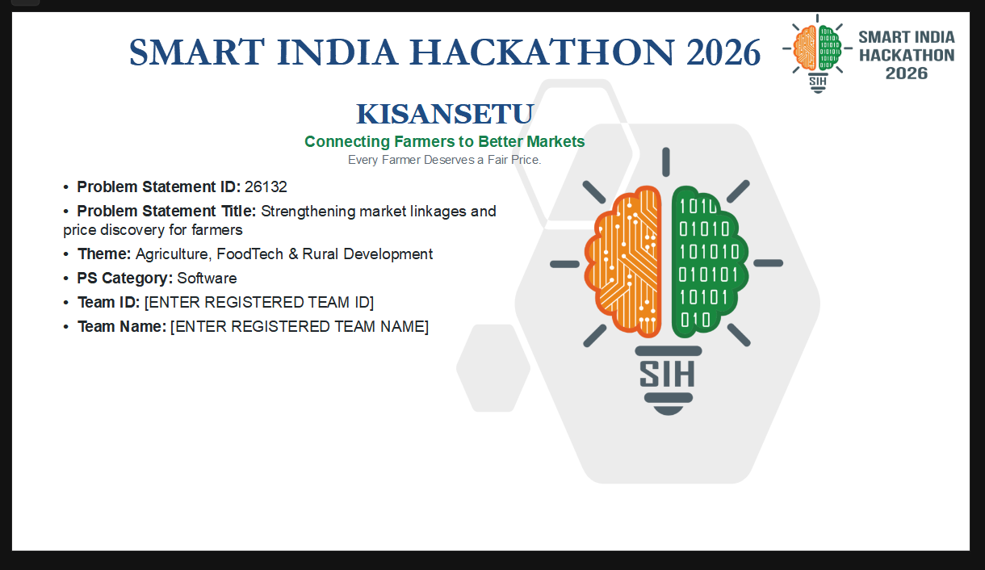
Visual 1: supplied KisanSetu six-slide PPT reference.
PPT reference visual 2
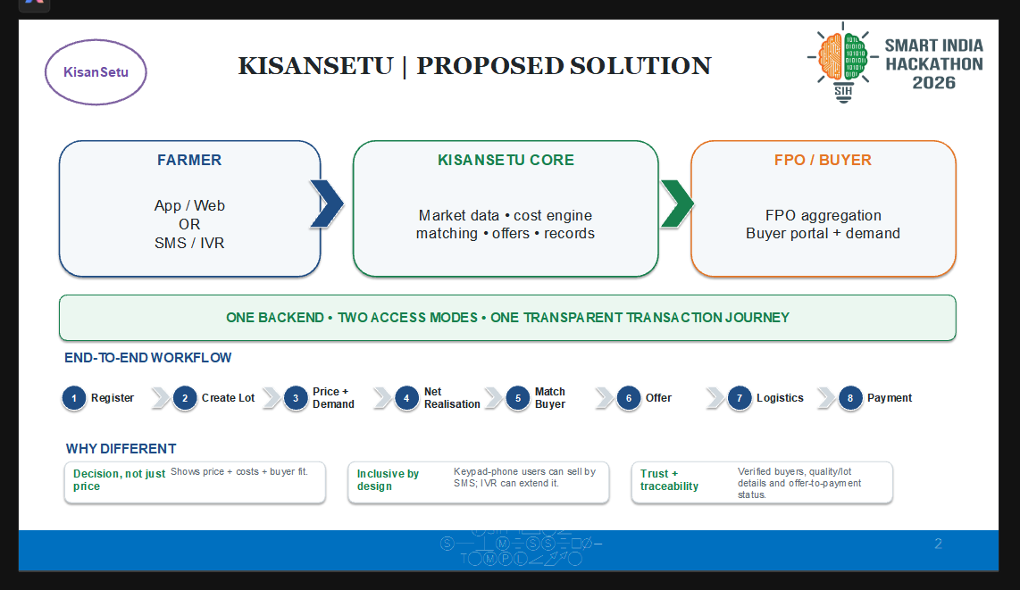
Visual 2: supplied KisanSetu six-slide PPT reference.

PPT reference visual 3
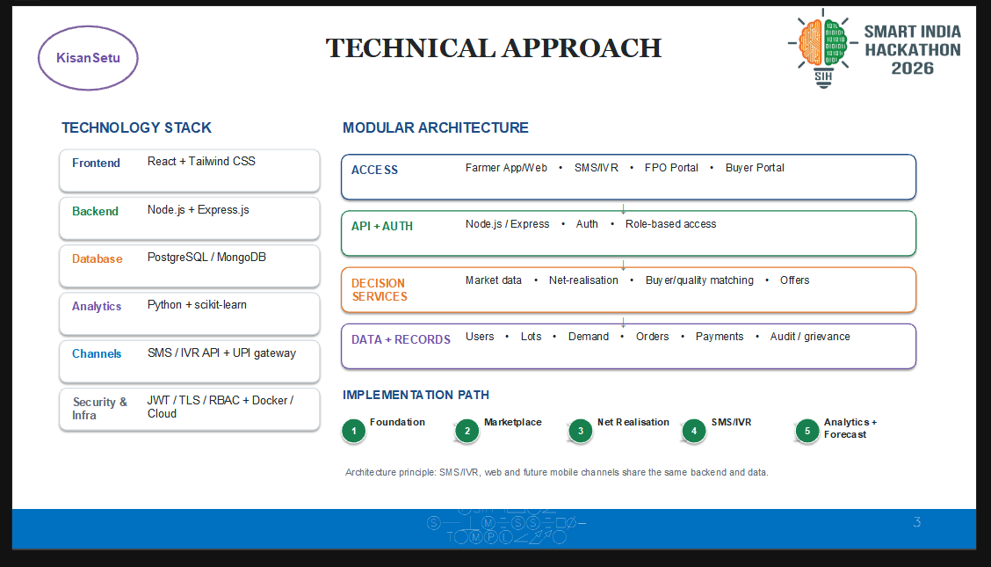
Visual 3: supplied KisanSetu six-slide PPT reference.
PPT reference visual 4
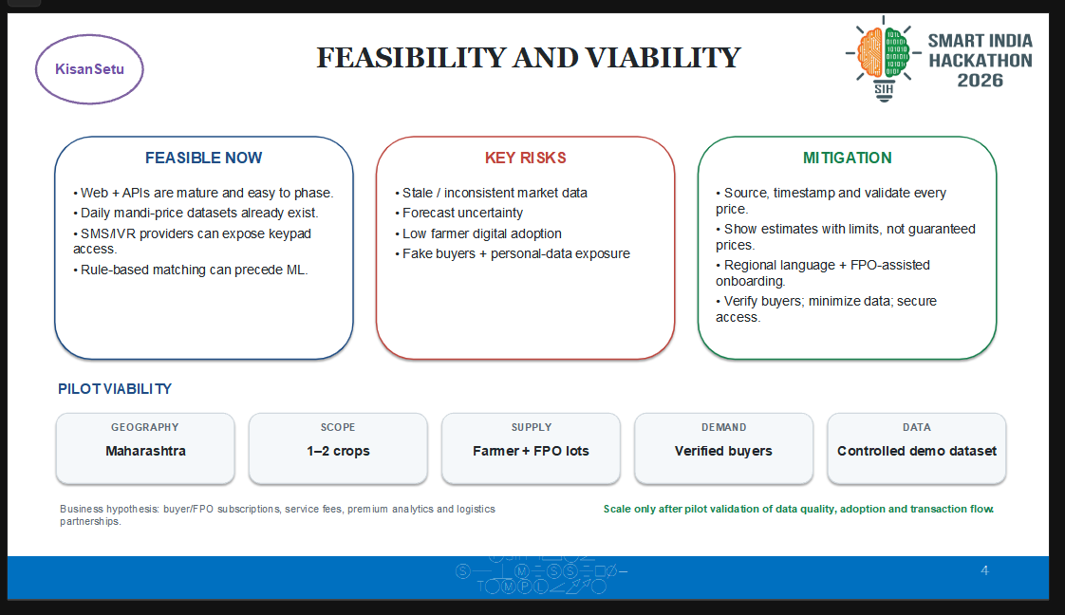
Visual 4: supplied KisanSetu six-slide PPT reference.

PPT reference visual 5
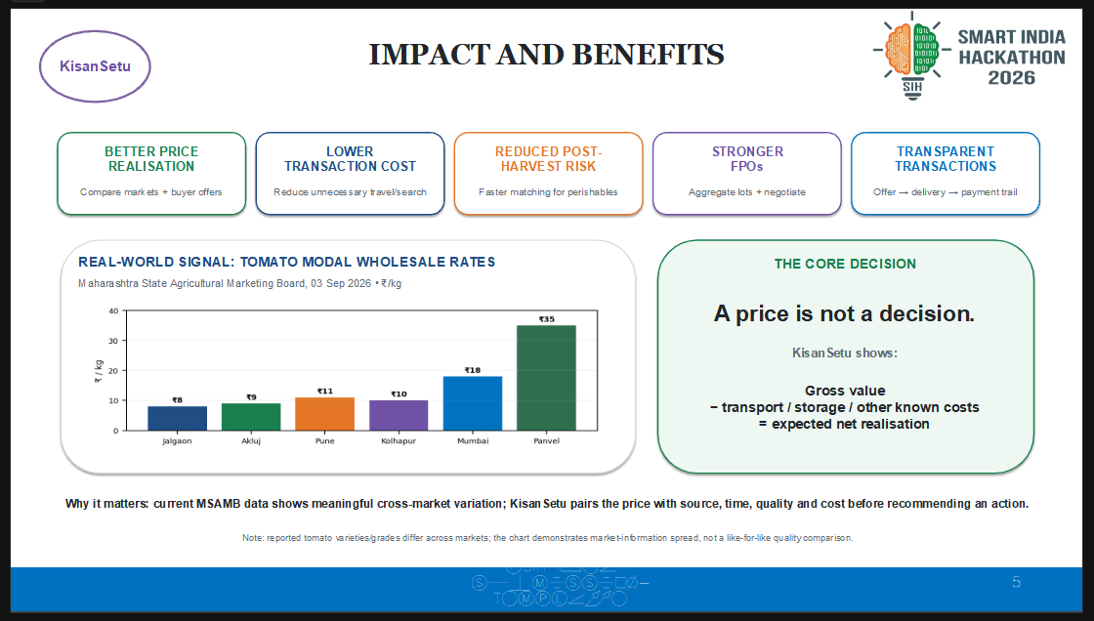
Visual 5: supplied KisanSetu six-slide PPT reference.
PPT reference visual 6
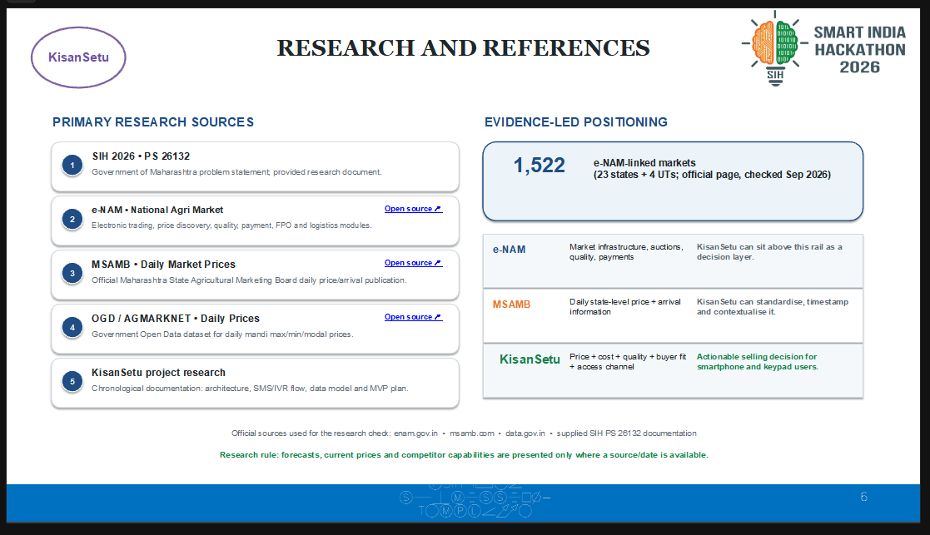
Visual 6: supplied KisanSetu six-slide PPT reference.

Appendix C. Source Notes and References
The master documentation was built from the uploaded project materials. The references below preserve the source list contained in the independent research and project documentation; current claims should still be re-verified immediately before formal judging or submission.
[1] SIH26132 problem statement reference, “Strengthening market linkages and price discovery for farmers.”
https://sih2026.vuce.in/ps/SIH26132
[2] e-NAM official portal. Official overview of the National Agriculture Market model.
https://enam.gov.in/
[3] e-NAM registration guidelines.
https://enam.gov.in/resources/registration-guideline
[4] e-NAM Agmarknet price dashboard.
https://www.enam.gov.in/web/dashboard/agmarknet
[5] PIB, “Strengthening of Agricultural Marketing”, 28 July 2026.
https://www.pib.gov.in/PressReleasePage.aspx?PRID=2290633&lang=2&reg=48
[6] PIB, “National Agriculture Market: Digital Transformation of Agricultural Trade in India”, 13 April 2026.
https://www.pib.gov.in/PressNoteDetails.aspx?ModuleId=3&NoteId=158169&id=158169&lang=1&reg=22
[7] Open Government Data Platform, Current Daily Price of Various Commodities from Various Markets (Mandi).
https://www.data.gov.in/resource/current-daily-price-various-commodities-various-markets-mandi
[8] Open Government Data Platform, Variety-wise Daily Market Prices Data of Commodity.
https://www.data.gov.in/resource/variety-wise-daily-market-prices-data-commodity
[9] PRS India, Demand for Grants 2026-27 Analysis: Agriculture and Farmers Welfare.
https://prsindia.org/files/budget/budget_parliament/2026/DfG_Analysis_2026-27-Agriculture.pdf
[10] Economic Survey 2025-26, digital agriculture/e-NAM context.
https://static.investindia.gov.in/s3fs-public/2026-03/economic_survey_25-26.pdf
[11] AgriBazaar Marketplace product description.
https://www.agribazaar.com/our-products/marketplace
[12] NABARD, FPO promotion and development information.
https://www.nabard.org/contentsearch.aspx?AID=95&Key=CROP
[13] ICAR/MANAGE, Strengthening Farmer-Market Linkages.
https://epubs.icar.org.in/index.php/JAEM/article/view/78923

Source files used for this master document
- KisanSetu_SIH_26132_Chronological_Documentation(4).pdf - 16-page team/project documentation.
- SIH26132_Independent_Research_Analysis_Report(2).docx - 16-page independent research and problem-analysis report.
- Supplied six-slide KisanSetu PPT screenshots - used for visual and pitch-alignment checks.
Final status
Research phase complete. Product definition and MVP scope established. Ready for repository audit and sequential implementation in Antigravity.

