**Name-Manojit Kumar Das**

[Email-dasmonojit026@gmail.com](mailto:Email-dasmonojit026@gmail.com)

Task:-

**Download Process Explorer,Process Monitor,PS Tool,Register Monitor,System Monitor**

**---------------------------------------------------------------------------------------------------------------------------------**

**Process Monitor**

Step 1:-search for Process Monitor in chrome

Step 2:-go to the site

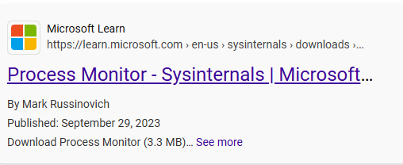

Step 3:- visit the site

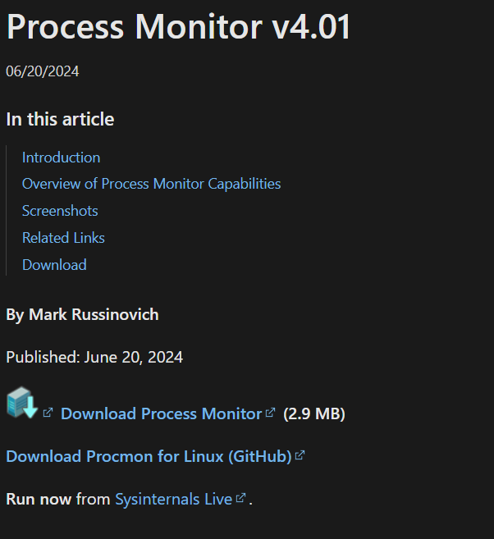

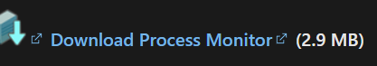Step 4:-Click the DOWNLOAD

Process Explorer

Step 1:-search for Process Explorerr in chrome

Step 2:-go to the site

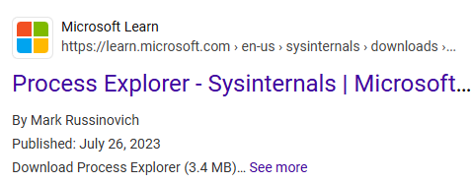

Step 3:- visit the site

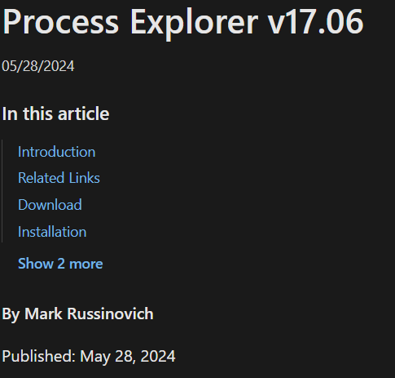

Step 4:-Click the DOWNLOAD

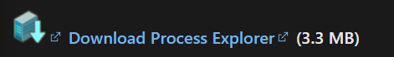

Process Tools

Step 1:-search for ProcessTools in chrome

Step 2:-go to the site

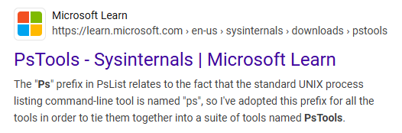

Step 3:- visit the site

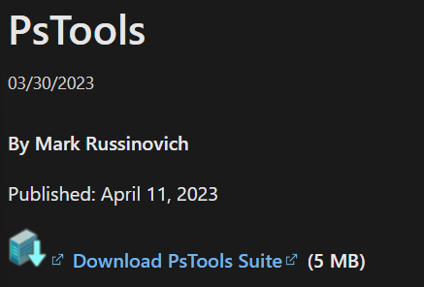

Step 4:-Click the DOWNLOAD

