**What is Registry?**

The **Windows Registry** is a hierarchical database used by the Windows operating system to **store low-level configuration settings** for the OS, installed applications, device drivers, and user profiles.

Key points:-

* It consists of **keys** and **values**, similar to folders and files.
* It replaces older INI configuration files used in DOS/Windows 3.x.

**There are how many types of Registry?**

There are mainly 5 types of Registry available:-

**HKEY_CLASSES_ROOT**:-this stores file associations and COM object information

**HKEY_CURRENT_USER**:- this stores the information about current logged in user

**HKEY_LOCAL_MACHINE**:-it contains settings for the entire computer

**HKEY_USER**:-stores settings for all users on that particular machine

**HKEY_CURRENT_CONFIG**:-this contains hardware profile information used during system startup

Which Registry path is responsible for finding product code?

The **HKEY_LOCAL_MACHINE** is responsible for that and the path is:-

**HKEY_LOCAL_MACHINE\SOFTWARE\Microsoft\Windows\Uninstall**

**To register a dll in windows 32 bit we have to do**

**step 1:-**open the **Command Promt**

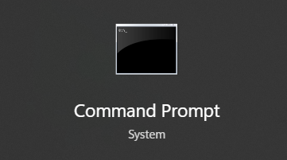

**step 2:-**Run it as **ADMINISTRATOR MODE**

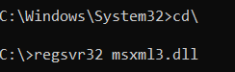**Step 3:-** write promt **regsvr32 followed with the dll** name to register a dll in a 32 bit system.

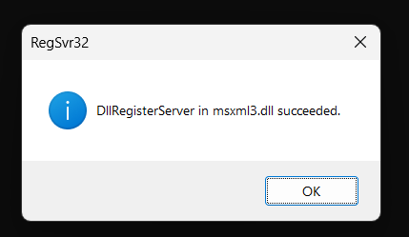**Step 4:-Press enter** and the dll is successfully registered.