Data Analysis and Reporting Using Power BI
University Academic Analytics
Student Information: [Name / ID placeholders]

Executive Summary
This submission contains a validated synthetic university analytics dataset, Power BI-ready documentation, a public static analytics viewer, demo video, formal report, presentation, and GitHub release. The cleaned dataset contains 1,000 students, 12,500 enrollments, 22,577 attendance records, and 5,994 payment records.

Dataset Description
The dataset covers 2023 to 2026 and contains separate raw and cleaned versions. Raw data includes controlled quality issues; cleaned data is validated and exported as Excel and CSV files.
Table | Rows | Columns
Students | 1000 | 12
StudentProfile | 1000 | 7
Departments | 10 | 6
Courses | 70 | 7
Faculty | 50 | 7
Semesters | 11 | 5
Enrollment | 12500 | 14
Attendance | 22577 | 6
Payments | 5994 | 10
DepartmentBudget | 40 | 11

Data Model and Relationships
The model documents one-to-one Students to StudentProfile, one-to-many department/student/course/faculty/budget and transaction relationships, and the conceptual Students-Courses many-to-many relationship resolved by Enrollment.
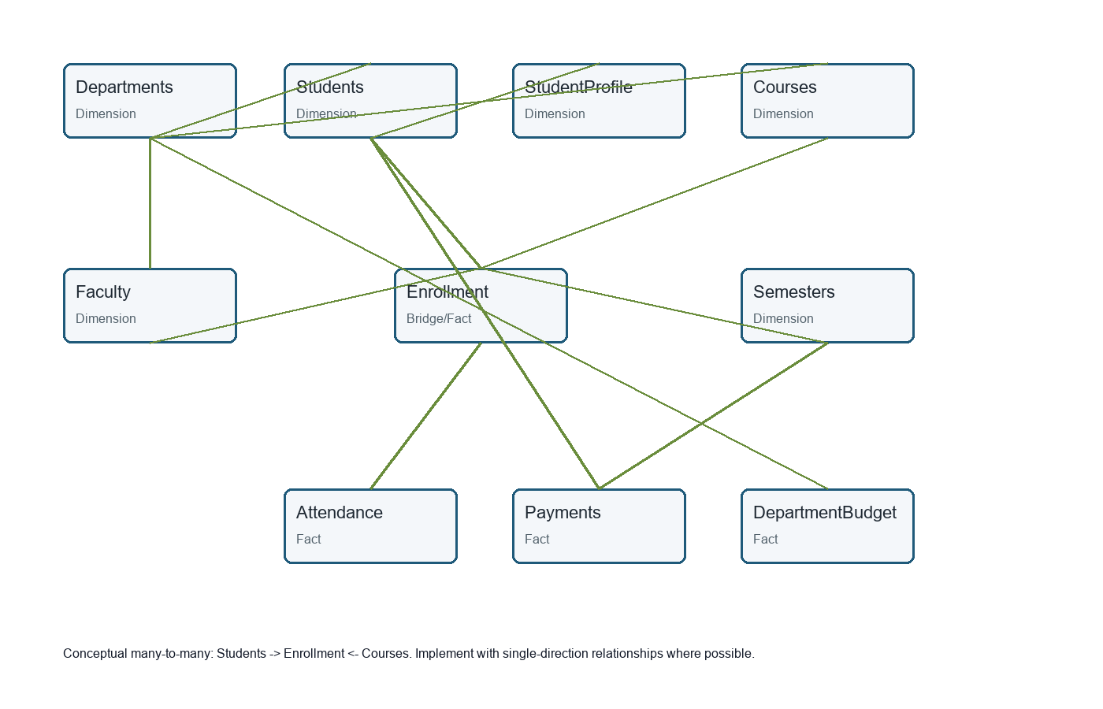

Power Query and DAX
Power Query transformations are documented table-by-table in powerbi/Power_Query_M_Code.md. The project includes 40 DAX measures, Date table DAX, and calculated-column examples.

Published Analytics
The public analytics viewer is available at https://monokayser.github.io/University-PowerBI-Analytics/ and the demo video is linked from docs/demo.html. This viewer is generated from cleaned data and is not a fabricated Power BI Service report.

Main Findings
Highest enrollment department: English has the largest student count. Recommended action: Review section sizes and faculty allocation.
Highest failure course: C018 has the highest failure rate. Recommended action: Add tutoring and review course design.
Attendance relationship: Lower attendance bands show lower average final marks. Recommended action: Trigger advising below 75% attendance.
Outstanding payments: Outstanding balance totals 125,733,250. Recommended action: Segment outreach by payment risk level.
Budget utilization: D007 has the highest utilization in 2023. Recommended action: Review mid-year budget reallocations.
Scholarship distribution: 32.0% of students receive a scholarship. Recommended action: Track outcomes by scholarship type.
Faculty workload: Enrollment links faculty to taught courses for workload analysis. Recommended action: Monitor distinct courses and enrollments per faculty.
Graduation eligibility: Credit and GPA measures identify students approaching eligibility. Recommended action: Add drill-through student review page.
Payment status: Paid, partial, and unpaid categories provide finance risk visibility. Recommended action: Use respectful outreach workflows.
Semester trend: Semester fields support enrollment and performance trend pages. Recommended action: Monitor semester-over-semester growth.

Limitations
Power BI Desktop was not installed, so a genuine .pbix file and Power BI Service report could not be created. The published analytics viewer is static and all data is synthetic.

Repository and Release
Repository: https://github.com/Monokayser/University-PowerBI-Analytics
Release: https://github.com/Monokayser/University-PowerBI-Analytics/releases/tag/v1.1.0
Published viewer: https://monokayser.github.io/University-PowerBI-Analytics/

