ACADEMIC PROJECT REPORT

Visual Analytics and Network Analysis of Facebook Engagement Using Python
  - An empirical engagement study and seven reproducible network-visualization exercises

Submission details
Field | Information
Student | S. M. Monowar Kayser
Student ID | 253-25-019
Course | Data Visualization (CSE628)
Semester | Summer 2026
Teacher | Sadat Hasan, Adjunct Faculty
Department | Department of Computer Science and Engineering
University | Daffodil International University
Prepared: 25 July 2026

Abstract
This project analyzes 7,050 anonymized Facebook posts and completes seven reproducible network-visualization exercises. It combines cleaning, feature engineering, static and interactive visualization, graph statistics, testing, and public web delivery. Video posts have the largest observed mean total engagement (1,041.57), but the observational design does not establish causality.
Keywords: Facebook engagement, data visualization, social-network analysis, NetworkX, Plotly, Python.

1. Introduction and research questions
The study describes multidimensional engagement while preserving the distinction between real tabular observations and synthetic relationship graphs. It asks how engagement varies by content and time, how visual layout changes structural readability, and which canonical graph models capture specific social-network properties.
A central methodological constraint is that the Facebook table contains no verified user-to-user edges. The empirical analysis therefore remains tabular; all assignment relationship graphs are explicitly synthetic.

2. Dataset, license, and ethics
Facebook Live Sellers in Thailand was authored by Nassim Dehouche and distributed by UCI under CC BY 4.0. It records anonymized post engagement from 2012-07-15 through 2018-06-13.
The official UCI archive was used because Kaggle credentials were not configured. The Kaggle mirror is documented but was not the acquisition route. No names, message text, or re-identification attempts are included.

3. Data cleaning and feature engineering
The raw table contained 7,050 rows and 16 columns. Four empty placeholder columns were removed; 0 duplicate rows and 0 invalid dates were found. The processed table contains 7,050 rows and 27 columns.
Total engagement equals reactions plus comments plus shares. Ratio features use zero-safe division. Temporal features include posting hour, weekday, month, ISO week, weekend, and time-of-day. No engagement rate is claimed because reach and impressions are absent.

4. Exploratory engagement findings
The data record 1,622,326 reactions, 1,581,710 comments, and 282,159 shares. Mean total engagement is 494.50, while the median is 69.00; the gap is consistent with strong right skew.
Table 1. Engagement summary by post type
Type | Posts | Mean reactions | Mean comments | Mean shares | Mean total
Video | 2,334 | 283.41 | 642.48 | 115.68 | 1,041.57
Status | 365 | 438.78 | 36.24 | 2.56 | 477.58
Link | 63 | 370.14 | 5.70 | 4.40 | 380.24
Photo | 4,288 | 181.29 | 15.99 | 2.55 | 199.84
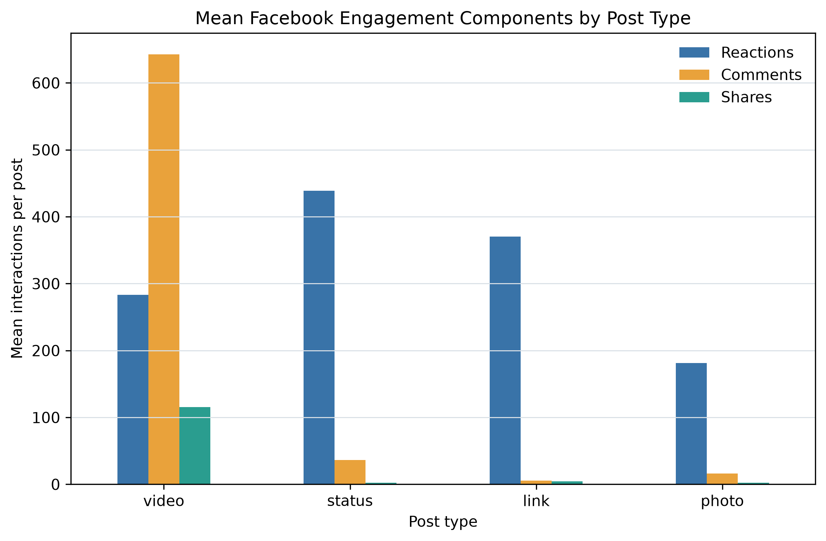
Figure 1. Mean engagement components by post type.

5. Distribution, correlation, and time
The upper Tukey fence flags 972 posts rather than deleting them. Rank correlations and log-transformed distributions are used because extreme posts make raw-count views difficult to read.
The largest observed median engagement occurs at 18:00, but content mix, seller behavior, and seasonality are plausible confounders.
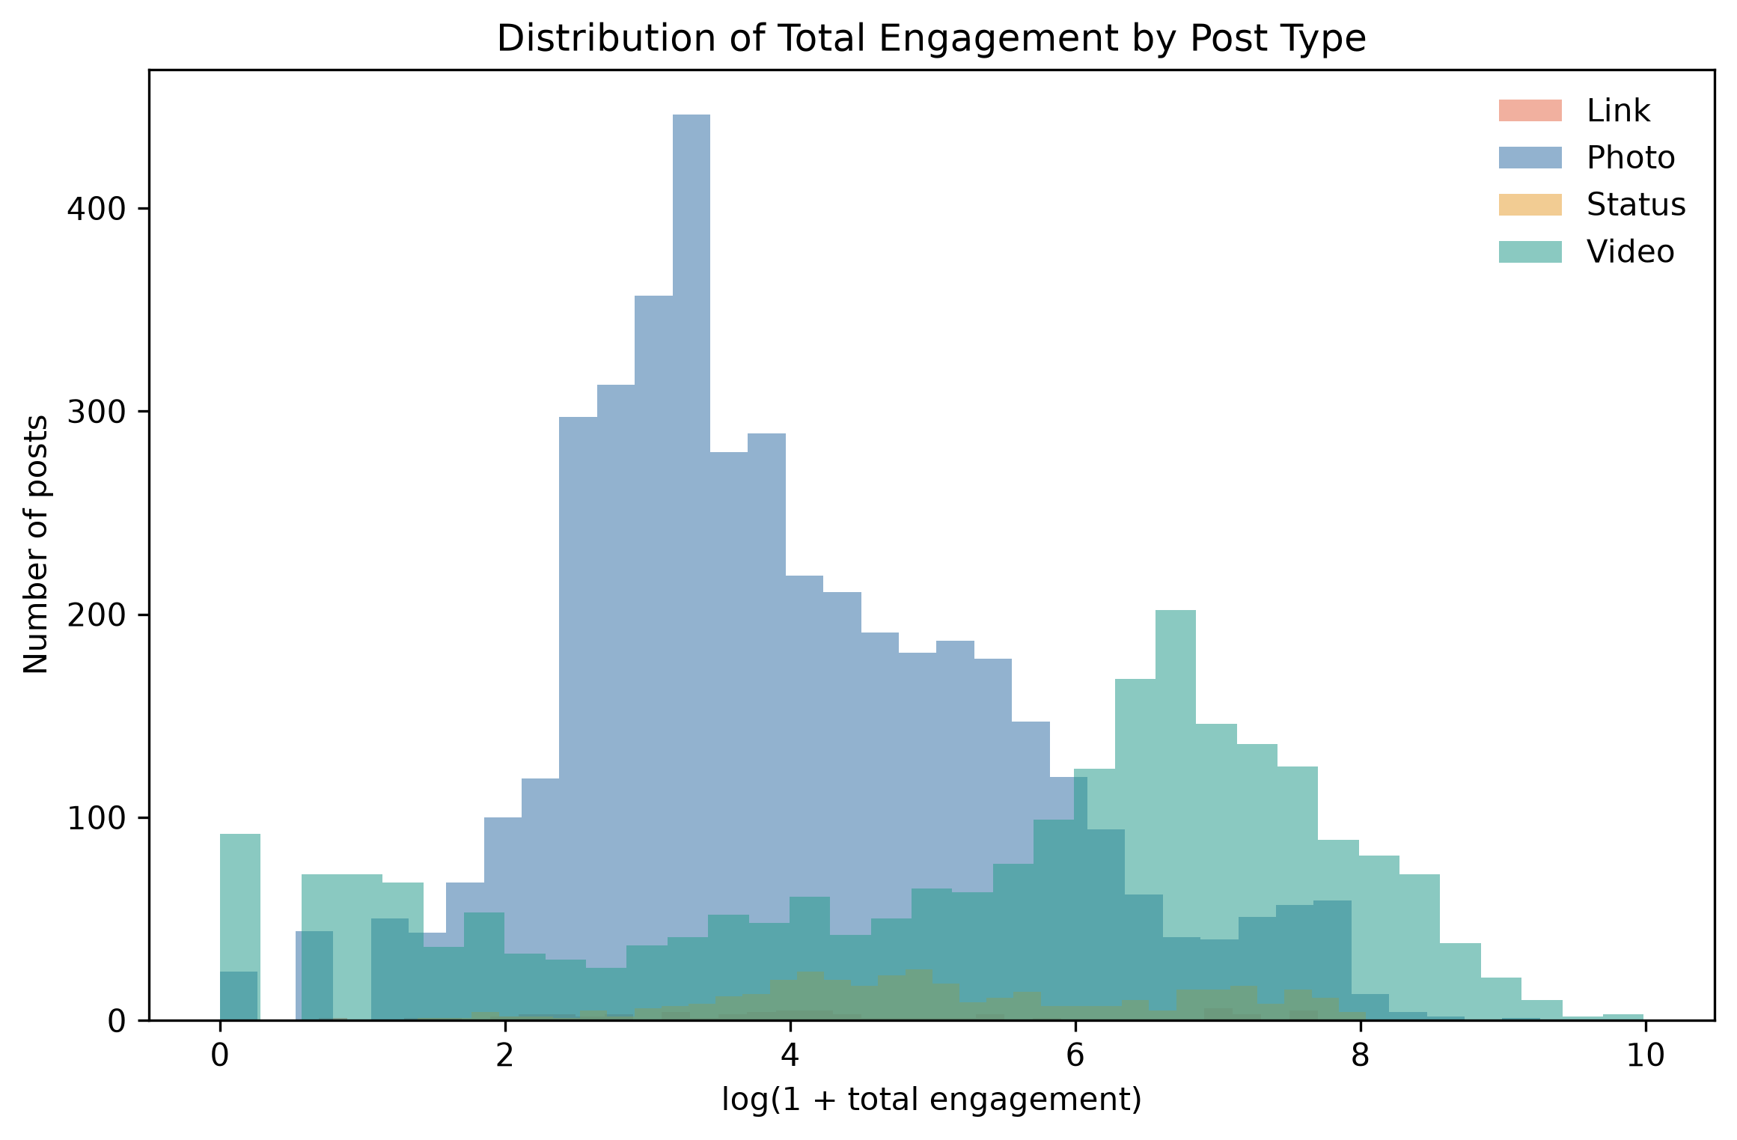
Figure 2. Log-transformed total-engagement distributions by post type.

6. Graph representation and visualization methodology
Adjacency matrices support exact pairwise lookup; node-link diagrams emphasize paths, clusters, bridges, and hubs. Visual encodings are held constant during layout comparison so that topology-driven placement is the primary changing variable.
Force-directed algorithms map graph-theoretic relationships to proximity, whereas circular and random layouts do not optimize community readability.

7. Exercise 1 - Weighted adjacency representations
The G_transport matrix stores route distances in kilometers and is symmetric: True. Symmetry follows from undirected equal-weight edges; a directed or directionally weighted network could be asymmetric.

8. Exercise 2 - Six-layout comparison
Kamada-Kawai is selected as the clearest layout for this exact 15-node G_ppi realization because it minimizes pairwise distance stress and makes ring locality plus rewired shortcuts legible. The measured average clustering is 0.000; no layout can reveal triangle-based clustering that is absent. Spring is a close alternative, and the judgment is not universal.
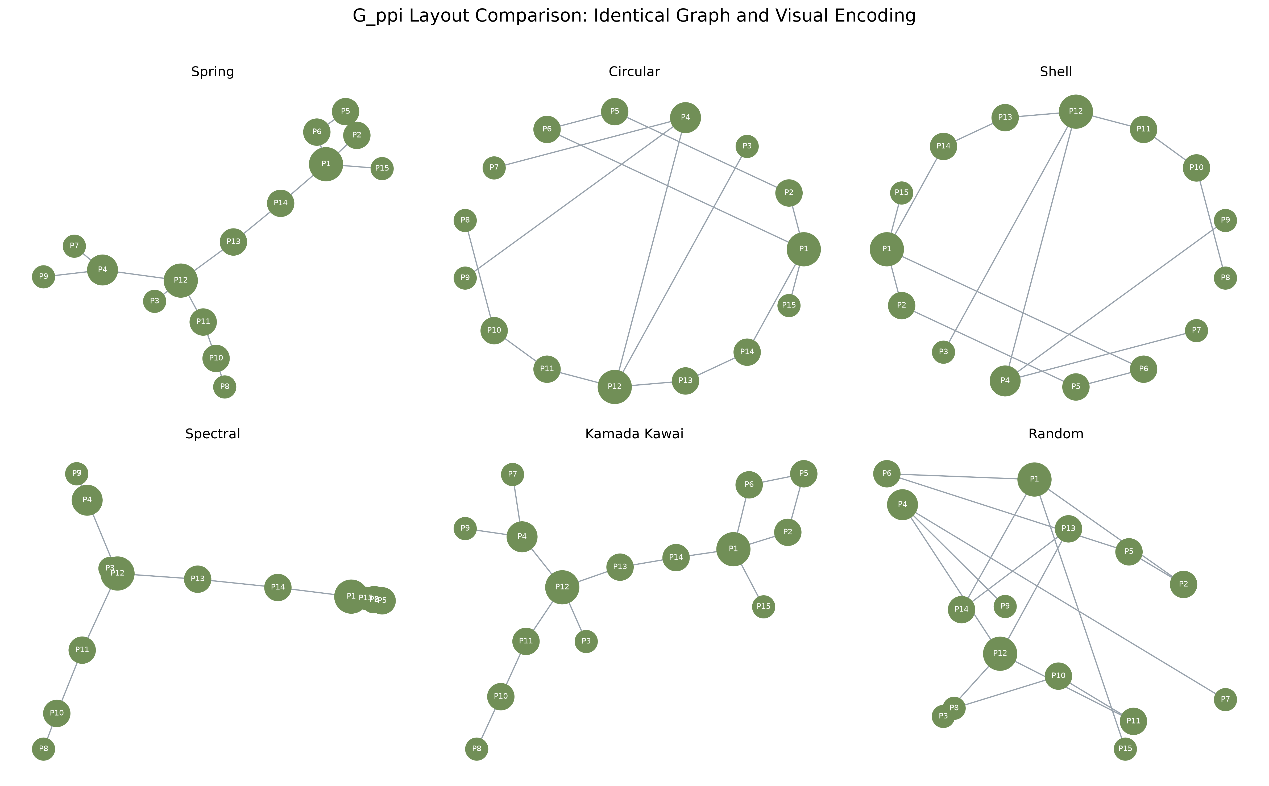
Figure 3. Six layouts of the identical synthetic G_ppi graph.

9. Exercise 3 - Student-course bipartite network
The stored CSV tables form a valid bipartite graph with 40 enrollments. Data Visualization is most popular, and Imran Kabir takes the largest number of courses.
Data Visualization bridges every represented major. Data Science students also concentrate in Machine Learning and Social Network Analysis, while Multimedia Technology students favor Human-Computer Interaction.
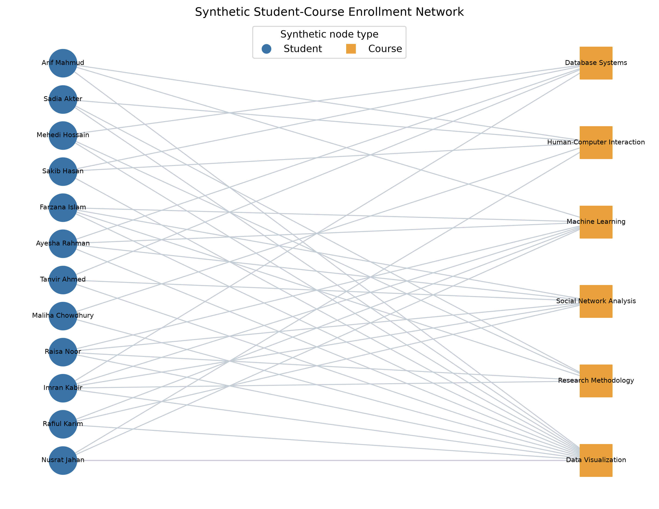
Figure 4. Synthetic student-course enrollment network.

10. Exercise 4 - Weighted Barabasi-Albert graph
All 196 edges received seeded integer weights from 1 to 10. Width changes tie salience but does not redefine degree-based hubs. Random weights demonstrate encoding rather than empirical importance.
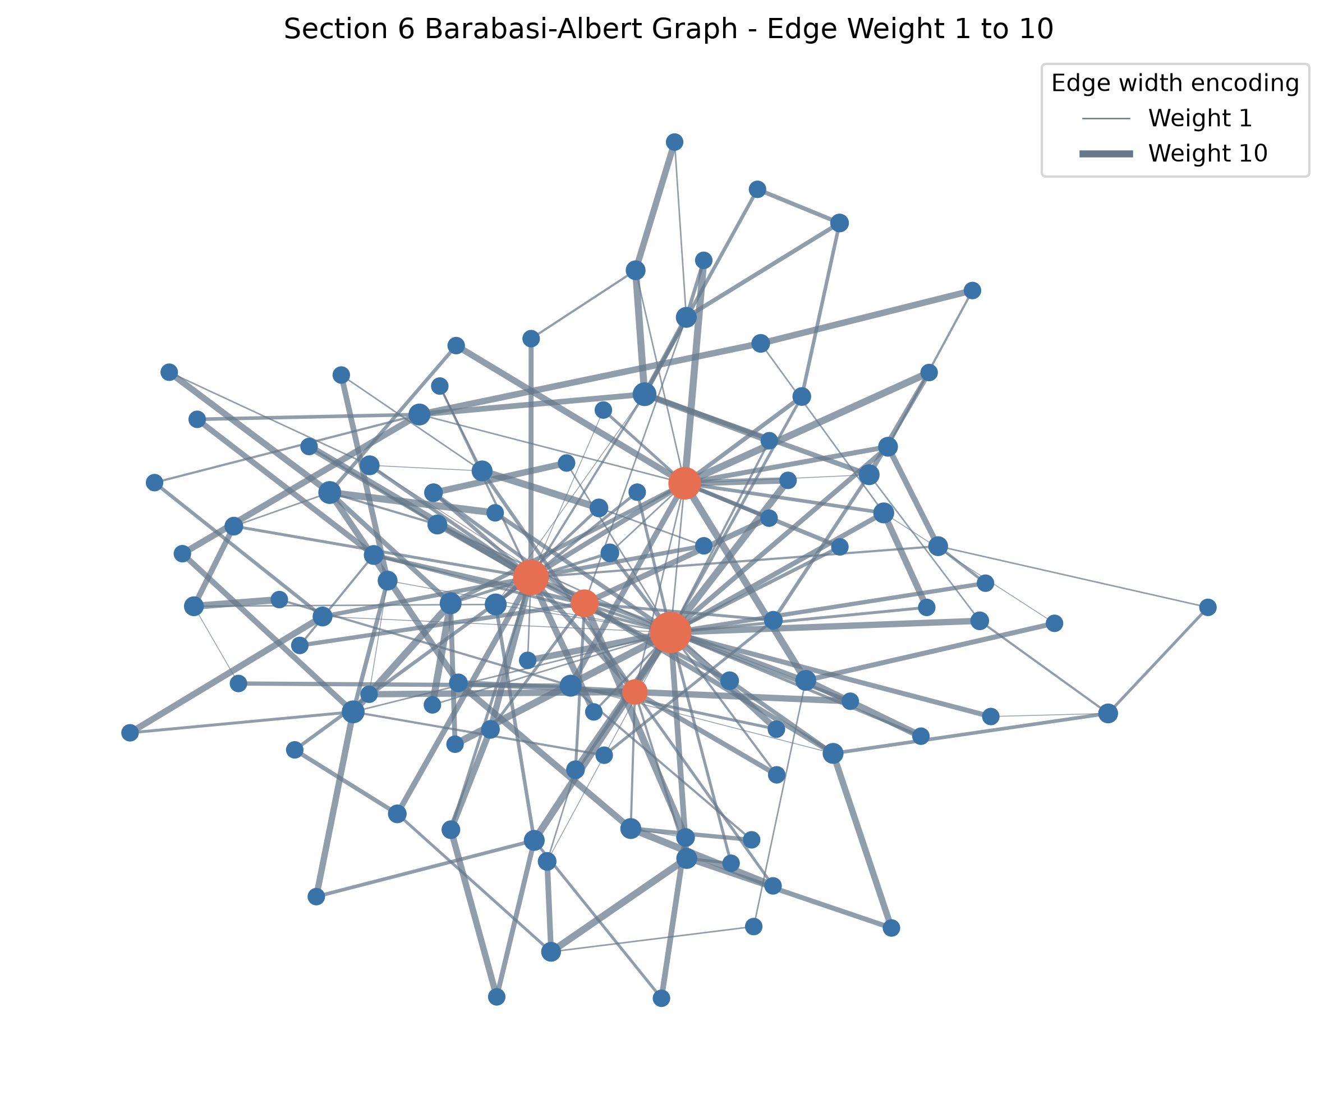
Figure 5. Barabasi-Albert graph with normalized edge-width encoding.

11. Exercise 5 - Generative-model comparison
Watts-Strogatz best captures high clustering and short paths; Barabasi-Albert best captures hubs and heterogeneous degree. A realistic social network may combine both, so none is universally best. Erdos-Renyi remains a useful homogeneous random baseline.
Table 2. Statistical comparison of Section 3 models
Model | Nodes | Edges | Density | Clustering | Avg. path | Max degree
Erdos-Renyi G(n,p) | 30 | 33 | 0.076 | 0.072 | 3.828 | 4
Watts-Strogatz small-world | 30 | 60 | 0.138 | 0.346 | 2.984 | 5
Barabasi-Albert scale-free | 30 | 56 | 0.129 | 0.300 | 2.182 | 18
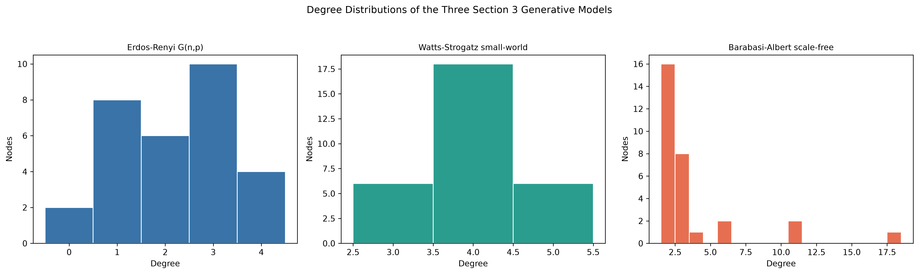
Figure 6. Degree distributions of the three Section 3 models.

12. Exercise 6 - Interactive node-color dashboard
The Plotly dashboard preserves node positions while a dropdown switches between categorical interest-group color and continuous in-degree color. Hover information reports node ID, group, in-degree, and out-degree, and edges remain visible in both modes.

13. Exercise 7 - Applied AI and Multimedia research graph
Recommendation Systems is the strongest bridge by betweenness, linking research themes, technical methods, and application outcomes. The graph is synthetic and demonstrates structural interpretation, not empirical evidence about a real research community.
The graph is synthetic and demonstrates centrality interpretation rather than empirical evidence about a research community.
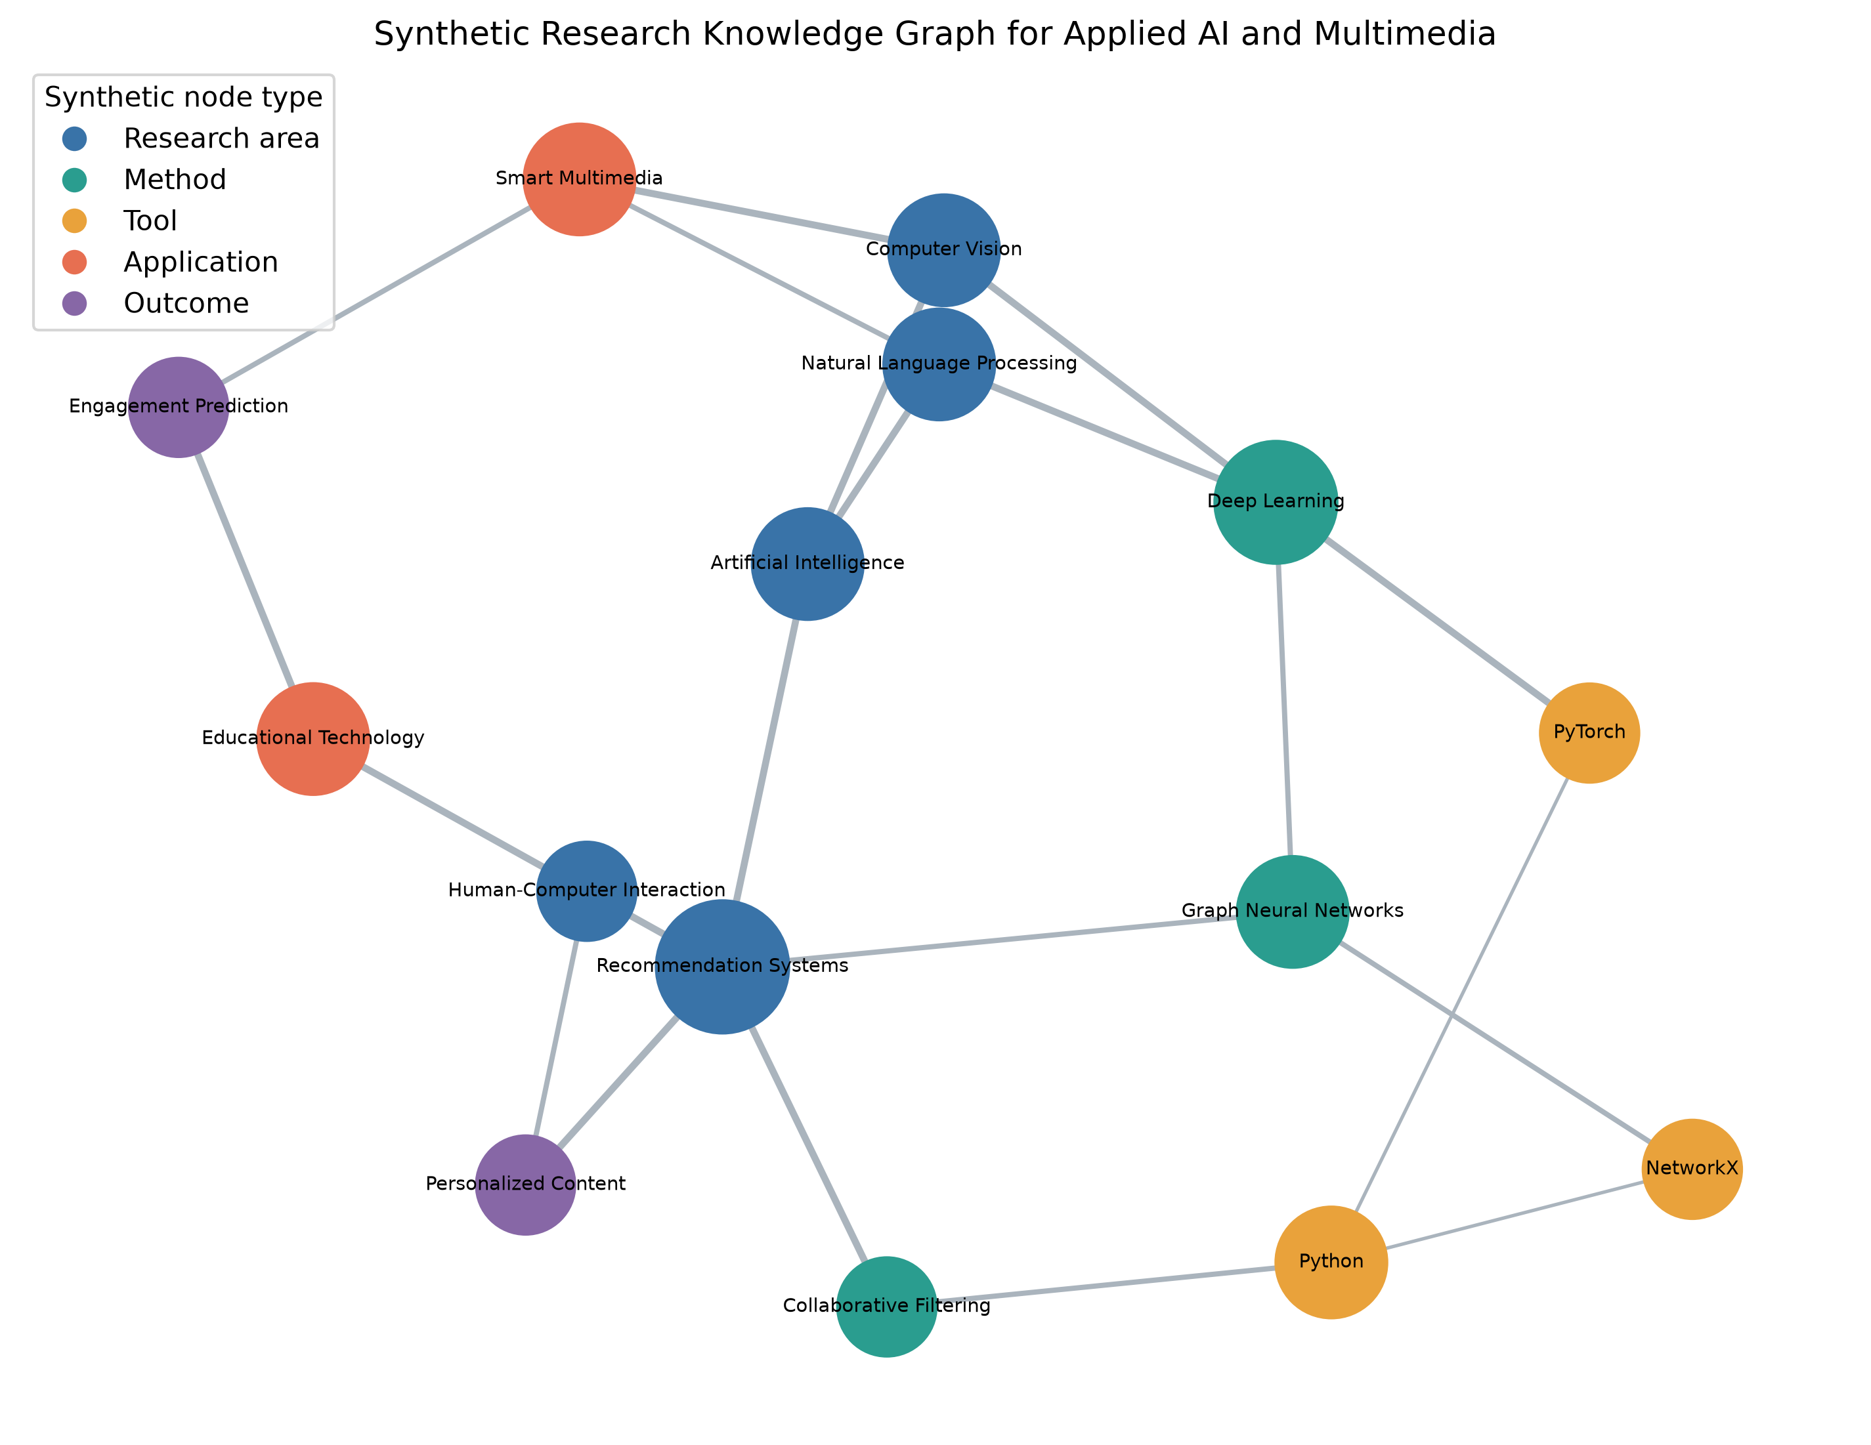
Figure 7. Synthetic applied-AI and multimedia research knowledge graph.

14. Discussion
The empirical and synthetic components answer different questions. The Facebook table supports descriptive post comparison but not individual relationship inference. The synthetic graphs reveal how topology, layout, and encoding shape network interpretation.
Mean engagement is influenced by extreme posts, so median summaries, log distributions, and outlier flags accompany it. Correlations remain associational and do not isolate algorithm, audience, or content effects.

15. Limitations and ethical considerations
The data end in 2018, represent ten Thai sellers, and omit reach, impressions, followers, campaign spend, page identity, and content text. Results may not generalize across settings or time.
The project preserves anonymization, reports aggregate findings, avoids re-identification, makes no unsupported causal claims, and clearly labels every dummy graph as synthetic.

16. Conclusion, recommendations, and future work
Video posts have the largest observed mean engagement, Kamada-Kawai most clearly presents the supplied small-world graph, weighted encoding separates tie salience from centrality, and the model comparison shows that social-network realism is multidimensional.
Future work should add ethically collected reach denominators, multiple seller populations, repeated graph simulations, uncertainty intervals, content representations, and user testing of dashboard accessibility.

References
1. Dehouche, N. (2018). Facebook Live Sellers in Thailand [Dataset]. UCI Machine Learning Repository. https://doi.org/10.24432/C5R60S
2. Dehouche, N. (2020). Dataset on usage and engagement patterns for Facebook Live sellers in Thailand. Data in Brief, 30, 105661. https://doi.org/10.1016/j.dib.2020.105661
3. Hagberg, A. A., Schult, D. A., & Swart, P. J. (2008). Exploring network structure, dynamics, and function using NetworkX. Proceedings of SciPy 2008, 11-15.
4. Barabasi, A.-L. (2016). Network Science. Cambridge University Press. http://networksciencebook.com/
5. Pandas documentation. https://pandas.pydata.org/docs/
6. Matplotlib documentation. https://matplotlib.org/stable/
7. Plotly Python documentation. https://plotly.com/python/
8. NetworkX documentation. https://networkx.org/documentation/stable/

Appendix: Reproducibility and assumptions
Run python main.py to rebuild every generated artifact and pytest to validate the pipeline. The supplied teaching notebooks are source-identical. The official UCI download was used because Kaggle credentials were unavailable. All assignment-only relationship graphs are labeled synthetic.

