ACADEMIC PROJECT REPORT

Visual Analytics and Network Analysis of Facebook Engagement Using Python
  - An empirical engagement study and seven reproducible network-visualization exercises

Submission details
Field | Information
Student | S. M. Monowar Kayser
Student ID | 253-25-019
Course | Data Visualization (CSE628)
Semester | Summer 2026
Teacher | Sadat Hasan, Adjunct Faculty
Department | Department of Computer Science and Engineering
University | Daffodil International University
Prepared: 27 July 2026

Abstract
An analysis is presented of 7,050 anonymized Facebook posts, and seven reproducible network-visualization exercises are completed. Cleaning, feature engineering, static and interactive visualization, graph statistics, testing, and public web delivery are combined. The largest observed mean total engagement is associated with video posts (1,041.57), but causality is not established by the observational design.
Keywords: Facebook engagement, data visualization, social-network analysis, NetworkX, Plotly, Python.

Contents
1. Introduction and research questions; 2. Dataset, license, and ethics; 3. Data cleaning and feature engineering; 4-6. Empirical findings and visualization methodology; 7. Extended analytical framework; 8. Seven mandatory exercises; 9-12. Discussion, limitations, conclusions, implications, references, and appendices.

1. Introduction and research questions
Multidimensional engagement is described while the distinction between real tabular observations and synthetic relationship graphs is preserved. Variation by content and time, structural readability under different visual layouts, and the social-network properties captured by canonical graph models are examined.
A central methodological constraint is that the Facebook table contains no verified user-to-user edges. The empirical analysis therefore remains tabular; all assignment relationship graphs are explicitly synthetic.

2. Dataset, license, and ethics
Facebook Live Sellers in Thailand was authored by Nassim Dehouche and distributed by UCI under CC BY 4.0. It records anonymized post engagement from 2012-07-15 through 2018-06-13.
The official UCI archive was used because Kaggle credentials were not configured. The Kaggle mirror is documented but was not the acquisition route. No names, message text, or re-identification attempts are included.

3. Data cleaning and feature engineering
The raw table contained 7,050 rows and 16 columns. Four empty placeholder columns were removed; 0 duplicate rows and 0 invalid dates were found. The processed table contains 7,050 rows and 27 columns.
Total engagement equals reactions plus comments plus shares. Ratio features use zero-safe division. Temporal features include posting hour, weekday, month, ISO week, weekend, and time-of-day. No engagement rate is claimed because reach and impressions are absent.

4. Exploratory engagement findings
The data record 1,622,326 reactions, 1,581,710 comments, and 282,159 shares. Mean total engagement is 494.50, while the median is 69.00; the gap is consistent with strong right skew.
Table 1. Engagement summary by post type
Type | Posts | Mean reactions | Mean comments | Mean shares | Mean total
Video | 2,334 | 283.41 | 642.48 | 115.68 | 1,041.57
Status | 365 | 438.78 | 36.24 | 2.56 | 477.58
Link | 63 | 370.14 | 5.70 | 4.40 | 380.24
Photo | 4,288 | 181.29 | 15.99 | 2.55 | 199.84
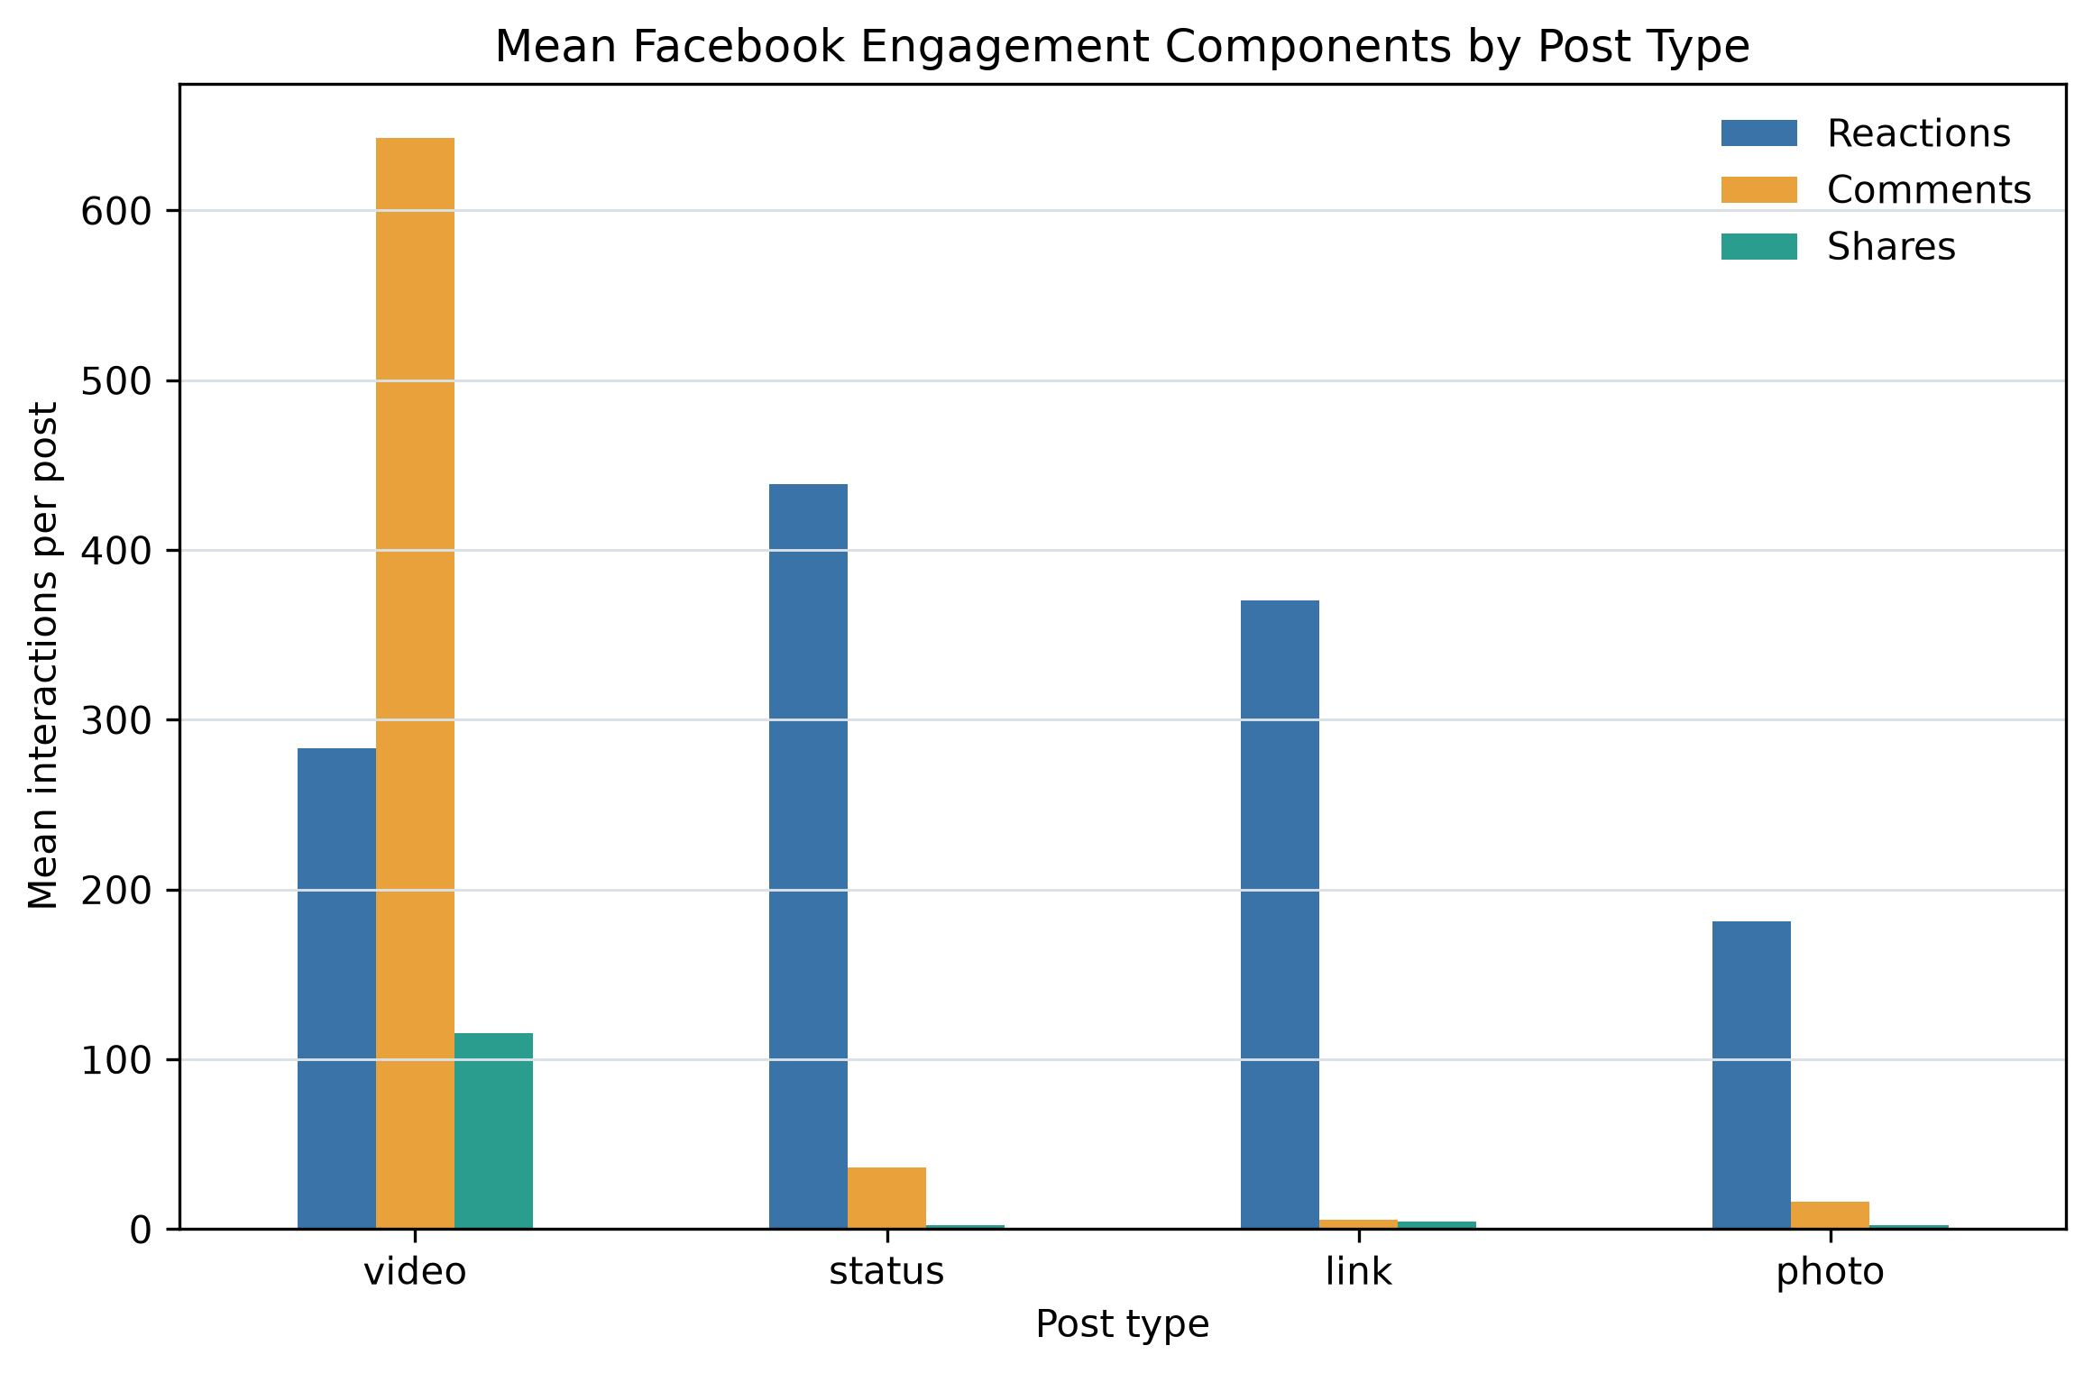
Figure 1. Mean engagement components by post type.

5. Distribution, correlation, and time
The upper Tukey fence flags 972 posts rather than deleting them. Rank correlations and log-transformed distributions are used because extreme posts make raw-count views difficult to read.
The largest observed median engagement occurs at 18:00, but content mix, seller behavior, and seasonality are plausible confounders.
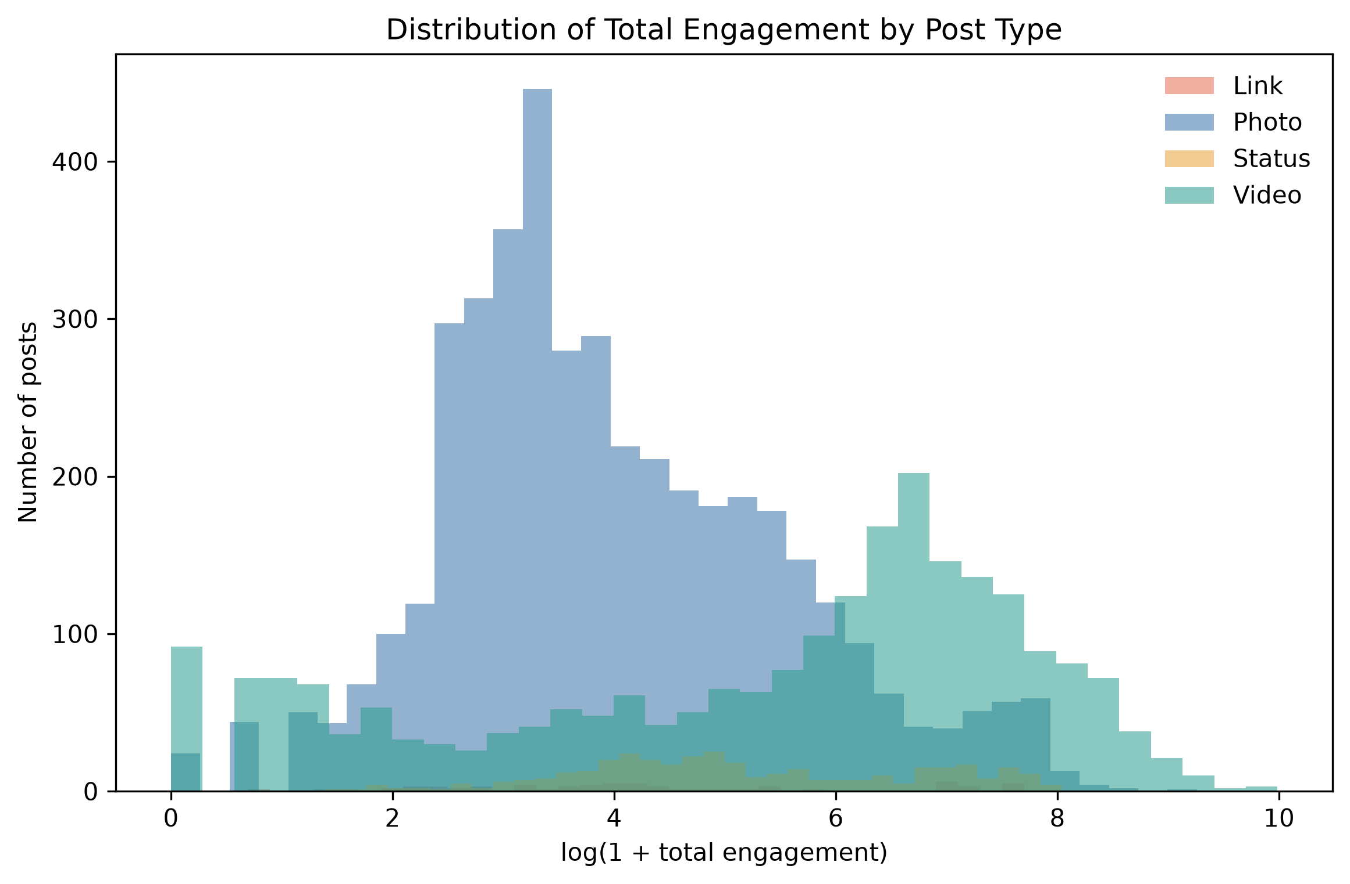
Figure 2. Log-transformed total-engagement distributions by post type.

5.1 Rank-correlation result
Spearman rank correlation was used because the engagement variables are strongly skewed. The coefficients describe monotonic association and were not interpreted as causal effects.
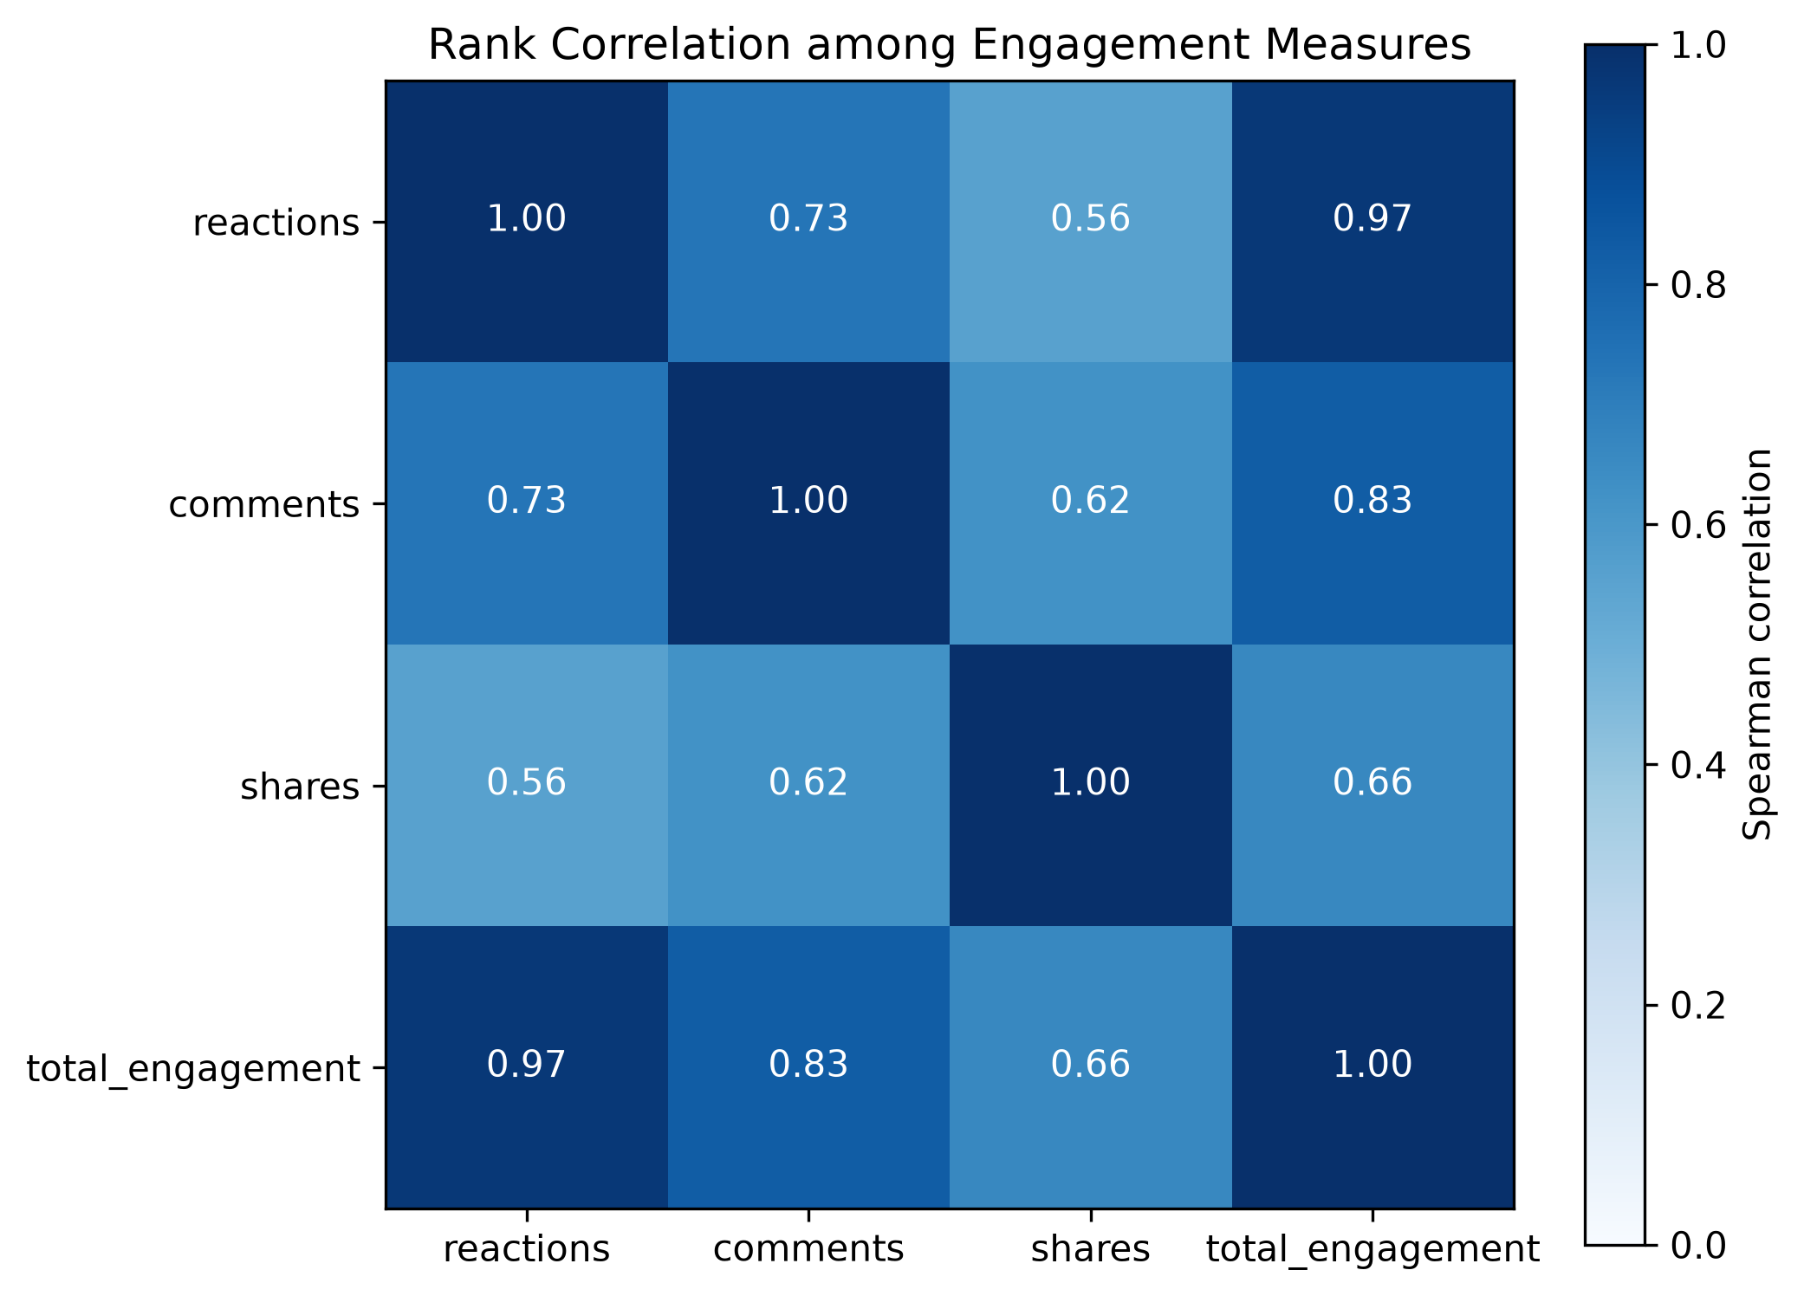
Figure 3. Spearman correlation matrix for engagement measures.

6. Graph representation and visualization methodology
Adjacency matrices support exact pairwise lookup; node-link diagrams emphasize paths, clusters, bridges, and hubs. Visual encodings are held constant during layout comparison so that topology-driven placement is the primary changing variable.
Force-directed algorithms map graph-theoretic relationships to proximity, whereas circular and random layouts do not optimize community readability.

7.1 Conceptual framework for engagement measurement
Engagement is treated as a family of observable platform actions rather than a direct measurement of attention, satisfaction, or persuasion. A reaction can be produced with comparatively little effort, whereas a comment or share may require additional cognitive or social commitment. Even this distinction is contextual: a short comment may be less consequential than a reaction from an influential account, and a share may be critical, supportive, or merely archival. The available table contains counts but no semantic evidence about motivation. Accordingly, the analysis preserves reactions, comments, and shares as separate variables before combining them into total engagement. The aggregate is useful for ranking overall activity, but it is not presented as a validated psychological scale.
The difference between exposure and response is also fundamental. An engagement rate normally requires a denominator such as reach, impressions, followers, or unique viewers. None is available in the source file. Dividing observed actions by an invented or inappropriate denominator would create false precision, so the project reports counts, composition ratios, and within-dataset comparisons instead. This constraint narrows the claims but improves their validity. It also explains why a post with many engagements cannot automatically be described as efficient: the number of people who had an opportunity to engage is unknown.

7.2 Evidence standards and reproducible design
The workflow follows a separation between source evidence, derived evidence, and presentation. The raw CSV is preserved and identified by SHA-256. Cleaning rules operate on a copy and produce an auditable processed table. Calculated statistics and graph metrics are then serialized in one machine-readable summary. Reports, notebook claims, and website text read from that summary instead of maintaining independent handwritten numbers. This design reduces the risk that a corrected metric remains stale in one publication surface. It also makes a discrepancy testable: a reported value can be traced to a specific JSON field and to the function that calculated it.
Reproducibility is understood as more than the presence of code. Paths are resolved from the repository root, stochastic operations use seed 42, graph parameters are recorded, notebooks are executed from clean kernels, and required artifacts are checked for existence and nontrivial size. The artifact manifest records hashes for the canonical data, tables, figures, interactive files, notebooks, and reports. These measures cannot guarantee that every software version will render pixels identically, but they make the analytical decisions and the delivered version observable and comparable.
The design also separates regeneration from verification. A pipeline can finish without proving that its outputs are correct, so completion is followed by independent checks: schema assertions, numerical cross-checks, notebook error inspection, document-structure audits, link validation, responsive browser review, and deployment status inspection. Failures are reported at the surface where they occur. For example, an analytical test cannot certify that a dropdown works, and a visual browser check cannot establish that a matrix used the correct edge-weight field. Layered verification prevents one successful tool from being treated as evidence for an unrelated requirement.

7.3 Data quality assessment and transformation rationale
The raw table contains 7,050 records and 16 columns. Four columns are empty across all rows and carry no analytical information; removing them is a structural correction rather than an imputation decision. Duplicate checks are performed both on complete rows and on `status_id`, because two identical records and two records sharing an identifier represent different quality concerns. The observed duplicate counts are 0 complete rows and 0 identifiers. Date parsing is validated before temporal features are produced, preventing malformed timestamps from silently entering hourly or monthly summaries.
Count variables are required to be numeric, finite, and nonnegative. Categorical labels are normalized so that spelling or capitalization does not split a post type into artificial groups. Missing-value handling is deliberately conservative: imputation is applied only where a defensible zero interpretation exists, and the audit records the number of affected values. The processed table is then validated against explicit invariants, including unique identifiers, complete engineered columns, nonnegative engagement, and finite ratios. These checks convert assumptions into executable conditions rather than leaving them as undocumented analyst judgment.
Extreme engagement is retained. The upper Tukey fence is 1,019.00, and 972 records exceed it. Deleting these observations would remove genuine high-performing posts and materially change the phenomenon under study. Instead, an outlier flag supports sensitivity-aware summaries, while log transformation makes distribution plots readable. Mean and median are reported together so that the influence of the long right tail remains visible.

7.4 Feature validity and analytical interpretation
Total engagement is defined as the sum of the dataset's authoritative reaction total, comments, and shares. Component reaction fields are retained for composition analysis and quality comparison, but they do not replace the documented total without evidence that the two constructs are identical. The comment-to-reaction and share-to-total ratios are calculated with a zero-safe operation. Returning zero when the denominator is zero avoids infinite values and preserves a clear interpretation: no observed denominator-supported ratio is available for that row.
Temporal features translate timestamps into posting hour, weekday, month, ISO week, weekend status, and broad time-of-day categories. They describe when posts were published, not when engagement occurred. A high median for a posting hour may reflect content selection, seller strategy, seasonal campaigns, or audience composition. The feature therefore supports descriptive scheduling analysis but not a causal recommendation that changing the clock time alone will improve results.
The low, medium, and high engagement bands are rank-based descriptive labels within this dataset. They are not universal performance benchmarks and should not be compared directly with another page or platform without recalibration. Similarly, the outlier indicator is a statistical flag rather than a judgment that a record is erroneous. These labels are useful for filtering and visual explanation only when their local definition remains visible.

7.5 Distribution-aware exploratory strategy
The 7,050 posts record 3,486,195 total engagements. The mean (494.50) is substantially larger than the median (69.00), demonstrating that a small proportion of posts contributes heavily to the aggregate. A mean-only comparison would therefore describe the economic weight of high observations but not the typical post. The report pairs means with medians, count distributions, and log-scaled views so that both questions remain answerable.
Post-type comparisons are observational. Video has the highest observed mean total engagement (1,041.57), but post type was not randomized. Seller identity, live-event context, promotion, topic, audience size, and the platform's historical ranking system may all affect the result. The finding is appropriately phrased as an association in the recorded sample. It can motivate a controlled content experiment, but it cannot substitute for one.
Spearman correlation is selected because it evaluates monotonic rank association without assuming normally distributed raw counts. Total engagement necessarily shares components with reactions, comments, and shares, so strong correlations with the total are partly mathematical. Correlation between components may also arise from a common exposure mechanism. The heatmap is therefore interpreted as a descriptive relationship map, not as evidence that one action causes another.

7.6 Graph representation and metric semantics
A graph is defined by its nodes, edges, direction, and attributes; the drawing is only one representation of that structure. Adjacency lists are efficient for neighbor inspection in sparse graphs, while matrices support exact pairwise lookup, linear-algebra operations, and symmetry tests. Node-link diagrams are effective for paths, hubs, bridges, and small-scale topology, but they become difficult to read as density and label count increase. The exercises use each form for the task it supports rather than treating visualization as decoration.
Metric meaning depends on the graph model. Degree counts incident ties, in-degree counts received directed ties, and PageRank distributes importance through linked neighbors. Betweenness identifies nodes on shortest paths, but weighted shortest paths require a distance. In the knowledge graph, semantic strength is transformed to inverse strength so that a strong relationship becomes a short effective distance. Using raw strength directly as distance would reverse the intended meaning and could change the ranking.
Connectivity also controls path interpretation. Average shortest path is undefined across disconnected components because no finite route joins every pair. The model comparison therefore reports whole-graph path length only for connected graphs and uses the largest connected component for the disconnected Erdos-Renyi realization. The scope is stored beside the value so that a reader cannot mistake the component result for a network-wide statistic.

7.7 Visual encoding and layout validity
Layout algorithms change coordinates, not topology. A spring layout uses attractive and repulsive forces, Kamada-Kawai minimizes a graph-distance stress objective, spectral layout uses eigenvectors, and circular, shell, or random placement applies different geometric constraints. Because the same graph can look clustered or dispersed under different coordinates, visual grouping must be checked against calculated community or clustering measures. In Exercise 2, node attributes, sizes, edge styles, labels, and figure dimensions are held constant so that placement is the controlled variable.
The supplied `G_ppi` realization has average clustering 0.000. Kamada-Kawai is selected because it gives the clearest distance-oriented account of ring locality and shortcuts, not because it reveals communities that the metric does not support. This distinction is important in academic graph drawing: an aesthetically separated region may be a layout artifact, while a visually dense region may reflect label placement rather than structural cohesion.
Color, size, shape, and width are assigned specific semantic roles. Categorical variables use distinct hues; ordered measures use a continuous scale; student and course partitions use separate node forms; and synthetic edge weight is encoded through width. Legends, captions, and hover text state these mappings. Redundant visual cues are used where they improve accessibility, while unnecessary three-dimensional effects and decorative encodings are avoided.

7.8 Static and interactive visualization roles
Static figures provide a stable scholarly record. They can be numbered, cited, printed, and compared without requiring a runtime. They are exported at high resolution with explicit titles, labels, legends, and captions. Interactive Plotly artifacts answer different needs: readers can inspect individual nodes and posts, zoom into the long tail, isolate categories, and switch encodings. The project therefore treats interactivity as an analytical affordance rather than a replacement for documented static evidence.
The node-color dashboard illustrates controlled interaction. Both modes retain the same coordinates and edge traces. Interest-group color is categorical, whereas in-degree color is continuous. Because geometry remains fixed, changes in perception can be attributed to the selected color variable rather than a simultaneous layout change. Hover fields disclose group, in-degree, and out-degree, enabling the reader to check the visual impression against exact values.

8.1 Exercise 1 - Weighted adjacency representations
The relationship between an adjacency list and a weighted adjacency matrix was examined through the supplied G_transport network. Matrix symmetry and its implication for route direction were evaluated.

8.1.1 Objective, construction, and procedure
Seven cities and 9 undirected teaching routes were represented. Distance in kilometers was stored in every edge weight. Density was 0.4286, and Dhaka received the largest degree (6).
A labeled adjacency list was produced from neighbor iterators. A weighted matrix was generated with nx.to_pandas_adjacency, and symmetry was tested by comparison with the transpose through numpy.allclose. Off-diagonal zeros were treated as absent routes.

8.1.2 Verified results
The symmetry test returned True. The Chattogram-Sylhet edge was longest at 350 km, while the Khulna-Barishal edge was shortest at 130 km. Unique edge distances totaled 2,056 km.
Table 2. Weighted adjacency matrix (kilometers)
City | Dhaka | Chattogram | Sylhet | Khulna | Rajshahi | Barishal | Rangpur
Dhaka | 0 | 264 | 247 | 209 | 256 | 170 | 300
Chattogram | 264 | 0 | 350 | 0 | 0 | 0 | 0
Sylhet | 247 | 350 | 0 | 0 | 0 | 0 | 0
Khulna | 209 | 0 | 0 | 0 | 0 | 130 | 0
Rajshahi | 256 | 0 | 0 | 0 | 0 | 0 | 130
Barishal | 170 | 0 | 0 | 130 | 0 | 0 | 0
Rangpur | 300 | 0 | 0 | 0 | 130 | 0 | 0

8.1.3 Interpretation, limitations, and verification
Symmetry was produced because every route was encoded as an undirected edge with one shared weight. An asymmetric matrix would be expected under one-way travel or direction-dependent cost. The adjacency list was better suited to neighbor inspection, while the matrix supported exact pairwise lookup.
The graph was treated as a classroom illustration rather than a complete transportation model. The matrix was saved as a CSV, and symmetry is covered by an automated graph-representation test.

8.2 Exercise 2 - Six-layout comparison
Six layouts were compared for one unchanged G_ppi topology. Identity, labels, node size, color, and edges were fixed so that placement was the only changing visual variable.

8.2.1 Graph construction and controlled procedure
The graph was reproduced with nx.watts_strogatz_graph using n=15, k=3, p=0.3, and seed 42, then relabeled P1 through P15. The realization contains 15 edges, density 0.1429, average degree 2.00, diameter 8, and degree range 1-4.
Spring, circular, shell, spectral, Kamada-Kawai, and random placement were assessed through crossings, label separation, ring locality, shortcut visibility, and correspondence between graph distance and visual proximity.

8.2.2 Verified result and critical interpretation
Kamada-Kawai was selected for this realization because pairwise distance stress was minimized and ring-like locality remained legible. Spring placement was a close alternative.
Average clustering was 0.000. Triangle-based clustering was absent in this exact seeded graph, so the layouts were interpreted as views of locality and shortcuts rather than as evidence of communities.
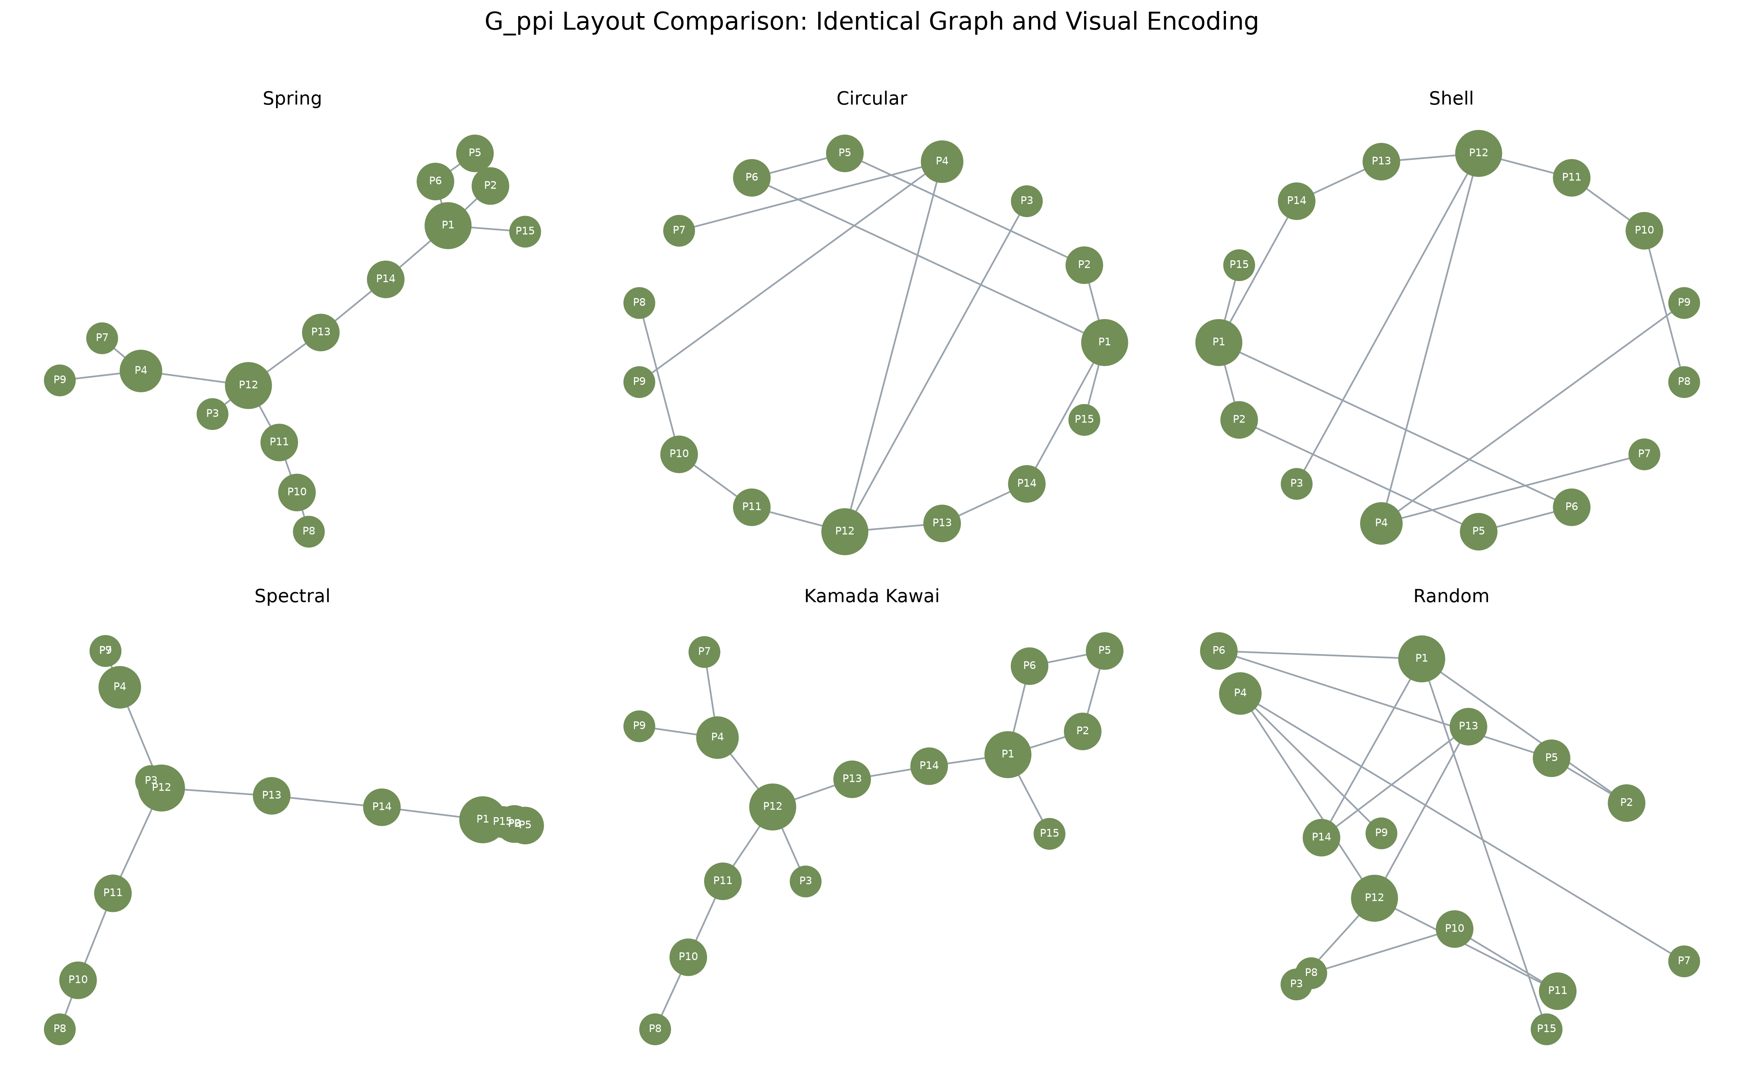
Figure 4. Six layouts of the identical synthetic G_ppi graph.

8.2.3 Limitations and verification
Layout preference remains dependent on graph size, parameters, task, and labeling. Six individual figures and a combined comparison were saved, and all reported graph statistics were recalculated from the generated NetworkX object.

8.3 Exercise 3 - Student-course bipartite network
A two-mode enrollment network was constructed without inventing student-student or course-course edges.

8.3.1 Data design, construction procedure, and validation
The stored synthetic data contain 12 students, 6 courses, and 40 enrollment records. Students were assigned to partition 0 and courses to partition 1.
An edge was added only when a stored enrollment linked the two partitions. Bipartiteness returned True, and bipartite density was 0.5556.

8.3.2 Degree results
Mean course load was 3.33 per student, and mean course enrollment was 6.67. Data Visualization had the largest course degree (12), while Imran Kabir had the largest student degree (5).
Table 3. Enrollment degree by course
Course | Student enrollments
Data Visualization | 12
Machine Learning | 7
Social Network Analysis | 6
Database Systems | 5
Human-Computer Interaction | 5
Research Methodology | 5

8.3.3 Visual result and interpretation
Separate columns, shapes, and colors made partition membership explicit. Student degree represented course load, whereas course degree represented synthetic popularity. A one-mode projection was not used because derived ties were outside the exercise scope.
Data Visualization bridges every represented major. Data Science students also concentrate in Machine Learning and Social Network Analysis, while Multimedia Technology students favor Human-Computer Interaction.
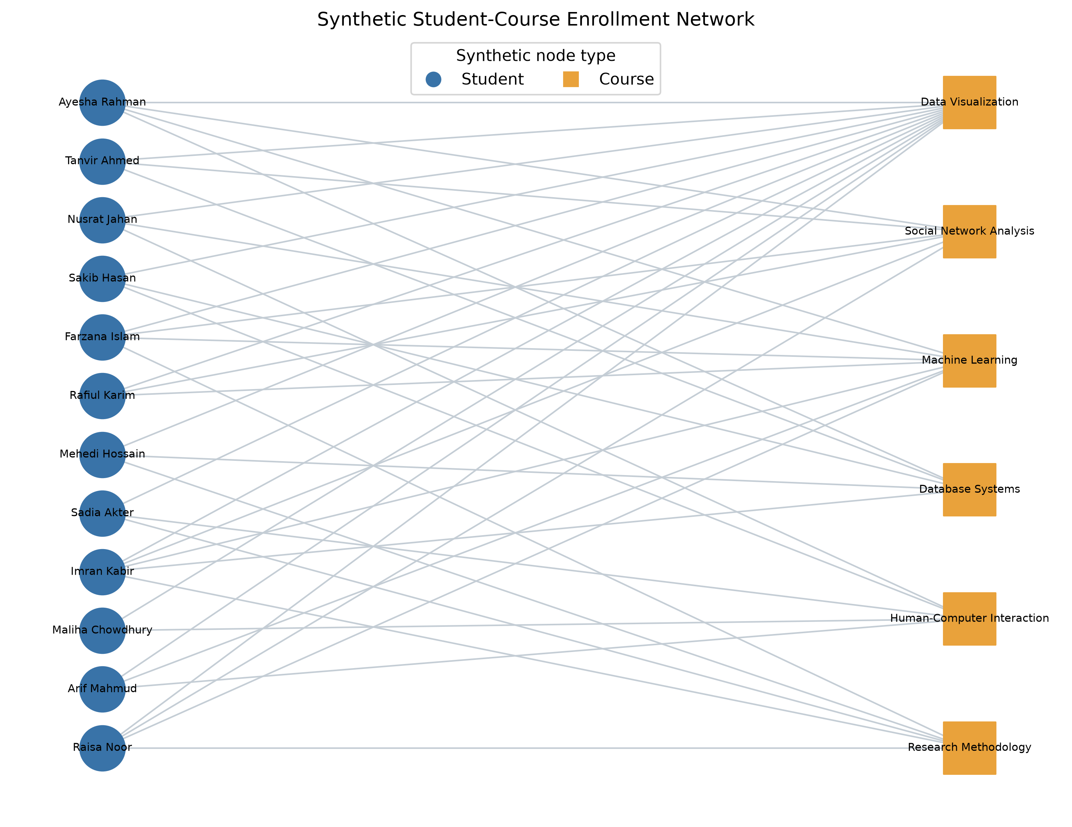
Figure 5. Synthetic student-course enrollment network.

8.3.4 Limitations and verification
Names and enrollment records were generated solely for teaching. No claim was made about actual students or enrollment behavior. Source tables, calculated degree results, and an automated partition test provide reproduction evidence.

8.4 Exercise 4 - Weighted Barabasi-Albert graph
The perceptual effect of edge-width encoding was examined while the underlying 100-node preferential-attachment topology was preserved.

8.4.1 Construction and weight assignment
The topology was generated with n=100, m=2, and seed 42. It contains 196 edges, average degree 3.92, and maximum degree 36.
Each copied edge received a reproducible integer weight from 1 through 10. Edge width was scaled from weight; topology, degree, and node positions were not changed.

8.4.2 Verified weight distribution
The observed range was 1-10, the mean was 5.388, the median was 5.0, and the population standard deviation was 2.852. Total assigned edge weight was 1,056.
Table 4. Frequency of assigned edge weights
Edge weight | Number of edges
1 | 16
2 | 26
3 | 18
4 | 25
5 | 20
6 | 18
7 | 17
8 | 14
9 | 25
10 | 17
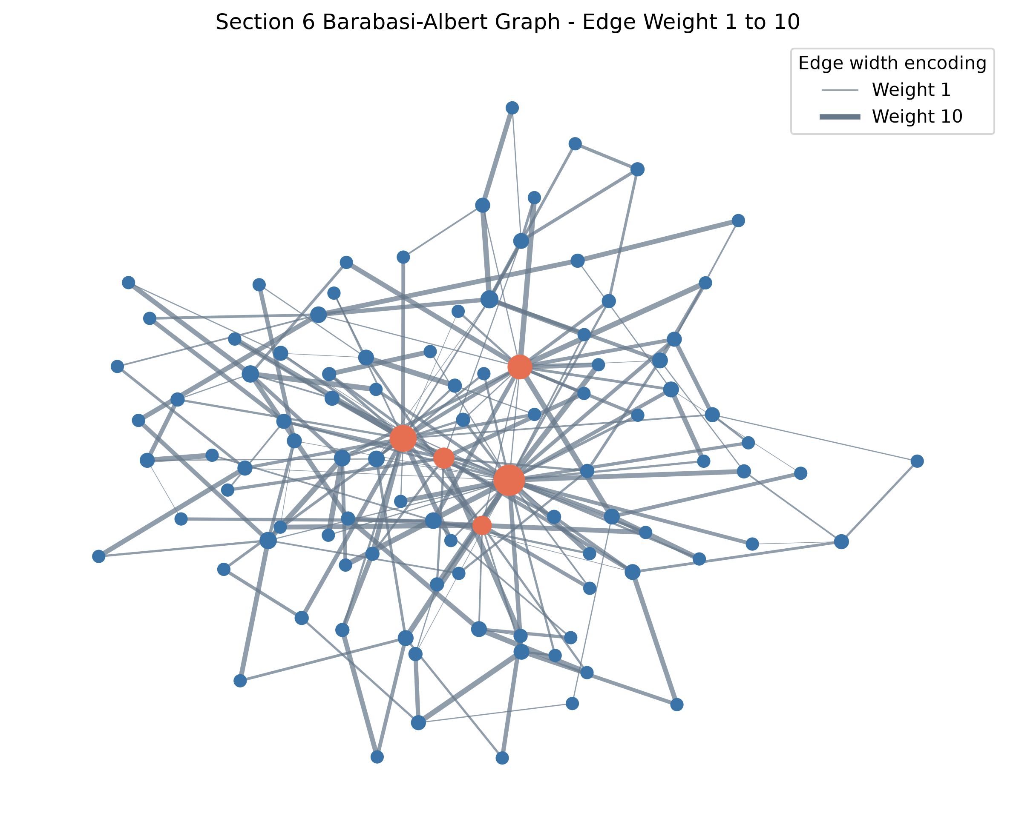
Figure 6. Barabasi-Albert graph with edge-width encoding.

8.4.3 Interpretation, limitations, and verification
Thicker lines increased tie salience while hub structure remained unchanged. Edge weight was not treated as node centrality. A weighted centrality analysis would require weight to be defined as strength, capacity, cost, or distance.
The random weights demonstrate encoding only. The edge table was saved, and automated tests verify graph order, size, range, and determinism.

8.5 Exercise 5 - Generative-model comparison
Random mixing, local clustering with rewiring, and preferential attachment were compared under the exact supplied parameters.

8.5.1 Model construction, parameters, and metric procedure
Erdos-Renyi G(30, 0.08), Watts-Strogatz WS(30, 4, 0.1), and Barabasi-Albert BA(30, 2) were generated with seed 42.
Order, size, density, average degree, clustering, connectivity, components, average path length, maximum degree, and degree standard deviation were calculated. For the disconnected Erdos-Renyi graph, path length was calculated on the largest connected component.

8.5.2 Verified statistical results
Table 5. Statistical comparison of seeded models
Model | Nodes | Edges | Density | Clustering | Avg. path | Components | Max degree
Erdos-Renyi G(n,p) | 30 | 33 | 0.076 | 0.072 | 3.828 | 3 | 4
Watts-Strogatz small-world | 30 | 60 | 0.138 | 0.346 | 2.984 | 1 | 5
Barabasi-Albert scale-free | 30 | 56 | 0.129 | 0.300 | 2.182 | 1 | 18
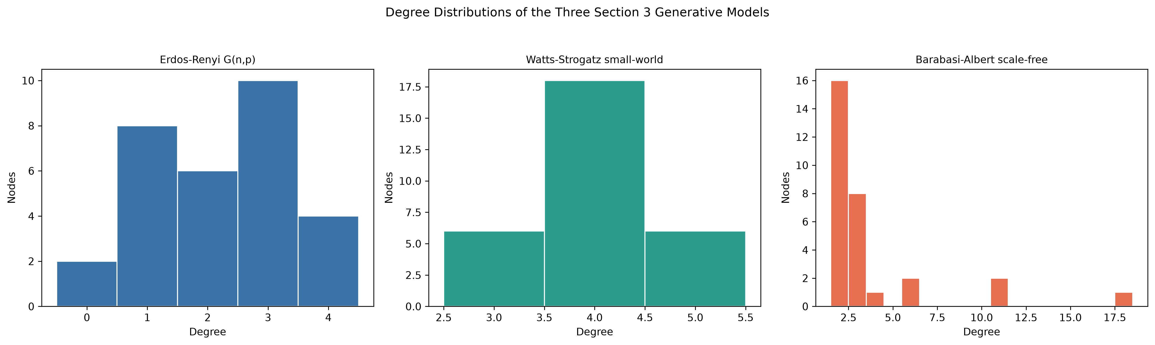
Figure 7. Degree distributions of the three seeded models.

8.5.3 Model-by-model interpretation
The Erdos-Renyi realization produced three components and low clustering (0.072); it served as a homogeneous random baseline.
The Watts-Strogatz realization remained connected and produced the highest clustering (0.346) with a narrow degree distribution.
The Barabasi-Albert realization remained connected, produced the shortest average path (2.182), and generated maximum degree 18 with strong degree heterogeneity.
Watts-Strogatz captures clustering and short paths; Barabasi-Albert captures hubs and heterogeneous degree. A social network can require both properties, so no model is universally best.

8.5.4 Limitations and verification
Only one small seeded realization was compared per model. Repeated simulation and uncertainty intervals would be required for general model inference. The comparison CSV and separate degree-distribution figures provide reproduction evidence.

8.6 Exercise 6 - Interactive node-color dashboard
One directed graph was interpreted through categorical interest-group color and continuous in-degree color without changing node positions.

8.6.1 Graph construction procedure and results
The seeded logic produced 20 users and 52 directed follow edges. Directed density was 0.1368. Mean in-degree was 2.60; in-degree ranged from 1 to 5, and out-degree ranged from 1 to 5.
The three largest in-degree results were user_11 (5), user_12 (4), user_13 (4).
Table 6. Synthetic interest-group membership
Interest group | Users
Music | 2
Sports | 8
Tech | 7
Travel | 3

8.6.2 Initial categorical-color state
Categorical color was used to support comparison of synthetic interest groups. Node coordinates, edges, labels, and hover fields were fixed.
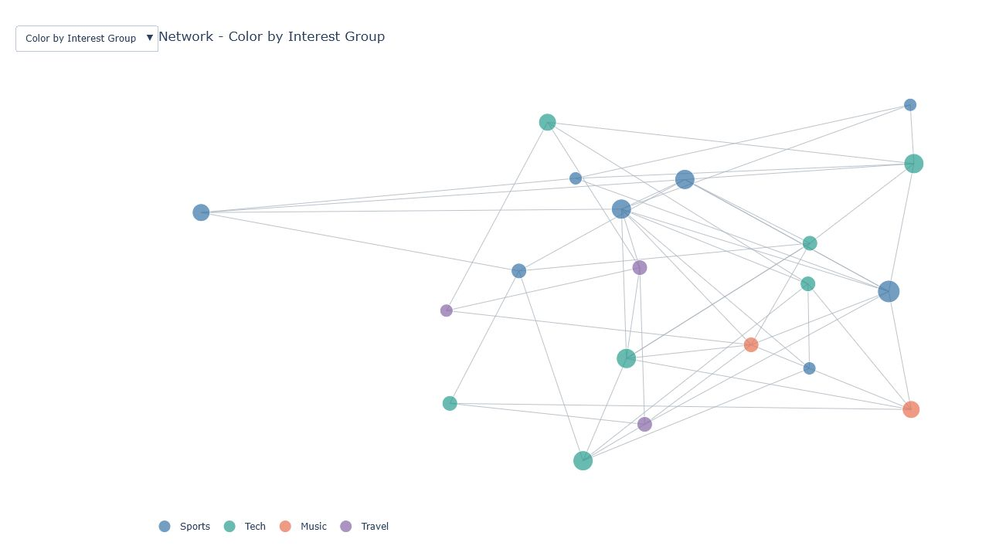
Figure 8. Interactive network colored by interest group.

8.6.3 Continuous in-degree state
The dropdown changed marker color, legend, and scale metadata to in-degree while coordinates remained fixed. Position preservation was verified as True.
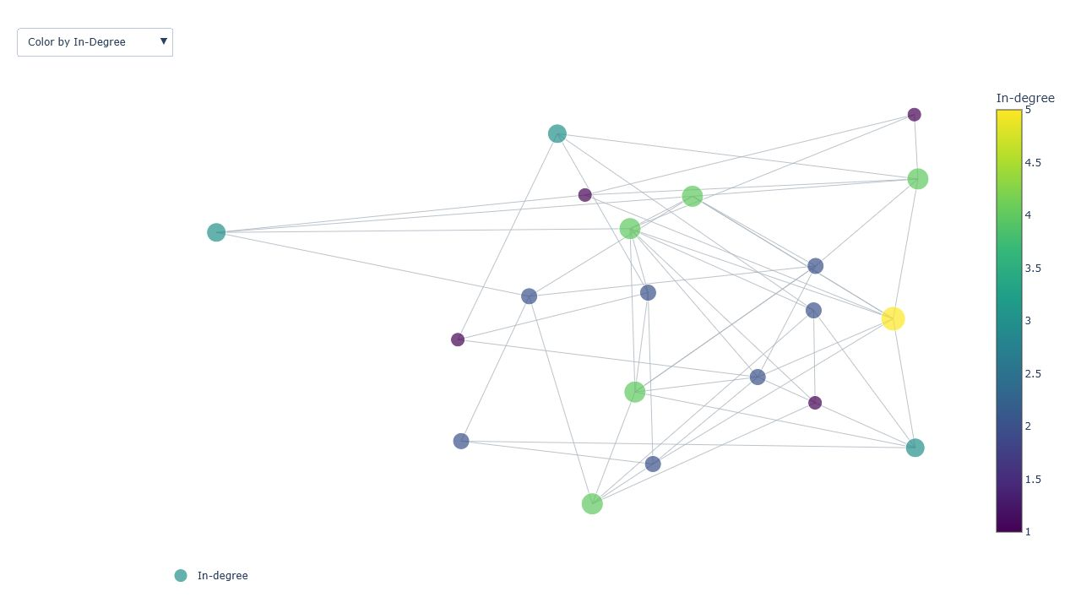
Figure 9. Interactive network colored by in-degree.

8.6.4 Interpretation, limitations, and verification
The categorical state supported group-mixing interpretation, while the continuous state emphasized incoming-tie popularity. Perceptual change was attributable to color because position was preserved.
The graph is synthetic, and Plotly line traces do not display arrowheads. Direction remains available through degree metrics. Both dropdown states were verified through browser interaction.

8.7 Exercise 7 - Research-domain knowledge graph
A typed synthetic graph was used to represent research areas, methods, tools, applications, outcomes, and semantic relationships.

8.7.1 Construction and metric procedure
The graph contains 15 nodes and 21 undirected links. Density was 0.2000, average degree was 2.80, and connectivity was verified as True.
Degree centrality, inverse-strength weighted betweenness, closeness, and strength-weighted PageRank were calculated. Edge distance was defined as 1 / strength before shortest-path betweenness was evaluated.

8.7.2 Verified centrality results
Recommendation Systems received the largest weighted betweenness value (0.5385).
Table 7. Five highest weighted-betweenness nodes
Node | Type | Degree | Betweenness | Closeness | PageRank
Recommendation Systems | Research area | 5 | 0.5385 | 0.5600 | 0.1297
Artificial Intelligence | Research area | 3 | 0.2509 | 0.4667 | 0.0790
Deep Learning | Method | 4 | 0.1923 | 0.4667 | 0.1011
Computer Vision | Research area | 3 | 0.1667 | 0.4375 | 0.0795
Graph Neural Networks | Method | 3 | 0.1612 | 0.5000 | 0.0630
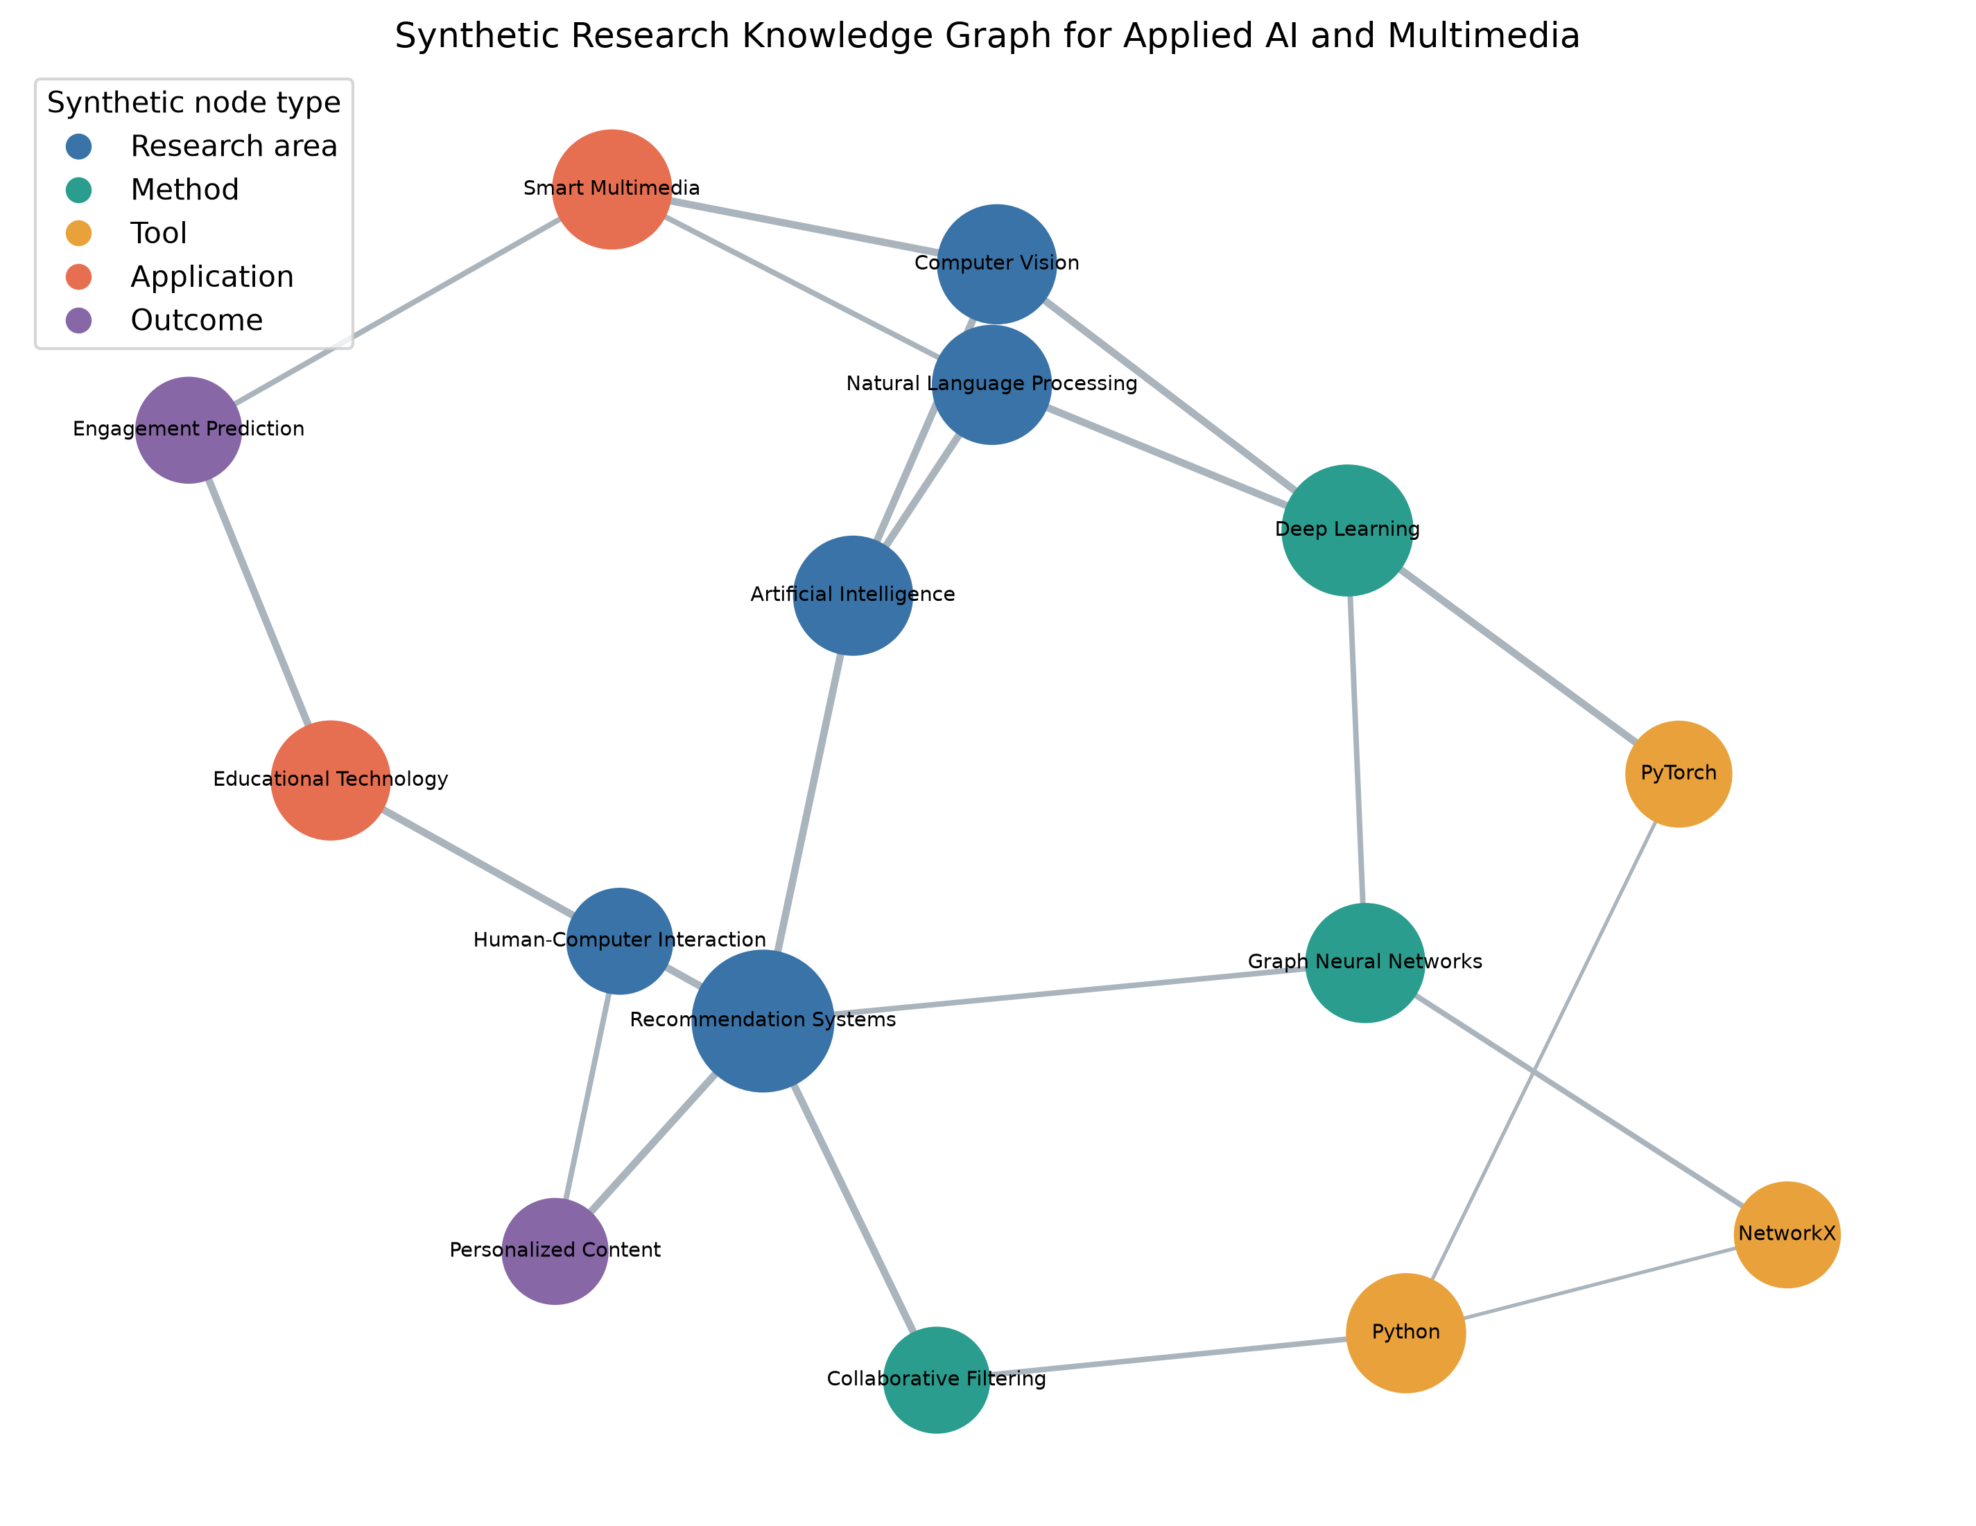
Figure 10. Synthetic Applied AI and Multimedia knowledge graph.

8.7.3 Interpretation, limitations, and verification
Recommendation Systems is the strongest bridge by inverse-strength weighted betweenness, linking research themes, technical methods, and application outcomes. The graph is synthetic and demonstrates structural interpretation, not empirical evidence about a real research community.
The graph was not extracted from publications. The inverse-strength transformation assumes that stronger semantic relationships represent shorter effective distances. A different substantive meaning for strength would require a different transformation.
Stored node and edge tables, calculated centrality metrics, and static and interactive figures provide reproduction evidence.

9. Discussion
The empirical and synthetic components answer different questions. The Facebook table supports descriptive post comparison but not individual relationship inference. The synthetic graphs reveal how topology, layout, and encoding shape network interpretation.
Mean engagement is influenced by extreme posts, so median summaries, log distributions, and outlier flags accompany it. Correlations remain associational and do not isolate algorithm, audience, or content effects.

10. Limitations and ethical considerations
The data end in 2018, represent ten Thai sellers, and omit reach, impressions, followers, campaign spend, page identity, and content text. Results may not generalize across settings or time.
The project preserves anonymization, reports aggregate findings, avoids re-identification, makes no unsupported causal claims, and clearly labels every dummy graph as synthetic.

11. Conclusion, recommendations, and future work
The largest observed mean engagement was associated with video posts. The supplied small-world graph was presented most clearly by Kamada-Kawai, tie salience was separated from centrality through weighted encoding, and the multidimensional nature of social-network realism was revealed by the model comparison.
For future work, ethically collected reach denominators, multiple seller populations, repeated graph simulations, uncertainty intervals, content representations, and user testing of dashboard accessibility should be added.

12.1 Critical synthesis of empirical and synthetic evidence
The project contains two related but noninterchangeable forms of evidence. The Facebook analysis is empirical at the post level: rows are observed records and calculated values describe that sample. The network exercises are synthetic demonstrations of graph construction, measurement, and visual encoding. Their reproducibility does not make them empirical claims about Facebook users, students, transport, proteins, or research communities. Maintaining this boundary protects the report from a visually persuasive but unsupported narrative.
Taken together, the components show why data visualization requires both numerical and perceptual validation. A distribution plot explains why the mean and median differ; a matrix test verifies a symmetry that a node-link drawing merely suggests; clustering corrects an overly enthusiastic visual reading of layout; and a fixed-coordinate dropdown isolates the effect of color. Each major interpretation is therefore paired with a calculated value, controlled encoding, or explicit limitation.

12.2 Generalizability and uncertainty
External validity is limited by time, geography, industry, and platform context. The posts end in 2018 and originate from ten Thai fashion and cosmetics sellers. Facebook interfaces, ranking systems, audience behavior, and commercial practices have changed since collection. Results should therefore be read as a careful description of this dataset, not as a current global benchmark for social-media strategy.
The graph-model comparison is also conditional. Metrics from one 30-node seeded realization are exact for that realization but uncertain as estimates of a model's typical behavior. A stronger simulation study would repeat each parameter set across many seeds, summarize the metric distributions, and report confidence or percentile intervals. Parameter sweeps could then separate a mechanism's general tendency from a particular random draw.
Sensitivity analysis would also strengthen the empirical component. Post-type rankings could be recalculated after winsorization, within time periods, or with seller-level controls if stable page identifiers became available. Median and quantile regression could describe different parts of the engagement distribution without allowing the largest posts to dominate. Missing exposure denominators remain the most important obstacle: no transformation of the current counts can recover the unobserved population that saw each post. Future inference should therefore improve data collection before increasing model complexity.

12.3 Ethical, privacy, and academic-integrity safeguards
The source is anonymized and contains no post text, account names, or direct personal identifiers. The project does not attempt linkage, re-identification, or inference about protected characteristics. Aggregated reporting further reduces exposure. Synthetic people and relationships are labeled as such in data files, figures, notebooks, the website, and the report. These labels are not cosmetic: they prevent readers from confusing pedagogical structures with observed human behavior.
Academic integrity is supported through source attribution, explicit acquisition history, calculated rather than fabricated statistics, and reproducible code. The UCI dataset and its accompanying article are cited, software tools are acknowledged, and the unlicensed teaching package is not republished. The report distinguishes a Kaggle mirror from the actual UCI acquisition route and does not claim that credentials or an API were used when they were unavailable.
Accessibility is treated as an ethical property of communication. Figures use descriptive captions and alternative text; tables identify header rows; keyboard focus remains visible; and color is accompanied by labels, shape, position, or downloadable values when feasible. Interactive frames retain meaningful titles, while static equivalents preserve the central result for readers who cannot or prefer not to operate a dynamic chart. These measures do not constitute a complete accessibility certification, but they reduce avoidable barriers and make the evidential content less dependent on a single sensory channel.

12.4 Practical recommendations
For applied content analysis, future data collection should prioritize reach and impression denominators, stable page identifiers, content metadata, and campaign context. These variables would permit rate estimation, multilevel seller comparisons, and adjustment for exposure. A prospective design could rotate content formats or posting windows under controlled conditions. Until such evidence exists, video should be described as the highest-engagement observed category rather than a guaranteed intervention.
For network analysis, repeated simulations should precede general claims about model behavior. Community detection should be calculated independently of layout, and weighted metrics should document whether an edge attribute represents strength, capacity, probability, cost, or distance. Interactive views should preserve a stable reference state when comparing visual variables and should expose exact values through accessible text or downloadable tables.
For project maintenance, the canonical summary and artifact manifest should remain the only numerical publication interfaces. Changes to cleaning, graph parameters, or metric definitions should trigger the complete pipeline, notebook execution, report generation, website build, and cross-surface tests. A published release should be tied to a commit SHA so that the local project, repository, and GitHub Pages artifact can be compared unambiguously.
For teaching and assessment, each exercise should remain inspectable at three levels. The notebook shows how the calculation unfolds, the standalone source module shows reusable implementation, and the website connects code to output and interpretation. This layered presentation supports readers with different technical backgrounds while preserving one analytical result. Assessment should reward the justification of a representation and the accuracy of its limitation, not only the presence of an attractive graph.

12.5 Integrated design framework
The project adopts a question-first visualization framework. The empirical questions concern differences in recorded engagement across post types and time; the exercise questions concern graph structure, layout, weighting, and interaction. Those question classes require different evidence. Comparisons use aligned bars and tables, skewed outcomes use distributions and robust summaries, pairwise monotonic association uses a rank-correlation matrix, and network questions use matrices, node-link views, and calculated graph metrics. Selecting a representation from the analytical task prevents decorative novelty from becoming the governing design criterion.
Network science also distinguishes structure from its visual realization. Barabasi (2016) treats degree distributions, clustering, paths, and generative mechanisms as properties of graphs rather than of drawings. This report follows that distinction by calculating metrics with NetworkX and using layouts only to expose selected relationships. Hagberg, Schult, and Swart (2008) describe NetworkX as a platform for structural analysis; its role here is therefore computational, while Matplotlib and Plotly provide complementary static and interactive presentations. Recalculating metrics before rendering keeps visual appearance subordinate to the stored graph.
The empirical component is similarly anchored in provenance. Dehouche (2018, 2020) documents the Facebook Live Sellers in Thailand data and its engagement variables. The present study retains that observational unit and does not reinterpret posts as users or infer social ties. It adds reproducible cleaning, feature definitions, descriptive analysis, and visual communication, but it does not enlarge the evidential scope of the source. This source-to-claim traceability is especially important when a project combines a real table with synthetic graph exercises: the common software environment must not be mistaken for a common population or a shared causal design.
Finally, the communication design recognizes that reproducibility is both technical and rhetorical. A fixed seed and checksum reproduce an artifact, but a reader also needs definitions, captions, limitations, and accessible alternatives to understand what that artifact supports. The notebooks expose calculations, the report supplies sustained argument, the website supports navigation and interaction, and the machine-readable summary binds their numerical claims. Agreement among these layers is tested rather than assumed. The resulting architecture makes revision auditable: a change to a statistic must propagate from the canonical JSON through every presentation surface or cause a contract test to fail.

References
Barabasi, A.-L. (2016). Network science. Cambridge University Press. http://networksciencebook.com/
Dehouche, N. (2018). Facebook Live Sellers in Thailand [Data set]. UCI Machine Learning Repository. https://doi.org/10.24432/C5R60S
Dehouche, N. (2020). Dataset on usage and engagement patterns for Facebook Live sellers in Thailand. Data in Brief, 30, 105661. https://doi.org/10.1016/j.dib.2020.105661
Hagberg, A. A., Schult, D. A., & Swart, P. J. (2008). Exploring network structure, dynamics, and function using NetworkX. Proceedings of the 7th Python in Science Conference, 11-15.
Matplotlib Development Team. (2026). Matplotlib documentation. https://matplotlib.org/stable/
NetworkX Developers. (2026). NetworkX documentation. https://networkx.org/documentation/stable/
pandas development team. (2026). pandas documentation. https://pandas.pydata.org/docs/
Plotly Technologies Inc. (2026). Plotly Python documentation. https://plotly.com/python/

Appendix: Reproducibility and assumptions
Run python main.py to rebuild every generated artifact and pytest to validate the pipeline. The supplied teaching notebooks are source-identical. The official UCI download was used because Kaggle credentials were unavailable. All assignment-only relationship graphs are labeled synthetic.

