FPT UNIVERSITY

SOFTWARE DESIGN SPECIFICATION
eBay Clone — Administration and Operations System

Project | eBay Clone — Administration and Operations System
Document | SDS Document v1.2
Prepared by | Group 3
Status | Final for academic submission — aligned with source code
Date | 10/11/2026

– Hanoi, November 2026 –

I. RECORD OF CHANGES
Date | A/M/D | In charge | Change description
30/10/2026 | A | Group 3 | Initial SDS based on the project brief, source modules and the Trust & Safety proposal.
06/11/2026 | A, M | Group 3 | v1.1: design of the implemented security and anti multi-account mechanisms (registration and email verification, sign-in history and lockout, account-linking weights).
10/11/2026 | M, D, A | Group 3 | v1.2: document rewritten in English and aligned with the source code: real modules, routes, policies, entities, workers and configuration. Removed design-only parts (Trust & Safety cases, VeRO, appeals, restriction lifecycle, outbox, evidence store, logical /api/admin routes); they are listed as future work in 8.3. New diagrams: authentication flow, deployment, ERD, return and user state machines.

A = Added; M = Modified; D = Deleted.

TABLE OF CONTENTS
I. RECORD OF CHANGES 2
TABLE OF CONTENTS 3
II. SOFTWARE DESIGN DOCUMENT 5
1. HIGH LEVEL DESIGN 5
1.1. Scope and Architecture Goals 5
1.2. Software Architecture 5
1.3. Package Diagram and Dependency Rules 6
1.4. Logical Data Model and ERD 7
1.5. Authentication, Identity and Permissions 9
1.6. Deployment Overview 11
2. STATE TRANSITION DIAGRAMS 12
2.1. Dispute State 12
2.2. Return Request State 13
2.3. User Account State 14
2.4. Product, Review and Notification States 14
3. DETAILED DESIGN 14
3.1. Authentication & 2FA (R-A10, X-01, X-04) 14
3.2. Dashboard & Statistics (R-A01, R-A05, R-A12) 15
3.3. Users & Sellers (R-A02, X-02, X-03, X-07) 15
3.4. Products & Moderation (R-A03, X-05, X-06) 15
3.5. Global Orders (R-A04) 15
3.6. Reviews & Feedback (R-A06) 16
3.7. Disputes (R-A07) 16
3.8. Return & Refund Requests (R-A08) 16
3.9. Broadcasts & Notifications (R-A09, X-11) 16
3.10. Admin Roles (R-A11) 17
3.11. Audit & Sensitive Logs (R-A13) 17
3.12. Finance: Fees, Settlement, Payouts, Wallets (X-08, X-09) 17
3.13. Account Linking, Risk Score and Monitoring (X-02, X-03, X-04) 17
3.14. Rate Limiting, Nginx and Realtime (R-N01, R-N02) 18
3.15. System Admin and Simulation Toolbox (X-10, X-12) 18
4. ACCOUNT RISK AND ENFORCEMENT RULES 18
4.1. Risk Score Weights (RiskOptions, configurable) 18
4.2. Enforcement Ladder and Limits 19
5. API / INTEGRATION DESIGN 19
5.1. Endpoint Matrix 19
5.2. Main Request Examples 20
5.3. Sequence: Resolve Dispute 20
5.4. Sequence: Decrypt Sensitive Log 20
6. SECURITY AND DATA PROTECTION DESIGN 21
7. OPERATIONS, CI/CD AND TESTING 21
7.1. Background Workers 21
7.2. CI/CD 21
7.3. Kubernetes Rolling Update 22
7.4. Tests 22
8. DESIGN DECISIONS, KNOWN GAPS AND TRACEABILITY 22
8.1. Design Decisions 22
8.2. Known Gaps 22
8.3. Future Work (removed from v1.1 design) 22
8.4. Requirement → Design Traceability 23
8.5. References 23

II. SOFTWARE DESIGN DOCUMENT

1. HIGH LEVEL DESIGN

1.1. Scope and Architecture Goals
This SDS describes how the requirements of SRS v1.2 (R-A01…R-A14, R-N01…R-N06 and extensions X-01…X-12) are implemented in the repository PRN232.Ebay-Clone-Admin_Role. Everything described here exists in the code unless it is explicitly marked as future work.
• Architecture pattern: Clean Architecture (Domain, Application, Infrastructure, Web) with CQRS through MediatR; one deployable ASP.NET Core application that also serves the React SPA.
• Quality drivers: Server-side authorization (internal IP + 2FA + policies), audit and encryption of sensitive data, financial correctness, horizontal scaling behind Nginx, safe rolling releases.
• Source of truth: Code and configuration in src/, k8s/, docker-compose*.yml and .github/workflows.

1.2. Software Architecture
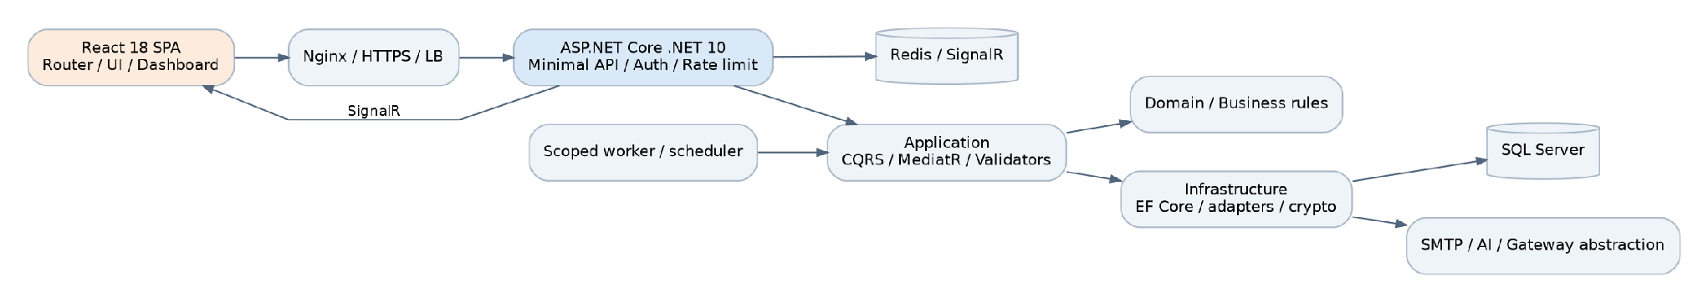
Figure 1. System software architecture.
Layer | Technology | Responsibility
Presentation | React 18, React Router 6, Bootstrap/Reactstrap, Axios, chart libraries, xlsx, jsPDF, @microsoft/signalr | Role-aware pages, forms, tables, charts, export, realtime updates.
Web / API | ASP.NET Core (.NET 10) Minimal API endpoint groups, SignalR hubs, middleware | HTTPS endpoints under /api/{Group}, JWT cookie auth, InternalIp and session middleware, rate limiting, security headers, Swagger (/api).
Application | MediatR, FluentValidation, AutoMapper, pipeline behaviours | Commands/queries per feature, validation, risk rules (Users/Risk), interfaces for infrastructure.
Domain | Entities and constants | Entities, status constants (DisputeStatuses, ReturnStatuses, Roles, Policies).
Infrastructure | EF Core 10 (SQL Server), BCrypt, Otp.NET/QRCoder, AES-GCM/HMAC, SMTP (System.Net.Mail), HttpClient | Persistence, migrations, seeders, JWT, encryption, email, AI moderation, captcha, mock bank, workers.
Deployment | Docker, Docker Compose, Nginx, Kubernetes, Redis | Load balancing, SignalR backplane, rolling update, health checks.

1.2.1. External integrations and failure behaviour
Integration | Interface / class | On failure
Gmail SMTP | IEmailService → EmailService | Business state is saved first; send errors are logged. Dev/test may use LogInsteadOfSending (refused in Production).
OpenAI / OpenRouter | IContentModerationService → OpenAiModerationService | Content is kept for manual review instead of being auto-approved.
Cloudflare Turnstile | TurnstileCaptchaVerifier | Registration is rejected (400).
Mock bank | MockPaymentGatewayService | Payout marked failed and listed in payout exceptions.
AWS / Google IP ranges, DB-IP | DatacenterRangesService (24 h refresh), GeoIpLocator | Last good data kept; signals are skipped, never auto-reject.

1.3. Package Diagram and Dependency Rules
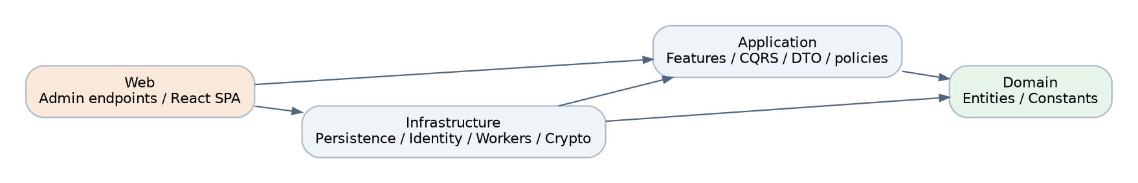
Figure 2. Clean Architecture package dependencies.
Package | Content
src/Domain | Entities (User, Product, OrderTable, Dispute, ReturnRequest, …) and constants; no dependency on EF or Web.
src/Application | Feature folders (Admin/Disputes, Users, Products, Reviews, ReturRequests, Broadcasts, Financials, Payouts, Stats, AdminRoles, AuditLogs, SensitiveLogs, SystemAdmin, Withdrawals, …), Common interfaces and behaviours, Users/Risk rules.
src/Infrastructure | ApplicationDbContext, configurations, migrations, seeders, services (encryption, JWT, email, AI, captcha, mock bank, workers), DependencyInjection (policies).
src/Web | Endpoints (one class per group), Hubs, Infrastructure middleware, Web/Services workers (payout, settlement, seller evaluation), Program.cs, ClientApp (React).
tests/ | Application.UnitTests, Domain.UnitTests, Application.FunctionalTests (NUnit, Moq, Shouldly, Respawn, Testcontainers.MsSql), Infrastructure.IntegrationTests, Web.AcceptanceTests (SpecFlow), jmeter/.

1.4. Logical Data Model and ERD
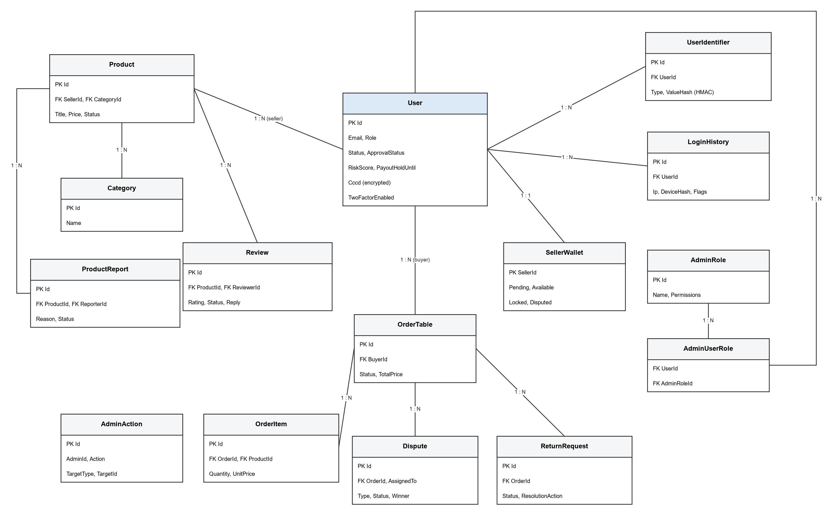
Figure 3. Core entities and relationships (simplified).

1.4.1. Database design principles
• SQL Server through EF Core migrations (src/Infrastructure/Data/Migrations); startup never migrates or seeds (DatabaseInitialization:RunMigrationsOnStartup = false, Seeding:Mode = None).
• Soft moderation: products are hidden or set to Banned, users are banned, nothing with order or money history is hard-deleted.
• Sensitive columns (CCCD, bank account, sensitive log payload) are AES-GCM encrypted; equality lookups use HMAC hashes (CccdLookupHash, UserIdentifier.ValueHash).
• Audit entries (AdminAction, SensitiveDataLog) are append-only and reference targets by type + id.

1.4.2. Data dictionary (main tables)
Entity | Main fields | Rules
User | Id; Email; PasswordHash; Role; Status; ApprovalStatus; BanReason; TwoFactorEnabled/Secret; Cccd (enc.) + CccdLookupHash; RiskScore; RiskCheckedAt; PayoutHoldUntil; ProductBanUntil; EmailVerifiedAt; EmailOtpHash/SentAt/Attempts; SellerLevel; bank fields (enc.) | Status and ApprovalStatus are independent; OTP stored as HMAC.
UserIdentifier | Id; UserId; Type (Cccd, Email, Phone, Bank, Address, Ip, Geo, Device); ValueHash | Unique (UserId, Type, ValueHash); lookup by (Type, ValueHash).
LoginHistory | Id; UserId; Ip; DeviceHash; Location; flags NewDevice/Datacenter/ImpossibleTravel; CreatedAt | Written on every session issue; purged after 180 days.
AdminRole / AdminUserRole | Id; Name; Permissions; Description / UserId; AdminRoleId | Permissions are policy names granted through a claim.
AdminAction | Id; AdminId; Action; TargetType; TargetId; Details; IpAddress; CreatedAt | Append-only audit.
SensitiveDataLog | Id; actor; action; target; encrypted payload | Decrypt only by SuperAdmin; decrypt logged.
IpBlock | Id; Network; Reason; ExpiresAt | Checked by middleware.
Category / Product / ProductReport | Category Id, Name / Product Id, SellerId, CategoryId, Title, Price, Status / Report Id, ProductId, ReporterId, Reason, Status | One pending report per reporter and product.
OrderTable / OrderItem | Id, BuyerId, Status, TotalPrice, dates / Id, OrderId, ProductId, Quantity, UnitPrice | Order history preserved.
Payment / ShippingInfo / Address | Order payment, delivery status and tracking, addresses | Address data masked in DTOs.
Review / ReviewReport / Feedback | Rating, Comment, Status, ModerationAction, SellerReply / reports / seller aggregates | Hiding updates the seller feedback.
Dispute / DisputeMessage | CaseId, OrderId, RaisedBy, Type, Status, Priority, AssignedTo, Deadline, Evidence, Winner, RefundAmount / messages | Resolve once.
ReturnRequest | OrderId, Reason, Status, ResolutionAction, ReturnLabelUrl, AdminNote | Guarded transitions (2.2).
Notification / UserNotificationRead | Title, Content, Type (Email/InApp), Audience, Status, ScheduledAt / NotificationId, UserId, ReadAt | Read state per user.
SellerWallet / FinancialTransaction | SellerId; PendingBalance; AvailableBalance; LockedBalance; DisputedBalance / ledger rows | Money moves inside one SaveChanges.
PlatformFee / PayoutConfig / PayoutTransaction / WithdrawalRequest | Fee rules / schedule and thresholds / payout status, amount, bank snapshot / withdrawal (no endpoint yet) | Bank snapshot encrypted.
SellerLevelCriteria | Thresholds for TopRated / AboveStandard / BelowStandard | Edited by staff.

1.4.3. Relationship rules
Relationship | Cardinality | Rule
User (seller) → Product → ProductReport | 1:N, 1:N | Moderation keeps the product row and its order references.
User (buyer) → OrderTable → OrderItem | 1:N, 1:N | Users with open orders cannot be banned.
Product → Review → ReviewReport | 1:N, 1:N | Review moderation recalculates seller feedback.
OrderTable → Dispute / ReturnRequest | 1:N | Terminal states block repeated financial actions.
User ↔ AdminRole (AdminUserRole) | M:N | Changes re-validated on the next request.
User → UserIdentifier / LoginHistory | 1:N | Used by risk scoring and sign-in monitor.
User (seller) → SellerWallet | 1:1 | Created on first earning.
Notification → UserNotificationRead | 1:N | Unique per user.

1.5. Authentication, Identity and Permissions
Identity is the domain User table (no ASP.NET Identity). Passwords use BCrypt, sessions are JWT tokens with a jti stored in the HttpOnly cookie auth_token, and 2FA uses TOTP (Otp.NET, QR via QRCoder). Admin access is stricter than the brief: internal IP AND 2FA.
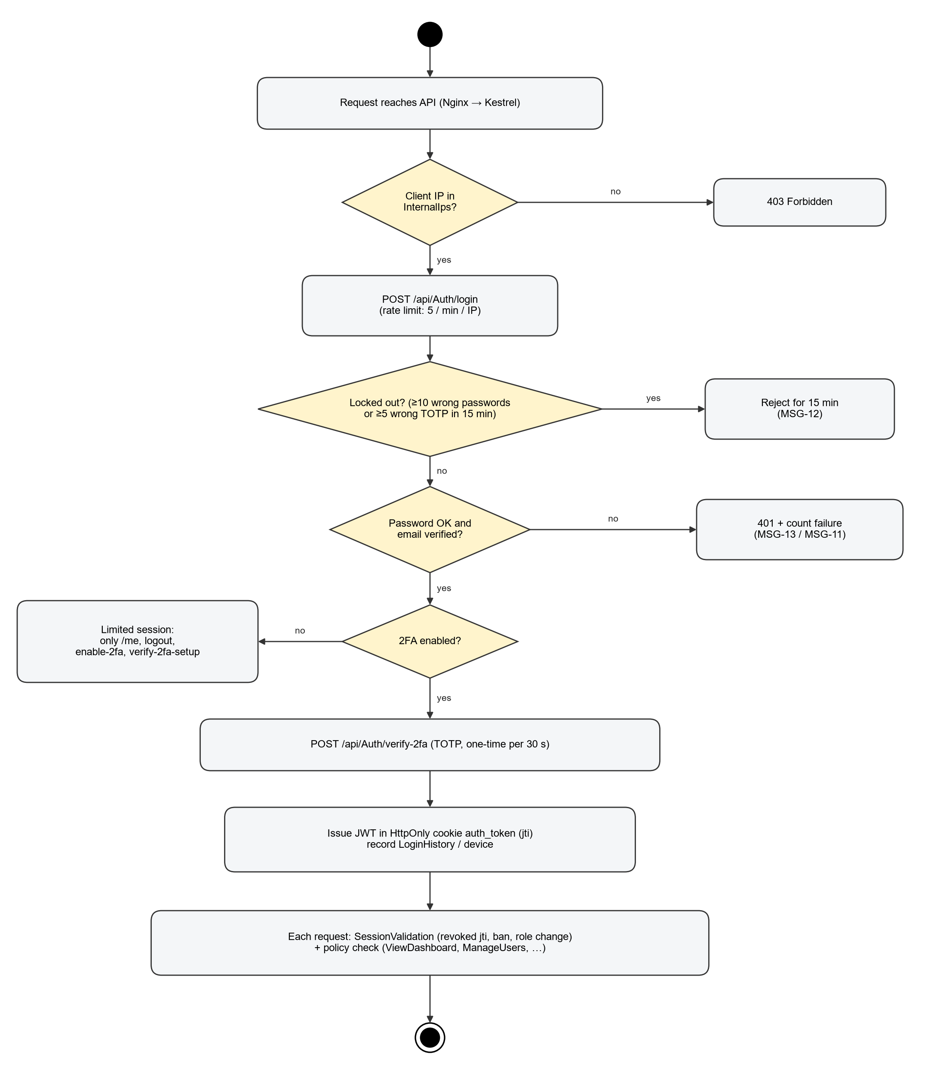
Figure 4. Authentication and admin access gate.
Condition | API behaviour
Client IP not in InternalIps (InternalIpMiddleware) | 403 for every API call.
Not authenticated | 401.
Authenticated, 2FA not enabled | Only /api/Auth/me, logout, enable-2fa, verify-2fa-setup; other APIs 403.
Authenticated + 2FA, missing policy/role | 403.
Token jti revoked, user banned, role or permissions changed | 401 on the next request (SessionValidation; revoked ids in Redis).
≥ 10 wrong passwords or ≥ 5 wrong TOTP codes in 15 min | Account refused on all IPs for 15 min (SecurityCache).
Forged X-Forwarded-For | Ignored; only the configured proxy (Nginx) is trusted for the real client IP.

1.5.1. Authorization policies
Policy | Default roles | Grantable to custom role
ViewDashboard | Monitor, Support, SuperAdmin | Yes
ViewReports | Monitor, SuperAdmin | Yes
ManageUsers, ManageProducts, ManageOrders, ManageDisputes, ModerateReviews, ManageBroadcasts | Support, Administrator, SuperAdmin | Yes
ManageAdminRoles, ViewAuditLogs, CanPurge | SuperAdmin | No
Role Administrator/SuperAdmin (Financials, Wallets) | Administrator, SuperAdmin | —
Role SuperAdmin (SystemAdmin, Mocking money endpoints) | SuperAdmin | —

1.5.2. API conventions and error contract
HTTP status | When | Behaviour
200 / 201 / 204 | Successful read, create, command | DTO or id; 204 for commands without body.
400 | Validation or business rule (FluentValidation / ValidationException) | Field errors in ProblemDetails; no stack trace.
401 | Missing/expired/revoked session | No resource data.
403 | IP, 2FA or policy check failed | Generic message.
404 | Target not found | —
429 | Rate limit | Retry later.
500 | Unexpected error (CustomExceptionHandler) | Generic message; details only in the log.

1.6. Deployment Overview
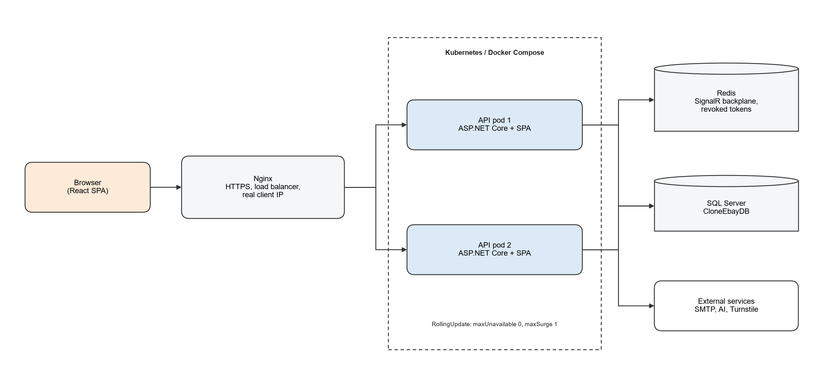
Figure 5. Multi-instance deployment.
docker-compose.yml runs SQL Server, Redis, the API and Nginx locally; docker-compose.vps.yml is used on the VPS. k8s/ contains namespace, config map, secret examples, SQL Server StatefulSet, Redis, API Deployment (2 replicas, RollingUpdate maxUnavailable 0 / maxSurge 1, readiness probe) and Nginx.

2. STATE TRANSITION DIAGRAMS

2.1. Dispute State
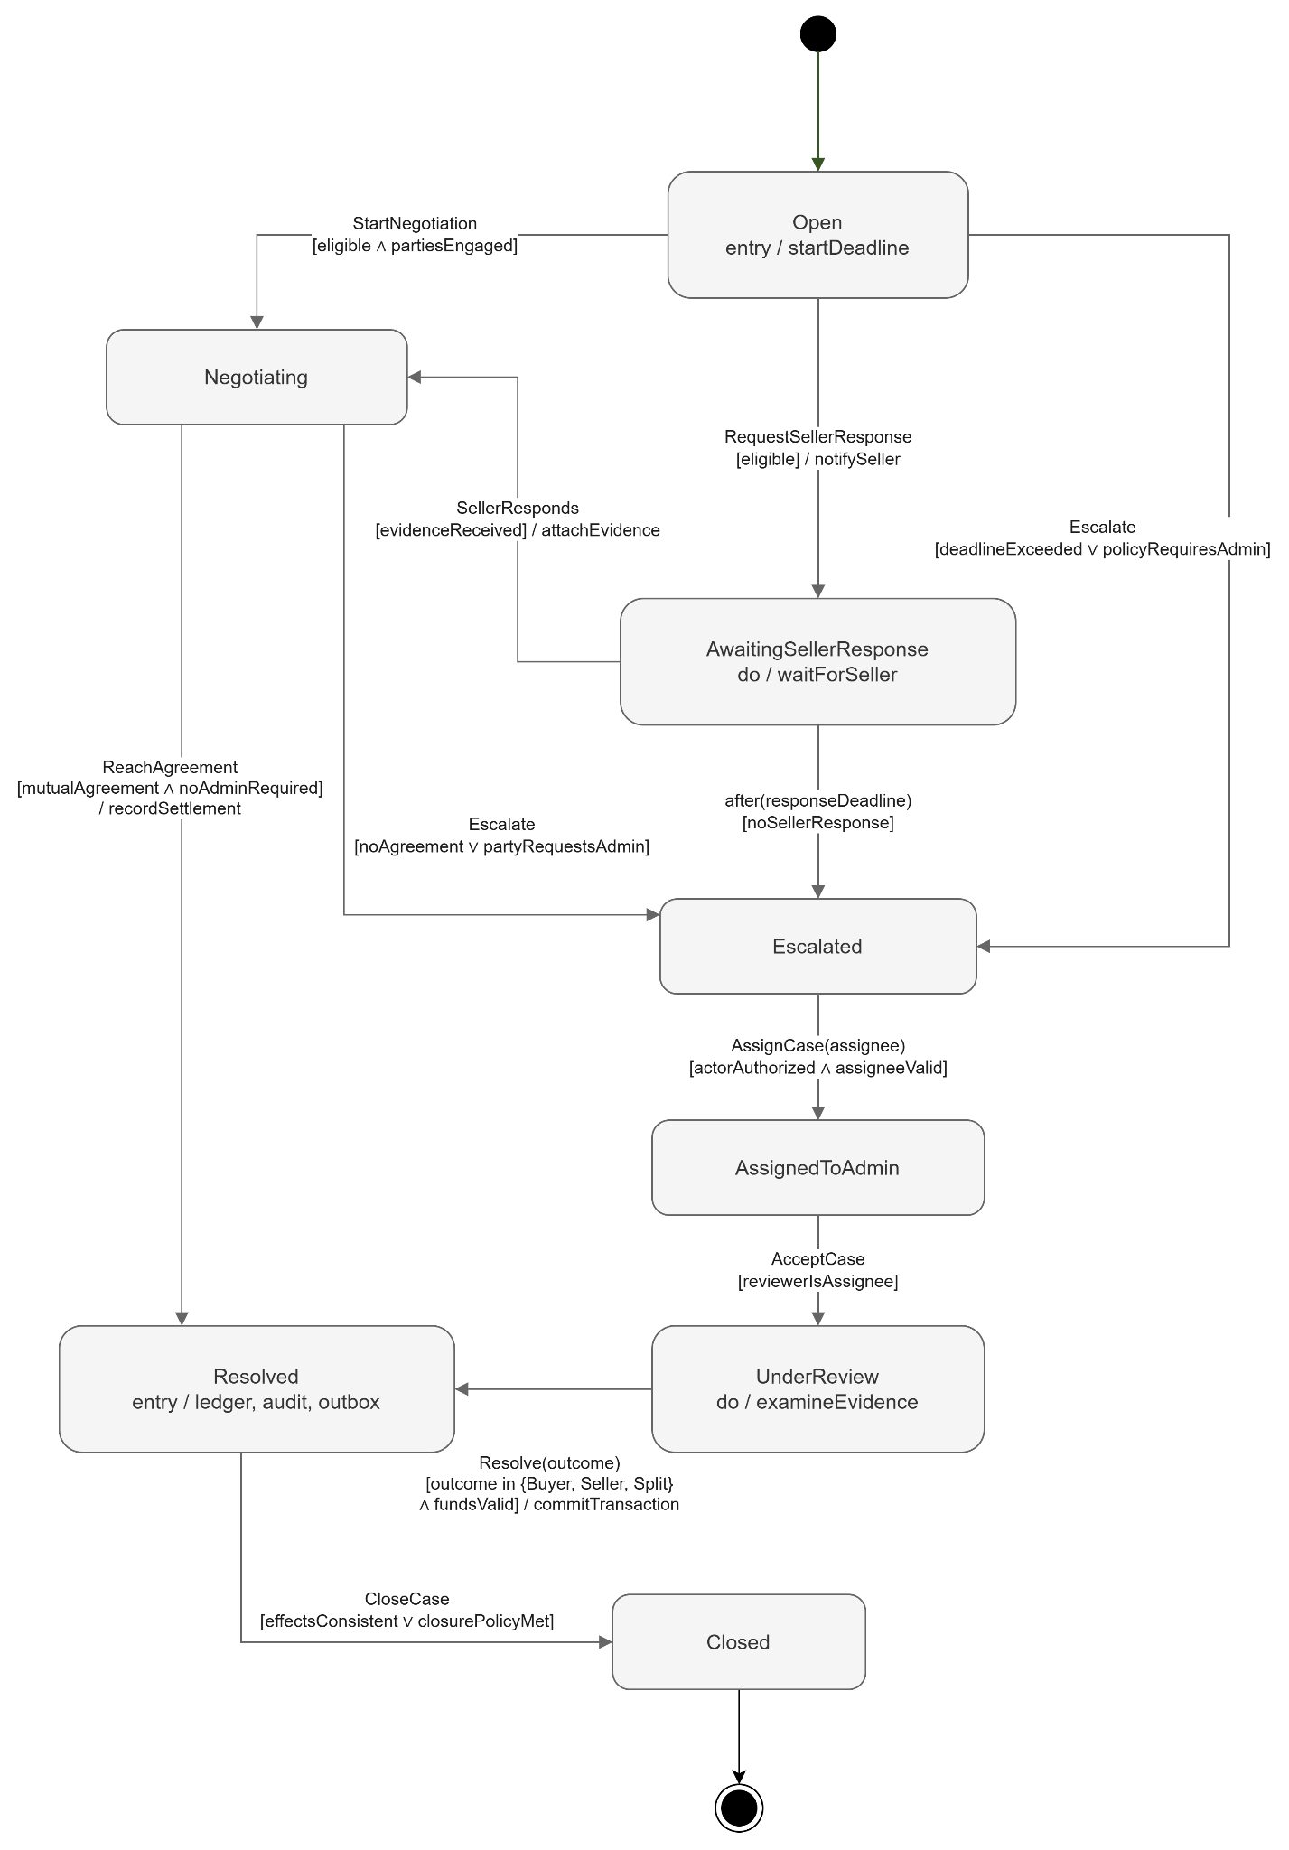
Figure 6. Dispute state machine.
Admin commands: AssignDispute (→ AssignedToAdmin), ResolveDispute (→ Resolved, refused when already Resolved/Closed), UpdateDisputePriority. Seller response, negotiation and escalation are produced by the marketplace side and by the mock generator.

2.2. Return Request State
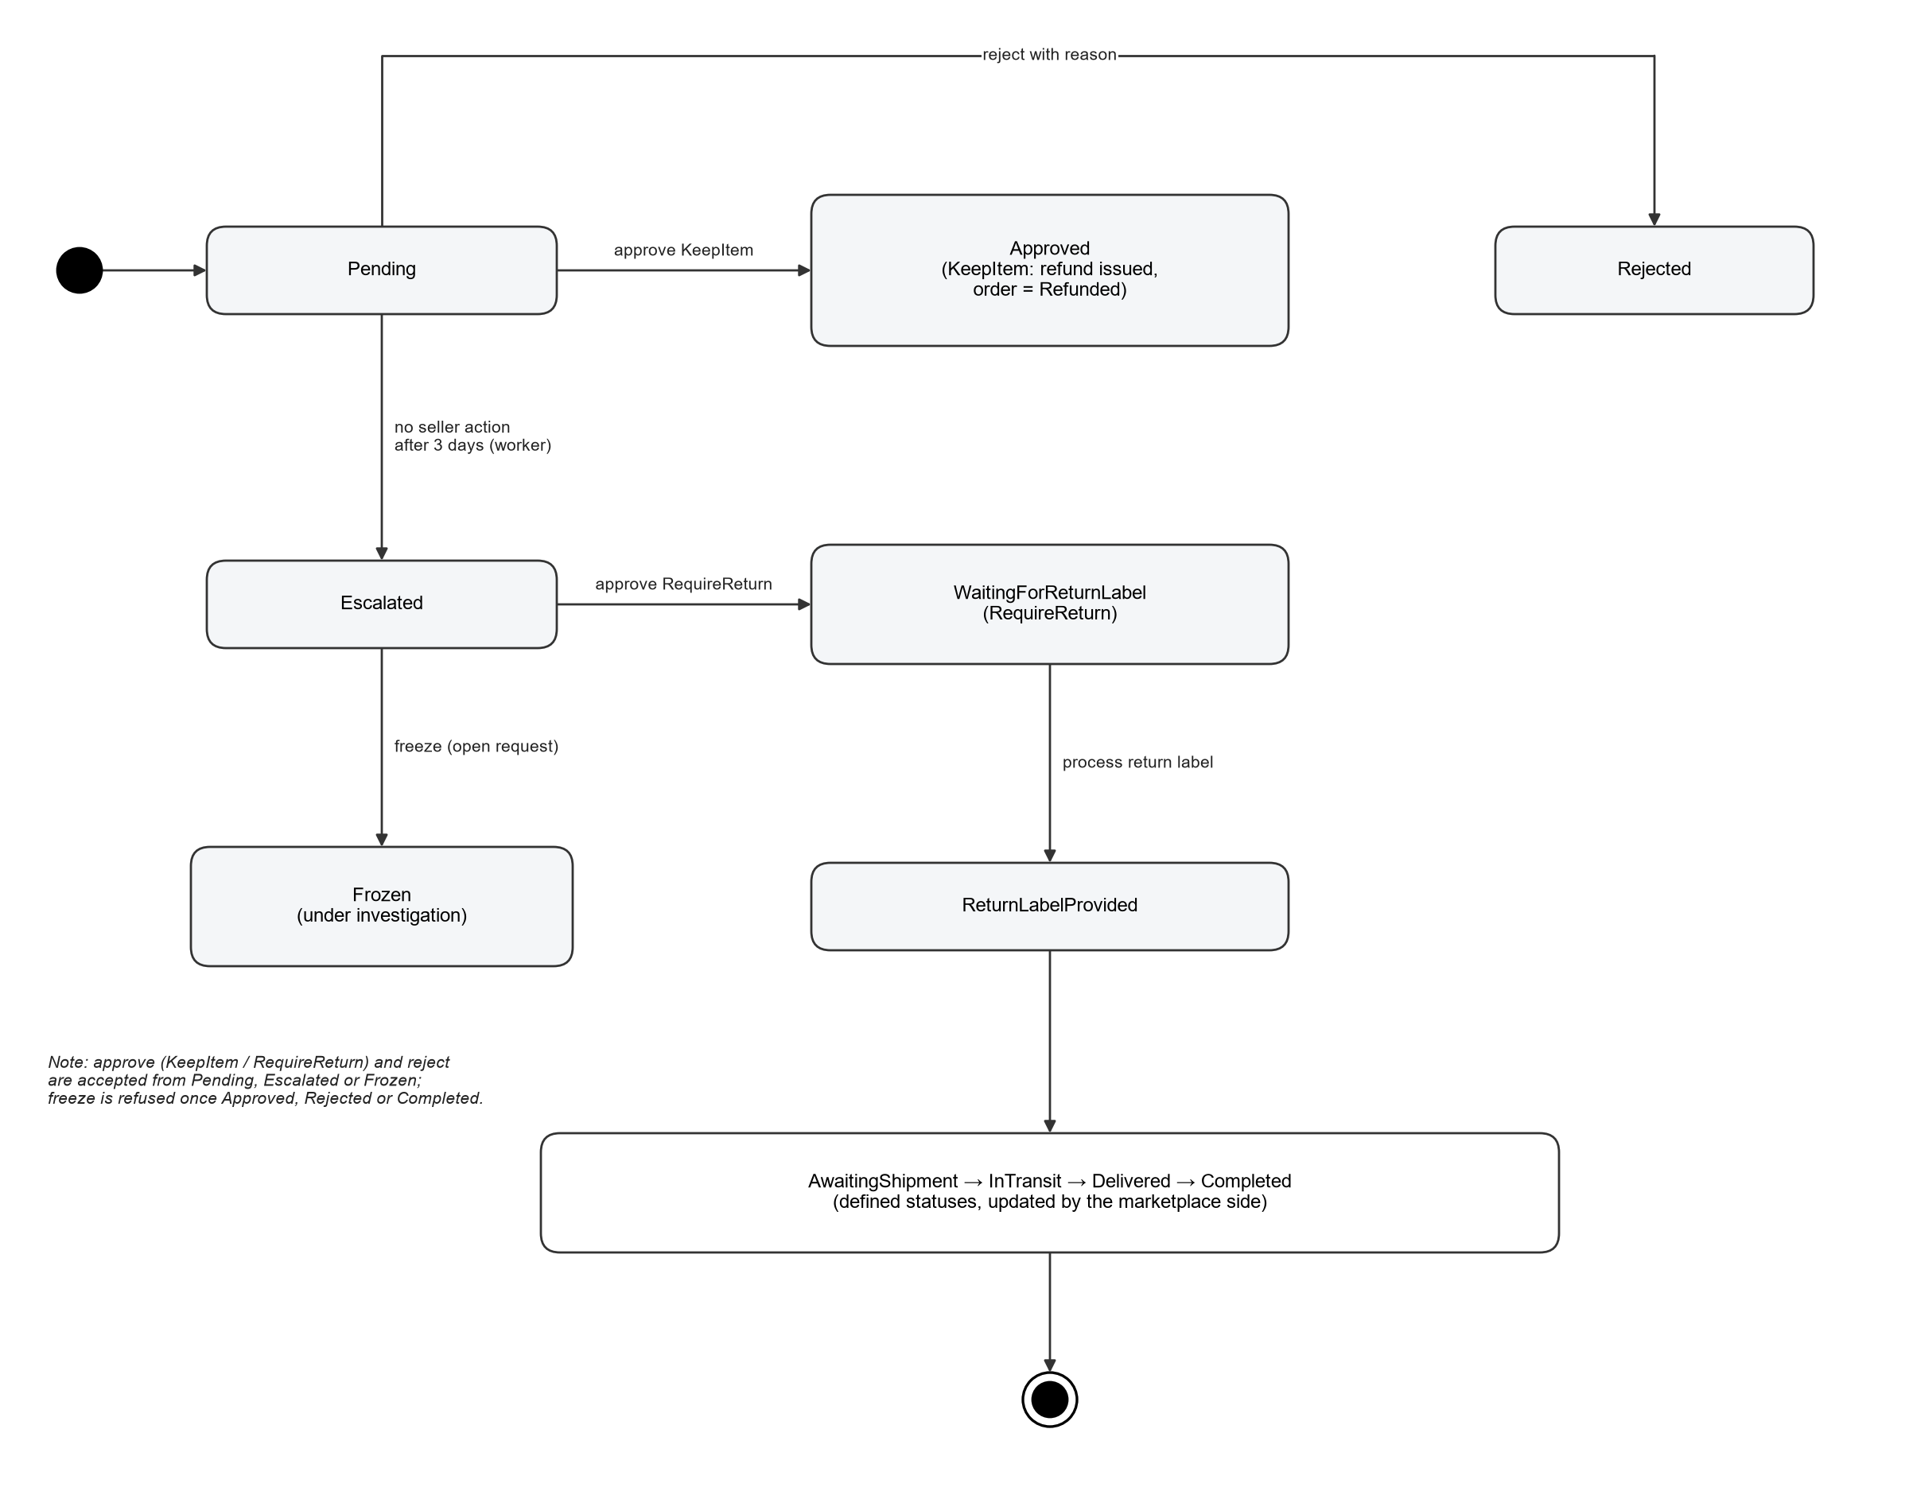
Figure 7. Return request state machine.
Command | Allowed from | Result
ApproveReturnRequest (approve / adjudicate), ResolutionAction = KeepItem | Pending, Escalated, Frozen | Approved; order Refunded; wallet debited; refund PayoutTransaction; AdminAction.
ApproveReturnRequest, ResolutionAction = RequireReturn | Pending, Escalated, Frozen | WaitingForReturnLabel.
ProcessReturnLabel | WaitingForReturnLabel | ReturnLabelProvided.
RejectReturnRequest | Pending, Escalated, Frozen | Rejected with admin note.
FreezeReturnRequest | any except Approved, Rejected, Completed | Frozen.
ReturnRequestEscalationService (hourly) | Pending older than 3 days | Escalated.

2.3. User Account State
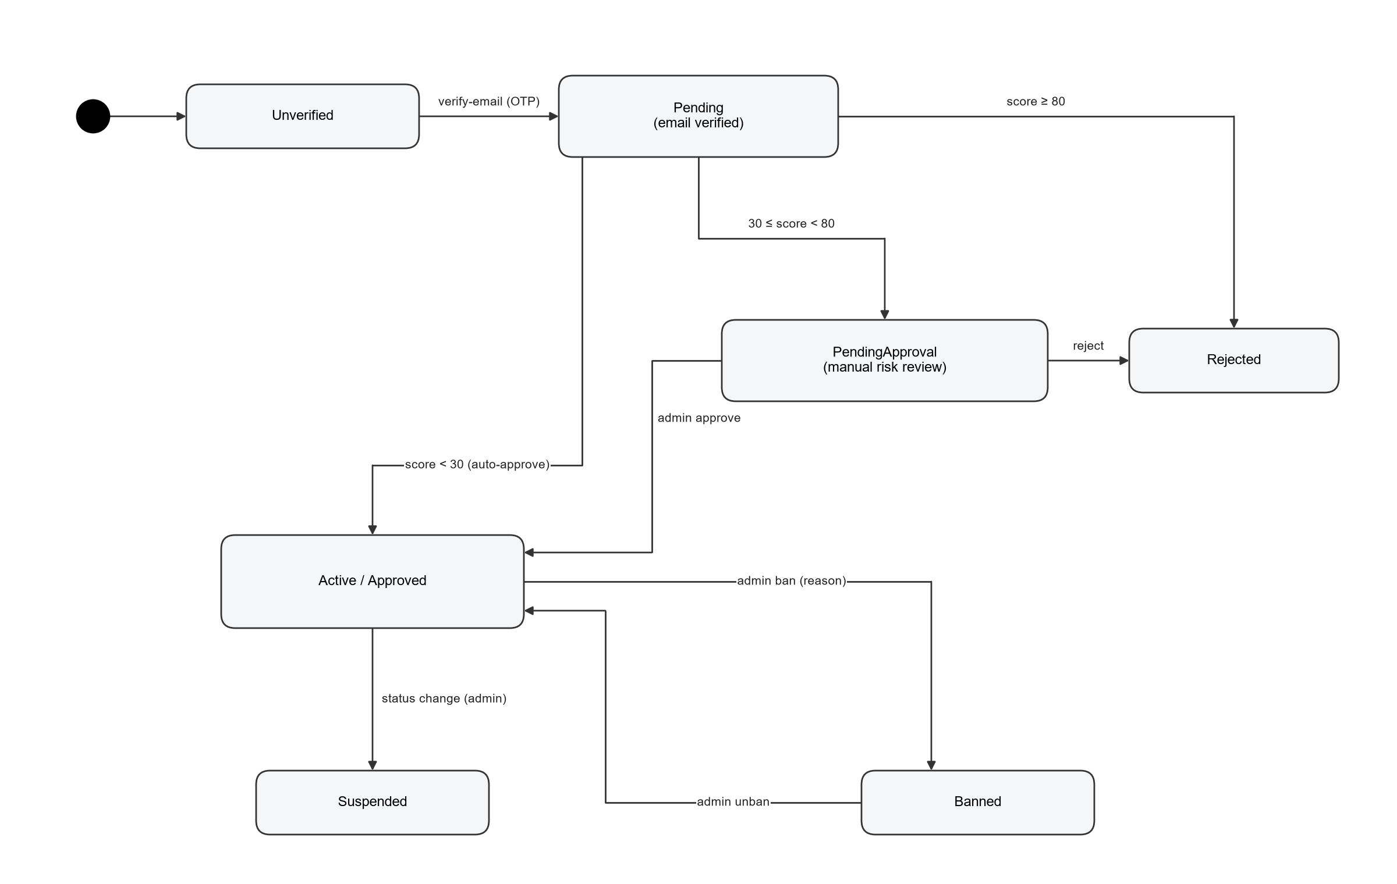
Figure 8. User account state machine.

2.4. Product, Review and Notification States
Aggregate | States and transitions
Product | Active/Visible → Hidden (Hide) → Active (Restore); Delete & Warn → Banned (soft delete, seller warned); Ignore report keeps the product and closes the reports.
Review | Visible ↔ Hidden (Keep/Hide); PendingReview when AI flags the text or the reviewer is linked to the seller.
Notification | Scheduled → Sent (ScheduledBroadcastService, every minute) or Sent immediately; read state in UserNotificationRead.
Payout | Pending → Completed / Failed (exception) / OnHold → released by admin; Refund records for KeepItem returns.

3. DETAILED DESIGN
Each module lists its endpoints, the MediatR commands/queries behind them, the main entities and the design rules.

3.1. Authentication & 2FA (R-A10, X-01, X-04)
Item | Design
Endpoints | /api/Auth: POST login, verify-2fa, register, verify-email, resend-email-code, logout, enable-2fa, verify-2fa-setup; GET captcha-config, me
Commands / queries / services | LoginCommand, RegisterCommand, VerifyEmailCommand, ResendEmailCodeCommand; JwtService; SignInMonitor; SecurityCache
Entities | User, LoginHistory, UserIdentifier
Design rules | Strict rate limit (5/min/IP) on login/register/verify. Lockout per account. TOTP one-time per 30 s. Responses for email verification never reveal account existence. Cookie auth_token is HttpOnly + Secure.

3.2. Dashboard & Statistics (R-A01, R-A05, R-A12)
Item | Design
Endpoints | /api/Dashboard/metrics; /api/Stats/dashboard, reports/revenue, reports/users, reports/orders; /api/Financials/reports/revenue
Commands / queries / services | Dashboard and Stats queries
Entities | Users, Products, Orders, PlatformFee
Design rules | Aggregations run in SQL with date-range filters; export (xlsx / jsPDF) is generated in the browser from the same data.

3.3. Users & Sellers (R-A02, X-02, X-03, X-07)
Item | Design
Endpoints | /api/Users: GET list, summary, {id}, seller-metrics, seller-level-criteria; PUT {id}/status, seller-level-criteria; POST {id}/ban, unban, approve, reject, lift-restrictions, evaluate-sellers
Commands / queries / services | BanUser, UnbanUser, ApproveUser, RejectUser, UpdateUserStatus, LiftRestrictions, EvaluateSellerLevels, UpdateSellerLevelCriteria, ApplySellerPenalty
Entities | User, UserIdentifier, SellerLevelCriteria, AdminAction
Design rules | Ban refused while the user has non-terminal orders. Approval of a risky account sets a 30-day payout hold. Seller hub (/hubs/seller) pushes live seller changes to staff.

3.4. Products & Moderation (R-A03, X-05, X-06)
Item | Design
Endpoints | /api/Products: GET list, {id}, seller/{sellerId}, managed, managed/summary, managed/{id}/violation-details; POST create, reports, managed/{id}/resolve-violation; PUT/DELETE {id}; /api/Categories
Commands / queries / services | CreateProduct, UpdateProduct, DeleteProduct, CreateProductReport, ResolveProductViolation
Entities | Product, ProductReport, Category
Design rules | Create/update checks AccountStanding and SellingLimits; AI moderation on create. Actions: DeleteAndWarn (Status Banned + warning email), Hide, Reject (ignore report), Restore.

3.5. Global Orders (R-A04)
Item | Design
Endpoints | /api/Orders: GET list, summary, {id}
Commands / queries / services | GetOrdersWithPagination, GetOrderSummary, GetOrderById
Entities | OrderTable, OrderItem, Payment, ShippingInfo
Design rules | Read-only for staff; filters by status, buyer and date; paged.

3.6. Reviews & Feedback (R-A06)
Item | Design
Endpoints | /api/reviews: GET flagged, statistics, seller-feedbacks; PUT {id}/status; POST create, {id}/reply, {id}/report
Commands / queries / services | CreateReview, ReplyToReview, ReportReview, UpdateReviewStatus
Entities | Review, ReviewReport, Feedback
Design rules | Reviewer id from session; reviewer linked to the seller → PendingReview; Hide notifies the reviewer once.

3.7. Disputes (R-A07)
Item | Design
Endpoints | /api/Disputes: GET '', statistics, {id}; POST {id}/assign, {id}/resolve; hub /hubs/dispute
Commands / queries / services | AssignDispute, ResolveDispute, UpdateDisputePriority, GetDisputeDocket, GetStatistics
Entities | Dispute, DisputeMessage, SellerWallet, FinancialTransaction
Design rules | Winner Buyer/Seller/Split; refund required for Buyer/Split; options RequireReturn, AddSellerViolation, SendNotifications; resolution, wallet changes and audit saved together.

3.8. Return & Refund Requests (R-A08)
Item | Design
Endpoints | /api/AdminReturnRequests: GET '', {id}, {id}/messages; POST {id}/approve, adjudicate, return-label, reject, freeze
Commands / queries / services | ApproveReturnRequest, ProcessReturnLabel, RejectReturnRequest, FreezeReturnRequest
Entities | ReturnRequest, OrderTable, SellerWallet, PayoutTransaction
Design rules | See 2.2. KeepItem refunds from the seller wallet and records a refund transaction.

3.9. Broadcasts & Notifications (R-A09, X-11)
Item | Design
Endpoints | /api/Broadcasts: GET '', POST '', POST schedule; GET active, POST active/{id}/read; hub /hubs/notifications
Commands / queries / services | SendBroadcast, MarkNotificationAsRead; ScheduledBroadcastService
Entities | Notification, UserNotificationRead
Design rules | Audience All/Buyer/Seller/Group (seller level or role); channels Email/InApp; scheduled items sent every minute.

3.10. Admin Roles (R-A11)
Item | Design
Endpoints | /api/AdminRoles: GET/POST roles, PUT roles/{id}, GET/POST users, POST users/assign
Commands / queries / services | CreateAdminRole, UpdateAdminRole, CreateAdminUser, AssignRole
Entities | AdminRole, AdminUserRole, User
Design rules | Permissions are policy names; AddGrantablePolicy lets a custom role satisfy a policy.

3.11. Audit & Sensitive Logs (R-A13)
Item | Design
Endpoints | /api/AuditLogs: GET '', summary, admin/{adminId}, entity/{targetType}/{targetId}; /api/sensitive-logs: GET '', summary, POST {id}/decrypt
Commands / queries / services | GetAuditLogs, GetAuditLogSummary, sensitive log queries, DecryptLog; SensitiveDataLogger
Entities | AdminAction, SensitiveDataLog
Design rules | Payload encrypted with AES-GCM (Security:EncryptionKey); decrypt is itself logged; --migrate-sensitive-data re-encrypts legacy rows.

3.12. Finance: Fees, Settlement, Payouts, Wallets (X-08, X-09)
Item | Design
Endpoints | /api/Financials: GET/PUT fees; POST trigger-settlement, settle-order/{id}; GET settlement-orders, pending/{sellerId}; POST payouts/run, payouts/{id}/release-hold; GET payouts/history, payouts/exceptions, payouts/config; PUT payouts/config; /api/Wallets; /api/Account/bank-account
Commands / queries / services | UpdatePlatformFees, SettlePendingFunds, SettleOrder, RunPayoutEngine, ReleaseHold, UpdatePayoutConfig, UpdateBankAccount; Settlement/PayoutEngine background services
Entities | PlatformFee, SellerWallet, FinancialTransaction, PayoutConfig, PayoutTransaction
Design rules | Payout skips sellers with PayoutHoldUntil in the future or without a bank account; payout goes through IPaymentGatewayService (mock). Withdrawal commands exist but are not exposed.

3.13. Account Linking, Risk Score and Monitoring (X-02, X-03, X-04)
Item | Design
Endpoints | No public endpoint; runs in AutoReviewUsersService (every 15 s for pending users, full AccountMonitor sync every 10 min with a leader lock)
Commands / queries / services | RiskAssessment, AccountLinking, AccountMonitor, AccountStanding, SellingLimits, SignInMonitor
Entities | User, UserIdentifier, LoginHistory
Design rules | Weights and thresholds come from RiskOptions (section 4).

3.14. Rate Limiting, Nginx and Realtime (R-N01, R-N02)
Item | Design
Endpoints | Policies Strict / Standard / Authenticated (RateLimitingExtensions); hubs /hubs/dispute, /hubs/notifications, /hubs/seller
Commands / queries / services | —
Entities | —
Design rules | Strict: fixed window 5 per 60 s per IP; Standard: 60 per 60 s per IP; Authenticated: sliding window 200 per 60 s per user (6 segments). Nginx passes the real client IP; Redis backplane shares SignalR messages between replicas.

3.15. System Admin and Simulation Toolbox (X-10, X-12)
Item | Design
Endpoints | /api/SystemAdmin: GET active-ips, ip-blocks; POST ip-blocks, ip-blocks/{id}/lift; /api/Mocking: generate-mock-users, generate-seller-order, generate-mock-dispute, generate-mock-return-request, generate-mock-defect, accelerate-settlement, push-payout
Commands / queries / services | BlockIpCommand, LiftIpBlockCommand, mock commands
Entities | IpBlock, generated demo data
Design rules | SystemAdmin is SuperAdmin only; Mocking requires ManageUsers, money endpoints SuperAdmin, and is disabled in Production.

4. ACCOUNT RISK AND ENFORCEMENT RULES

4.1. Risk Score Weights (RiskOptions, configurable)
Identifiers are normalised and stored as HMAC values. A match with another account adds the weight below (higher when that account is banned). Defaults can be overridden in the "Risk" configuration section.
Signal | Linked to active account | Linked to banned account
CCCD | 80 | 100
Bank account | 50 | 100
Email (normalised) | 40 | 60
Phone | 30 | 60
Device | 30 | 60
Address | 15 | 40
IP address | 15 | 30
Geolocation | 15 | 20

Other signal | Score
Disposable email domain | +20
Datacenter IP (AWS/Google ranges) | +20
Bank account holder name differs from the verified ID name | +40
Sign-up burst (≥ 3 other accounts from the same IP within 24 h) | +30
Review threshold | 30 (PendingApproval)
Reject threshold | 80 (Rejected)

4.2. Enforcement Ladder and Limits
Step | Trigger | Effect | Undo
1. Warning | Approved account linked to a banned account | Notification; score visible to admins | —
2. Restrict listings | Link to banned account (7 days) or listing spike ≥ 20/24 h and ≥ 5× normal (1 day) | ProductBanUntil | lift-restrictions
3. Hold payouts | Link to banned account (30 days); risky approval (30 days); bank change or takeover signal (48 h) | PayoutHoldUntil | lift-restrictions / release-hold
4. Suspend | Admin decision | Status Suspended | Status change
5. Ban | Admin decision with reason (no open orders) | Status Banned, sessions revoked | Unban

New-account selling limit (first 90 days after approval) | Max active listings | Max item price
Normal new seller | 10 | 500
Risky new seller (score ≥ 30) | 3 | 100
TopRated / AboveStandard or older than 90 days | No limit | No limit

5. API / INTEGRATION DESIGN

5.1. Endpoint Matrix
Group (/api/…) | Main operations | Authorization
Auth | login, verify-2fa, register, captcha-config, verify-email, resend-email-code, logout, me, enable-2fa, verify-2fa-setup | Anonymous / authenticated
Dashboard, Stats | metrics; dashboard; reports/revenue, users, orders | ViewDashboard; ViewReports
Users | list, summary, detail, status, ban, unban, approve, reject, lift-restrictions, seller metrics/criteria, evaluate-sellers | ManageUsers
Products, Categories | public list/detail/seller; create/update/delete own; managed list/summary/violation/resolve; reports | Anonymous / authenticated / ManageProducts
reviews | flagged, statistics, seller-feedbacks, status; create, reply, report | ModerateReviews / authenticated
Orders | list, summary, detail | ManageOrders
AdminReturnRequests | list, detail, messages, approve, adjudicate, return-label, reject, freeze | ManageOrders
Disputes | docket, statistics, detail, assign, resolve | ManageDisputes
Broadcasts | history, send, schedule; active, read | ManageBroadcasts / authenticated
Financials, Wallets | fees, settlement, payouts, config, revenue; wallets | Administrator, SuperAdmin
Account | PUT bank-account | Seller
AdminRoles | roles, users, assign | ManageAdminRoles
AuditLogs | list, summary, by admin, by entity | ViewAuditLogs
sensitive-logs | list, summary, decrypt | ManageAdminRoles (SuperAdmin)
SystemAdmin | active-ips, ip-blocks | SuperAdmin
Mocking | generators, accelerate-settlement, push-payout | ManageUsers; SuperAdmin for money; off in Production

5.2. Main Request Examples
Endpoint | Body (JSON)
POST /api/Disputes/{id}/resolve | { disputeId, winner: "Buyer|Seller|Split", refundAmount, adminNotes, requireReturn, addSellerViolation, sendNotifications }
POST /api/AdminReturnRequests/{id}/approve | { returnRequestId, resolutionAction: "KeepItem|RequireReturn", adminNote }
POST /api/Products/managed/{id}/resolve-violation | { productId, action: "DeleteAndWarn|Hide|Reject|Restore", adminNote, violationType }
POST /api/Broadcasts | { title, content, targetAudience: "All|Buyer|Seller|Group", targetGroup, channels: ["Email","InApp"], scheduleAt }
POST /api/Users/{id}/ban | { userId, reason }
POST /api/SystemAdmin/ip-blocks | { network, reason, days }

5.3. Sequence: Resolve Dispute
• Support opens /disputes/{id}; the page joins /hubs/dispute.
• POST /api/Disputes/{id}/resolve → ResolveDisputeCommand validator (winner, refund amount).
• Handler loads the dispute; refuses Resolved/Closed; applies refund to buyer and wallet changes for the seller; sets Status = Resolved, Winner, notes; writes AdminAction.
• SaveChanges commits everything in one transaction; emails/notifications are sent; the hub broadcasts the update to other staff.

5.4. Sequence: Decrypt Sensitive Log
• SuperAdmin opens /sensitive-logs and selects an entry.
• POST /api/sensitive-logs/{id}/decrypt → policy check (ManageAdminRoles) → AesEncryptionService decrypts with Security:EncryptionKey.
• The decrypt action is itself logged; the plain value is returned only in this response.

6. SECURITY AND DATA PROTECTION DESIGN
Control | Design
Secrets | Connection string MyCnn, Security:EncryptionKey and Jwt:Key come from User Secrets / environment / Azure Key Vault; weak or known JWT keys stop startup (JwtKeyPolicy).
PII | CCCD and bank data AES-GCM encrypted, HMAC lookup; masked in DTOs; backups require the same key.
Passwords / OTP | BCrypt password hashes; email OTP stored as HMAC with attempt counter; TOTP one-time use.
Network | InternalIpMiddleware allow-list; IpBlock list; Nginx real-IP handling; security headers.
Abuse | Rate limiting, account lockout, captcha, risk score, selling limits, payout holds.
Errors | CustomExceptionHandler hides internal details (500 generic).
Realtime | Hubs require authentication and policies (ManageDisputes, ManageUsers).
Dev tools | Mocking and LogInsteadOfSending / AllowApiWithout2FA refused in Production.

7. OPERATIONS, CI/CD AND TESTING

7.1. Background Workers
Worker | Schedule | Responsibility
AutoReviewUsersService | Every 15 s; full sync every 10 min (leader lock) | Risk review of Pending users; AccountMonitor (links to banned accounts, listing spikes).
ReturnRequestEscalationService | Hourly | Escalate Pending returns older than 3 days.
ScheduledBroadcastService | Every minute | Send due scheduled broadcasts.
SettlementBackgroundService | Periodic | Move cleared earnings from Pending to Available.
PayoutEngineBackgroundService | Per PayoutConfig schedule | Pay Available balances through the mock bank.
SellerEvaluationBackgroundService | Periodic | Recalculate seller levels.
DatacenterRangesService | Every 24 h | Refresh AWS/Google IP ranges.

7.2. CI/CD
Pipeline | Steps
.github/workflows/ci.yml | Checkout → .NET 10 → restore → build (Release) → Application unit tests → Domain unit tests → functional tests.
.github/workflows/cd.yml | Docker Buildx → login GHCR → metadata → build and push image.
.github/workflows/azure-dev.yml | Optional Azure Developer CLI deployment.

Jenkins is not used; GitHub Actions covers R-N03.

7.3. Kubernetes Rolling Update
API Deployment with 2 replicas, RollingUpdate maxUnavailable 0 and maxSurge 1, readiness probe, Redis for SignalR and revoked tokens, SQL Server as a StatefulSet. Schema changes must stay backward compatible during a rollout (expand first, contract later).

7.4. Tests
Suite | Tools | Focus
Domain.UnitTests / Application.UnitTests | NUnit, Moq, Shouldly | Entities, validators, risk rules, policies.
Application.FunctionalTests | NUnit, Testcontainers.MsSql, Respawn | Commands and HTTP flows against a real SQL Server (register, auto review, security review, disputes, returns).
Infrastructure.IntegrationTests | NUnit | EF Core and services.
Web.AcceptanceTests | SpecFlow | UI acceptance scenarios.
tests/jmeter/plans | Apache JMeter | 00 login smoke, 01 brute force, 02 dashboard stats, 03 users/orders paging, 04 dispute detail, 10 IP allow-list, 11 2FA, 12 RBAC.

8. DESIGN DECISIONS, KNOWN GAPS AND TRACEABILITY

8.1. Design Decisions
Decision | Reason
Admin gate = internal IP AND 2FA (stricter than the brief's OR) | Defence in depth for an admin panel exposed through a VPS.
One deployable app (API + SPA) instead of microservices | Simpler deployment and consistent transactions for the project size.
Risk thresholds and weights in configuration | Can be tuned without a code change.
Mock payment gateway | No real money in an academic project.
Startup does not migrate or seed | Avoid accidental schema/data changes in shared environments.

8.2. Known Gaps
• Administrator can call several APIs (users, products, reviews, disputes, returns, payout engine) that the React routes do not yet show for that role.
• Withdrawal request commands have no HTTP endpoint.
• Seller-side screens for disputes/returns are outside this admin system; the related states are produced by seeders and the simulation toolbox.

8.3. Future Work (removed from v1.1 design)
• Account appeals with document upload and independent review.
• VeRO / IP rights reporting.
• Trust & Safety case management, evidence store and fraud rule engine.
• Transactional outbox for emails and payment side effects.
• SMS OTP, eKYC and bank account verification.

8.4. Requirement → Design Traceability
Requirement | SDS sections
R-A01, R-A05, R-A12 | 3.2
R-A02 | 2.3, 3.3
R-A03 | 2.4, 3.4
R-A04 | 3.5
R-A06 | 2.4, 3.6
R-A07 | 2.1, 3.7, 5.3
R-A08 | 2.2, 3.8
R-A09 | 3.9
R-A10 | 1.5, 3.1
R-A11 | 1.5.1, 3.10
R-A13 | 3.11, 5.4, 6
R-A14 | 1.2
R-N01, R-N02 | 1.6, 3.14
R-N03 | 7.2
R-N05 | 7.4
R-N06 | 1.6, 7.3
X-01…X-04 | 3.1, 3.13, 4
X-07 | 3.3
X-08, X-09 | 3.12
X-10, X-12 | 3.15
X-11 | 3.9, 3.14

8.5. References
• SRS — eBay Clone Admin, v1.2 (this release).
• README.md and README-DATABASE.md in the repository.
• Repository: https://github.com/Monomee/PRN232.Ebay-Clone-Admin_Role
• Clean Architecture template (Jason Taylor) used as the solution base.

