FPT UNIVERSITY

SOFTWARE REQUIREMENT SPECIFICATION
eBay Clone — Administration and Operations System

Project | eBay Clone — Administration and Operations System
Document | SRS Document v1.2
Prepared by | Group 3
Status | Final for academic submission — aligned with source code
Date | 10/11/2026

– Hanoi, November 2026 –

I. RECORD OF CHANGES
Date | A/M/D | In charge | Change description
30/10/2026 | A | Group 3 | Initial SRS based on the project brief, source modules and the Trust & Safety proposal.
06/11/2026 | A, M | Group 3 | v1.1: security and anti multi-account requirements implemented in code (PR #17–#26): self-registration with email OTP, account linking and risk scoring, account standing gate, sign-in history and account lockout.
10/11/2026 | M, D, A | Group 3 | v1.2: whole document rewritten in English and aligned with the source code. Real API routes, roles, policies and status values are used. Design-only items that were never implemented (VeRO, account appeals, Trust & Safety case management, FraudInvestigator / IPReviewer / AppealReviewer roles, outbox, evidence store) were removed from the requirements and listed as future scope (5.7). New context diagram, use case diagrams per actor, business process diagrams and ERD were added; use case specifications were rewritten for the implemented functions.

A = Added; M = Modified; D = Deleted.

TABLE OF CONTENTS
I. RECORD OF CHANGES 2
TABLE OF CONTENTS 3
II. SOFTWARE REQUIREMENT SPECIFICATION 5
1. OVERALL REQUIREMENTS 5
1.1. Project Overview and Scope 5
1.2. Context Diagram 6
1.3. Actors and Stakeholders 6
1.4. Use Case Diagrams 7
1.5. Main Business Processes 12
1.6. User Requirements and Role Permissions 15
1.7. System Functionalities & Requirement Inventory 16
1.8. Screen Authorization and Major UI Screens 18
1.9. Logical Entity Relationship Model 19
2. USE CASE SPECIFICATIONS 19
2.1. UC-01 — Register Account 19
2.2. UC-02 — Verify Email (OTP) 20
2.3. UC-03 — Login and Verify 2FA 20
2.4. UC-04 — Set Up Two-Factor Authentication 20
2.5. UC-05 — View Own Profile / Logout 21
2.6. UC-06 — View Active Broadcasts / Receive Notifications 21
2.7. UC-07 — Write Product Review 22
2.8. UC-08 — Report Product / Report Review 22
2.9. UC-09 — Create Product 22
2.10. UC-10 — Update / Delete Own Product 23
2.11. UC-11 — Reply to Review 23
2.12. UC-12 — Register Payout Bank Account 23
2.13. UC-13 — View Admin Dashboard 24
2.14. UC-14 — View Statistical Reports and Export 24
2.15. UC-15 — View / Filter Users 25
2.16. UC-16 — Approve / Reject User 25
2.17. UC-17 — Ban / Unban User, Change Status 25
2.18. UC-18 — Lift Account Restrictions 26
2.19. UC-19 — Manage Seller Levels 26
2.20. UC-20 — Moderate Reported Products 26
2.21. UC-21 — Moderate Reviews 27
2.22. UC-22 — View Global Orders 27
2.23. UC-23 — Handle Return Requests 28
2.24. UC-24 — Handle Disputes 28
2.25. UC-25 — Send / Schedule Broadcast 28
2.26. UC-26 — Manage Fees, Settlement and Payouts 29
2.27. UC-27 — Manage Admin Roles and Accounts 29
2.28. UC-28 — View Audit Logs 30
2.29. UC-29 — View and Decrypt Sensitive Logs 30
2.30. UC-30 — Monitor Connections and Block IP 30
2.31. UC-31 — Use Simulation Toolbox 31
3. FUNCTIONAL REQUIREMENTS 31
3.1. R-A01 — Dashboard 31
3.2. R-A02 — User management 31
3.3. R-A03 — Product moderation 31
3.4. R-A04 — Global orders 32
3.5. R-A05 — Statistics 32
3.6. R-A06 — Reviews and feedback 32
3.7. R-A07 — Disputes 32
3.8. R-A08 — Returns and refunds 32
3.9. R-A09 — Broadcasts 32
3.10. R-A10 — Admin access gate 33
3.11. R-A11 — Admin roles 33
3.12. R-A12 — Extensible dashboard 33
3.13. R-A13 — Sensitive audit 33
3.14. R-A14 — Usable UI 33
3.15. R-N01…R-N06 — Operations 33
3.16. X-01…X-04 — Registration and account security 34
4. NON-FUNCTIONAL REQUIREMENTS 34
4.1. External Interfaces 34
4.2. Quality Attributes and Acceptance Method 34
5. REQUIREMENT APPENDIX 35
5.1. Business Rules 35
5.2. Status Vocabulary 36
5.3. System Messages 36
5.4. Business Data Requirements 37
5.5. Acceptance Scenarios 37
5.6. Requirements Traceability Matrix 38
5.7. Future Scope (not implemented) 39

II. SOFTWARE REQUIREMENT SPECIFICATION

1. OVERALL REQUIREMENTS

1.1. Project Overview and Scope
eBay Clone — Administration and Operations System is the back-office of a marketplace where many buyers and sellers trade. The project focuses on the Admin Panel: user approval and restriction, product and review moderation, global orders, disputes, return/refund requests, broadcasts, statistics, admin roles, audit logs, and the security and operations work around them (internal IP + mandatory 2FA, rate limiting, encrypted sensitive logs, Nginx load balancing, CI/CD, Kubernetes rolling updates, JMeter tests).
Business goals: one place for operational data; transparent moderation; disputes and refunds decided on evidence; consistent metrics for decisions; least privilege, full auditability and controlled releases.
Tags used in this document:
• [R]: required by the assignment brief (R-A01…R-A14, R-N01…R-N06).
• [C]: implemented in the source code beyond the brief (extensions X-01…X-12).
• [F]: future scope: not implemented, kept only in section 5.7 so the reader knows it is not part of this release.
Category | Scope
Mandatory [R] | 14 Admin requirements (R-A01…R-A14) and 6 operations requirements (R-N01…R-N06).
Implemented extensions [C] | Categories; seller levels and performance evaluation; platform fees, settlement, payout engine and seller wallets (mock bank); scheduled broadcasts and realtime notifications (SignalR); Excel/PDF export; AI content moderation; self-registration with captcha and email OTP; account linking with risk score; account standing gate and new-account selling limits; sign-in history and account lockout; IP blocking and active connections; simulation toolbox.
Out of scope | A full buyer storefront (cart, checkout, bidding engine), real payment gateway, mobile app, VeRO / appeal workflows (see 5.7). Buyer/seller functions are only implemented where the Admin Panel needs them (registration, products, reviews, reports, bank account).

1.2. Context Diagram
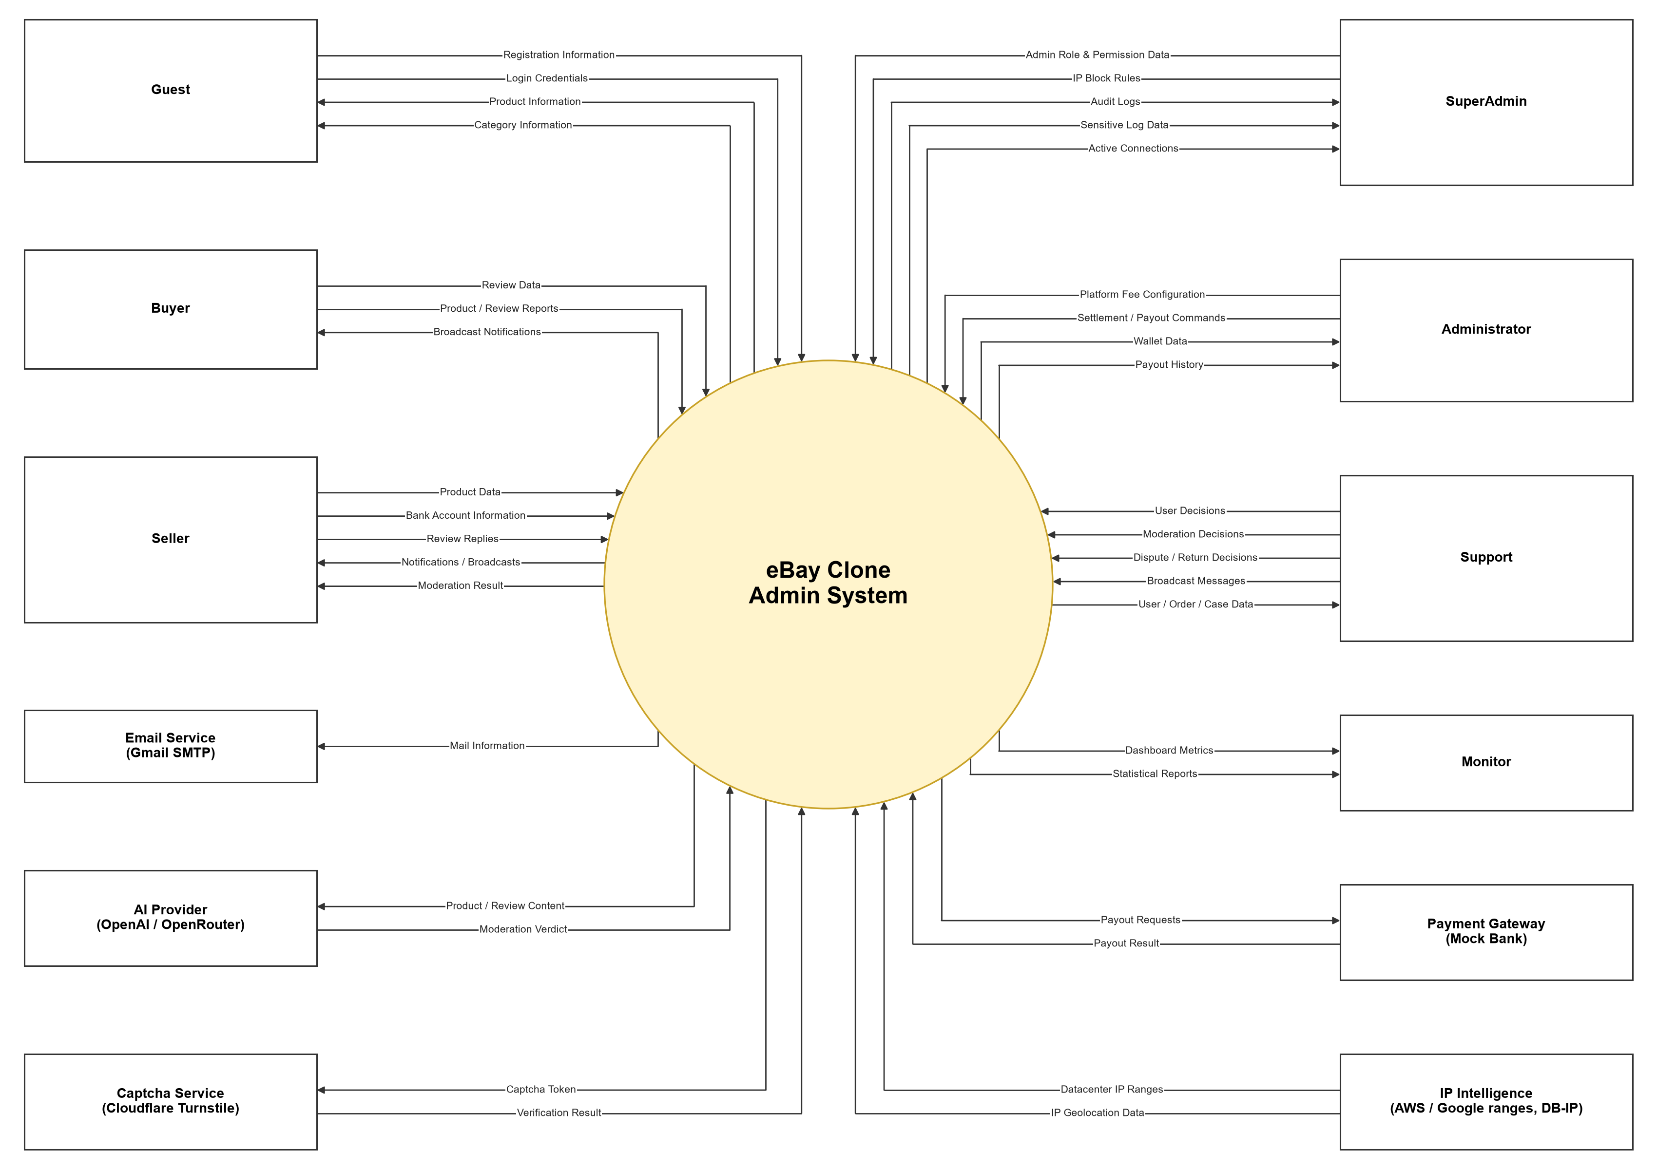
Figure 1. System context diagram — external entities and data flows.
External entity | Interaction with the system
Guest | Registers a Buyer/Seller account, logs in, browses products and categories (public API).
Buyer / Seller | Authenticated marketplace users: write/report reviews, report products (Buyer); create and manage products, reply to reviews, register a payout bank account (Seller). They cannot open Admin pages.
SuperAdmin / Administrator / Support / Monitor | Staff roles that use the Admin Panel (see 1.3 and 1.6).
Email Service (Gmail SMTP) | Sends registration OTP, broadcast emails and moderation / decision notices.
AI Provider (OpenAI / OpenRouter) | Classifies new product and review content (IContentModerationService). If unavailable the content goes to manual review.
Captcha Service (Cloudflare Turnstile) | Verifies the captcha token sent with POST /api/Auth/register.
Payment Gateway (Mock Bank) | MockPaymentGatewayService: receives payout requests from the payout engine and returns success/failure. No real money is moved.
IP Intelligence | AWS / Google published IP ranges (datacenter detection) and DB-IP geolocation, used for risk scoring and sign-in flags.

1.3. Actors and Stakeholders
Actor | Responsibilities (as implemented)
Guest | Unauthenticated visitor: register, verify email, log in, view products and categories.
Authenticated User | Abstract actor for every logged-in account: set up 2FA, view own profile (/me), view and mark broadcasts, receive realtime notifications, log out.
Buyer | Writes product reviews, reports reviews and products. Blocked while the account is Unverified, Pending, PendingApproval, Suspended or Banned.
Seller | Creates, updates and deletes own products, replies to reviews, registers the payout bank account. New sellers have selling limits for 90 days.
Monitor | Read-only staff: dashboard (ViewDashboard) and statistical reports (ViewReports) with export.
Support | Operations staff: users, sellers, products, reviews, orders, return requests, disputes and broadcasts (Manage* policies) plus dashboard.
Administrator | Operations staff with the same Manage* policies as Support (no ViewDashboard) plus finance: platform fees, settlement, payout engine, payout history and seller wallets.
SuperAdmin | Everything above plus admin roles and admin accounts, audit logs, sensitive logs (decrypt), IP blocks, active connections and the simulation toolbox.
System (background workers) | AutoReviewUsersService (risk review + AccountMonitor), ReturnRequestEscalationService, ScheduledBroadcastService, SettlementBackgroundService, PayoutEngineBackgroundService, SellerEvaluationBackgroundService, DatacenterRangesService. Actions are logged under the System identity.

Custom admin roles can be created in Admin Roles; each grants a list of the policies above (ManageUsers, ManageProducts, …) through a permission claim. The backend policy is the only source of truth; React route guards only improve the user experience.

1.4. Use Case Diagrams
The diagrams are split by actor. Actor generalisation is shown with a hollow arrow (e.g. Buyer and Seller are Guests before they log in; Support and Administrator share the Operations Staff use cases; SuperAdmin inherits every staff role). <<include>> marks a step that always happens, <<extend>> an optional step started from the base use case.

1.4.1. Use cases for Guest
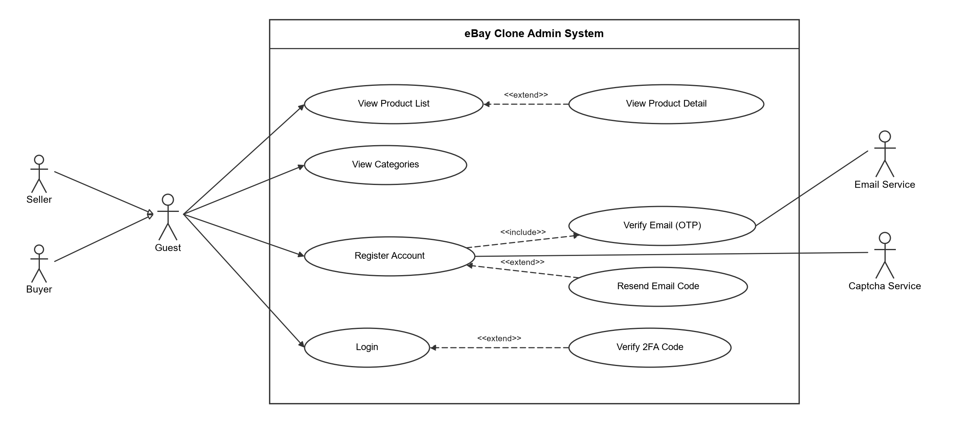
Figure 2. Use case diagram — Guest.

1.4.2. Use cases for Authenticated User
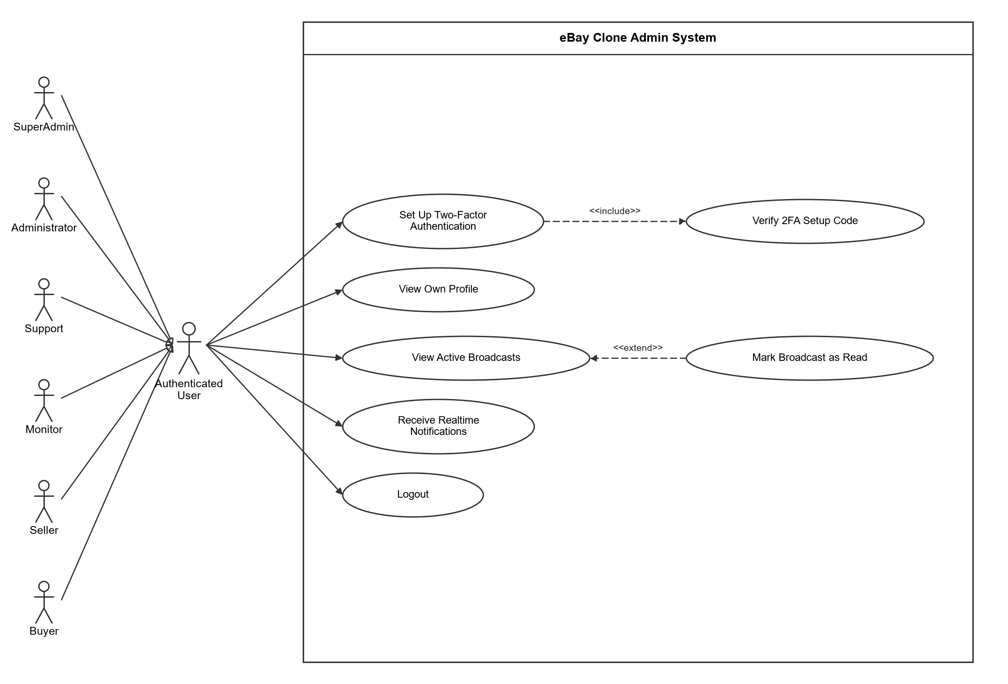
Figure 3. Use case diagram — Authenticated User (all roles).

1.4.3. Use cases for Buyer
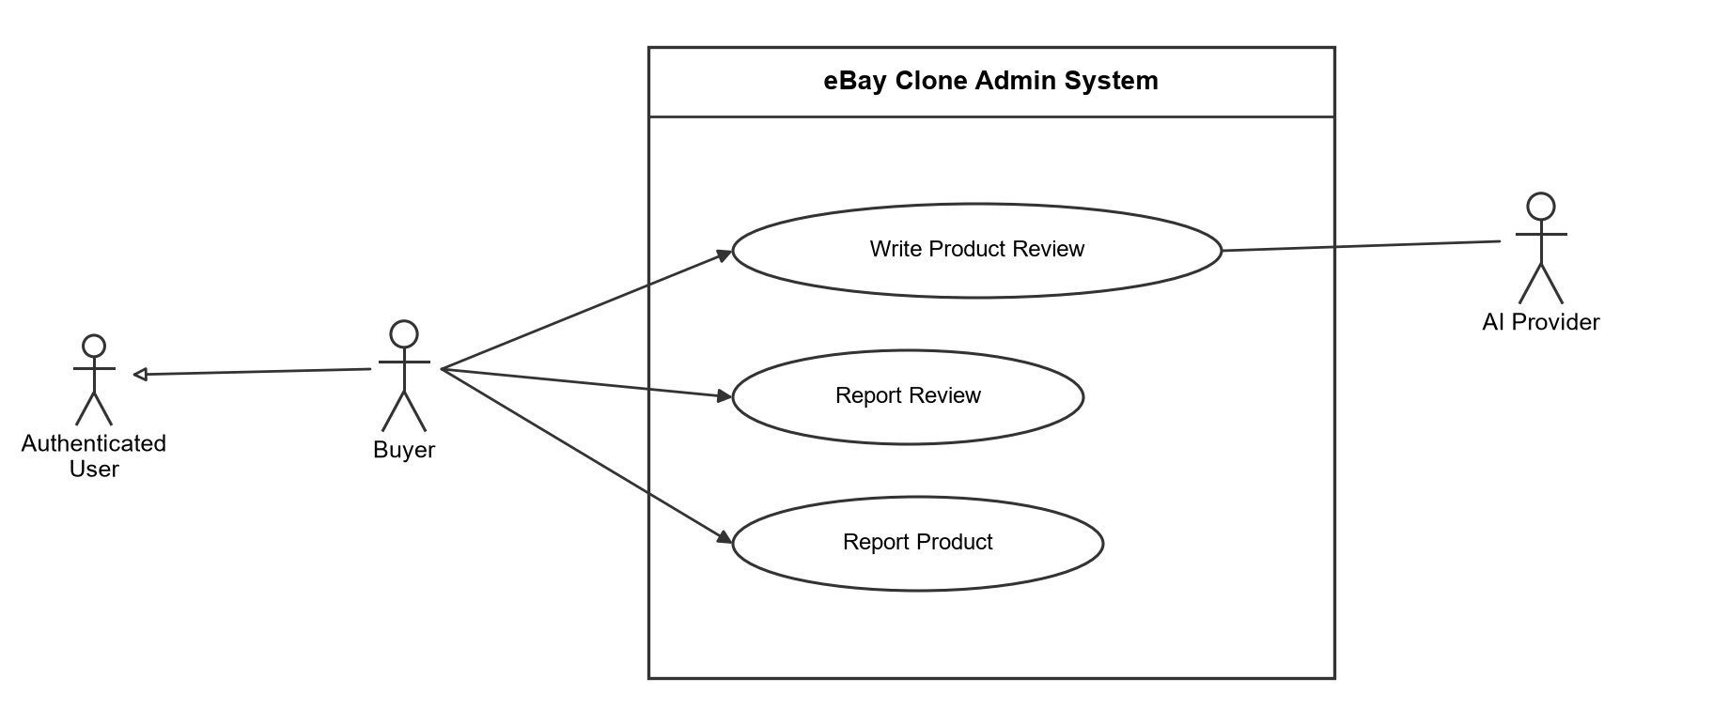
Figure 4. Use case diagram — Buyer.

1.4.4. Use cases for Seller
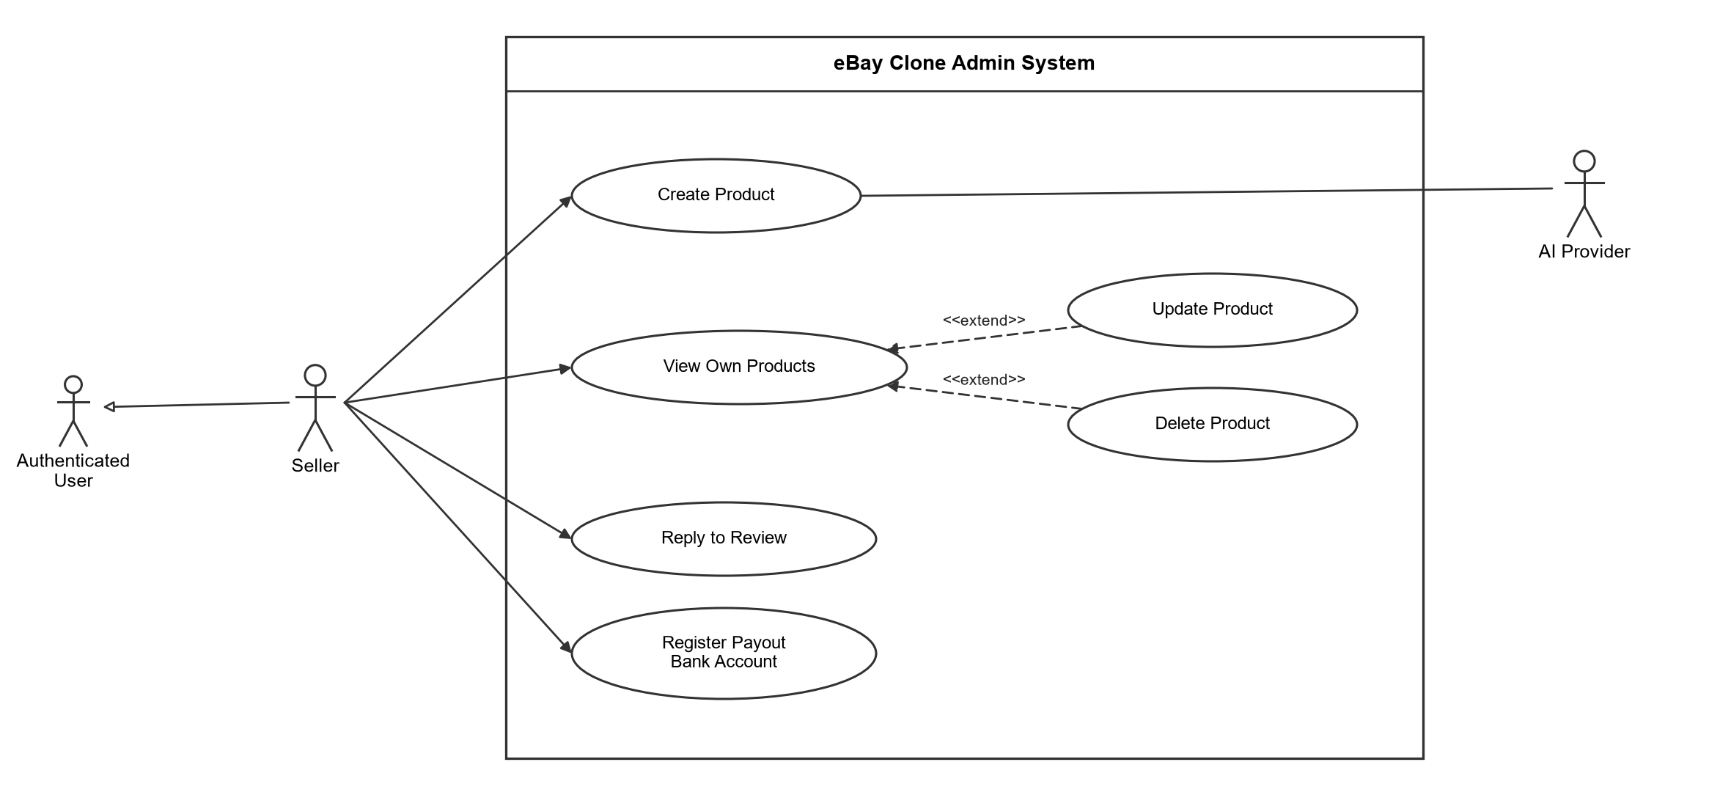
Figure 5. Use case diagram — Seller.

1.4.5. Use cases for Monitor
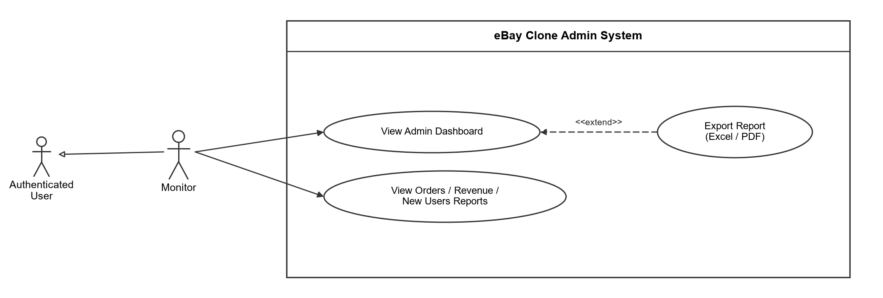
Figure 6. Use case diagram — Monitor.

1.4.6. Use cases for Operations Staff (Support, Administrator)
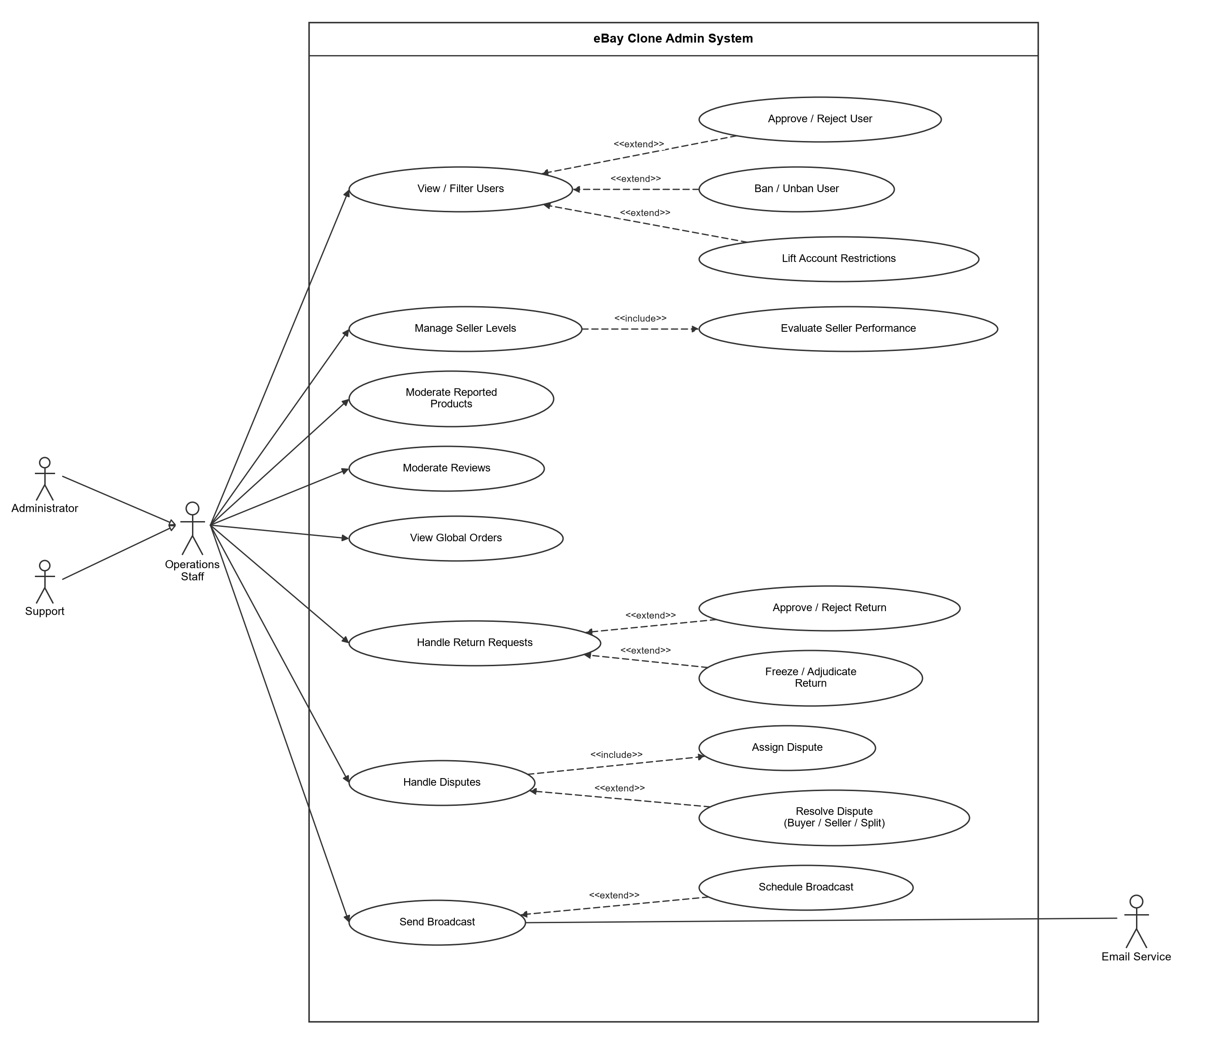
Figure 7. Use case diagram — Operations Staff.

1.4.7. Use cases for Administrator (finance)
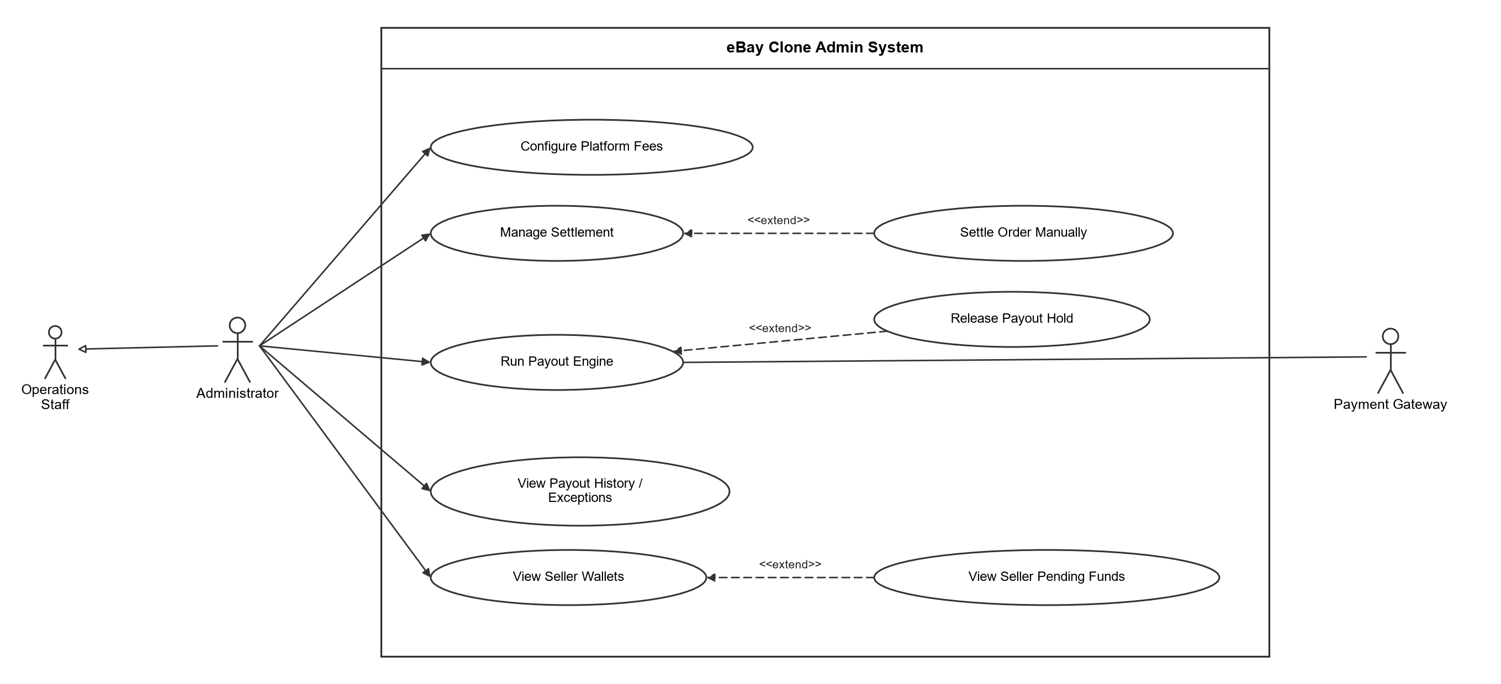
Figure 8. Use case diagram — Administrator finance functions.

1.4.8. Use cases for SuperAdmin
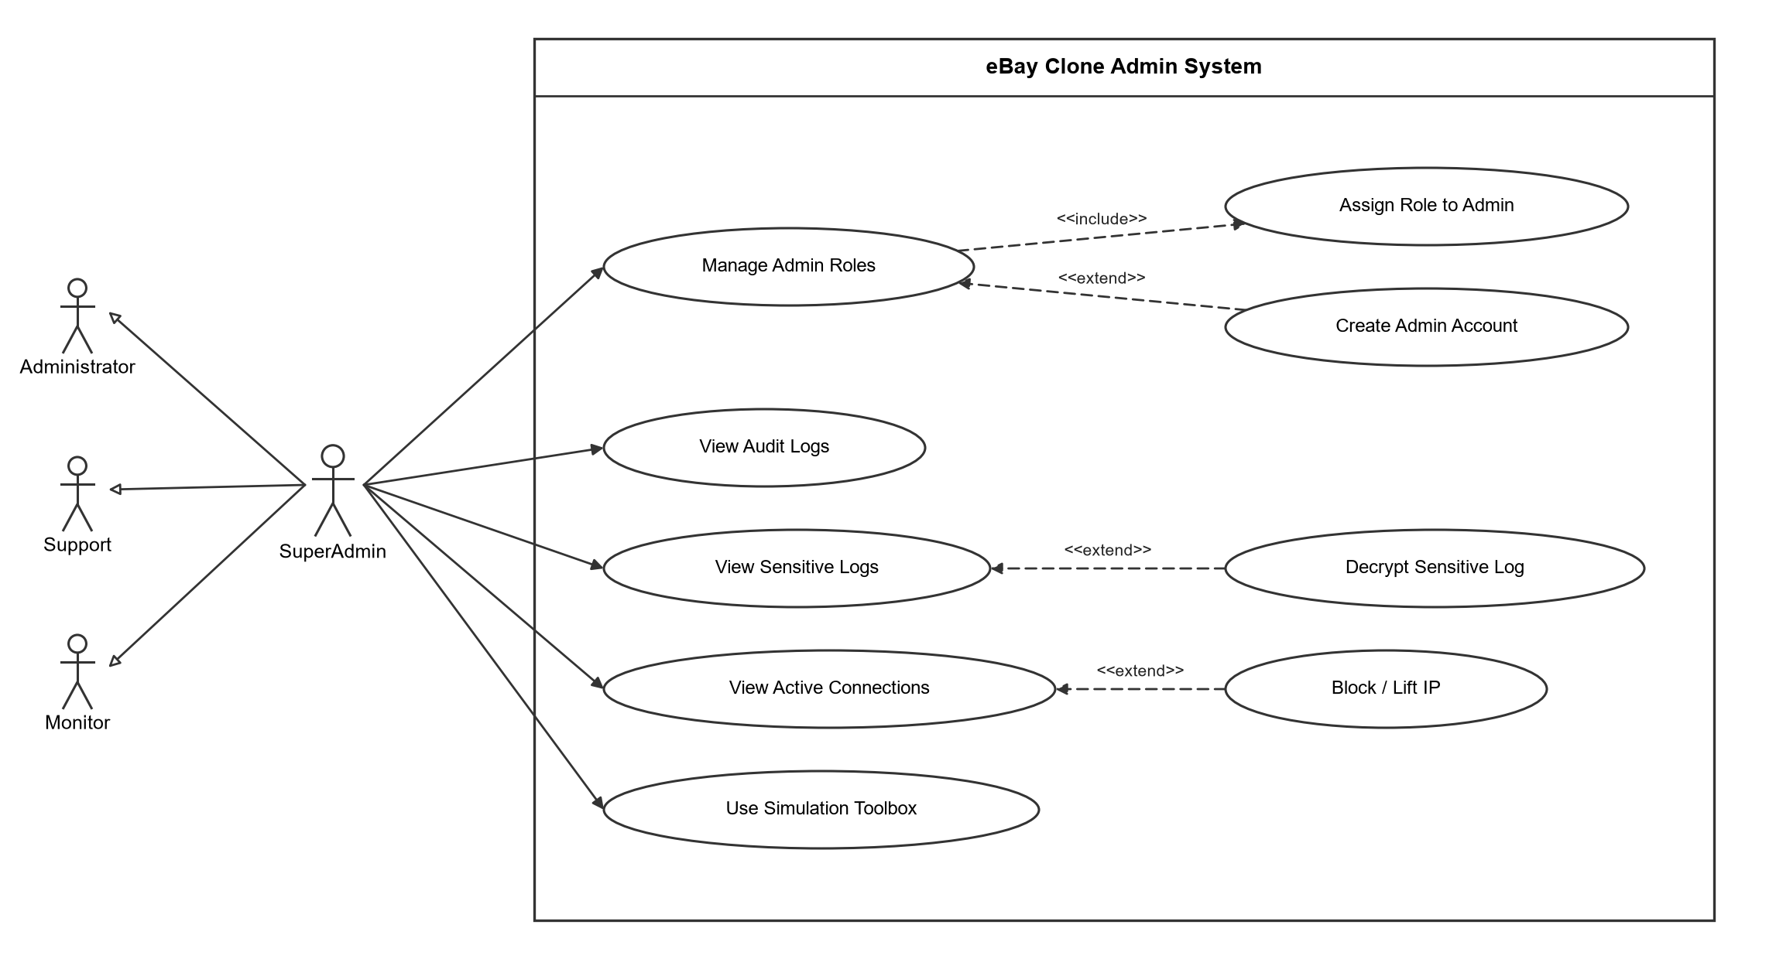
Figure 9. Use case diagram — SuperAdmin.

1.5. Main Business Processes

1.5.1. Registration, email verification and risk review
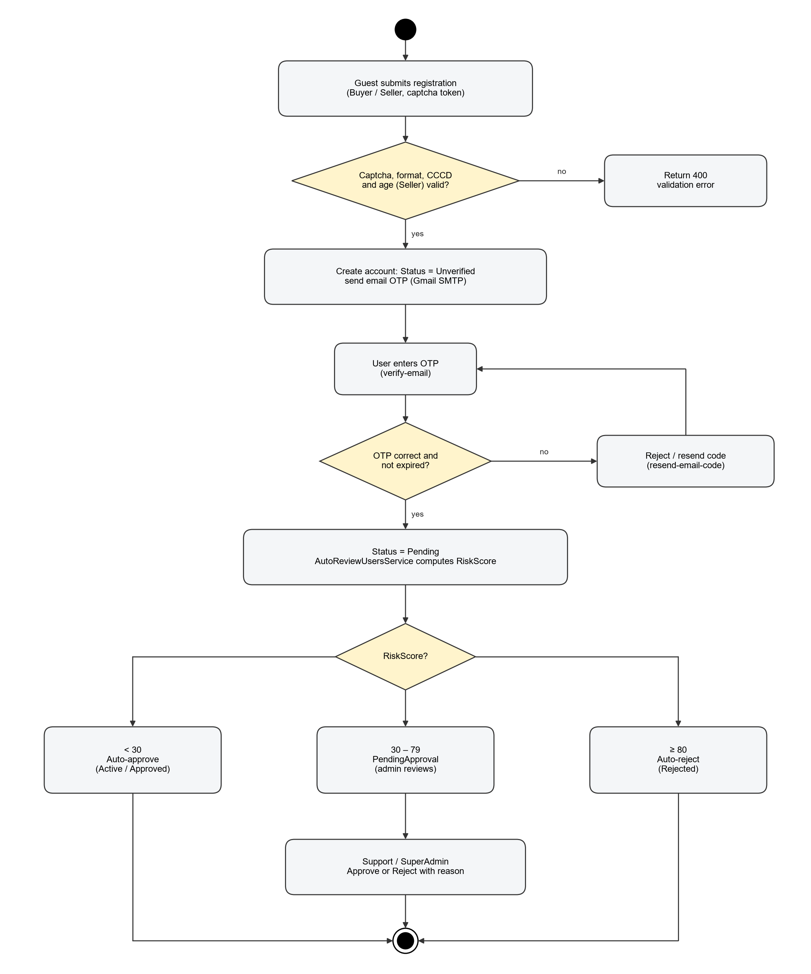
Figure 10. Self-registration and automatic risk review.
A Guest registers as Buyer or Seller through POST /api/Auth/register with a Cloudflare Turnstile token. Sellers must also give full name, CCCD (12 digits), date of birth (18+). The account starts as Unverified and an OTP is emailed; after POST /api/Auth/verify-email the status becomes Pending. AutoReviewUsersService then computes a risk score from linked identifiers (CCCD, bank account, email, phone, address, IP, geolocation, device) and signals (disposable email, datacenter IP, name mismatch, sign-up burst). Score < 30 is approved automatically, 30–79 waits for an admin (PendingApproval), ≥ 80 is rejected. Thresholds and weights are configuration values (section "Risk" in appsettings).

1.5.2. User status lifecycle and restrictions
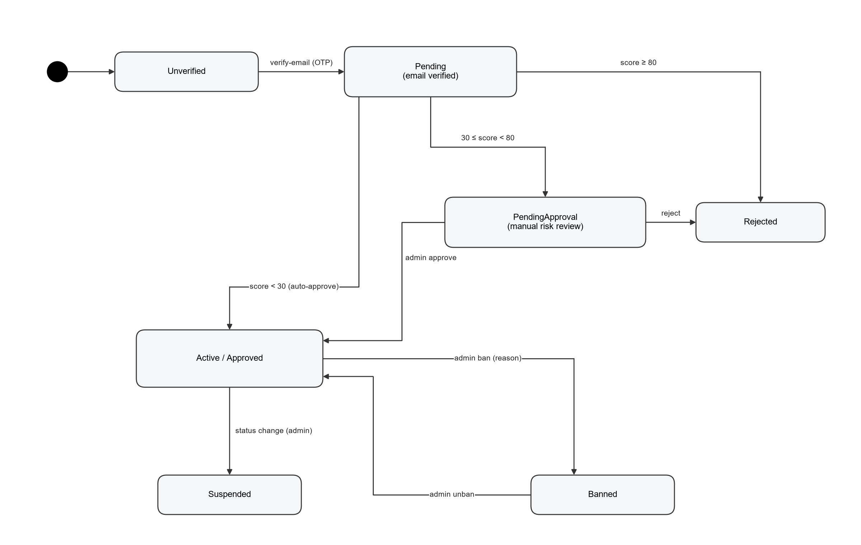
Figure 11. User status lifecycle.
Admins approve or reject PendingApproval accounts, ban/unban with a reason, or change the status (Active, Pending, Suspended). A ban is refused while the user still has open orders. After approval, AccountMonitor keeps watching: an account that becomes linked to a banned account gets a warning, a listing restriction (7 days) or a payout hold (30 days); a sudden listing spike gets a 1-day listing restriction. Admins remove these automatic restrictions with POST /api/Users/{id}/lift-restrictions. Suspending or banning always stays a human decision.

1.5.3. Dispute resolution
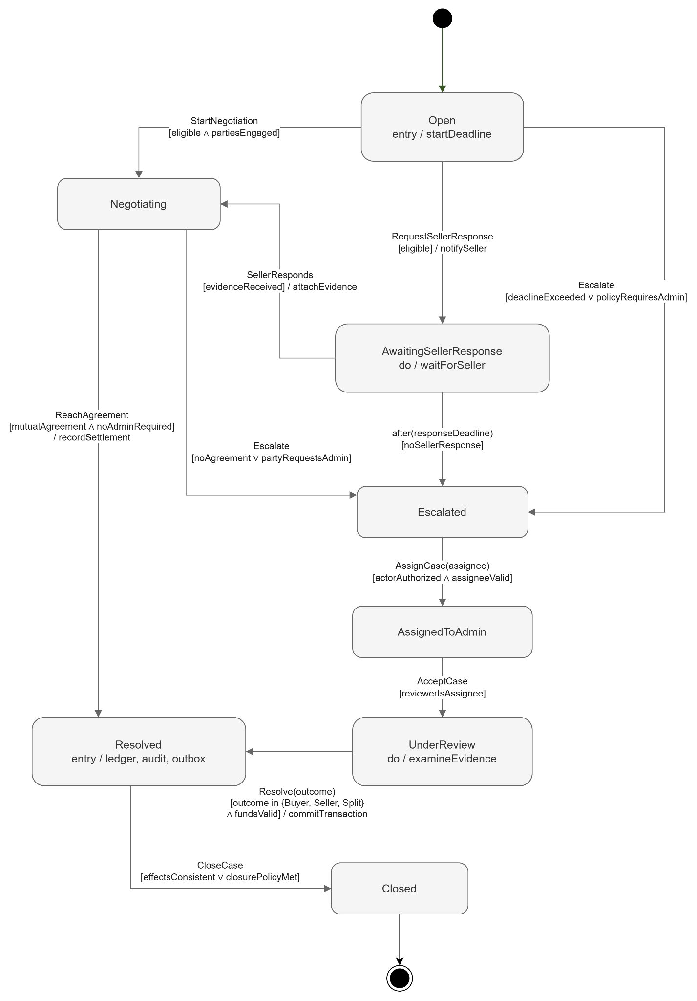
Figure 12. Dispute state machine.
Disputes (INR, INAD, Damaged, Counterfeit, Other) move through Open → AwaitingSellerResponse → Negotiating → Escalated. Staff assign the case (AssignedToAdmin / UnderReview) and resolve it once with Winner = Buyer, Seller or Split. Buyer and Split require a refund amount; the decision can require a return, add a seller violation and notify both parties. A Resolved or Closed dispute cannot be resolved again. Changes are pushed live to /hubs/dispute.

1.5.4. Return and refund requests
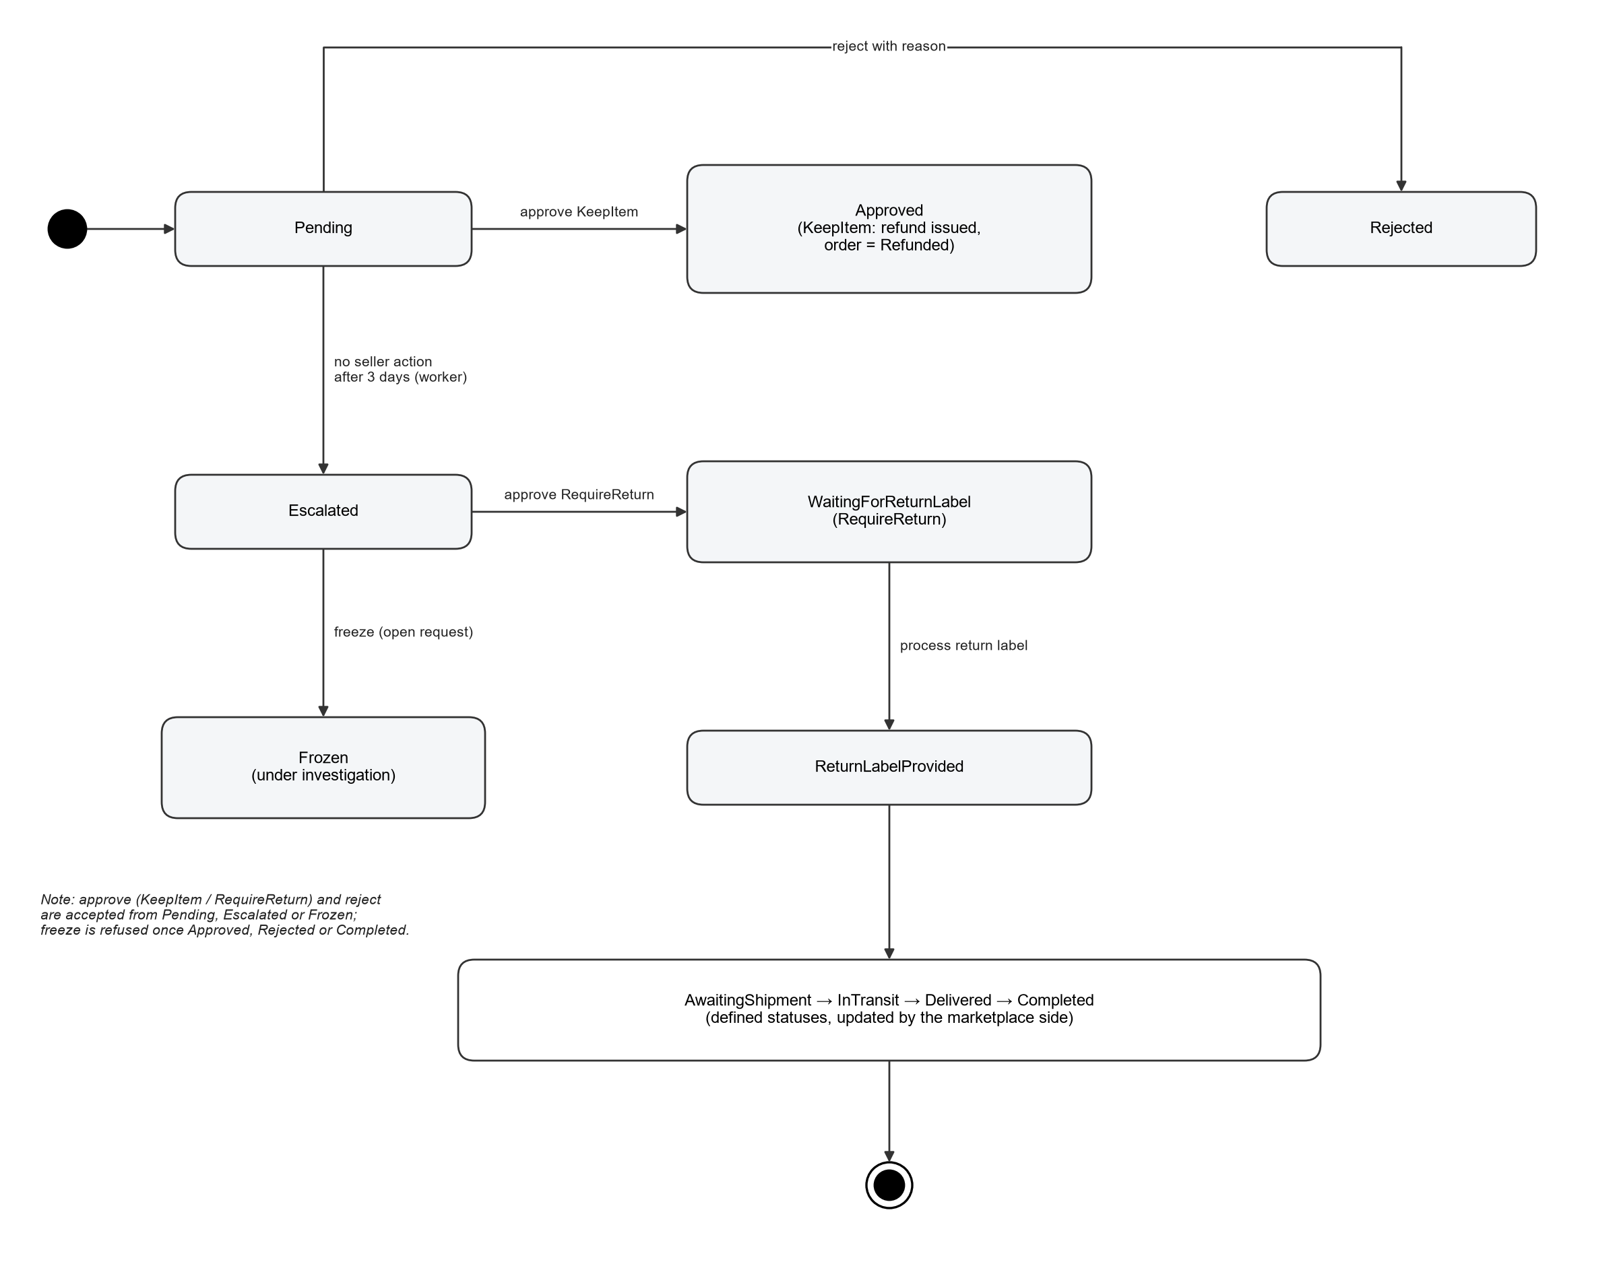
Figure 13. Return request states handled by the Admin Panel.
Pending requests that the seller does not handle within 3 days are escalated by ReturnRequestEscalationService. Staff can approve with KeepItem (refund immediately, order becomes Refunded, seller wallet debited and a refund PayoutTransaction recorded) or RequireReturn (WaitingForReturnLabel → ReturnLabelProvided after a label URL is entered), reject with a note, or freeze a suspicious request for investigation.

1.5.5. Settlement and payout
SettlementBackgroundService moves seller earnings of completed orders from Pending to Available after the holding period (or an Administrator settles an order manually). PayoutEngineBackgroundService (or POST /api/Financials/payouts/run) pays Available balances to the registered bank account through the mock gateway, skipping sellers with an active PayoutHoldUntil. Failed payouts appear as exceptions; holds can be released by an Administrator.

1.6. User Requirements and Role Permissions
Function (policy / rule) | Monitor | Support | Administrator | SuperAdmin
Dashboard (ViewDashboard) | Yes | Yes | No | Yes
Statistical reports + export (ViewReports) | Yes | No | No | Yes
Users, sellers, seller levels (ManageUsers) | No | Yes | Yes | Yes
Product moderation (ManageProducts) | No | Yes | Yes | Yes
Global orders, return requests (ManageOrders) | No | Yes | Yes | Yes
Disputes + /hubs/dispute (ManageDisputes) | No | Yes | Yes | Yes
Review moderation (ModerateReviews) | No | Yes | Yes | Yes
Broadcasts (ManageBroadcasts) | No | Yes | Yes | Yes
Fees, settlement, payouts, wallets (role Administrator/SuperAdmin) | No | No | Yes | Yes
Admin roles and admin accounts (ManageAdminRoles) | No | No | No | Yes
Audit logs (ViewAuditLogs) | No | No | No | Yes
Sensitive logs + decrypt | No | No | No | Yes
IP blocks, active connections (role SuperAdmin) | No | No | No | Yes
Simulation toolbox (ManageUsers; money endpoints SuperAdmin; disabled in Production) | No | Partly | Partly | Yes

Policies ViewDashboard … ManageBroadcasts can also be granted to a custom admin role. Every admin API additionally requires the internal IP allow-list AND an account with 2FA enabled (R-A10). Known UI gap: the React routes for users, products, reviews, disputes, return requests and the payout engine currently admit only SuperAdmin/Support (orders also Administrator), so an Administrator reaches those functions through the API but not yet through every page.

1.7. System Functionalities & Requirement Inventory
ID | Requirement [R] | Module | Implementation in code
R-A01 | Dashboard: totals of users/products/orders | Dashboard | GET /api/Dashboard/metrics, GET /api/Stats/dashboard; metric cards and pending-work lists.
R-A02 | User management: approve, lock/unlock | Users | Approve/reject, ban/unban with reason, status change, lift restrictions, user detail.
R-A03 | Product moderation: hide/remove violation | Products | Reported products, violation details, Delete & Warn / Hide / Ignore report / Restore.
R-A04 | View/manage all system orders | Orders | Paged order list, summary, order detail.
R-A05 | Daily/monthly/quarterly statistics | Stats | Revenue, orders and new-user reports by period; Excel/PDF export.
R-A06 | Monitor Review and Feedback | Reviews | Flagged reviews, statistics, seller feedback, Keep / Hide decision.
R-A07 | Dispute review/assignment/adjudication | Disputes | Docket, statistics, detail, assign, resolve (Buyer/Seller/Split), realtime hub.
R-A08 | Return/refund approval | Returns | Approve (KeepItem/RequireReturn), adjudicate, return label, reject, freeze.
R-A09 | Email alert/broadcast | Broadcasts | Audience All/Buyer/Seller/Group, channels Email/InApp, schedule, history, read state.
R-A10 | Admin panel: internal IP OR 2FA | Auth | Implemented stricter: internal IP allow-list AND mandatory TOTP 2FA.
R-A11 | Fine-grained admin role permissions | AdminRoles | Policies per module, custom roles with permission lists, admin accounts.
R-A12 | Extend dashboard metrics | Dashboard | Metrics computed by query handlers; new cards added without API changes to existing ones.
R-A13 | Encrypt sensitive audit separately | SensitiveLogs | SensitiveDataLog encrypted with AES-GCM; decrypt only by SuperAdmin and audited.
R-A14 | User-friendly Admin UI | UX | React SPA with search, filters, pagination, confirmations, toasts and role-aware menu.
R-N01 | Load balance using Nginx | Operations | Nginx upstream to 2 API replicas; Redis SignalR backplane.
R-N02 | Rate limit by user/window | Security | Strict 5/min/IP (auth), standard 60/min/IP, authenticated 200/min/user (sliding window); 429.
R-N03 | CI/CD Jenkins, GitHub Actions | DevOps | GitHub Actions CI (build + unit/domain/functional tests) and CD (Docker image to GHCR). Jenkins not used.
R-N04 | Jira team management | Project | Team tasks tracked in the project board (ClickUp/Jira) by requirement ID.
R-N05 | JMeter load/security tests | Testing | tests/jmeter/plans: login smoke, brute force, dashboard, paging, dispute detail, IP allow-list, 2FA, RBAC.
R-N06 | K8s zero-downtime updates | Deployment | k8s/api-deployment.yaml: 2 replicas, RollingUpdate maxUnavailable 0 / maxSurge 1, readiness probe.

ID | Implemented extension [C] | Module | Implementation in code
X-01 | Self-registration with captcha and email OTP | Auth | register, verify-email, resend-email-code, captcha-config; KYC fields for sellers.
X-02 | Account linking and risk score | Users/Risk | UserIdentifiers (HMAC), RiskOptions weights, auto approve/review/reject.
X-03 | Account standing gate and selling limits | Users/Risk | Blocks listing/review/report/cash-out until approved; 90-day limits (10 listings ≤ 500, risky 3 ≤ 100); payout holds.
X-04 | Sign-in history, new device and lockout | Auth | LoginHistory with NewDevice/Datacenter/ImpossibleTravel flags; 10 password / 5 TOTP failures in 15 min → 15-min lock.
X-05 | AI content moderation | Products/Reviews | OpenAiModerationService on product and review creation; fallback to manual review.
X-06 | Categories | Catalog | GET /api/Categories.
X-07 | Seller levels and performance | Users | TopRated / AboveStandard / BelowStandard; criteria, metrics and evaluation job.
X-08 | Finance: fees, settlement, payouts, wallets | Financials | Platform fees, settlement orders, payout engine with mock bank, history, exceptions, config, revenue report, wallets.
X-09 | Seller payout bank account | Account | PUT /api/Account/bank-account (Seller); 48-hour payout hold after a change.
X-10 | IP blocking and active connections | SystemAdmin | Block / lift IP ranges, list active IPs (SuperAdmin).
X-11 | Realtime notifications | Hubs | /hubs/notifications (any user), /hubs/dispute (ManageDisputes), /hubs/seller (ManageUsers).
X-12 | Simulation toolbox | Mocking | Generate users, orders, disputes, returns, defects; accelerate settlement; push payout. Disabled in Production.

1.8. Screen Authorization and Major UI Screens
Route (React) | Allowed roles / policy | Main functions
/login, /register | Public | Sign in (with 2FA step), create Buyer/Seller account, verify email.
/enable2FA | Logged in, 2FA not yet set | QR code / secret, verify first TOTP code.
/, /dashboard | SuperAdmin, Support, Monitor (ViewDashboard) | Metric cards, charts, report tabs and export (ViewReports).
/users, /users/:userId | SuperAdmin, Support (ManageUsers) | Search/filter users, approve/reject, ban/unban, status, lift restrictions, risk details.
/sellers | SuperAdmin, Support (ManageUsers) | Seller metrics, levels, criteria, evaluation.
/products | SuperAdmin, Support (ManageProducts) | Reported products, violation details, moderation actions.
/review-monitoring | SuperAdmin, Support (ModerateReviews) | Flagged reviews, statistics, seller feedback, Keep/Hide.
/orders | SuperAdmin, Support, Administrator (ManageOrders) | Global orders, summary, detail.
/return-requests, /return-requests/:id | SuperAdmin, Support (ManageOrders) | Queue, detail, messages, approve, label, reject, freeze.
/disputes, /disputes/:id, /disputes/dashboard | SuperAdmin, Support (ManageDisputes) | Docket, analytics, evidence, assign, resolve.
/broadcasts | SuperAdmin, Support (ManageBroadcasts) | Compose, schedule, history.
/payout-engine, /sellers/pending/:sellerId | SuperAdmin | Run payouts, history, exceptions, config, seller pending funds.
/admin-roles | SuperAdmin | Roles, permissions, admin accounts, assignment.
/audit-logs, /sensitive-logs | SuperAdmin | Audit search and summary; sensitive log list and decrypt.
/active-connections | SuperAdmin | Active IPs, IP blocks.
/mock | SuperAdmin | Simulation toolbox.
/seller-products, /seller-bank-account | Seller (products also SuperAdmin, Support) | Own products CRUD; payout bank account.
/home, /product/:id | Public | Storefront preview and product detail.

1.9. Logical Entity Relationship Model
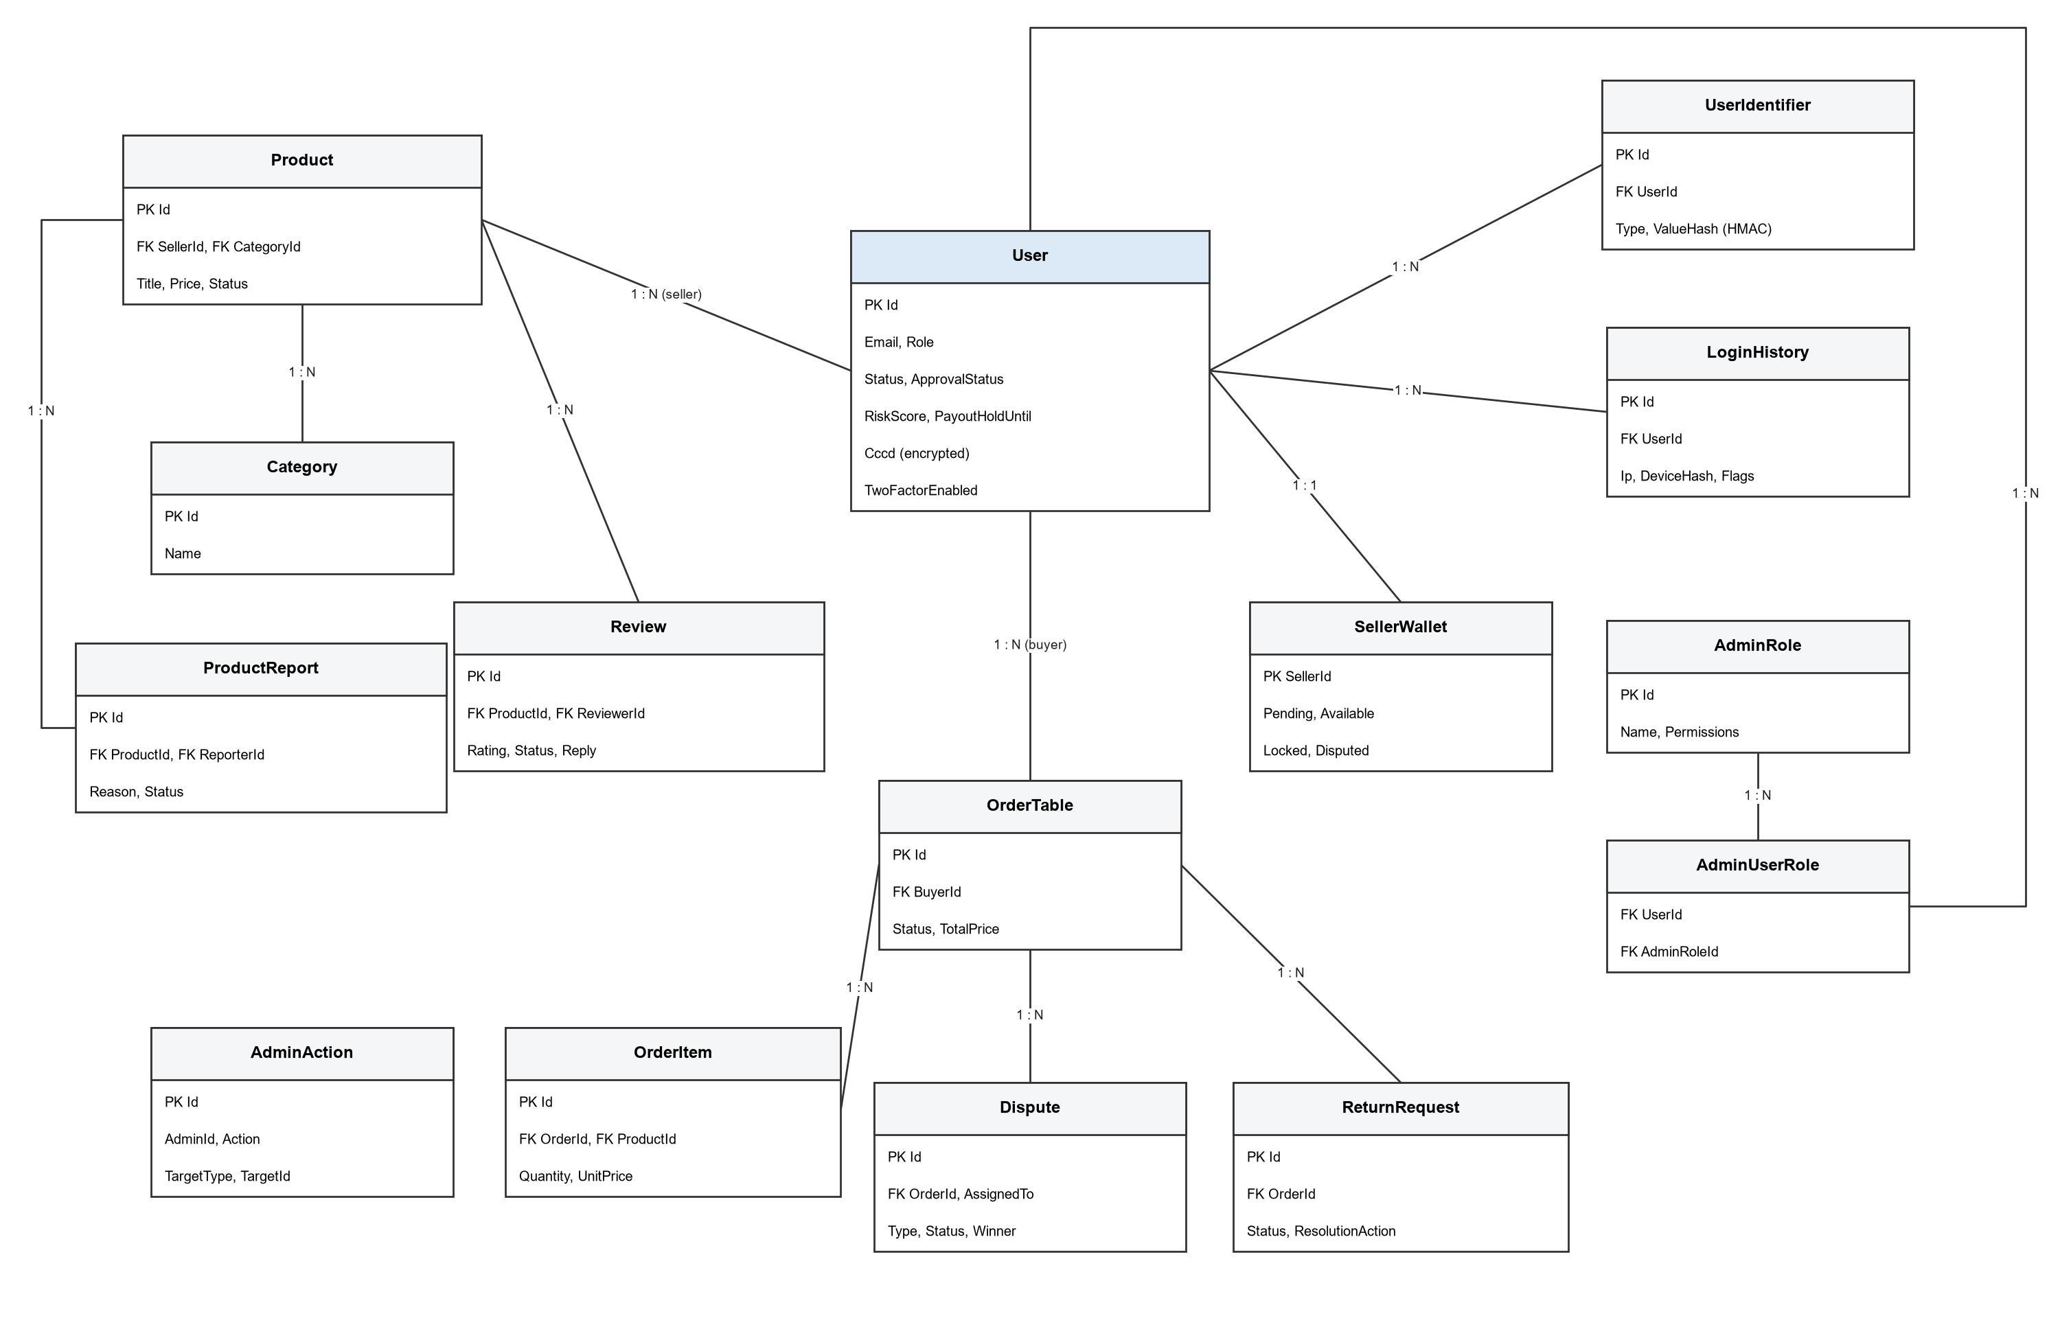
Figure 14. Core entities and relationships (simplified).
All entities exist in the EF Core model (src/Domain/Entities). Other tables not drawn: Address, ShippingInfo, Payment, Inventory, Coupon, Bid, Message, Notification, UserNotificationRead, DisputeMessage, ReviewReport, Feedback, Store, FinancialTransaction, PlatformFee, PayoutConfig, PayoutTransaction, WithdrawalRequest, SellerLevelCriteria, IpBlock, SensitiveDataLog.

2. USE CASE SPECIFICATIONS
Each use case follows the SRS template: actors, description, preconditions, postconditions, normal flow, alternative flows and business rules. All staff use cases share these preconditions: the request comes from an internal IP, the account is active and has 2FA enabled, and the JWT session is valid.

2.1. UC-01 — Register Account
Field | Specification
Primary actors | Guest
Secondary actors | Captcha Service, Email Service
Description | A guest creates a Buyer or Seller account. Trace: X-01, X-02.
Preconditions | Registration form is open; captcha-config loaded.
Postconditions | Account saved with Status = Unverified and an email OTP sent.
Normal flow | 1. Guest enters email, password, name, phone, role (Seller: CCCD, date of birth, address).  2. System verifies the Turnstile token.  3. System validates format, CCCD and age ≥ 18 for sellers.  4. System stores the account (CCCD encrypted + HMAC lookup) and identifiers.  5. System emails a 6-digit OTP.
Alternative / exception flows | Invalid captcha / data / duplicate email: 400 with field errors. Rate limit exceeded: 429 (MSG-04).
Business rules | BR-13, BR-14. Passwords hashed with BCrypt; OTP stored as HMAC only.

2.2. UC-02 — Verify Email (OTP)
Field | Specification
Primary actors | Guest
Secondary actors | Email Service
Description | The guest confirms the email address with the OTP; includes Resend Email Code. Trace: X-01.
Preconditions | Account is Unverified.
Postconditions | Status = Pending; account queued for the risk review.
Normal flow | 1. Guest enters email and code.  2. System checks the HMAC, expiry and attempt counter.  3. System sets EmailVerifiedAt and Status = Pending.
Alternative / exception flows | Wrong or expired code: generic message (MSG-15); too many attempts: request a new code with resend-email-code.
Business rules | Responses never reveal whether an email exists.

2.3. UC-03 — Login and Verify 2FA
Field | Specification
Primary actors | Guest (any account)
Secondary actors | —
Description | Sign in with email/password, then the TOTP code when 2FA is enabled. Trace: R-A10, R-N02, X-04.
Preconditions | Account exists, email verified; for staff the client IP is in InternalIps.
Postconditions | JWT issued in HttpOnly cookie auth_token; LoginHistory recorded.
Normal flow | 1. User submits email and password.  2. System checks lockout, password and account status.  3. If 2FA is enabled the UI asks for the TOTP code (verify-2fa).  4. System validates the one-time code and issues the session.  5. UI opens the page allowed for the role.
Alternative / exception flows | Wrong password: 401 (MSG-13); 10 wrong passwords or 5 wrong codes in 15 min: account locked 15 min (MSG-12); unverified email: MSG-11; external IP: 403; no 2FA yet: limited session → UC-04.
Business rules | Lockout is per account across all IPs; TOTP code can be used once per 30-second window.

2.4. UC-04 — Set Up Two-Factor Authentication
Field | Specification
Primary actors | Authenticated User
Secondary actors | —
Description | Enable TOTP 2FA; includes Verify 2FA Setup Code. Trace: R-A10.
Preconditions | Logged in without 2FA (limited session).
Postconditions | TwoFactorEnabled = true; full access according to the role.
Normal flow | 1. User opens /enable2FA.  2. System returns a secret and QR code (enable-2fa).  3. User scans it and enters the first code.  4. System verifies (verify-2fa-setup) and enables 2FA.
Alternative / exception flows | Wrong code: 400, 2FA stays disabled.
Business rules | Until 2FA is enabled only /me, logout, enable-2fa and verify-2fa-setup are allowed.

2.5. UC-05 — View Own Profile / Logout
Field | Specification
Primary actors | Authenticated User
Secondary actors | —
Description | Read the current identity and end the session. Trace: R-A10, R-A11.
Preconditions | Valid session.
Postconditions | Logout revokes the token id (jti) and clears the cookie.
Normal flow | 1. UI calls GET /api/Auth/me to build the menu.  2. User clicks Logout.  3. System revokes the jti and deletes the cookie.
Alternative / exception flows | Expired/revoked token, banned user or changed role: 401 on the next request (MSG-01).
Business rules | Session is re-validated on every request (SessionValidation).

2.6. UC-06 — View Active Broadcasts / Receive Notifications
Field | Specification
Primary actors | Authenticated User
Secondary actors | —
Description | Read active in-app broadcasts, mark them as read and receive realtime notifications. Trace: R-A09, X-11.
Preconditions | Valid session.
Postconditions | UserNotificationRead stored per user.
Normal flow | 1. UI calls GET /api/Broadcasts/active.  2. UI connects to /hubs/notifications.  3. User opens a broadcast; UI calls POST /api/Broadcasts/active/{id}/read.
Alternative / exception flows | Broadcast not targeted to the user: not listed.
Business rules | Read state is per recipient (BR-10).

2.7. UC-07 — Write Product Review
Field | Specification
Primary actors | Buyer
Secondary actors | AI Provider
Description | Buyer rates and comments on a product. Trace: R-A06, X-05.
Preconditions | Buyer account in good standing (approved, not suspended/banned).
Postconditions | Review stored as Visible or PendingReview.
Normal flow | 1. Buyer submits rating and comment (POST /api/reviews).  2. System checks account standing.  3. AI moderation classifies the text.  4. System stores the review; seller feedback is recalculated.
Alternative / exception flows | Account not approved: 400; AI flags content or reviewer is linked to the seller: review stored as PendingReview for staff.
Business rules | BR-15, BR-17. Reviewer id is taken from the session.

2.8. UC-08 — Report Product / Report Review
Field | Specification
Primary actors | Buyer
Secondary actors | —
Description | Report a listing or a review for moderation. Trace: R-A03, R-A06.
Preconditions | Logged in, account in good standing.
Postconditions | ProductReport / ReviewReport created with server-side priority.
Normal flow | 1. Buyer chooses a reason (POST /api/Products/reports or /api/reviews/{id}/report).  2. System checks standing and duplicates.  3. System stores the report and increases the report counter.
Alternative / exception flows | Duplicate pending report by the same user: not counted again.
Business rules | At most one Pending report per user and product.

2.9. UC-09 — Create Product
Field | Specification
Primary actors | Seller
Secondary actors | AI Provider
Description | Seller publishes a listing. Trace: X-03, X-05.
Preconditions | Seller approved, no active listing restriction.
Postconditions | Product stored (seller = current user).
Normal flow | 1. Seller fills title, category, price, stock, images (POST /api/Products).  2. System checks standing and new-account selling limits.  3. AI moderation checks the content.  4. System saves the product.
Alternative / exception flows | Limit exceeded (e.g. > 10 active listings or price > 500 in the first 90 days): 400; AI rejects content: 400 with reason.
Business rules | BR-15, BR-16.

2.10. UC-10 — Update / Delete Own Product
Field | Specification
Primary actors | Seller
Secondary actors | —
Description | Seller edits or removes own listings from /seller-products. Trace: X-03.
Preconditions | Seller owns the product.
Postconditions | Product updated or deleted.
Normal flow | 1. Seller opens own products (GET /api/Products/seller/{sellerId}).  2. Seller edits (PUT /api/Products/{id}) or deletes (DELETE /api/Products/{id}).
Alternative / exception flows | Not the owner: 403/404; price change above the limit: 400.
Business rules | Handler checks ownership on the server.

2.11. UC-11 — Reply to Review
Field | Specification
Primary actors | Seller
Secondary actors | —
Description | Seller answers a review of own product. Trace: R-A06.
Preconditions | Review belongs to the seller's product.
Postconditions | SellerReply saved.
Normal flow | 1. Seller writes a reply (POST /api/reviews/{id}/reply).  2. System checks ownership and saves.
Alternative / exception flows | Not the owner: rejected.
Business rules | —

2.12. UC-12 — Register Payout Bank Account
Field | Specification
Primary actors | Seller
Secondary actors | —
Description | Seller sets the bank account used for payouts. Trace: X-09.
Preconditions | Seller logged in.
Postconditions | Bank data encrypted; 48-hour payout hold when an existing account is changed.
Normal flow | 1. Seller opens /seller-bank-account.  2. Seller enters bank name, account number, account name (PUT /api/Account/bank-account).  3. System encrypts and stores the data and updates identifiers.
Alternative / exception flows | Invalid data: 400.
Business rules | Payouts go only to the registered account (BR-16).

2.13. UC-13 — View Admin Dashboard
Field | Specification
Primary actors | Monitor, Support, SuperAdmin
Secondary actors | —
Description | Overview of users, products, orders, revenue and pending work. Trace: R-A01, R-A12.
Preconditions | ViewDashboard policy.
Postconditions | No data change.
Normal flow | 1. Staff opens /dashboard.  2. UI calls GET /api/Dashboard/metrics and GET /api/Stats/dashboard.  3. UI shows cards, charts and links to pending queues.
Alternative / exception flows | No permission: 403 (MSG-02).
Business rules | —

2.14. UC-14 — View Statistical Reports and Export
Field | Specification
Primary actors | Monitor, SuperAdmin
Secondary actors | —
Description | Revenue, orders and new users by day/month/quarter, exported to Excel or PDF. Trace: R-A05.
Preconditions | ViewReports policy.
Postconditions | Report file generated on the client.
Normal flow | 1. Staff chooses period and range.  2. UI calls /api/Stats/reports/revenue, /orders, /users.  3. Staff exports the result.
Alternative / exception flows | Invalid range: 400.
Business rules | Same period boundaries for charts and exports (BR-09).

2.15. UC-15 — View / Filter Users
Field | Specification
Primary actors | Support, Administrator, SuperAdmin
Secondary actors | —
Description | Search, filter and page users; open user detail with risk data. Trace: R-A02, R-A14.
Preconditions | ManageUsers.
Postconditions | No data change.
Normal flow | 1. Staff opens /users and filters by role, status, approval.  2. UI calls GET /api/Users and /api/Users/summary.  3. Staff opens /users/{id}.
Alternative / exception flows | —
Business rules | Sensitive values are masked.

2.16. UC-16 — Approve / Reject User
Field | Specification
Primary actors | Support, Administrator, SuperAdmin
Secondary actors | Email Service
Description | Decide a PendingApproval account (extends UC-15). Trace: R-A02, X-02.
Preconditions | User is PendingApproval.
Postconditions | ApprovalStatus Approved or Rejected; AdminAction logged; payout hold 30 days if the risk score ≥ 30.
Normal flow | 1. Staff reviews risk score and linked accounts.  2. Staff approves (POST /api/Users/{id}/approve) or rejects with a reason (POST /api/Users/{id}/reject).  3. System updates the account, logs the action and notifies the user.
Alternative / exception flows | User already decided: 400.
Business rules | BR-01, BR-02.

2.17. UC-17 — Ban / Unban User, Change Status
Field | Specification
Primary actors | Support, Administrator, SuperAdmin
Secondary actors | —
Description | Lock or unlock an account, or set Active / Pending / Suspended (extends UC-15). Trace: R-A02.
Preconditions | ManageUsers.
Postconditions | Status changed; sessions of a banned user rejected; AdminAction logged.
Normal flow | 1. Staff chooses Ban with a reason (POST /api/Users/{id}/ban), Unban (POST …/unban) or a new status (PUT …/status).  2. System validates and saves.
Alternative / exception flows | User has open orders: ban refused with a message; invalid status: 400.
Business rules | History of orders and payments is never deleted (BR-03).

2.18. UC-18 — Lift Account Restrictions
Field | Specification
Primary actors | Support, Administrator, SuperAdmin
Secondary actors | —
Description | Remove automatic listing restriction and payout hold (extends UC-15). Trace: X-03.
Preconditions | User has ProductBanUntil or PayoutHoldUntil.
Postconditions | Both fields cleared; sensitive log written.
Normal flow | 1. Staff clicks Lift restrictions (POST /api/Users/{id}/lift-restrictions).
Alternative / exception flows | —
Business rules | Only reverses automatic steps 2–3 of the enforcement ladder.

2.19. UC-19 — Manage Seller Levels
Field | Specification
Primary actors | Support, Administrator, SuperAdmin
Secondary actors | —
Description | View seller metrics, edit level criteria and run the evaluation (includes Evaluate Seller Performance). Trace: X-07.
Preconditions | ManageUsers.
Postconditions | Seller levels updated.
Normal flow | 1. Staff opens /sellers (GET /api/Users/seller-metrics).  2. Staff edits criteria (PUT /api/Users/seller-level-criteria).  3. Staff runs POST /api/Users/evaluate-sellers (also run by the background job).
Alternative / exception flows | —
Business rules | Levels: TopRated, AboveStandard, BelowStandard.

2.20. UC-20 — Moderate Reported Products
Field | Specification
Primary actors | Support, Administrator, SuperAdmin
Secondary actors | Email Service
Description | Decide on reported or flagged listings. Trace: R-A03.
Preconditions | ManageProducts.
Postconditions | Product status updated, reports closed, seller notified.
Normal flow | 1. Staff opens /products (GET /api/Products/managed).  2. Staff opens violation details.  3. Staff resolves with Delete & Warn, Hide, Ignore report (Reject) or Restore (POST /api/Products/managed/{id}/resolve-violation).
Alternative / exception flows | Product not found: 404.
Business rules | Delete & Warn is a soft delete (Status = Banned); order history is kept.

2.21. UC-21 — Moderate Reviews
Field | Specification
Primary actors | Support, Administrator, SuperAdmin
Secondary actors | Email Service
Description | Handle flagged reviews and monitor seller feedback. Trace: R-A06.
Preconditions | ModerateReviews.
Postconditions | Review Visible or Hidden; feedback recalculated.
Normal flow | 1. Staff opens /review-monitoring (flagged, statistics, seller-feedbacks).  2. Staff chooses Keep or Hide (PUT /api/reviews/{id}/status).
Alternative / exception flows | —
Business rules | Hiding notifies the reviewer once.

2.22. UC-22 — View Global Orders
Field | Specification
Primary actors | Support, Administrator, SuperAdmin
Secondary actors | —
Description | Search and inspect all orders. Trace: R-A04.
Preconditions | ManageOrders.
Postconditions | No data change.
Normal flow | 1. Staff opens /orders (GET /api/Orders, /summary).  2. Staff opens an order (GET /api/Orders/{id}).
Alternative / exception flows | —
Business rules | —

2.23. UC-23 — Handle Return Requests
Field | Specification
Primary actors | Support, Administrator, SuperAdmin
Secondary actors | —
Description | Approve (KeepItem / RequireReturn), provide a return label, reject or freeze. Trace: R-A08.
Preconditions | ManageOrders; request is Pending, Escalated or Frozen.
Postconditions | Status updated; refund and wallet movement for KeepItem; AdminAction logged.
Normal flow | 1. Staff opens /return-requests and a request (detail, messages).  2. Staff approves or adjudicates (POST …/approve or …/adjudicate) with a resolution.  3. For RequireReturn staff adds a label URL (POST …/return-label).  4. Or staff rejects (POST …/reject) or freezes (POST …/freeze) with a note.
Alternative / exception flows | Wrong state: 400; freeze refused once Approved, Rejected or Completed.
Business rules | Approval of a return is not the same as a completed refund (BR-04).

2.24. UC-24 — Handle Disputes
Field | Specification
Primary actors | Support, Administrator, SuperAdmin
Secondary actors | Email Service
Description | Review evidence, assign and resolve disputes. Trace: R-A07.
Preconditions | ManageDisputes.
Postconditions | Dispute Resolved with winner, refund and notes; parties notified; hub updated.
Normal flow | 1. Staff opens /disputes (docket, statistics).  2. Staff opens a case and assigns it (POST /api/Disputes/{id}/assign).  3. Staff resolves (POST /api/Disputes/{id}/resolve) with Winner Buyer/Seller/Split, refund amount, notes and options.
Alternative / exception flows | Already Resolved/Closed: 400; Buyer/Split without refund amount: 400.
Business rules | Resolve happens once (BR-11); financial effects and audit in one transaction (BR-04).

2.25. UC-25 — Send / Schedule Broadcast
Field | Specification
Primary actors | Support, Administrator, SuperAdmin
Secondary actors | Email Service
Description | Send a message to All, Buyer, Seller or a Group via Email and/or InApp, now or later. Trace: R-A09.
Preconditions | ManageBroadcasts.
Postconditions | Notification stored (Sent or Scheduled); emails sent; history updated.
Normal flow | 1. Staff composes title, content, audience and channels.  2. Staff sends (POST /api/Broadcasts) or schedules (POST /api/Broadcasts/schedule).  3. ScheduledBroadcastService sends scheduled items on time.  4. Staff reviews history (GET /api/Broadcasts).
Alternative / exception flows | No channel or invalid channel: 400.
Business rules | —

2.26. UC-26 — Manage Fees, Settlement and Payouts
Field | Specification
Primary actors | Administrator, SuperAdmin
Secondary actors | Payment Gateway
Description | Configure platform fees, settle orders, run the payout engine, release holds, view history/exceptions and seller wallets. Trace: X-08.
Preconditions | Role Administrator or SuperAdmin.
Postconditions | Wallets and payout transactions updated.
Normal flow | 1. Admin updates fees (PUT /api/Financials/fees).  2. Admin triggers settlement or settles one order.  3. Admin runs payouts (POST /api/Financials/payouts/run).  4. Admin reviews history, exceptions and wallets (GET /api/Wallets) and releases holds.
Alternative / exception flows | Seller on payout hold or without bank account: skipped and listed as exception.
Business rules | No duplicate payout for the same funds (BR-05).

2.27. UC-27 — Manage Admin Roles and Accounts
Field | Specification
Primary actors | SuperAdmin
Secondary actors | —
Description | Create roles with permission lists, create admin accounts and assign roles. Trace: R-A11.
Preconditions | ManageAdminRoles.
Postconditions | Roles and assignments saved; affected sessions re-validated.
Normal flow | 1. SuperAdmin opens /admin-roles.  2. Creates or updates a role (POST/PUT /api/AdminRoles/roles).  3. Creates an admin user (POST …/users) and assigns a role (POST …/users/assign).
Alternative / exception flows | Duplicate role name: 400.
Business rules | Permission changes take effect on the next request.

2.28. UC-28 — View Audit Logs
Field | Specification
Primary actors | SuperAdmin
Secondary actors | —
Description | Search admin actions by admin, entity and time. Trace: R-A13.
Preconditions | ViewAuditLogs.
Postconditions | No data change.
Normal flow | 1. SuperAdmin opens /audit-logs.  2. UI calls GET /api/AuditLogs, /summary, /admin/{adminId}, /entity/{type}/{id}.
Alternative / exception flows | —
Business rules | Audit actor comes from the session (BR-01).

2.29. UC-29 — View and Decrypt Sensitive Logs
Field | Specification
Primary actors | SuperAdmin
Secondary actors | —
Description | List encrypted sensitive logs and decrypt one entry. Trace: R-A13.
Preconditions | SuperAdmin; Security:EncryptionKey configured.
Postconditions | Decrypted value shown once; the decrypt itself is logged.
Normal flow | 1. SuperAdmin opens /sensitive-logs.  2. Selects an entry and clicks Decrypt (POST /api/sensitive-logs/{id}/decrypt).
Alternative / exception flows | Wrong key or tampered data: decrypt fails (MSG-10).
Business rules | BR-08.

2.30. UC-30 — Monitor Connections and Block IP
Field | Specification
Primary actors | SuperAdmin
Secondary actors | —
Description | See active IPs and block or lift IP ranges. Trace: X-10.
Preconditions | SuperAdmin.
Postconditions | IpBlock stored; blocked IPs rejected.
Normal flow | 1. SuperAdmin opens /active-connections (GET /api/SystemAdmin/active-ips).  2. Blocks a network for N days with a reason (POST …/ip-blocks) or lifts a block.
Alternative / exception flows | Invalid CIDR: 400.
Business rules | —

2.31. UC-31 — Use Simulation Toolbox
Field | Specification
Primary actors | SuperAdmin
Secondary actors | —
Description | Generate demo users, orders, disputes, returns and defects; accelerate settlement; push payouts. Trace: X-12.
Preconditions | Non-production environment.
Postconditions | Demo data created.
Normal flow | 1. SuperAdmin opens /mock.  2. Chooses a generator (POST /api/Mocking/…).
Alternative / exception flows | Production: endpoints disabled; money endpoints require SuperAdmin.
Business rules | For testing and demos only.

3. FUNCTIONAL REQUIREMENTS
Each requirement from 1.7 is broken into verifiable statements. Column "Status" shows the state of the source code at v1.2.

3.1. R-A01 — Dashboard
FR ID | The system shall… | Status
R-A01-F01 | The system shall show total users, products and orders with the time of calculation. | Implemented
R-A01-F02 | The system shall list pending work (users to approve, reported products, disputes, return requests) with links to the queues. | Implemented

3.2. R-A02 — User management
FR ID | The system shall… | Status
R-A02-F01 | The system shall search, filter and page users by role, status and approval. | Implemented
R-A02-F02 | The system shall approve or reject a pending account with a reason and record actor and time. | Implemented
R-A02-F03 | The system shall ban/unban and change status without deleting order or financial history; a ban is refused while the user has open orders. | Implemented

3.3. R-A03 — Product moderation
FR ID | The system shall… | Status
R-A03-F01 | The system shall show the product, its reports and the seller before a decision. | Implemented
R-A03-F02 | The system shall support Delete & Warn (soft delete), Hide, Ignore report and Restore. | Implemented
R-A03-F03 | The system shall notify the seller and write an audit entry for each decision. | Implemented

3.4. R-A04 — Global orders
FR ID | The system shall… | Status
R-A04-F01 | The system shall page and filter all orders and show order details. | Implemented

3.5. R-A05 — Statistics
FR ID | The system shall… | Status
R-A05-F01 | The system shall report revenue, orders and new users per day, month and quarter. | Implemented
R-A05-F02 | The system shall export reports to Excel and PDF. | Implemented

3.6. R-A06 — Reviews and feedback
FR ID | The system shall… | Status
R-A06-F01 | The system shall list flagged reviews and review statistics. | Implemented
R-A06-F02 | The system shall let staff keep or hide a review and update seller feedback. | Implemented
R-A06-F03 | The system shall run AI moderation on new reviews and fall back to manual review when the provider fails. | Implemented

3.7. R-A07 — Disputes
FR ID | The system shall… | Status
R-A07-F01 | The system shall list disputes with statistics, priority and deadlines. | Implemented
R-A07-F02 | The system shall assign a dispute to an admin. | Implemented
R-A07-F03 | The system shall resolve a dispute once with winner Buyer/Seller/Split, refund amount and notes. | Implemented

3.8. R-A08 — Returns and refunds
FR ID | The system shall… | Status
R-A08-F01 | The system shall approve a return as KeepItem (refund now) or RequireReturn (label first). | Implemented
R-A08-F02 | The system shall reject or freeze a request with a note. | Implemented
R-A08-F03 | The system shall escalate pending requests after 3 days without seller action. | Implemented

3.9. R-A09 — Broadcasts
FR ID | The system shall… | Status
R-A09-F01 | The system shall send a broadcast to All, Buyer, Seller or a Group by Email and/or InApp. | Implemented
R-A09-F02 | The system shall schedule broadcasts and keep per-user read state. | Implemented

3.10. R-A10 — Admin access gate
FR ID | The system shall… | Status
R-A10-F01 | The system shall reject requests from IPs outside InternalIps (403). | Implemented
R-A10-F02 | The system shall require TOTP 2FA before any business API is used. | Implemented
R-A10-F03 | The system shall lock an account for 15 minutes after 10 wrong passwords or 5 wrong TOTP codes within 15 minutes. | Implemented

3.11. R-A11 — Admin roles
FR ID | The system shall… | Status
R-A11-F01 | The system shall protect each module with a named policy. | Implemented
R-A11-F02 | The system shall let SuperAdmin create roles with permission lists and assign them to admins. | Implemented

3.12. R-A12 — Extensible dashboard
FR ID | The system shall… | Status
R-A12-F01 | New metrics shall be added as new query fields/cards without breaking existing ones. | Implemented

3.13. R-A13 — Sensitive audit
FR ID | The system shall… | Status
R-A13-F01 | The system shall store sensitive audit payloads encrypted with AES-GCM. | Implemented
R-A13-F02 | Only SuperAdmin shall decrypt, and every decrypt shall be logged. | Implemented

3.14. R-A14 — Usable UI
FR ID | The system shall… | Status
R-A14-F01 | The UI shall provide search, filters, pagination, confirmation dialogs and success/error messages. | Implemented

3.15. R-N01…R-N06 — Operations
FR ID | The system shall… | Status
R-N01-F01 | Nginx shall balance traffic across API replicas and pass the real client IP. | Implemented
R-N02-F01 | The API shall apply strict/standard/authenticated rate limits and return 429. | Implemented
R-N03-F01 | Every push/PR shall build and test in GitHub Actions; CD shall publish a Docker image. | Implemented (no Jenkins)
R-N04-F01 | Work items shall be tracked on the team board by requirement ID. | Process
R-N05-F01 | JMeter plans shall cover login, brute force, dashboard, paging, dispute detail, IP allow-list, 2FA and RBAC. | Implemented
R-N06-F01 | Kubernetes shall update the API with RollingUpdate (maxUnavailable 0, maxSurge 1) and readiness probes. | Implemented

3.16. X-01…X-04 — Registration and account security
FR ID | The system shall… | Status
X-01-F01 | Registration shall require a valid Turnstile token and email OTP before login. | Implemented
X-02-F01 | The system shall compute a risk score from HMAC identifiers and signals and approve/review/reject by threshold. | Implemented
X-03-F01 | Unapproved, suspended or banned accounts shall not list, review, report or cash out. | Implemented
X-03-F02 | New sellers shall be limited for 90 days (10 listings, price ≤ 500; risky: 3 listings, ≤ 100). | Implemented
X-04-F01 | The system shall record sign-in history with NewDevice, Datacenter and ImpossibleTravel flags; a takeover signal puts a 48-hour payout hold on sellers. | Implemented

4. NON-FUNCTIONAL REQUIREMENTS

4.1. External Interfaces
Interface | Technology | Contract / constraint
Web UI | React 18 SPA over HTTPS | JSON API, role-aware menu and route guards, SignalR client.
REST API | ASP.NET Core (.NET 10) Minimal API, /api/{Group} | JWT in HttpOnly cookie, policies, validation, ProblemDetails errors; Swagger at /api.
Database | SQL Server + EF Core 10 | Migrations only through EF CLI; no auto-migrate or auto-seed on startup.
Redis | SignalR backplane, revoked token ids | Required for multi-replica realtime.
SMTP | Gmail SMTP | OTP, broadcasts and notices; LogInsteadOfSending only outside Production.
AI moderation | OpenAI / OpenRouter | Assistive only; failures go to manual review.
Captcha | Cloudflare Turnstile | Server-side token verification on register.
Payment gateway | MockPaymentGatewayService | Simulated payouts; no live payment integration claimed.
IP intelligence | AWS/Google ranges, DB-IP | Refreshed by DatacenterRangesService; used as risk signals only.

4.2. Quality Attributes and Acceptance Method
ID | Category | Requirement | Verification
NFR-SEC01 | Security | Admin APIs enforce authentication, policy authorization, internal IP and 2FA. | Negative API tests and JMeter plans 10–12.
NFR-SEC02 | Security | CCCD, bank data and sensitive logs encrypted with AES-GCM; lookups use HMAC. | Round-trip and wrong-key tests; --migrate-sensitive-data dry run 0/0/0.
NFR-SEC03 | Security | Passwords (BCrypt), OTP (HMAC) and tokens are never logged in plain text. | Code review and log inspection.
NFR-SEC04 | Security | App refuses to start with a weak/known JWT key or dev-only flags in Production. | JwtKeyPolicy tests.
NFR-SEC05 | Security | Unexpected errors return 500 with a generic message; details only in logs. | CustomExceptionHandler tests.
NFR-SEC06 | Security | Hubs authorised by policy; /api/Mocking disabled in Production. | HTTP tests on hubs and mocking.
NFR-PER01 | Performance | Lists are paged and indexed; dashboard and paging endpoints stay responsive under load. | JMeter plans 02–04 (thresholds agreed by the team).
NFR-RATE01 | Abuse protection | Rate limits per IP/user with 429. | JMeter 01 and functional tests.
NFR-AVL01 | Availability | API rolling update without dropping requests. | scripts/ rolling-update demo with continuous traffic.
NFR-DAT01 | Data integrity | Dispute/return/payout financial changes are saved in one transaction and cannot run twice. | Functional tests on resolve/approve/payout.
NFR-UX01 | Usability | Core admin flows have feedback, confirmations, empty and error states. | Walkthrough review.
NFR-OPS01 | Recoverability | Database backups are usable only with the same Security:EncryptionKey. | Restore exercise (README-DATABASE.md §6).

5. REQUIREMENT APPENDIX

5.1. Business Rules
Rule | Business constraint
BR-01 | The audit actor comes from the authenticated session, never from a client field.
BR-02 | ApprovalStatus (PendingApproval/Approved/Rejected) and Status (Unverified/Pending/Active/Suspended/Banned) are separate dimensions.
BR-03 | Hiding/banning never deletes order, dispute or financial history.
BR-04 | Financial effects of dispute/return decisions and their audit entry are saved together.
BR-05 | A refund or payout must not be executed twice for the same funds.
BR-07 | CCCD lookup uses normalisation + HMAC, never a comparison of ciphertext.
BR-08 | Sensitive values are decrypted only at an authorised boundary and never returned by normal APIs or logs.
BR-09 | KPIs, charts and exports use the same periods and formulas.
BR-10 | Notification read state is stored per recipient.
BR-11 | State transitions are guarded; terminal states are not processed again.
BR-12 | Startup does not migrate, seed or repair data; background jobs are enabled on purpose.
BR-13 | Self-registered accounts must verify their email before login and risk review.
BR-14 | Re-used CCCD/bank/email/phone/device across accounts raises the risk score; links to banned accounts weigh more; IP/location alone never auto-rejects.
BR-15 | Accounts not approved, suspended or banned cannot list, review, report or withdraw.
BR-16 | Payouts go only to the registered bank account and not during a payout hold.
BR-17 | Reporter, reviewer and seller ids are taken from the session, not from the request body.
BR-18 | Secrets are injected at runtime and never committed; leaked keys must be rotated.

5.2. Status Vocabulary
Aggregate | Values (from code)
User.Status | Unverified, Pending, Active, Suspended, Banned
User.ApprovalStatus | PendingApproval, Approved, Rejected
Dispute.Status | Open, AwaitingSellerResponse, Negotiating, Escalated, AssignedToAdmin, UnderReview, Resolved, Closed
Dispute.Type / Winner | INR, INAD, Damaged, Counterfeit, Other / Buyer, Seller, Split
ReturnRequest.Status | Pending, Approved, AwaitingShipment, InTransit, Delivered, Completed, Rejected, Escalated, WaitingForReturnLabel, ReturnLabelProvided, Frozen
Return resolution | KeepItem, RequireReturn
Product moderation action | DeleteAndWarn, Hide, Reject (ignore report), Restore
Review.Status | Visible, Hidden, PendingReview (e.g. FlagReason = LinkedToSeller)
Broadcast | Audience All/Buyer/Seller/Group; channels Email/InApp; status Sent/Scheduled
Seller level | TopRated, AboveStandard, BelowStandard

5.3. System Messages
ID | Trigger | Message
MSG-01 | 401 | Your session has expired or is invalid. Please sign in again.
MSG-02 | 403 | You do not have permission to perform this action.
MSG-04 | 429 | Too many requests. Please try again later.
MSG-05 | User decision saved | The decision has been saved and recorded in the history.
MSG-10 | Decrypt denied/failed | This data cannot be opened under the current permissions or key.
MSG-11 | Login before email verification | Please verify your email before signing in.
MSG-12 | Account lockout | This account is temporarily locked after too many failed attempts. Try again in 15 minutes.
MSG-13 | Wrong credentials | Incorrect email or password.
MSG-14 | 500 | A system error occurred. Please try again later.
MSG-15 | verify-email / resend-email-code | Generic message that does not reveal whether the email exists.
MSG-16 | Payout without bank account | Register a bank account before requesting a payout.

5.4. Business Data Requirements
Entity | Required information
User | Email, password hash, role, Status, ApprovalStatus, ban metadata, 2FA secret, encrypted CCCD + lookup hash, RiskScore, RiskCheckedAt, PayoutHoldUntil, ProductBanUntil, email OTP fields, seller level.
UserIdentifier | UserId, Type (Cccd/Email/Phone/Bank/Address/Ip/Geo/Device), ValueHash (HMAC); unique (UserId, Type, ValueHash).
LoginHistory | UserId, IP, device hash, location, flags, time; kept 180 days.
Product, ProductReport, Category | Seller, category, price, status; report reason, reporter, status.
OrderTable, OrderItem, Payment, ShippingInfo | Buyer, items, totals, status, delivery data.
Review, ReviewReport, Feedback | Rating, comment, status, seller reply; aggregated seller reputation.
Dispute, DisputeMessage | Type, status, priority, assignee, evidence, winner, refund, messages.
ReturnRequest | Reason, status, resolution action, label, admin note.
Notification, UserNotificationRead | Audience, channel, schedule, status; per-user read time.
AdminRole, AdminUserRole, AdminAction | Roles, permissions, assignments; append-only audit entries.
SensitiveDataLog | Actor, action, target, encrypted payload.
SellerWallet, FinancialTransaction, PlatformFee, PayoutTransaction, PayoutConfig | Balances, ledger entries, fees, payouts, payout settings.
IpBlock | Network, reason, expiry.

5.5. Acceptance Scenarios
AC | Related IDs | Expected behaviour
AC-01 | R-A01/R-A05/R-A12 | Dashboard and reports show correct totals for the chosen period; export matches the screen.
AC-02 | R-A02 | Support approves/bans a user with a reason; action is audited; order history remains.
AC-03 | R-A03 | Hide/Restore a product; reports and orders still exist.
AC-04 | R-A04 | Order list filters and detail work for permitted roles only.
AC-05 | R-A06 | Hiding a review updates seller feedback; AI failure leaves the review for manual review.
AC-06 | R-A07 | A resolved dispute cannot be resolved again; refund recorded once.
AC-07 | R-A08 | KeepItem refunds immediately; RequireReturn waits for the label; freeze blocks further action.
AC-08 | R-A09 | Broadcast reaches only the chosen audience; read state is per user.
AC-09 | R-A10/R-A11 | External IP → 403; no 2FA → limited session; missing policy → 403.
AC-10 | R-A13 | Sensitive log decrypts with the right key only; decrypt is logged.
AC-12 | R-N01/R-N02 | Two replicas behind Nginx; 429 per IP/user without cross-user impact.
AC-13 | R-N03 | CI runs build and tests on push; CD publishes the image.
AC-15 | R-N05 | JMeter reports contain real measured results.
AC-16 | R-N06 | Rolling update under continuous traffic completes without failed requests.
AC-25 | X-01 | Wrong captcha/CCCD/age rejected; unverified email cannot log in; correct OTP → Pending.
AC-26 | X-02 | Same CCCD as another account → score ≥ 80 → rejected; shared IP only → admin review.
AC-27 | X-03 | PendingApproval/Suspended account cannot list or review; listing over the new-seller limit → 400.
AC-28 | X-04 | 10 wrong passwords from different IPs → 15-minute lock even with the correct password.

5.6. Requirements Traceability Matrix
Requirement | Use cases | Acceptance | SDS section
R-A01, R-A12 | UC-13 | AC-01 | 3.2
R-A02 | UC-15–UC-18 | AC-02 | 3.3
R-A03 | UC-08, UC-20 | AC-03 | 3.4
R-A04 | UC-22 | AC-04 | 3.5
R-A05 | UC-14 | AC-01 | 3.2
R-A06 | UC-07, UC-11, UC-21 | AC-05 | 3.6
R-A07 | UC-24 | AC-06 | 3.7
R-A08 | UC-23 | AC-07 | 3.8
R-A09 | UC-06, UC-25 | AC-08 | 3.9
R-A10 | UC-03, UC-04, UC-05 | AC-09 | 1.5, 3.1
R-A11 | UC-27 | AC-09 | 3.10
R-A13 | UC-28, UC-29 | AC-10 | 3.11
R-A14 | all staff UCs | — | 1.2
R-N01, R-N02 | UC-03 | AC-12 | 3.14, 6
R-N03…R-N06 | — | AC-13–AC-16 | 6
X-01…X-04 | UC-01–UC-03, UC-09, UC-16, UC-18 | AC-25–AC-28 | 3.13
X-07 | UC-19 | — | 3.3
X-08, X-09 | UC-12, UC-26 | — | 3.12
X-10, X-12 | UC-30, UC-31 | — | 3.15

5.7. Future Scope (not implemented)
The following items were in the v1.1 design proposal but are not in the source code. They are not requirements of this release:
• VeRO / intellectual-property reporting by rights owners.
• Account appeal submission, independent appeal review and scoped restoration (planned as an MVP: banned/suspended users upload documents to appeal).
• Trust & Safety case management, case evidence store, fraud rule engine (shill bidding, ban evasion) and FraudInvestigator / IPReviewer / AppealReviewer roles.
• Transactional outbox for notifications and payment side effects.
• Withdrawal request API: the Application layer has Request/Approve/Reject withdrawal commands, but no HTTP endpoint exposes them yet.
• OTP by SMS, eKYC of the CCCD card and bank account verification (Napas).

