4차_이름_1.docx (문서이름)

1. 아래와 같이 EMP Table을 사용하여 부서별 MAX SAL,MIN SAL,AVG SAL(소수점 절삭),건수 그리고 전체 MAX SAL,MIN SAL,AVG SAL(소수점 절삭),건수를 구하시요.

( 1개는 Inline View를 통해 작성하고 1개는 Analytic Function을 사용하여 EMP Table 한번만 조회하도록 작성)

**inline View 사용**

select e1.EMPNO,

e1.ENAME,

e1.DEPTNO,

e1.SAL,

e3.MAX_DEPT_SAL,

e3.MIN_DEPT_SAL,

e3.AVG_DEPT_SAL,

e3.COUNT_DEPT,

e2.MAX_SAL,

e2.MIN_SAL,

e2.AVG_SAL,

e2.COUNT_ALL

from EMP e1,

(select e2.DEPTNO,MAX(e2.SAL)as MAX_SAL,

MIN(e2.SAL)as MIN_SAL,

count(e2.DEPTNO)as COUNT_ALL,

round(avg(e2.SAL))as AVG_SAL

from EMP e2)e2,

(select e3.DEPTNO,

max(e3.SAL)as MAX_DEPT_SAL,

MIN(e3.SAL)as MIN_DEPT_SAL,

count(e3.DEPTNO)as COUNT_DEPT,

round(avg(e3.SAL))as AVG_DEPT_SAL

from EMP e3

group by e3.DEPTNO)e3

where e1.DEPTNO=e3.DEPTNO

order by e1.DEPTNO

**Analytic Function 사용**

select EMPNO,

ENAME,

DEPTNO,

SAL,

max(sal)over(partition by DEPTNO)as MAX_DEPT_SAL,

min(sal)over(partition by DEPTNO)as MIN_DEPT_SAL,

round(avg(sal)over(partition by DEPTNO))as AVG_DEPT_SAL,

count(DEPTNO)over(partition by DEPTNO)as COUNT_DEPT,

max(sal)over()MAX_SAL,

min(sal)over()MIN_SLA,

round(avg(sal)over())AVG_SAL,

count(DEPTNO)over()COUNT_ALL

from EMP;

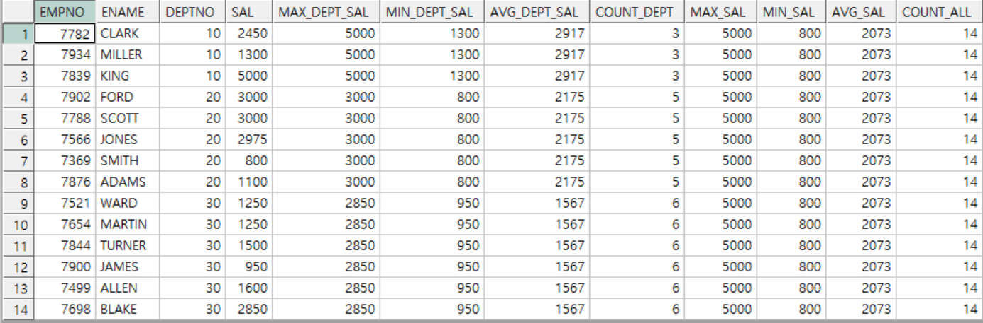

2. 아래와 같이 EMP Table을 사용하여 부서별 SAL,HIREDATE 순 Numbering, 누적 SAL을 Analytic Function을 사용하여 구하시요.

select EMPNO,

ENAME,

DEPTNO,

SAL,

HIREDATE,

row_number()over( partition by DEPTNO

order by SAL, HIREDATE)NUM_SAL ,

sum(SAL)over(partition by DEPTNO

order by SAL, HIREDATE)CUMM_SAL

from EMP;

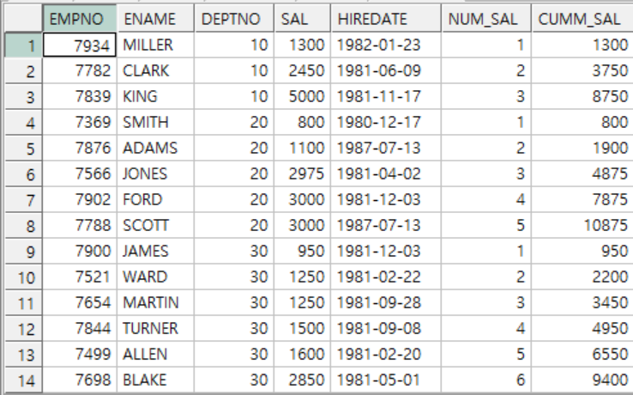

3. 아래와 같이 2번 SQL을 참조하여 부서별로 SAL,HIREDATE 순으로 ENAME을 나열하는 SQL을 작성하시요. (ENAME_6 까지)

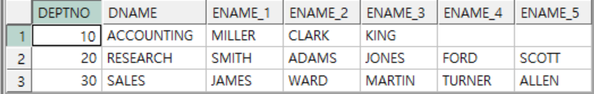

select b.DEPTNO,

b.DNAME,

last_value(a.ENAME)over(partition by a.DEPTNO,b.DEPTNO order by a.SAL,a.HIREDATE)ENAME_1

from EMP a,DEPT b

where a.DEPTNO=b.DEPTNO

//결과값 컬럼 별로 테이블 재조합 필요

10 ACCOUNTING MILLER

10 ACCOUNTING CLARK

10 ACCOUNTING KING

20 RESEARCH SMITH

20 RESEARCH ADAMS

20 RESEARCH JONES

20 RESEARCH FORD

20 RESEARCH SCOTT

30 SALES JAMES

30 SALES WARD

30 SALES MARTIN

30 SALES TURNER

30 SALES ALLEN

30 SALES BLAKE