4차_이름_1.docx (문서이름)

1. 아래와 같이 EMP Table을 사용하여 부서별 MAX SAL,MIN SAL,AVG SAL(소수점 절삭),건수 그리고 전체 MAX SAL,MIN SAL,AVG SAL(소수점 절삭),건수를 구하시요.

( 1개는 Inline View를 통해 작성하고 1개는 Analytic Function을 사용하여 EMP Table 한번만 조회하도록 작성)

**inline View 사용**

select e1.EMPNO,

e1.ENAME,

e1.DEPTNO,

e1.SAL,

e3.MAX_DEPT_SAL,

e3.MIN_DEPT_SAL,

e3.AVG_DEPT_SAL,

e3.COUNT_DEPT,

e2.MAX_SAL,

e2.MIN_SAL,

e2.AVG_SAL,

e2.COUNT_ALL

from EMP e1,

(select MAX(e2.SAL)as MAX_SAL,

MIN(e2.SAL)as MIN_SAL,

count(e2.DEPTNO)as COUNT_ALL,

round(avg(e2.SAL))as AVG_SAL

from EMP e2)e2,

(select e3.DEPTNO,

max(e3.SAL)as MAX_DEPT_SAL,

MIN(e3.SAL)as MIN_DEPT_SAL,

count(e3.DEPTNO)as COUNT_DEPT,

round(avg(e3.SAL))as AVG_DEPT_SAL

from EMP e3

group by e3.DEPTNO)e3

where e1.DEPTNO=e3.DEPTNO

order by e1.DEPTNO

**Analytic Function 사용**

select EMPNO,

ENAME,

DEPTNO,

SAL,

max(sal)over(partition by DEPTNO)as MAX_DEPT_SAL,

min(sal)over(partition by DEPTNO)as MIN_DEPT_SAL,

round(avg(sal)over(partition by DEPTNO))as AVG_DEPT_SAL,

count(DEPTNO)over(partition by DEPTNO)as COUNT_DEPT,

max(sal)over()MAX_SAL,

min(sal)over()MIN_SLA,

round(avg(sal)over())AVG_SAL,

count(DEPTNO)over()COUNT_ALL

from EMP;

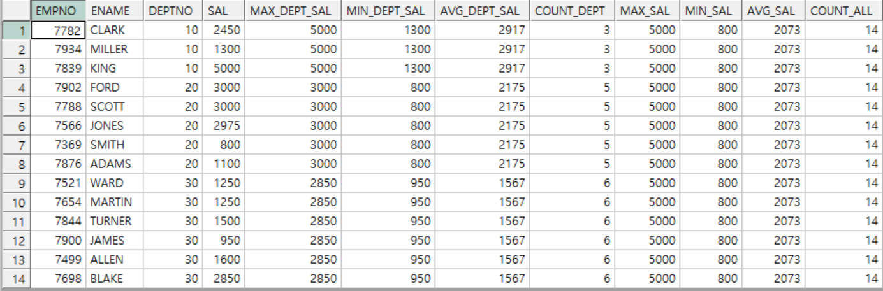

2. 아래와 같이 EMP Table을 사용하여 부서별 SAL,HIREDATE 순 Numbering, 누적 SAL을 Analytic Function을 사용하여 구하시요.

select EMPNO,

ENAME,

DEPTNO,

SAL,

HIREDATE,

row_number()over( partition by DEPTNO

order by SAL, HIREDATE)NUM_SAL ,

sum(SAL)over(partition by DEPTNO

order by SAL, HIREDATE)CUMM_SAL

from EMP;

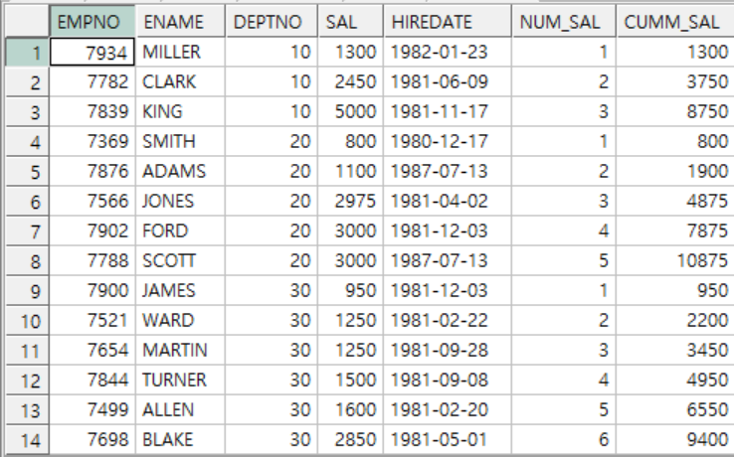

3. 아래와 같이 2번 SQL을 참조하여 부서별로 SAL,HIREDATE 순으로 ENAME을 나열하는 SQL을 작성하시요. (ENAME_6 까지)

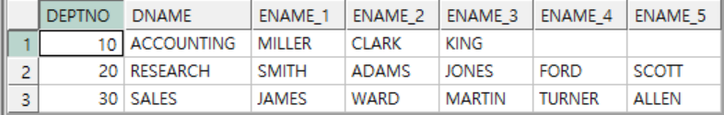

select b.DEPTNO,

b.DNAME,

max(decode(a.num_sal, '1', a.ename))ENAME_1,

max(decode(a.num_sal, '2', a.ename))ENAME_2,

max(decode(a.num_sal, '3', a.ename))ENAME_3,

max(decode(a.num_sal, '4', a.ename))ENAME_4,

max(decode(a.num_sal, '5', a.ename))ENAME_5,

max(decode(a.num_sal, '6', a.ename))ENAME_6

from (select a1.DEPTNO,

a1.ENAME,

row_number()over( partition by a1.DEPTNO

order by a1.SAL, a1.HIREDATE)NUM_SAL

from EMP a1)a ,

DEPT b

where b.deptno=a.deptno group by b.DEPTNO,b.DNAME;