1. 아래와 같이 EMP Table의 각 로우가 2번씩 조회되도록 하되 GUBUN 컬럼을 두어 EMPNO 컬럼값을 구분하도록 한다. 총 28건 조회되며 순서는 EMPNO 컬럼순으로 조회되도록 함.

(Join으로 1개,Compound Operator 사용하여 1개)

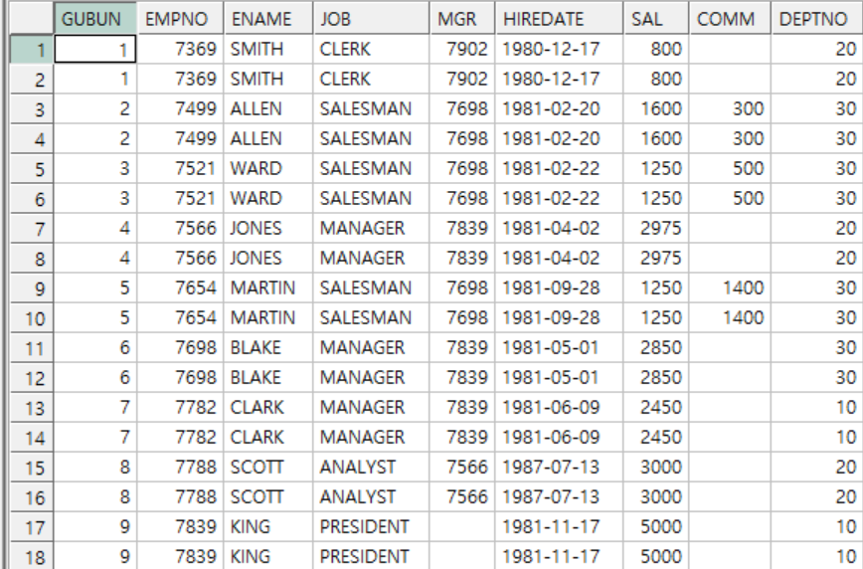

**join 사용**

select a.gubun,

a.empno,

a.ename,

a.job,

a.mgr,

a.hiredate,

a.sal,

a.comm

from (select rank()over(

order by a.empno)gubun,

a.empno,

a.ename,

a.job,

a.mgr,

a.hiredate,

a.sal,

a.comm,

a.deptno

from emp a)a,

(select level no

from dual connect by level <=2)

order by gubun

**compound operator 사용**

select *

from (select rank()over(

order by a.empno)gubun,

a.empno,

a.ename,

a.job,

a.mgr,

a.hiredate,

a.sal,

a.comm,

a.deptno

from emp a

union all

select rank()over(

order by b.empno)gubun,

b.empno,

b.ename,

b.job,

b.mgr,

b.hiredate,

b.sal,

b.comm,

b.deptno

from emp b)

order by gubun

2. 아래와 같이 EMP Table의 각 로우가 2번씩 조회되도록 하되 GUBUN 컬럼을 두어 첫번째 로우와 두번째 로우를 구분하는 컬럼을 둔다. 총 28건 조회되며 순서는 EMPNO 와 GUBUN 컬럼순으로 조회되도록 함.

(Join으로 1개,Compound Operator 사용하여 1개)

**join 사용**

select row_number()over(partition by a.empno

order by a.empno)gubun,

a.empno,

a.ename,

a.job,

a.mgr,

a.hiredate,

a.sal,

a.comm,

a.deptno

from (select a.empno,

a.ename,

a.job,

a.mgr,

a.hiredate,

a.sal,

a.comm,

a.deptno

from emp a)a,

(select level no

from dual connect by level <=2)

**compound operator 사용**

select row_number()over(partition by c.empno

order by c.empno)gubun,

c.empno,

c.ename,

c.job,

c.mgr,

c.hiredate,

c.sal,

c.comm,

c.deptno

from (select *

from emp a

union all

select *

from emp b)c

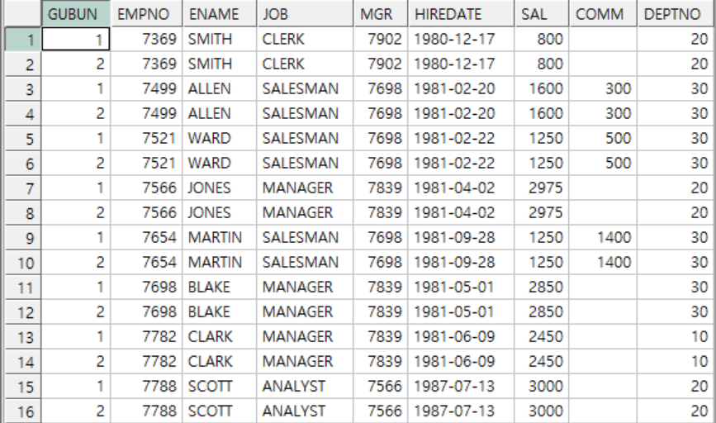

3. 아래와 같이 EMP Table을 참조하여 금년 매월 1일에 해당하는 SAL_DATE 컬럼이 조회되도록 하여 2020년도 월별 총 14*12 건이 조회되도록 함.

WITH TEMP_DATE AS (SELECT TO_DATE(YYYY||MM, 'YYYYMM') sal_date

FROM (SELECT LPAD(LEVEL, 2, '0') MM

FROM DUAL CONNECT BY LEVEL <= 12) ,

(SELECT TO_CHAR(LEVEL+2019) YYYY

FROM DUAL CONNECT BY LEVEL <= 1)

ORDER BY 1)

select a.empno,

a.ename,

a.job,

b.sal_date,

a.sal

from emp a,

temp_date b

order by b.sal_date

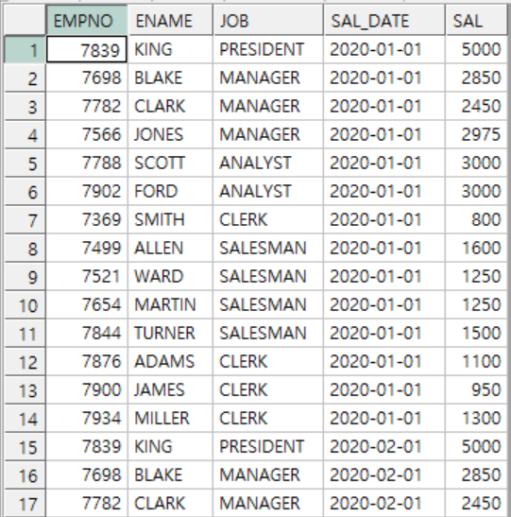

4. 3번 답을 사용하여 아래와 같이 월별 SAL SUM이 나오도록 하여 총 14*12 건이 조회되도록 함. ROLLUP 사용하지 말것..

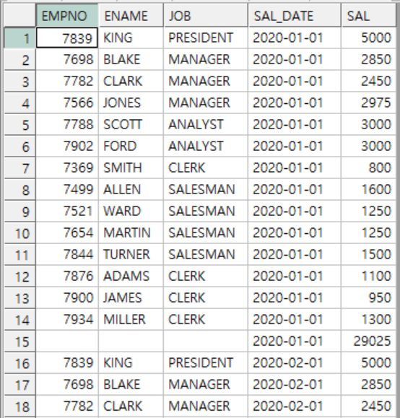

WITH TEMP_DATE AS (SELECT TO_DATE(YYYY||MM, 'YYYYMM') sal_date

FROM (SELECT LPAD(LEVEL, 2, '0') MM

FROM DUAL CONNECT BY LEVEL <= 12) ,

(SELECT TO_CHAR(LEVEL+2019) YYYY

FROM DUAL CONNECT BY LEVEL <= 1)

ORDER BY 1)

select a.empno,

a.ename,

a.job,

b.sal_date,

a.sal

from emp a,

temp_date b

union all

select null as empno,

null as ename,

null as job,

b.sal_date,

sum(a.sal)

from emp a,

temp_date b

group by b.sal_date

order by sal_date,empno