1. 아래와 같이 각 empno 당 2개씩 row가 생성되도록 만든 후 각 empno 당 1건만 남기고 삭제시키는 문을 작성하시요.

(최소 2개 이상)

create table emp_dup

as

select a.*

from emp a,

(select 1 from emp where rownum <= 2) b;

**1.**

**delete emp_dup**

**where rowid in(select rowid**

**from(select \***

**from(select row_number()over(partition by empno**

**order by empno)as num**

**from emp_dup)**

**where num > 1));**

**2.**

**delete emp_dup a**

**where rowid>(select min(rowid)**

**from emp_dup b**

**where a.empno = b.empno);**

2. 아래와 같이 SAL_HIST Table을 생성한 후 아래와 같이 기간이 조회되도록 하시요.

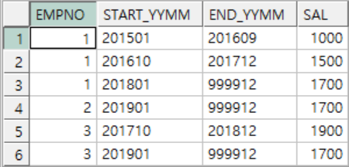

CREATE TABLE SAL_HIST

(

EMPNO NUMBER (4) NOT NULL,

START_YYMM CHAR(6),

SAL NUMBER (7,2)

);

INSERT INTO SAL_HIST VALUES (1,'201501',1000);

INSERT INTO SAL_HIST VALUES (1,'201610',1500);

INSERT INTO SAL_HIST VALUES (1,'201801',1700);

INSERT INTO SAL_HIST VALUES (2,'201901',1700);

INSERT INTO SAL_HIST VALUES (3,'201710',1900);

INSERT INTO SAL_HIST VALUES (3,'201901',1700);

commit;

**select empno,**

**start_yymm,**

**to_char(lead(to_date(start_yymm, 'yyyymm')-1, 1, to_date(999912, 'yyyymm'))over(partition by empno**

**order by empno), 'yyyymm')end_yymm,**

**sal**

**from sal_hist;**

3. 아래와 같이 EMP Table을 참조하여 부서별,기간별 소속된 직원수를 구하는 SQL을 작성하시요.

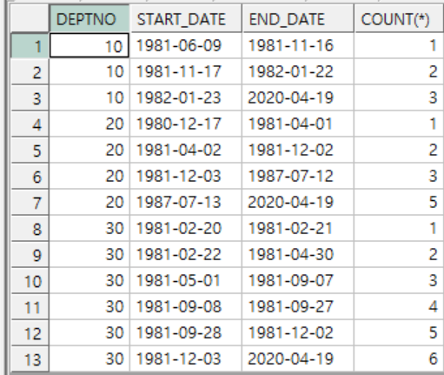

**select a.deptno,**

**start_date,**

**end_date,**

**count(*)**

**from emp a,**

**(select deptno,**

**to_char(hiredate, 'yyyy-mm-dd') as start_date,**

**to_char(lead(hiredate-1, 1, sysdate)over(partition by deptno**

**order by deptno), 'yyyy-mm-dd')end_date**

**from emp**

**order by deptno,**

**start_date)b**

**where hiredate < end_date**

**and start_date < end_date**

**group by a.deptno,**

**b.deptno,**

**start_date,**

**end_date**

**having a.DEPTNO=b.deptno**

**order by a.deptno,**

**count(*);**