US Housing Affordability Crisis (2000–2024): Buy vs. Rent Dynamics
Adam Torres, Charlie Tran

Abstract
Between 2000 and 2024 the cost of buying a home in the United States rose far faster than household income, and after 2021 a sharp increase in mortgage rates made the financing of that purchase substantially more expensive. This report measures how the financial balance between owning and renting shifted across the four U.S. census regions over a quarter century. Drawing on county-level Fair Market Rents (FMR), the Federal Housing Finance Agency House Price Index, the Case–Shiller national home price index, 30-year fixed mortgage rates, regional median sale prices, and national median household income, we build a reproducible dataset and a set of derived affordability metrics. Real home prices rose 68% from 2000 to 2024 while real median income rose only 16%, a 52-point gap. A modeled monthly mortgage payment on a representative home roughly doubled between 2021 and 2024. By 2024 the price-to-rent ratio exceeded our estimated breakeven threshold in every region, and the gap was widest in the Northeast and West. Across individual metros, home-price growth ranged from roughly 82% (Detroit) to 425% (Miami), showing that national averages mask very different local realities. The evidence points toward renting as the more affordable choice in the short run for many households, particularly in high-cost regions.

List of Figures
- Figure 1. Real home prices vs. real income (2000 = 100).
- Figure 2. Mortgage rate vs. Case–Shiller-based modeled monthly P&I.
- Figure 3. Regional median new-home sale price (2000–2024).
- Figure 4. Regional average 2-bedroom Fair Market Rent (2000–2024).
- Figure 5. 2024 price-to-rent ratio by region vs. breakeven.
- Figure 6. Summary statistics of key variables.
- Figure 7. Regional price-to-rent ratio over time.
- Figure 8. Distribution of county 2-bedroom FMR, 2024.
- Figure 9. Average county 2-bedroom FMR by region, 2024.
- Figure 10. Number of counties by region and 2024 FMR quartile.
- Figure 11. Distribution of metro HPI growth (%), 2000–2024.
- Figure 12. Top and bottom 10 metros by HPI growth, 2000–2024.
- Figure 13. Home price vs. rent index (2000 = 100).
- Figure 14a. 2024 average 2-bedroom FMR by state.
- Figure 14b. Home price growth by state, 2000–2024.

1. Introduction

1.1 Problem Statement
Housing affordability in the United States has deteriorated markedly since the pandemic. Two forces drove the deterioration: a surge in home prices and a rapid increase in mortgage rates. Together they raised both the price of a home and the cost of borrowing to buy it, while rents rose more slowly. Households deciding whether to buy or rent face a very different calculation in 2024 than they did in 2000. Understanding this shift is important not only for individual households but also for investors in residential real estate and for local policymakers who must plan housing supply and rental support.

1.2 Objective and Research Questions
Our objective is to quantify how the buy-versus-rent balance shifted across U.S. regions from 2000 to 2024 and to identify which regions became least affordable. We address four questions:
- How far did real home prices outrun real household income over the period?
- How much did the cost of financing a home rise, in dollars, after 2021?
- By 2024, in which regions does buying cost more than our estimated breakeven relative to renting, and by how much?
- How much variation exists across individual metros and states beneath the national averages?

1.3 Audience
The intended audience is first-time homebuyers, residential REIT investors, and local housing policy boards. Each group needs the same underlying measurement — the relative cost of owning versus renting — but applies it differently: buyers to time a purchase, investors to anticipate rental demand, and policymakers to target supply and subsidy.

1.4 Scope and Data Window
The analysis covers 2000 through 2024, a window that spans the pre-crisis boom, the 2008 crash, the post-crisis recovery, the pandemic-era price surge, and the 2022–2024 rate shock. Because the report relies on existing public data, no new data collection was performed for this analysis.

2. Data Sources and Preparation

2.1 Sources
The analysis combines several public sources into a single tidy dataset:
Variable | Source | Level / Frequency
Fair Market Rent, 2-bedroom (fmr_2br) | HUD | County / annual
FHFA House Price Index (hpi_sa) | FHFA | MSA, State, Division / quarterly
30-year fixed mortgage rate | FRED MORTGAGE30US | National / weekly
Median household income (real) | FRED MEHOINUSA672N | National / annual
Median new-home sale price | FRED MSPNE/MW/S/W | 4 Regions / quarterly
Case–Shiller national HPI | FRED CSUSHPINSA | National / monthly
CPI-U (derived) | FRED CUUR0000SA0R | National / monthly
Renter / owner occupied units | FRED ERNTOCCUSQ176N / EOWNOCCUSQ176N | National / quarterly

2.2 Data Corrections and Caveats
Three issues were identified and corrected during preparation; they materially affect the results and are worth stating explicitly.
- The source column labeled “CPI Rent” (CUUR0000SA0R) is not a rent index; it is the Purchasing Power of the Consumer Dollar (1982–84 = 100). The CPI-U used here is recovered as 10000 / value and verified against published CPI-U values (e.g., 2024 = 313.7).
- MEHOINUSA672N is already reported in real (constant) dollars. Deflating it again would double-count inflation, so it is used as-is.
- Only four census regions exist in the price data (Northeast, Midwest, South, West); regional income is not available, so income-based affordability is national and illustrative.

2.3 Assumptions
All modeled costs use the following assumptions: down payment LTV = 80%; 30-year fixed term; property tax 1.00% of price per year; insurance 0.35% per year; maintenance 1.00% per year; expected appreciation 3.00% per year. The mortgage rate is the national annual mean of the 30-year fixed rate, applied uniformly to all regions.

3. Methodology

3.1 Pipeline
We aggregated county-level FMR (3,229 counties, 2000–2024), quarterly FHFA HPI, national macro series, and other data into a single dataset to work from. Nominal prices were deflated to real terms using the derived CPI-U with 2000 as the base year. The pipeline is reproducible: a build step cleans and joins the raw workbook, a derived-metrics step computes models, and a figure step renders the visualizations.

3.2 Derived Metrics
Metric | Definition
Real home price index | Case–Shiller HPI ÷ CPI-U, rebased 2000 = 100
Real income index | Real median income, rebased 2000 = 100
Price-to-rent ratio (dollar) | Median sale price ÷ (average FMR × 12)
Price-to-rent ratio (index) | HPI index ÷ FMR index, both rebased
Modeled monthly P&I | Payment on an 80% LTV 30-year loan at that year's rate
PITI | P&I + property tax + insurance
Breakeven price-to-rent | 1 ÷ (rate × LTV + tax + ins + maint − appreciation)

3.3 The Buy-Cost Model
To translate mortgage rates into a practical dollar amount, we modeled a representative home financed with a fixed-rate loan and computed the monthly payment each year. Because the payment depends on both the size of the loan and the interest rate, the model captures the compounding effect of rising prices and rising rates. The same framework produces the PITI figure once taxes and insurance are added, and the price-to-rent ratio used throughout the report.

3.4 Breakeven Analysis
The breakeven price-to-rent ratio is the level at which, under our assumptions, the annual cost of owning equals the annual cost of renting. When the observed price-to-rent ratio exceeds the breakeven ratio, renting is the cheaper financial choice for a household planning a short holding period. The breakeven ratio falls as mortgage rates rise, because higher financing costs make ownership more expensive relative to rent; the 2024 breakeven was 21.2 for an 80% LTV loan and 16.5 for a fully financed purchase.

4. National Trends
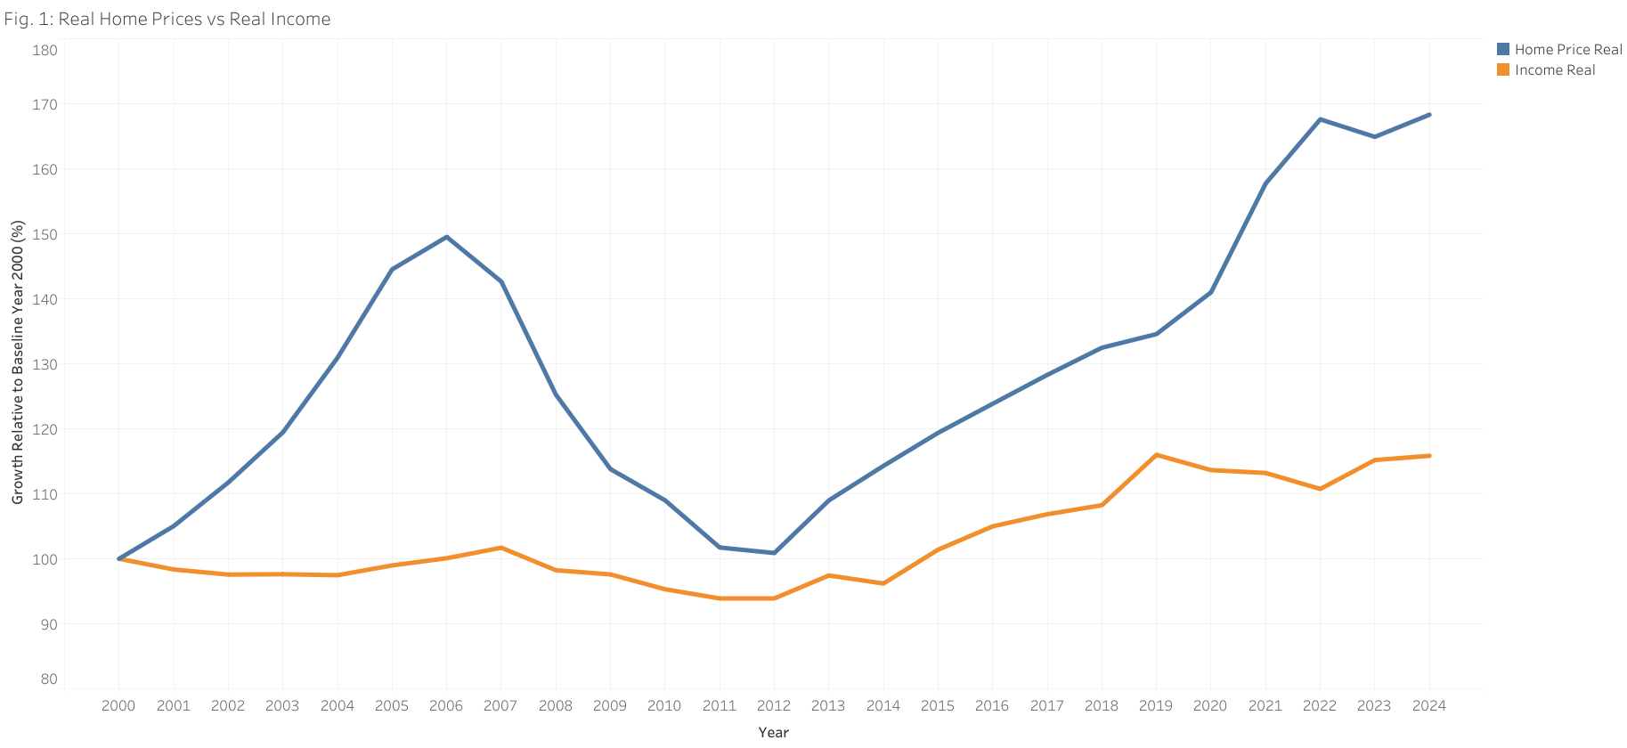
Figure 1. Real home prices vs. real income (2000 = 100).
From 2000 to 2024 the real home price index rose from 100 to 168.3 (+68.3%) while the real median income index rose from 100 to only 115.8 (+15.8%). By 2024 the two measures were 52.5 index points apart despite starting together in 2000. Housing prices outgrew household purchasing power by a wide margin, meaning the down payment and the price of a home consumed a growing share of a typical household's finances. Notably, real income was essentially flat from 2000 to 2014 and only began to recover after 2015, while real home prices dipped after 2006 and then climbed steeply from 2012 onward.
Year | Mortgage rate (%) | Real price idx | Real income idx | HPI idx | FMR idx | Avg FMR ($)
2000 | 8.05 | 100.0 | 100.0 | 100.0 | 100.0 | 519.0
2005 | 5.87 | 144.5 | 99.0 | 163.9 | 117.2 | 609.0
2010 | 4.69 | 109.0 | 95.3 | 138.1 | 144.3 | 750.0
2015 | 3.85 | 119.4 | 101.4 | 164.3 | 155.3 | 807.0
2020 | 3.11 | 141.0 | 113.6 | 211.9 | 178.0 | 924.0
2021 | 2.96 | 157.7 | 113.2 | 248.1 | 184.8 | 960.0
2022 | 5.34 | 167.6 | 110.7 | 284.7 | 192.0 | 998.0
2023 | 6.81 | 164.9 | 115.2 | 291.8 | 211.0 | 1096.0
2024 | 6.72 | 168.3 | 115.8 | 306.7 | 232.6 | 1208.0
Table 1. Selected national indicators, 2000–2024 (indices rebased 2000 = 100).
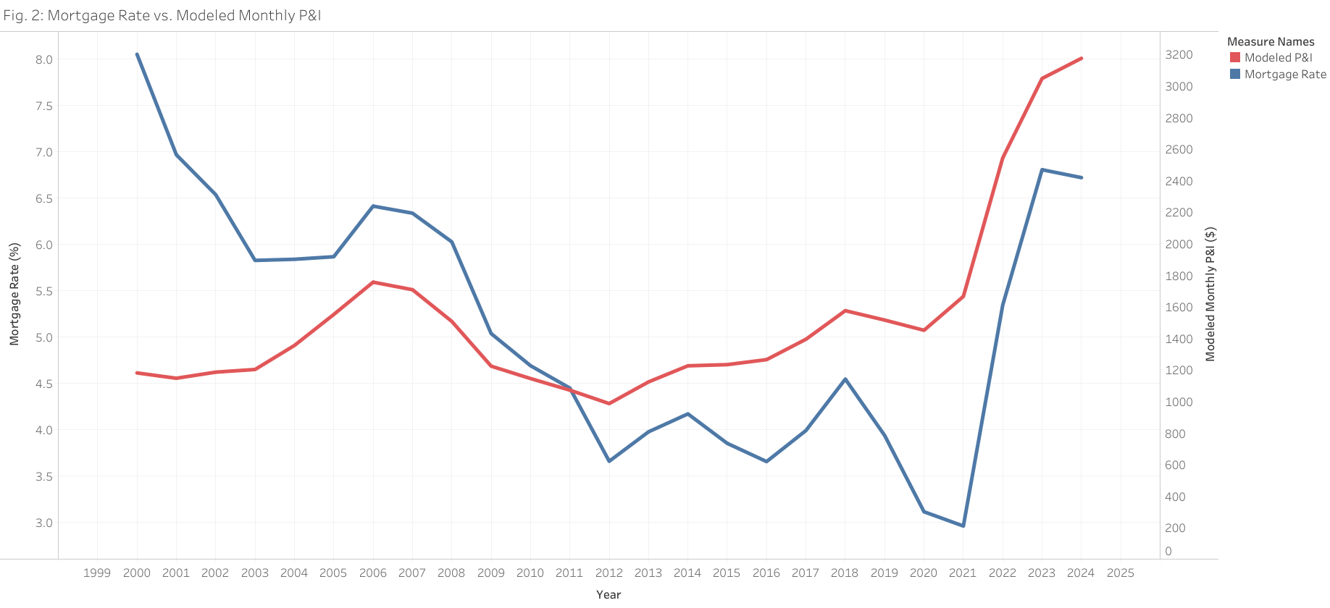
Figure 2. Mortgage rate vs. Case–Shiller-based modeled monthly P&I.
The annual average 30-year fixed rate fell to a low of 2.96% in 2021 and rose to 6.72% by 2024 — its highest level of the period outside the 2000 start. To translate these rates into a practical dollar amount, we created an illustrative model of a $200,000 home in 2000, assumed its value changed with the national Case–Shiller index, and calculated the payment on a new 30-year mortgage each year with a 20% down payment. Under these assumptions, the estimated monthly principal-and-interest payment increased from about $1,665 in 2021 to $3,173 in 2024 — approximately $1,508 more per month, or a 91% increase. The combination of larger loan balances and more expensive borrowing reduces the purchasing power of a given monthly housing budget and may make renting more practical for households that are not prepared for the upfront and recurring costs of buying.

5. Buy-versus-Rent Analysis
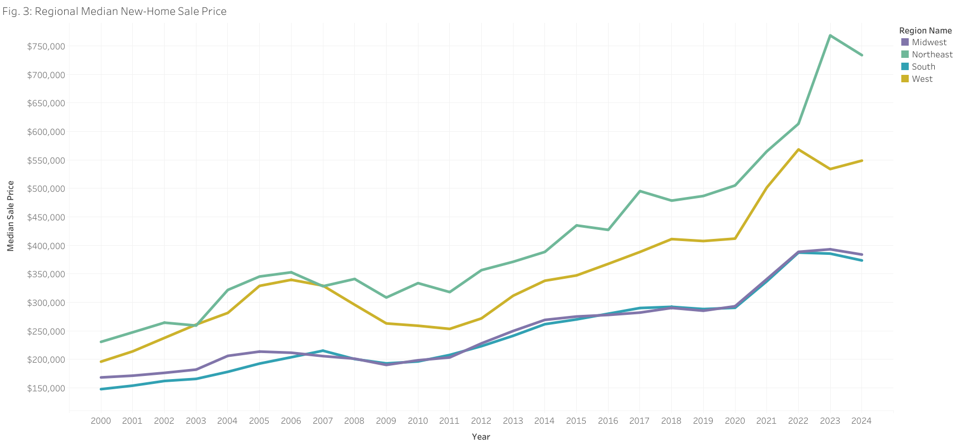
Figure 3. Regional median new-home sale price (2000–2024).
Median new-home sale prices rose in every region, but unevenly. From 2000 to 2024 median sale prices increased 218% in the Northeast, 180% in the West, 153% in the South, and 128% in the Midwest. The Northeast entered the period at the highest level and remained there throughout, while the South and Midwest remained the most affordable by price.
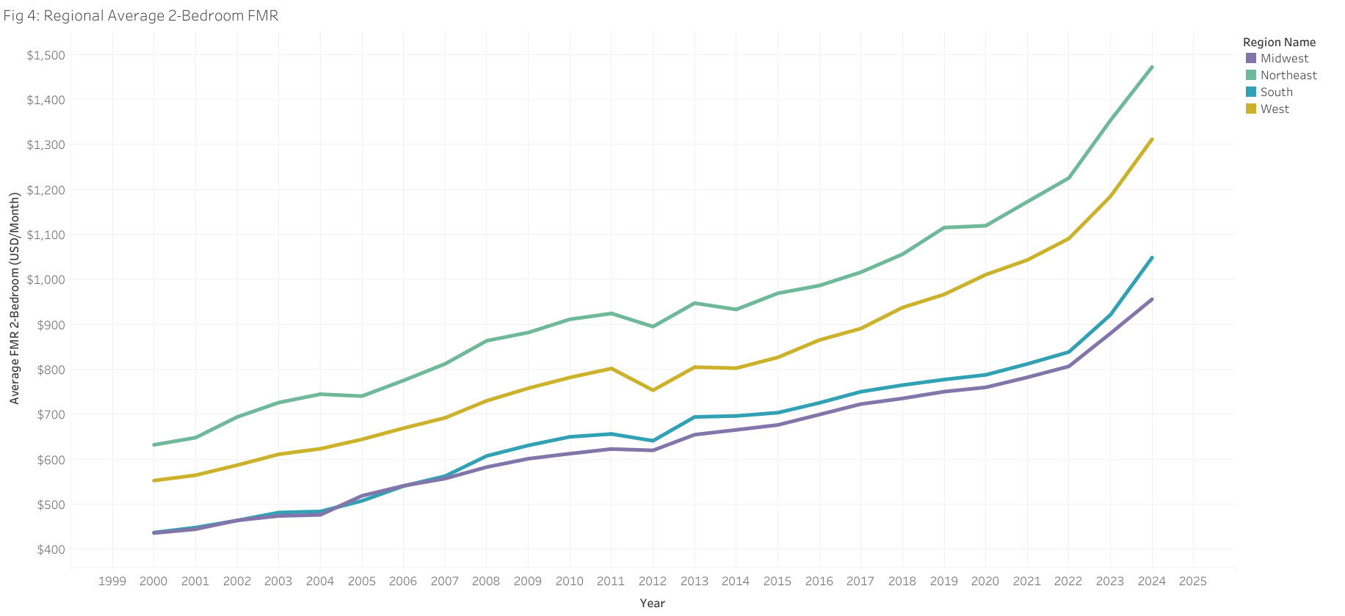
Figure 4. Regional average 2-bedroom Fair Market Rent (2000–2024).
Rents rose too, but much more slowly and more evenly: 133% in the Northeast, 137% in the West, 140% in the South, and 119% in the Midwest over the same period. The divergence between the price and rent series is the core of the affordability problem — purchase prices ran away from rents, especially after 2020.
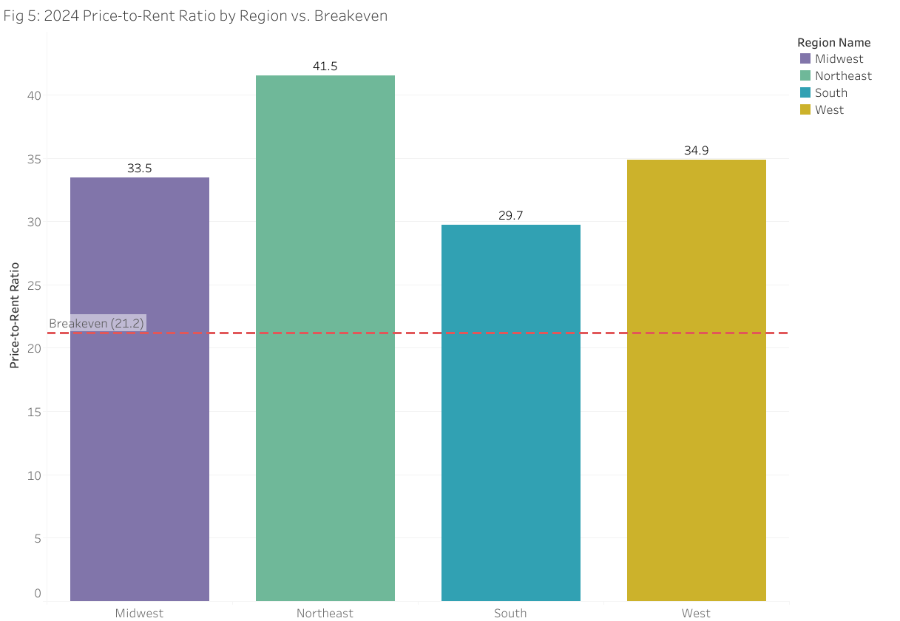
Figure 5. 2024 price-to-rent ratio by region vs. breakeven.
In 2024 the dollar price-to-rent ratio was 41.5 in the Northeast, 34.9 in the West, 33.5 in the Midwest, and 29.7 in the South. Our estimated breakeven ratio for 2024 — the point at which owning and renting cost the same under our assumptions — is 21.2. Every region exceeds the breakeven, and all but the South exceed it by a wide margin, indicating that renting is the cheaper financial choice under our assumptions. As a ratio of monthly payments, PITI was 3.14× FMR in the Northeast, 2.64× in the West, 2.53× in the Midwest, and 2.25× in the South in 2024.
Region (2024) | Median price ($) | Loan ($) | P&I ($) | PITI ($) | Avg FMR ($) | PITI/FMR | P/R ratio | Tier
Northeast | 733,750 | 587,000 | 3,796 | 4,621 | 1,472 | 3.14 | 41.5 | Severe (>30)
Midwest | 383,950 | 307,160 | 1,986 | 2,418 | 956 | 2.53 | 33.5 | Severe (>30)
South | 373,600 | 298,880 | 1,933 | 2,353 | 1,048 | 2.25 | 29.7 | Moderate (20-30)
West | 548,700 | 438,960 | 2,839 | 3,456 | 1,311 | 2.64 | 34.9 | Severe (>30)
Table 2. Modeled 2024 buy costs by region versus rent, under 80% LTV assumptions.
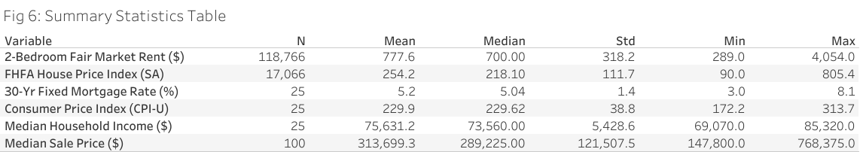
Figure 6. Summary statistics of key variables.
Figure 6 reports descriptive statistics. County 2-bedroom FMR averages $778 per month (median $700) with a standard deviation of $318, ranging from $289 to $4,054. The FHFA HPI averages 254. The 30-year mortgage rate averaged 5.15% over the period, ranging from 2.96% to 8.05%. Real median household income averaged roughly $75,600 and the median sale price averaged about $313,700 across region-years.

6. Regional Structure and Distribution
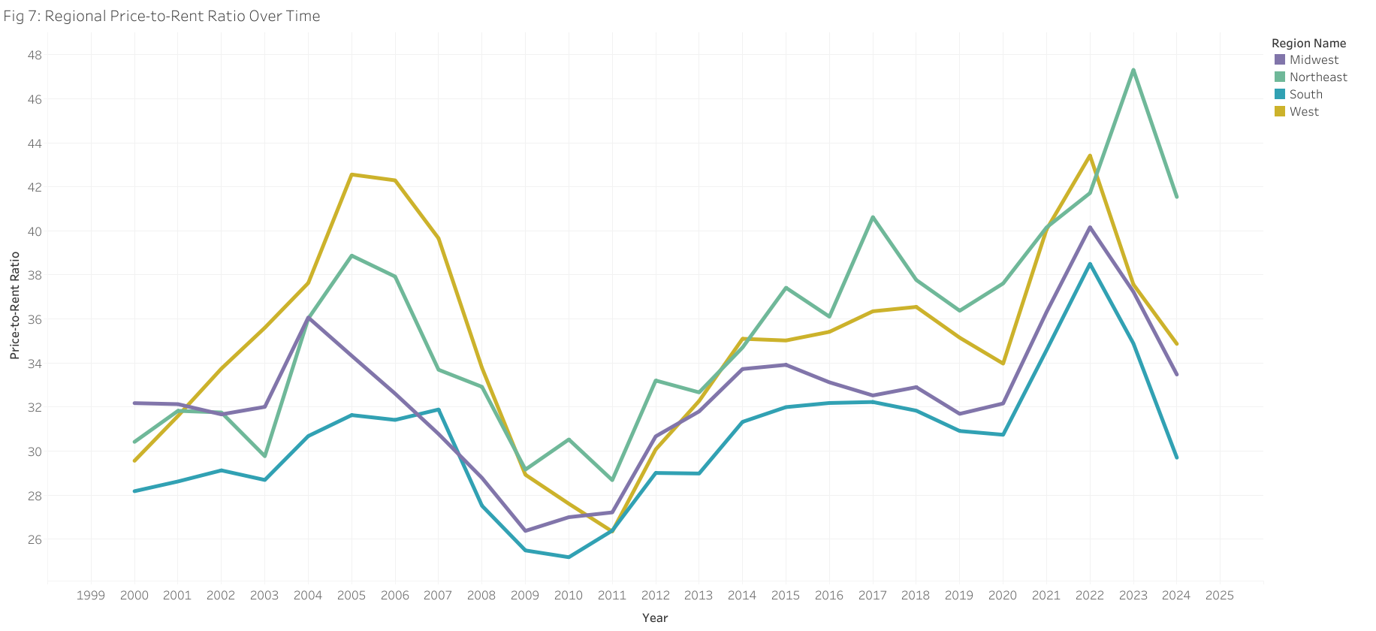
Figure 7. Regional price-to-rent ratio over time.
The price-to-rent ratio rose in all regions, but the West climbed fastest, overtaking the Northeast in the post-2021 period, and the upward break after 2021 is visible in every region. This confirms that the affordability deterioration was national in scope rather than confined to a single region.
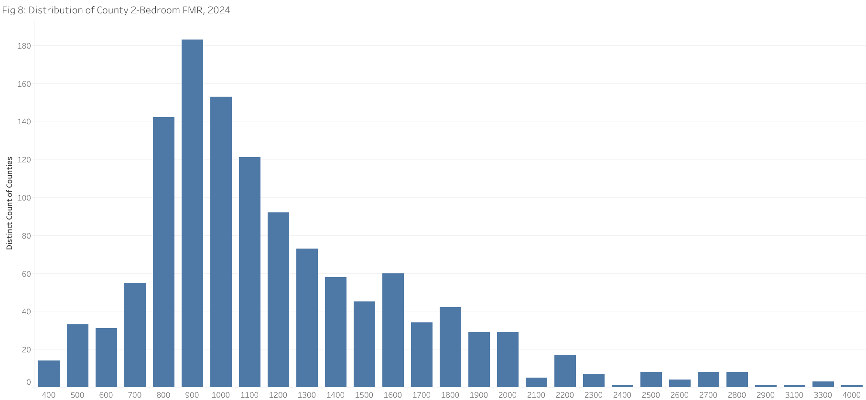
Figure 8. Distribution of county 2-bedroom FMR, 2024.
The distribution of county rents is strongly right-skewed: most counties cluster between $700 and $1,200 per month, with a long tail of high-cost counties above $2,000. A small number of coastal and resort counties pull the mean above the median, which is why the mean ($778) exceeds the median ($700).
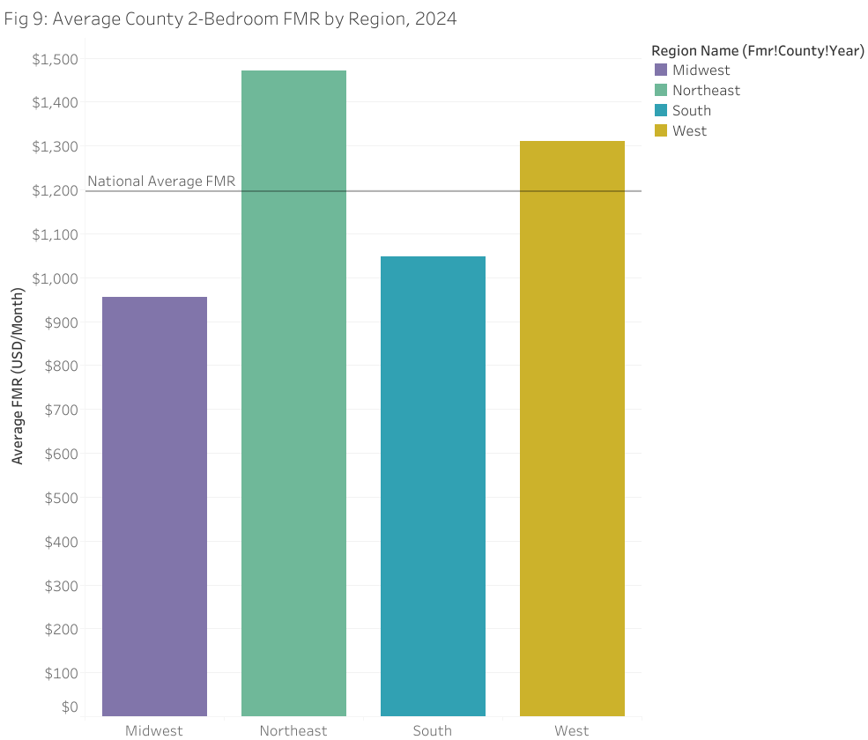
Figure 9. Average county 2-bedroom FMR by region, 2024.
Average 2-bedroom FMR was highest in the Northeast ($1,472) and lowest in the Midwest ($956), with the West ($1,311) and South ($1,048) in between. The Northeast thus combines the highest purchase prices and the highest rents, while the South combines moderate prices with the lowest relative gap to rents.
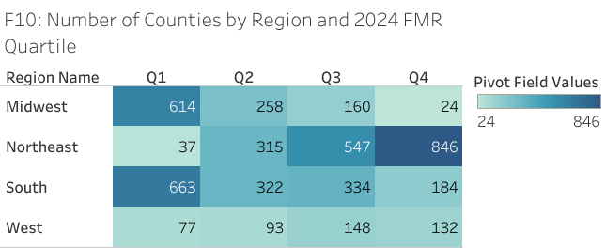
Figure 10. Number of counties by region and 2024 FMR quartile.
The contingency table shows stark regional structure. The Midwest is dominated by the lowest-cost quartile (614 counties), whereas the Northeast is dominated by the highest-cost quartile (846 counties). The South is the most evenly spread region, which is consistent with its more moderate price-to-rent ratio.
Region | Q1 lowest | Q2 | Q3 | Q4 highest | Total
Midwest | 614 | 258 | 160 | 24 | 1056
Northeast | 37 | 315 | 547 | 846 | 1745
South | 663 | 322 | 334 | 184 | 1503
West | 77 | 93 | 148 | 132 | 450
Table 3. Counties by census region and 2024 FMR quartile.

7. Metro and State Dispersion
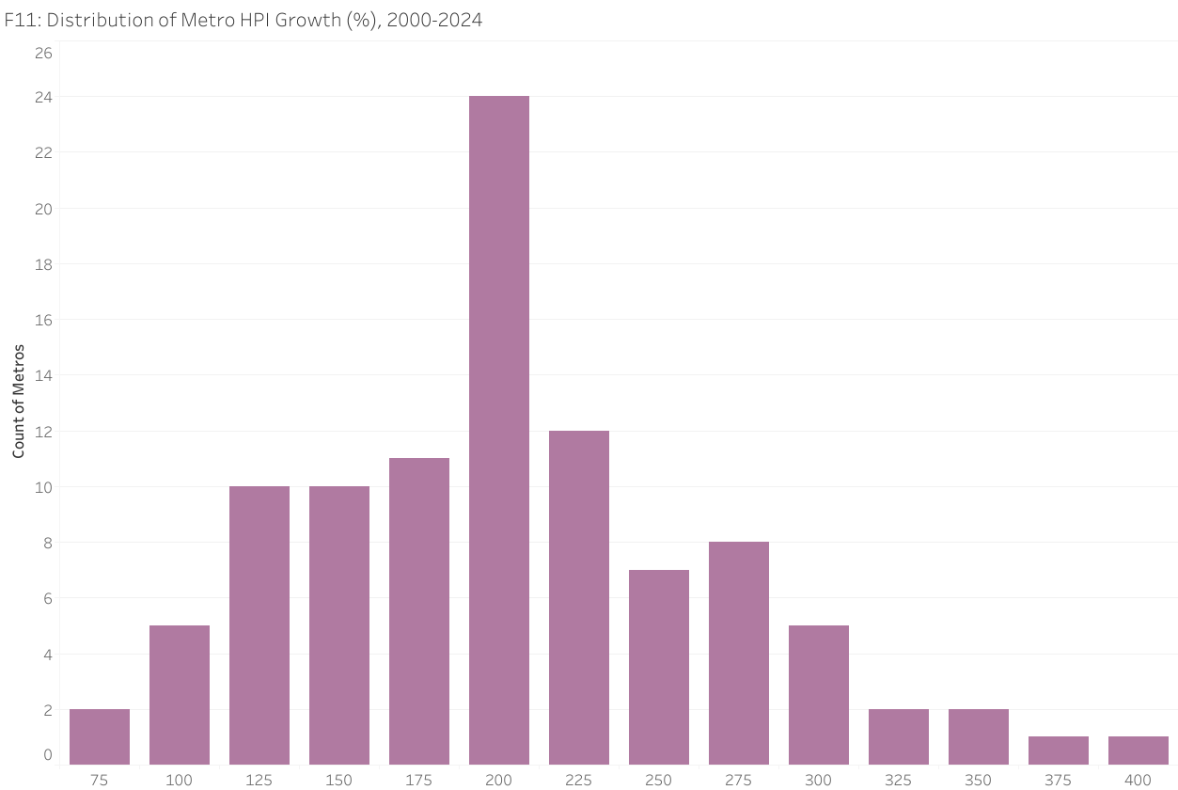
Figure 11. Distribution of metro HPI growth (%), 2000–2024.
Metro home-price growth varies enormously, with a median of about 212% and a long right tail. The fastest-appreciating metros roughly quadrupled prices, while the slowest roughly doubled them — a spread of more than 340 percentage points. The national averages therefore hide very different local experiences.
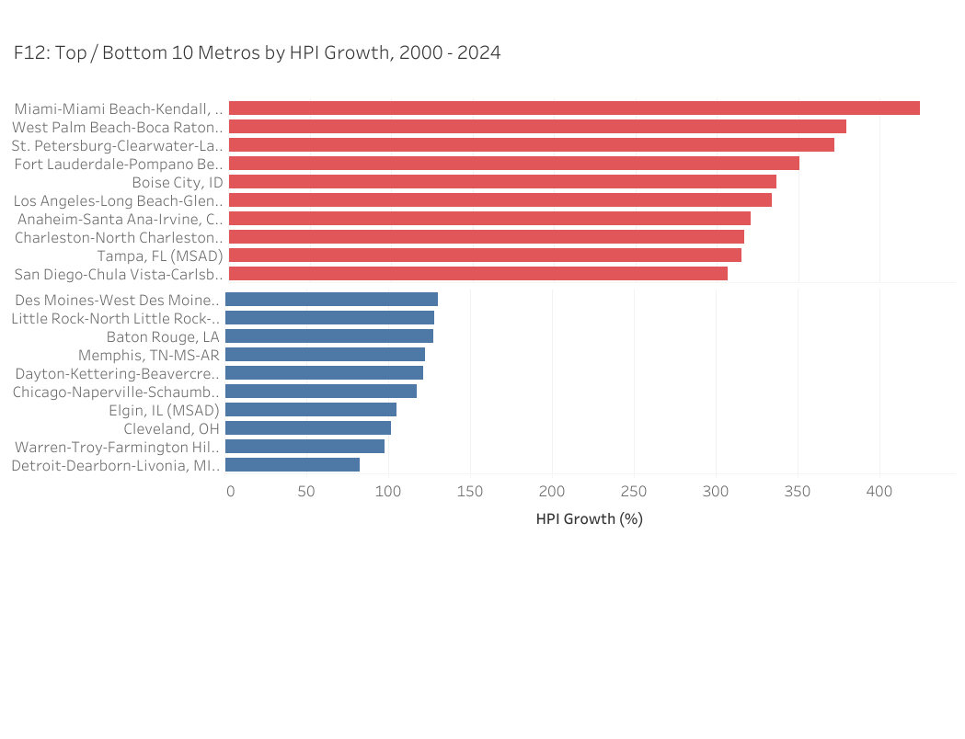
Figure 12. Top and bottom 10 metros by HPI growth, 2000–2024.
The fastest-appreciating metros were concentrated in Florida (Miami, West Palm Beach, St. Petersburg, Fort Lauderdale) and the Mountain West (Boise, up about 336%). The slowest were in the industrial Midwest (Detroit, Cleveland, Chicago). A buyer in Miami faced a fundamentally different market than a buyer in Detroit, even though both faced the same national mortgage rate.
Top 10 metros | Growth (%) | Bottom 10 metros | Growth (%)
Miami-Miami Beach-Kendall, FL (MSAD) | 424.9 | Detroit-Dearborn-Livonia, MI (MSAD) | 82.4
West Palm Beach-Boca Raton-Delray Beach, FL (MSAD) | 379.4 | Warren-Troy-Farmington Hills, MI (MSAD) | 97.6
St. Petersburg-Clearwater-Largo, FL (MSAD) | 372.4 | Cleveland, OH | 101.5
Fort Lauderdale-Pompano Beach-Sunrise, FL (MSAD) | 350.8 | Elgin, IL (MSAD) | 105.2
Boise City, ID | 336.5 | Chicago-Naperville-Schaumburg, IL (MSAD) | 117.2
Los Angeles-Long Beach-Glendale, CA (MSAD) | 334.0 | Dayton-Kettering-Beavercreek, OH | 121.6
Anaheim-Santa Ana-Irvine, CA (MSAD) | 321.1 | Memphis, TN-MS-AR | 122.5
Charleston-North Charleston, SC | 317.0 | Baton Rouge, LA | 127.5
Tampa, FL (MSAD) | 315.2 | Little Rock-North Little Rock-Conway, AR | 128.4
San Diego-Chula Vista-Carlsbad, CA | 306.8 | Des Moines-West Des Moines, IA | 130.5
Table 4. Top and bottom 10 metropolitan areas by home-price growth, 2000–2024.
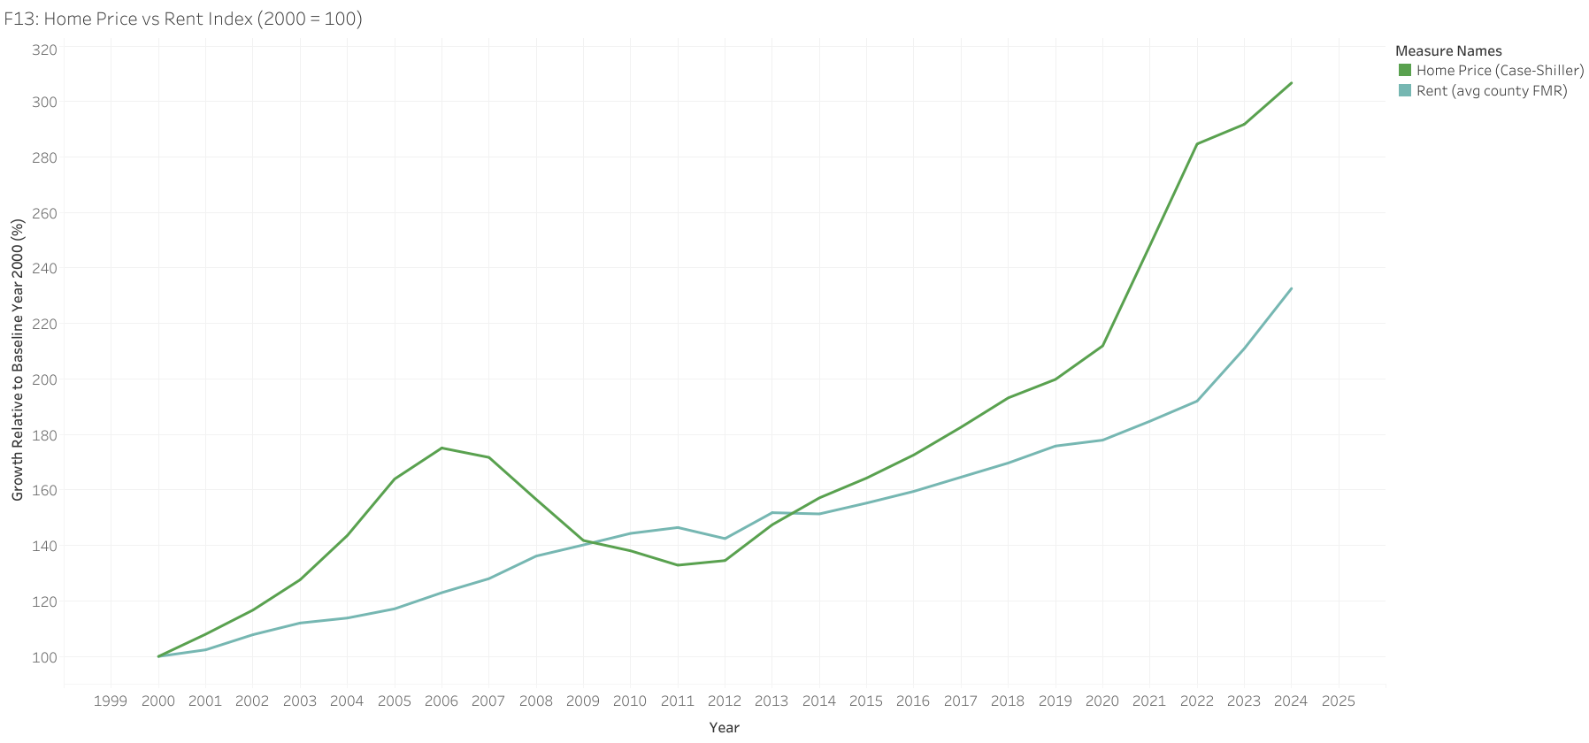
Figure 13. Home price vs. rent index (2000 = 100).
Nationally, the home-price index roughly tripled (100 to about 307) while the national rent index roughly doubled (100 to about 233). The widening wedge between the two lines is the visual signature of the affordability crisis: ownership costs outran renting costs throughout the period, and the gap accelerated after 2020.

8. Geographic Patterns
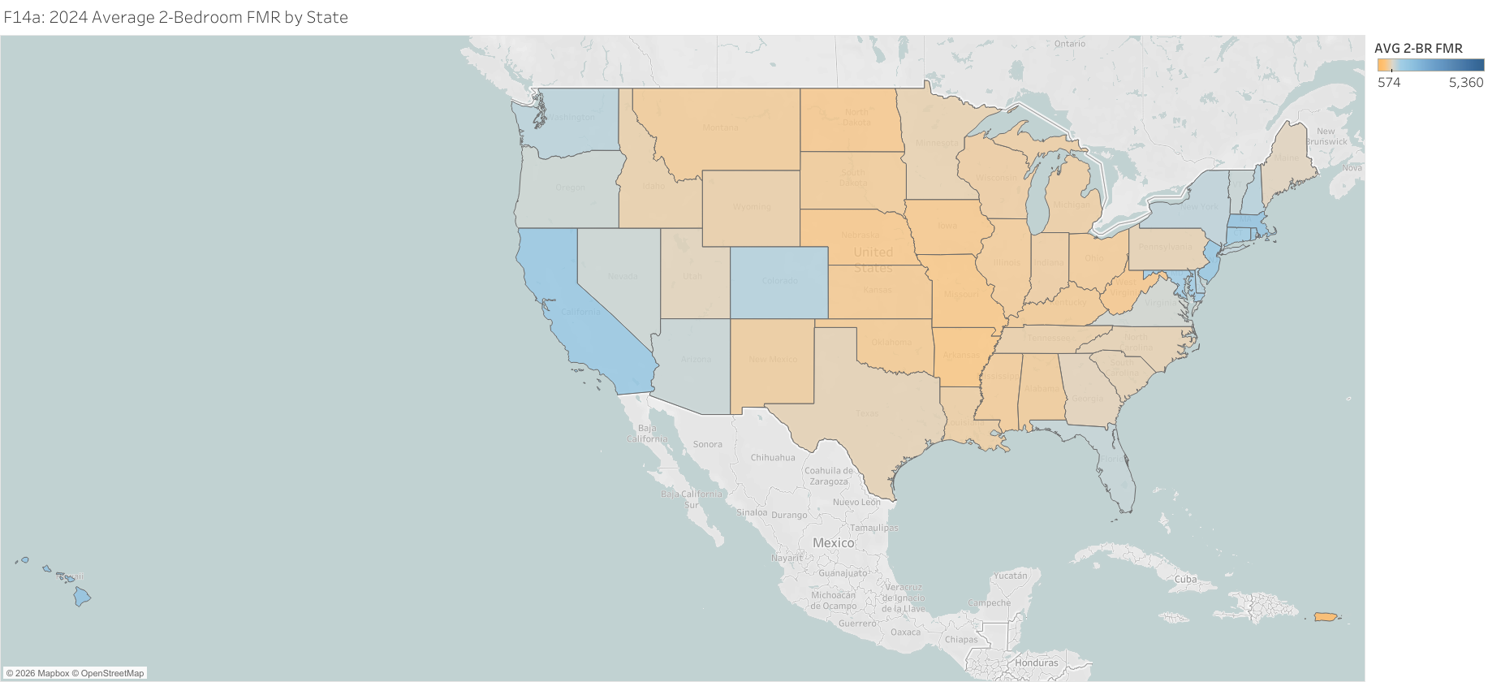
Figure 14a. 2024 average 2-bedroom FMR by state.
The state map shows high 2024 rents concentrated on the coasts and in Hawaii. Hawaii ($2,122), the District of Columbia ($2,045), Massachusetts ($2,026), New Jersey ($1,889), and California ($1,864) had the highest average 2-bedroom rents, while Arkansas ($875), Missouri ($887), Nebraska ($902), Iowa ($909), and West Virginia ($909) were the lowest.
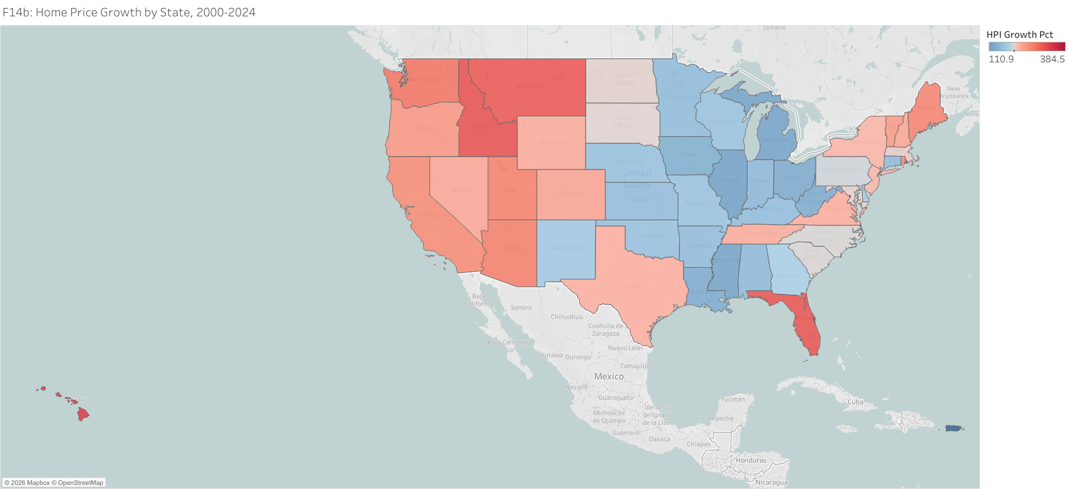
Figure 14b. Home price growth by state, 2000–2024.
The price-growth map shows the largest gains in the District of Columbia (+384%), Hawaii (+338%), Idaho (+312%), Florida (+310%), and Montana (+305%), and the smallest in Illinois (+111%), Michigan (+115%), Mississippi (+117%), and Ohio (+125%). The pattern reflects migration and supply constraints in the Sun Belt and Mountain West against slower demand in much of the industrial Midwest.

9. Discussion
Three findings stand out. First, the divergence between home prices and income is large and durable: real prices grew roughly four times faster than real income, and the gap did not close even during the 2008 crisis. Second, the cost of financing is now a first-order driver of affordability. The jump in rates from 2.96% in 2021 to 6.72% in 2024 roughly doubled the modeled monthly payment, meaning a household that could comfortably afford a home in 2021 may no longer qualify for the same home in 2024 even if its income rose. Third, the market is highly segmented. Regions and metros differ so much that a single national narrative obscures the experience of buyers in Miami, Boise, or Detroit.
Taken together, these findings imply that the buy-versus-rent decision is increasingly a short-horizon affordability calculation. When the price-to-rent ratio exceeds breakeven — as it does in every region in 2024 — a household that does not expect to hold the home long enough to amortize the upfront and transaction costs may be better served by renting and investing the difference.

10. Limitations
Several limitations qualify these results. The FMR is a fair-market benchmark, not the rent every household actually pays. The price-to-rent ratio uses median sale prices for newly sold homes rather than the value of a specific property a household might also rent. Income data are national, so income-based affordability is illustrative rather than regional. The model applies a single national mortgage rate to all regions and omits closing costs, the recurring maintenance in the monthly payment, and the opportunity cost of the down payment. Finally, the breakeven calculation is sensitive to the assumed appreciation rate; a lower appreciation assumption would raise the breakeven ratio and narrow the measured gap.

11. Conclusion and Recommendations
Findings. Real home prices grew about four times faster than real income (+68% versus +16%); the post-2021 jump in mortgage rates (2.96% to 6.72%) roughly doubled a modeled monthly mortgage payment; by 2024 the price-to-rent ratio exceeded breakeven in every region, most severely in the Northeast and West; and metro-level dispersion was wide, led by Florida and the Mountain West.
Recommendations. Prospective buyers in high-ratio regions should weigh longer renting horizons against purchase. REIT investors should expect stronger rental demand where price-to-rent ratios are highest. Housing policy boards in fast-appreciating metros should prioritize supply, including density and permitting reform. Future work will add metro- and county-level income and dollar home values to produce a true regional Housing Affordability Index and an interactive, rate-adjustable dashboard.

References and Data Sources
- Housing Inventory Estimate: Renter Occupied Housing Units in the United States (ERNTOCCUSQ176N). https://fred.stlouisfed.org/series/ERNTOCCUSQ176N
- Housing Inventory Estimate: Owner Occupied Housing Units in the United States (EOWNOCCUSQ176N). https://fred.stlouisfed.org/series/EOWNOCCUSQ176N
- Median Sales Price of Houses Sold for the South Census Region (MSPS). https://fred.stlouisfed.org/graph/?m=QzEg
- S&P CoreLogic Case-Shiller U.S. National Home Price Index (CSUSHPINSA). https://fred.stlouisfed.org/series/CSUSHPINSA
- Federal Housing Finance Agency National, State, and County HPI. https://www.fhfa.gov/data/hpi/datasets?tab=annual-data
- Real Median Household Income in the United States (MEHOINUSA672N). https://fred.stlouisfed.org/series/MEHOINUSA672N
- 30-Year Fixed Rate Mortgage Average in the United States (MORTGAGE30US). https://fred.stlouisfed.org/series/MORTGAGE30US
- Housing Affordability Index (Fixed) (FIXHAI). https://fred.stlouisfed.org/series/FIXHAI
- Gross Rent as a Percentage of Household Income in the Past 12 Months. https://data.census.gov/table/ACSDT1Y2024.B25070
- Consumer Price Index for All Urban Consumers: Purchasing Power of the Consumer Dollar in U.S. City Average (CUUR0000SA0R). https://fred.stlouisfed.org/series/CUUR0000SA0R
- Consumer Price Index for All Urban Consumers: Rent of Primary Residence in U.S. City Average (CUSR0000SEHA). https://fred.stlouisfed.org/series/CUSR0000SEHA
Interactive Dashboard (Tableau Public)
- US Housing Affordability Crisis 2000-2024 – Buy vs. Rent Dynamics, Part 1. https://public.tableau.com/views/USHousingAffordabilityCrisis20002024Buyvs_RentDynamicsPt_1/USHousingAffordabilityCrisis20002024Buyvs_RentDynamicsPt_1
- US Housing Affordability Crisis 2000-2024 – Buy vs. Rent Dynamics, Part 2. https://public.tableau.com/app/profile/adam.torres5234/viz/USHousingAffordabilityCrisis20002024Buyvs_RentDynamicsPt_2/USHousingAffordabilityCrisis20002024Buyvs_RentDynamicsPt_2

Appendix A. Supporting Tables
A.1 Summary statistics for key variables.
Variable | N | Mean | Median | Std | Min | Max
fmr_2br (USD) | 118766 | 777.62 | 700.00 | 318.21 | 289.00 | 4,054.00
hpi_sa (index) | 17066 | 254.21 | 218.10 | 111.67 | 89.97 | 805.40
mortgage_rate (%) | 25 | 5.15 | 5.04 | 1.38 | 2.96 | 8.05
cpi_all (1982-84=100) | 25 | 229.90 | 229.62 | 38.81 | 172.17 | 313.73
median_household_income (USD) | 25 | 75,631.20 | 73,560.00 | 5,428.59 | 69,070.00 | 85,320.00
median_sale_price (USD) | 100 | 313,699.25 | 289,225.00 | 121,507.47 | 147,800.00 | 768,375.00
A.2 Breakeven price-to-rent ratio for selected years (80% LTV).
Year | Mortgage rate (%) | Breakeven P/R (LTV 80) | Breakeven P/R (LTV 100)
2000 | 8.05 | 17.3 | 13.5
2005 | 5.87 | 24.7 | 19.2
2010 | 4.69 | 32.2 | 24.8
2015 | 3.85 | 41.1 | 31.2
2020 | 3.11 | 54.4 | 40.6
2021 | 2.96 | 58.3 | 43.3
2022 | 5.34 | 27.6 | 21.3
2023 | 6.81 | 20.9 | 16.2
2024 | 6.72 | 21.2 | 16.5
A.3 Top and bottom states by 2024 average 2-bedroom FMR.
Top 5 states | FMR ($) | Bottom 5 states | FMR ($)
Hawaii | 2,122 | Puerto Rico | 574
District of Columbia | 2,045 | Arkansas | 875
Massachusetts | 2,026 | Missouri | 887
New Jersey | 1,889 | Nebraska | 902
California | 1,864 | Iowa | 909

