Keaton Carter

Ben McCloskey

Ethan Iverson

CRUD Documents

CRUD Model

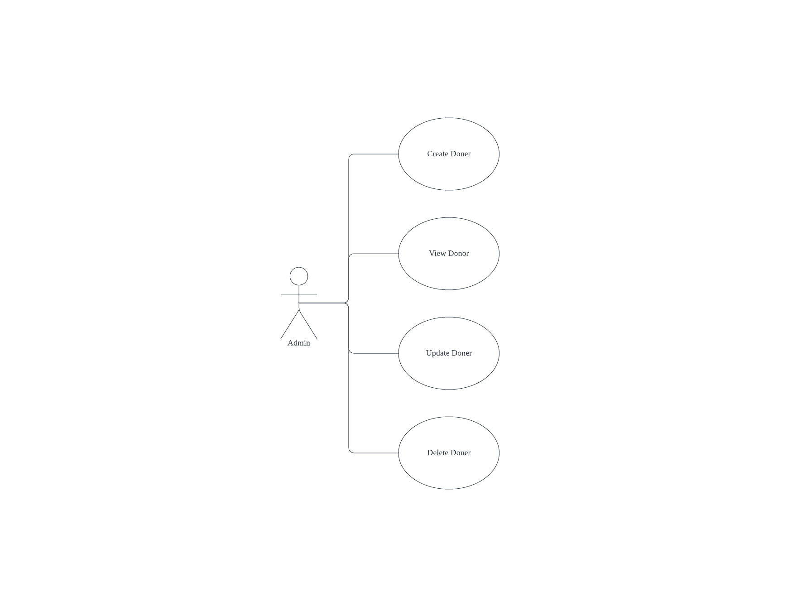

|  |  |  |
| --- | --- | --- |
| Use Case | Update a Donor | |
| Objective | Create a new Donor in the system | |
| Business Event | Create a new Donor in the system | |
| Primary Actor(s) | Admin | |
| Secondary Actor(s) | None | |
| Pre-Condition | Admin must be logged into the system  Admin clicks on the “Add Donor” button in the “Donors” page | |
| Post-Condition | Admin is forwarded to the add-donor.php | |
| Failure Outcomes | Admin is in add-donor.php  User is shown an error message ‘Error in adding a new donor’ | |
| Flow of Events | Actor | System |
| 1 | Admin is on the Donors page (donor-list.php).  Admin clicks on the “Add Donor” button which takes you to the add donor page (add-donor.php) | Add donor page is shown. |
| 2 | Admin adds donor details |  |
| 3 | Admin submits the form | Connect to the database. Insert donor details into the donor table. Forward admin to the donor-list.php page |
| 4 | Admin sees the donor-list.php for the updated donor. |  |

Use Case Activity Diagram: Create Donor

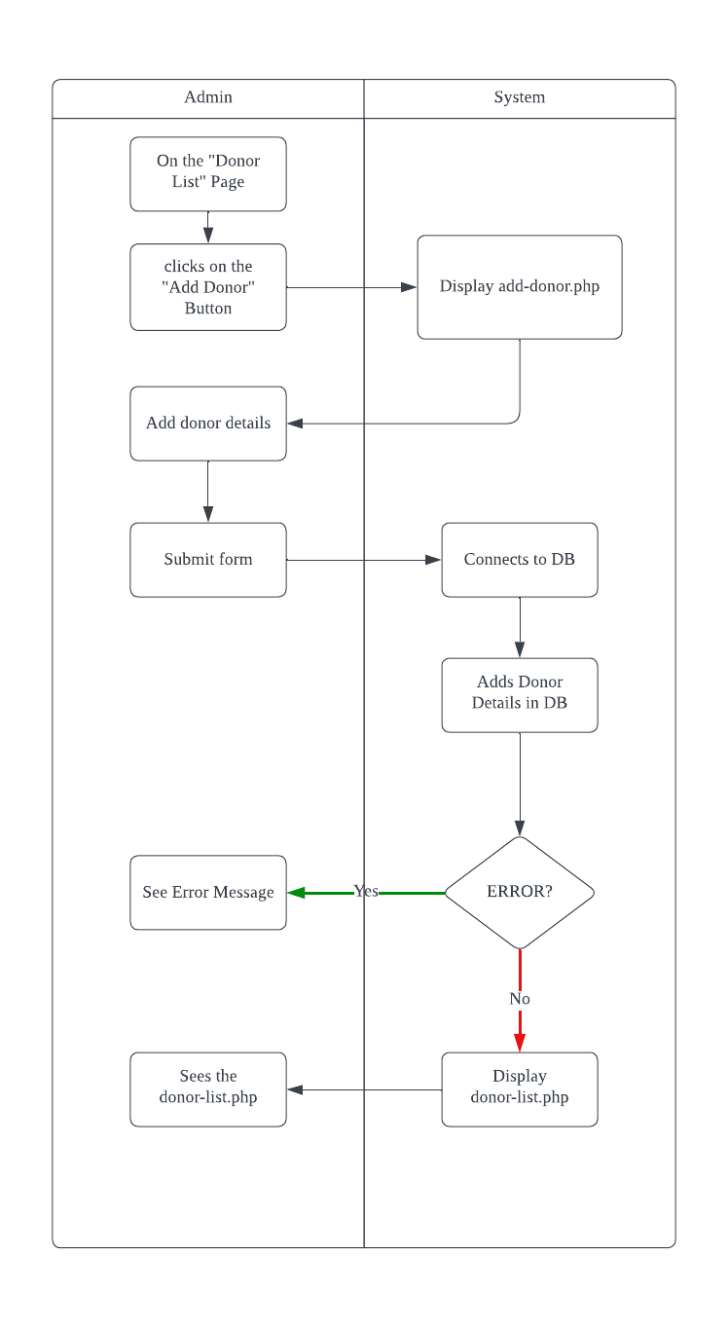

|  |  |  |
| --- | --- | --- |
| Use Case | Update a Donor | |
| Objective | View a Donor in the system | |
| Business Event | View a Donor in the system | |
| Primary Actor(s) | Admin | |
| Secondary Actor(s) | None | |
| Pre-Condition | Admin must be logged into the system  Admin clicks on the ‘Donors’ link on the homepage | |
| Post-Condition | Admin is forwarded to the View Donor List Page | |
| Failure Outcomes | Admin is in the homepage  User is shown an error message ‘Error in viewing donors’ | |
| Flow of Events | Actor | System |
| 1 | Admin is on the home page (homepage.php).  Admin clicks on the “Donors” link which takes you to the donor list page (donor-list.php) | Donor list page is shown. |
| 2 | Admin sees the donor-list.php |  |

Use Case Activity Diagram: View Donor

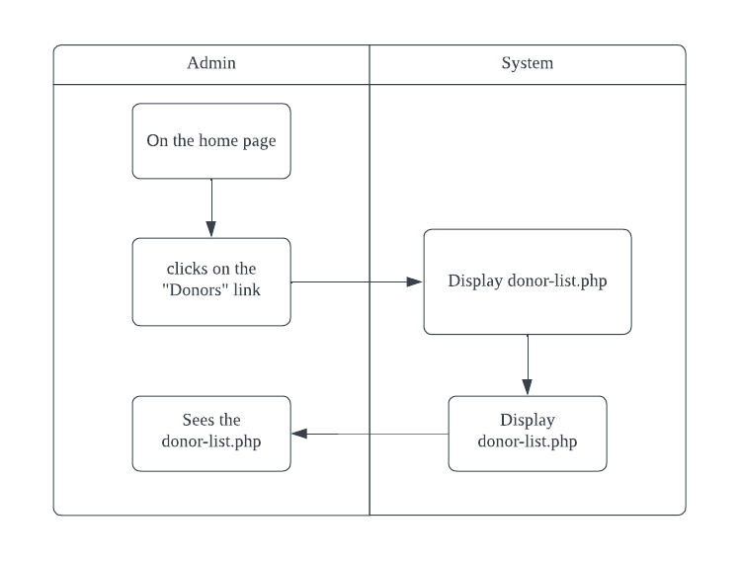

|  |  |  |
| --- | --- | --- |
| Use Case | Update a Donor | |
| Objective | Update a Donor in the system | |
| Business Event | Update a Donor in the system | |
| Primary Actor(s) | Admin | |
| Secondary Actor(s) | None | |
| Pre-Condition | Admin must be logged into the system  Admin clicks on the “Edit” Button link on the donor-details.php | |
| Post-Condition | Admin is forwarded to the edit-donor.php | |
| Failure Outcomes | Admin is in the edit-donor.php Page  User is shown an error message ‘Error in updating donors’ | |
| Flow of Events | Actor | System |
| 1 | Admin is on some donors details page (donor-details.php).  Admin clicks on the “Edit” button which takes you to the update donor page (edit-donor.php) | Edit donor page is shown. |
| 2 | Admin updates desired donor details |  |
| 3 | Admin saves changes | Connect to the database, update donor details into the donor table. Forward admin to the donor-details.php page |
| 4 | Admin sees the donor-details.php for the updated donor. |  |

Use Case Activity Diagram: Update Donor

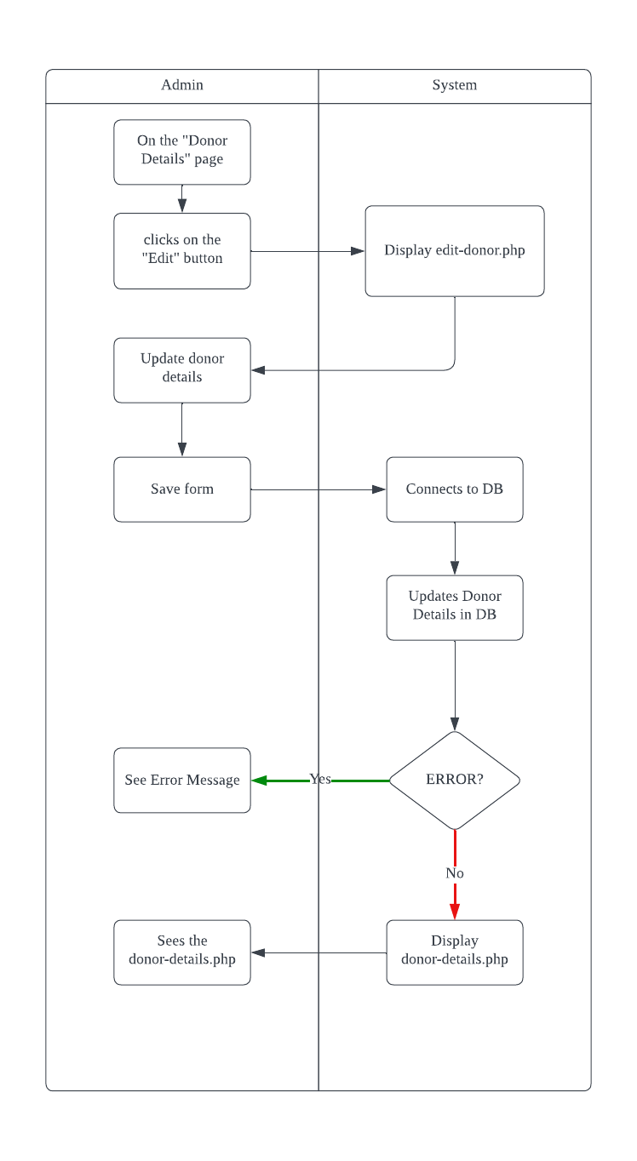

|  |  |  |
| --- | --- | --- |
| Use Case | Update a Donor | |
| Objective | Delete a Donor in the system | |
| Business Event | Delete a Donor in the system | |
| Primary Actor(s) | Admin | |
| Secondary Actor(s) | None | |
| Pre-Condition | Admin must be logged into the system  Admin clicks on the trash icon on the donor-list.php | |
| Post-Condition | Admin is forwarded to the Deletion Confirmation Page | |
| Failure Outcomes | Admin is in the donor-list.php Page  User is shown an error message ‘Error in deleting donors’ | |
| Flow of Events | Actor | System |
| 1 | Admin is on some donor list page (donor-list.php).  Admin clicks on the trash can icon which takes you to the deletion confirmation page (deletion-confirmation.php) | Deletion confirmation page is shown. |
| 2 | Admin confirms deletion | Connect to the database, update donor details into the donor table. Forward admin to the donor-details.php page |
| 3 | Admin sees the deletion-confirmation.php for the selected donor. |  |

Use Case Activity Diagram: Delete Donor

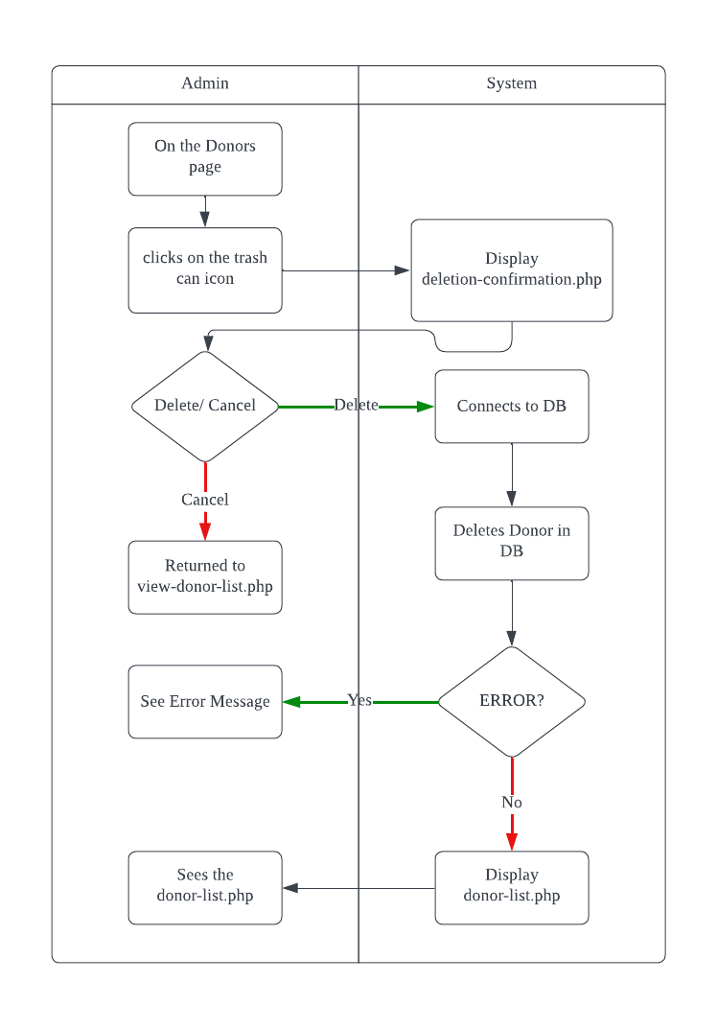

ERD:

**Wire Frames:**

donor-list.php wire frame

donor-details.php wire frame

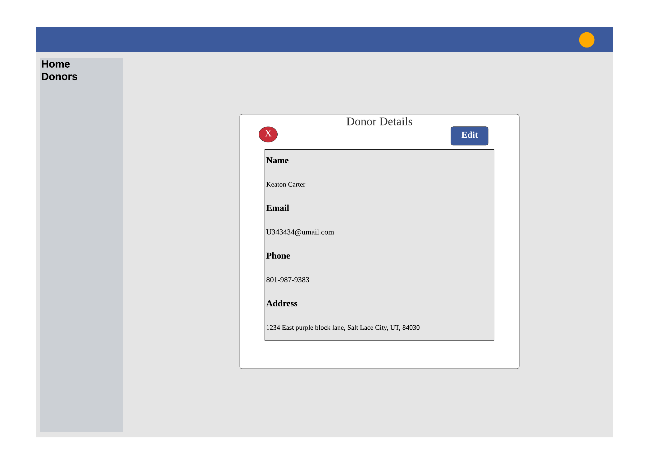

add-donor.php wire frame

edit-donor.php wire fram

