

**CSE488 (Section 1)**

**[Summer 2022]**

**Lab Assignment Submission Report**

**Assignment Title: Lab03 (Offline)**

**Submitted by:**

**Md. Monwar Hossain**

**ID: 2019-1-60-052**

**### A flat file (instructor.txt) is given as per the following format:  
1, Alice, CSE, 45000  
2, Bob, EEE, 35000  
3, Charlie, ECE, 56000  
4, Don, CSE, 75000  
5, Elton, EEE, 25000  
6, Fox, ECE, 36000  
Each line represents an instructor. The first value is id, next name, next department name and the last value is the salary.**

**Problem 1:***Find instructor id, name, and department who get a salary of more than 50000.*

1. **Required Code for the Jar File:**

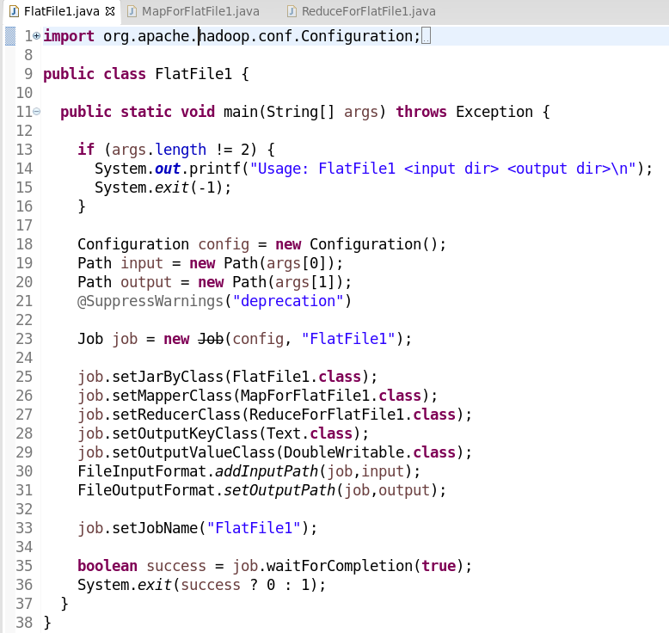

*Fig: FlatFile1.java*

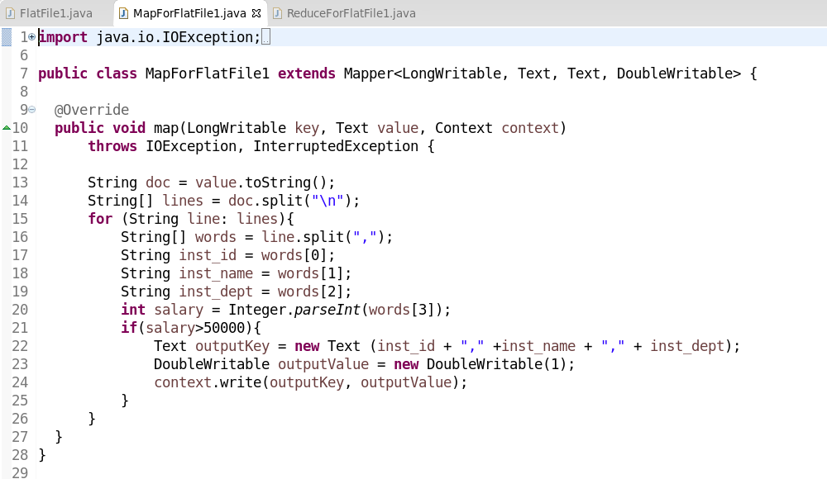

*Fig: MapForFlatFile1.java*

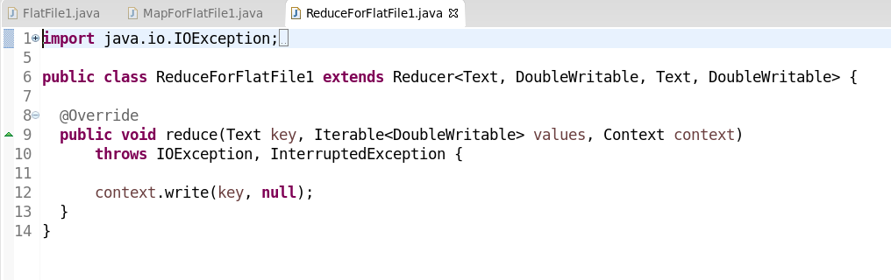

*Fig: ReduceForFlatFile1.java*

1. **Command Lines in Command Prompt & Output:**

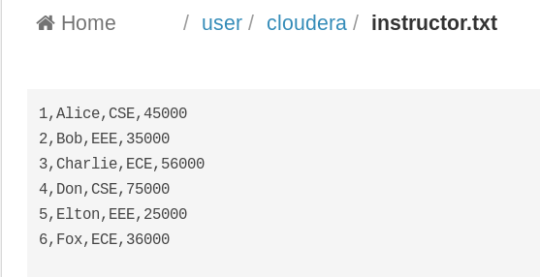

*Fig: Input File*

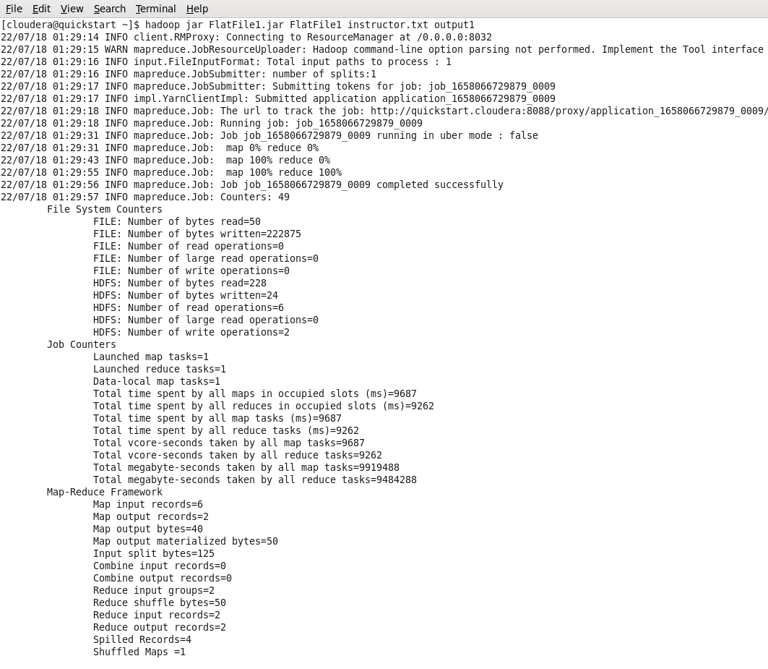

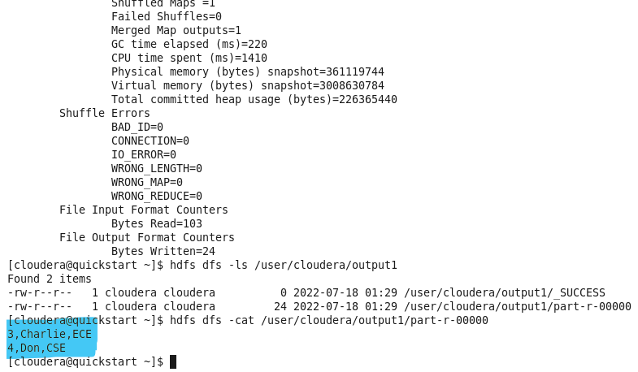

*Fig: Command Prompt*

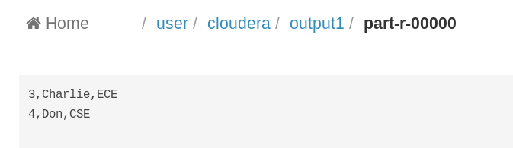

*Fig: Output File*

**Problem 2:**   
Find the number of instructors who gets a salary of more than 40000.

1. **Required Code for the Jar File:**

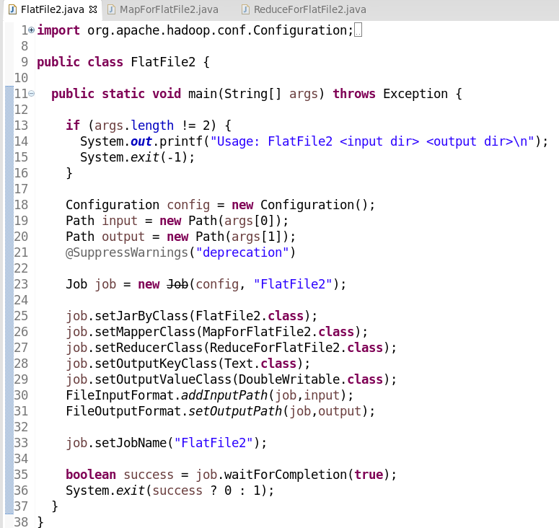

*Fig: FlatFile2.java*

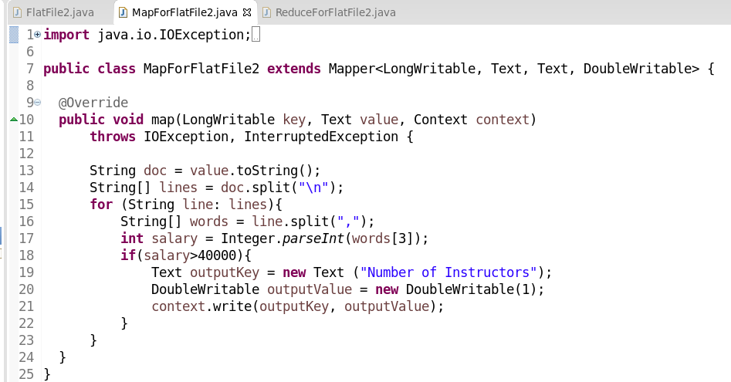

*Fig: MapForFlatFile2.java*

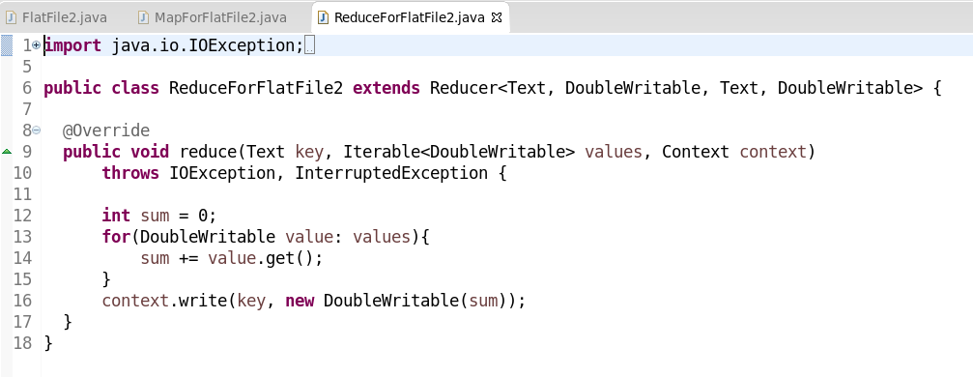

*Fig: ReduceForFlatFile2.java*

1. **Command Lines in Command Prompt & Output:**



*Fig: Input File*

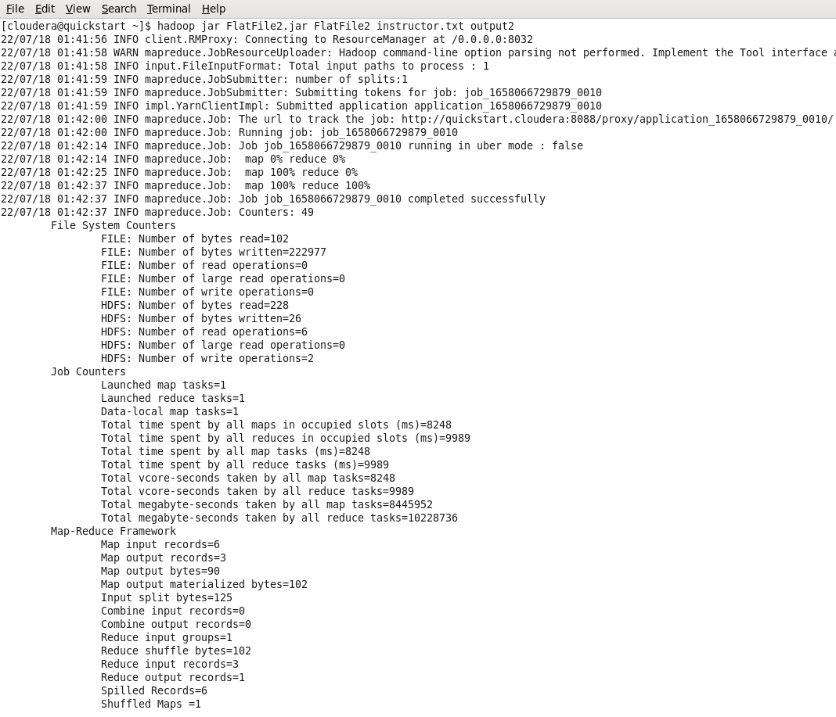

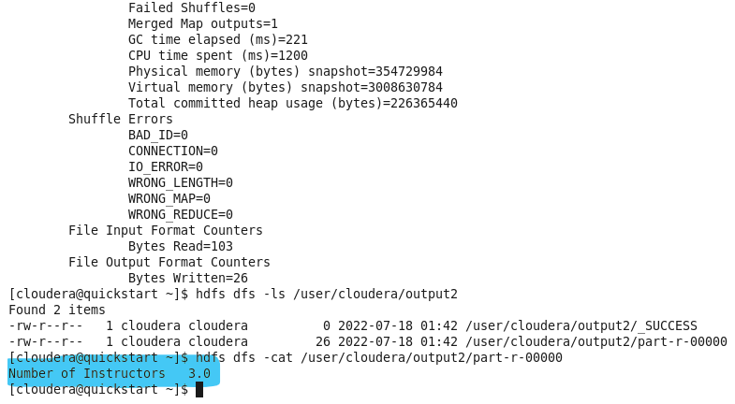

*Fig: Command Prompt*

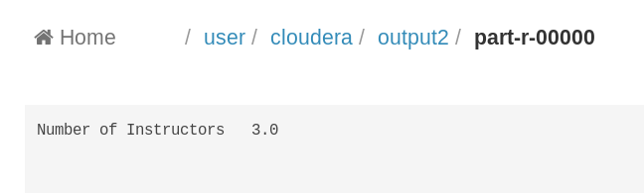

*Fig: Output File*

Problem 3:   
Find the average and sum of salaries of instructors for each department. You must use a combiner in this case.

1. **Required Code for the Jar File:**

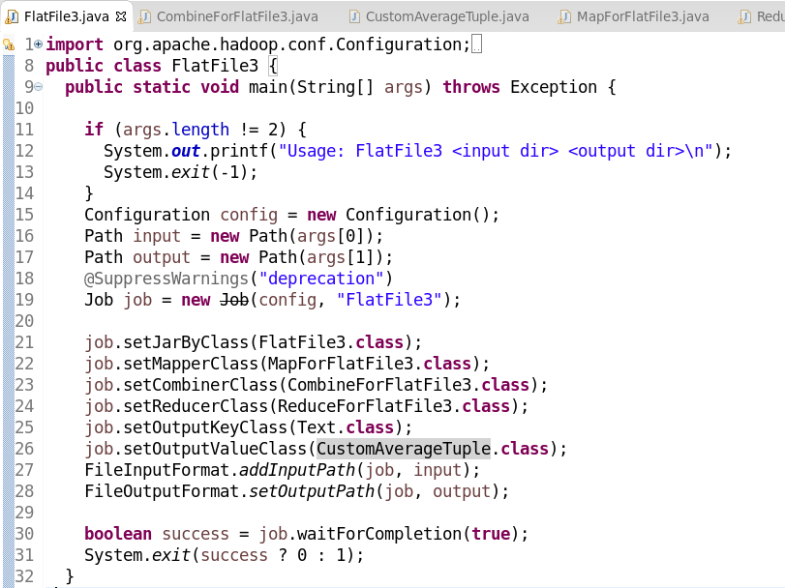

*Fig: FlatFile3.java*

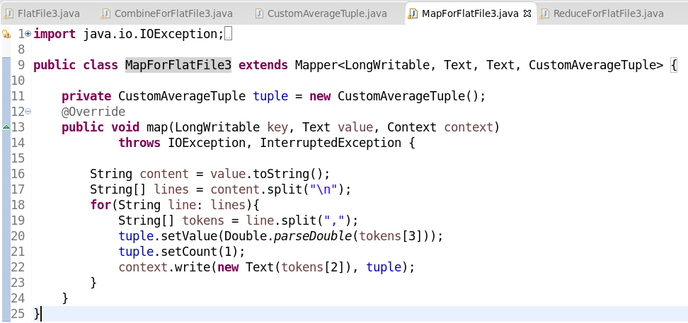

*Fig: MapForFlatFile3.java*

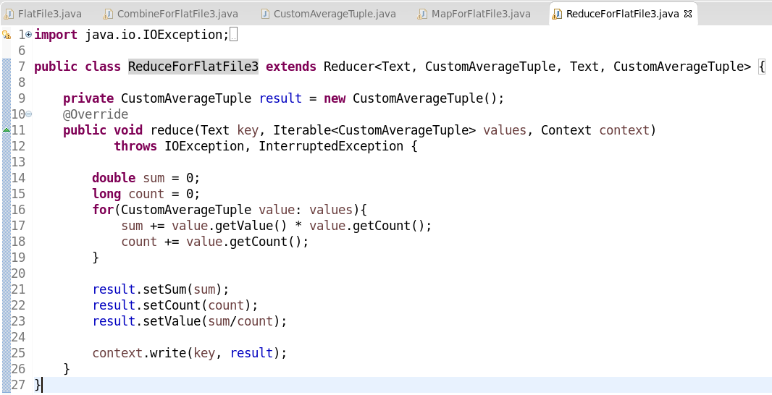

*Fig: ReduceForFlatFile3.java*

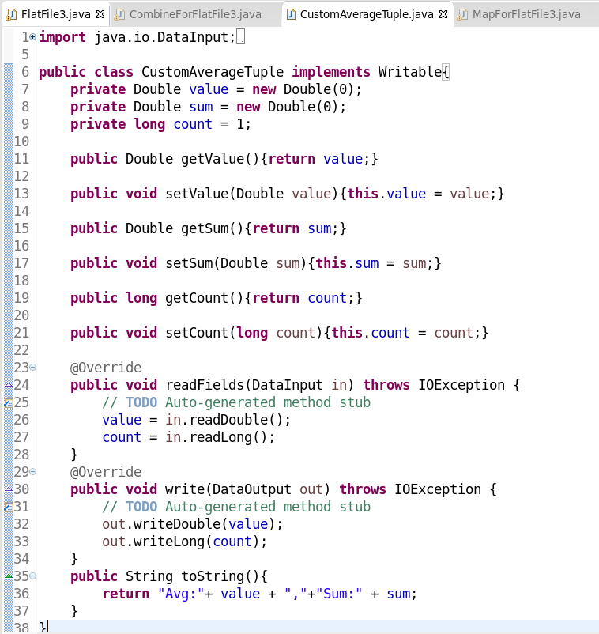

*Fig: CustomAverageTuple.java*

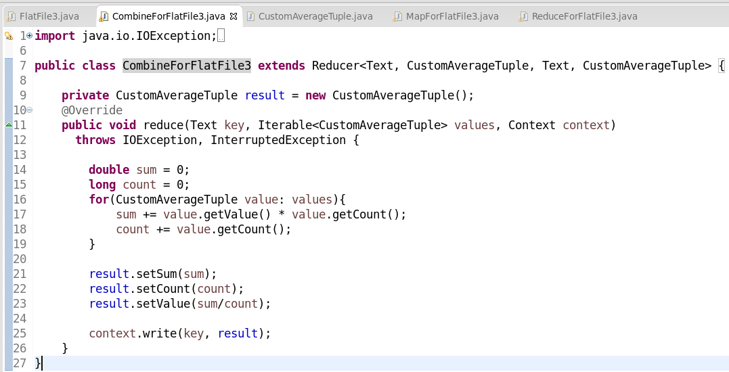

*Fig: CombineForFlatFile3.java*

1. **Command Lines in Command Prompt & Output:**



*Fig: Input File*

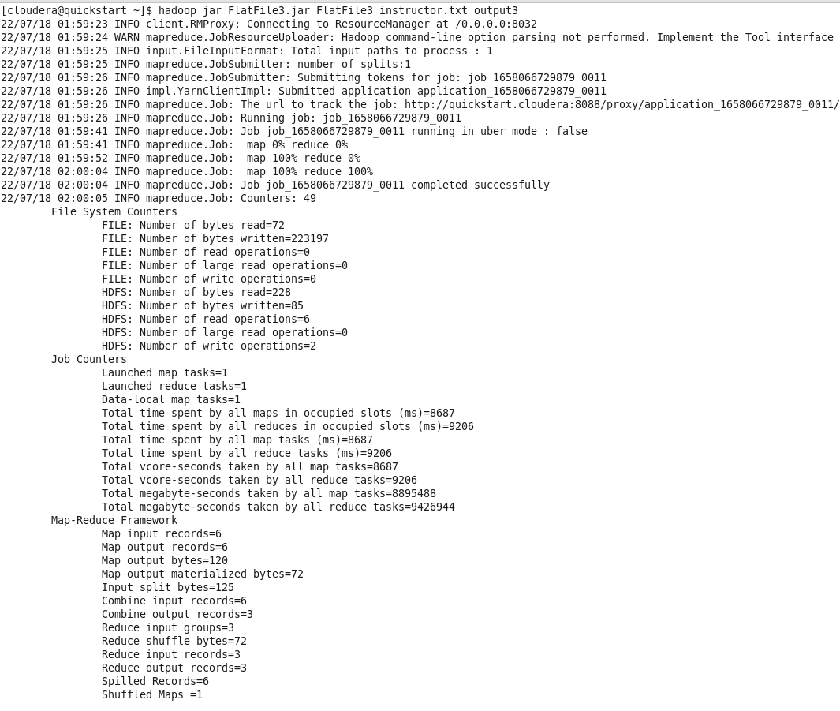

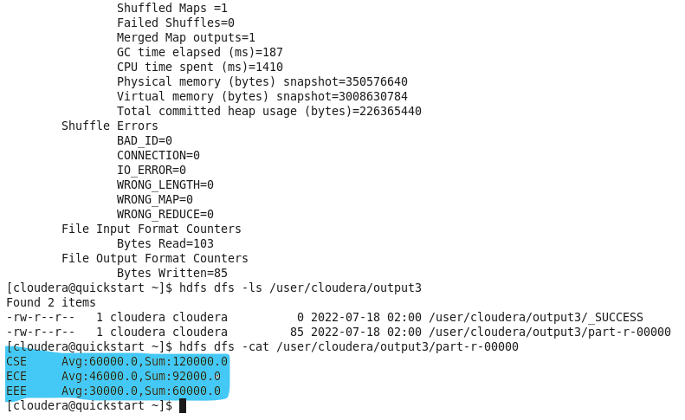

*Fig: Command Prompt*

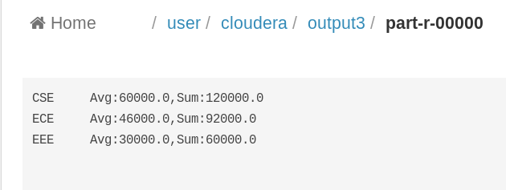

*Fig: Output File*

**Learning Outcome:**

I have learnt about the mapping and reducing complexity. How to calculate the average in combine file, how to use tuple in output, how to split the doc file, how to separate the member document as group wise.

END