

East West University

Department of CSE

Lab-05 Report

|  |  |
| --- | --- |
| **Course Code:** CSE488 | |
| **Course Title:** Big Data Analytics | |
| **Title: U**sing pySpark | |
| **Name of Students & ID:**  Md. Monwar Hossain  ID:2019-1-60-052  Section: 01 | **Course Instructor information:**  Dr. Mohammad Rezwanul Huq,  Associate Professor,  Department of Computer Science &  Engineering, East West University |
| **Date of Report Submission: 18/09/2022** | |

**Solve the following queries using pySpark. For each solution, think about a suitable graph/chart to visualize the result**  
***Q1.****Find the number of missions completed on each day for each of the countries involved.*

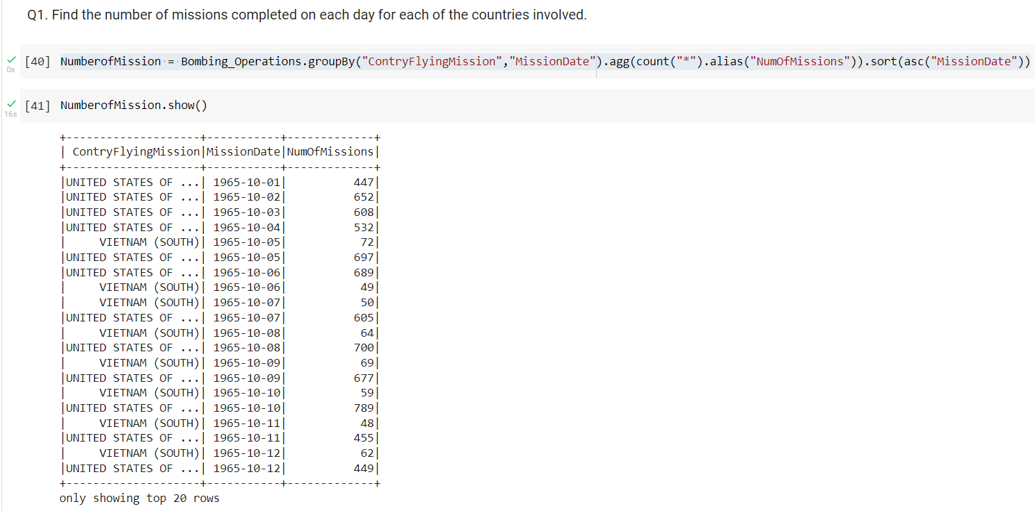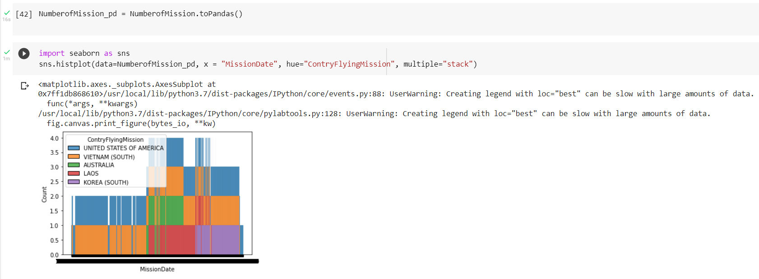

***Q2.*** *Find the number of missions completed for each take-off location on June 29, 1966 by the US Air Force over NORTH VIETNAM.*

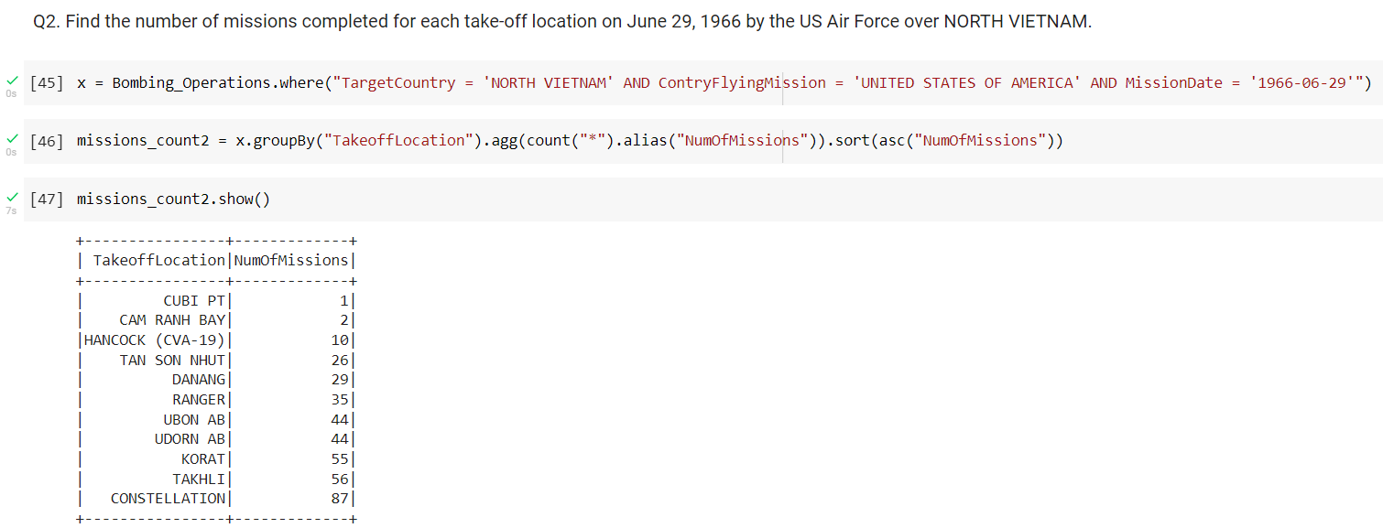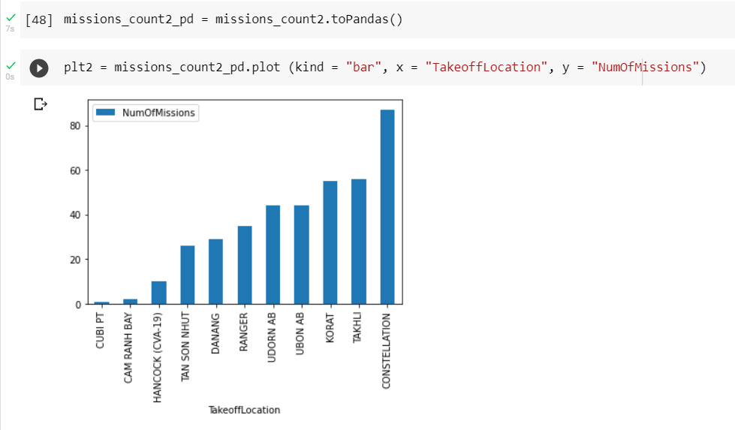

***Q3.*** *Find the number of times each AirCraftType used during the Vietnam war. (need join operation)*

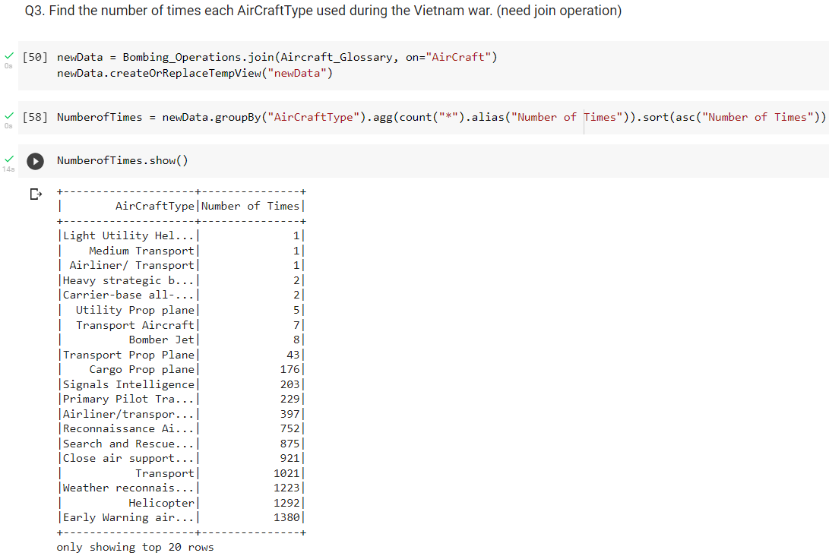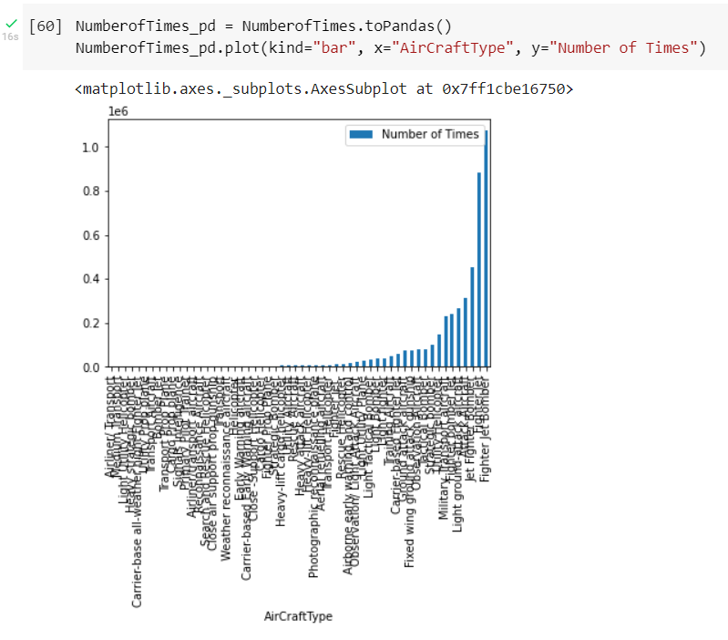

**Learning Outcomes:**

Here we can learn use of pySpark and the use of the query in the pySpark and the visualization of the query.