E-Commerce Sales Data Analysis, Prediction and Customer Segmentation Using Python
Programming for Data Science | Final Project Report

Abstract
This project extends an existing RFM-based customer segmentation notebook into a combined e-commerce analytics and prediction workflow. The UCI Online Retail dataset contains 541,909 transaction lines, of which 397,884 remain after cleaning. Exploratory analysis examines monthly sales and geographical differences. A Random Forest regression model uses lagged sales, rolling averages and calendar features to predict daily revenue in a chronological holdout period. The test MAE is £11,257.85, RMSE is £21,906.92, and R² is 0.314. A 7-day seasonal-naive benchmark achieves MAE £13,155.37. The original K-Means model groups 4,338 customers into high-, mid- and low-engagement segments. The combined approach illustrates descriptive analytics, supervised learning and unsupervised learning in one Python workflow.

1. Introduction and Objectives
E-commerce transaction records support multiple analytical questions: how sales change over time, how future sales might be estimated from recent history, and how customers differ in purchasing behaviour. This project uses one dataset to answer all three questions using Python.
Objectives: (i) clean retail transactions, (ii) explore sales patterns, (iii) evaluate a daily-sales prediction model on unseen dates, (iv) identify customer segments using RFM and K-Means, and (v) translate findings into practical business interpretations.

2. Dataset and Cleaning
Source: Chen (2015), UCI Online Retail. Original: 541,909 rows and 8 columns. Removed missing CustomerID values, cancelled invoices (invoice numbers beginning with C), and non-positive quantities or unit prices. Retained 397,884 transaction lines, 18,532 invoices and 4,338 customers. Transaction-line Sales = Quantity × UnitPrice; cleaned total sales = £8,911,407.90. The transaction period runs from 01 December 2010 to 09 December 2011.

3. Exploratory Sales Analysis
Monthly sales show substantial variation, with a marked rise in the autumn months and a partial final month in December 2011. Country-level revenue is unevenly distributed. Monthly totals must be interpreted with care because the first and last calendar months do not cover equal observation periods.
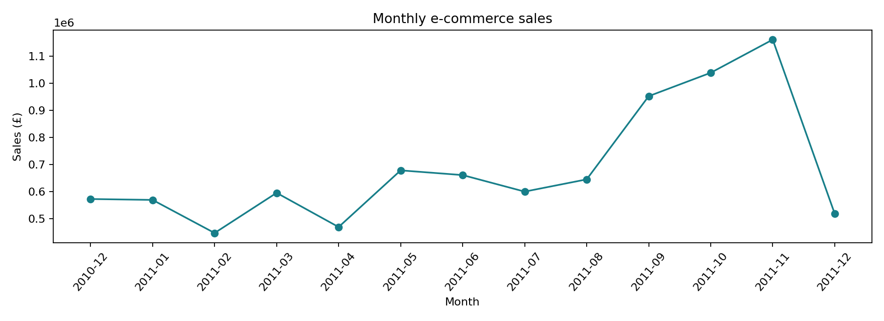
Figure 1. Monthly sales in the cleaned dataset.
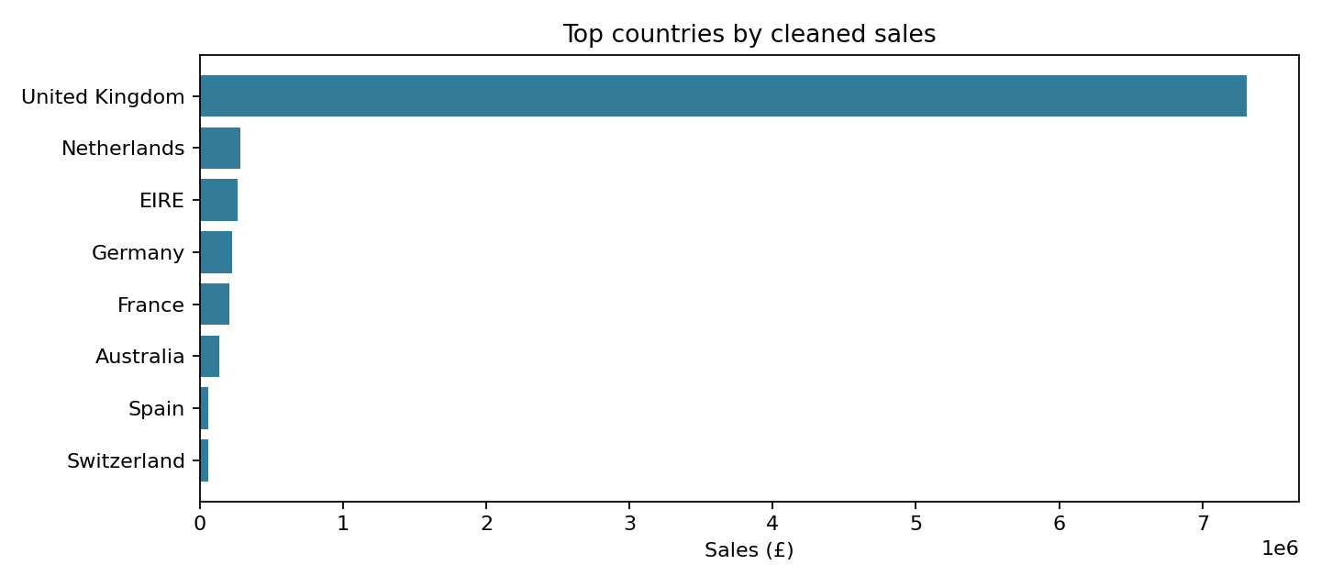
Figure 2. Countries with the highest recorded sales.

4. Sales Prediction Methodology
Daily sales were computed by summing cleaned transaction-line sales for each date. Dates without recorded transactions were assigned zero sales, yielding 374 calendar days. Predictors included previous-day sales, 7- and 14-day lags, rolling 7- and 14-day averages based on earlier days only, day of week, day of month, month and weekend indicator. The first 14 days were excluded because lag features were unavailable.
The remaining 360 days were divided chronologically: 288 training days and 72 testing days (29 September 2011–09 December 2011). RandomForestRegressor used 180 trees, maximum depth 9, minimum leaf size 3 and random_state=42. The benchmark predicts sales equal to the value seven days earlier. This is a historical one-step-ahead evaluation: actual preceding-day sales are available when making each test-date prediction. Random splitting was avoided to preserve temporal order.

5. Prediction Results
Metric | Random Forest | Lag-7 baseline
MAE (£) | 11,257.85 | 13,155.37
RMSE (£) | 21,906.92 | 22,451.47
R² | 0.314 | —
WAPE | 28.91% | —
MAE and RMSE are measured in pounds of daily sales. Lower is better. R² describes the model’s fit on the held-out dates and may be negative if the model underperforms a constant-mean predictor. WAPE is the total absolute prediction error divided by total actual test sales. The lag-7 benchmark is included to prevent overclaiming model usefulness.
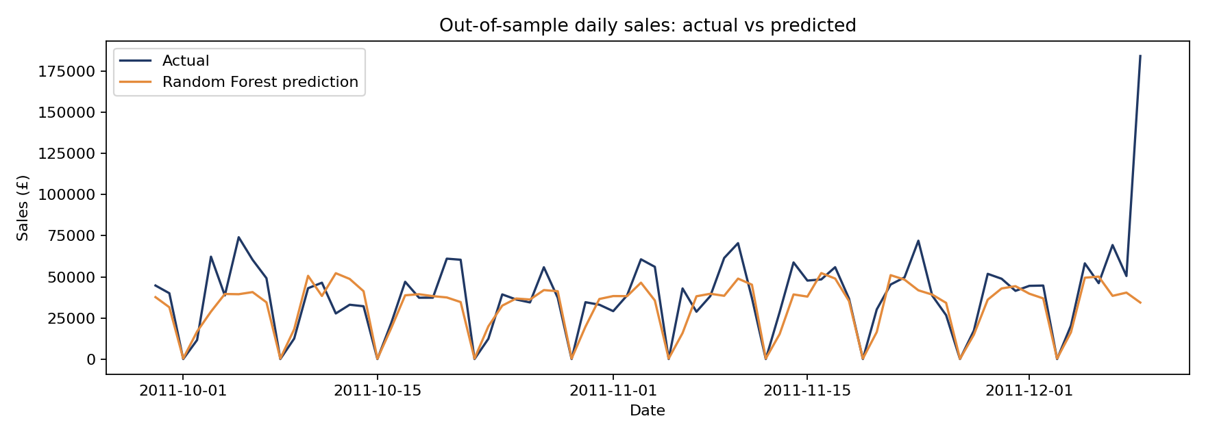
Figure 3. Actual and predicted sales on the chronological test period.
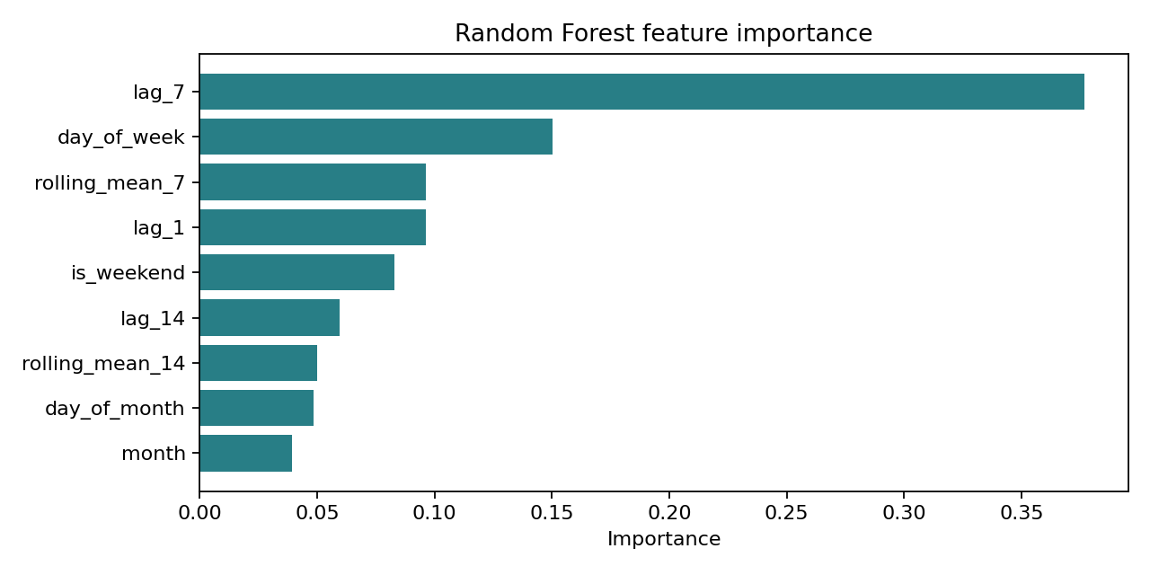
Figure 4. Feature importance within the fitted Random Forest.

6. RFM Customer Segmentation
The original notebook’s segmentation analysis is preserved. Recency is days since the last purchase (reference date 10 December 2011), Frequency counts distinct invoices, and Monetary sums customer spending. Features are transformed with log1p and standardised, then K-Means is fitted. Although K=2 has the highest silhouette score (0.4326), K=3 (0.3377) is retained for three interpretable business groups (Mehta & Sehgal, 2024; Rousseeuw, 1987).
Segment | Customers | Median R (days) | Median F | Median M (£)
High-value | 757 (17.45%) | 10 | 10 | 3,722.82
Mid-value | 1,695 (39.07%) | 30 | 3 | 982.38
Low-engagement | 1,886 (43.48%) | 158 | 1 | 299.81
The low-engagement label is descriptive and does not constitute a validated future-churn prediction. High-value customers may merit retention, mid-value customers cross-selling, and low-engagement customers carefully tested reactivation efforts.

7. Conclusions and Limitations
This adapted project demonstrates a complete Python data-science workflow: transaction cleaning, sales EDA, chronological predictive evaluation and customer clustering. Sales prediction is an added experiment, while the RFM segmentation findings are carried over from the original project. The available history spans roughly one year, lacks promotions and stock availability, and contains zero-filled dates; these constraints limit the reliability of longer-term forecasts. The predictive test is not a recursive future forecast. Future work should test more temporal folds, alternative models and external explanatory variables.

References
Chen, D. (2015). Online Retail [Data set]. UCI Machine Learning Repository. https://doi.org/10.24432/C5BW33
Mehta, D., & Sehgal, S. (2024). A study on micro-segmentation of retail customers using K-means clustering. Journal of Business Thought, 15, 75–87. https://doi.org/10.18311/jbt/2024/44468
Rousseeuw, P. J. (1987). Silhouettes: A graphical aid to the interpretation and validation of cluster analysis. Journal of Computational and Applied Mathematics, 20, 53–65. https://doi.org/10.1016/0377-0427(87)90125-7

