# CareStack Health – Patient Care & Daycare Management System

(System Design & Implementation Guide)

A multi-role healthcare platform for Patients, Doctors, Daycare Nurses, Compounders (Doctor's Assistants), Ambulance Drivers, and Hospital Admins — PHP/MySQL, secure RBAC, reusable UI.

## 1) Introduction

CareStack Health unifies emergency care (ambulance + ICU), consultations and prescriptions, nurse-centric daycare with document verification, admin-managed reports, and billing (including distance-based ambulance fares). This guide explains the roles, modules, data model, and build plan so anyone can understand and implement it.

The system now includes:

- Professional verification for medical staff (BM&DC for doctors, admin verification for nurses)

- Location-based hospital discovery

- Comprehensive rating system for all service providers

- SOS emergency functionality with location tracking

- Custom ambulance routing

- Enhanced billing management with role-based permissions

- Real-time chat between patients and healthcare providers

- Flexible appointment scheduling with multi-hospital support

- Doctor availability management across multiple hospitals

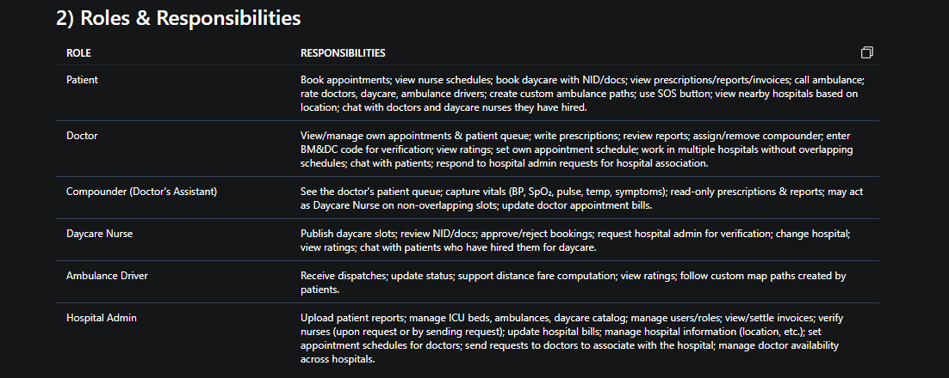

## 3) Confirmed Rules

• Two nurse types: Daycare Nurse and Compounder (doctor's assistant).

• A Compounder may also be a Daycare Nurse only when daycare slots do not overlap with the doctor's duty slots.

• Compounder can access the doctor's patient queue (appointments list) only for their assigned doctor.

• Doctor writes prescriptions; Compounder is read-only on prescriptions & reports, but records vitals that auto-attach to prescriptions.

• Hospital Admin uploads reports; visible to Patient, Doctor, and Compounder.

• Billing includes consultation, daycare, reports, and distance-based ambulance fare added automatically.

• Doctor must be verified using BM&DC code to use the system.

• Nurse must be verified by hospital admin to be available for daycare service. Verification can be initiated by nurse (request to admin) or by admin (sending request to nurse). Verified nurse gets a badge.

• Nurse can change hospital (with re-verification at the new hospital).

• Patients can rate doctors, daycare services, and ambulance drivers. System will suggest top-rated providers.

• Hospitals are displayed to users based on their current location (distance-based).

• Only hospital admin can upload, edit, or remove patient reports. Doctors, compounders, and patients can only view.

• Compounder can capture basic vitals and attach to prescriptions but cannot add medicines.

• Nurses (both compounders and daycare nurses) can only read prescriptions (no edit/delete).

• Patient can create a custom path on the map for ambulance drivers to follow.

• SOS button: For registered users, auto-fill user data; for non-registered, capture phone number and location.

• Ambulance bill is added to the hospital bill.

• Hospital management updates hospital bills; compounder updates doctor appointment bills.

• **New Rules:**

- Patients can chat with doctors they have appointments with and daycare nurses they have hired.

- Doctors can set their own appointment schedules. Hospital admins can also set schedules for doctors.

- Hospital admin can send requests to doctors to associate with their hospital. Upon acceptance, the doctor will be listed as available at that hospital.

- Doctors can work in multiple hospitals, but their schedules must not overlap (enforced by the system).

## 4) Modules

### Emergency Care

• Ambulance: nearest driver dispatch; fare = base + per_km × distance; added to invoice automatically; custom map path for navigation; SOS button integration.

• ICU beds: per-hospital capacity and occupancy.

### Consultation & Prescriptions

• Appointments (Doctor↔Patient); Doctor & Compounder see queue; Compounder captures vitals (BP, SpO2, etc.) and attaches to prescriptions; Doctor writes prescriptions (only doctors can add medicines).

### Daycare

• Daycare nurses publish slots; patient books with NID/docs; nurse reviews/approves; non-overlap rule for compounder; nurse verification and badge; rating system.

### Reports

• Admin uploads patient reports; secure access for patient/doctor/compounder; only admin can edit/remove.

### Billing

• Invoices & items; ambulance fare auto-posted from ambulance call distance; hospital bills (updated by hospital admin) and doctor appointment bills (updated by compounder).

### Verification & Badges

• Doctor verification via BM&DC code.

• Nurse verification process (two-way) and badge display.

### Rating System

• Patients can rate doctors, daycare services, and ambulance drivers; system calculates average ratings and suggests top-rated providers.

### Location Services

• Display nearby hospitals based on user location.

• Custom map path creation for ambulance navigation.

### SOS Emergency

• SOS button for emergency requests; auto-fill data for registered users; capture phone and location for non-registered.

### **New Modules:**

#### Chat System

• Real-time messaging between patients and doctors (for appointments) and patients and daycare nurses (for hired daycare services).

• Chat history stored and accessible by involved parties.

#### Appointment Scheduling

• Doctors can set their available time slots for appointments.

• Hospital admins can also set appointment schedules for doctors.

• System prevents overlapping schedules for doctors working in multiple hospitals.

#### Doctor-Hospital Association

• Hospital admin can send requests to doctors to associate with their hospital.

• Doctors can accept or reject these requests.

• Upon acceptance, the doctor is listed as available at that hospital for appointments.

## 5) Architecture Overview

• PHP micro-MVC: front controller + Router → Controller → Model → View (components/layout).

• RBAC: users, roles, permissions; pivots for user_roles & role_permissions.

• Doctor↔Compounder link (doctor_compounders) controls queue access; nurse_slots purpose distinguishes duties.

• Uploads stored outside public/; downloads via permission-checked endpoints.

• Integration with mapping services for location-based features and custom paths.

• External BM&DC verification API for doctor verification.

• Rating calculation engine.

• **New:**

- WebSocket or similar technology for real-time chat functionality.

- Calendar/scheduling component for appointment management with conflict detection.

## 6) Database Schema (High-Level)

• users, roles, permissions, user_roles, role_permissions

• hospitals (with location: latitude, longitude), doctors (user_id, bmdc_code, verified), nurses (user_id, is_daycare, is_compounder, verified, current_hospital_id)

• doctor_slots (duty), nurse_slots (purpose: 'daycare'|'compounder_support', non-overlap validated in app)

• doctor_compounders (doctor_id ↔ nurse_id)

• appointments (patient_id, doctor_id, starts_at, status) + patient_queue views

• patient_vitals (captured by compounder), prescriptions, prescription_items (only doctors can add items)

• patient_reports (uploaded_by admin; visible to patient/doctor/compounder; admin can edit/remove)

• daycare_procedures, daycare_bookings (NID/docs, nurse approves)

• icu_beds, ambulances, ambulance_calls (distance_km, fare, custom_path_data)

• invoices, invoice_items (consultation/daycare/report/ambulance)

• verifications (for doctor and nurse verifications, with status, badge)

• ratings (id, user_id (patient), target_id (doctor/nurse/ambulance_driver), target_type, rating, comment)

• sos_requests (id, user_id (if registered), phone, location, status)

• hospital_bills (id, hospital_id, amount, updated_by_admin, etc.)

• appointment_bills (id, appointment_id, amount, updated_by_compounder)

• **New Tables:**

- `chats` (id, sender_id, receiver_id, message, timestamp, related_appointment_id (optional), related_daycare_booking_id (optional))

- `doctor_hospitals` (id, doctor_id, hospital_id, status (pending/accepted/rejected), requested_by (doctor/admin))

- `appointment_slots` (id, doctor_id, hospital_id, start_time, end_time, created_by (doctor/admin))

## 7) Permissions (RBAC)

• patient: appointment.create/view.self, nurse_schedule.view, daycare.book, records.upload, invoice.view, ambulance.call, sos.create, rating.create, map_path.create, hospital.view_nearby, chat.with_doctor, chat.with_daycare_nurse

• doctor: appointment.view.doctor, patient_queue.view, prescriptions.create/view, reports.view, compounder.assign, bmdc.verify (own), ratings.view (own), appointment_slot.create/manage, hospital_association.respond, chat.with_patient

• compounder: patient_queue.view (assigned doctor only), vitals.capture, prescriptions.view (read-only), reports.view (read-only), appointment_bill.update

• daycare nurse: nurse_schedule.manage (purpose=daycare), daycare.review_docs, verification.request, hospital.change, ratings.view (own), chat.with_patient (for hired daycare)

• admin: users.manage, reports.upload/edit/remove, icu.update, ambulance.update, daycare.manage, invoices.manage, nurse.verify, hospital_bill.update, hospital.manage, appointment_slot.create/manage (for doctors), doctor_hospital_association.request