|  |
| --- |
| [06/23/2017] |

|  |
| --- |
| [Boulder Dash] Group 6 |

# Summary

We had 1.5 week to do a remake of the abandonware "Boulder Dash" in team of 4.

1. The objective of the game is to pick up 10 diamonds without dying but some monsters and obstacles will make the game more difficult.

## Required Features

We have created five levels and stock them in a database, three of them include some different monsters.

Rockford (the hero of the game), and dig stones when he walk. He's blocked by the walls and the rocks but he can move them. Rockford is killed when a rock or diamond falls on him.

Monsters are killed too when a rock or diamond falls on them. They can't dig, move rocks and pass through obstacles.

The game is over when Rockford dead's or picked up 10 diamonds.

## Initial Planning

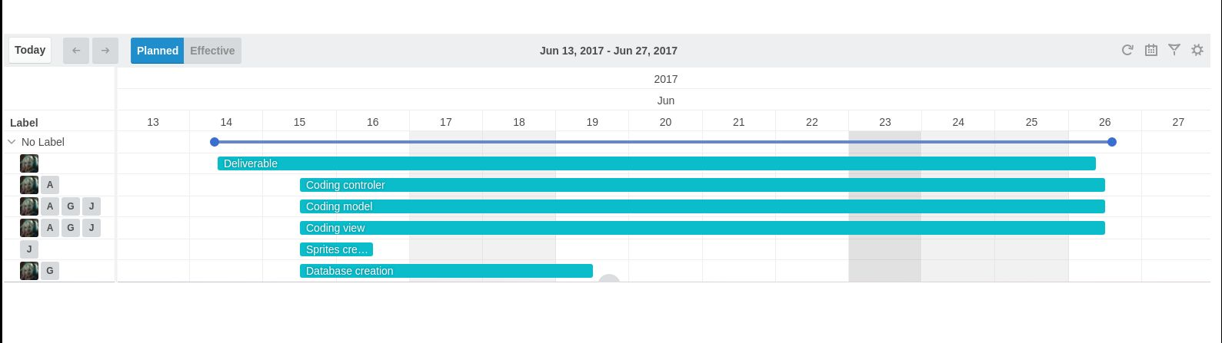

## 

## 

## Class Diagram

#### Sprite :

#### Movement, main, database and monster :

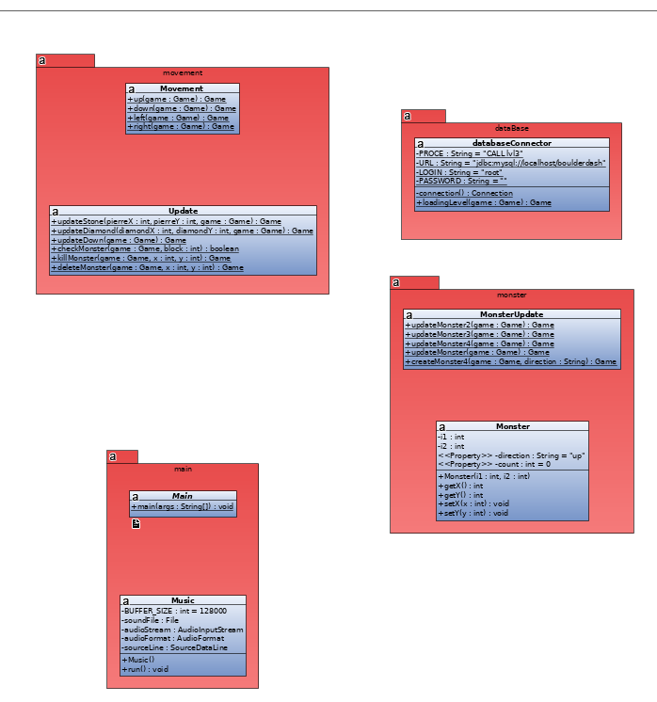

#### View :

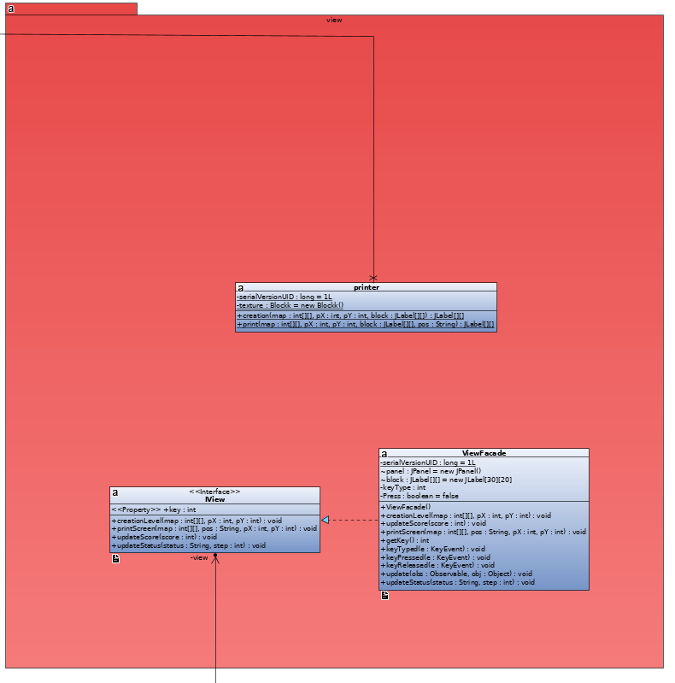

#### Model :

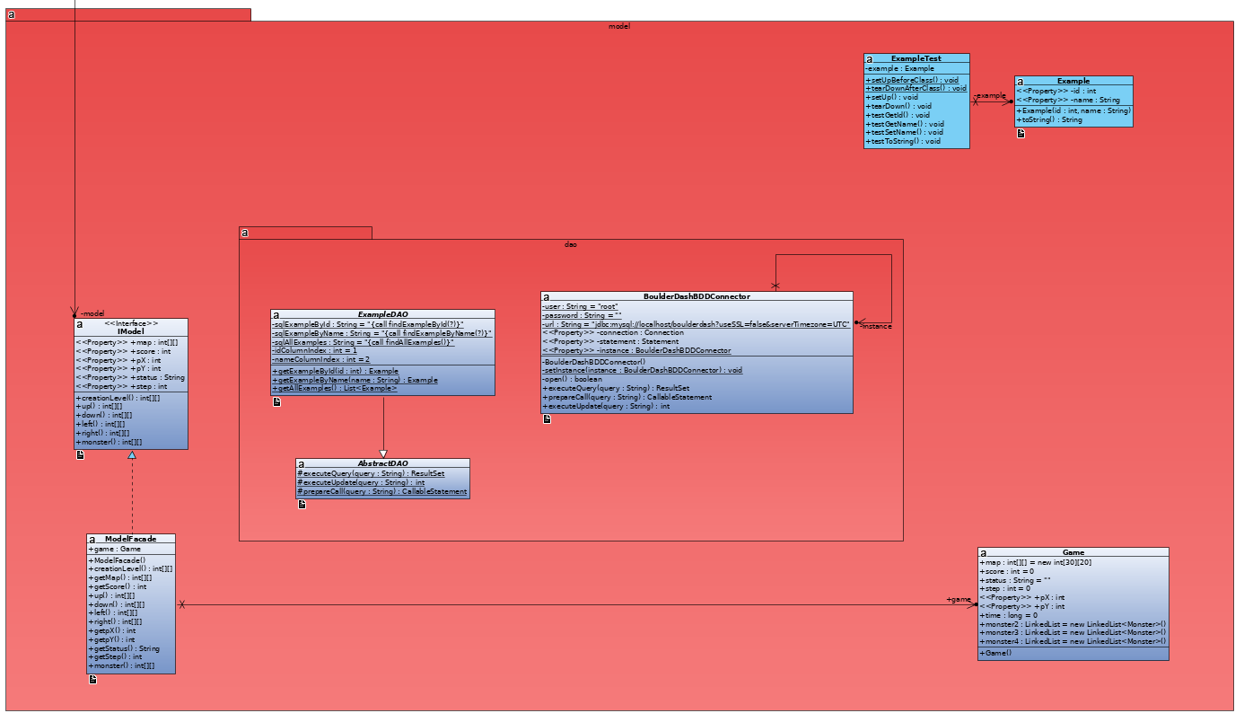

## Packages Diagram :

