restful接口设计

V1.0

目录

1 数据模型 3

公司表company 3

部门表department 3

雇员表employee 4

雇员信息表employee_info 4

2 restful接口说明 5

公司表相关 5

部门表相关 10

雇员表相关 16

异常情况 23

# 数据模型

## 公司表company

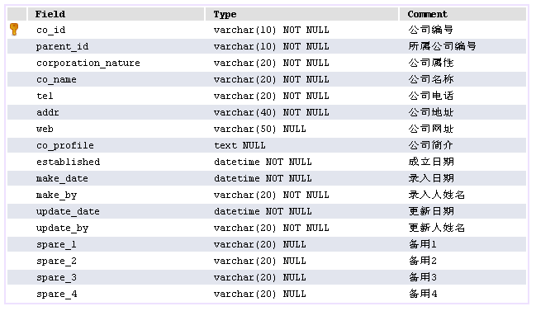

## 部门表department

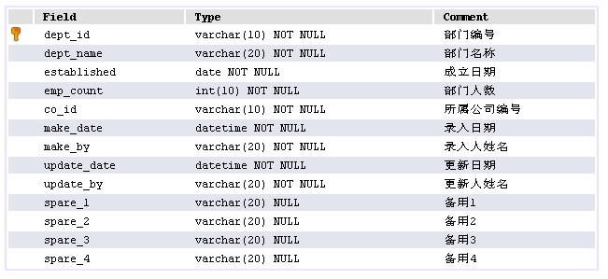

## 雇员表employee

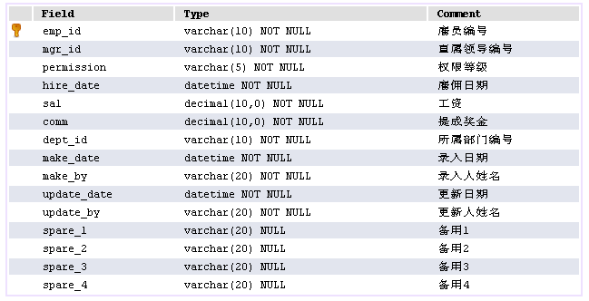

decima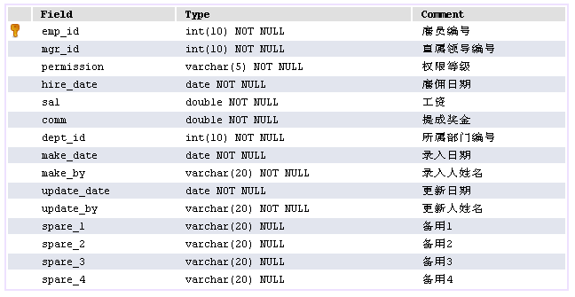l

## 雇员信息表employee_info

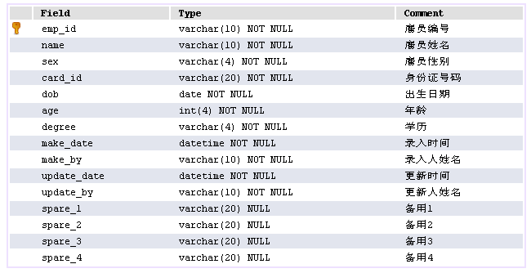

# restful接口说明

## 公司表相关

##### GET

|  |  |
| --- | --- |
| 请求方法 | GET |
| URL | http://locahost:8080/co/{id} |
| 参数说明 | id公司编码 |
| 示例 | http://locahost:8080/co/1 |
| 返回值 | {  "code": "success",  "data": {  "coId": 1,  "parentId": 1,  "corporationNature": "股份制企业",  "coName": "阿里巴巴",  "tel": "86-571-88480877",  "addr": "浙江省杭州市滨江区网商路699号",  "web": "www.zoneland.net",  "established": 1557763200000,  "makeDate": 1557158400000,  "makeBy": "jie",  "updateDate": 1557763200000,  "updateBy": "jie",  "spare1": null,  "spare2": null,  "spare3": null,  "spare4": null,  "coProfile": "阿里巴巴（Alibaba.com）是全球企业间（B2B）电子商务的著名品牌，是全球国际贸易领域内最大、最活跃的网上交易市场和商人社区。"  }  } |

|  |  |
| --- | --- |
| 请求方法 | GET |
| URL | <http://locahost:8080/co/all> |
| 参数说明 | 无 |
| 示例 | http://locahost:8080/co/all |
| 返回值 | {  "code": "success",  "data": [{  "coId": 1,  "parentId": 1,  "corporationNature": "股份制企业",  "coName": "阿里巴巴",  "tel": "86-571-88480877",  "addr": "浙江省杭州市滨江区网商路699号",  "web": "www.zoneland.net",  "established": 1557763200000,  "makeDate": 1557158400000,  "makeBy": "jie",  "updateDate": 1557763200000,  "updateBy": "jie",  "spare1": null,  "spare2": null,  "spare3": null,  "spare4": null,  "coProfile": null  },  ………  ]  } |

##### POST

|  |  |
| --- | --- |
| 请求方法 | POST |
| URL | http://locahost:8080/co |
| 参数说明 | {  "parentId": 1,  "corporationNature": "股份制企业",  "coName": "阿里巴巴",  "tel": "86-571-88480877",  "addr": "浙江省杭州市滨江区网商路699号",  "web": "www.zoneland.net",  "established": 1557763200000,  "makeDate": 1557158400000,  "makeBy": "jie",  "updateDate": 1557763200000,  "updateBy": "jie",  "coProfile": "阿里巴巴（Alibaba.com）是全球企业间（B2B）电子商务的。。"  } |
| 示例 | http://locahost:8080/co |
| 返回值 | {  "code": "success",  "data": {  "coId": 3,  "parentId": 1,  "corporationNature": "股份制企业",  "coName": "阿里巴巴",  "tel": "86-571-88480877",  "addr": "浙江省杭州市滨江区网商路699号",  "web": "www.zoneland.net",  "established": 1557763200000,  "makeDate": 1557158400000,  "makeBy": "jie",  "updateDate": 1557763200000,  "updateBy": "jie",  "spare1": null,  "spare2": null,  "spare3": null,  "spare4": null,  "coProfile": "阿里巴巴（Alibaba.com）是全球。。。"  }  } |

##### PUT

|  |  |
| --- | --- |
| 请求方法 | PUT |
| URL | http://locahost:8080/co |
| 参数说明 | {  "coId": 3,  "parentId": 1,  "corporationNature": "股份制企业",  "coName": "阿里巴巴集团",  "tel": "86-571-88480877",  "addr": "浙江省杭州市滨江区网商路699号",  "web": "www.zoneland.net",  "established": 1557763200000,  "makeDate": 1557158400000,  "makeBy": "jie",  "updateDate": 1557763200000,  "updateBy": "jie",  "coProfile": "阿里巴巴（Alibaba.com）是。。"  } |
| 示例 | http://locahost:8080/co |
| 返回值 | {  "code": "success",  "data": {  "coId": 3,  "parentId": 1,  "corporationNature": "股份制企业",  "coName": "阿里巴巴集团",  "tel": "86-571-88480877",  "addr": "浙江省杭州市滨江区网商路699号",  "web": "www.zoneland.net",  "established": 1557763200000,  "makeDate": 1557158400000,  "makeBy": "jie",  "updateDate": 1557763200000,  "updateBy": "jie",  "spare1": null,  "spare2": null,  "spare3": null,  "spare4": null,  "coProfile": "阿里巴巴（Alibaba.com）是全。。"  }  } |

##### DELETE

|  |  |
| --- | --- |
| 请求方法 | DELETE |
| URL | http://locahost:8080/co/{id} |
| 参数说明 | id公司编码 |
| 示例 | http://locahost:8080/co/3 |
| 返回值 | {  "code": "success",  "data": {  "coId": 3,  "parentId": 1,  "corporationNature": "股份制企业",  "coName": "阿里巴巴集团",  "tel": "86-571-88480877",  "addr": "浙江省杭州市滨江区网商路699号",  "web": "www.zoneland.net",  "established": 1557763200000,  "makeDate": 1557158400000,  "makeBy": "jie",  "updateDate": 1557763200000,  "updateBy": "jie",  "spare1": null,  "spare2": null,  "spare3": null,  "spare4": null,  "coProfile": "阿里巴巴（Alibaba.com）是全球企业间（B2B）电子商务的著名品牌，是全球国际贸易领域内最大、最活跃的网上交易市场和商人社区。"  }  } |

## 部门表相关

##### GET

|  |  |
| --- | --- |
| 请求方法 | GET |
| URL | http://locahost:8080/dept/{id} |
| 参数说明 | id部门编码 |
| 示例 | http://locahost:8080/dept/1 |
| 返回值 | {  "code": "success",  "data": {  "deptId": 1,  "deptName": "研发部一部",  "established": 1557849600000,  "empCount": 1,  "coId": 1,  "makeDate": 1557849600000,  "makeBy": "jie",  "updateDate": 1557849600000,  "updateBy": "jie",  "spare1": null,  "spare2": null,  "spare3": null,  "spare4": null  }  } |

|  |  |
| --- | --- |
| 请求方法 | GET |
| URL | http://locahost:8080/dept/all |
| 参数说明 | 无 |
| 示例 | http://locahost:8080/dept/all |
| 返回值 | {  "code": "success",  "data": [{  "deptId": 1,  "deptName": "研发部一部",  "established": 1557849600000,  "empCount": 1,  "coId": 1,  "makeDate": 1557849600000,  "makeBy": "jie",  "updateDate": 1557849600000,  "updateBy": "jie",  "spare1": null,  "spare2": null,  "spare3": null,  "spare4": null  }, …………  ]  } |

|  |  |
| --- | --- |
| 请求方法 | GET |
| URL | http://locahost:8080/dept |
| 参数说明 | {  "countMin": 1, //部门人数大于等于1  "countMax": 3 //部门人数小于7  } |
| 示例 | http://locahost:8080/dept |
| 返回值 | {  "code": "success",  "data": [{  "deptId": 7,  "deptName": "人事部",  "established": 1557849600000,  "empCount": 2,  "coId": 2,  "makeDate": 1557849600000,  "makeBy": "jie",  "updateDate": 1557849600000,  "updateBy": "jie",  "spare1": null,  "spare2": null,  "spare3": null,  "spare4": null,  "companyName": "恒生电子"  }, {  "deptId": 5,  "deptName": "测试部一部",  "established": 1557849600000,  "empCount": 1,  "coId": 2,  "makeDate": 1557849600000,  "makeBy": "jie",  "updateDate": 1557849600000,  "updateBy": "jie",  "spare1": null,  "spare2": null,  "spare3": null,  "spare4": null,  "companyName": "恒生电子"  }, {  "deptId": 1,  "deptName": "研发部一部",  "established": 1557849600000,  "empCount": 1,  "coId": 1,  "makeDate": 1557849600000,  "makeBy": "jie",  "updateDate": 1557849600000,  "updateBy": "jie",  "spare1": null,  "spare2": null,  "spare3": null,  "spare4": null,  "companyName": "阿里巴巴"  }]  } |

##### POST

|  |  |
| --- | --- |
| 请求方法 | POST |
| URL | http://locahost:8080/dept |
| 参数说明 | {  "deptName": "研发部二部",  "established": 1557849600000,  "empCount": 1,  "coId": 1,  "makeDate": 1557849600000,  "makeBy": "jie",  "updateDate": 1557849600000,  "updateBy": "jie"  } |
| 示例 | http://locahost:8080/dept |
| 返回值 | {  "code": "success",  "data": {  "deptId": 10,  "deptName": "研发部二部",  "established": 1557849600000,  "empCount": 1,  "coId": 1,  "makeDate": 1557849600000,  "makeBy": "jie",  "updateDate": 1557849600000,  "updateBy": "jie",  "spare1": null,  "spare2": null,  "spare3": null,  "spare4": null  }  } |

##### PUT

|  |  |
| --- | --- |
| 请求方法 | PUT |
| URL | http://locahost:8080/dept |
| 参数说明 | {  "deptId": 10,  "deptName": "研发部二部第一开发部",  "established": 1557849600000,  "empCount": 1,  "coId": 1,  "makeDate": 1557849600000,  "makeBy": "jie",  "updateDate": 1557849600000,  "updateBy": "jie"  } |
| 示例 | http://locahost:8080/dept |
| 返回值 | {  "code": "success",  "data": {  "deptId": 10,  "deptName": "研发部二部第一开发部",  "established": 1557849600000,  "empCount": 2,  "coId": 1,  "makeDate": 1557849600000,  "makeBy": "jie",  "updateDate": 1557849600000,  "updateBy": "jie",  "spare1": null,  "spare2": null,  "spare3": null,  "spare4": null  }  } |

##### DELETE

|  |  |
| --- | --- |
| 请求方法 | DELETE |
| URL | http://locahost:8080/dept/{id} |
| 参数说明 | id部门编号 |
| 示例 | http://locahost:8080/dept/10 |
| 返回值 | {  "code": "success",  "data": {  "deptId": 10,  "deptName": "研发部二部第一开发部",  "established": 1557849600000,  "empCount": 2,  "coId": 1,  "makeDate": 1557849600000,  "makeBy": "jie",  "updateDate": 1557849600000,  "updateBy": "jie",  "spare1": null,  "spare2": null,  "spare3": null,  "spare4": null  }  } |

## 雇员表相关

##### GET

|  |  |
| --- | --- |
| 请求方法 | GET |
| URL | http://locahost:8080/emp/{id} |
| 参数说明 | id雇员编号 |
| 示例 | http://locahost:8080/emp/1 |
| 返回值 | {  "code": "success",  "data": {  "emp": {  "empId": 1,  "mgrId": 1,  "permission": "S",  "hireDate": 1557849600000,  "sal": 10000.0,  "comm": 20000.0,  "deptId": 1,  "makeDate": 1557849600000,  "makeBy": "jie",  "updateDate": 1557849600000,  "updateBy": "jie"  },  "empinfo": {  "empId": 1,  "name": "溧阳",  "sex": "男",  "cardId": "512501197203035172",  "dob": 1544457600000,  "age": 30,  "degree": "本科",  "makeDate": 1558022400000,  "makeBy": "jie",  "updateDate": 1558022400000,  "updateBy": "jie"  }  }  } |

|  |  |
| --- | --- |
| 请求方法 | GET |
| URL | http://locahost:8080/emp/all |
| 参数说明 | 无 |
| 示例 | http://locahost:8080/emp/all |
| 返回值 | {  "code": "success",  "data": [{  "emp": {  "empId": 1,  "mgrId": 1,  "permission": "S",  "hireDate": 1557849600000,  "sal": 10000.0,  "comm": 20000.0,  "deptId": 1,  "makeDate": 1557849600000,  "makeBy": "jie",  "updateDate": 1557849600000,  "updateBy": "jie"  },  "empinfo": {  "empId": 1,  "name": "溧阳",  "sex": "男",  "cardId": "512501197203035172",  "dob": 1544457600000,  "age": 30,  "degree": "本科",  "makeDate": 1558022400000,  "makeBy": "jie",  "updateDate": 1558022400000,  "updateBy": "jie"  }  },………  ]  } |

|  |  |
| --- | --- |
| 请求方法 | GET |
| URL | http://locahost:8080/emp |
| 参数说明 | {  "commMin": 2000, //奖金不小于2000  "commMax": 20000 //奖金小于20000  } |
| 示例 | http://locahost:8080/emp |
| 返回值 | {  "code": "success",  "data": [{  "empId": 9,  "name": "东篱",  "sex": "女",  "cardId": "51052119850508797x",  "dob": 1544457600000,  "age": 32,  "degree": "本科",  "makeDate": 1544457600000,  "makeBy": "jie",  "updateDate": 1544457600000,  "updateBy": "jie",  "spare1": null,  "spare2": null,  "spare3": null,  "spare4": null,  "comName": "恒生电子",  "deptName": "人事部"  }, ………  ]  } |

##### POST

|  |  |
| --- | --- |
| 请求方法 | POST |
| URL | http://locahost:8080/emp |
| 参数说明 | {  "emp": {  "empId": 1,  "mgrId": 1,  "permission": "S",  "hireDate": 1557849600000,  "sal": 10000.0,  "comm": 20000.0,  "deptId": 1,  "makeDate": 1557849600000,  "makeBy": "jie",  "updateDate": 1557849600000,  "updateBy": "jie"  },  "empinfo": {  "empId": 1,  "name": "溧阳",  "sex": "男",  "cardId": "512501197203035172",  "dob": 1544457600000,  "age": 30,  "degree": "本科",  "makeDate": 1558022400000,  "makeBy": "jie",  "updateDate": 1558022400000,  "updateBy": "jie"  }  } |
| 示例 | http://locahost:8080/emp |
| 返回值 | {  "code": "success",  "data": {  "emp": {  "empId": 20,  "mgrId": 1,  "permission": "S",  "hireDate": 1557849600000,  "sal": 10000.0,  "comm": 20000.0,  "deptId": 1,  "makeDate": 1557849600000,  "makeBy": "jie",  "updateDate": 1557849600000,  "updateBy": "jie",  "spare1": null,  "spare2": null,  "spare3": null,  "spare4": null  },  "empinfo": {  "empId": 20,  "name": "溧阳",  "sex": "男",  "cardId": "512501197203035172",  "dob": 1544457600000,  "age": 30,  "degree": "本科",  "makeDate": 1558022400000,  "makeBy": "jie",  "updateDate": 1558022400000,  "updateBy": "jie",  "spare1": null,  "spare2": null,  "spare3": null,  "spare4": null  }  }  } |

##### PUT

|  |  |
| --- | --- |
| 请求方法 | PUT |
| URL | http://locahost:8080/emp |
| 参数说明 | {  "empId": 20,  "mgrId": 1,  "permission": "S",  "hireDate": 1557849600000,  "sal": 10000.0,  "comm": 20200.0,  "deptId": 1,  "makeDate": 1557849600000,  "makeBy": "jie",  "updateDate": 1557849600000,  "updateBy": "jie"  }, "empinfo": {  "empId": 20,  "name": "溧阳",  "sex": "男",  "cardId": "512501197203035172",  "dob": 1544457600000,  "age": 30,  "degree": "本科",  "makeDate": 1558022400000,  "makeBy": "jie",  "updateDate": 1558022400000,  "updateBy": "jie"  } |
| 示例 | http://locahost:8080/emp |
| 返回值 | {  "code": "success",  "data": {  "emp": {  "empId": 20,  "mgrId": 1,  "permission": "S",  "hireDate": 1557849600000,  "sal": 10000.0,  "comm": 20200.0,  "deptId": 1,  "makeDate": 1557849600000,  "makeBy": "jie",  "updateDate": 1557849600000,  "updateBy": "jie",  "spare1": null,  "spare2": null,  "spare3": null,  "spare4": null  },  "empinfo": {  "empId": 20,  "name": "溧阳",  "sex": "男",  "cardId": "512501197203035172",  "dob": 1544457600000,  "age": 30,  "degree": "本科",  "makeDate": 1558022400000,  "makeBy": "jie",  "updateDate": 1558022400000,  "updateBy": "jie",  "spare1": null,  "spare2": null,  "spare3": null,  "spare4": null  }  }  } |

##### DELETE

|  |  |
| --- | --- |
| 请求方法 | PUT |
| URL | http://locahost:8080/emp/{id} |
| 参数说明 | id雇员编号 |
| 示例 | http://locahost:8080/emp/20 |
| 返回值 | {  "code": "success",  "data": {  "emp": {  "empId": 20,  "mgrId": 1,  "permission": "S",  "hireDate": 1557849600000,  "sal": 10000.0,  "comm": 20200.0,  "deptId": 1,  "makeDate": 1557849600000,  "makeBy": "jie",  "updateDate": 1557849600000,  "updateBy": "jie"  },  "empinfo": {  "empId": 20,  "name": "溧阳",  "sex": "男",  "cardId": "512501197203035172",  "dob": 1544457600000,  "age": 30,  "degree": "本科",  "makeDate": 1558022400000,  "makeBy": "jie",  "updateDate": 1558022400000,  "updateBy": "jie"  }  }  } |

## 异常情况

日志输出信息，返回null