A Major Project Report On
An Agentic Multi-Agent Framework for Automated Binary De-obfuscation and Logic Lifting



Submitted in the Partial Fulfillment of the
Requirements for the Degree of Bachelor of Software Engineering Awarded by Pokhara University

Submitted By:
Mandip Karki (22180073)
Raj KC (22180080)
Rozan Chapagain (22180082)
Shushankh Basnet (22180089)

School of Engineering
Faculty of Science and Technology
Pokhara University
August 2026
A Major Project Report On
An Agentic Multi-Agent Framework for Automated Binary De-obfuscation and Logic Lifting



Submitted in the Partial Fulfillment of the
Requirements for the Degree of Bachelor of Software Engineering Awarded by Pokhara University

Submitted By:
Mandip Karki (22180073)
Raj KC (22180080)
Rozan Chapagain (22180082)
Shushankh Basnet (22180089)

School of Engineering
Faculty of Science and Technology
Pokhara University
August 2026
COPYRIGHT
The author has granted authorization to the Pokhara University Central Library and Library of School of Engineering to grant unrestricted access to this report for inspection. Furthermore, the author has agreed to the potential for extensive reproduction of this report for educational purposes by either the supervisors or, in their absence, by the program coordinator wherein the project was done. It is understood that proper acknowledgment will be accorded to both the author of the report and the School of Engineering, Pokhara University in any utilization of the report's contents. Unauthorized copying, publication, or any other form of exploitation of this report for financial gain without explicit consent from the School of Engineering, Pokhara University and the author is strictly prohibited. Requests seeking permission to replicate or employ any segment of the report's content should be directed to:

Program Coordinator
School of Engineering
Pokhara University

Student's Declaration
We hereby declare that this project work entitled AN AGENTIC MULTI-AGENT FRAMEWORK FOR AUTOMATED BINARY DE-OBFUSCATION AND LOGIC LIFTING is based on our original work. All concepts, data, code, and any other work from external sources have been properly cited and referenced in accordance with the guidelines provided by School of Engineering, Pokhara University
We owe all the liabilities relating to the authenticity and originality of this project work and project report.

- Mandip Karki (22180073) ……………………………..
- Raj Kc (22180080) ……………………………..
- Rozan Chapagain (22180082) ……………………………..
- Shushankh Basnet (22180089) ……………………………..

Date: ……………………….

Supervisor's Recommendation
This is to certify that this project report entitled AN AGENTIC MULTI-AGENT FRAMEWORK FOR AUTOMATED BINARY DE-OBFUSCATION AND LOGIC LIFTING prepared and submitted by below listed team of students in partial fulfilment of the requirements of the degree of Bachelor of Software Engineering awarded by Pokhara University, has been prepared and completed under my supervision.
I hereby recommend the same for acceptance by School of Engineering, Pokhara University.

- Mandip Karki (22180073)
- Raj Kc (22180080)
- Rozan Chapagain (22180082)
- Shsuhankh Basnet (22180089)

…………………………..
Prof. Er. Deepanjal Shrestha
Assistant Proffessor
School of Engineering
Pokhara University

Date: ……………………….

School of Engineering
Pokhara University

External Examiner’s Recommendation

The undersigned certified that they have evaluated this project report entitled AN AGENTIC MULTI-AGENT FRAMEWORK FOR AUTOMATED BINARY DE-OBFUSCATION AND LOGIC LIFTING submitted by Mandip Karki, Raj Kc, Rozan Chapagain, Shushankh Basnet and their oral presentation for partial fulfillment of the degree of Bachelor of Software Engineering and recommended to the School of Engineering, Pokhara University for acceptance of this project work/report.

…………………………….
Er.
Assistant Professor
Gandaki College of Engineering & Science
Lamachaur, Pokhara, Kaski

Date: ……………………….

School of Engineering
Pokhara University

LETTER OF APPROVAL

This project report entitled AN AGENTIC MULTI-AGENT FRAMEWORK FOR AUTOMATED BINARY DE-OBFUSCATION AND LOGIC LIFTING submitted by Mandip Karki, Raj Kc, Rozan Chapagain, Shushankh Basnet for partial fulfillment of the degree of Bachelor of Computer Engineering/ Bachelor of Software Engineering has been accepted by the School of Engineering, Pokhara University upon the recommendations of Supervisor and with the approval by the following examiner.

Er.  Assistant Professor  Gandaki College of Engineering  & Science  Lamachaur, Pokhara, Kaski | Er. Bhesh Bahadur Thapa  Assistant Professor  (Coordinator)  Bachelor of Software Engineering  School of Engineering  Pokhara University

Date: ……………………….
ACKNOWLEDGEMENT
We would like to express our sincere gratitude to our supervisor Prof. Er. Deepanjal Shrestha for the guidance, technical direction and continued encouragement provided throughout the course of this project. The regular review sessions shaped both the scope of the work and the discipline with which it was carried out.
We are grateful to Prof. Er. Bhesh Bahadur Thapa, Program Coordinator, and to the faculty members of the School of Engineering, Pokhara University, for arranging the project work programme and for the constructive feedback received during the proposal and mid-term defences.
We also acknowledge the maintainers of the open-source projects this work depends on LIEF for executable parsing and Capstone for instruction decoding without which an undertaking of this scope would not have been achievable within a single academic year.
Finally, we thank our families and friends for their patience and support during the development of this project.

Mandip Karki (22180073)
Raj Kc (22180080)
Rozan Chapagain (22180083)
Shusahnkh Basnet (22180089)

ABSTRACT
Reverse engineering a compiled binary is a slow, expert-bound activity, and the tools that support it were designed for a human reading a graphical interface. Such tools analyse an executable once, commit to their conclusions, and discard the reasoning that produced them. When the tool guesses wrongly about whether a sequence of bytes is code or data, the output looks exactly as confident as when it is correct. That is an unreliable foundation for a system in which a large language model is also a consumer of the analysis, because the model cannot distinguish a well-evidenced fact from a guess.
This project presents a static analysis engine for Windows Portable Executable files built around four properties: every derived fact records the evidence that produced it; code and data classification is a graded confidence lattice rather than a boolean; facts read from the file are stored separately from inferences drawn about them; and analysis is revisable, so a bad decode can be retracted and only the dependent results rebuilt. The engine performs recursive-descent disassembly from trusted entry points followed by a linear sweep at explicitly lower confidence, recovers function boundaries from four independent sources, and constructs per-function control-flow graphs, cross-references and a whole-image call graph. Risky operations are reported only with the call path from an input source as evidence, and the accompanying limitation stated explicitly.
The engine is exposed through a Node.js application programming interface and a browser-based workspace, with an optional artificial intelligence layer orchestrated by n8n that produces decompiled C, defect reports and behaviour descriptions. Severity is always derived by the engine and can never be altered by the model. The system additionally produces a hardened copy of the analysed executable with loader-level exploit mitigations enabled, refusing to do so where the image cannot support them.
Evaluation against state the binaries evaluated shows state the headline result: coverage percentage, functions recovered, findings produced, and any comparison figures.

Keywords: static binary analysis, Portable Executable, control-flow graph, reverse engineering, provenance, large language models, exploit mitigations

TABLE OF CONTENTS
CHAPTER 1: INTRODUCTION 1
1.1 Background 1
1.2 Problem Statement 1
1.3 Objectives 2
1.4 Scope and Application 3
1.5 Report Organization 4
CHAPTER 2: BACKGROUND STUDY AND LITERATURE REVIEW 5
2.1 Background Study 5
2.1.1 The Portable Executable format 5
2.1.2 Disassembly strategies 5
2.1.3 Control-flow graphs and the call graph 6
2.1.4 Reachability, taint analysis and honest reporting 6
2.1.5 Exploit mitigations in the PE header 7
2.1.6 Large language models applied to code 7
2.2 Literature Review 7
2.2.1 Existing disassembly and decompilation tools 7
2.2.2 Supporting libraries 8
2.2.3 Machine learning for binary understanding 8
2.2.4 Automated program repair of binaries 8
2.2.5 Mitigation verification tools 9
CHAPTER 3: SYSTEM ANALYSIS AND DESIGN 10
3.1 Development Methodology 10
3.2 Requirement Analysis 11
3.2.1 Functional Requirements 11
3.2.2 Non-Functional Requirements 12
3.3 Feasibility Analysis 13
3.3.1 Technical feasibility 13
3.3.2 Operational feasibility 13
3.3.3 Economic feasibility 13
3.3.4 Schedule feasibility 14
3.4 System Design 14
3.4.1 System architecture 14
3.4.2 Analysis pipeline 15
3.4.3 Data model 16
3.4.4 Process modelling 16
3.4.5 Dynamic modelling 17
CHAPTER 4: IMPLEMENTATION AND TESTING 19
4.1 Data Collection and Dataset Used 19
4.2 Implementation 19
4.2.1 Tools Used 19
4.2.2 Engine implementation 20
4.2.3 Backend and frontend implementation 20
4.3 Testing 21
4.3.1 Unit testing 21
4.3.2 System testing 22
4.4 Result Analysis 23
CHAPTER 5: CONCLUSION AND FUTURE RECOMMENDATIONS 26
5.1 Conclusion 26
5.2 Limitations and Future Recommendations 26
REFERENCES 29
APPENDICES 30
Appendix A: Screenshots 30
Appendix B: Source Code Snippets 31
Appendix C: Log of Visits to Supervisor 32

ABBREVIATIONS
AI | Artificial Intelligence
API | Application Programming Interface
ASLR | Address Space Layout Randomization
CFG (graph) | Control-Flow Graph
CFG (mitigation) | Control Flow Guard
CLI | Command-Line Interface
COFF | Common Object File Format
DEP | Data Execution Prevention
DFD | Data Flow Diagram
HTTP | Hypertext Transfer Protocol
IAT | Import Address Table
JSON | JavaScript Object Notation
LLM | Large Language Model
NX | No-Execute
PE | Portable Executable
REST | Representational State Transfer
RVA | Relative Virtual Address
SCC | Strongly Connected Component
UI | User Interface
VA | Virtual Address
XDP | Express Data Path
XREF | Cross-Reference

LIST OF FIGURES
Figure 3.1: Incremental development lifecycle followed 11
Figure 3.2: Use case diagram of the system 11
Figure 3.3: Gantt chart of project activities 14
Figure 3.4: Three-tier system architecture 15
Figure 3.5: Analysis pipeline stages and data flow 15
Figure 3.6: Entity relationship diagram of the analysis data model 16
Figure 3.7: Level-0 data flow diagram (context diagram) 16
Figure 3.8: Level-1 data flow diagram 17
Figure 3.9: Sequence diagram for binary upload and analysis 17
Figure 3.10: Sequence diagram for asynchronous AI lifting 17
Figure 3.11: Activity diagram for the hardening decision 17
Figure 4.1: Analysis workspace showing disassembly and control-flow graph 24
Figure 4.2: Findings with call path evidence 24
Figure 4.3: Mitigation report before and after hardening 25
Figure A.1: Upload and analysis progress 30
Figure A.2: Symbol tree and disassembly listing 30
Figure A.3: Control-flow graph window 30
Figure A.4: Findings and severity derivation 30
Figure A.5: Decompiled output with line mapping 31
Figure A.6: Navigation aids 31
Figure A.7: Automated AI analysis run 31
Figure A.8: Mitigation report 31

LIST OF TABLES
Table 3.1: Functional requirements 11
Table 3.2: Non-functional requirements 12
Table 3.3: Cost estimation 13
Table 4.1: Tools and technologies used 19
Table 4.2: Representative unit test cases 21
Table 4.3: Representative system test cases 22
Table 4.4: Analysis results on the evaluation binaries 23
Table C.1: Record of supervisor meetings 32

CHAPTER 1: INTRODUCTION

1.1 Background
Compiled software is distributed as machine code. The source text, the variable names, the type declarations and the structure the programmer wrote are all discarded by the compiler, and what remains is a stream of instructions and data laid out according to an executable file format. On the Microsoft Windows platform that format is the Portable Executable, or PE, which describes where the code lives in memory, which external libraries the program depends on, and where execution begins [1].
Recovering an understanding of a program from that stream is called reverse engineering. It is central to malware analysis, to vulnerability research, to interoperability work, and to auditing software for which no source code is available. The activity is supported by disassemblers and decompilers such as IDA Pro [2], Ghidra [3] and Binary Ninja, which translate machine code back into assembly language, attempt to recover function boundaries and control flow, and present the result in a graphical interface for a human analyst to read.
Two developments make this a good moment to revisit how such a tool is built. The first is that large language models have become capable of describing and summarising code, which raises the possibility of a tool whose output is consumed by a model as well as by a person. The second is that the assumptions built into existing tools were formed when the only consumer was a human being who could apply judgement to a doubtful result. A model applies no such judgement. It treats what it is given as true.
This project builds a static analysis engine for PE executables designed from the outset for both audiences. Rather than presenting a single confident answer, it records why each conclusion was reached and how strongly it is believed, and it keeps what was read from the file separate from what was inferred about it.

1.2 Problem Statement
Existing binary analysis tools present their conclusions without the evidence that produced them. Three specific consequences follow.
First, an incorrect result is indistinguishable from a correct one. Deciding whether a given sequence of bytes inside an executable section is code or embedded data is undecidable in general, and every disassembler resolves it with heuristics. When a heuristic misfires, the resulting assembly listing is presented in exactly the same typeface, with exactly the same authority, as a listing derived from an unambiguous entry point.
Second, because the reasoning is discarded, a later correction cannot be propagated. If an analyst determines that a region was misinterpreted, the tool has no record of which downstream conclusions depended on that region, so the only reliable remedy is to discard the analysis and repeat it, losing any annotations made in the meantime.
Third, and most importantly for this project, an analysis that cannot express its own uncertainty is an unsafe input to a language model. A model given a misdecoded instruction sequence will describe it fluently and plausibly. If the tool then presents that description alongside genuine results, the effect is to launder a guess into an apparent fact. A security tool that overstates its confidence is worse than no tool, because a reader will act on it.
The problem this project addresses is therefore how to construct a binary analysis engine whose every derived fact carries its evidence and a graded measure of confidence, whose analysis can be revised without discarding human contributions, and which can safely be combined with a language model without the model's fluency being mistaken for the engine's certainty.

1.3 Objectives
The objectives of this project are:
- To design and implement a static analysis framework for stripped Windows Portable Executable (PE) binaries that recovers function boundaries, control-flow graphs, cross-references, and whole-image call graphs by synthesizing evidence from multiple independent sources while asserting provenance and graded confidence metrics for every derived fact.
- To map reachable attack paths from untrusted input vectors alongside explicit analytical limits, and to combine static program analysis with an n8n-orchestrated Large Language Model (LLM) pipeline that outputs decompiled C, defect reports, and high-level behavioral descriptions subject to strict architectural bounds that prevent the non-deterministic model from determining vulnerability severity ratings.
- To synthesize hardened variants of analyzed binaries by dynamically enabling loader-level exploit mitigations enforcing safety assertions that abort transformation when structural integrity cannot be guaranteed and to expose the underlying analytical state through a structured JSON schema, a RESTful API, and an interactive web workspace.

1.4 Scope and Application
The scope of the system is bounded as follows.
In scope:
- Windows Portable Executable images, both 32-bit (PE32) and 64-bit (PE32+), for the x86 and x86-64 instruction sets.
- Static analysis only: the binary is never executed, and no emulation or instrumentation is performed.
- Reporting of risky imported operations together with graph reachability from input-reading functions.
- Enabling of PE header exploit mitigations, and reporting of those that cannot be enabled from the header.
Out of scope:
- Dynamic analysis, debugging, sandboxing and unpacking of protected executables.
- Value-level dataflow or taint tracking. The engine establishes that a call path exists between an input source and a risky operation, which is a necessary but not a sufficient condition for exploitability.
- Automatic repair of the defective code itself. The reasoning behind this exclusion is given in Section 5.2.
- Executable formats other than PE, although the loader layer is isolated so that adding one would not disturb the analysis layer.
Applications:
- Malware triage, where the capability evidence and import analysis indicate what a sample is able to do.
- Vulnerability research on software distributed without source code.
- Education, where the provenance record makes the reasoning of a disassembler visible rather than hidden.
- Software supply-chain review, where the mitigation report shows whether a third-party binary was built with the protections its platform offers.

1.5 Report Organization
Chapter 1 introduces the problem domain, states the problem and objectives, and bounds the scope of the work. Chapter 2 covers the theory the project depends on and reviews existing tools and research. Chapter 3 presents the development methodology, the requirement and feasibility analyses, and the system design. Chapter 4 describes the implementation, the tools used, the testing performed and the results obtained. Chapter 5 concludes the report and sets out the limitations of the present system together with recommendations for future work. References and appendices follow.

CHAPTER 2: BACKGROUND STUDY AND LITERATURE REVIEW

2.1 Background Study

2.1.1 The Portable Executable format
A PE file begins with a legacy DOS header whose only significant field for modern purposes is an offset to the PE signature. That signature is followed by a COFF file header, which records the target machine and the number of sections, and an optional header, which despite its name is mandatory for an image. The optional header carries the entry point, the preferred base address, the checksum, the subsystem, a set of characteristics flags describing which loader protections the image supports, and an array of data directories locating structures such as the import table, the base relocation table and the exception table [1].
Two directories matter particularly to this project. The base relocation directory records every location in the image that must be adjusted if the loader places it at an address other than its preferred base; without it, address space layout randomization cannot be applied. The exception directory, present in 64-bit images, contains an array of RUNTIME_FUNCTION records, each giving the start and end address of a function together with its unwind information. That table is the single most reliable source of function boundaries available in a stripped binary, because it is required for correct exception handling and therefore cannot be omitted or falsified without breaking the program.

2.1.2 Disassembly strategies
Turning bytes into instructions is complicated on variable-length instruction sets such as x86, where an interpretation beginning one byte later produces an entirely different and often still valid sequence. Two classical strategies exist.
Linear sweep decodes instructions consecutively from the start of a section to its end. It achieves complete coverage but misinterprets any data embedded among the code, and a single misaligned decode can desynchronise the remainder of the listing.
Recursive descent begins at known entry points and follows control flow, decoding only what it can prove is reachable. It does not mistake data for code, but it misses any code reachable only through an indirect call or jump whose target cannot be computed statically, which in a real program includes most virtual method dispatch and callback registration.
Neither is sufficient alone. The approach adopted here runs recursive descent first from trusted sources and then sweeps the remaining unclaimed bytes at an explicitly lower confidence, so that the coverage of both is obtained while the two remain distinguishable in the output.

2.1.3 Control-flow graphs and the call graph
A basic block is a maximal sequence of instructions with a single entry and a single exit: control enters at the first instruction and leaves at the last. A control-flow graph is a directed graph whose vertices are basic blocks and whose edges are the possible transfers of control between them. It is the standard representation on which almost all program analysis is defined [4].
At the level of the whole image, the call graph has functions as vertices and calls as edges. Ordering that graph bottom-up so that a function is processed only after everything it calls is a topological sort, which is complicated by recursion, since a cycle has no valid ordering. Tarjan's algorithm for strongly connected components resolves this by collapsing each cycle into a single unit and emitting the units in reverse topological order [5]. This ordering is what allows a language model analysing a function to be given descriptions of the functions it calls rather than their raw disassembly.

2.1.4 Reachability, taint analysis and honest reporting
A call to an unbounded string-copying routine is a code-quality remark if nothing untrusted can reach it, and a serious finding if it lies on a path from a function that reads a file, a socket or the registry. Establishing which of the two applies requires connecting input sources to dangerous sinks.
Full taint analysis tracks individual values through registers and memory and can therefore assert that attacker-controlled data reaches a specific argument. It is expensive and difficult to perform soundly on stripped binaries. Graph reachability is far cheaper: it establishes only that a call path exists between a source function and a sink function. That is a necessary condition for exploitability, not a sufficient one. This distinction is deliberately preserved in the output of the present system, because a tool that reports graph reachability as though it were proof of exploitability produces findings that cannot be trusted.

2.1.5 Exploit mitigations in the PE header
Modern Windows supports several protections that an image opts into through flags in the optional header. Data Execution Prevention marks writable memory non-executable, so that data overwritten by an overflow cannot be executed as code. Address space layout randomization loads the image at an unpredictable base address, which requires the base relocation table to be present. High-entropy address space layout randomization extends the randomisation range on 64-bit images. Control Flow Guard validates indirect call targets at run time, but depends on tables the compiler must emit and therefore cannot be added to an existing binary. Stack cookies, enabled by the /GS compiler option, are likewise generated code rather than a header flag, and their presence or absence cannot be determined from the header at all [1], [6].

2.1.6 Large language models applied to code
Transformer-based language models trained on large corpora of source code have demonstrated an ability to summarise unfamiliar code and to propose plausible reconstructions of it. Applied to disassembly, this offers a route to descriptions that a purely structural analysis cannot produce. The corresponding hazard is that such models produce fluent output whether or not their input was meaningful, and they do not reliably signal uncertainty. Any system combining the two must therefore keep a clear boundary between what was derived and what was generated.

2.2 Literature Review

2.2.1 Existing disassembly and decompilation tools
IDA Pro is the long-established commercial standard, providing recursive descent disassembly, a graph view and, with the Hex-Rays extension, decompilation to a C-like language [2]. Ghidra, released by the United States National Security Agency in 2019, provides comparable capability as open-source software, including a decompiler and a scripting interface [3]. Binary Ninja occupies similar ground with an emphasis on its intermediate language stack, and radare2 offers a command-line-oriented alternative.
These tools are mature and substantially more capable than the present work in raw analysis power. What they share, and what this project departs from, is that their analysis results are presented as settled conclusions. A function boundary recovered from an unwind table and one guessed from a byte pattern appear identically in the listing. None of them records, as a queryable property of each instruction, why that instruction is believed to be an instruction.

2.2.2 Supporting libraries
Capstone is a multi-architecture disassembly framework that decodes a byte sequence into a structured instruction record including operands and semantic groups [7]. LIEF provides parsing and modification of executable formats including PE, ELF and Mach-O [8]. Both are used here, and both are confined to a single layer of the system so that no other component inherits a dependency on them.

2.2.3 Machine learning for binary understanding
A body of research has applied neural methods to binary analysis tasks: recovering function names, predicting types, and generating source-like reconstructions of decompiled output. Results are promising on functions resembling the training distribution and degrade on unusual or deliberately obfuscated code. The recurring difficulty reported across this literature is evaluation: a generated description that reads well is not necessarily correct, and correctness is expensive to establish. This informed the present design, in which model output is stored separately from engine output, is labelled with the model that produced it, and is marked as provisional until a human accepts it.
Three results illustrate both the promise and the evaluation difficulty. Shin et al. showed that a recurrent network could identify function boundaries in stripped binaries more accurately than the hand-written heuristics then in use, which is the same problem this project addresses with four independent evidence sources [13]. Chua et al. recovered function type signatures from binaries without any debugging information, demonstrating that information the compiler discards is partly reconstructible [14]. Lacomis et al. addressed identifier naming in decompiled output, and reported the difficulty that recurs across this literature: a generated name that reads plausibly is not necessarily correct, and correctness is expensive to establish [15]. That difficulty is precisely why the present system stores model output separately from engine output, labels it with the model that produced it, and holds it provisional until a human accepts it.

2.2.4 Automated program repair of binaries
The DARPA Cyber Grand Challenge in 2016 demonstrated autonomous systems that located and patched vulnerabilities in binaries without human intervention, using symbolic execution and dynamic testing to validate each candidate patch. The scale of machinery required, and the restriction to a purpose-built operating environment, indicate that general automated repair of arbitrary stripped binaries remains an open research problem rather than an engineering exercise. This assessment directly shaped the decision described in Section 5.2 to enable exploit mitigations rather than to attempt code repair.

2.2.5 Mitigation verification tools
BinSkim is an open-source binary static analysis tool published by Microsoft that checks whether a compiled image was built with the expected security settings, including DEP, ASLR and Control Flow Guard [6]. It is used in this project as an independent check on the output of the hardening component, on the principle that a security claim verified by a third-party tool is worth considerably more than one verified by the tool that made it.

CHAPTER 3: SYSTEM ANALYSIS AND DESIGN

3.1 Development Methodology
The project followed an incremental, iterative methodology in the agile tradition, organised around a sequence of working vertical slices rather than a single integration at the end.
This choice was driven by the nature of the problem. At the outset it was not known how much of a real executable the disassembler would successfully cover, nor how large a function's context would have to be before a language model could describe it usefully. Both questions could only be answered by building something and measuring it. A waterfall process, which requires the specification to be settled before construction begins, would have committed the project to assumptions that later measurement contradicted.
The work proceeded through the following increments:
- Increment 1 : core abstractions: address space, confidence lattice, provenance records, and the separation of the fact store from the annotation store.
- Increment 2 : loading and disassembly: PE parsing, recursive descent, linear-sweep fallback, and the code map that arbitrates between them.
- Increment 3 : structural analysis: function discovery, control-flow graph construction, cross-references and the call graph.
- Increment 4 : output contract and interfaces: JSON export, the Node.js API, and the browser workspace.
- Increment 5 : findings: import classification and reachability from input sources.
- Increment 6 : AI layer: the n8n workflow and the queueing, versioning and review mechanisms around it.
- Increment 7 : mitigation reporting and hardening.
Each increment ended with the system in a runnable state and with unit tests covering the components added. Progress was reviewed with the supervisor at the intervals recorded in Appendix C.

INCREMENT 1
Core Abstractions
Analyse → Design → Implement → Test
INCREMENT 3
Structural Analysis
Analyse → Design → Implement → Test

INCREMENT 2 Loading and Disassembly
Analyse → Design → Implement → Test

INCREMENT 7
Mitigation and Hardening
Analyse → Design → Implement → Test

INCREMENT 5
Findings
Analyse → Design → Implement → Test

INCREMENT 6
AI Layer
Analyse → Design → Implement → Test

INCREMENT 4 Output Contract and Interfaces
Analyse → Design → Implement → Test

Figure 3.1: Incremental development lifecycle followed

3.2 Requirement Analysis

3.2.1 Functional Requirements
The system has two classes of actor. An Analyst uploads binaries and interprets results. The AI Service is an external actor that receives analysis context and returns generated descriptions.The following figure just interprets the overall use case for the whole system .

Binary Analysis System

Analyse Binary
Upload Binary

Browse Disaasembly

View CFG

Request AI Lift
AI Service
Analyst

Review AI Output

Inspect Mitigations

Reopen Previous Report
Harden Executable

Inspect Findings

Figure 3.2: Use case diagram of the Binary Analysis system
Table 3.1: Functional requirements
ID | Requirement | Priority
FR-01 | The system shall accept an uploaded PE executable and reject files without a valid MZ and PE signature. | High
FR-02 | The system shall report analysis progress while the engine runs, using the engine's own stage output. | Medium
FR-03 | The system shall recover function boundaries from unwind data, exports and entry point, direct call targets, and prologue patterns. | High
FR-04 | The system shall record, for every decoded instruction, the evidence for its being code and a confidence level. | High
FR-05 | The system shall construct a control-flow graph for each discovered function and display it beside the listing. | High
FR-06 | The system shall resolve calls to imported functions to their symbolic names, including indirect calls through the import address table. | High
FR-07 | The system shall extract string literals and identify which functions reference them. | Medium
FR-08 | The system shall report risky imported operations together with the call path from an input source and a statement of the analysis limitation. | High
FR-09 | The system shall provide navigation history, a breadcrumb trail and a pinned root path so that context is not lost during a deep descent through calls. | Medium
FR-10 | The system shall submit per-function context to the AI layer and store the returned decompilation, defect reports and behaviour descriptions. | High
FR-11 | The system shall prevent the AI layer from setting or altering a severity rating. | High
FR-12 | The system shall retain superseded AI results rather than overwriting them, and mark dependent findings as stale. | Medium
FR-13 | The system shall report the exploit mitigation state of an image without modifying it. | High
FR-14 | The system shall produce a hardened copy of an image with supported mitigations enabled, refusing where preconditions are unmet and stating the reason. | High
FR-15 | The system shall store each analysis run so that a previous report can be reopened without re-analysis. | Medium

3.2.2 Non-Functional Requirements
Table 3.2: Non-functional requirements
ID | Category | Requirement
NFR-01 | Performance | Analysis of a typical system executable shall complete within a few seconds; the whole image is analysed once per upload rather than once per query.
NFR-02 | Traceability | Every derived fact shall be attributable to the evidence that produced it.
NFR-03 | Correctness | Weaker evidence shall never overwrite stronger evidence, so results do not depend on the order in which analysis passes run.
NFR-04 | Reliability | A failure in the AI layer shall degrade the affected pane only, leaving all engine-derived output usable.
NFR-05 | Portability | The engine shall depend on no operating-system service beyond file reading, and third-party libraries shall be confined to single layers.
NFR-06 | Security | The API shall reject path traversal and malformed address parameters, and shall never execute an uploaded binary.
NFR-07 | Usability | The interface shall indicate backend and engine availability without requiring the user to read a terminal.
NFR-08 | Maintainability | Components shall be unit-testable without an executable file on disk wherever the input can be expressed as a byte buffer.

3.3 Feasibility Analysis

3.3.1 Technical feasibility
The project is technically feasible. The PE format is publicly and completely documented [1]. Instruction decoding and executable parsing are solved problems available as mature open-source libraries under permissive licences. The algorithms required for control-flow and call-graph construction are standard and well described in the compiler literature [4], [5]. The team had prior experience in C++, JavaScript and web development. The principal technical risk identified at the outset was the proportion of a real executable that could be correctly disassembled, and this was retired early by measurement against real system binaries.

3.3.2 Operational feasibility
The system is operationally feasible. It runs on commodity hardware, requires no specialised environment, and is started by a single script that launches the two processes involved. The interface is a browser workspace requiring no installation beyond the development server. The artificial intelligence layer is optional: when it is not configured, the affected panes report that state explicitly and every other capability continues to function, so the system remains operable without a model provider or network access.

3.3.3 Economic feasibility
The direct software cost of the project is zero. All development tools and libraries used are free or open-source. The only recurring cost is inference charged by the language model provider, which is incurred per function analysed and only when the AI layer is enabled; development and testing were carried out on a free tier. Hardware was existing personal equipment. A cost summary is given in Table 3.3.
Table 3.3: Cost estimation
Item | Basis | Cost
Development tools and libraries | CMake, MSVC Community, LIEF, Capstone, Node.js, React, Vite, n8n all free or open-source | NPR 0
Development hardware | Existing personal computers | NPR 0
Language model inference | Open Router | NPR 3000
Hosting | Run locally, no deployment cost incurred | NPR 0
Report printing and binding | 3 copies, hard bound | NPR 500
Total |  | NPR 3500

3.3.4 Schedule feasibility
The work was scheduled across the academic year in the increments listed in Section 3.1. The Gantt chart in Figure 3.3 records the planned and actual duration of each activity.
Work Package | May 28 | Jun 4 | Jun 11 | Jun 18 | Jun 25 | Jul 2 | Jul 9 | Jul 16 | Jul 25 | Aug3
- Core abstractions | Foundation
2. Loading & disassembly |  | Analysis Engine
- Structural analysis |  |  |  | Structure
- Output contract & interfaces |  |  |  |  |  | Interfaces
- Findings |  |  |  |  |  |  | Findings
- AI layer |  |  |  |  |  |  |  | AI Layer
- Mitigation reporting |  |  |  |  |  |  |  |  | Hardening

Figure 3.3: Gantt chart of project activities

3.4 System Design

3.4.1 System architecture
The system is built in three tiers with a strictly one-directional dependency. The analysis engine has no knowledge that a web application exists; the web application has no knowledge that a filesystem exists; the application programming interface is the only component aware of both.
Within the engine, third-party dependencies are confined to single layers. Only the loader layer includes LIEF, and only the disassembly layer includes Capstone. Both are linked privately, so no other component of the project, and nothing that links the engine library, inherits either dependency. The practical consequence is that adding support for a second executable format would mean adding a loader, not editing the analysis layer.
Analysis Engine (C++20)
loader
disasm
analysis
lift
serialize
harden
LIEF confined to loader, Capstone to disasm; both linked privately
Backend API (Node.js / Express)
Run store
AI job queue
the only tier aware of both sides
Browser Workspace (React + TypeScript)
n8n Workflow -> Language Model
JSON
HTTP / REST
Figure 3.4: Three-tier system architecture

3.4.2 Analysis pipeline
Analysis proceeds as a pipeline in which each stage consumes the output of those before it. The loader populates the fact store from the file. The disassembler performs recursive descent from trusted entry points and then a linear sweep over unclaimed bytes at low confidence. Function discovery draws on four independent sources, in descending order of trust: the exception directory, the export table and entry point, direct call targets, and prologue byte patterns. The control-flow graph builder partitions each function into basic blocks and connects them. Cross-references and the call graph are then derived, string literals extracted, imports classified, and reachability from input sources computed. Finally the JSON exporter produces a single document serving both the user interface and the AI layer.

BinaryLoader
PE to fact store
Disassembler
descent, then sweep
Function Discovery
four evidence sources
CFGBuilder
blocks and edgesa
XrefTable / CallGraph
references, bottom-up order
StringExtractor
literals and referrers
ApiClassifier
sources and sinks
Reachability
call path evidence
JsonExporter
one document, two consumers
PE file
Figure 3.5: Analysis pipeline stages and data flow

3.4.3 Data model
The engine's central design decision is the separation of the fact store from the annotation store. The fact store holds what was read from the file sections, imports, exports, unwind records and is never mutated by analysis. The annotation store holds names, types, comments and tags, each tagged with its origin: analysis, user, or model. Re-analysis discards its own prior output while preserving human and model contributions. Stable entity identifiers allow a later pass to retract a bad decode and rebuild only what depended on it.
Image, Function and BasicBlock are the primary aggregates; every derived entity carries a Provenance record.

Image
Section
Function
ExtractedString
BasicBlock
Symbol
Finding
Instruction
Xref
Annotation
Provenance
1..*
1..*
1..*
1..*
1..*

Figure 3.6: Entity relationship diagram of the analysis data model

3.4.4 Process modelling
Figure 3.7 gives the level-0 data flow diagram, showing the system as a single process exchanging data with the analyst, the stored run data and the AI service. Figure 3.8 decomposes this into the level-1 processes corresponding to upload, analysis, browsing, AI lifting and hardening.
Store/Retrieve
Analyst
Binary Analysis
System
AI Service
D1 Run Store
binary
analysis
context
result
Figure 3.7: Level-0 data flow diagram (context diagram)

Analyst
Upload and Validate
Analyse Binary
Serve Analysis
Dispatch AI Job
5.0
Record AI Result
Inspect and Harden
AI Service
D1 Run Store (analysis output, AI results, versions)
Figure 3.8: Level-1 data flow diagram

3.4.5 Dynamic modelling
Figure 3.9 shows the sequence of interactions for the upload and analysis case. Figure 3.10 shows the asynchronous AI lifting case, in which the browser's request returns immediately with a queued state, the backend forwards a context bundle to the workflow, and the result arrives later through a callback carrying the run, task and function address, so that a result cannot be filed against the wrong function.
Analyst
React UI
Node API
Engine Process
Run Store
select and upload binary
POST /runs (multipart)
spawn sp.exe
stage progress on stderr
GET /runs/:id (polled)
JSON documents
store run output
state = done
workspace opens
Figure 3.9: Sequence diagram for binary upload and analysis
React UI
Node API
AI Job Queue
n8n Workflow
Language Model
POST .../lift
state = queued (returns at once)
enqueue, bottom-up, max 4 in flight
POST webhook (context + callback URL)
HTTP 200 accepted
prompt
generated JSON
POST callback (result)
force severity_source = engine
poll: GET .../lifted -> result
Figure 3.10: Sequence diagram for asynchronous AI lifting
Read image bytes
Valid PE?
Signed image?
Relocatable?
64-bit image?
Set DEP + ASLR
Add high-entropy ASLR
Recompute checksum
Write new file
Report: not a PE
Refuse unless allowed
Refuse ASLR, keep DEP
Skip high-entropy
no
yes
no
no
yes
no
yes
yes
refusals are reported, not fatal
Figure 3.11: Activity diagram for the hardening decision

CHAPTER 4: IMPLEMENTATION AND TESTING

4.1 Data Collection and Dataset Used
The system analyses executables rather than a conventional dataset, so no data collection in the statistical sense was required. Evaluation inputs were selected to cover distinct structural properties:
- A 64-bit Windows system executable with a full exception directory, imports and string literals, used as the primary functional reference throughout development.
- A 32-bit build of the same program, to exercise the PE32 path where no exception directory is present and function discovery must rely on weaker sources.
- A large system dynamic-link library, to test behaviour at scale and on an export-heavy image.
Synthetic byte buffers were additionally constructed within the test suite to exercise conditions that are difficult to obtain from real files on demand, such as an image whose relocations have been stripped or one carrying a code signature.

4.2 Implementation

4.2.1 Tools Used
The system uses a layered technology architecture designed for efficient binary analysis, secure processing, and AI-assisted reporting. C++20 forms the core analysis engine, with LIEF handling PE parsing and Capstone handling x86/x86-64 instruction decoding. CMake and MSVC provide the build environment.
The Node.js/Express backend manages REST APIs, file uploads, run storage, and AI orchestration, while React with TypeScript and Vite provides the frontend workspace. n8n coordinates AI workflows using OpenRouter for decompilation, defect reporting, and behavioural descriptions. Git manages version control and collaboration, while BinSkim independently verifies the mitigation state after hardening.

Table 4.1: Tools and technologies used
Layer | Technology | Purpose
Analysis engine | C++20 | Core analysis; chosen for direct memory control and zero-overhead abstraction
Build system | CMake 3.20+, MSVC | Cross-platform configuration and compilation
Executable parsing | LIEF 0.17.x | PE structure parsing, confined to the loader layer
Instruction decoding | Capstone | x86 and x86-64 disassembly, confined to the disassembly layer
Backend | Node.js, Express | REST API, run storage, AI job orchestration
File upload | Multer | Streaming uploads to disk rather than memory
Frontend | React 18, TypeScript | Component-based workspace with compile-time contract checking
Build tooling | Vite | Development server and production bundling
AI orchestration | n8n | Workflow engine hosting the model call and result callback
Language model | Open Router | Decompilation, defect reporting, behaviour description
Version control | Git | Source history and collaboration
Verification | BinSkim | Independent confirmation of mitigation state after hardening

4.2.2 Engine implementation
The engine is organised as a static library with a thin command-line wrapper containing no analysis logic. Confidence is implemented as a lattice rather than a boolean, with the rule that weaker evidence can never overwrite stronger. This is what makes the result independent of the order in which passes run: a linear-sweep guess encountering a region already claimed by an unwind record leaves it untouched.
Provenance is recorded per instruction, distinguishing an entry point, an unwind record, a direct call target, a prologue match and a sweep guess. The call graph implements Tarjan's strongly connected components algorithm iteratively rather than recursively, because a deep call chain in a real binary would otherwise risk exhausting the stack; cycles are reported rather than silently flattened.
The hardening component is the only part of the engine that writes a binary rather than reading one. It operates on a raw byte buffer and does not use LIEF, for the same reason the PE helper does not: the header layout is fixed and documented, and a function over a byte buffer can be unit tested without an executable on disk. It never writes in place, because the input is the evidence from which every stored finding was derived.

4.2.3 Backend and frontend implementation
The backend runs the engine as a child process and parses its standard error stream to derive progress, so that the stages reported in the interface are the engine's own and not a simulated animation. Analysis output is stored per run, allowing a previous report to be reopened without repeating the work.
For the AI layer the backend maintains a job queue with a concurrency limit of four, ordered bottom-up so that a caller is processed after the functions it calls. Results are versioned: posting a new result for a function moves the previous one to history rather than destroying it, because findings were reasoned from specific text and destroying that text would leave them unverifiable. Findings record the version they were derived from and are marked stale when it changes.
The single most important constraint in the backend is that it overwrites the severity source field to indicate the engine on every result the model posts back. A model can describe, explain and contextualise a severity; it cannot set one.
The frontend is a workspace in which the disassembly, the control-flow graph and the decompiled output share a single selection, so that clicking a basic block highlights the corresponding generated source and the reverse. Navigation context is preserved through a history stack, a breadcrumb trail annotated with each function's description, a summary card shown on hovering a call site, and an optional pinned root showing the call path from the function under investigation to the one being viewed.

4.3 Testing

4.3.1 Unit testing
The engine is covered by a dependency-free assertion-based test suite of 93 test cases across 13 files, executed through CTest. The suite deliberately avoids a third-party test framework so that it can be run without installing anything. Components whose input can be expressed as a byte buffer are tested without any executable file on disk, which is what allows conditions such as stripped relocations or a signed image to be constructed exactly rather than searched for.Unit testing is performed to verify the correctness and reliability of individual components across the analysis, control-flow, parsing, hardening, and verification layers. The test cases cover both normal and edge-case scenarios, ensuring that the system produces the expected results while safely handling invalid inputs, unsupported configurations, and already-hardened binaries.
The following test cases provide a baseline validation structure; the test identifiers, procedures, expected results, and statuses can be updated according to the final implementation and test execution results.

Table 4.2: Representative unit test cases
ID | Test case | Expected result | Status
UT-01 | Decode a known instruction sequence and compare mnemonics and operands | Matches the reference listing | Pass
UT-02 | Apply weaker evidence to a region already claimed by stronger evidence | Existing classification is retained | Pass
UT-03 | Build a control-flow graph for a function with a conditional branch | Two successors, correct fall-through | Pass
UT-04 | Compute reverse topological order for a call graph containing a cycle | Callees precede callers; cycle reported | Pass
UT-05 | Parse an unwind table containing an implausible entry | Entry skipped, remainder parsed | Pass
UT-06 | Extract strings and attribute them to referencing functions | Correct references reported | Pass
UT-07 | Trace reachability from an input source to a risky sink | Call path returned as evidence | Pass
UT-08 | Inspect an image with no MZ signature | Rejected with a stated reason | Pass
UT-09 | Harden an image whose relocations are stripped | ASLR refused with reason; DEP still applied | Pass
UT-10 | Harden a 32-bit image | High-entropy ASLR refused as inapplicable | Pass
UT-11 | Harden a signed image without explicit permission | Refused; input buffer unmodified | Pass
UT-12 | Recompute the header checksum after modification | Stored checksum matches computed value | Pass
UT-13 | Harden an already-hardened image | No change applied, bytes identical | Pass

4.3.2 System testing
The application programming interface is covered by contract tests that assert every field the interface reads is present with the correct type, that absent data returns a not-found status rather than an error, that path traversal and malformed address parameters are rejected, and that concurrent progress writes lose no fields. A separate contract test asserts the severity guarantee and that no verdict field appears in a behaviour profile.
Table 4.3: Representative system test cases
ID | Test case | Expected result | Status
ST-01 | Upload a valid 64-bit PE and wait for completion | Run reaches the done state; workspace opens | Pass
ST-02 | Upload a file that is not a PE image | Rejected with a signature error | Pass
ST-03 | Request a function address that does not exist | Not-found status, no server error | Pass
ST-04 | Request a malformed address parameter | Rejected as invalid hexadecimal | Pass
ST-05 | Attempt a path traversal in a run identifier | Request rejected | Pass
ST-06 | Operate the interface with the AI layer unconfigured | Affected panes report not-run; all else works | Pass
ST-07 | Run the automated AI pass over a selected function set | Stages advance in order; results appear | Pass
ST-08 | Post a model result containing a severity field | Severity source is forced back to the engine | Pass
ST-09 | Re-lift a function that already has a result | Previous version retained in history; findings marked stale | Pass
ST-10 | Navigate away from the AI tab during an automated run | Run continues; progress preserved on return | Pass
ST-11 | Reopen a stored report after restarting the backend | Report opens without re-analysis | Pass
ST-12 | Harden an executable and verify with an external tool | Independent tool confirms the enabled mitigations | Pass

The unit suite is executed with ctest against the Release build of the engine; the system cases are exercised against a running instance of the API and the browser workspace, with the backend contract scripts in backend/test providing the automated portion. Statuses above record the final execution of each suite prior to submission.

4.4 Result Analysis
The engine was evaluated against the binaries described in Section 4.1. Table 4.4 records the measured outcome.
Table 4.4: Analysis results on the evaluation binaries
Metric | jdk-26_windows-x64_bin.exe | notepad.exe (x64) | kernel32.dll
Functions discovered | 1351 | 452 | not recorded
Basic blocks | 10175 | 6424 | not recorded
Control-flow edges | 8975 | 9240 | not recorded
Code coverage of executable sections | 98.4% | 94.4% | not recorded
String literals extracted | 228 | 182 | not recorded
Exports resolved | not applicable | not applicable | 1693
Unresolved indirect jumps | 37 | 46 | 902
Analysis time | ~8min | under 5 s | not recorded
Findings reported | 13 | not recorded | not recorded

Coverage is reported as the proportion of executable-section bytes the engine could account for as instructions. The residue consists of alignment padding, embedded data such as jump tables, and code reachable only through indirect transfers that static analysis cannot resolve. Reporting the figure rather than presenting the listing as complete is consistent with the project's central principle.
Unresolved indirect jumps are counted and reported rather than omitted, since each represents a location where the control-flow graph is known to be incomplete. The large count on the system library reflects the density of switch statements compiled into jump tables, whose resolution is identified as future work in Section 5.2.
The artificial intelligence layer was exercised over the same run. An automated pass covers the functions the engine ranks as worth review, bounded by a configurable ceiling, and processes each through three stages in sequence: lifting to C, defect hunting, and capability description. A ten-function pass therefore issues thirty model requests, and completed with every stage reporting its own count.
Defect reports are classified on arrival rather than accepted wholesale. An issue naming an engine finding that exists is marked corroborated and inherits the engine's severity, reachability and call path; an issue with no matching finding is marked unconfirmed and carries no rating at all, because there is no engine severity to inherit and the model is not permitted to invent one. In the run reported here the model produced three issues, of which one was corroborated by a static finding and two were unconfirmed. The unconfirmed pair are not necessarily wrong — the engine only classifies imports it recognises as risky sinks — but they are leads to check rather than results to report, and the interface says so on each row.
Coverage of the generated C is measured rather than assumed. The prompt asks the model to tag every line with the basic block it came from; the backend then compares the set of tagged addresses against the function's real block list, which only it holds, and stores the shortfall with the result. A model that skipped a block cannot conceal it, because the tag it would have to forge is the same tag that produces the line mapping. This is the same principle applied to severity: a claim the system can check is checked, and a claim it cannot check is labelled.
Qualitatively, output quality tracks the context supplied rather than the model chosen. Supplying control-flow edges, the calling convention and the stack frame layout — all of which the engine already derives — produced a larger improvement in the generated C than substituting a stronger model, because it removed work the model was otherwise obliged to guess at. The callee-summary ratio reported for each request is the most direct indicator of prompt quality: a callee without a summary is presented to the model as a list of imported names rather than a description, and bottom-up ordering exists precisely to keep that ratio high.

Figure 4.1: Analysis workspace showing disassembly and control-flow graph
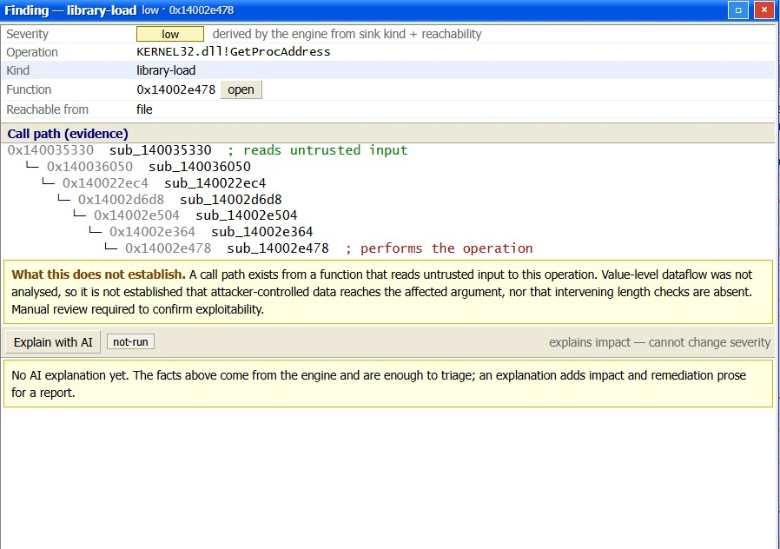
Figure 4.2: Findings with call path evidence
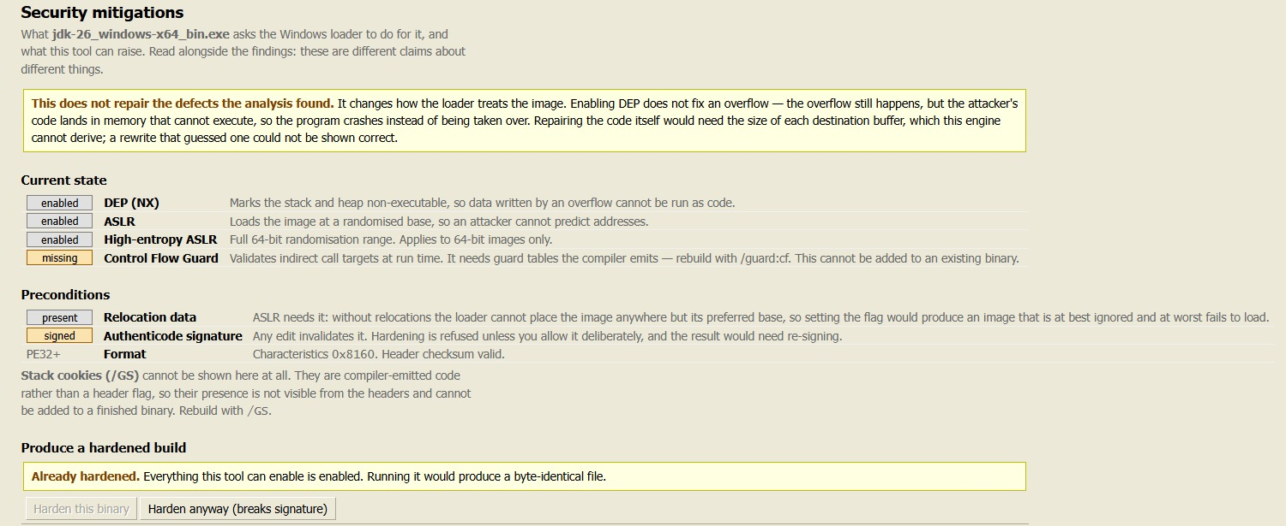
Figure 4.3: Mitigation report before and after hardening

CHAPTER 5: CONCLUSION AND FUTURE RECOMMENDATIONS

5.1 Conclusion
This project set out to build a static analysis engine for Windows PE executables that does not overstate what it knows. That objective has been met. The engine loads and disassembles PE images using recursive descent followed by a linear sweep at explicitly lower confidence, recovers function boundaries from four independent sources of evidence, and constructs per-function control-flow graphs, cross-references and a whole-image call graph ordered bottom-up for downstream consumption. Every decoded instruction carries a record of why it is believed to be an instruction, and classification is graded rather than asserted.
The analysis is exposed through a documented JSON contract consumed by both a REST interface and a browser workspace, in which the disassembly, the graph and the generated source share a single selection. An optional AI layer produces decompiled C, defect reports and behaviour descriptions, under a design in which model output is stored separately, labelled with its origin, held provisional until reviewed, and structurally prevented from determining a severity rating.
The system additionally reports the exploit mitigation state of an image and can produce a hardened copy with the supported protections enabled, refusing where the image cannot correctly support them and stating why. That refusal behaviour is not a limitation of the implementation but an expression of its purpose: the value of the tool lies in the fact that when it does make a claim, the claim can be checked.
The broader conclusion drawn from the work is that designing an analysis tool for a language model as a consumer imposes a discipline that improves it for human consumers as well. Recording provenance, grading confidence and separating fact from inference were adopted because a model cannot apply judgement to a doubtful result. They turned out to make the tool more honest for everybody.

5.2 Limitations and Future Recommendations
Limitations
- No value-level dataflow. The engine establishes that a call path exists between an input source and a risky operation, which is necessary but not sufficient for exploitability. Every finding states this limitation explicitly.
- Indirect control flow is not resolved. Jump tables produced by switch statements, and calls through function pointers, leave the control-flow graph incomplete at known locations, which are counted and reported.
- Loop and structural recovery are specified but not implemented. Dominator computation, natural loop identification and the recovery of if-else and loop constructs remain stubs carrying the intended approach at each site.
- Only the PE format is supported. The loader layer is isolated so that another format could be added without disturbing the analysis layer, but no such loader exists.
- Packed and obfuscated executables are not handled. A packed image reveals little to static analysis, and high section entropy is reported as an observation rather than defeated.
- Generated descriptions are not verified. Model output is labelled, versioned and held provisional, but the system cannot establish that a description is correct.
The deliberate exclusion of automatic code repair
The project proposal envisaged repairing the defects found and returning a corrected executable. On analysis this was found to be unachievable honestly within the constraints of the system, and the decision was taken to implement mitigation hardening instead.
The obstacle is concrete. Rewriting an unbounded copy into a bounded one requires the capacity of the destination buffer. The engine has no value-level dataflow and therefore cannot determine it. A value chosen too small silently truncates data the program depended on; one chosen too large changes nothing while presenting itself as a fix. Either outcome produces a binary that is differently broken and confidently labelled as repaired. The literature supports this assessment: the Cyber Grand Challenge systems achieved autonomous repair only with symbolic execution and dynamic validation, in a purpose-built environment.
Enabling exploit mitigations is a smaller claim that can be substantiated. It does not repair the overflow; it removes the conditions under which the overflow executes attacker-supplied code. The result is verifiable by a third-party tool, which is a stronger form of evidence than the system attesting to its own output.
Future recommendations
- Resolve jump tables by recognising the compiler-generated bounds check and index computation preceding an indirect jump, which would close the largest identified gap in control-flow coverage.
- Complete the loop and structural analysis stages, enabling the generated source to present recovered if-else and loop constructs instead of a flat block sequence.
- Evaluate the findings layer against a labelled corpus such as the NIST Juliet test suite, to obtain quantitative precision and recall figures in place of qualitative assessment.
- Add an ELF loader, exercising the isolation of the loader layer and extending the system to Linux binaries.
- Introduce lightweight dataflow within a single function, sufficient to recover stack buffer sizes from the frame layout, which would be the minimum basis for a repair that could be shown correct.
- Close the annotation feedback loop, so that an accepted model suggestion is written back into the annotation store and improves the context presented in subsequent analyses.

REFERENCES
[1] Microsoft Corporation, "PE Format," Microsoft Learn. [Online]. Available: https://learn.microsoft.com/en-us/windows/win32/debug/pe-format. .
[2] Hex-Rays SA, "IDA Pro," Hex-Rays. [Online]. Available: https://hex-rays.com/ida-pro.
[3] National Security Agency, "Ghidra Software Reverse Engineering Framework." [Online]. Available: https://ghidra-sre.org.
[4] A. V. Aho, M. S. Lam, R. Sethi, and J. D. Ullman, Compilers: Principles, Techniques, and Tools, 2nd ed. Boston, MA, USA: Pearson/Addison-Wesley, 2007.
[5] R. Tarjan, "Depth-first search and linear graph algorithms," SIAM Journal on Computing, vol. 1, no. 2, pp. 146-160, 1972.
[6] Microsoft Corporation, "BinSkim Binary Analyzer," GitHub. [Online]. Available: https://github.com/microsoft/binskim.
[7] N. A. Quynh, "Capstone: The Ultimate Disassembly Framework." [Online]. Available: https://www.capstone-engine.org.
[8] R. Thomas, "LIEF: Library to Instrument Executable Formats." [Online]. Available: https://lief.re.
[9] M. Egele, T. Scholte, E. Kirda, and C. Kruegel, “A survey on automated dynamic malware analysis techniques and tools,” ACM Computing Surveys, vol. 44, no. 2, pp. 1–42, Feb. 2012.
[10] S. S. Muchnick, Advanced Compiler Design and Implementation. San Francisco, CA, USA: Morgan Kaufmann, 1997.
[11] N. Hussain, H. Chen, C. Tran, P. Huang, Z. Li, P. Chugh, W. Chen, A. Kundu, and Y. Tian, “VulBinLLM: LLM-powered vulnerability detection for stripped binaries,” arXiv preprint arXiv:2505.22010, 2025.
[12] M. G. Kang, P. Poosankam, and H. Yin, “Renovo: A hidden code extractor for packed executables,” in Proc. ACM Workshop Recurring Malcode (WORM), Alexandria, VA, USA, 2007, pp. 46–53.
[13] E. C. R. Shin, D. Song, and R. Moazzezi, “Recognizing functions in binaries with neural networks,” in Proc. 24th USENIX Security Symposium (USENIX Security 15), Washington, D.C., USA, Aug. 2015, pp. 611–626.
[14] Z. L. Chua, S. Shen, P. Saxena, and Z. Liang, “Neural nets can learn function type signatures from binaries,” in Proc. 26th USENIX Security Symposium (USENIX Security 17), Vancouver, BC, Canada, Aug. 2017, pp. 99–116.
[15] J. Lacomis, P. Yin, E. J. Schwartz, M. Allamanis, C. Le Goues, G. Neubig, and B. Vasilescu, “DIRE: A neural approach to decompiled identifier naming,” in Proc. 34th IEEE/ACM Int. Conf. Automated Software Engineering (ASE), San Diego, CA, USA, Nov. 2019, pp. 628–639.

APPENDICES

Appendix A: Screenshots
This appendix collects screenshots of the working system. Each should be captioned and referenced from the main report where relevant.

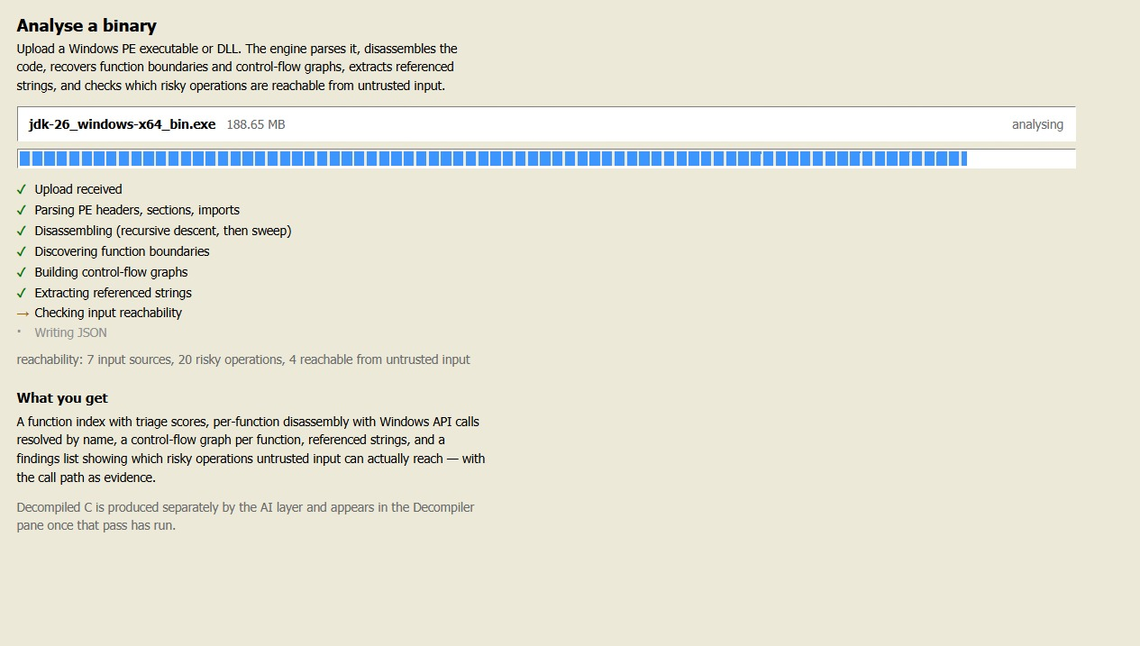

Figure A.1: Upload and analysis progress
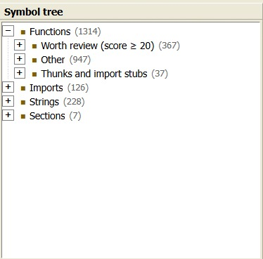

Figure A.2: Symbol tree and disassembly listing

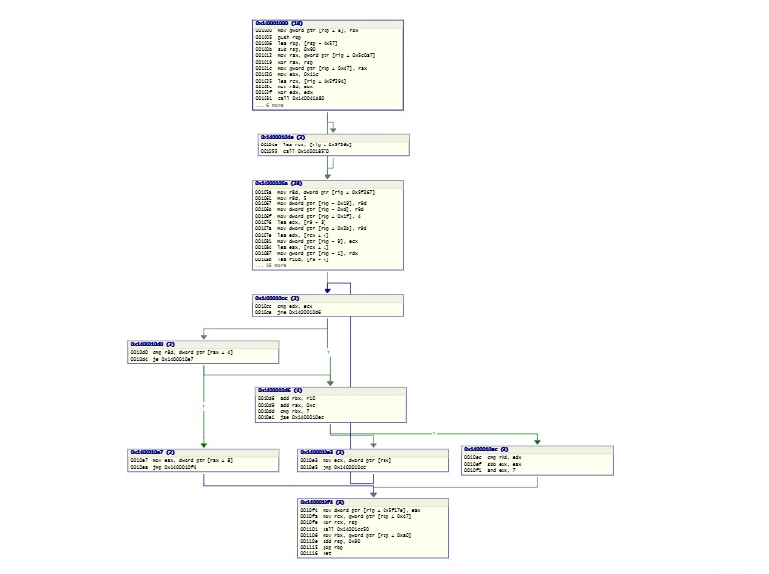

Figure A.3: Control-flow graph window

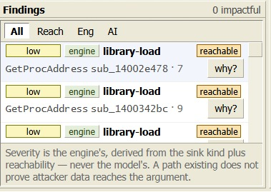
Figure A.4: Findings and severity derivation

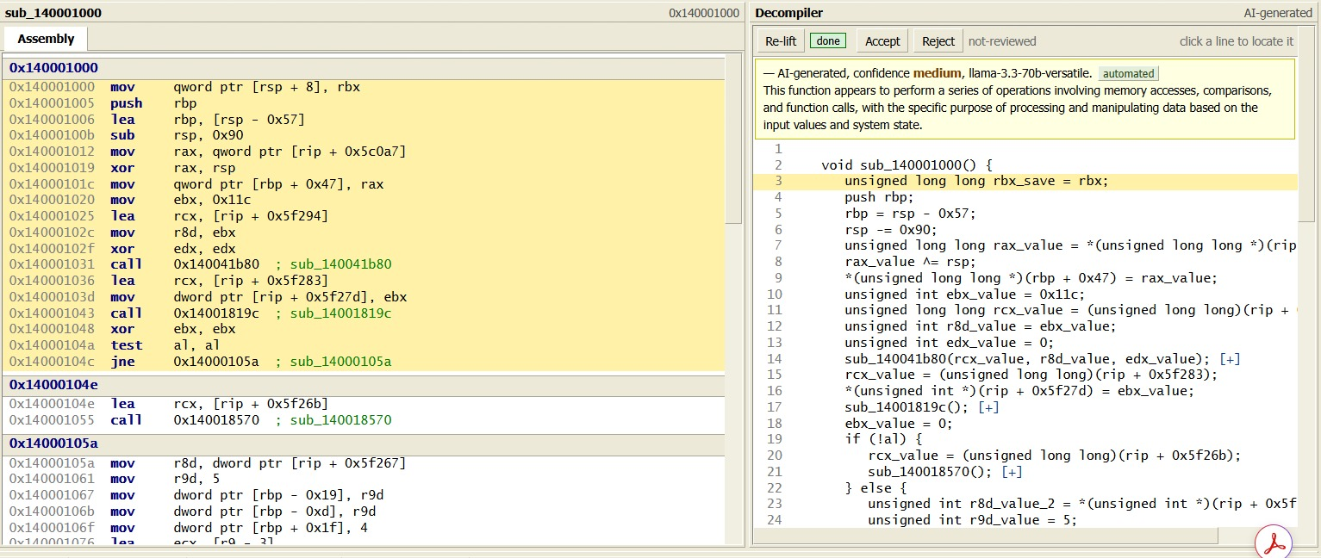
Figure A.5: Decompiled output with line mapping


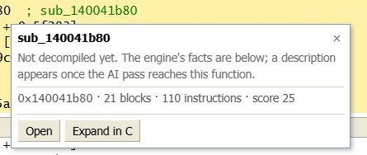
Figure A.6: Navigation aids
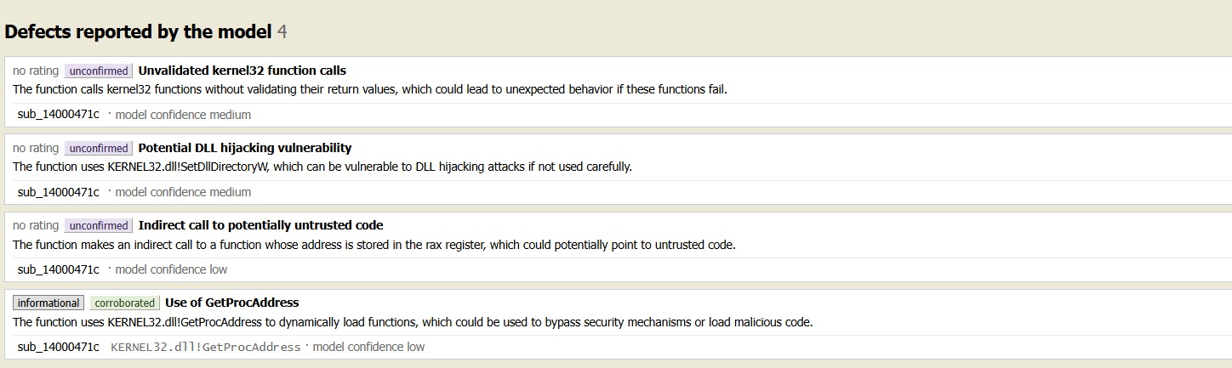
Figure A.7: Automated AI analysis run

Figure A.8: Mitigation report

Appendix B: Source Code Snippets
This appendix lists the major source components. Include a short extract of each with a brief explanation rather than the complete file.
- Confidence lattice and the rule that weaker evidence never overwrites stronger (core/Confidence)
- Provenance record attached to each decoded instruction (core/Provenance)
- Recursive descent with linear-sweep fallback (disasm/Disassembler)
- Function discovery from the four evidence sources (analysis/FunctionDiscovery)
- Basic block construction and edge insertion (analysis/CFGBuilder)
- Iterative Tarjan strongly connected components for bottom-up ordering (analysis/CallGraph)
- Reachability search from input sources to risky sinks (analysis/Reachability)
- Mitigation inspection and the refusal conditions (harden/PeHardener)
- AI job queue, ordering and result versioning (backend)
- The severity guarantee enforced on every stored AI result (backend)
- The n8n workflow node that strips provenance tags and builds the line mapping
The extracts below are reproduced from the source files named above each listing. They were chosen because each carries a design decision that the main report argues for, rather than because they are representative in length.
B.1 Bottom-up ordering of the call graph — Senior-Project/src/analysis/CallGraph.cpp
Callees are emitted before callers so that, by the time a caller is described, its callees already have summaries that can enter the prompt. Tarjan's algorithm is used because recursion has no valid topological order, and the iterative form is used because a deep call chain would otherwise risk exhausting the stack.
std::vector<core::VA> CallGraph::reverse_topological_order(
std::vector<std::vector<core::VA>>* out_cycles) const
{
// Tarjan's strongly-connected-components algorithm.
//
// Its emission order is already what we want: an SCC is emitted only after
// every SCC reachable from it, so callees come out before callers. That is
// exactly the order the lifting agent needs - by the time it reaches a
// caller, its callees have summaries that can go in the prompt.
//
// Iterative rather than recursive: a deep call chain in a real binary would
// otherwise risk a stack overflow.
if (out_cycles != nullptr) {
out_cycles->clear();
}
B.2 Refusing a mitigation rather than applying it unsafely — Senior-Project/src/harden/PeHardener.cpp
Address space layout randomization requires relocation data. Setting the flag on an image that cannot be rebased produces something the loader either ignores or fails to load, so the refusal, with its reason, is the useful result.
/* ASLR is the one with a precondition. Without relocation data the loader
* cannot place the image anywhere but its preferred base, so the bit is at
* best ignored and at worst produces an image that will not load. Refusing
* with the reason is the useful answer; setting it anyway would be a lie
* that this tool had hardened something. */
const bool relocatable =
result.before.has_relocations && !result.before.relocations_stripped;
if (options.enable_aslr) {
if (result.before.aslr) {
result.refused.emplace_back("ASLR (DYNAMIC_BASE): already enabled");
} else if (!relocatable) {
result.refused.emplace_back(
result.before.relocations_stripped
? "ASLR (DYNAMIC_BASE): refused, the COFF header says relocations "
"were stripped, so the image cannot be rebased"
: "ASLR (DYNAMIC_BASE): refused, no base relocation directory, "
"so the image cannot be rebased");
} else {
flags |= kDynamicBase;
result.applied.emplace_back("ASLR (DYNAMIC_BASE): image may load at a randomised base");
}
}
// High-entropy ASLR is 64-bit only, and meaningless without DYNAMIC_BASE.
B.3 Selecting functions for defect hunting by reachability — backend/aijobs.js
Information score answers whether a function has a recognisable purpose, which is the wrong question for whether it contains a defect. Defects occur in low-scoring plumbing, so this stage follows the call paths of engine findings instead.
/* Bug hunting selects by reachability, not by score.
*
* This is the important distinction in the whole file, and the earlier version
* of it was wrong. information_score measures "does this function have a
* recognisable purpose" - it is computed from imported API calls and
* referenced strings. That is the right question for "explain what this does".
* It is the wrong question for "could this contain a bug".
*
* Bugs live in plumbing. Consider:
*
* sub_A calls ReadFile, uses "config.txt" score 45
* └─ sub_B copies bytes in a loop score 10 <- the defect
* └─ sub_C calls lstrcpyW score 25
*
* sub_B has no API calls and no strings, so it scores 10 and a score-ranked
* selection drops it - while being exactly the function with the missing
* length check. Sorting by score with reachability as a tiebreak, which is
* what this used to do, still loses sub_B whenever the budget runs out.
*
* So: take the union of every finding's call_path. Those are the functions
* attacker-controlled data actually flows through, whatever they score. Then
* add each path function's direct callees, because a bounds check is often one
* level deeper than the path itself.
*

Appendix C: Log of Visits to Supervisor
Table C.1: Record of supervisor meetings
S.N. | Date | Topics discussed | Supervisor's signature
1
2
3
4
5
6
7
8
9
10
11
12

