**EART 30: Water in the Environment**

**Module 4 Assignment**

**Total points: 20**

Assignment introduction: An overarching question in this class and in the field of water science is, **How do our human actions impact the local and global water cycle?** For this assignment you are asked to explore how deforestation impacts the components of the local water cycle as well as stream water quality.

**Question 1.** A watershed received 2000 mm of rain during 1 year. It stored 200 mm of that precipitation in its soil and lost 800 mm of water downstream through streamflow. How much of the incoming precipitation was lost to the atmosphere (mainly through plants)? To receive full credit for this problem, write out the water budget equation and show your full work.

**Answer:** The formula that I used is $P=ET+ΔS+Q_{\text{out}}$. We can just put the numbers in. Then we get $2000\text{mm}=ET+200\text{mm}+800\text{mm}$. Therefore, the answer is: $ET=1000\text{mm}$.

**Question 2.** Now, imagine the trees in this watershed were cut down, as shown in the before-after diagrams below.

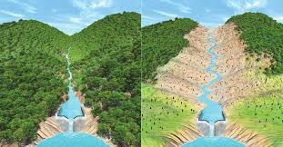

**AFTER**

**BEFORE**

Please determine the correct response, **circle it**, and **provide a 1-2 sentence explanation as to why:**

1. After the trees were cut down, evapotranspiration: **[increased], [decreased], [did not change].**
2. If precipitation and water storage in the soils stayed the same, that must mean streamflow would **[increase], [decrease], [not change].**

**Question 3.** Below is a plot from the original scientific publication (Likens et al. 1978) that presented the results from the Hubbard Brook Experimental Forest whole-watershed experiment where researchers cut down the entire forest in a watershed (see module 4 lecture 2 in which I introduce this experiment).

The x-axis is year, where the deforestation occurred from 1966-1970. The y-axis is the annual net export of different water quality parameters in the stream water (calcium, potassium, nitrate, and organic matter). The units are kilograms per hectare (1 hectare = 2.47 acres). Each circle on the plot represents the total annual export of these water quality parameters. The white circles are measurements from the experimental watershed which had all of its trees removed and herbicide applied for several years (designated by the four year ‘Deforested’ period on the plot). The black circles are measurements from a ‘control’ watershed where the researchers did nothing.

Please respond to the four prompts below in 1-2 sentences.

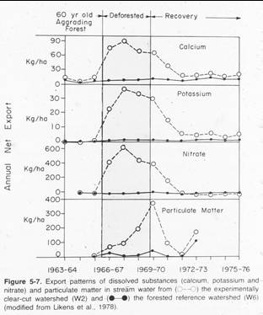

1. How did the control and experimental watershed compare in water quality parameter export BEFORE deforestation?
2. How did the control and experimental watershed compare in water quality parameter export DURING deforestation?
3. How many years did it take during ‘recovery’ for the deforested watershed to have similar export amounts as the control watershed?
4. Why do you think deforestation caused an increase in the export of water quality parameters?