**ASSIGNMENT 12:**

**Problem Statement: Deploy and run project in AWS without using port.**

**Procedure:**

1. At first log into your AWS account, then go to EC2.

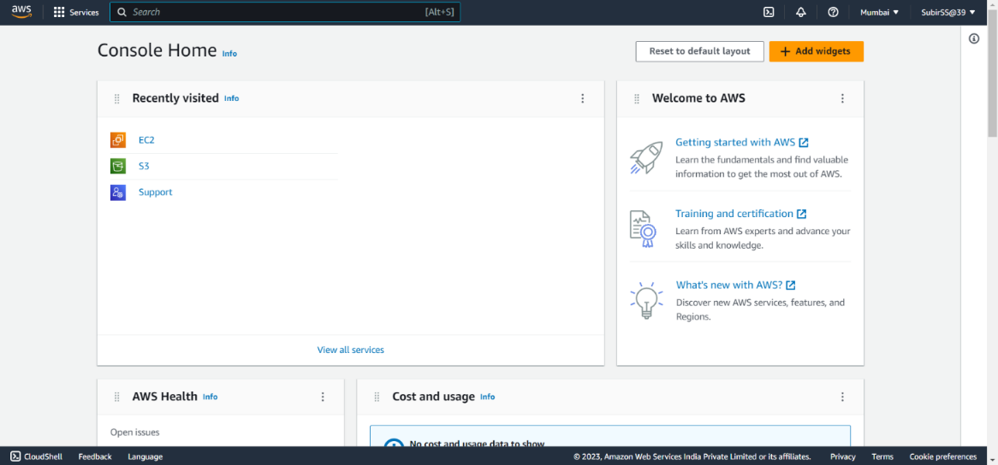

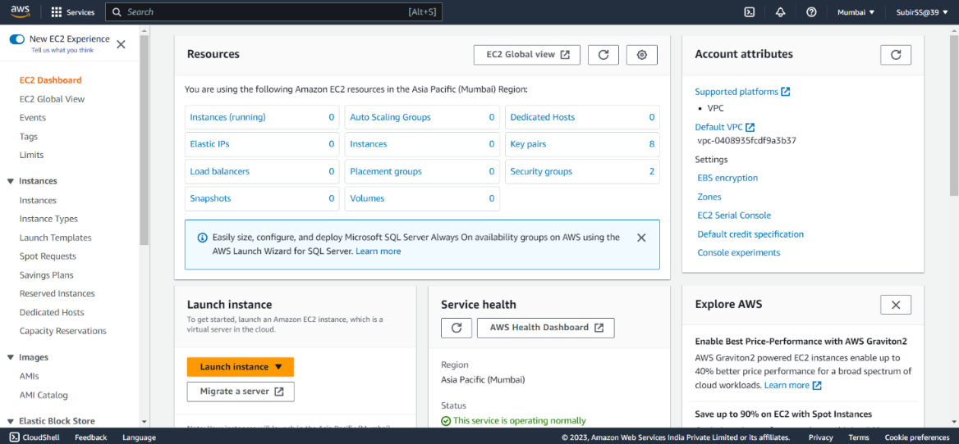

1. Create an EC2 instance. In network settings, select the existing security group and choose the created group.

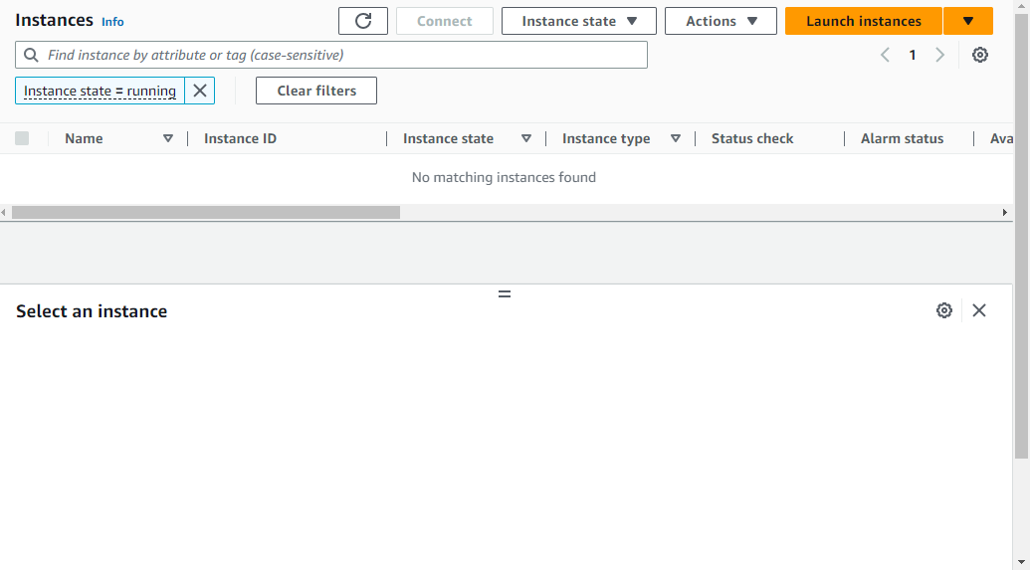

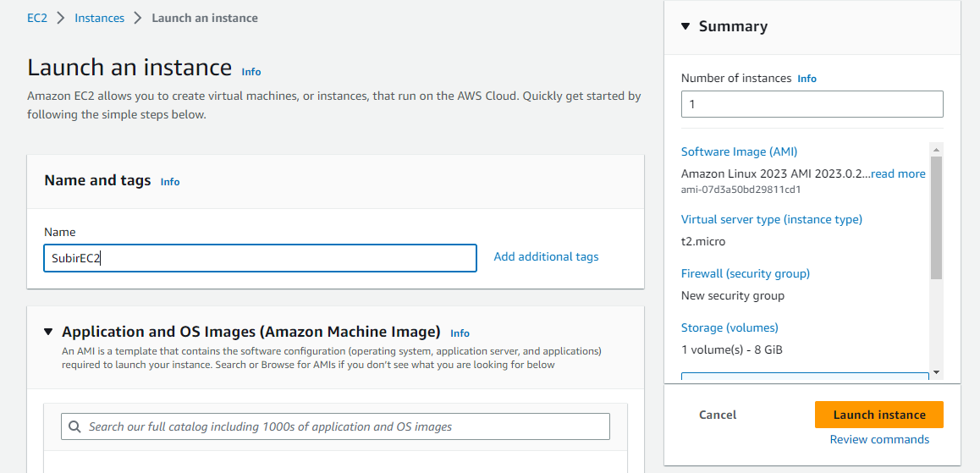

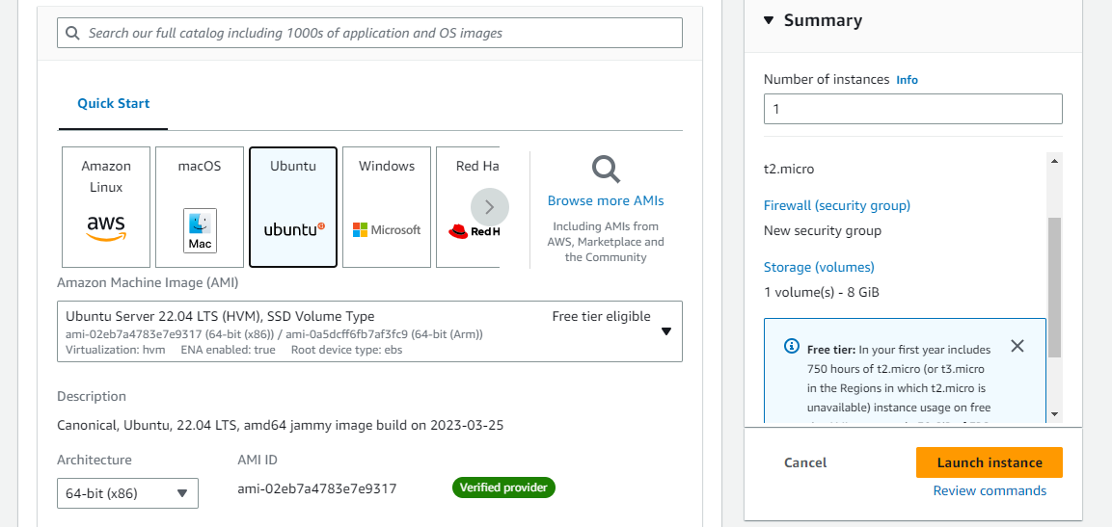

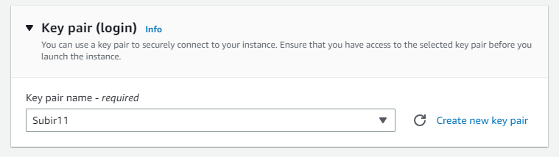

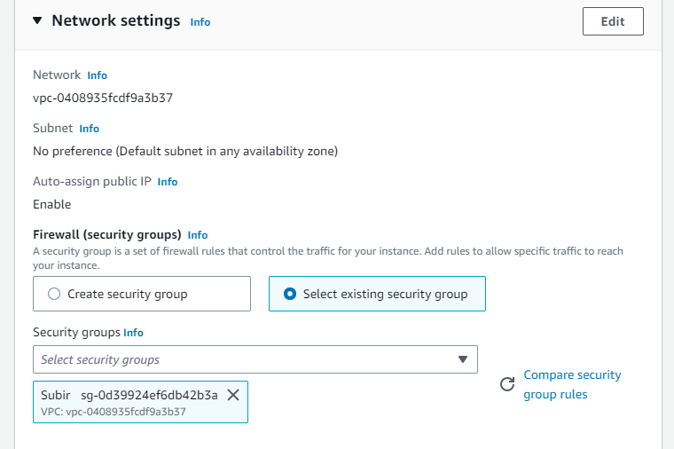

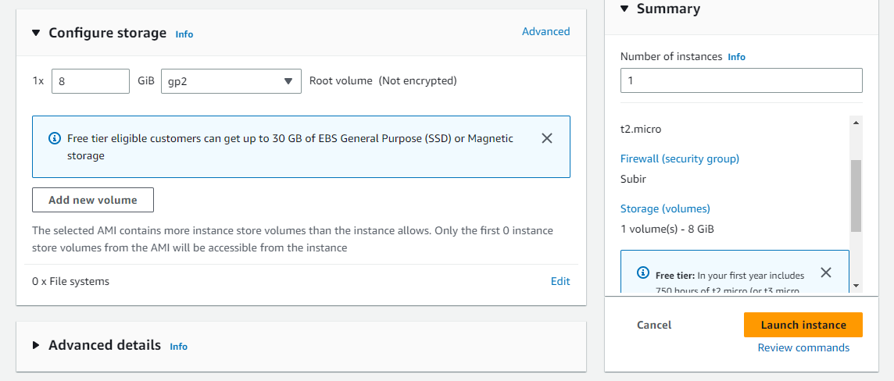

1. In advanced details, enter the following commands in ‘User data’ section-

**#!/bin/bash**

**apt-get update**

**apt-get install -y nginx**

**systemctl start nginx**

**systemctl enable nginx**

**apt-get install -y git**

**curl -sL https://deb.nodesource.com/setup_18.x | sudo -E bash -**

**apt-get install -y nodejs**

**git clone Repo link**

**cd Repo name**

**npm install**

**node index.js**

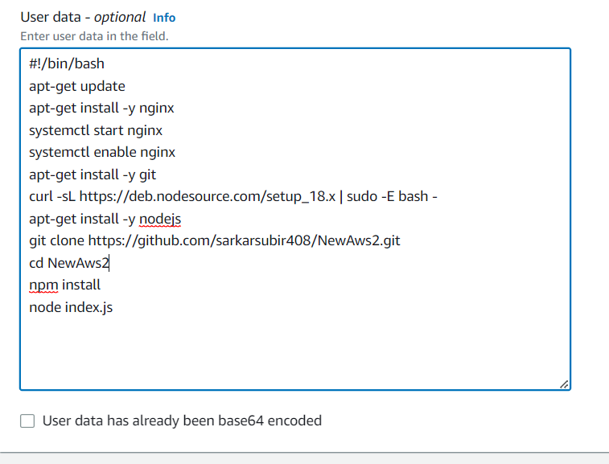

1. Launch the instance and then connect it using Bitvise SSH Client.

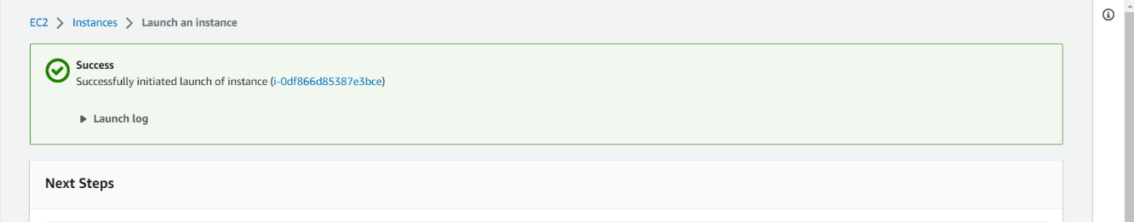

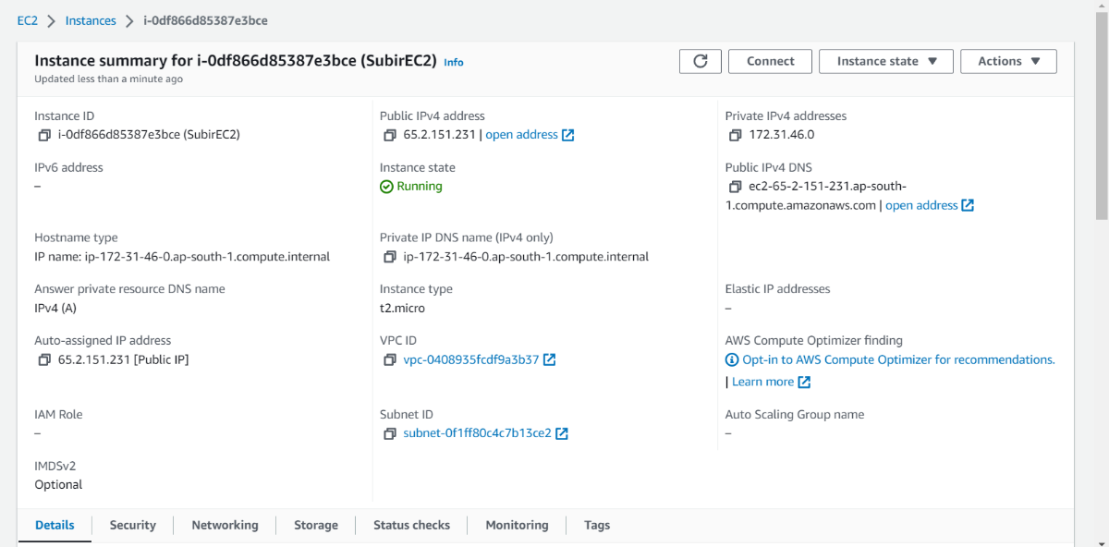

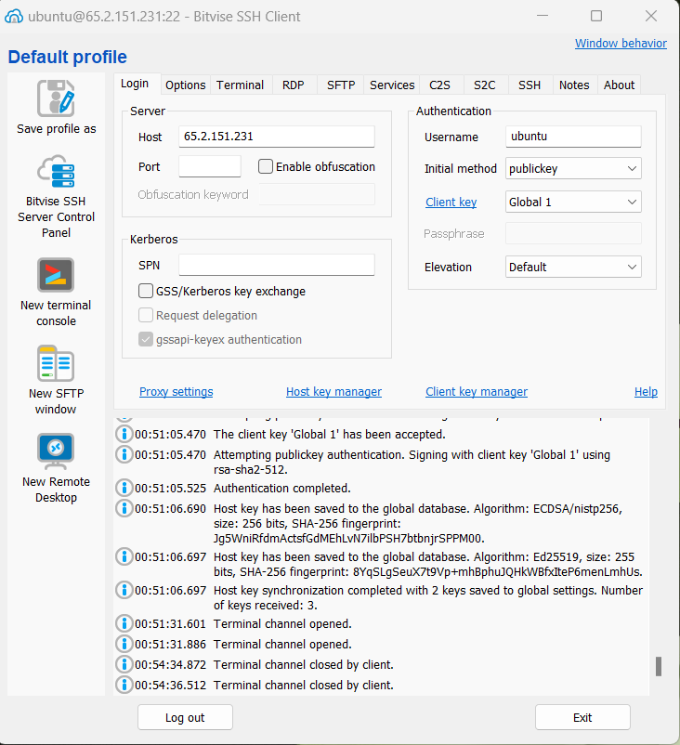

1. In New terminal console type the following commands-

**pwd**

**cd /**

**cd /etc/nginx/sites-available/**

**sudo nano default**

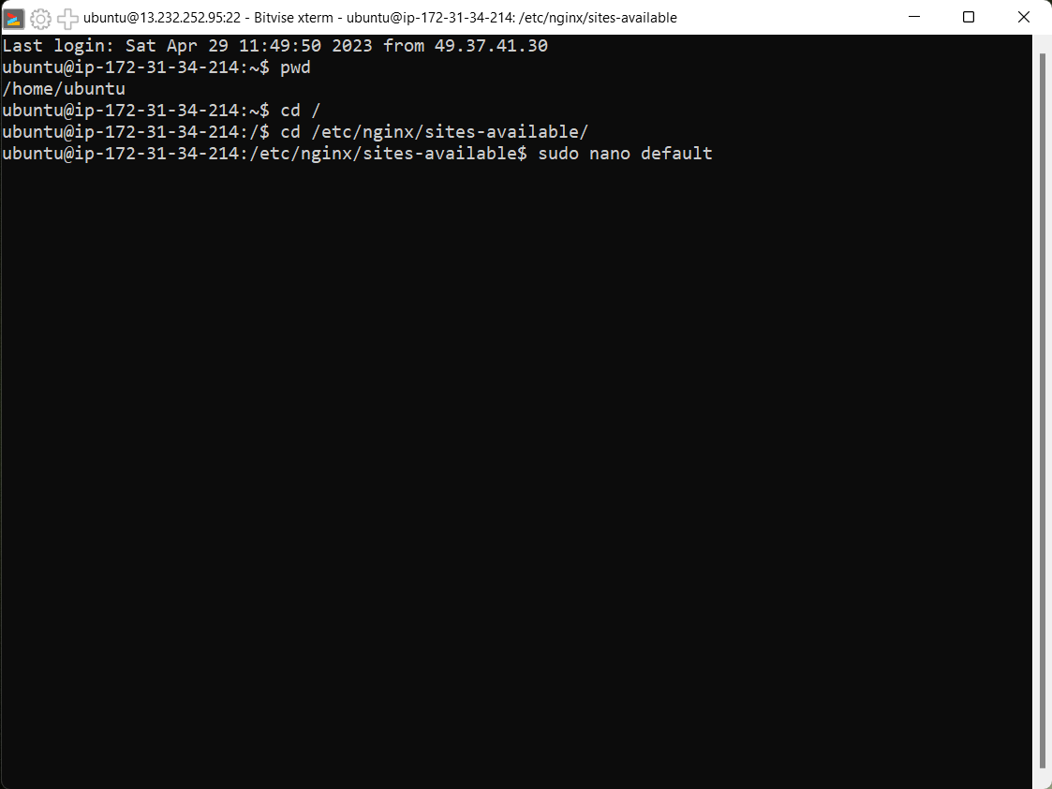

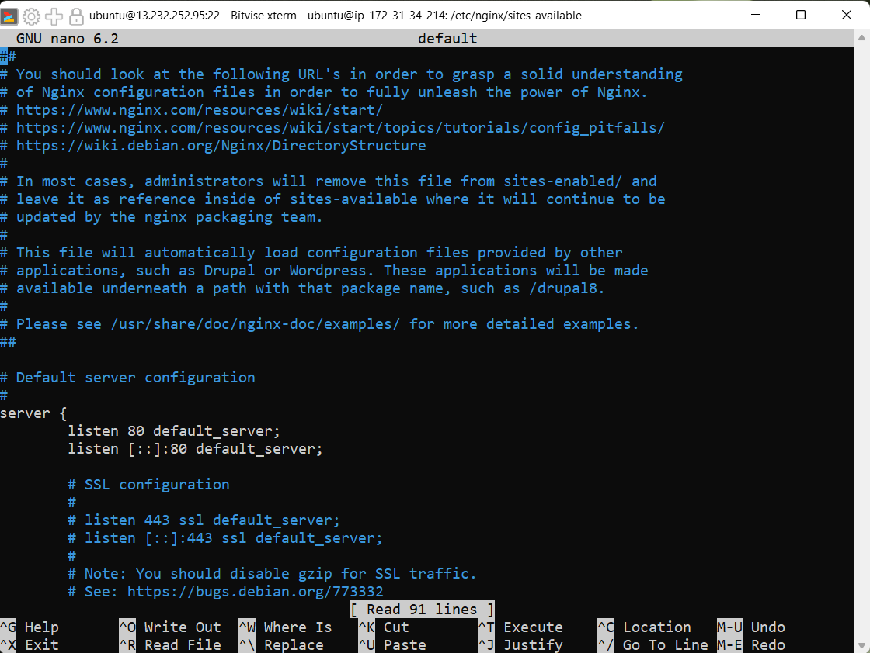

1. Now a PHP default code will arrive.At the end part of the code you can see three lines are not hashed(at the location part of the code shown in the below picture), hash them all.

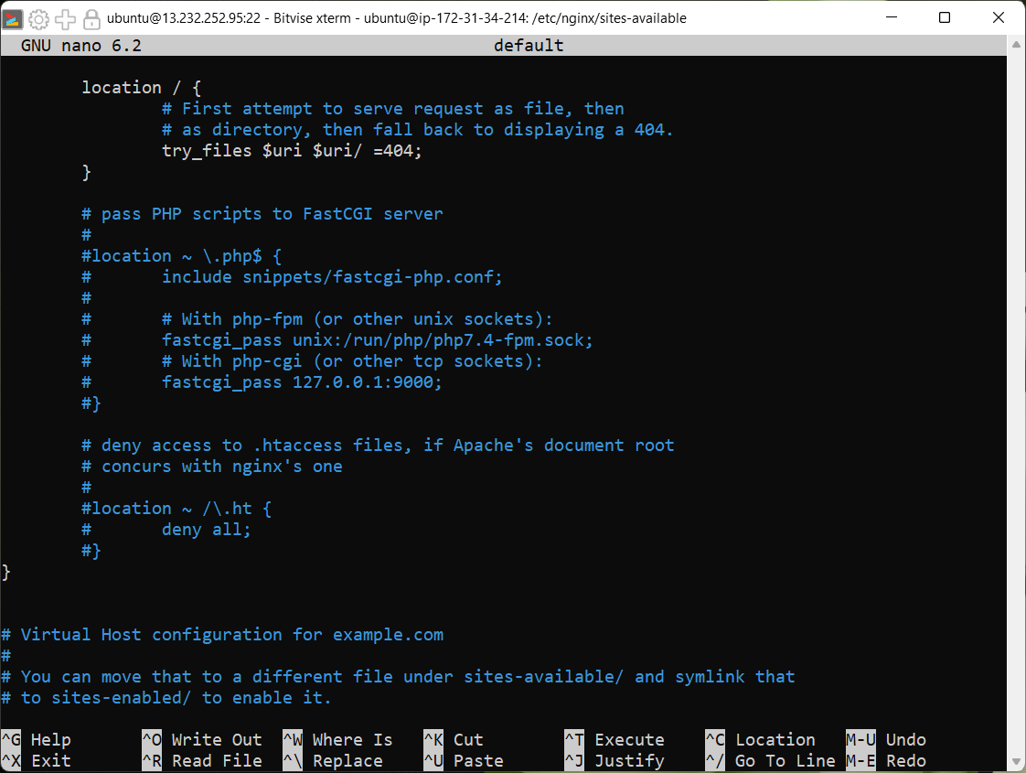

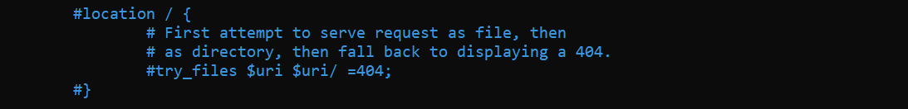

1. Then paste the location code(given below) under the hashed location part.

**location / {**

**proxy_pass http://localhost:4000;**

**proxy_http_version 1.1;**

**proxy_set_header Upgrade $http_upgrade;**

**proxy_set_header Connection 'Upgrade';**

**proxy_set_header Host $host;**

**proxy_cache_bypass $http_upgrade;**

**}**

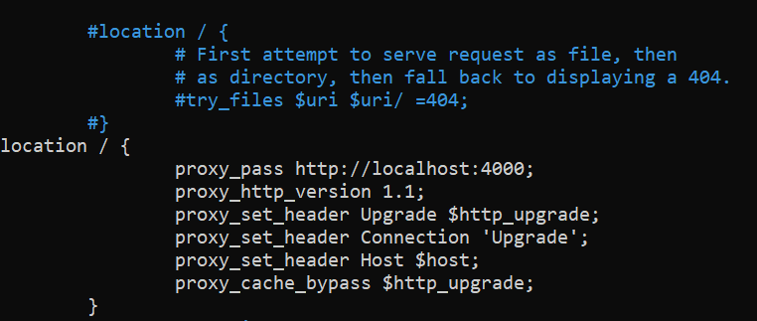

1. Then press ‘ctrl+X’ AND then answer the question by ‘y’ or ’Y’.Then press ’Enter’ and you’ll go back to your terminal console.Then write the command-

**sudo systemctl restart nginx**

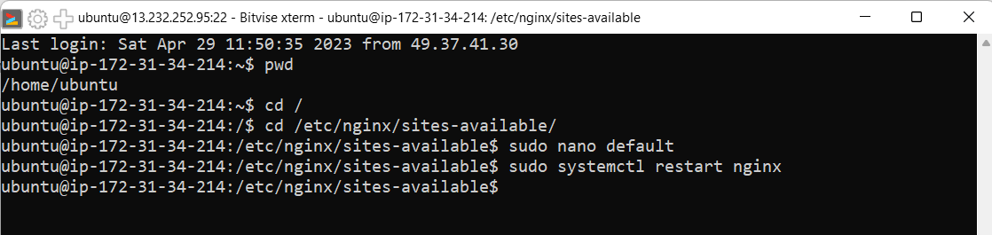

1. Now run the Public IPv4 Address in a web browser without using the port number.

