**ASSIGNMENT 13:**

**Problem Statement: Create a workmail for your organisation.**

**Procedure:**

1. At first log into your AWS account.

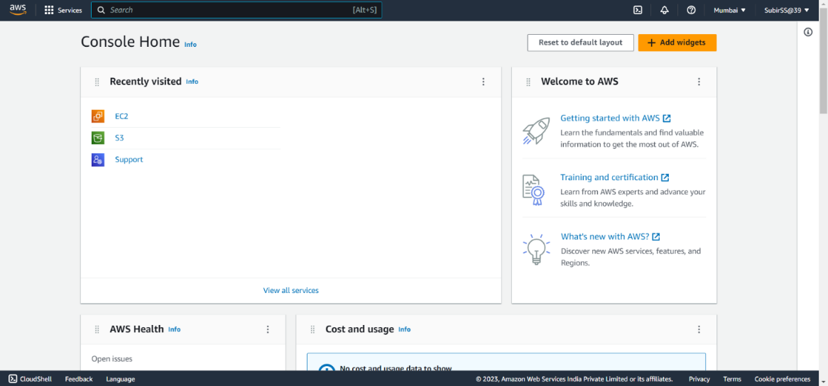

1. Then search workmail on the top menu bar and open the first option(Amazon Workmail) that comes.

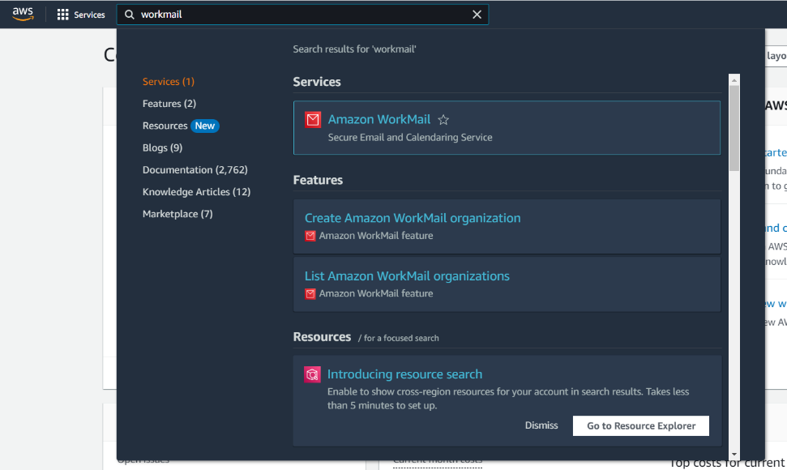

1. Then click on Create organization.

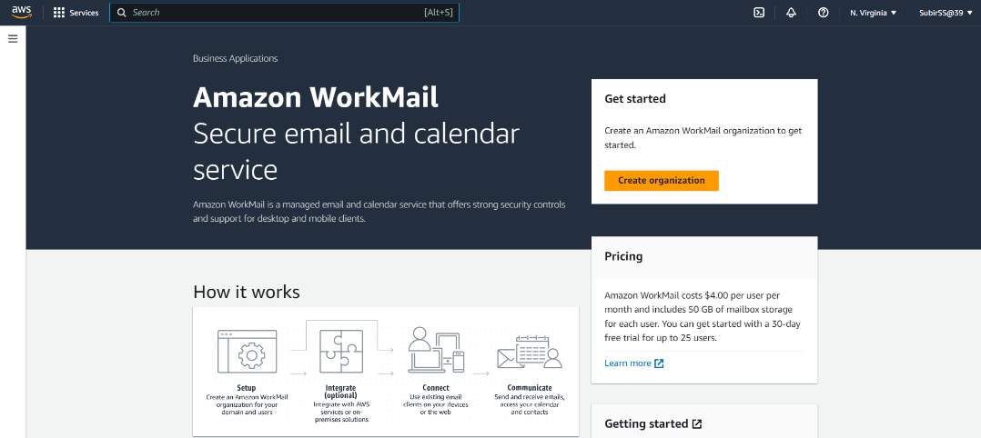

1. Then in the Organization settings select Email domain as ‘Free test domain’ and give any name to the Alias.Then click on ‘Create organization’.

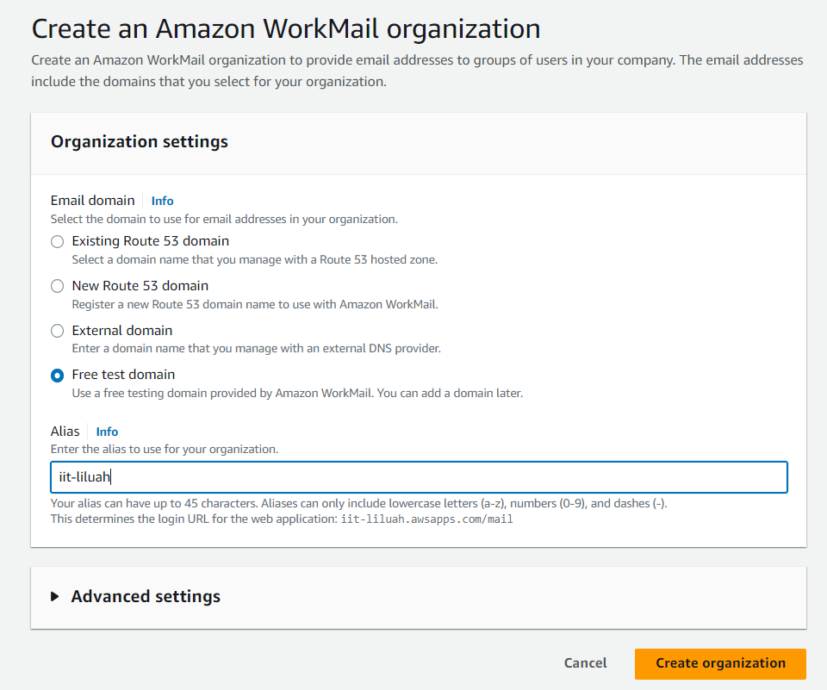

1. Now your organization is created.Then open your organization by clicking on it.

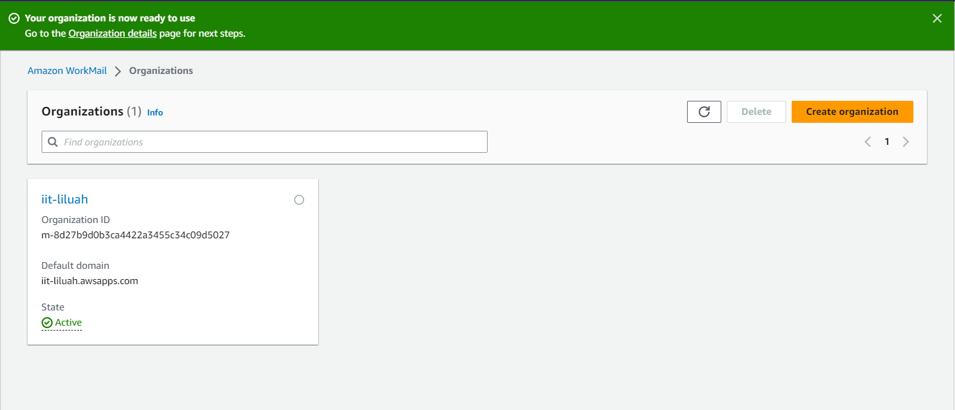

1. Then a window will be open(shown in the first image below).On the left-hand side you can see a ‘Users’ option.Open it.

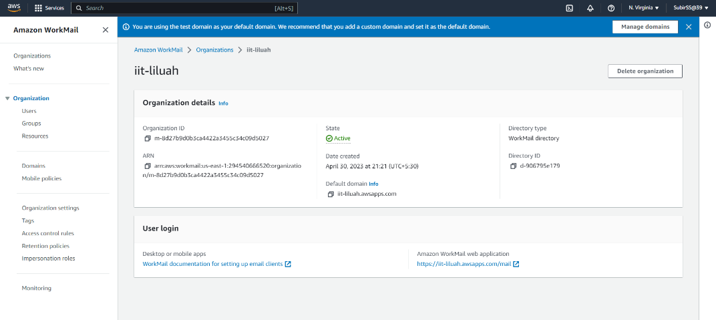

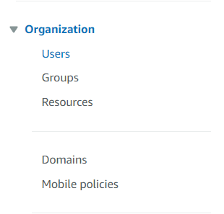

1. Then click on ‘Create user’.

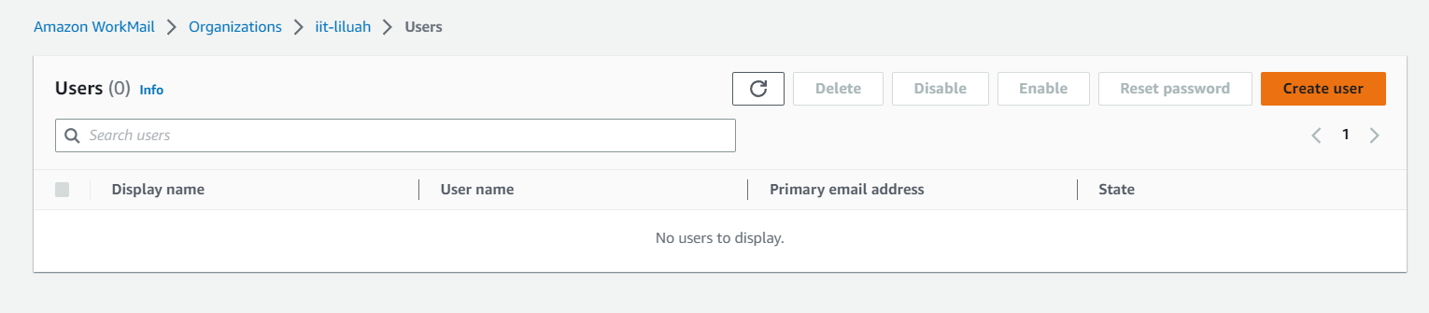

1. Then a user form will be arrived.Fill the form with proper information to add a user to your Amazon WorkMail Organization(AWO).After filling up the form click on ‘Create user’.

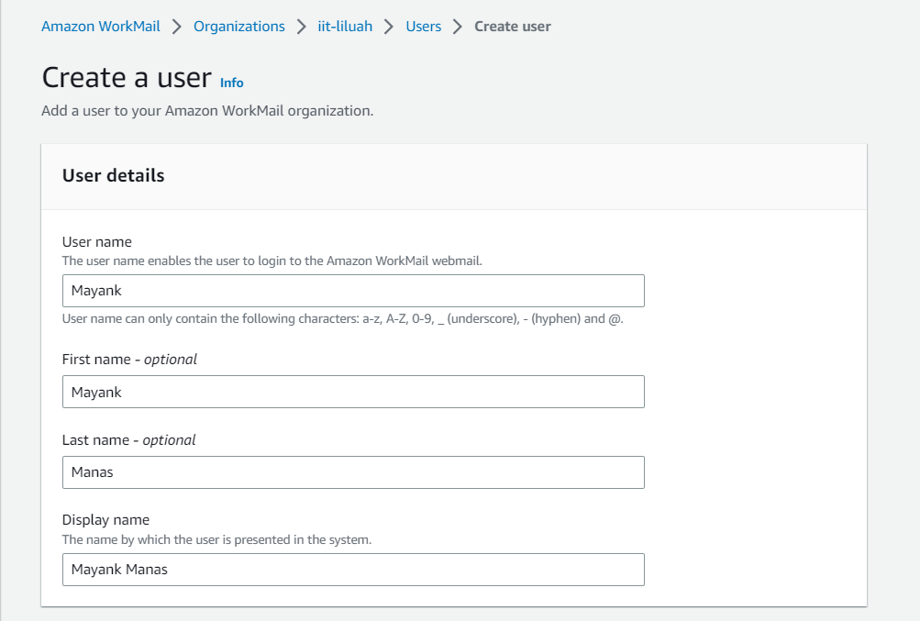

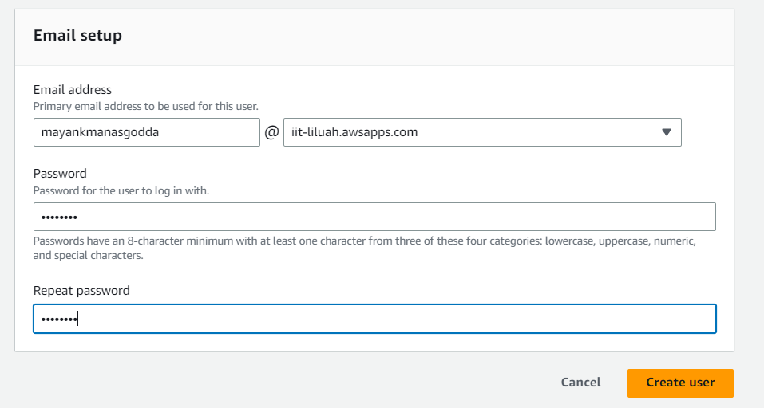

1. Now the user for your WorkMail Organization has been created successfully.

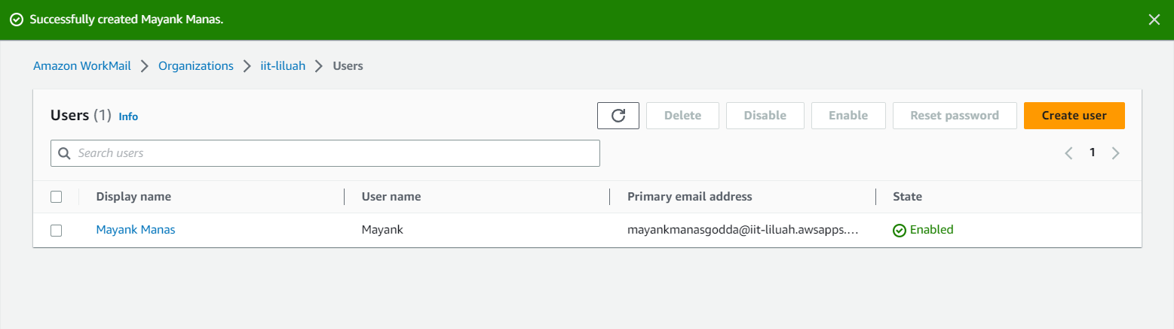

1. Then go to the ‘Organization’ option on your left hand side, open it. Then the previous window will be open again, there you can see a ‘Amazon WorkMail web application’ option, click on the link below of that option.

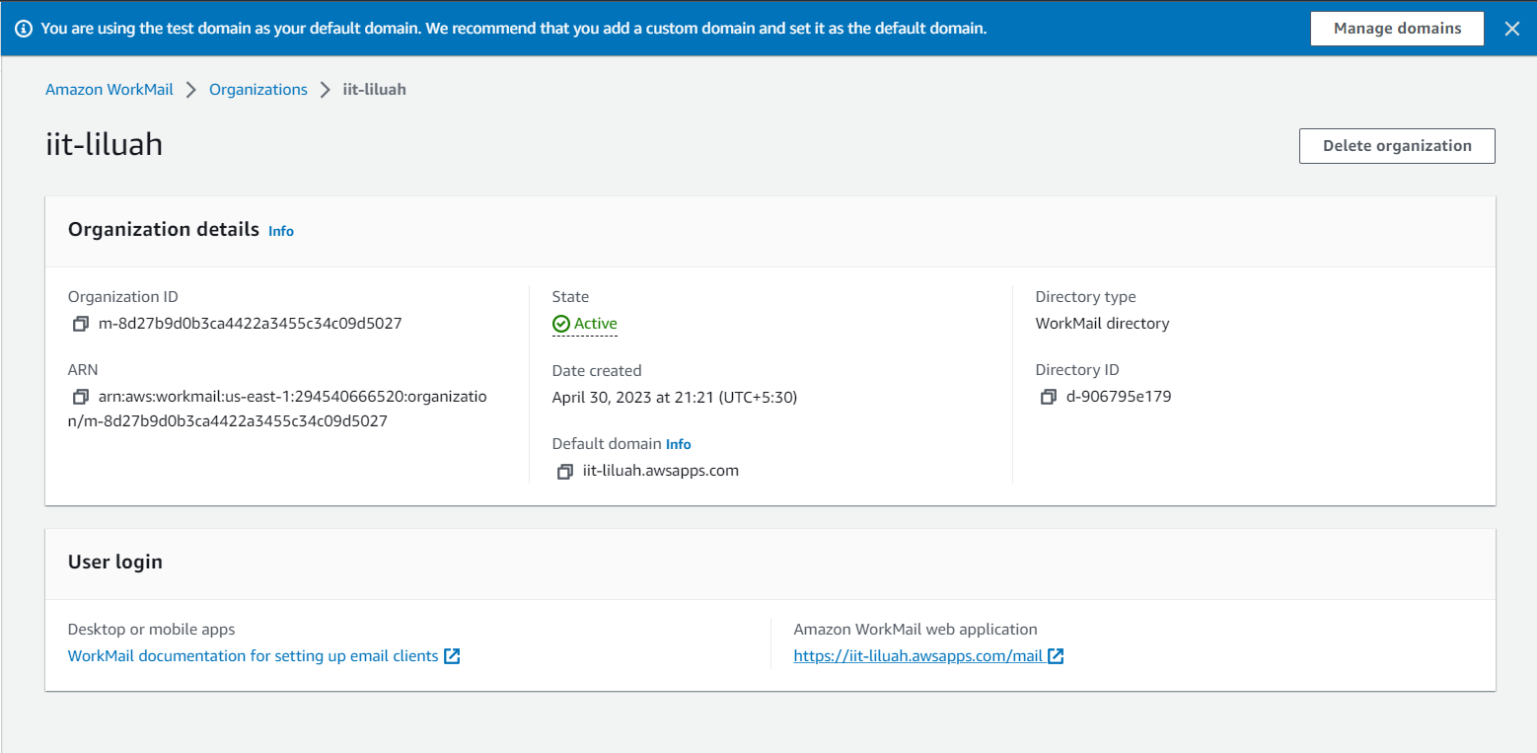

1. Then a sign in web page will be arrived.Sign in with the correct user name & password to check whether your WorkMail Organization is working properly or not.

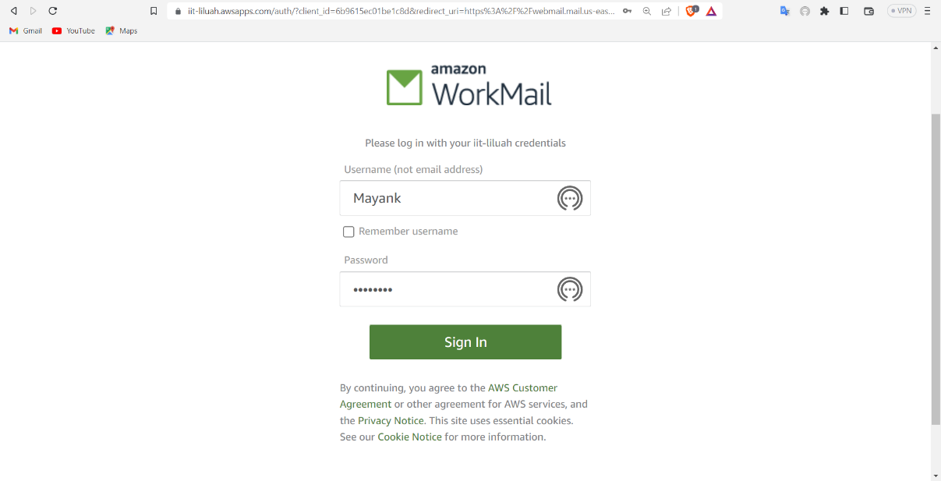

1. After successful log in you can see your newly created Amazon WorkMail Account. Now you can access your WorkMail’s inbox,outbox,drafts and other things.

