**ASSIGNMENT – 16**

**Problem Statement: Manage Amazon DNS service and run a project using domain-name and URL .**

**Procedure:**

1. Sign-in to your AWS console.
2. Create an instance with custom security group and user data (**Refer Ass10**) **3.** Click on the instance.

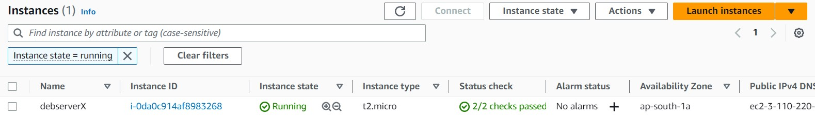

1. Copy the public IPv4 address and paste it in another browser.

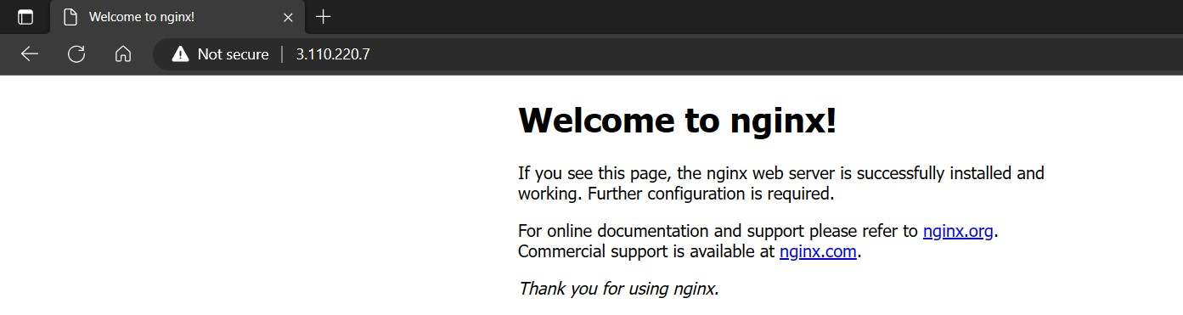

1. Check if the project webpage is accessible by appending :4000 to your address.

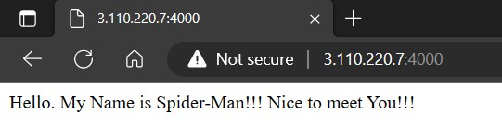

Our EC2 instance works as intended. However, to access our webpage one always requires the public IPv4 address of our server instance which is very complicated/less accessible for end-users of our webpage/web application.

So, to make it easier for our end-users, we need to bind a domain name to the server instance. Now anyone can use the domain name and the URL to access our project.

1. Search Route 53 in the search bar of AWS console. Select the first result.

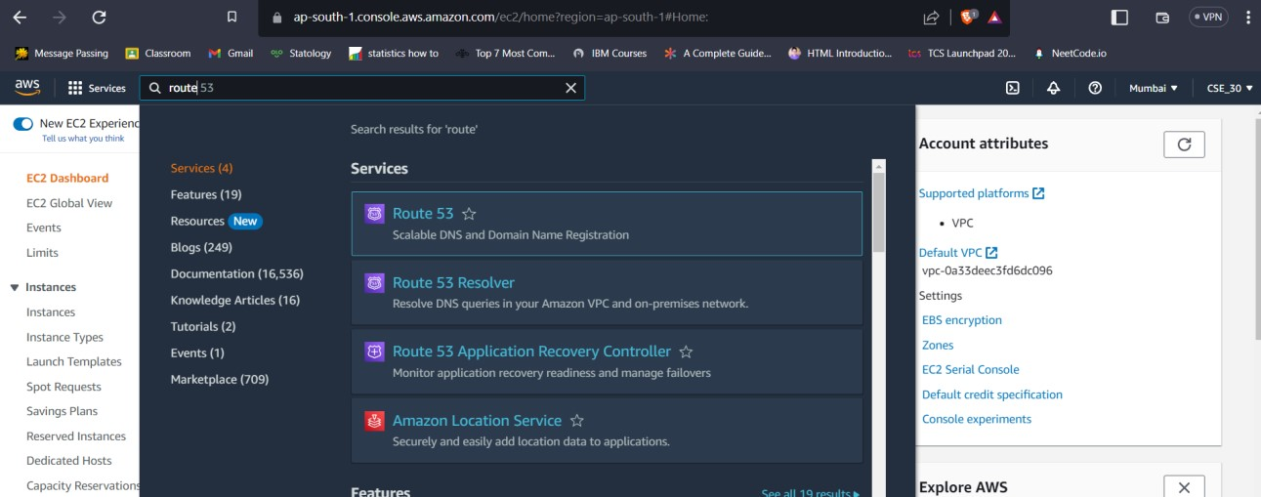

We require a registered Domain name for this assignment. So, after obtaining one (free or paid) go to the Webpage of your Domain provider and log-in to your account where you can find all the details of your purchased Domains.

This may vary from site to site, so you will have to do this based on what site you are using.

We (for now) will be using GoDaddy.com, because we have purchased a Domain from them.

1. After Reaching the Route 53 dashboard click on the Create Hosted Zone button.

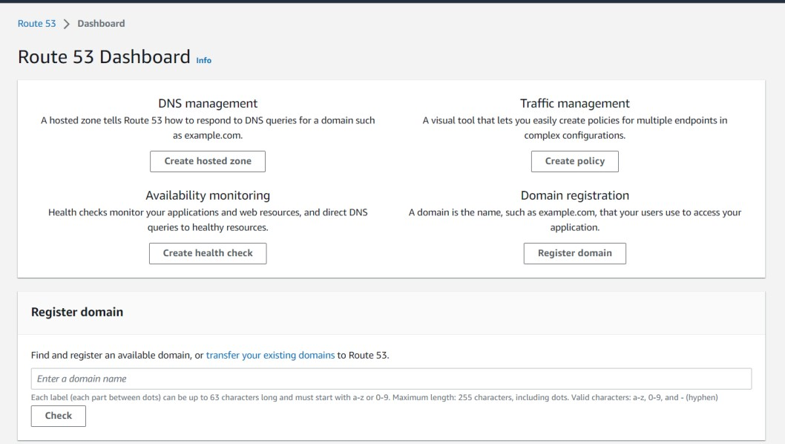

Alternatively, you can go to hosted zones from the left-side bar and then select create hosted zone option.

1. Now, copy your Domain name from your Domain providers website. Here we used GoDaddy.com. Paste the domain name in the given field in Hosted Zone configuration page.

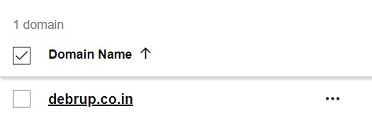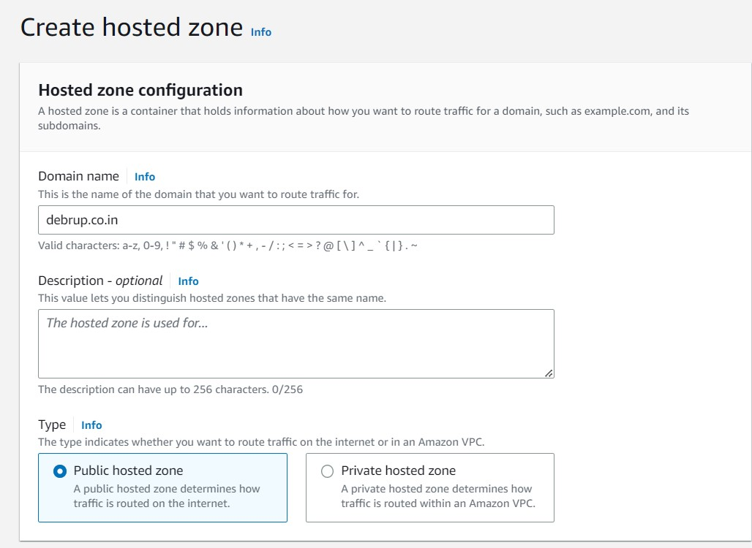

1. Now scroll-down and click on the Create Hosted Zone button.
2. Now click on the Create a record button.

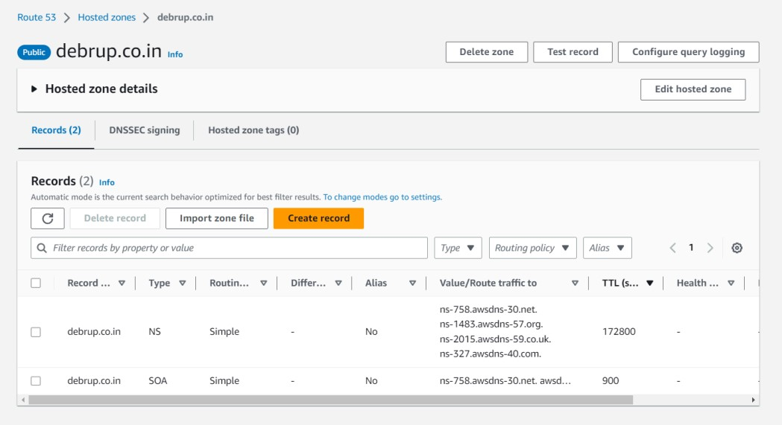

1. Follow these Steps:
   1. Do not give any name. Keep the record name blank.
   2. Keep record type as it is. No change required.
   3. Under the value, copy and paste your server instance public IPv4 address which you want to route to using your DNS.
   4. Then click on create records button

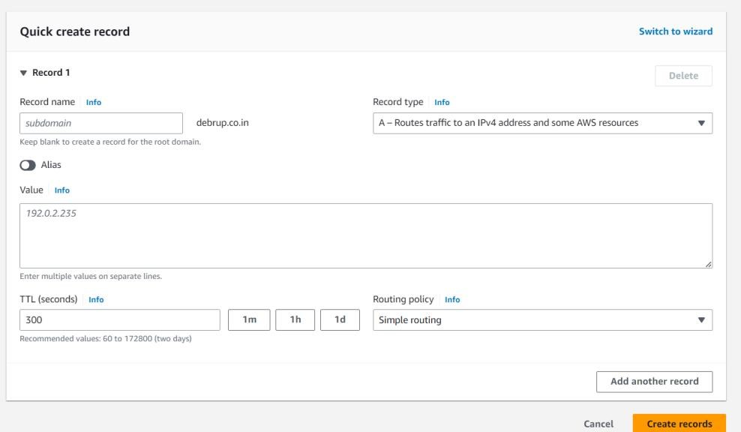

1. Now again click on the Create Record button like the previous step.
   1. But this time give the record name as → **www**
   2. Select Record type as CNAME
   3. In the text box under value, write the full domain-name there. (For example: example.com)
   4. Click on create records button

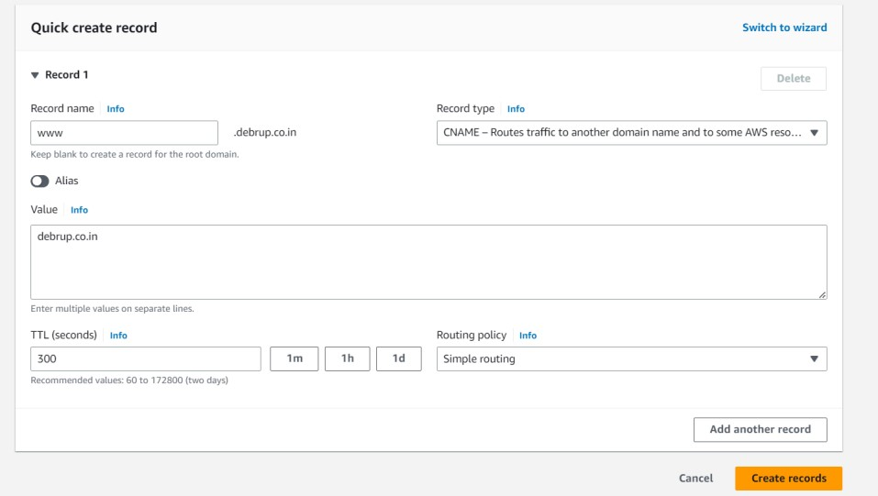

1. Now select the record with type nameserver (NS).

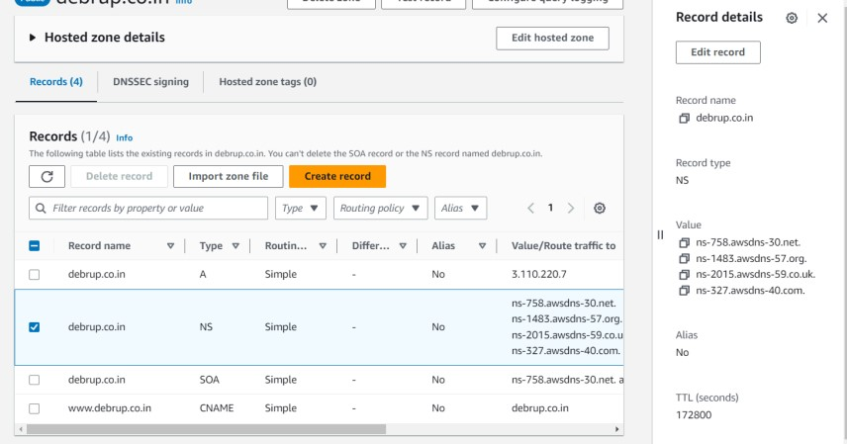

The values seen on the right-hand side are required for the next steps.

1. Now go to your Domain providers webpage. Go to your purchased Domains settings.

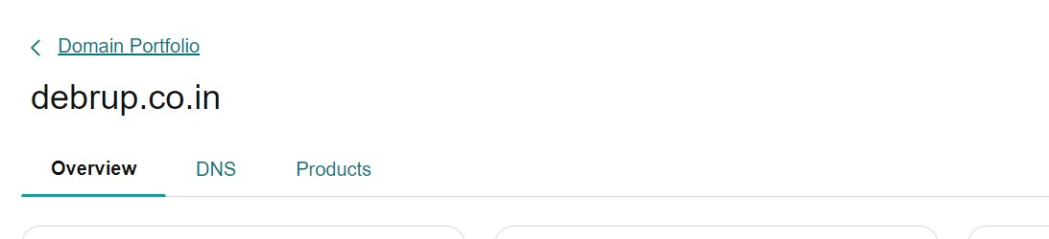

1. Click on DNS section. (This may vary from provider to provider)
2. Click on the nameservers option.

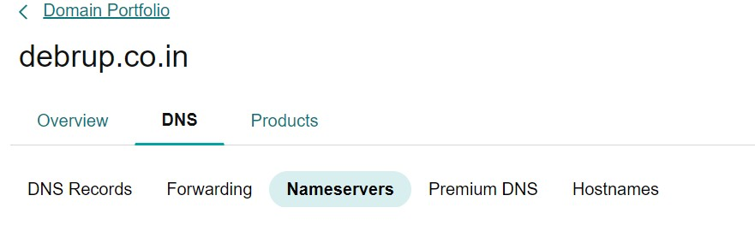

1. Click on the Change nameservers and add here all the values opened in the Route 53 page.
   1. Select use my own nameservers option.
   2. Add nameservers.
   3. Then click on the save button.

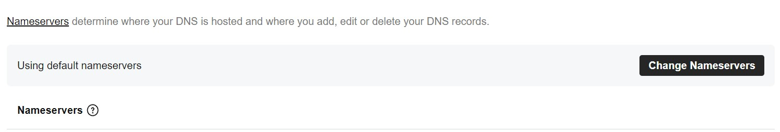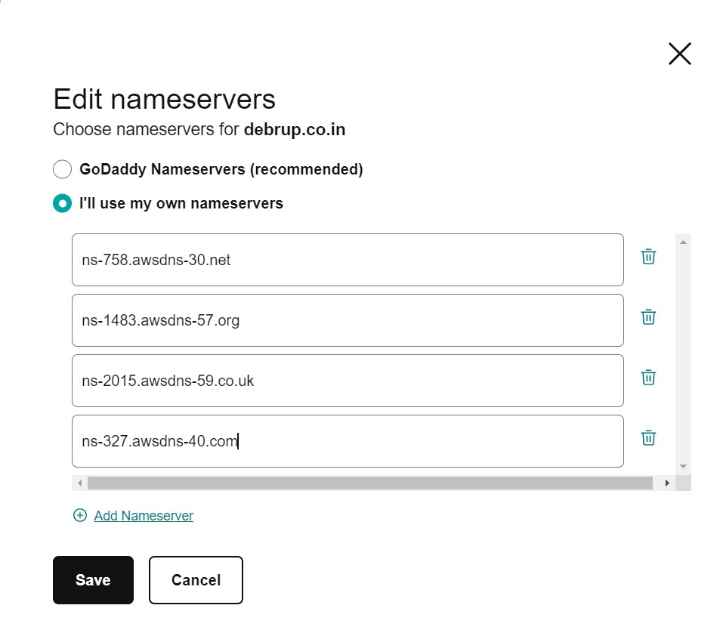

1. Wait for few minutes.
2. Now try searching from any browser using your domain name with www.

(For example: [www.example.com)](http://www.example.com/)

1. Also append port no. like we always do to access our project webpage.

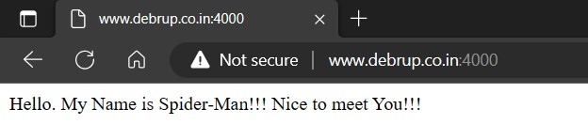

**We have successfully run our project using our custom domain-name and URL.**