April 2024 Session

INTI International College Penang

School of Computing (SOC)

|  |
| --- |
| **INT4000CEM**  **Programming and Algorithms** |

**Instructions to candidates:**

Time allowed: 2 hours

This is a Mock Test

The total number of questions in this paper: 4.

You should answer ALL questions.

**Question 1 (25 Marks)**

1. You are required to write a pseudocode to calculate the total price of items purchased by the customer. First, the customer is required to enter the type of item and the quantity to be purchased. Then, the program will display the total price that should be paid by the customer. The following table is a list of items and their prices.

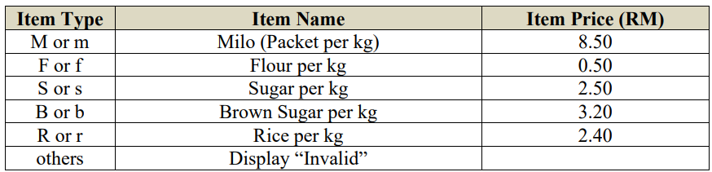

1. marks)

**Answer:**

Start

1. Enter the type_of_items and quantity
2. If(M or m)

Display itemName=Milo(Packet per kg) and itemPrice=8.50

Else if(F or f)

Display itemName=Flour per kg and itemPrice=0.50

Else if(S or s)

Display itemName=Sugar per kg and itemPrice=2.50

Else if(B or b)

Display itemName=Brown Sugar per kg and itemPrice=3.20

Else if(R or r)

Display itemName=Rice per kg and itemPrice=2.40

Else

Display “Invalid input”

1. Calculate the price by multiplying the quantity and the itemPrice
2. Display the total price needed to pay to purchase the items

End

(b) For each line of code below, fill in the value and datatype created.

|  |  |  |
| --- | --- | --- |
| **Line of Code** | **Value** | **Datatype** |
| a = 10%3  b = a/4  c = b*3  d = str(b)  e = d+d+d | *1*  *0.25*  *0.75*  *0.25*  *0.250.250.25* | *integer*  *float*  *float*  *string*  *string* |

(15 marks)

**Question 2 (25 Marks)**

Universe Petrol company wants you to write a python program for customer fueling. The program will display a menu to select the types of petrol and how many whole liters they wish to purchase. It then calculates the total cost of filling up their vehicle and display it on the output screen. The fuel options and tariffs at this petrol station are tabulated in below Table. If the customer enters the wrong input, it will display a message “Wrong input!!” Write a complete python program by using selection statement. Refer to Figure below for the example of the output.

***Table Q2***

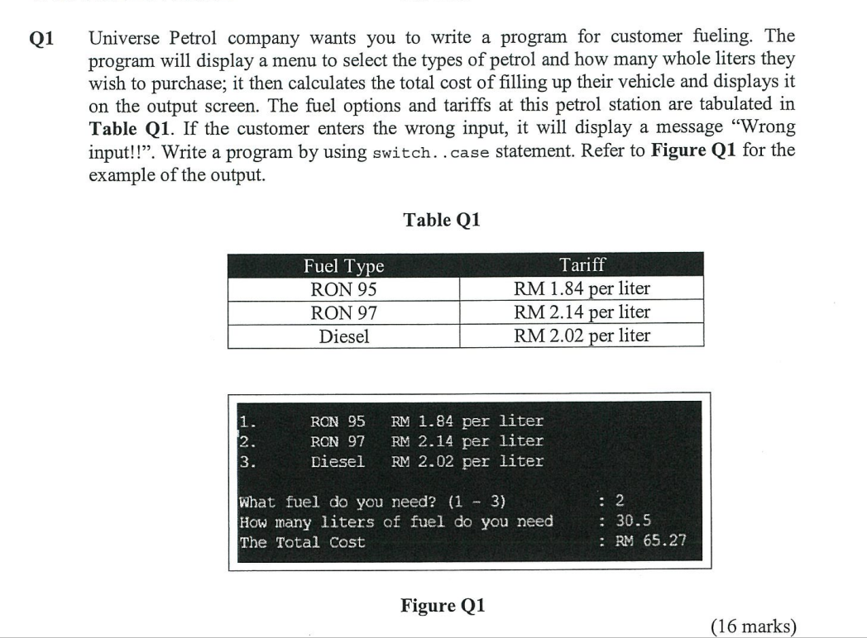

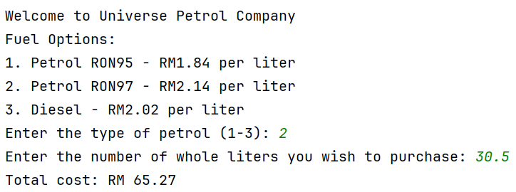

***Figure Q2***

***Answer:***

**Question 3 (25 Marks)**

Create three functions named GetData() and CalculateAvg() and DisplayAvg(). GetData() is designed to get the input from three numbers. CalculateAvg function used to calculate the average of three numbers. DisplayAvg function is to display the average value. Write a python program for the above statements.

Answer:

(25 marks)

.

**Question 4 (25 Marks)**

1. Create a list of ten fruits. Ask the user for a starting number between 0 and 5 and an end number between 6 and 9. Display the list for those fruits between the start and end numbers the user input.

Answer:

(10 marks

1. Create two lists of integers. Then, compute average of two given lists. Display the original lists and the average of the two lists.

Sample of output: Original list:

[1, 1, 3, 4, 4, 5, 6, 7]

[0, 1, 2, 3, 4, 4, 5, 7, 8]

Average of two lists: 3.823

Answer:

(15 marks)

***~THE END~***