Prevalence and Risk Factors Associated with Anabolic-Androgenic Steroid Use Among Gym Users in Muscat Governorate, Oman: A Cross-Sectional Study
Al Muhalab Al Farsi; Ahmed Al Ismaili
Supervised by Dr. Asma Al Salmani and Dr. Nouf Al Alawi
Muscat Governorate, Sultanate of Oman

Abstract
Background: Anabolic-androgenic steroids (AAS) are synthetic derivatives of testosterone that are used non-medically by some gym attendees to increase muscle mass, strength, and physical appearance. AAS misuse is associated with endocrine, cardiovascular, hepatic, psychiatric, and dermatologic complications. Regional studies from Gulf countries have reported considerable AAS use among gym attendees, but data from Oman remain limited.
Objective: To determine the prevalence of AAS use among male gym users in Muscat Governorate, Oman, and to explore beliefs, attitudes, and selected factors associated with use.
Methods: A cross-sectional questionnaire-based study was conducted among healthy male adults aged 18-55 years attending 12 gyms across six wilayats of Muscat Governorate. Two gyms were selected from each wilayat. Participants completed a self-administered questionnaire covering demographic information, AAS use, beliefs about muscularity and hormones, perceived harms, peer exposure, advice received to use hormones, sources of hormones, route of administration, and supplement use. Data were entered in EpiData. Categorical variables were summarized as frequencies and percentages of valid responses, and associations were assessed using Pearson chi-square or Fisher exact tests, as appropriate.
Results: A total of 343 participants were included. Current AAS use was reported by 42 participants (12.2%; 95% CI 9.2-16.1%); a further 13 (3.8%) intended to use AAS in the future, 95 (27.7%) were undecided, and 171 (49.9%) had no intention of use. AAS-use orientation was significantly associated with personally knowing someone who uses hormones (97.6% among users vs 29.8% among participants with no intention of use, p<0.001), believing that large muscles require hormones (70.0% vs 15.1%, p<0.001), having been advised by someone to use hormones (72.5% vs 17.1%, p<0.001), and believing that hormones are not harmful if used correctly (50.0% vs 7.7%, p<0.001). Compared with non-users, users were less likely to have university education (42.9% vs 59.1%, p=0.046) and more likely to have intermediate/institute education (23.8% vs 9.8%, p=0.017). Among users, the most common age at first use was older than 35 years (33.3%), followed by 19-25 and 26-34 years (28.6% each); friends at the gym were the most common source (40.0%), and oral and injectable routes were equally common (35.7% each).
Conclusion: AAS use among gym attendees in Muscat Governorate appears to be driven by peer influence, misconceptions about the necessity of hormones for muscularity, and underestimation of harms. Gym-based awareness programs, trainer education, and regulation of informal sources of AAS are recommended.
Keywords: Anabolic-androgenic steroids; gym users; Oman; Muscat; prevalence; risk factors; peer influence; cross-sectional study.

Background
Anabolic-androgenic steroids are synthetic derivatives of testosterone. They have legitimate medical indications, including treatment of selected forms of hypogonadism and catabolic states, but are also used non-medically by athletes and gym attendees for rapid increases in muscle mass, strength, and perceived physical attractiveness. The non-medical use of AAS is a public health concern because users often obtain products from informal sources and may use supraphysiologic doses without medical monitoring.
The adverse effects of AAS are multisystemic. Endocrine and reproductive complications include hypogonadism, testicular atrophy, infertility, gynecomastia, and menstrual disturbance in females. Cardiovascular complications include dyslipidemia, hypertension, cardiomyopathy, myocardial infarction, and stroke. Hepatic complications, particularly with oral alkylated AAS, include enzyme elevation, cholestasis, peliosis hepatis, and hepatic tumors. Psychiatric effects such as aggression, irritability, mood disturbance, depression, and dependence have also been described.
The Gulf region has a strong culture of gym attendance and bodybuilding, and several regional studies have reported high levels of AAS use among fitness-center attendees. A study among male fitness-center attendees in Kuwait reported that 22.7% had used AAS, with the 19-25 age group being the most common age at first use. Studies from the United Arab Emirates and Saudi Arabia have similarly shown substantial AAS use among gym attendees and athletes.
Despite these regional data, local evidence from Oman remains limited. Understanding the prevalence, sources, motivations, beliefs, and risk factors for AAS use in Oman is necessary for designing targeted educational interventions and informing gym-based and public health prevention strategies. The present study therefore aimed to estimate the prevalence of AAS use among gym users in Muscat Governorate and identify selected factors associated with use.

Methods

Study design and setting
This was a cross-sectional survey conducted among gym users in Muscat Governorate, Sultanate of Oman. The study was designed to assess the prevalence of AAS use and associated knowledge, attitudes, and practices among gym attendees.

Study population
The study population consisted of healthy male adults aged 18-55 years attending gym facilities in Muscat Governorate. Individuals using anabolic steroids for medical indications or health-related reasons were excluded.

Sampling and recruitment
The study included gyms from six wilayats in Muscat Governorate: Muscat, Bawshar, As Seeb, Al Amerat, Muttrah, and Quriyat. Two popular gyms were selected from each wilayat, giving a total of 12 gyms. Verbal permission was obtained from gym owners or coaches. Participants were approached on randomly chosen days, and the study title and rationale were explained before questionnaire distribution.

Questionnaire and variables
A self-administered questionnaire was used. It assessed AAS use status, demographic characteristics, beliefs about muscularity and hormone use, perceived harmfulness of AAS, knowledge of possible health problems, peer exposure, advice received to use hormones, reasons for attending the gym, sources of obtaining hormones, route and context of administration, supplement use, and reasons for non-use. Use status was categorized as current users, intended future users, undecided non-users, and participants with no intention of use.

Ethical considerations
Ethical approval was obtained from the Regional Research Committee, Directorate General of Health Services, Muscat Governorate (Proposal ID: MOH/CSR/24/28484). Approval was also obtained from the National Center for Statistics and Information. Participation was voluntary and anonymous.

Statistical analysis
Completed questionnaires were coded and entered in EpiData (EpiData Manager, .epx format); the EpiData file was cross-checked against the Excel data-entry file, and the 343 records were identical in both. Code 9 (no answer) was treated as missing, and percentages are reported out of valid responses with the denominator given for each estimate. Participants were classified into four AAS-use orientation groups using the questions on current use (Q2) and intention to use (Q3): current users (n=42), intended future users (non-users who intended to use hormones, n=13), undecided non-users (n=95), and non-users with no intention of use (n=171). Nineteen non-users who did not answer the intention question and three participants who did not answer the current-use question could not be classified and were excluded from comparisons across orientation groups. The 95% confidence interval (CI) for prevalence was calculated using the Wilson method. Associations between categorical variables and AAS-use orientation were assessed using Pearson chi-square tests. For two-group comparisons between users and non-users, the Pearson chi-square test was used when all expected counts were at least 5, and Fisher's exact test otherwise. A two-sided p-value <0.05 was considered statistically significant.

Results

Study sample and prevalence
A total of 343 male gym attendees were included. Current AAS use was reported by 42 participants (12.2%; 95% CI 9.2-16.1%), and three participants did not answer this question. Among non-users, 13 (3.8% of the total sample) intended to use AAS in the future, 95 (27.7%) were undecided, and 171 (49.9%) had no intention of future use, while 19 (5.5%) did not answer the intention question. The distribution of AAS-use orientation is shown in Table 1 and Figure 1.

Education level
University education was the most common educational level among both users and non-users; however, it was less common among AAS users than non-users (18/42, 42.9% vs 175/296, 59.1%; p=0.046). Intermediate and institute-level education combined were more frequent among users than non-users (10/42, 23.8% vs 29/296, 9.8%; p=0.017), whereas secondary education was similar in the two groups (33.3% vs 31.1%) (Table 3).

Beliefs and attitudes toward muscularity and hormones
Beliefs about the necessity of hormones for muscularity differed markedly across use-orientation groups. The belief that large muscles require hormones was reported by 70.0% of current users, 61.5% of intended future users, 28.7% of undecided respondents, and 15.1% of participants with no intention of future use (p<0.001) (Table 2, Figure 2).
When asked whether hormones are harmful (more than one option could be selected), only 25.3% of respondents (85/336) considered them very harmful, whereas 27.7% considered them not harmful if used correctly, 23.2% considered them harmful but not very harmful, and 25.3% did not know. The belief that hormones are not harmful if used correctly was reported by 50.0% of users, 53.8% of intended future users, 53.2% of undecided respondents, and only 7.7% of the no-intention group (p<0.001). Conversely, 41.7% of the no-intention group considered hormones very harmful, compared with 5.0% of users, none of the intended future users, and 6.4% of undecided respondents (p<0.001).

Peer influence
Peer exposure was one of the strongest correlates of AAS-use orientation. Nearly all current users (41/42, 97.6%) reported personally knowing someone who used hormones, compared with 84.6% of intended future users, 68.4% of undecided respondents, and 29.8% of participants with no intention of future use (p<0.001) (Figure 3). Similarly, 72.5% of users, 76.9% of intended future users, and 65.6% of undecided respondents had been advised by someone to use hormones, compared with 17.1% of the no-intention group (p<0.001). Overall, a friend or fellow gym member was the most commonly reported source of such advice (101/331, 30.5%), followed by gym trainers (17/331, 5.1%).

Supplement use
Amino acid/protein supplements were the most commonly used products (144/297, 48.5%), followed by creatine (104/301, 34.6%), growth products (41/300, 13.7%), super pump (37/293, 12.6%), and super charge (29/295, 9.8%). Hormone boosters (7.0%), cutting pills (5.0%), vasodilators (2.7%), and growth boosters (2.5%) were less commonly reported (Figure 6).

Patterns of AAS use among users
Among the 42 users, the most common age category at first use was older than 35 years (14/42, 33.3%), followed by 19-25 years and 26-34 years (12/42, 28.6% each) and 14-18 years (4/42, 9.5%). Friends at the gym were the most frequently reported main source of hormones (16/40, 40.0%), followed by gym trainers and hormone sellers (7/40, 17.5% each), pharmacies or doctors (5/40, 12.5%), the internet (3/40, 7.5%), and purchase abroad during travel (2/40, 5.0%). Oral and injectable routes were equally common (15/42, 35.7% each), and 12 users (28.6%) used both. Administration most commonly occurred at the gym by a specialist (15/37, 40.5%) or with friends who also used hormones (13/37, 35.1%), while 9 users (24.3%) self-administered alone. Building muscle shape was the most common main reason for use (29/40, 72.5%), followed by gaining strength (13/40, 32.5%). More than half of users (24/42, 57.1%) believed that they must use hormones to get results, and 22 (52.4%) reported having achieved the desired result (Table 4).

Reasons for non-use
Among non-users, the most commonly reported main reasons for not using hormones were not feeling a need for them yet (171/270, 63.3%), believing they are harmful to health (159/271, 58.7%), and not having thought about using them (102/267, 38.2%).
Table 1. Distribution of AAS-use orientation among respondents
Use-orientation category | n | %
Current AAS users | 42 | 12.2
Intended future users | 13 | 3.8
Undecided non-users | 95 | 27.7
No intention of future use | 171 | 49.9
Non-users, intention not reported | 19 | 5.5
Use status not reported | 3 | 0.9
Total | 343 | 100.0

Table 2. Beliefs, peer exposure, and perceived harm by AAS-use orientation
Variable | Current users n/N (%) | Intended future users n/N (%) | Undecided n/N (%) | No intention n/N (%) | p-value
Belief that large muscles require hormones | 28/40 (70.0) | 8/13 (61.5) | 27/94 (28.7) | 25/166 (15.1) | <0.001
Personally knows someone who uses hormones | 41/42 (97.6) | 11/13 (84.6) | 65/95 (68.4) | 50/168 (29.8) | <0.001
Advised by someone to use hormones | 29/40 (72.5) | 10/13 (76.9) | 61/93 (65.6) | 28/164 (17.1) | <0.001
Believes hormones are not harmful if used correctly | 20/40 (50.0) | 7/13 (53.8) | 50/94 (53.2) | 13/168 (7.7) | <0.001
Believes hormones are very harmful | 2/40 (5.0) | 0/13 (0.0) | 6/94 (6.4) | 70/168 (41.7) | <0.001

N = valid responses in each group. p-values from Pearson chi-square tests (2 x 4). Nineteen non-users who did not report their intention and three participants who did not report their use status were excluded.
Table 3. Education-level comparisons between users and non-users
Education variable | Users n/N (%) | Non-users n/N (%) | p-value
University education | 18/42 (42.9) | 175/296 (59.1) | 0.046
Intermediate/institute education | 10/42 (23.8) | 29/296 (9.8) | 0.017

Note: Each education category is compared with all other levels combined. Non-users are participants who answered No to current use; two non-users with missing education were excluded. p-values: Pearson chi-square test (university) and Fisher exact test (intermediate/institute, expected count <5).
Table 4. Patterns of AAS use among current users
Characteristic among AAS users | n | %
First use at 14-18 years | 4 | 9.5
First use at 19-25 years | 12 | 28.6
First use at 26-34 years | 12 | 28.6
First use at >35 years | 14 | 33.3
Source: friends at gym | 16 | 40.0
Source: gym trainers | 7 | 17.5
Source: hormone sellers | 7 | 17.5
Source: pharmacy/doctor | 5 | 12.5
Source: internet | 3 | 7.5
Source: abroad during travel | 2 | 5.0
Route: mostly injection | 15 | 35.7
Route: mostly oral | 15 | 35.7
Route: both oral and injection | 12 | 28.6
Administered at gym by a specialist | 15 | 40.5
Administered with friends who also use | 13 | 35.1
Self-administered alone | 9 | 24.3

Note: Percentages are of valid responses among current users: age at first use and route, N=42; main source, N=40; manner of administration, N=37.

Figures
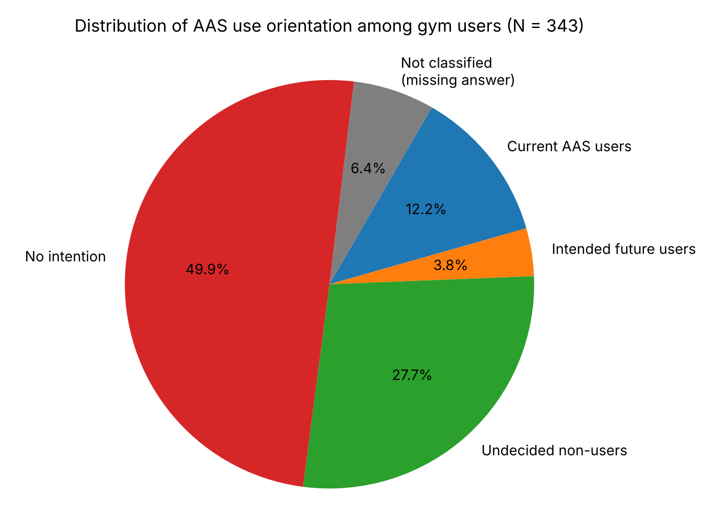
Figure 1. Distribution of AAS-use orientation among all respondents.
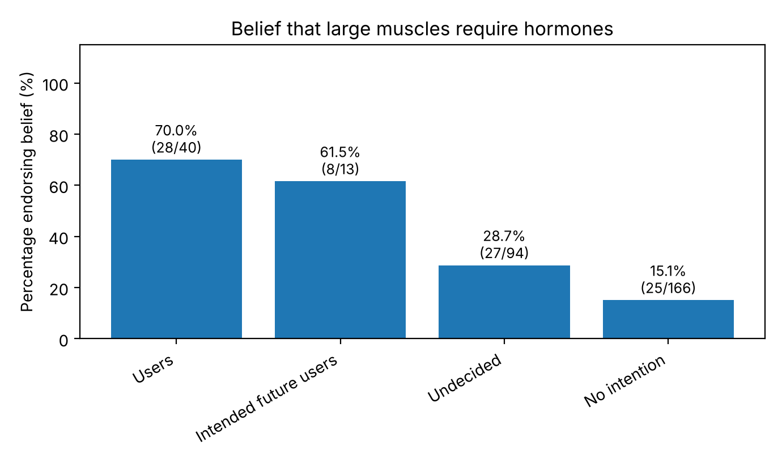
Figure 2. Belief that large muscles require hormones by AAS-use orientation.
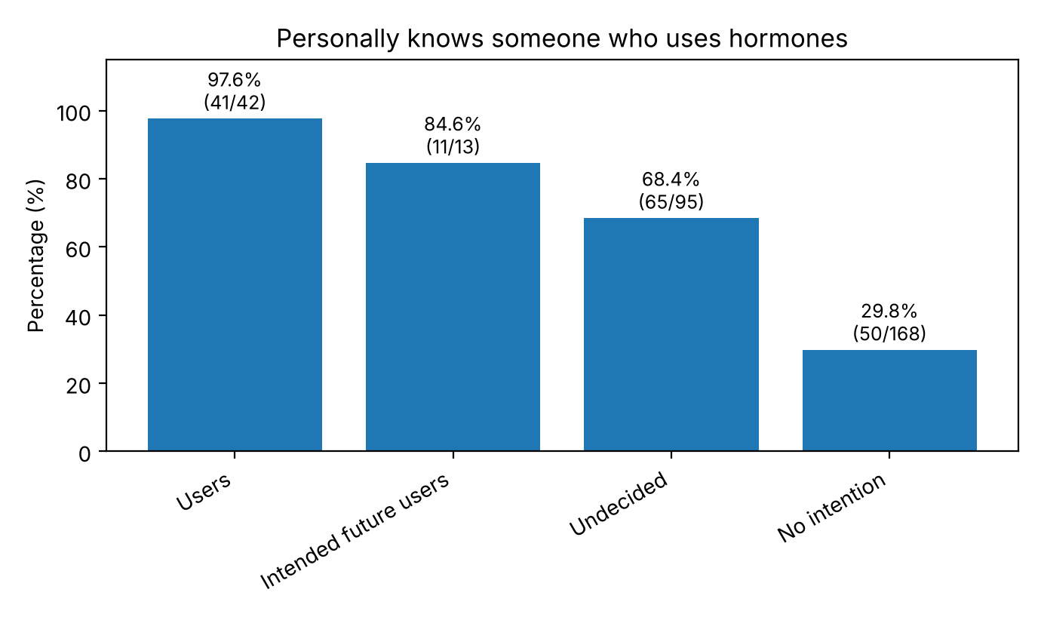
Figure 3. Peer exposure (personally knowing someone who uses hormones) by AAS-use orientation.
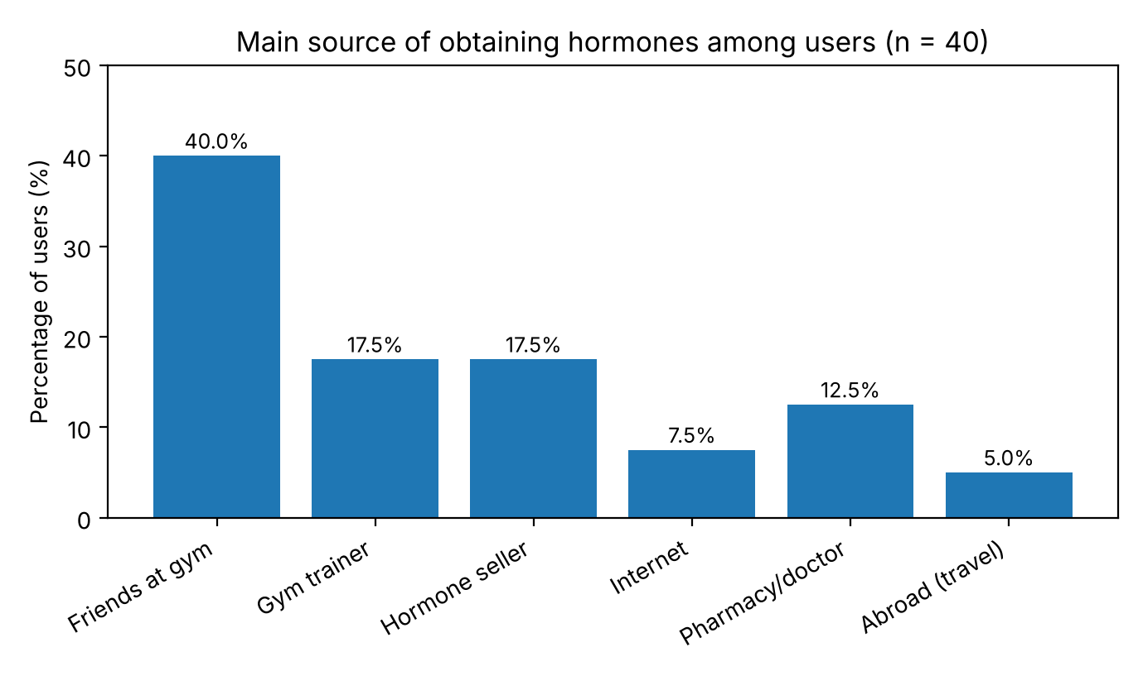
Figure 4. Main source of obtaining hormones among current users.
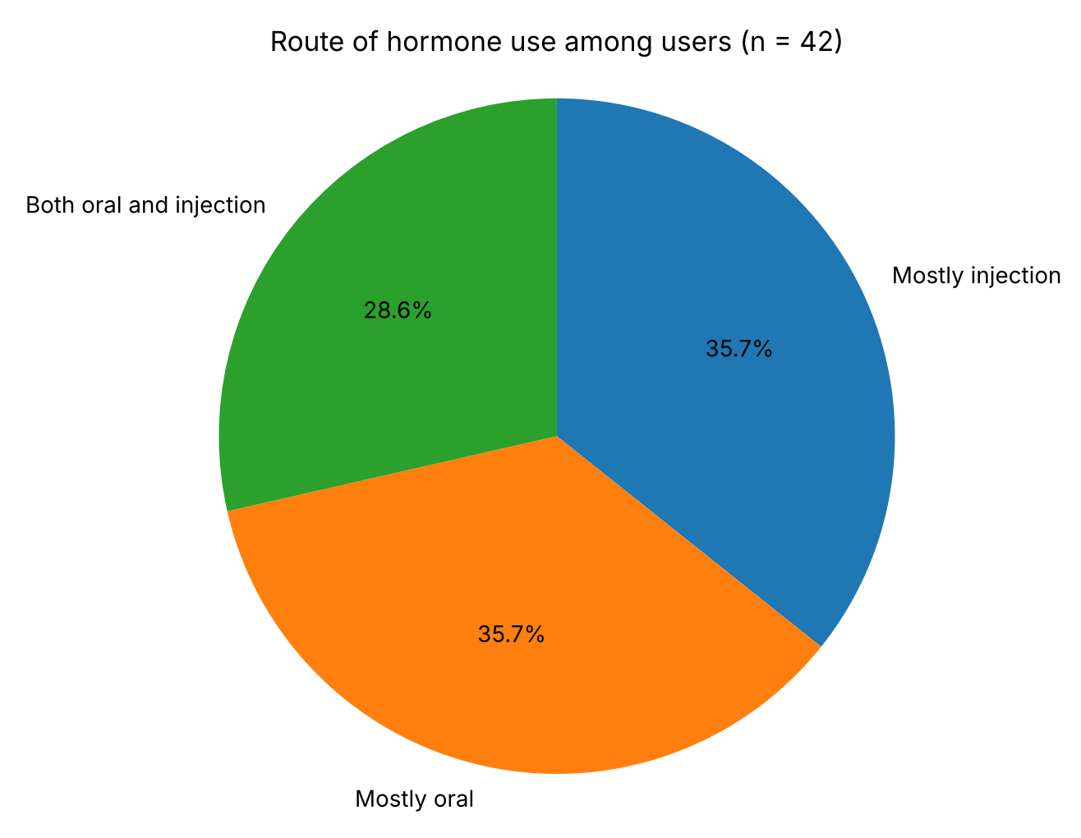
Figure 5. Route of hormone use among current users.
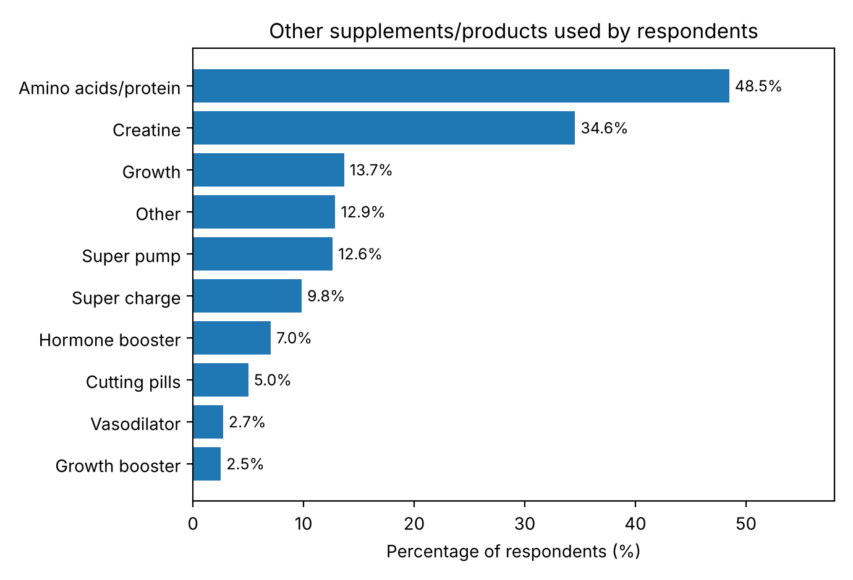
Figure 6. Use of other supplements/products reported in the study.

Discussion
This study provides one of the first available descriptions of AAS use among male gym attendees in Muscat Governorate, Oman. The prevalence of current AAS use was 12.2% (42/343). Although this is lower than the 22.7% reported among male fitness-center attendees in Kuwait and lower than several Saudi and UAE estimates, it still represents an important public health concern because AAS use is associated with substantial short- and long-term harms.
The lower prevalence observed in the present study may reflect differences in sampling, gym characteristics, local availability of AAS, social desirability bias, or differences in awareness and enforcement. The study included gyms across six wilayats and recruited an average of approximately 28 participants per gym, which supports broad geographic representation within Muscat Governorate. However, AAS use is a sensitive topic, and some under-reporting is possible.
Beliefs regarding muscularity were strongly associated with AAS use. Seventy percent of users and more than 60% of intended future users believed that large muscles require hormones, compared with only 15% of participants with no intention of use. This finding parallels observations from Kuwait, where most AAS users believed that an optimally muscular body could only be achieved through AAS use. The implication is that knowledge of side effects alone may not be sufficient; interventions must directly address body-image beliefs and the perceived necessity of pharmacological enhancement.
Peer influence was also a major finding. Nearly all current users (97.6%) personally knew someone who used hormones, and almost three-quarters had been advised by someone to use them, most often a friend or fellow gym member. This pattern suggests that AAS use may spread through social networks within gyms. In the present study, friends at the gym were the most common source of hormones, followed by gym trainers and hormone sellers. This emphasizes the role of gym culture and informal networks in both normalization and access. Similar regional studies have reported that advice from peers and trainers is an important contributor to AAS initiation.
Risk perception was low among current users, intended users, and undecided respondents. Only about one quarter of all respondents considered AAS very harmful, and the majority either underestimated harms or were uncertain. Half of users, and a similar proportion of intended and undecided respondents, believed that hormones were not harmful if used correctly, compared with fewer than 8% of participants with no intention of use. This is an important misconception, because non-medical use frequently involves unregulated products, supraphysiologic doses, multiple substances, and lack of laboratory monitoring. Users may interpret the absence of immediate symptoms as safety despite potential endocrine, cardiovascular, hepatic, and psychiatric complications.
In this study, first use was spread across adult age groups: 19-25 years and 26-34 years each accounted for 28.6% of users, and one third started after the age of 35 years. This differs from the Kuwait study, in which the 19-25 age group was the most common age at first use. The considerable proportion of later initiation suggests that prevention efforts should target not only late adolescents and young adults but also older gym attendees, alongside new members beginning intensive resistance training.
Oral and injectable routes were equally common (35.7% each), and more than a quarter of users used both. Injection practices have clinical implications because they may increase the risk of injection-related infections, abscesses, and transmission of blood-borne infections if equipment is shared or injection technique is unsafe, while oral alkylated AAS carry a particular risk of hepatotoxicity. The finding that administration commonly occurred at the gym by a specialist or with friends further supports the need for gym-based education and regulation.
Educational level was also associated with AAS use: users were less likely than non-users to have university education and more likely to have intermediate or institute-level education. This may reflect differences in health literacy or in the social environments of gym attendees. Future studies should explore whether education, peer exposure, and beliefs remain independently associated with AAS use after adjusting for age, training intensity, and supplement use.
From a public health perspective, the findings support interventions at multiple levels. At the individual level, clinicians should ask young male gym attendees about AAS use in a nonjudgmental manner, particularly when they present with infertility, acne, gynecomastia, mood disturbance, hypertension, dyslipidemia, liver enzyme elevation, or unexplained endocrine abnormalities. At the gym level, trainers and coaches should be educated about AAS harms and discouraged from promoting non-medical use. At the policy level, informal distribution channels should be addressed through regulation and awareness campaigns.

Limitations
This study has several limitations. First, the cross-sectional design does not allow causal inference. Second, AAS use was self-reported and may be affected by recall bias and social desirability bias. Third, some items had missing responses, and questions answered only by users had small denominators (N=37-42), so estimates of patterns of use are imprecise. Fourth, the gym from which each questionnaire was collected was not recorded in the dataset, so clustering by gym could not be taken into account. Fifth, the study included male gym users in Muscat Governorate and may not be generalizable to female gym users, adolescents, non-gym athletes, or gym attendees in other governorates. Finally, the analysis was bivariate; multivariable regression was not performed, and confounding cannot be excluded.

Recommendations
Based on the findings, educational interventions should focus on correcting the belief that large muscles require hormones, improving understanding of AAS harms, and reducing peer-driven normalization of AAS use. Gym trainers should be included in awareness programs because they may influence both attitudes and access. Future research should use validated questionnaires, include larger samples from multiple governorates, and perform multivariable analysis to identify independent predictors of AAS use.

Conclusion
AAS use among gym attendees in Muscat Governorate was reported by 12.2% of participants. Use was strongly associated with peer exposure, advice from others to use hormones, and the belief that large muscles require hormones. Many users underestimated the harms of AAS and obtained hormones through friends, trainers, and informal sellers. These findings highlight the need for gym-based awareness programs, trainer education, and public health strategies to reduce non-medical AAS use in Oman.

References
1. Alsaeed I, Alabkal JR. Usage and perceptions of anabolic-androgenic steroids among male fitness centre attendees in Kuwait: a cross-sectional study. Subst Abuse Treat Prev Policy. 2015;10:33. doi:10.1186/s13011-015-0030-5.
2. Al-Falasi O, Al-Dahmani K, Al-Eisaei K, Al-Ameri S, Al-Maskari F, Nagelkerke N, et al. Knowledge, attitude and practice of anabolic steroids use among gym users in Al-Ain District, United Arab Emirates. Open Sports Med J. 2008;2:75-81. doi:10.2174/1874387000802010075.
3. Alharbi FF, Gamaleddin I, Alharbi SF, Almodayfer O, Allohidan F, Alghobain M, et al. Knowledge, attitudes and use of anabolic-androgenic steroids among male gym users: a community-based survey in Riyadh, Saudi Arabia. Saudi Pharm J. 2019;27(2):254-263. doi:10.1016/j.jsps.2018.11.007.
4. Al Bishi KA, Afify A. Prevalence and awareness of anabolic androgenic steroids among gymnasts in the western province of Riyadh, Saudi Arabia. Electron Physician. 2017;9(12):6050-6057. doi:10.19082/6050.
5. Althobiti SD, Alqurashi NM, Alotaibi AS, Alharthi TF, Alswat KA. Prevalence, attitude, knowledge, and practice of anabolic androgenic steroid use among gym participants. Mater Sociomed. 2018;30(1):49-52. doi:10.5455/msm.2018.30.49-52.
6. Pope HG Jr, Kanayama G, Hudson JI. Risk factors for illicit anabolic-androgenic steroid use in male weightlifters: a cross-sectional cohort study. Biol Psychiatry. 2012;71(3):254-261.
7. Kanayama G, Hudson JI, Pope HG Jr. Long-term psychiatric and medical consequences of anabolic-androgenic steroid abuse: a looming public health concern? Drug Alcohol Depend. 2008;98(1-2):1-12.
8. Rahnema CD, Crosnoe LE, Kim ED. Designer steroids: over-the-counter supplements and their androgenic component. Andrology. 2015;3(2):150-155.
9. Nieschlag E, Vorona E. Doping with anabolic androgenic steroids: adverse effects on non-reproductive organs and functions. Rev Endocr Metab Disord. 2015;16(3):199-211.
10. World Anti-Doping Agency. The World Anti-Doping Code: International Standard Prohibited List. Montreal: WADA; current edition.

