SC-RRT: A Search-State-Driven Path Planning Algorithm with Adaptive Asymmetric Dual-Ellipsoid Constrained Sampling

Yan Wu¹ · Xingyu Guo¹ · MuChun Fan¹ · Feng Hong¹ ·HongYu Gao¹ · JiaLe Hu¹

Abstract:
Sampling-based path planning algorithms commonly suffer from excessive invalid samples, slow convergence, and reduced success rates in high-obstacle-density environments. To address these limitations, this paper presents SC-RRT, a path planning algorithm built on adaptive asymmetric dual-ellipsoid constrained sampling.The algorithm operates within a bidirectional parallel expansion framework and introduces waypoint-guided decomposition, breaking the global planning task into a sequence of staged subproblems. By constructing scale-variable, asymmetric informed sampling subsets in both directions, sampling is progressively concentrated toward feasible path regions with greater improvement potential. This forms the Adaptive Dual-Ellipsoid Constrained Sampling strategy (ADCS), which improves effective sampling density while preserving global exploration coverage.To suppress invalid sampling caused by over-inflation or premature contraction of the informed subset due to cost estimation bias, an online regulation mechanism based on Search State Feedback (SSFOR) is developed. Using the historical evolution of the current optimal path cost as a feedback signal, SSFOR performs closed-loop adjustment of the hyperellipsoid expansion factor γ and the heuristic sampling probability p, allowing the informed subset to evolve continuously with the search progress. Sampling density is thereby adaptively redistributed between the global exploration space and locally constrained regions, reducing redundant expansion while sustaining search continuity. Directional compression and expansion of the sampling space via asymmetric hyperellipsoid constraints further sharpen the algorithm's resolution along potentially feasible passage directions.
Simulation experiments across varying obstacle densities and spatial dimensions show that, compared with the structurally closest counterpart Dynamic-RRT, SC-RRT reduces path length by approximately 10.5% and achieves a path efficiency of 0.9553. Although path quality is marginally lower than the asymptotically optimal Informed RRT*, planning time is only 16.2% of the latter, with node count reduced by approximately 94.2%. These results indicate that SC-RRT achieves a favorable balance among path quality, planning efficiency, and computational cost. The algorithm requires no prior parameter tuning and operates reliably across different scenarios; its modular ADCS and SSFOR components can also be integrated as standalone modules into other RRT-based planning frameworks.
Keywords：Sampling-based path planning; asymmetric dual-ellipsoid informed sampling; bidirectional tree search; online parameter regulation; motion planning
- Introduction
With the rapid advancement of Industry 4.0 and service robotics, intelligent robots have become a key driver of automation and operational efficiency across manufacturing, service, and related sectors. Their application scope has expanded from structured factory settings to dynamic, complex environments where humans and robots work in close collaboration[1][4]. With the rapid advancement of Industry 4.0 and service robotics, intelligent robots have become a key driver of automation and operational efficiency across manufacturing, service, and related sectors. Their application scope has expanded from structured factory settings to dynamic, complex environments where humans and robots work in close collaboration[5][7]. Accordingly, in-depth research into robot path planning algorithms for complex environments carries not only considerable theoretical value, but also practical significance for advancing the real-world engineering deployment of intelligent robots. The core objective of path planning is to generate a collision-free trajectory for a robot within a known configuration space defined by a start point and a goal point, subject to kinematic constraints, while balancing two fundamental requirements: real-time responsiveness and path optimality[8]-[9]. In dynamic environments, randomly distributed obstacles and system uncertainties further compound the difficulty of planning. The shrinkage of the feasible region under sampling constraints and the resulting decline in tree growth efficiency are particularly pronounced [10], making the simultaneous achievement of fast convergence and high-quality paths a central challenge in current research[11][12].
The Rapidly Exploring Random Tree (RRT) algorithm and its bidirectional variants, such as Bidirectional RRT*, are classical sampling-based path planning methods. Owing to their probabilistic completeness and ease of implementation, they have been widely applied in complex environments[13][14]. However, the traditional Bidirectional RRT* algorithm still suffers from inherent limitations, such as strong randomness in the sampling

¹ School of Mechanical Engineering, Shanghai Institute of Technology, Shanghai 201418, China
² Corresponding Author: Xingyu Guo
³ Email:Gxyhaoxianghenlihai@gmail.com
process, low search efficiency, and insufficient geometric smoothness of the planned paths[15][16]. These limitations restrict its performance in scenarios involving large-scale environments, dense obstacles, or dynamically distributed obstacles[17][18]. To address the aforementioned issues, researchers in recent years have proposed various improvement strategies from the perspectives of sampling guidance, coordination of search strategies, and path structure optimization. A representative line of work enhances convergence efficiency by improving the bidirectional search framework and sampling guidance mechanisms, with particular emphasis on improving accessibility in “difficult-to-sample” scenarios such as narrow passages[19]. ARRT-Connect [20] , proposed by Li and Chen (2022), as well as ABQ-RRT* based on similar principles, adaptively adjust the sampling strategy according to the scale of unexplored regions identified through dual-tree exploration. By incorporating the principal component analysis (PCA) approach introduced by Tahirovic and Ferizbegovic (2018) in RRT [21], these methods enhance the directional growth of trees within “elongated feasible corridors,” thereby accelerating exploration and connectivity in narrow environments.
However, such methods may still generate a large number of redundant sampling points in regions unrelated to the optimal path when operating in high-dimensional spaces or complex environments with multiple passages, thereby reducing overall planning efficiency. In particular, as the environment scale increases or obstacle density rises, fixed sampling bias strategies struggle to adapt to the varying demands of different search stages, leading to diminished guidance effectiveness of the informed subset. Informed RRT* proposed by Gammell et al. [23][24] restricts the sampling space to an informed subset defined by a hyper-ellipsoid with the start and goal states as its foci, thereby concentrating the sampling process on regions that can potentially improve the cost of the current best path. This work establishes the theoretical foundation for cost-guided constrained sampling. Building upon this foundation, Gammell et al. further proposed the BIT* algorithm [25][26] , which unifies informed sampling and graph search into a heuristic search over an implicit random geometric graph, thereby further improving planning efficiency in high-dimensional scenarios. To further reduce the sensitivity of fixed ellipsoids to cost estimation bias, recent studies have attempted to introduce dynamic corridor constraints [27] or adaptive bidirectional hyper-ellipsoidal sampling [28] to enhance the adaptability of the sampling domain. The Dynamic-RRT algorithm proposed by Zhao et al. innovatively introduces a heuristic hyper-ellipsoidal constrained sampling mechanism. By estimating the path cost through expanded nodes, it restricts the sampling space to a hyper-ellipsoid with the start and goal states as its foci and the estimated path length as the major axis, thereby significantly improving the effectiveness of new node generation [29]. Meanwhile, the algorithm incorporates the Pareto Dominance principle[30] and dynamic programming concepts. By selecting Pareto-optimal nodes as new starting points to decompose the planning problem, it further reduces convergence time while ensuring path length optimization. Its performance is significantly superior to classical algorithms such as RRT, RRT*, and Informed RRT. Such methods effectively balance convergence speed and path quality through sampling space constraints and problem decomposition strategies. However, the performance of the sampling constraint mechanism in this algorithm still heavily depends on the accuracy of path cost estimation. When the cost is overestimated, the ellipsoidal constraint region becomes excessively large, leading to a considerable number of invalid samples; when the cost is underestimated, the constraint region shrinks prematurely, potentially excluding feasible optimal paths from the sampling space and causing the algorithm to converge to a suboptimal solution or even fail. Moreover, Dynamic-RRT adopts a unidirectional search framework, in which the informed subset is defined solely by the start and goal as focal points. In complex environments, its ability to guide the global search direction remains limited, and redundant expansions may still occur.
Overall, existing improvement methods still exhibit a pronounced trade-off between efficiency and optimality. While sampling guidance or bidirectional connectivity strategies can accelerate the acquisition of feasible solutions, they generally lack guarantees of asymptotic optimality. In contrast, cost-driven constrained sampling and problem decomposition approaches can increase the proportion of effective samples and improve path quality; however, their performance is highly sensitive to the accuracy of cost estimation. Moreover, the constraint domains are typically static or only weakly adaptive, which may lead to excessive shrinkage in the early search stage, reducing reachability, or cause oscillations in sampling ratios and tree expansion behavior when cost values fluctuate, thereby weakening global robustness and convergence consistency.
To address the aforementioned issues, this paper proposes an SC-RRT algorithm based on an adaptive asymmetric dual-ellipsoid constrained sampling subset. Within a bidirectional parallel search framework guided by intermediate points, the algorithm constructs asymmetric dual-ellipsoid sampling subsets on the start and goal sides that can independently expand and contract. To overcome the sensitivity of traditional constrained sampling to cost estimation bias and to prevent premature shrinkage or ineffective expansion of the sampling space, a search state feedback-based online regulation mechanism is established. Using the current best path cost and its historical evolution as feedback, a closed-loop control strategy is employed to adjust the scale of the hyper-ellipsoidal informed subsets. During the stage when a stable feasible solution has not yet been obtained, the constraints are moderately relaxed to enhance exploration coverage; once feasible paths emerge and continue to improve, the constraints are progressively strengthened to increase effective sampling density and suppress redundant expansions. In this way, a controllable dynamic balance is achieved among convergence speed, path quality, and search stability. Comparative experiments are conducted in representative scenarios with varying obstacle densities and spatial dimensions, using Dynamic-RRT and classical RRT variants as baselines. The effectiveness of the proposed mechanisms is systematically evaluated in terms of path length, planning time, node scale, and path smoothness.
- Algorithm statement
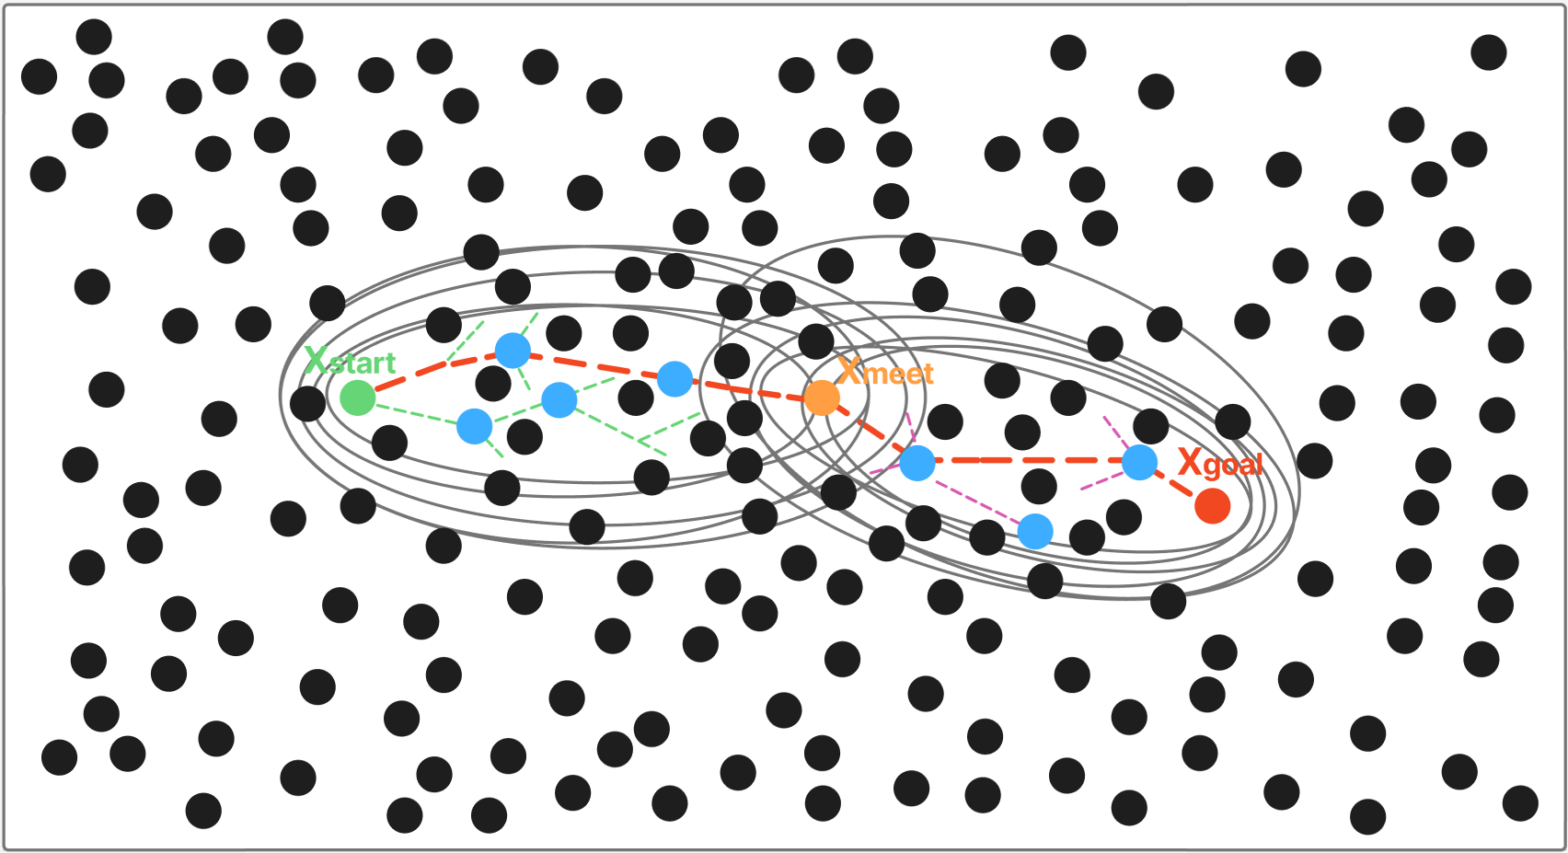
Figure 1.Schematic Diagram of the Search State-Driven Adaptive Asymmetric Dual-Ellipsoid Constrained Sampling SC-RRT Path Planning Algorithm
To establish the mathematical model of the path planning problem[31], the Cartesian workspace and the configuration space are defined, where m and n denote the corresponding dimensions, respectively[32]. There exists a mapping relationship between the workspace and the configuration space. Path planning is primarily carried out in the configuration space C, while obstacle information is mapped from the workspace W to the configuration space through coordinate transformation. Let the state be defined as, and partition the space into the collision-free region , shown as the white area in the figure, and the obstacle region , represented by the black circular obstacles, such that . The planning start and goal states are denoted as as illustrated in Figure 1.
The SC-RRT algorithm constructs two random trees T_{A},T_{B} from the start state x_{start} and the goal state x_{goal} , respectively, and introduces a dynamic intermediate point , thereby decoupling the global search into two subproblems: “start–intermediate” and “goal–intermediate,” as defined in Equation (1). The intermediate point is updated online based on the bidirectional search states. Unlike a traditional single static ellipsoid, the super-ellipsoid constructed in this paper does not maintain a fixed shape. Its parameters are dynamically updated as the path cost improves and the intermediate point shifts. Using as a bridge, the super-ellipsoid adaptively expands and contracts according to changes in path cost and the exploration states during the search process. Sampling constraints are constructed separately on the start side and the goal side, ensuring coverage of potentially optimal paths while progressively tightening the sampling domain boundaries, thereby effectively reducing invalid samples.
  - An Adaptive Asymmetric Dual-Ellipsoid Constrained Sampling (ADCS） Strategy
This paper proposes an asymmetric bi-ellipsoidal constrained sampling subset mechanism to achieve asymmetric regulation of the sampling domain. Unlike the Probabilistic Roadmap (PRM) method [33], which adopts an offline planning paradigm based on a multi-query graph structure, the proposed approach balances global exploration and local refined search during bidirectional tree expansion. Ultimately, it achieves simultaneous reductions in path length, planning time, and the number of nodes. The overall concept of the strategy is illustrated in Figure 1.
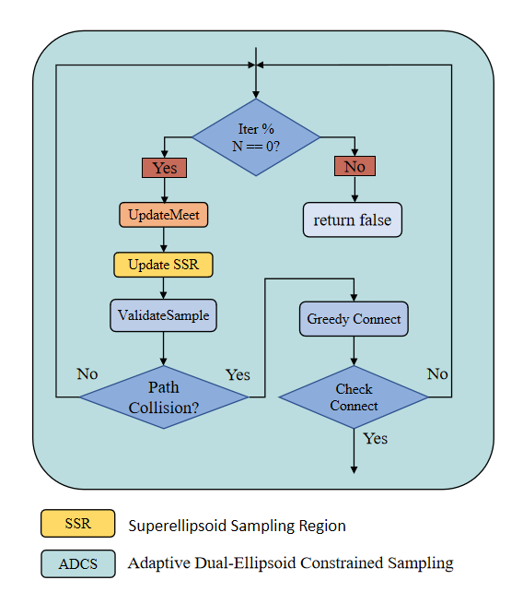
Fig. 1 Flowchart of the Adaptive Asymmetric Dual-Ellipsoid Constrained Sampling Strategy
The core of this sampling strategy lies in dynamically computing the constraint parameters of the super-ellipsoid. For either direction, taking the start side as an example, it is defined as follows:
where:
- Denotes the expansion coefficient adaptively adjusted online by the SSFOR mechanism;；
- Denotes the estimated optimal total cost from the start side based on heuristic evaluation;
- Denotes the accumulated path cost from the start node x_{start} to node x;
- Denotes the heuristic distance from node x to the intermediate point x_meet;
The goal side is defined correspondingly. The two ellipsoids are updated independently, forming an asymmetric constraint structure. In each iteration, informed sampling is conducted within the above ellipsoids with probability p; with a certain probability, biased sampling is performed toward the optimal node selected from the opposite tree according to the Pareto dominance principle; and with the remaining probability, global uniform sampling is carried out. This ensures that the search remains focused on effective regions while preserving global coverage capability.
For each newly expanded node, a direct connection to the opposite tree is attempted first. If the distance exceeds the threshold, the opposite tree greedily advances toward it. Once the two trees are successfully connected, node rewiring optimization and adaptive smoothing are performed on the concatenated path[34][35] , yielding the final feasible path.
  - Search State Feedback-Based Online Regulation (SSFOR) Mechanism

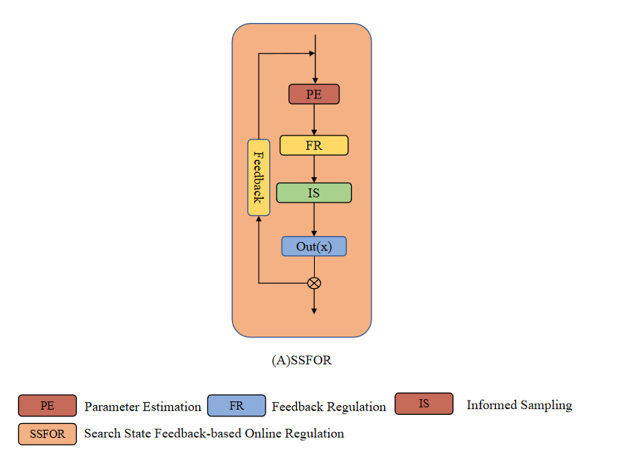

Fig. 2. Flow diagram of the Search State Feedback-Based Online Regulation (SSFOR) mechanism.

The effectiveness of ADCS depends on the timely adjustment of the expansion coefficient γ and the informed sampling ratio p. Existing convergence-acceleration methods—such as path-biased sampling[36] , batch forward-propagation search[37] , cost lower-bound trade-off strategies [38] , and anytime planning frameworks [39][40] —generally adopt preset static parameters. Heuristic sampling pruning methods [41] also require predefined thresholds, and thus lack online feedback regulation based on the search state. To address this limitation, this paper proposes the SSFOR mechanism to implement closed-loop regulation of both parameters. The relative rate of decrease in the estimated total optimal path cost is used as a signal of the current search progress. When the path cost shows no significant improvement over time, the constraints are considered potentially too restrictive or the search is deemed to have stagnated. Accordingly, γ is increased to expand the ellipsoidal coverage, and p is reduced to enhance global random exploration. Conversely, when the path cost continues to improve effectively, γ is decreased to tighten the constrained sampling subset, while p is increased to strengthen informed sampling and accelerate local convergence.

To ensure the boundedness and reproducibility of the above adjustment process, this paper specifies the value ranges and initial states of the two parameters as follows: The hyper-ellipsoid expansion factor γ is defined within the range γ∈[1.0, 4.0] , with a nominal value of γ₀=1.5 . At algorithm initialization , γ is set to 2.5 to ensure sufficient exploratory coverage during the early stage of the search. A larger γ corresponds to a greater degree of ellipsoidal expansion, leading the algorithm to favor broader exploration. Conversely, a smaller γ results in a more compact constrained sampling subset, causing the algorithm to shift toward intensified local convergence. The heuristic sampling probability p is defined within the range p∈[0.2, 0.95] , with a nominal value of p₀=0.8 . The initial value is set to p=0.0 , so that before any feasible path is obtained, the algorithm relies entirely on global random sampling for initial exploration. A higher p corresponds to a greater proportion of informed sampling, favoring refined local search; a lower p increases the proportion of global random sampling, thereby maintaining search diversity. When the constraint is overly relaxed, a large number of nodes fall into inefficient regions; when it is overly restrictive, the effective sampling rate drops sharply in obstacle-dense environments. Under the closed-loop regulation of SSFOR, both parameters fluctuate within the aforementioned valid ranges, preventing unbounded expansion or excessive contraction of the constrained sampling subset, and ensuring that the constraint strength continuously matches the current stage of the search.

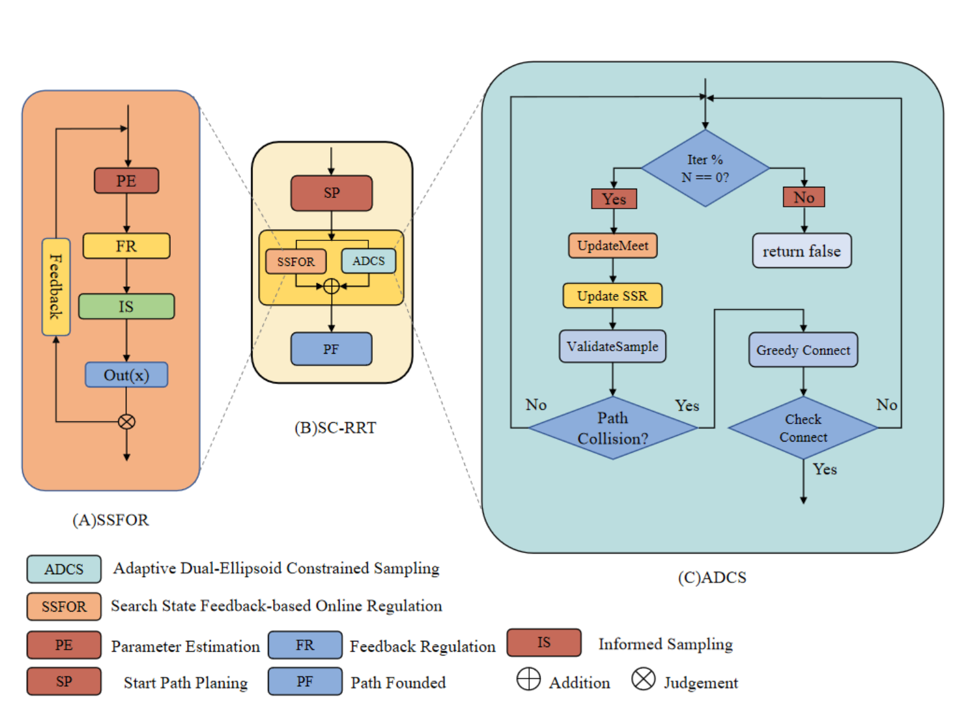

Fig. 4. Overall framework of the SC-RRT algorithm. It consists of the main search loop, SSFOR-based online regulation, and ADCS sampling. Dashed arrows indicate the internal implementation of key modules.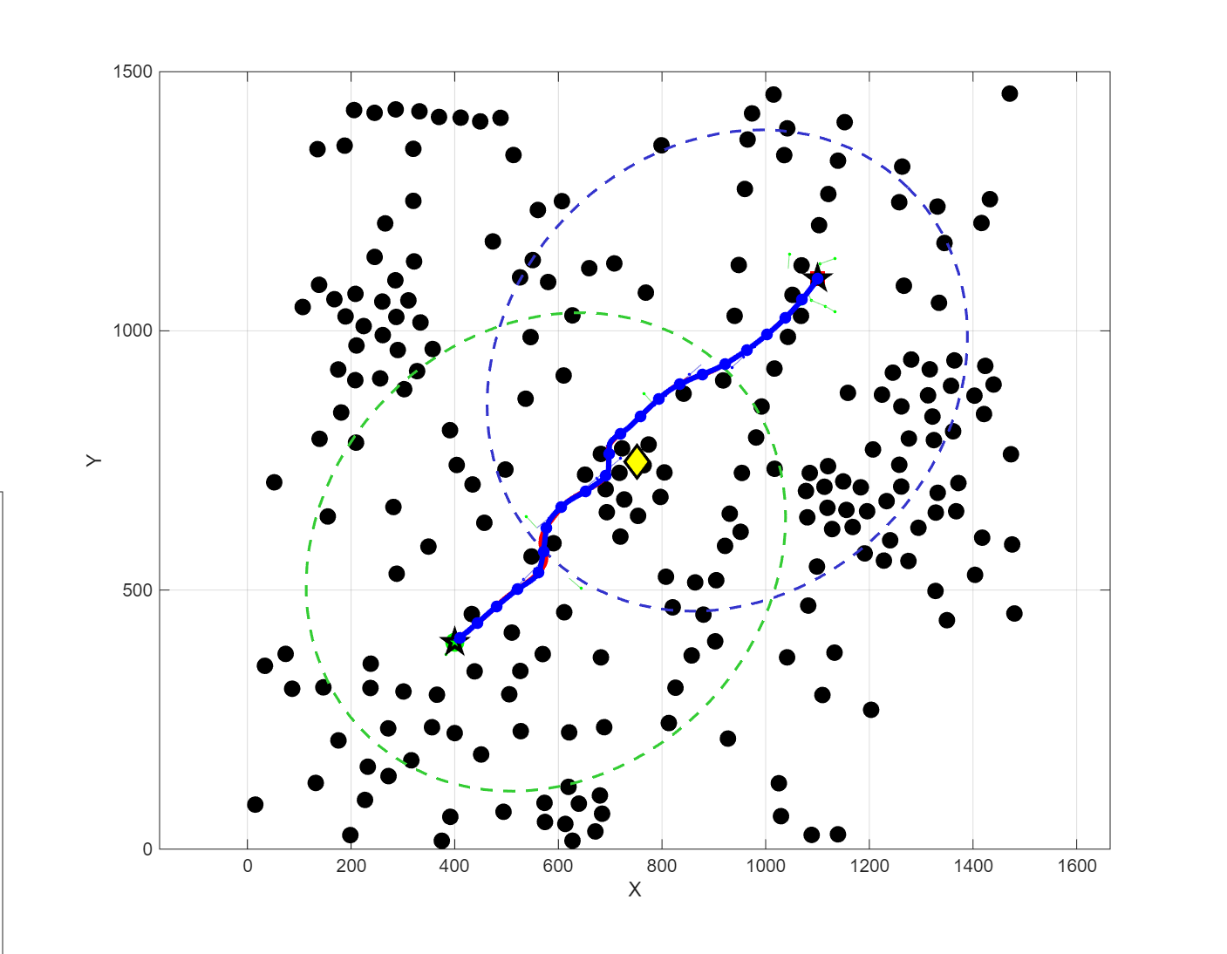
Fig. 5. Path planning process of SC-RRT in a 2D environment.
- Simulation
To systematically evaluate the performance of SC-RRT under consistent environmental scale and obstacle density, comparative simulation experiments were conducted in both two-dimensional and three-dimensional spaces. The results are shown in Figures 6 and 7. The evaluation metrics include: Path Length, defined as the sum of the Euclidean distances between adjacent nodes along the path (mm); Convergence Time, defined as the time required for the algorithm to achieve path convergence (s); Node Count, defined as the total number of sampled nodes generated during the planning process; and Path Efficiency, defined as the ratio of the straight-line distance between the start and goal to the actual path length, where values closer to 1.0 indicate a path that is nearer to the optimal solution.
Table 1 Environment configurations
Dimension | Environment | Obstacles | Start | Goal | Max Iteration
2 | 1500*1500 | 225 | (75, 75) | (1425, 1425) | 5000
3 | 1500*1500*1500 | 400 | (75, 75, 75) | (1425, 1425, 1425) | 88000
Based on previous studies in path planning, five representative algorithms—RRT, RRT-Connect, RRT*, Informed RRT*, and Dynamic-RRT—were selected for comparison with the proposed SC-RRT algorithm to validate its performance and stability. To ensure fairness in performance comparison among different path planning algorithms, all methods were evaluated under identical environmental spaces and obstacle configurations. Using the environment specified in Table 1 as an example, each algorithm was executed 500 times, and performance metrics such as path length and convergence time were assessed.
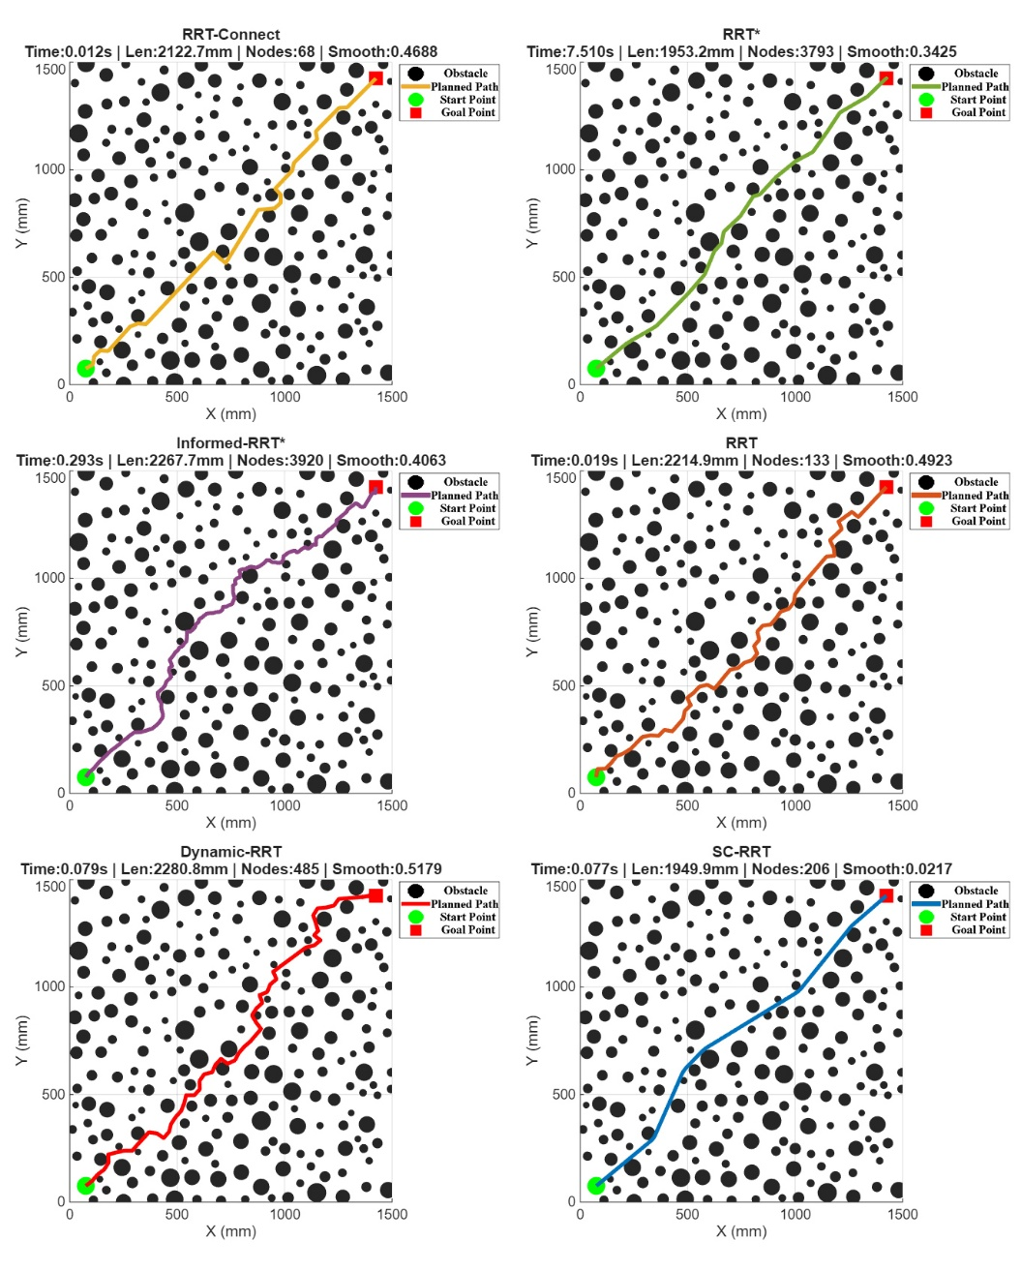
Figure 6 Comparison Results of Different Path Planning Algorithms in Two-Dimensional Space
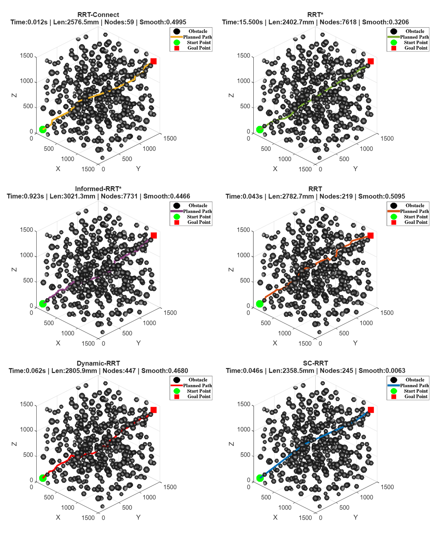
Figure 7 Comparison Results of Different Path Planning Algorithms in Three-Dimensional Space

Table 2 Comparison of Path Planning Algorithms
Algorithm | Path Length /mm | Convergence time /s | Node Count | Path Efficiency
RRT | 2329.5500±126.2500 | 0.0409±0.0305 | 279.4000 ± 175.5000 | 0.8219 ± 0.0429
RRT-connect | 2143.2400±93.4900 | 0.0108±0.0053 | 69.3000 ± 10.8000 | 0.8924 ± 0.0376
RRT* | 1970.7200±19.9400 | 0.1629 ± 0.0843 | 3846.6000 ± 99.7000 | 0.9689 ± 0.0098
Informed RRT* | 1938.4500±24.1300 | 0.2134 ± 0.0487 | 3612.3000 ± 108.6000 | 0.9714 ± 0.0076
SC-RRT | 2049.0900±57.5300 | 0.0345 ± 0.0124 | 209.6000 ± 38.5000 | 0.9553 ± 0.0265
Dynamic-RRT | 2288.1300±136.0200 | 0.0414 ± 0.0384 | 281.3000 ± 160.2000 | 0.8372 ± 0.0468
Under typical scenarios with varying obstacle densities in both two-dimensional and three-dimensional spaces, a systematic comparison was conducted between SC-RRT and mainstream algorithms including RRT, RRT-Connect, RRT*, Informed RRT*, and Dynamic-RRT, under identical environmental configurations and computational budgets. The results are presented in Table 2. Overall, the asymptotic optimality of Dynamic-RRT relies on sufficient computation time to be fully realized, which leads to notable limitations in scenarios with high real-time requirements. Although biasing the probability distribution of the random sample node x_rand toward the goal direction yields some improvement in path length and efficiency metrics, the degree of enhancement remains limited. In contrast, leveraging the online adaptive regulation mechanism (SSFOR), SC-RRT significantly reduces convergence time and sampling scale while maintaining comparable path length, demonstrating superior overall real-time performance compared to Dynamic-RRT.
Regarding path quality, SC-RRT achieves an average path length of 2049.09 mm. This represents a 10.5% reduction compared to Dynamic-RRT and deviates by only 4.0% from the asymptotically optimal RRT*, yet it incurs a fraction of the computational cost. With a path efficiency of 0.9553, SC-RRT ranks third, trailing only the computationally intensive Informed RRT* and RRT*. Crucially, SC-RRT accomplishes this with a planning time that is just 16.2% of Informed RRT*'s requirement. The marginal 1.40% efficiency gap compared to RRT* highlights SC-RRT's ability to approach optimality without the associated time penalty. These metrics validate that the ADCS mechanism effectively concentrates sampling along near-straight corridors, minimizing detours while drastically accelerating convergence. Furthermore, the low standard deviation in path length (±57.53 mm) confirms the algorithm's stability across diverse obstacle configurations.
In terms of computational efficiency, SC-RRT achieves an average convergence time of 0.0345 s, with a node consumption of only 209.6, demonstrating excellent real-time responsiveness. Although RRT* guarantees asymptotic optimality, it requires as many as 3846.6 nodes and a convergence time of 0.1629 s. In comparison, SC-RRT achieves nearly a 4.7-fold speedup, highlighting its significant advantage in time-sensitive tasks.
In terms of path stability, SC-RRT exhibits a path length standard deviation of only ±57.53 mm, which is significantly lower than that of RRT (±126.25 mm) and Dynamic-RRT (±136.02 mm), demonstrating markedly superior consistency and reproducibility in planning results. In summary, SC-RRT achieves an optimal overall balance among path quality, computational efficiency, and planning stability. It maintains stable convergence and strong scalability across both two-dimensional and three-dimensional scenarios with varying obstacle densities, demonstrating robust generalization capability and substantial practical engineering value.
- Conclusion
To address the issues of low effective sampling rates, slow convergence in obstacle-dense environments, and the sensitivity of informed subsets to cost estimation bias in sampling-based path planning algorithms, this paper proposes the SC-RRT algorithm. The algorithm comprises two tightly coupled core mechanisms.
First, Adaptive Asymmetric Dual-Ellipsoidal Constrained Sampling (ADCS). A dynamically updated intermediate point, derived online from the bidirectional search state, is introduced to decompose the global planning task into two directional subproblems: “start–intermediate” and “goal–intermediate.” For each direction, a hyper-ellipsoidal informed subset with independently adjustable scale is constructed. Unlike Dynamic-RRT, which adopts a single symmetric ellipsoid with the start and goal as fixed focal points, the asymmetric dual-ellipsoid structure of ADCS enables directional compression and expansion according to the differing search progress on the two sides. While maintaining exploratory coverage, it significantly increases the sampling density along potentially feasible corridors, effectively mitigating the insufficient global guidance capability of single-direction frameworks highlighted in the introduction.
Second, the Search-State Feedback Online Regulation (SSFOR) mechanism. Using the current best path cost and its recent historical sequence as feedback signals, SSFOR dynamically outputs the hyper-ellipsoid expansion factor γ and the informed sampling probability p, implementing closed-loop regulation over the volume of the informed subset and the sampling allocation ratio. When path improvement stagnates, the exploration range is automatically expanded; when improvement is efficient, the constraints are progressively tightened to enhance local convergence. In this way, the mechanism overcomes the sensitivity issues in traditional methods, where cost overestimation leads to an excessively large informed subset and cost underestimation results in premature contraction of the sampling region.
Under representative scenarios with varying obstacle densities in both two-dimensional and three-dimensional spaces, and under identical environmental configurations and computational budgets, SC-RRT—through the synergistic effect of ADCS’s bidirectional asymmetric constraints and SSFOR’s closed-loop regulation—demonstrates more consistent convergence behavior, fewer redundant expansions, and higher planning stability across different spatial dimensions and obstacle distributions. These results confirm that the integration of adaptive asymmetric dual-ellipsoidal constrained sampling with online constraint feedback regulation is an effective approach to enhancing the overall performance of sampling-based planning algorithms. It further provides a generalizable modeling paradigm for mitigating sensitivity to cost estimation bias in similar methods. SC-RRT inherits the probabilistic completeness of Informed RRT* and, within the asymptotic optimality framework, further accelerates convergence through bidirectional expansion and dynamic constraint regulation, thereby ensuring both theoretical soundness and engineering efficiency.

Authors' Contributions All authors contributed to the conception and design of the study. Xingyu Guo wrote the manuscript and performed the research. Technical support was provided by Muchun Fan, Feng Hong. Valuable comments on manuscript revision were provided by Hongyu Gao. Prof. Yan Wu provided guidance for manuscript writing. All authors have read and approved the final manuscript.

Funding None
Code availability The source code in this paper is not publicly available.

Declarations
Ethics approval Not applicable.

Competing interests The authors have no relevant financial or non- financial interests to disclose.

Consent to participate Not applicable.

Consent for publication Not applicable.

References
- Zhong R Y, Xu X, Klotz E, et al. Intelligent manufacturing in the context of industry 4.0: A review[J]. Engineering, 2017, 3(5): 616–630.
- Wirtz J, Patterson P G, Kunz W H, et al. Brave new world: Service robots in the frontline[J]. Journal of Service Management, 2018, 29(5): 907–931.
- Ajoudani A, Zanchettin A M, Ivaldi S, et al. Progress and prospects of the human-robot collaboration[J]. Autonomous Robots, 2018, 42(5): 957–975.
- Villani V, Pini F, Leali F, et al. Survey on human-robot collaboration in industrial settings: Safety, intuitive interfaces and applications[J]. Mechatronics, 2018, 55: 248–266.
- Elbanhawi M, Simic M. Sampling-based robot motion planning: A review[J]. IEEE Access, 2014, 2: 56–77.
- Karaman S, Frazzoli E. Sampling-based algorithms for optimal motion planning[J]. International Journal of Robotics Research, 2011, 30(7): 846–894.
- Mac T T, Copot C, Tran D T, et al. Heuristic approaches in robot path planning: A survey[J]. Robotics and Autonomous Systems, 2016, 86: 13–28.
- LaValle S M. Planning Algorithms[M]. Cambridge: Cambridge University Press, 2006. ISBN: 978-0-521-86205-9.
- Latombe J C. Robot Motion Planning[M]. Boston, MA: Springer, 1991. ISBN: 978-0-7923-9129-1.
- Kingston Z, Moll M, Kavraki L E. Sampling-based methods for motion planning with constraints[J]. Annual Review of Control, Robotics, and Autonomous Systems, 2018, 1: 159–185.
- Mohanan M G, Salgoankar A. A survey of robotic motion planning in dynamic environments[J]. Robotics and Autonomous Systems, 2018, 100: 171–185.
- Aggarwal S, Kumar N. Path planning techniques for unmanned aerial vehicles: A review, solutions, and challenges[J]. Computer Communications, 2020, 149: 270–299.
- LaValle S M. Rapidly-exploring random trees: A new tool for path planning[R]. TR 98-11, Computer Science Department, Iowa State University, 1998.
- LaValle S M, Kuffner J J. Randomized kinodynamic planning[J]. International Journal of Robotics Research, 2001, 20(5): 378–400.
- Kuffner J J, LaValle S M. RRT-Connect: An efficient approach to single-query path planning[C]. Proceedings of IEEE International Conference on Robotics and Automation (ICRA), San Francisco, CA, USA: IEEE, 2000: 995–1001.
- Gammell J D, Barfoot T D, Srinivasa S S. Asymptotically optimal sampling-based motion planning methods[J]. Annual Review of Control, Robotics, and Autonomous Systems, 2021, 4: 295–318.
- Qureshi A H, Ayaz Y. Intelligent bidirectional rapidly-exploring random trees for optimal motion planning in complex cluttered environments[J]. Robotics and Autonomous Systems, 2016, 68: 1–11.
- Ding J, Zhou Y, Huang X, et al. An improved RRT* algorithm for robot path planning based on path expansion heuristic sampling[J]. Journal of Computational Science, 2023, 67: 101904.
- Noreen I, Khan A, Habib Z. Optimal path planning using RRT* based approaches: A survey and future directions[J]. International Journal of Advanced Computer Science and Applications, 2016, 7(11): 97–107. DOI: 10.14569/IJACSA.2016.071114
- Li B, Chen B. An adaptive rapidly-exploring random tree[J]. IEEE/CAA Journal of Automatica Sinica, 2022, 9(2): 283–294.
- Huang Z, Gao Y, Guo J, et al. An adaptive bidirectional quick optimal rapidly-exploring random tree algorithm for path planning[J]. Engineering Applications of Artificial Intelligence, 2024, 133: 108072.
- Tahirovic A, Ferizbegovic M. Rapidly-exploring random vines (RRV) for motion planning in configuration spaces with narrow passages[C]. Proceedings of IEEE International Conference on Robotics and Automation (ICRA), Brisbane, QLD, Australia: IEEE, 2018: 7055–7062.
- Gammell J D, Srinivasa S S, Barfoot T D. Informed RRT*: Optimal sampling-based path planning focused via direct sampling of an admissible ellipsoidal heuristic[C]. Proceedings of IEEE/RSJ International Conference on Intelligent Robots and Systems (IROS), Chicago, IL, USA: IEEE, 2014: 2997–3004.
- Gammell J D, Srinivasa S S, Barfoot T D. Informed sampling for asymptotically optimal path planning[J]. IEEE Transactions on Robotics, 2018, 34(4): 966–984.
- Gammell J D, Srinivasa S S, Barfoot T D. Batch informed trees (BIT*): Sampling-based optimal planning via the heuristically guided search of implicit random geometric graphs[C]. Proceedings of IEEE International Conference on Robotics and Automation (ICRA), Seattle, WA, USA: IEEE, 2015: 3067–3074.
- Gammell J D, Barfoot T D, Srinivasa S S. Batch Informed Trees (BIT*): Informed asymptotically optimal anytime search[J]. International Journal of Robotics Research, 2020, 39(5): 543–567. DOI: 10.1177/0278364919890396
- Yuan L, Zhao J, Li W, et al. Improved informed-RRT* based path planning and trajectory optimization for mobile robots[J]. International Journal of Precision Engineering and Manufacturing, 2023, 24(3): 469–482.
- Zeng Z, Chang Y. ABF-RRT*: Bidirectional fast optimal rapidly-exploring random tree via adaptive sampling of a permissible hyper-ellipsoid[J]. Journal of King Saud University - Computer and Information Sciences, 2025, 37: 165.
- Zhao P, Chang Y, Wu W, et al. Dynamic RRT: Fast feasible path planning in randomly distributed obstacle environments[J]. Journal of Intelligent & Robotic Systems, 2023, 107(1): 48.
- Deb K, Pratap A, Agarwal S, et al. A fast and elitist multiobjective genetic algorithm: NSGA-II[J]. IEEE Transactions on Evolutionary Computation, 2002, 6(2): 182–197. DOI: 10.1109/4235.996017
- Choset H, Lynch K M, Hutchinson S, et al. Principles of Robot Motion: Theory, Algorithms, and Implementations[M]. Cambridge, MA: MIT Press, 2005. ISBN: 978-0-262-03327-5.
- Lynch K M, Park F C. Modern Robotics: Mechanics, Planning, and Control[M]. Cambridge: Cambridge University Press, 2017. ISBN: 978-1-107-15630-2. DOI: 10.1017/9781316661239
- Kavraki L E, Švestka P, Latombe J C, et al. Probabilistic roadmaps for path planning in high-dimensional configuration spaces[J]. IEEE Transactions on Robotics and Automation, 1996, 12(4): 566–580. DOI: 10.1109/70.508439
- Ravankar A, Ravankar A A, Kobayashi Y, et al. Path smoothing techniques in robot navigation: State-of-the-art, current and future challenges[J]. Sensors, 2018, 18(9): 3170. DOI: 10.3390/s18093170
- Yang K, Sukkarieh S. An analytical continuous-curvature path-smoothing algorithm[J]. IEEE Transactions on Robotics, 2010, 26(3): 561–568. DOI: 10.1109/TRO.2010.2042990
- Nasir J, Islam F, Malik U, et al. RRT*-SMART: A rapid convergence implementation of RRT*[J]. International Journal of Advanced Robotic Systems, 2013, 10(7): 299. DOI: 10.5772/56718
- Janson L, Schmerling E, Clark A, et al. Fast marching tree: A fast marching sampling-based method for optimal motion planning in many dimensions[J]. International Journal of Robotics Research, 2015, 34(7): 883–921. DOI: 10.1177/0278364915577958
- Salzman O, Halperin D. Asymptotically near-optimal RRT for fast, high-quality, motion planning[C]. Proceedings of IEEE International Conference on Robotics and Automation (ICRA), Hong Kong, China: IEEE, 2014: 4680–4685. DOI: 10.1109/ICRA.2014.6907543
- Ferguson D, Stentz A. Anytime RRTs[C]. Proceedings of IEEE/RSJ International Conference on Intelligent Robots and Systems (IROS), San Diego, CA, USA: IEEE, 2006: 5369–5375. DOI: 10.1109/IROS.2006.282100
- Karaman S, Walter M R, Perez A, et al. Anytime motion planning using the RRT*[C]. Proceedings of IEEE International Conference on Robotics and Automation (ICRA), Shanghai, China: IEEE, 2011: 1478–1483. DOI: 10.1109/ICRA.2011.5980479
- Akgun B, Stilman M. Sampling heuristics for optimal motion planning in high dimensions[C]. Proceedings of IEEE/RSJ International Conference on Intelligent Robots and Systems (IROS), San Francisco, CA, USA: IEEE, 2011: 2640–2645. DOI: 10.1109/IROS.2011.6095077

