Superellipsoid-Constrained Bidirectional RRT: Path Planning with Adaptive Asymmetric Dual-Super-Ellipsoidal Constrained Sampling
Yan Wu, Xinyu Guo¹∗, Wenjun Lv¹, Jianyu Zheng¹, Jiaqing Ye¹, Jiale Hu¹
Abstract: Sampling-based path planning algorithms commonly suffer from excessive invalid samples, slow convergence, and reduced success rates in high-obstacle-density environments. This paper presents SC-RRT, a path planning algorithm based on adaptive asymmetric dual-super-ellipsoid constrained sampling. Within a bidirectional parallel expansion framework, SC-RRT employs an intermediate meeting point xmeet to decompose the global task into staged subproblems. Scale-variable, asymmetric informed sampling subsets are constructed in both directions to concentrate sampling toward feasible regions with greater improvement potential, forming the Adaptive Dual-Super-Ellipsoid Constrained Sampling strategy (ADCS). To suppress invalid sampling caused by over-inflation or premature contraction of the informed subset due to cost estimation bias, a Search State Feedback Online Regulation mechanism (SSFOR) is developed. SSFOR uses the historical evolution of the optimal path cost to perform closed-loop adjustment of the super-ellipsoid expansion factor γ and heuristic sampling probability p, enabling the informed subset to evolve with search progress while reducing redundant expansion. Asymmetric super-ellipsoidal constraints further sharpen resolution along feasible passage directions. Simulation experiments show that SC-RRT reduces path length by approximately 10.5% compared with DynamicRRT, achieving a path efficiency of 0.9553. Although path quality is marginally lower than Informed RRT*, planning time is only 16.2% of the latter with node count reduced by 94.2%. SC-RRT thus balances path quality, planning efficiency, and computational cost without prior parameter tuning; its modular ADCS and SSFOR components can be independently integrated into other RRT-based frameworks.
Keywords: Sampling-based path planning, Informed sampling, bidirectional tree search, online parameter regulation, motion planning

Introduction
With the accelerated development of new energy vehicles, the industry demands increasingly higher performance for the connections between battery tabs and busbars, requiring both low-cost solutions and superior properties such as electrical conductivity, thermal conductivity, and corrosion resistance^{[1-2]}. Copper, as one of the metals with the highest electrical conductivity, ensures low energy loss during high-current transmission, making it suitable for thin-sheet tab applications. Aluminum, owing to its advantages of light weight, corrosion resistance, and low cost, serves as an ideal material for busbars^{[3-4]}. Laser welding, as an efficient and flexible non-contact fusion joining technology, has fully demonstrated its adaptability and precision in connecting thin-sheet aluminum alloy materials^{[5-7]}.
However, during thin-sheet laser welding, the rapid heating and cooling rates, coupled with the steep temperature gradients within the weld pool, present significant challenges. The substantial property differences between copper and aluminum further complicate the process: aluminum exhibits high reflectivity and high thermal conductivity, while copper also possesses high thermal conductivity. These characteristics lead to inefficient laser energy absorption and difficulties in controlling the welding process^{[8-11]}. Consequently, the weldability between these dissimilar metals is poor, and the joint exhibits high susceptibility to cracking. The welding process faces challenges such as complex interfacial reactions, insufficient molten pool stability, and difficulties in achieving sound weld morphology. Particularly in high-energy-density laser deep penetration welding, defects like cracks and porosity readily form in the weld seam^{[12-13]}.Therefore, conducting numerical simulation studies on the heat and mass transfer processes during laser deep penetration welding of copper-aluminum dissimilar metals is crucial for optimizing welding parameters and controlling weld morphology. Welding techniques for joining these two metals have also been extensively investigated^{[14-16]}.Currently, research institutions around the world have carried out extensive studies on laser welding of thin-sheet copper and aluminum, aiming to optimize the welding process, improve the efficiency of heat and mass transfer, control interfacial reactions, and enhance weld quality.
Internationally, research has mainly focused on optimizing laser parameters, analyzing the microstructure of dissimilar metal interfaces, and improving joint performance to achieve efficient regulation of heat and mass transfer processes. For example, Le Mener et al. developed a multi-physics model for laser welding of steel and Inconel, which simulates heat transfer, fluid flow, and species tracking during welding, and verified the accuracy of the model with experimental data^{[17]}. Kimthong et al. explored the microstructural heterogeneity of laser-welded steel-aluminum joints through experiments and finite element simulations^{[18]}.
Domestically, research has concentrated on the influence of process parameters on weld quality and exploring novel welding techniques to address interfacial issues during welding. Several studies have analyzed the state at the keyhole bottom during laser deep penetration welding and assessed the global efficiency of heat and mass transfer by combining fluid dynamics simulations to better evaluate the welding process^{[19-20]}. For example, Xie et al. developed a three-dimensional transient numerical model to investigate molten pool behavior and mass transfer mechanisms during laser welding of steel and aluminum. They employed the Volume of Fluid (VOF) method to track the free surface, with particular focus on the effects of recoil pressure and surface tension on the keyhole wall^{[21]}.Furthermore, the adoption of hybrid welding techniques has become an active area of research. Techniques such as laser-gas metal arc welding (Laser-GMAW) hybrid welding are being explored to increase deposition rates, improve weld morphology, and effectively reduce porosity^{[22-24]}.
In summary, current research on laser deep penetration welding of copper-aluminum dissimilar metals still lacks comprehensive analysis of the coupled heat and mass transfer processes through numerical simulation, making it difficult to precisely guide process optimization. Therefore, this study focuses on thin-sheet TU1 oxygen-free copper and 6061 aluminum alloy as the research materials. By developing a numerical model for heat and mass transfer in laser deep penetration welding and validating it with experimental data, we investigate the evolution mechanisms of the temperature field and flow field within the molten pool. This work aims to provide a theoretical foundation for enhancing welding quality.
- Laser Welding Test Materials and Methods
The test tab material is Y-state TU1 oxygen-free copper with dimensions of 40mm×40mm×0.3mm, and the busbar material is T6-state 6061 aluminum alloy with dimensions of 40mm×40mm×2mm. The schematic diagram of the welding method is shown in Figure 1. The welding mode is laser deep penetration welding. The welding equipment used is a YLS-3000 laser produced by IPG in Germany, with a wavelength of 1070 nm, a rated output power of 3000 W, a laser beam defocus amount of 0 mm, a protective gas (argon) purity of 99.9%, and a flow rate of 20 L/min. Laser deep penetration welding under each set of process parameters was carried out one by one, and the process parameters are shown in Table 1.
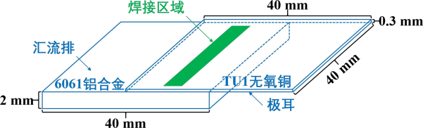
Fig.1 Schematic diagram of welding mode
Tab.1 Laser welding process parameters
Group No. | Laser Power (W) | Welding Speed (mm/s)
1 | 1000 | 55
2 | 1100 | 55
3 | 1200 | 55
4 | 1300 | 55
5 | 1400 | 55
6 | 900 | 25
7 | 900 | 35
8 | 900 | 45
9 | 900 | 55
10 | 900 | 65
- Establishment of Finite Element Model for Laser Deep Penetration Welding of Copper-Aluminum Dissimilar Metals
  - Mesh Generation
The mesh division directly affects the accuracy and results of the simulation. Near the metal flow region, equidistant dense meshing is adopted to ensure calculation accuracy, while in areas far from this region, sparse meshing with gradually increasing spacing is used to improve calculation efficiency. As a non-primary calculation region, the air part is divided with equidistant sparse meshing, which only needs to meet the heat dissipation requirements of welding. Since regular hexahedral meshes can achieve more accurate simulation, Gambit is used to complete the mesh division. The model is shown in Figure 2, containing a total of 114,400 meshes.
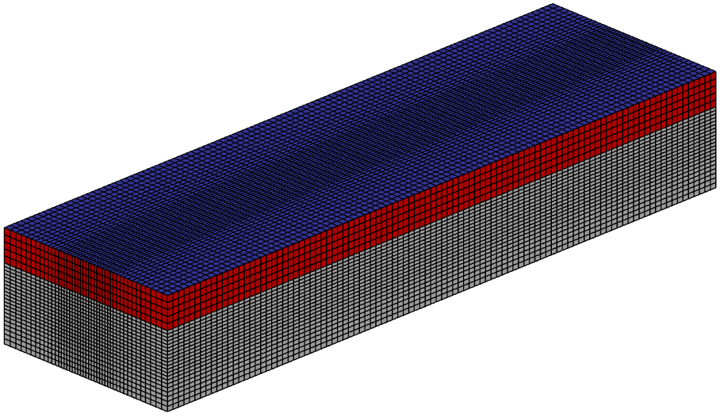
Fig.2 The mesh model.
  - Material Performance Parameters
The physical properties of copper and aluminum vary with temperature. To achieve accurate simulation, the corresponding parameters need to be dynamically adjusted. The relevant material performance parameters for laser deep penetration welding of thin-plate copper-aluminum dissimilar metals are shown in Table 2^{[25]}.

Tab.2 Performance parameters of copper and aluminum materials

Property | Al | Cu
Density ρ(kg·m⁻³) | ρ=−0.5387T+2880.6（solid）  ρ=−0.3125T+2669.1（liquid） | ρ=−0.911T+9233.3（solid）  ρ=−0.8193T+9109.4（liquid）
Thermal Conductivity  W(m·K) | k=-0.0494T+256.0（solid）  k=101（liquid） | k=-0.0603T+415.4（solid）  k=172（liquid）
Specific Heat Capacity  J(kg·K) | c=0.5411T+728.4（solid）  c=1176.15（liquid） | c=0.1482T+327.7（solid）  c=572.12（liquid）
Melting Point Tm(K) | 933.52 | 1356.15
Latent Heat L(kJ·kg⁻¹) | 385 | 188
Viscosity μ(kg·m⁻¹·s⁻¹) | μ=1（solid）  μ=-1.71×10⁻⁶T+2.90×10⁻³（liquid） | μ=1（solid）  μ=-3.37×10⁻⁶T+8.35×10⁻³（liquid）
Surface Tension Gradient  γ(N·m⁻¹·K⁻¹) | −0.6×10⁻⁴ | −1.5625×10⁻⁴

  - Initial and Boundary Condition Settings
To avoid the influence of the boundary conditions, the initial point of heat source loading is set as P_{start} (4, 0, 0), and the end point is P_{end} (16, 0, 0). To simplify the model, the following assumptions are proposed^{[26]}:(1) Both liquid TU1 oxygen-free copper and liquid 6061 aluminum alloy are incompressible Newtonian fluids. (2) The thermophysical properties of the materials are uniform, and some parameters remain constant.(3) Non-major elements of the materials are ignored. (4) The influence of protective gas during the welding process is ignored. (5) There is no gap between the materials. (6) Chemical reactions are not considered.
  - Selection of Heat Source Model
Choosing a reasonable heat source model is the most critical step to complete laser welding simulation, which mainly depends on the actual welding conditions. In view of the heterogeneous copper-aluminum thin plates used as base metals in this paper, a double-ellipsoid heat source model is selected for numerical simulation. The schematic diagram of the double-ellipsoid heat source model is shown in Figure 3, and the governing equation is shown in Equation 1^{[27]}.The schematic diagram of its moving loading is shown in Figure 4.
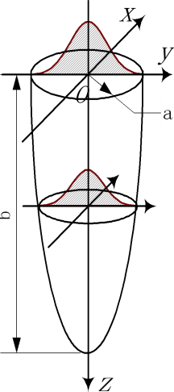
Fig.3 Double-ellipsoidal heat source model.

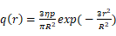
In the equation, Q represents the heat source power in W; mm denotes the laser beam focusing radius; b represents the heat source depth in m; mm is the welding starting point; v denotes the welding speed in m/s; t represents time in s; and mm indicates the total thickness of the workpiece.
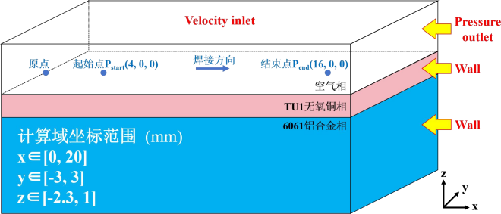
Fig.4 Schematic diagram of heat source moving loading
- Research on Heat and Mass Transfer Processes
  - Simulation, Calculation, and Analysis of Temperature Field in Laser Deep Penetration Welding of Copper-Aluminum Dissimilar Metals
    - Verification of Heat Source Model

The comparison between the simulated cross-section when the laser beam is moved to the weld center and the experimental weld cross-section is shown in Figure 5. Obviously, the boundary lines basically coincide, the shape and size of the simulated molten pool are close to those of the actual weld, and the temperature in this area exceeds the melting point of the base metal. It indicates that the selected double-ellipsoid heat source model is reasonable for simulating the laser deep penetration welding process of thin-plate copper/aluminum dissimilar metals, and meanwhile verifies the reliability of the numerical simulation in this paper.

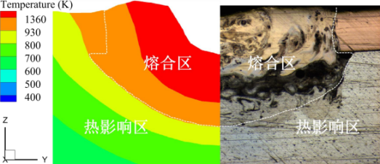

Fig.5 Comparison between simulated and tested molten pool morphology
    - Heat Transfer Process in Laser Deep Penetration Welding

The numerical simulation results of the temperature field show that the heat transfer processes under different parameters in this paper have similarity. To make the characteristics of heat and mass transfer more obvious, this section selects the 5th group of parameters with the highest laser power (W, mm/s) to analyze the heat and mass transfer process of laser deep penetration welding of thin-plate copper-aluminum dissimilar metals. To analyze the temperature variation law during the welding process more clearly, the heat source is selected to move along the weld direction on the upper surface to three time points A, B, and C to study the temperature field distribution and the corresponding cross-sectional heat transfer process nephograms. The corresponding temperature distribution nephograms and cross-sectional heat transfer process nephograms are shown in Figure 6 and Figure 7.


- s
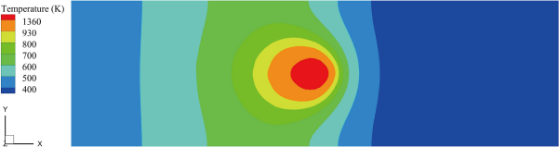
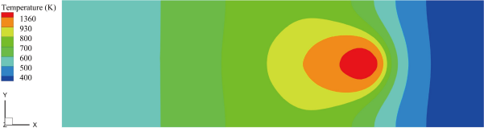
- s

Fig.6 Cloud image of heat transfer processes on the upper surface (W, mm/s)

Figure 6 shows that under the high-power density of laser deep penetration welding, the temperature of the welded parts rises sharply. At times t₁, t₂ and t₃, the shape of the red high-temperature region fluctuates slightly. The shape of the molten pool is stable, symmetric along the central trajectory of the laser beam, and presents a relatively regular elliptical shape. At time t₁, the laser beam irradiation raises the surface temperature of the welded parts from room temperature to above the melting point of copper (1360 K), causing the base metal to melt. At time t₂, the temperature gradient at the rear end of the laser beam continues to decrease. Although the temperature gradient at the front end remains relatively large, the heat-affected zone (HAZ) at the front expands slightly, indicating that the temperature gradient at the front is slightly reduced. This suggests that the movement rate of the laser beam is slightly lower than the thermal conduction rate of the metal along the welding direction. At time t₃, with continuous energy input from the laser beam, the meteor-shaped trailing tail becomes more pronounced, the heat-affected zone expands, and the shape of the molten pool remains essentially unchanged, though its area increases.

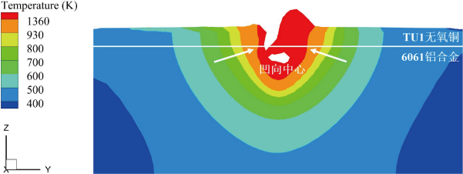
- s
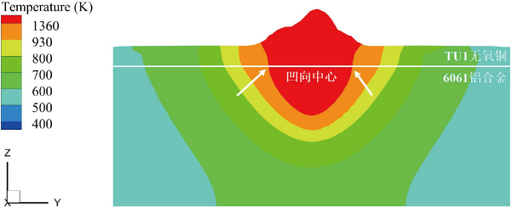
- s
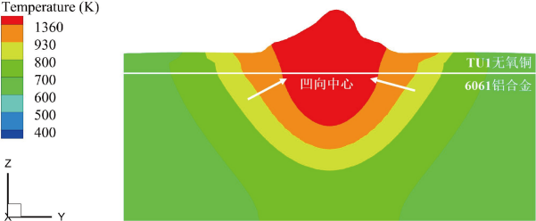
- s

Fig.7 Cloud view of cross-sectional heat transfer process (W, mm/s)

Figure 7 shows that during the laser deep penetration welding of thin-plate copper-aluminum dissimilar metals, the morphology of the cross-sectional molten pool presents an open-narrowing "bowl" shape. The melting width of the upper copper layer is generally smaller than that of the lower aluminum layer, and the melting width near the copper-aluminum interface is the largest. Due to the high power density of the laser beam forming deep penetration welding, the laser beam directly irradiates the deep-layer aluminum, narrowing the gap in laser energy directly absorbed by the two materials. Combined with heat transfer to the lower-layer aluminum and the fact that the melting point of copper is higher than that of aluminum, the overall melting width on the copper side is smaller than that on the aluminum side. The temperature field distribution shows an overall increase over time, with heat conduction in the longitudinal direction slightly greater than that in the lateral directions. This is caused by the keyhole effect in laser deep penetration welding, which allows laser energy to act deeply in the longitudinal direction. The molten pool area and the heat-affected zone (HAZ) expand as welding proceeds. At 0.1092 seconds, the molten pool area reaches stability and no longer expands, while the HAZ continues to expand. Near the center of the laser beam, the isotherms in the region are concave from the edges toward the center and dense, indicating an extremely large temperature gradient.
  - Mass Transfer Process in Laser Deep Penetration Welding
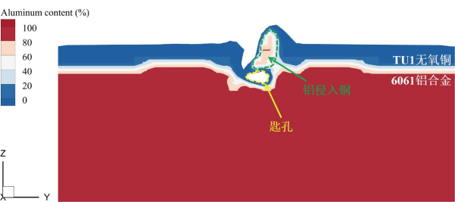
- s
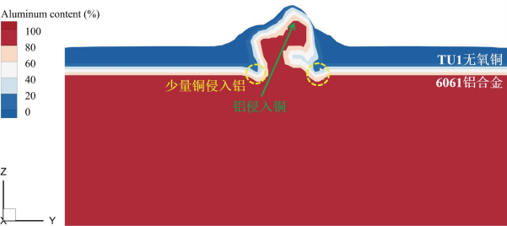
- s
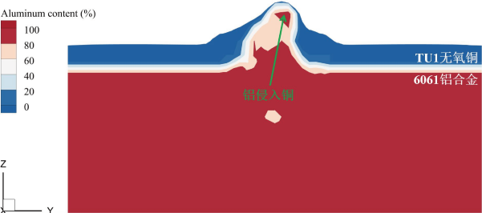
- s

Fig.8 Cloud image of mass transfer process (W, mm/s)
The intermetallic mass transfer process in laser deep penetration welding of thin - plate copper - aluminum dissimilar metals is manifested as the distribution variation of copper and aluminum elements. In line with the heat transfer analysis, after removing the air phase, the metal phase fields at time points t₁ to t₃ covering the entire welding process were selected for observation and analysis. The results are shown in Figure 8. The gradient from blue to red in the figure indicates that the aluminum element content increases from 0% to 100%, that is, the copper element content decreases from 100% to 0%. Overall, it presents as "aluminum intruding into copper", that is, during welding, the lower-layer aluminum migrates to the upper-layer copper region in a heated fluid state. It acts together with laser energy to liquefy copper and fully mix them, and then cools and solidifies into a weld.
At the start of welding, part of the copper absorbs laser energy and sublimes into vapor to form a keyhole, while part of the aluminum liquefies, peels off from the lower layer, and tends to recoil upward, as shown in Figure 8(a).The formation and expansion of the keyhole allow the laser to directly irradiate the lower-layer aluminum, triggering more aluminum to liquefy and surge upward. At this time, due to the reduction in local metal content at the two side edges of the aluminum recoil, a small amount of liquid copper intrudes downward under the action of gravity, resulting in the "copper intruding into aluminum" phenomenon, as shown in Figure 8(b).With the continuous input of laser energy, the "aluminum intrusion into copper" intensifies, and the "copper intrusion into aluminum" almost disappears. This is because the upwelling of a large amount of liquefied aluminum is restricted by the opening on the copper side, and the liquid aluminum at the edges is blocked by solid copper, gradually filling the edge area, as shown in Figure 8(c).
- Laser Deep Penetration Welding Tests
  - Comparison of Penetration Width and Depth
The comparison of penetration width and depth will further enhance the reliability of the numerical simulation in this paper. The penetration width refers to the maximum horizontal distance between the two boundaries of the weld, while the penetration depth refers to the vertical distance from the workpiece surface to the deepest part of the fusion. As shown in Figure 9, it should be noted that due to the melting point of aluminum being much lower than that of copper, the maximum horizontal distance of the boundary occurs at the copper-aluminum interface, so this is where the penetration width is measured. Because the surface of the upper copper layer is thermally deformed, which affects the accuracy of penetration depth measurement, the measurement starts from the relatively flat copper-aluminum interface and proceeds downward. The obtained value needs to add the thickness of the copper side (0.3 mm) as the penetration depth measurement value. To reduce accidental errors, two measurements are taken for each, and the average value is used as the measurement result of the penetration width and depth.

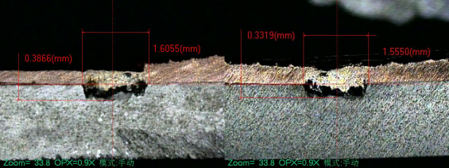
Fig.9 Width and depth measurement diagram (W, mm/s)
  - Weld Morphology Characteristics
The weld morphology characteristics under the optimal laser power parameters (W, mm/s) deduced in this paper were observed using an Axio Observer D1M microscope, as shown in Figure 10. In the surface morphology, the weld fish-scale patterns of the thin-plate copper-aluminum dissimilar metals are obvious, and the boundary line between the base metal and the weld is straight. This helps to improve the mechanical properties of the weld, as well as enhance its corrosion resistance and fatigue resistance. In the cross-sectional morphology, due to the enhanced influence of the keyhole effect, both the "aluminum intrusion into copper" phenomenon and the bulges on both sides are weakened.
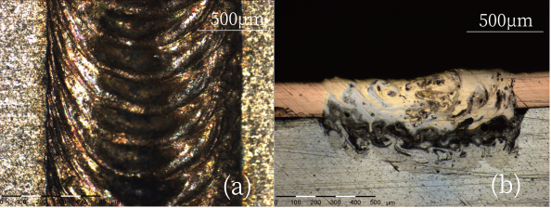
（a）Surface Morphology；（b）Cross-Sectional Morphology
Fig.10 Weld morphology of thin-plate heterogeneous aluminum alloy welded joint under optimum laser power(W, mm/s) :(a) surface morphology;(b) cross-sectional morphology
The weld morphology characteristics under the optimal welding speed parameters (mm/s, W) deduced in this paper are shown in Figure 11.When the welding speed is 55 mm/s, the surface morphology and cross-sectional morphology overall exhibit clear fish-scale patterns and well-mixed copper-aluminum fusion, indicating good weld quality. This makes 55 mm/s a suitable welding speed for laser deep penetration welding of thin-plate copper-aluminum dissimilar metals.
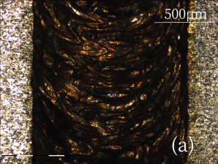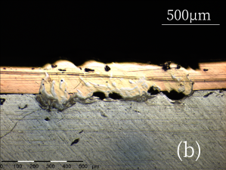
Fig.11 Weld morphology of thin-plate heterogeneous aluminum alloy welded joint at the best welding speed(mm/s, W) :(a) surface morphology;(b) cross-sectional morphology
- Conclusions
- This paper uses a double-ellipsoid heat source model to numerically simulate the laser deep penetration welding process of thin-plate copper-aluminum dissimilar metals, and deeply investigates the heat and mass transfer behaviors during the laser deep penetration welding process of thin-plate copper-aluminum dissimilar metals and the influence laws of process parameters on them.
- Heat transfer process: The temperature field is symmetrically distributed along the welding direction, and the shape of the molten pool is stable and gradually expands with the welding process. The temperature gradient at the front end of the laser beam is greater than that at the rear end, and the laser power dominates the size of the molten pool. The welding speed affects the temperature gradient by regulating the energy density. Due to the melting point of copper being higher than that of aluminum, its penetration width is smaller than that of the aluminum side. The molten pool in the cross-section is in a "bowl" shape with a narrowed opening, and the longitudinal heat conduction effect is significant.
- Mass transfer process: The phenomenon of "aluminum intrusion into copper" is overall presented. In the early stage of welding, part of the copper sublimes into vapor to form a keyhole, and after aluminum liquefies, it recoils upward and mixes with copper. As welding progresses, the "aluminum intrusion into copper" phenomenon intensifies, eventually forming a uniform copper-aluminum mixed weld.
- The effectiveness of the double-ellipsoid heat source model is verified through simulation and experiment (with errors in penetration width and depth both <10% and good agreement in weld morphology), providing process solutions for copper-aluminum welding in power batteries of new energy vehicles. Optimizing parameters can improve weld quality, enhance the performance of battery connection components, and promote the engineering application of copper-aluminum welding in this field.
Data Availability
The data that supports the findings of this study are available from the corresponding author, upon reasonable request.
References
- Maev, R. G., Leshchynsky, V., Strumban, E., et al. (2023). Tab-to-busbar interconnects formed by dual flow cold spraying. In International Thermal Spray Conference (pp. 597–603). ASM International. DOI:10.31399/asm.cp.itsc2023p0597
- Ma, B., Gao, X. D., Huang, Y. J., Gao, P. P., & Zhang, Y. X. (2023). A review of laser welding for aluminium and copper dissimilar metals. Optics & Laser Technology, 167, 109721. DOI:10.1016/j.optlastec.2023.109721
- Seffer, O., Springer, A., & Kaierle, S. (2018). Investigations on remote laser beam welding of dissimilar joints of austenitic chromium - nickel steel (X5CrNi18 - 10) and aluminum alloy (AA6082 - T6) for battery housings. Journal of Laser Applications, 30(3), 032404. DOI:10.2351/1.5040638
- Persic, A., Premec, A., Magas, L., et al. (2022). Battery package fused bus bar design for cylindrical battery cells. In 2022 26th Int. Conf. Electron. (pp. 1–6). IEEE. DOI:10.1109/IEEECONF55059.2022.9810386
- Chen, X., Tang, S., Xie, W., et al. (2025). Numerical simulation study of laser-arc hybrid welding of 6063/5083 aluminum alloy. J. Mater. Eng. Perform., 34(11): 9342–9351. DOI:10.1007/s11665-024-09842-4
- Mypati, O., Anwaar, T., Mitra, D., et al. (2023). Characterization and modelling of Al and Cu busbar during charging and discharging of Li-ion battery for electric vehicles. Appl. Therm. Eng., 218: 119239. DOI:10.1016/j.applthermaleng.2022.119239
- Li, K. (2023). Application of laser welding technology in the thin steel plate. Ship & Ocean Eng., 52(4): 124–126. DOI:10.3963/j.issn.1671-7953.2023.04.027
- Fujio, S., Sato, Y., Sudo, M., et al. (2024). Spatter reduction in deep penetration welding of pure copper using blue-IR hybrid laser. Weld. World, 68: 1515–1524. DOI:10.1007/s40194-024-01734-4
- Mei, L.F., Liang, Y., Yan, D.B., et al. Numeric simulation and experimental study in magnetic field-assisted laser scanning welding of T2 red copper. Opt. Laser Technol., 175(2024): 110839. DOI:10.1016/j.optlastec.2024.110839
- Yan, S., Li, Z.Y., Song, L.L., et al. Research and development status of laser micro-welding of aluminum-copper dissimilar metals: A review. Opt. Lasers Eng., 161(2023): 107312. DOI:10.1016/j.optlaseng.2022.107312
- Yang, H., Tang, X. H., Hu, C., et al. Study on laser welding of copper material by hybrid light source of blue diode laser and fiber laser [J]. J. Laser Appl., 33, 032018 (2021). DOI:10.2351/7.0000386
- Zhou, J., Chen, C.Y., Zhou, Z.K., et al. Dissimilar laser lap welding of Mg and Al alloys using a CoCrFeNi medium-entropy alloy interlayer. Opt. Laser Technol., 157(2023): 108639. DOI:10.1016/j.optlastec.2022.108639
- Ma, B., Gao, X. D., Huang, Y. J., Zhang, Y. X., & Huang, Y. W. (2024). Effect of different pulse shapes on the laser welding of aluminum and copper. Optics & Laser Technology, 171, 110312. DOI:10.1016/j.optlastec.2023.110312
- Mehta, K.P., & Badheka, V.J. (2015). A review on dissimilar friction stir welding of copper to aluminum: Process, properties, and variants. Materials and Manufacturing Processes, 30(5), 467–482. DOI:10.1080/10426914.2015.1025971
- Wang, C., Ma, L.N., Ma, X.G., et al. Effect of annealing temperature on microstructure and tensile properties of copper/aluminum composite thin strip. Trans. Nonferrous Met. Soc. China, 33(2023): 701–713. DOI:10.1016/S1003-6326(22)66139-9
- Shen, H.W., & Gupta, M.C. (2004). Nd:yttritium–aluminum–garnet laser welding of copper to stainless steel. J. Laser Appl., 16(1): 2–8. DOI:10.2351/1.1642635
- Le Mener, M., Courtois, M., Daviot, N., et al. Heat transfer and fluid flow modeling of steel-Inconel laser welding in an overlap configuration [J]. J. Laser Appl., 36(4), 042006 (2024). DOI:10.2351/7.0001357
- Kimthong, P., Wattanapornphan, P., Phongphisutthinan, C., et al. Experimental investigations and FE modeling considering microstructural inhomogeneity of laser welded steel aluminum joints. Archives of Civil and Mechanical Engineering, 22(2022): 29. DOI:10.1007/s43452-021-00353-w
- Kang, Y., Zhao, Y., Li, Y., et al. Simulation of the effect of keyhole instability on porosity during the deep penetration laser welding process. Metals, 12(2022): 1200. DOI:10.3390/met12071200
- Wu, J.Z., Zhang, H., Feng, Y., et al. 3D multiphysical modelling of fluid dynamics and mass transfer in laser welding of dissimilar materials. Metals, 8(2018): 443. DOI:10.3390/met8060443
- Xie, X.G., Zhou, J.X., & Long, J.Q. (2021). Numerical study on molten pool dynamics and solute distribution in laser deep penetration welding of steel and aluminum. Opt. Laser Technol., 140(2021): 107085. DOI:10.1016/j.optlastec.2021.107085
- Liu, Y.Q., Wang, W., & Zhu, Z.T. (2020). Deep-penetration welding-brazing of aluminum/steel dissimilar metal using laser-MIG arc hybrid heat source. Scientia Sinica Physica, Mechanica & Astronomica, 50(3): 034207. DOI:10.1360/SSPMA-2019-0204
- Yu, X.Q., Fan, D., Huang, J.K., et al. Arc-assisted laser welding brazing of aluminum to steel. Metals, 9(2019): 397. DOI:10.3390/met9040397
- Üstündağ, Ö., Avilov, V., Gumenyuk, A., & Rethmeier, M. (2019). Improvement of filler wire dilution using external oscillating magnetic field at full penetration hybrid laser-arc welding of thick materials. Metals, 9(2019): 594. DOI:10.3390/met9050594
- Gathers, G. R. (1983). Thermophysical properties of liquid copper and aluminum. International Journal of Thermophysics, 4(3), 209–226. DOI:10.1007/BF00502353
- 杨海奇，梁融，罗宇。考虑熔池流动的异种材料激光焊接接头的热流固耦合模拟研究 [J].热加工工艺,2017,46(19):200-204.DOI:10.14158/j.cnki.1001-3814.2017.19.054.
- Goldak, J., Chakravarti, A., & Bibby, M. (1984). A new finite element model for welding heat sources. Metallurgical Transactions B, 15(6), 299–305. DOI:10.1007/BF02667333

Statements & Declarations

Funding
The authors declare that no funds, grants, or other support were received during the preparation of this manuscript.

Competing Interests
The authors have no relevant financial or non-financial interests to disclose.

Author Contributions
All authors contributed to the study's conceptual design. Yan Wu supervised the entire manuscript writing process; Xingyu Guo, Wenjun Lv, and Jianyu Zheng prepared the materials; Jiaqing Ye and Jiale Hu collected and analyzed the experimental data; and Xingyu Guo drafted the manuscript. All authors provided revision suggestions, participated in revising all versions, and finally reviewed and approved the final draft.

School of Mechanical Engineering, Shanghai Institute of Technology, Shanghai 201418, China
∗ Corresponding Author:Xingyu Guo E-mail: gxyzhendehenlihai@163.com

