SC-RRT: Superellipsoid-Constrained Bidirectional RRT with Adaptive Dual-Super-Ellipsoid Sampling
Yan Wu, Xingyu Guo¹∗, Muchun Fan¹, Feng Hong¹, Hongyu Gao¹, Jianyu Zheng¹
Abstract: 基于采样的路径规划算法在障碍物密集环境中常存在无效采样过多、搜索效率不足及可行路径获取速度较慢等问题。本文提出一种具有自适应双超椭球约束采样机制的双向快速扩展随机树方法。该方法引入中间交汇点，将全局规划任务分解为两个协同搜索方向，并分别构建非对称约束采样区域。通过设计自适应双超椭球约束采样（ADCS）策略，使采样范围集中于高潜力可行区域；进一步提出基于搜索状态反馈的在线调节（SSFOR）机制，根据各搜索方向近期最优路径代价的改善程度构造反馈偏差，在搜索停滞时扩大搜索范围实现探索与开发之间的动态平衡。仿真实验结果表明,相较于 Dynamic-RRT，SC-RRT 平均路径长度缩短 12.6%，路径效率达到0.9553；其规划时间仅为 Informed RRT* 的 16.2%，采样节点数量降低 94.2%。表明该方法在保证可观路径质量的同时计算效率具有显著提升。此外，基于六自由度机械臂，在 RGB-D 感知构建的非结构化三维环境中开展实物实验。SC-RRT 规划得到长度 3.249 m 的多目标连续轨迹，机械臂实际运行路径长度为 3.245 m，路径长度偏差仅 0.12%；工具中心点（TCP）平均跟踪误差 1.98 mm，最大跟踪误差 3.09 mm，验证了规划轨迹能够在实体机器人系统中可靠执行。综上，SC-RRT 在路径质量与计算效率之间取得了较好的平衡，并表现出一定的真实机器人应用潜力。
Keywords: Sampling-based path planning; informed sampling; bidirectional tree search; online parameter regulation; robotic manipulator

- Introduction
随着工业机器人与服务机器人技术的快速发展，机器人正被广泛部署于复杂环境中，对其运动规划的可靠性与效率提出了更高要求。其应用场景已从结构化制造环境扩展至人机协作、非结构化空间以及空间受限操作等复杂任务环境中[1–5]。因此，复杂环境下的机器人路径规划问题已成为机器人领域的重要研究方向，具有显著的理论意义与工程价值。
机器人路径规划的核心目标是在已知配置空间内，从给定起点到目标点生成一条无碰撞轨迹，并满足相应的运动学约束[6,7]。在实际应用中，规划算法不仅需要具备较高的计算效率，还需保证路径质量。然而，在障碍物随机分布或几何约束复杂的环境中，可行采样空间显著收缩，树结构扩展受限，从而使得算法难以同时实现快速收敛与高质量路径生成[8–10]。
快速扩展随机树（RRT）及其典型改进方法如RRT-Connect与RRT*是经典的采样式路径规划算法[11–15]。由于其概率完备性及实现简单性，这类方法被广泛应用于复杂路径规划问题中。然而，传统RRT方法高度依赖随机采样机制，容易导致节点冗余、搜索效率低下以及路径几何形态不规则等问题，尤其在大规模环境、障碍密集区域以及窄通道场景中表现更为明显[16–19]。
为提升采样效率与搜索引导能力，国内外研究者提出了多种基于方向性采样与双向搜索增强的改进方法。例如ARRT-Connect[20]、ABQ-RRT*[21]以及PCA引导采样方法[22]，通过利用未探索区域信息或可行通道几何特征对采样过程进行引导，从而提升搜索效率与连通性。然而，这类方法在复杂高维环境或多通道场景中仍可能产生冗余采样，且固定偏置策略难以适应不同搜索阶段的动态需求。
Gammell等提出的Informed RRT*[23,24]通过当前最优路径代价构造启发式采样子空间，将采样限制在可能改进解质量的区域内，为代价引导的约束采样提供了重要基础。在此基础上，BIT*[25,26]进一步结合启发式采样与隐式随机几何图搜索机制，以提升高维空间中的规划效率。近年来，针对固定启发式区域对代价估计误差敏感的问题，研究者提出了多种自适应约束采样策略[27,28]。其中，Zhao等提出的Dynamic-RRT[29]引入基于超椭球体的启发式约束采样机制，通过估计路径代价确定采样区域，并结合Pareto支配节点选择策略[30]及问题分解方法，在保证路径质量的同时提升了可行路径生成效率。
尽管Dynamic-RRT在效率方面取得了一定改进，但仍存在两个关键局限性。首先，其约束采样机制对路径代价估计误差较为敏感。当代价被高估时，采样区域过大，导致大量无效采样；当代价被低估时，采样区域过早收缩，可能排除包含更优解的可行区域，从而影响收敛质量甚至导致规划失败。因此，仅依赖代价估计来确定采样范围，难以在整个搜索过程中稳定维持探索与开发之间的平衡。
其次，Dynamic-RRT采用单向搜索结构，其采样区域由起点与终点共同决定。在存在多通道或障碍分布不均的复杂环境中，该结构对搜索方向的自适应能力有限，仍可能产生冗余树扩展。因此，有效的约束采样方法不仅需要根据搜索进展动态调整采样范围，还应充分利用双向协同搜索机制以提升全局搜索效率。
针对上述问题，本文提出一种基于超椭球约束的双向快速扩展随机树方法——SC-RRT，并引入自适应双超椭球约束采样机制（ADCS）。在双向搜索框架下，引入中间汇合点，将全局规划问题分解为两个协同子问题，从而为双侧独立约束采样提供结构基础。ADCS方法在
两侧分别构建非对称超椭球采样区域，并根据两侧独立的路径代价估计形成不同的约束范围，从而提升采样效率并保持必要的探索能力。
此外，本文进一步提出基于搜索状态反馈的在线调节机制（SSFOR）。该机制利用当前最优路径代价的变化趋势，对超椭球扩张因子及启发式采样概率进行自适应调整。在搜索初期或陷入停滞阶段，适当放宽约束以扩大搜索范围；在路径持续优化阶段，则逐步收紧约束以提高有效采样密度并抑制冗余扩展，从而实现探索与开发之间的动态平衡。
本文方法在二维与三维环境中进行了系统验证，并以Dynamic-RRT及多种典型RRT方法作为对比基线，从路径长度、规划时间、节点数量及路径效率等指标对算法性能进行评估。此外，在真实六自由度机械臂系统中进行了实验验证，基于RGB-D感知的非结构化三维环境实现多目标连续轨迹规划与执行，以验证方法的实际可用性与工程适应性。
本文主要贡献如下：
1. 提出一种基于超椭球约束的双向RRT框架（SC-RRT），通过引入中间汇合点将全局规划问题分解为两个协同子问题，为双向独立约束采样提供结构基础。
2. 提出自适应非对称双椭球约束采样策略（ADCS），在双向搜索中分别构建约束采样区域，并结合方向特定的路径代价估计形成差异化采样范围，从而提升采样效率与探索能力。
3. 提出基于搜索状态反馈的在线调节机制（SSFOR），根据各搜索方向近期最优路径代价的改善程度构造反馈偏差，并通过直接映射方式在线调节超椭球扩张系数与启发式采样概率，有效缓解固定约束参数引起的过度扩张或过早收缩问题。
4. 通过二维、三维仿真以及真实六自由度机械臂实验对所提方法进行验证，结果表明SC-RRT在保持较高路径质量的同时能够显著降低规划时间和采样节点数量，并具有良好的实际轨迹执行能力。
- Proposed Method
  - Problem Formulation and Environment Representation
To establish the mathematical model of the path planning problem [31], the Cartesian workspace W ⊆ R^{m} and the configuration space C ⊆ R^{n} are defined, where m and n denote the corresponding dimensions, respectively [32]. The state of the robot in the workspace is represented as:
The workspace is partitioned into a collision-free region W_{free} and an obstacle region W_{obs}, where the former denotes the set of feasible configurations and the latter represents regions occupied by obstacles. Therefore, the workspace satisfies:
The start and goal states of the planning problem are denoted as x_{start} and x_{goal}, respectively, where both satisfy x_{start}, x_{goal} ∈ W_{free}. As illustrated in Fig. 1, the SC-RRT algorithm constructs two search trees, T_{A} and T_{B}, which are rooted at x_{start} and x_{goal}, respectively. To enhance the coordination of bidirectional search, a dynamic intermediate point x_{meet} is introduced as a shared geometric reference for the two search directions. It is used to construct the direction-specific constrained sampling regions rather than serving as the actual connection point of the two trees. The point x_{meet} is initialized between x_{start} and x_{goal} and is subsequently updated according to the expansion states of the two search trees. Based on this strategy, the algorithm constructs two independent constrained sampling regions for the two search directions, rather than relying on a single global sampling space.
The detailed construction of the dual constrained sampling regions, as well as their online regulation mechanism, will be presented in Sections 2.2 and 2.3, respectively.
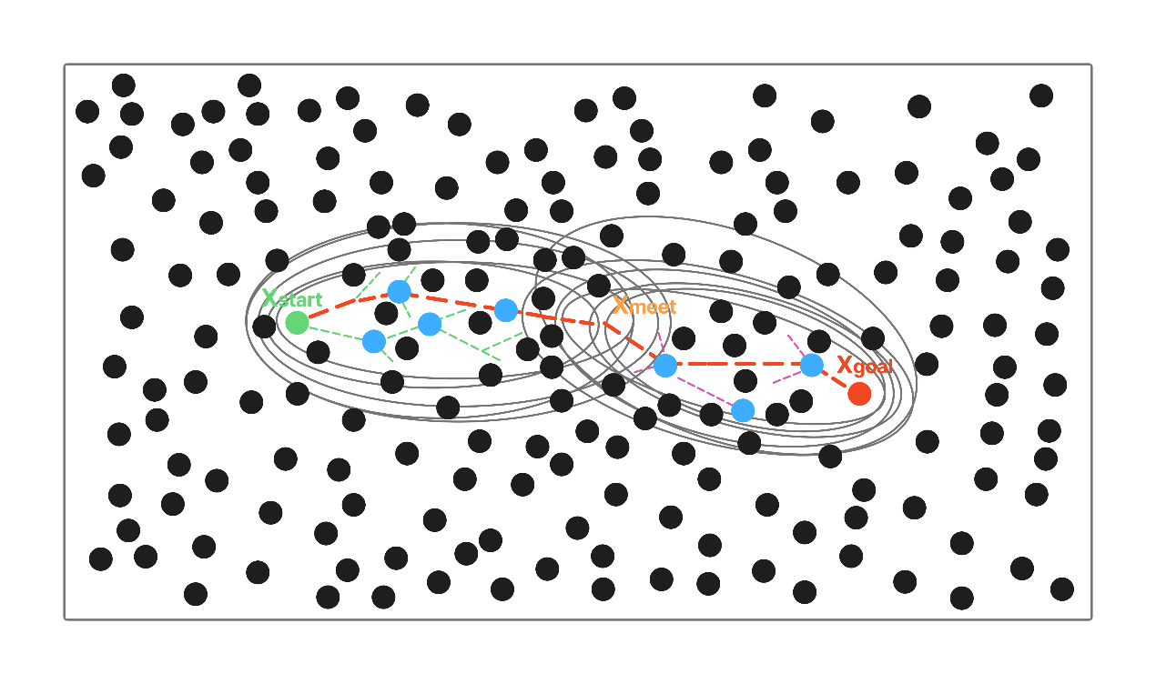
Fig. 1 Schematic diagram of the SC-RRT algorithm with adaptive asymmetric dual-super-ellipsoid constrained sampling.下面这一节的文献33被删除了
  - An Adaptive Asymmetric Dual-Super-Ellipsoid Constrained Sampling (ADCS) Strategy
This paper proposes an Adaptive Asymmetric Dual-Super-Ellipsoid Constrained Sampling (ADCS) strategy, as illustrated in Fig. 2, to adaptively regulate the sampling domains during bidirectional tree expansion. The two search directions are indexed by i∈{A,B}, where A and B denote the start-side and goal-side searches, respectively. For each search direction, the corresponding constrained sampling region is constructed according to its current search state. ADCS determines the geometric form and direction-specific location of the constrained sampling regions, whereas the SSFOR mechanism introduced in Section 2.3 dynamically regulates their constraint strength and informed sampling probability. The constrained sampling subset is defined as:
where γ_{i} denotes the expansion coefficient for search direction i, p_{i} denotes its informed sampling probability, is the current best estimated path cost for search direction i, and f_{1,i} and f_{2,i} denote the corresponding focal points. For the start-side search, f_{1,A} = x_{start} and f_{2,A} = x_{meet}, whereas for the goal-side search, f_{1,B} = x_{goal} and f_{2,B} = x_{meet}.
The two constrained regions are constructed independently, forming an asymmetric constraint structure due to their different focal points and direction-specific path costs. During each iteration, informed sampling is performed within the corresponding constrained region with probability p_{i}, biased sampling is performed toward a Pareto-optimal node selected from the opposite tree according to the Pareto-dominance principle [30], and global uniform sampling is used otherwise. This hybrid strategy balances focused search and global exploration.
For each newly expanded node, a direct connection to the opposite tree is first attempted. If the distance exceeds the predefined threshold, the opposite tree greedily advances toward the newly generated node. Once the two trees are successfully connected, node rewiring is performed according to the RRT* procedure, followed by path-smoothing operations on the concatenated path [34,35] to obtain the final feasible trajectory.
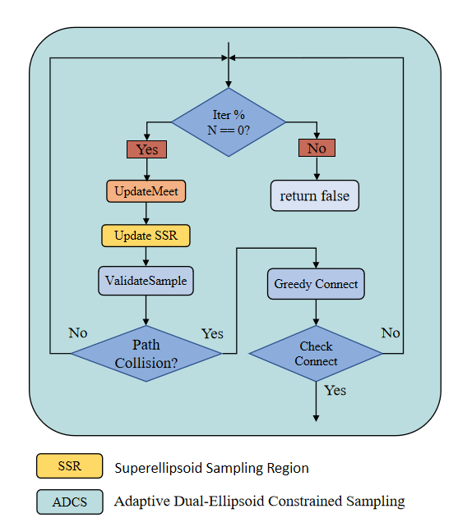
Fig. 2 Flowchart of the Adaptive Dual-Super-Ellipsoid Constrained Sampling Strategy.
  - Search State Feedback-Based Online Regulation (SSFOR) Mechanism（文献36-41删除）
The effectiveness of the ADCS strategy is strongly influenced by the selection of the expansion coefficient γ_{i} and the informed sampling probability p_{i}. To address this issue, a Search State Feedback-Based Online Regulation (SSFOR) mechanism is proposed to dynamically regulate these parameters according to the search progress, as illustrated in Fig.3.
Before a feasible solution is obtained, γ_{i} is initialized to 4.0 and the $p_{i}$ is set to 0, maintaining a broad exploration range and avoiding premature concentration of samples within the constrained regions. After a feasible solution is obtained, the regulation parameters are recomputed every N_{f}=50 iterations according to the recent variation in the best path cost. Since the two search directions may exhibit different search behaviors, the feedback signal is calculated independently for each direction.
Let denote the relative improvement of the best feasible path cost for search direction i over the latest feedback interval. The feedback deviation is defined as where 0.02 denotes the target improvement rate. The expansion coefficient and informed sampling probability are then directly determined from e_{i} by where
Here, e_{i} determines the adjustment of the two sampling parameters for search direction i. When the recent improvement is insufficient, $Δ_{i}$becomes smaller than the target value of 0.02, resulting in a positive e_{i}. Consequently, $γ_{i}$increases and $p_{i}$decreases, thereby enlarging the constrained sampling region and increasing the proportion of global exploration. Conversely, effective path improvement results in a smaller e_{i}, leading to a reduction in $γ_{i}$and an increase in $p_{i}$, concentrating samples within promising regions and promoting local refinement.
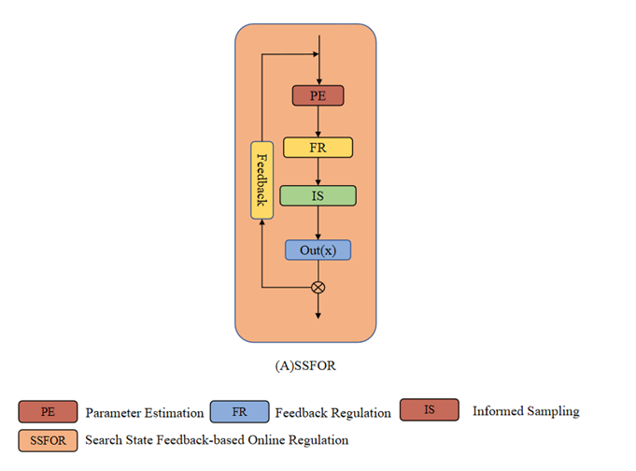
Fig. 3 Flow diagram of the Search State Feedback-Based Online Regulation (SSFOR) mechanism.
Through this feedback regulation mechanism, the constraint strength of the ADCS strategy can be dynamically matched with different search stages. During the early exploration stage, relatively relaxed constraints maintain sufficient search coverage. After feasible solutions are obtained, gradually strengthened constraints improve sampling efficiency by concentrating samples in promising regions.
To ensure the boundedness and reproducibility of the regulation process, γ_{i} and $p_{i}$are restricted within predefined ranges. The expansion coefficient is bounded by γ_{i} ∈ [1.0, 4.0]. A larger γ_{i} expands the constrained sampling region and improves exploration capability, whereas a smaller γ_{i} produces a tighter sampling region and promotes local convergence. The informed sampling probability is bounded by p_{i} ∈ [0.2, 0.95]. During the feedback regulation stage, p_{i} is adjusted within this range according to the search state. The value p_{i}=0 is used only before a feasible solution is obtained. A smaller p_{i} maintains a higher proportion of global exploration, whereas a larger p_{i} increases the contribution of informed sampling and promotes local refinement.
Under the closed-loop regulation of SSFOR, both parameters are dynamically adjusted for each search direction within the above ranges, allowing the two constrained sampling regions to adapt independently to their respective search states. This regulation prevents excessive expansion or premature contraction of the sampling domains while maintaining a balance between exploration capability and convergence efficiency.
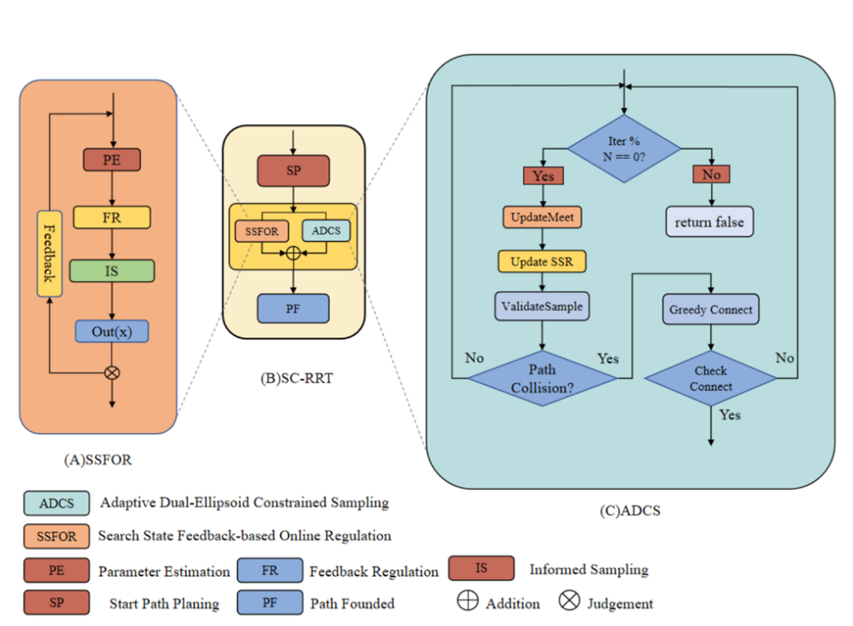
Fig. 4 Overall framework of the SC-RRT algorithm. It consists of the main search loop, SSFOR-based online regulation, and ADCS sampling. Dashed arrows indicate the internal implementation of key modules
The SSFOR mechanism is integrated into the SC-RRT framework as an online parameter regulation module. The internal closed-loop regulation process of SSFOR is presented in Fig. 3, while the complete framework of SC-RRT, including the main search loop, SSFOR regulation, and ADCS sampling, is illustrated in Fig. 4. During execution, ADCS performs constrained sampling based on the updated direction-specific parameters, and the complete search procedure in a representative two-dimensional environment is shown in Fig. 5.
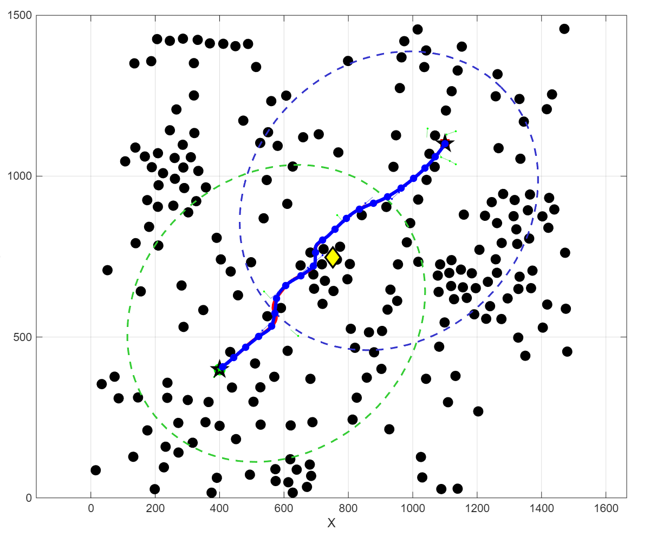
Fig. 5 Path planning process of SC-RRT in a 2D environment.
- Experiment
  - Algorithm Comparison Experiments in Baseline Environments
To systematically evaluate the effectiveness of the proposed SC-RRT algorithm, comparative simulation experiments were conducted in both two-dimensional and three-dimensional obstacle environments. The objective of these experiments was to compare the path quality and computational efficiency of SC-RRT with representative sampling-based path planning algorithms.
Two types of environments with different spatial dimensions were constructed, including a two-dimensional workspace and a three-dimensional workspace. The obstacle distributions, start states, goal states, and maximum iteration budget were kept identical for all compared algorithms to provide a consistent experimental setting. A common maximum iteration budget of 5000 was imposed on all algorithms. For SC-RRT, RRT, RRT-Connect, and Dynamic-RRT, the search was terminated once the first feasible path was obtained, whereas RRT and Informed RRT continued until the predefined iteration budget was reached to allow further path optimization. The detailed environmental configurations are summarized in Table 1. The performance of each algorithm was evaluated using four commonly adopted metrics: Path Length, Planning Time, Node Count, and Path Efficiency. Path Length represents the accumulated Euclidean distance between adjacent nodes along the generated path, which reflects the quality of the obtained solution. Planning Time denotes the wall-clock time required by the search process. Node Count indicates the total number of sampled nodes generated during the planning process, which is used to evaluate sampling efficiency. The path efficiency η is defined as:
whererepresents the total length of the generated path , and ∥x_{goal} − x_{start}∥ denotes the Euclidean distance between the start and goal states. A value of η closer to 1.0 indicates that the generated path has a shorter detour relative to the straight-line distance between the start and goal states. Based on previous studies on sampling-based motion planning, five representative algorithms, including RRT, RRT-Connect, RRT*, Informed RRT*, and Dynamic-RRT, were selected as baseline methods. All algorithms were implemented under the same computational conditions and executed independently for 500 trials in each environment. The average values and standard deviations of the evaluation metrics were recorded for quantitative comparison.
Tab.1 Environment Configuration
Dimension | Workspace | Obstacles | Start | Goal | Max Iterations
2 | 1500×1500 | 225 | （75，75） | (1425，1425) | 5000
3 | 1500×1500×1500 | 400 | (75, 75, 75) | (1425，1425，1425) | 5000
The qualitative comparison results of different algorithms in the two-dimensional and three-dimensional environments are presented in Fig. 6 and Fig. 7, respectively.
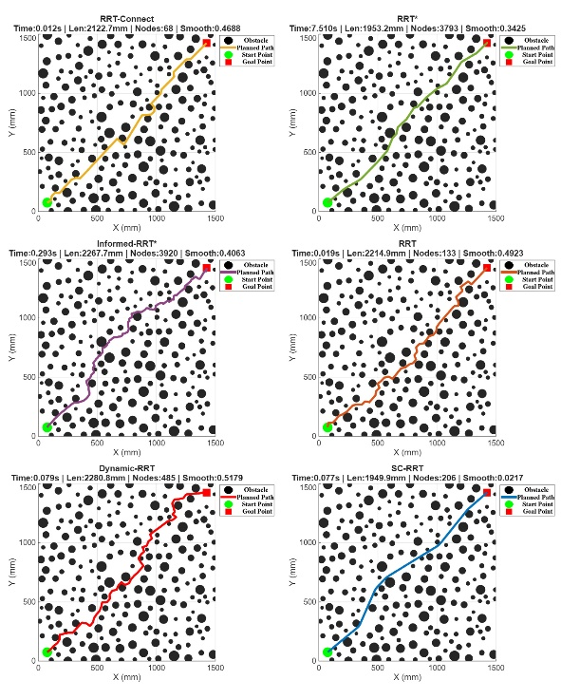
Fig.6 Comparison Results of Different Path Planning Algorithms in Two-Dimensional Space.
As shown in Fig. 6, all compared algorithms successfully generate collision-free paths between the start and goal states. However, noticeable differences can be observed in the search behaviors and generated trajectories. The conventional RRT algorithm tends to produce irregular paths due to the randomness of sampling, resulting in unnecessary exploration and longer trajectories. RRT* and Informed RRT* generate shorter paths by continuously optimizing the solution, but their improvement is achieved with significantly increased computational cost. In contrast, SC-RRT generates a more concentrated search process by restricting sampling within adaptive superellipsoid regions, leading to smoother trajectories with fewer redundant expansions.
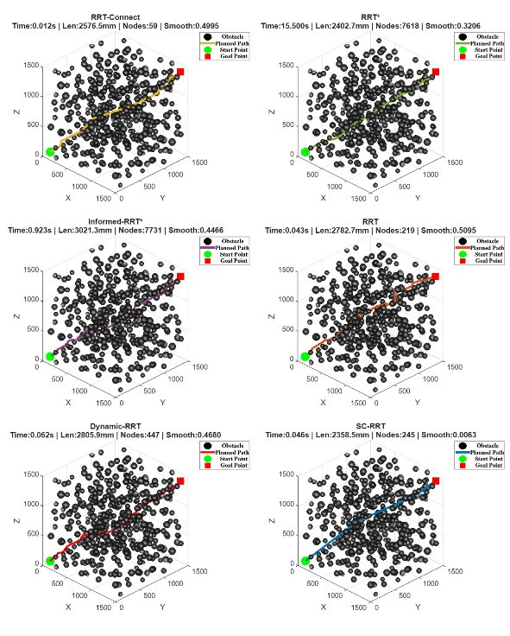
Fig.7 Comparison Results of Different Path Planning Algorithms in Three-Dimensional Space.
Similar results can be observed in the three-dimensional environment shown in Fig. 7. With the increase in spatial dimensionality, the search space becomes more complex, making sampling efficiency increasingly important. Compared with other algorithms, SC-RRT maintains a compact search structure and avoids excessive exploration in low-potential regions through adaptive dual-super-ellipsoid sampling. This enables efficient path generation while preserving path feasibility in complex environments. The quantitative comparison results are summarized in Table 2.
Tab.2 Comparison of Path Planning Algorithms
Algorithm | Path Length (mm) | Planning Time (s) | Node Count | Path Efficiency
RRT | 2329.5500 ± 126.2500 | 0.0409 ± 0.0305 | 279.4000 ± 175.5000 | 0.8219 ± 0.0429
RRT-Connect | 2143.2400 ± 93.4900 | 0.0108 ± 0.0053 | 69.3000 ± 10.8000 | 0.8924 ± 0.0376
RRT* | 1970.7200 ± 19.9400 | 0.1629 ± 0.0843 | 3846.6000 ± 99.7000 | 0.9689 ± 0.0098
Informed RRT* | 1938.4500 ± 24.1300 | 0.2134 ± 0.0487 | 3612.3000 ± 108.6000 | 0.9849 ± 0.0076
SC-RRT | 1998.8000 ± 57.5300 | 0.0345 ± 0.0124 | 209.6000 ± 38.5000 | 0.9553 ± 0.0265
Dynamic-RRT | 2288.1300 ± 136.0200 | 0.0414 ± 0.0384 | 281.3000 ± 160.2000 | 0.8372 ± 0.0468
According to the quantitative results in Table 2, SC-RRT achieves a favorable balance between path quality and computational efficiency. Regarding path quality, SC-RRT achieves an average path length of 1998.80 mm, which is 12.6% shorter than Dynamic-RRT (2288.13 mm). Although RRT* and Informed RRT* obtain shorter paths of 1970.72 mm and 1938.45 mm, respectively, the improvement is achieved at the expense of significantly increased computational cost. In particular, the path length generated by SC-RRT differs from RRT* by only 1.42%, while maintaining substantially lower computational requirements. Furthermore, SC-RRT achieves a path efficiency of 0.9553, which is close to RRT* (0.9689) and Informed RRT* (0.9849), indicating that the proposed method can generate paths with relatively small detours from the start–goal straight line while avoiding excessive optimization overhead.
In terms of computational efficiency, SC-RRT significantly reduces the sampling burden during the planning process. The average planning time of SC-RRT is 0.0345 s, which is considerably lower than RRT* (0.1629 s) and Informed RRT* (0.2134 s). Compared with Informed RRT*, SC-RRT reduces the planning time by approximately 83.8%, while maintaining comparable path efficiency. Moreover, SC-RRT generates only 209.6 nodes on average, representing a substantial reduction compared with RRT* (3846.6 nodes) and Informed RRT* (3612.3 nodes).
The standard deviation results further demonstrate the robustness of SC-RRT. The path length variation of SC-RRT is ±57.53 mm, which is lower than RRT (±126.25 mm) and Dynamic-RRT (±136.02 mm). This indicates that the proposed adaptive sampling strategy improves the consistency of path generation under different random sampling conditions.
Overall, the comparison results demonstrate that SC-RRT effectively improves sampling efficiency while preserving competitive path quality. The integration of bidirectional search, adaptive dual-super-ellipsoid constrained sampling (ADCS), and Search State Feedback-Based Online Regulation (SSFOR) enables the algorithm to achieve a better balance between exploration capability and convergence efficiency in complex environments. Moreover, the consistent performance observed in both two-dimensional and three-dimensional scenarios indicates that SC-RRT maintains stable search behavior when the dimensionality of the planning space increases. However, simulation environments cannot fully reflect the uncertainties and execution constraints existing in real robotic systems, such as perception errors, geometric disturbances, and motion tracking deviations. Therefore, a real-world robotic experiment was further conducted to evaluate the practical applicability and execution feasibility of SC-RRT in an actual manipulation scenario.
  - Real-world Validation of SC-RRT on a Robotic Manipulation Platform
To further evaluate the transferability and practical applicability of SC-RRT from simulation environments to real robotic systems, experiments were conducted on a robotic manipulation platform. Different from the idealized simulation environments, real robotic applications involve additional uncertainties, including perception noise, geometric modeling errors, and execution deviations. Therefore, the objective of this experiment was to validate whether the proposed algorithm can generate feasible and consistent motion trajectories under real three-dimensional working conditions.
The experimental platform configuration is summarized in Table 3. The robotic system consists of an AUBO-i10 six-degree-of-freedom manipulator, a KWT1D60-300 force sensor, and a Deptrum Aurora 930 RGB-D camera. The force sensor was only used to monitor the contact state during robot execution and was not involved in path planning or trajectory optimization. Therefore, force-related parameters were not considered as evaluation metrics in this study.
Tab.3 Configuration of the Real Robotic Experimental Platform
Component | Specification
Robot manipulator | AUBO-i10
Degrees of freedom | 6-DOF
Force sensor | KWT1D60-300
Perception system | Deptrum Aurora 930 RGB-D camera
Planning algorithm | SC-RRT
In the experiment, the human back surface was selected as a representative unstructured three-dimensional workspace with continuous spatial motion requirements. Multiple spatial target points obtained from the perception system were used as sequential planning objectives, forming a multi-target continuous trajectory planning task. This task involves complex geometric constraints, continuously distributed target points, and limited robot workspace, which is consistent with the design objectives of the proposed bidirectional search and constrained sampling strategy.
In the experiment, the spatial target points obtained from the perception system were transformed into the robot planning coordinate system and provided to SC-RRT as sequential planning objectives. The generated continuous trajectory was subsequently transferred to the physical robotic manipulator for execution.
As shown in Fig. 8, the robotic manipulator performs the planned motion on the actual curved human-back surface. The two views illustrate different execution states of the end-effector during the experiment. The manipulator maintains the required spatial relationship with the curved surface while completing the planned motion sequence, demonstrating the feasibility of executing SC-RRT-generated trajectories on the physical robotic platform.
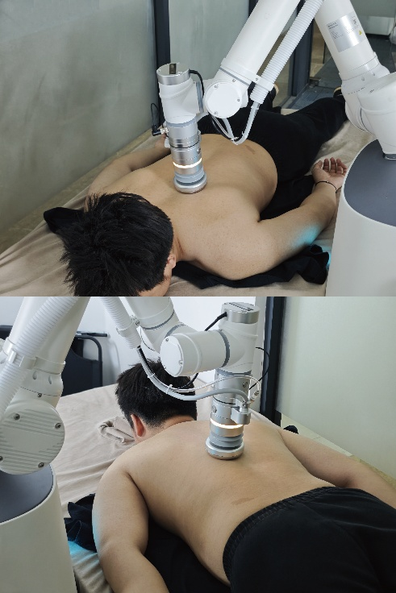
Fig.8 Real-world execution of SC-RRT on the robotic platform
To further analyze the interaction between perception and planning, Fig.9 illustrates the RGB-D-based three-dimensional reconstruction environment used for SC-RRT planning. The Deptrum Aurora 930 camera captures RGB and depth information, and the ROS2-based perception framework is employed to perform data alignment and point cloud reconstruction. The reconstructed point cloud provides the geometric representation of the actual working environment, while the detected spatial target points are used as sequential planning objectives for continuous trajectory generation.
As shown in Fig. 9, the reconstructed point cloud captures the geometric structure of the working environment together with the robotic manipulator. The local view further illustrates the spatial relationship between the end-effector, the reconstructed surface, and the planned motion. Compared with the simplified simulation environments, the RGB-D-reconstructed scene introduces practical uncertainties caused by sensor noise, incomplete surface reconstruction, and geometric modeling errors. Therefore, the experiment provides a more realistic evaluation of the applicability and execution feasibility of SC-RRT under practical conditions.
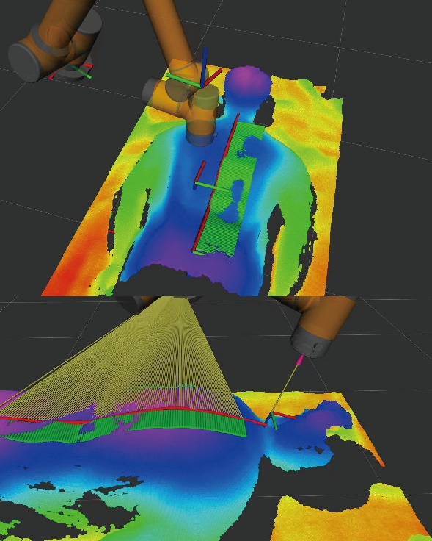
Fig.9 RGB-D point cloud reconstruction and planning environment.
Based on the reconstructed three-dimensional environment and the sequential target points described above, SC-RRT was then used to generate a continuous trajectory connecting the multiple target locations.Fig.10 shows the multi-target continuous trajectory generated by SC-RRT in the real three-dimensional environment. For the sequential motion task involving multiple spatial target points, SC-RRT constructs constrained search regions through bidirectional exploration and adaptive dual-super-ellipsoid sampling. As shown in Fig.10, the generated trajectory successfully connects all target points while maintaining consistency with the geometric characteristics of the human back surface. These results demonstrate the capability of SC-RRT to perform continuous trajectory generation in unstructured three-dimensional environments.
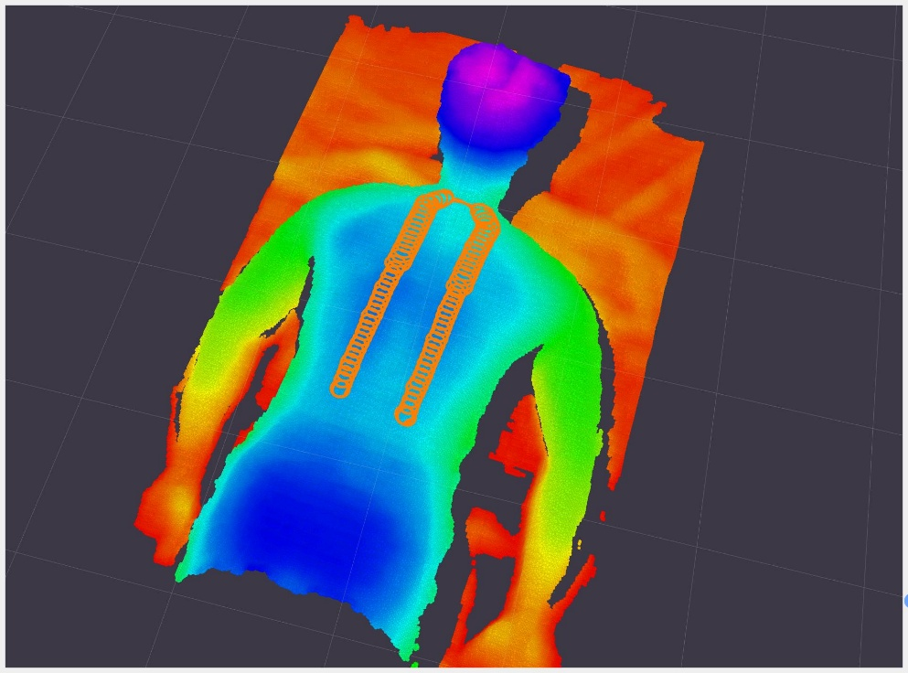
Fig.10 Multi-target continuous trajectory generated by SC-RRT in the RGB-D-reconstructed three-dimensional environment
The quantitative execution results of the real robotic experiment are summarized in Table 4.
Tab.4 真实机械臂实验性能指标
Metric | Value
Executed path length | 3.245 m
Planned path length | 3.249 m
Path length difference | 0.12 %
TCP tracking error | 1.98 mm (mean),3.09 mm (max)
Maximum joint displacement | 29.78°
As shown in Table 4, the planned trajectory length generated by SC-RRT is 3.249 m, while the actual executed trajectory length is 3.245 m, resulting in only a 0.12% difference. This indicates that the generated path can be accurately transferred to the physical robotic system. Furthermore, the TCP tracking error remains within 3.09 mm, with an average deviation of 1.98 mm, demonstrating satisfactory trajectory tracking performance under real environmental conditions.
Combining the trajectory visualization in Fig.10 and the quantitative results in Table 4, SC-RRT successfully generates and executes continuous feasible trajectories in a real three-dimensional environment reconstructed from RGB-D perception. Although real-world experiments introduce perception uncertainty, geometric reconstruction errors, and robot execution deviations, the proposed method maintains stable planning and execution performance. These results verify the feasibility of applying SC-RRT to practical robotic manipulation tasks beyond simulation environments.

- Conclusions
In this study, a Superellipsoid-Constrained Bidirectional RRT (SC-RRT) algorithm was proposed for efficient motion planning in complex robotic environments. The method integrates bidirectional search, Adaptive Dual-Super-Ellipsoid Constrained Sampling (ADCS), and Search State Feedback-Based Online Regulation (SSFOR). By constructing direction-specific asymmetric sampling regions and dynamically regulating their constraint strength according to the search state, SC-RRT reduces redundant exploration while maintaining sufficient search coverage.Comparative experiments were conducted in both two-dimensional and three-dimensional Cartesian workspaces using RRT, RRT-Connect, RRT*, Informed RRT*, and Dynamic-RRT as baseline methods. The results show that SC-RRT provides a favorable balance between path quality and computational efficiency. In the reported comparison, SC-RRT achieved a shorter mean path than Dynamic-RRT while requiring substantially fewer sampled nodes and less planning time than RRT* and Informed RRT*. Although RRT* and Informed RRT* obtained slightly shorter paths, SC-RRT maintained competitive path efficiency with a considerably lower computational burden.
The practical applicability of SC-RRT was further evaluated on a six-degree-of-freedom robotic manipulation platform equipped with an RGB-D perception system. In an unstructured three-dimensional environment, the proposed method successfully generated and executed a continuous multi-target trajectory. The small difference between the planned and executed path lengths, together with the measured TCP tracking errors, indicates that the generated trajectory could be transferred to the physical robotic system with satisfactory execution accuracy.
Overall, the proposed SC-RRT provides an adaptive sampling-based planning framework that improves sampling efficiency while preserving competitive path quality. The results from simulation and real-robot execution demonstrate its potential for robotic motion planning in complex three-dimensional environments. Future work will focus on improving adaptability to dynamically changing environments, incorporating dynamic obstacle avoidance, and extending the framework to more complex manipulation tasks involving real-time perception and physical interaction.
Acknowledgements
The authors would like to thank the School of Mechanical Engineering, Shanghai Institute of Technology, for providing the computational resources.
AI disclosure
During the preparation of this manuscript, the authors used GitHub Copilot as a translation aid to translate the original Chinese draft into English. All AI-assisted output was carefully reviewed and edited by the authors, who take full responsibility for the accuracy, scientific integrity, and originality of the manuscript.
Declarations
Author contributions: Xingyu Guo conceived the algorithm, conducted the simulation experiments, and drafted the manuscript. Yan Wu supervised the research and provided guidance on the overall manuscript. Muchun Fan and Feng Hong provided technical support during implementation. Hongyu Gao and Jianyu Zheng contributed to manuscript revision and provided valuable comments. All authors contributed to the conception and design of the study, and all authors read and approved the final manuscript.
Funding
This research received no specific grant from any funding agency, commercial, or not-for-profit sectors.
Competing interests
The authors declare no competing interests.
Ethics approval
Not applicable.
Consent to participate
Not applicable.
Consent for publication
All authors have approved the manuscript and agree to its submission for publication.
Data availability
The data that support the findings of this study are available from the corresponding author upon reasonable request.
Code availability
The code used in this study is not publicly available, but may be obtained from the corresponding author upon reasonable request.
References
- Zhong, R.Y., Xu, X., Klotz, E., Newman, S.T.: Intelligent manufacturing in the context of industry 4.0: a review. Engineering 3(5), 616–630 (2017)
- Wirtz, J., Patterson, P.G., Kunz, W.H., Gruber, T., Lu, V.N., Paluch, S., Martins, A.: Brave new world: service robots in the frontline. Journal of service management 29(5), 907–931 (2018)
- Mac, T.T., Copot, C., Tran, D.T., De Keyser, R.: Heuristic approaches in robot path planning: A survey. Robotics and Autonomous Systems 86, 13–28 (2016)
- Ajoudani, A., Zanchettin, A.M., Ivaldi, S., Albu-Sch¨affer, A., Kosuge, K., Khatib, O.: Progress and prospects of the human–robot collaboration. Autonomous robots 42(5), 957–975 (2018)
- Villani, V., Pini, F., Leali, F., Secchi, C.: Survey on human–robot collaboration in industrial settings: Safety, intuitive interfaces and applications. Mechatronics 55, 248–266 (2018)
- LaValle, S.M.: Planning Algorithms. Cambridge university press, Cambridge (2006)
- Latombe, J.-C.: Robot Motion Planning vol. 124. Springer, New York (2012)
- Kingston, Z., Moll, M., Kavraki, L.E.: Sampling-based methods for motion planning with constraints. Annual review of control, robotics, and autonomous systems 1(1), 159–185 (2018)
- Mohanan, M., Salgoankar, A.: A survey of robotic motion planning in dynamic environments. Robotics and Autonomous Systems 100, 171–185 (2018)
- Aggarwal, S., Kumar, N.: Path planning techniques for unmanned aerial vehicles: A review, solutions, and challenges. Computer communications 149, 270–299 (2020)
- Elbanhawi, M., Simic, M.: Sampling-based robot motion planning: A review. Ieee access 2, 56–77 (2014)
- Karaman, S., Frazzoli, E.: Sampling-based algorithms for optimal motion planning. The international journal of robotics research 30(7), 846–894 (2011)
- LaValle, S.: Rapidly-exploring random trees: A new tool for path planning. Research Report 9811 (1998)
- LaValle, S.M., Kuffner Jr, J.J.: Randomized kinodynamic planning. The international journal of robotics research 20(5), 378–400 (2001)
- Kuffner, J.J., LaValle, S.M.: Rrt-connect: An efficient approach to single-query path planning. In: Proceedings 2000 ICRA. Millennium Conference. IEEE International Conference on Robotics and Automation. Symposia Proceedings (Cat.No. 00CH37065), vol. 2, pp. 995–1001 (2000). IEEE
- Gammell, J.D., Strub, M.P.: Asymptotically optimal sampling-based motion planning methods. Annual Review of Control, Robotics, and Autonomous Systems 4(1), 295–318 (2021)
- Qureshi, A.H., Ayaz, Y.: Intelligent bidirectional rapidly-exploring random trees for optimal motion planning in complex cluttered environments. Robotics and Autonomous Systems 68, 1–11 (2015)
- Ding, J., Zhou, Y., Huang, X., Song, K., Lu, S., Wang, L.: An improved rrt* algorithm for robot path planning based on path expansion heuristic sampling. Journal of computational science 67, 101937 (2023)
- Noreen, I., Khan, A., Habib, Z., et al.: Optimal path planning using rrt* based approaches: a survey and future directions. International Journal of Advanced Computer Science and Applications 7(11), 97–107 (2016)
- Li, B., Chen, B.: An adaptive rapidly-exploring random tree. IEEE/CAA Journal of Automatica Sinica 9(2), 283–294 (2022)
- Huang, Z., Gao, Y., Guo, J., Qian, C., Chen, Q.: An adaptive bidirectional quick optimal rapidly-exploring random tree algorithm for path planning. Engineering Applications of Artificial Intelligence 135, 108776 (2024)
- Tahirovic, A., Ferizbegovic, M.: Rapidly-exploring random vines (rrv) for motion planning in configuration spaces with narrow passages. In: 2018 IEEE International Conference on Robotics and Automation (ICRA), pp. 7055–7062 (2018). IEEE
- Gammell, J.D., Srinivasa, S.S., Barfoot, T.D.: Informed rrt*: Optimal samplingbased path planning focused via direct sampling of an admissible ellipsoidal heuristic. In: 2014 IEEE/RSJ International Conference on Intelligent Robots and Systems, pp. 2997–3004 (2014). IEEE
- Gammell, J.D., Barfoot, T.D., Srinivasa, S.S.: Informed sampling for asymptotically optimal path planning. IEEE Transactions on Robotics 34(4), 966–984 (2018)
- Gammell, J.D., Srinivasa, S.S., Barfoot, T.D.: Batch informed trees (bit*): Sampling-based optimal planning via the heuristically guided search of implicit random geometric graphs. In: 2015 IEEE International Conference on Robotics and Automation (ICRA), pp. 3067–3074 (2015). IEEE
- Gammell, J.D., Barfoot, T.D., Srinivasa, S.S.: Batch informed trees (bit*): Informed asymptotically optimal anytime search. The International Journal of Robotics Research 39(5), 543–567 (2020)
- Yuan, L., Zhao, J., Li, W., Hou, J.: Improved informed-rrt* based path planning and trajectory optimization for mobile robots. International Journal of Precision Engineering and Manufacturing 24(3), 435–446 (2023)
- Zeng, Z., Chang, Y.: Abf-rrt*: Bidirectional fast optimal rapidly-exploring random tree via adaptive sampling of a permissible hyper-ellipsoid. Journal of King Saud University Computer and Information Sciences 37(7), 165 (2025)
- Zhao, P., Chang, Y., Wu, W., Luo, H., Zhou, Z., Qiao, Y., Li, Y., Zhao, C., Huang, Z., Liu, B., et al.: Dynamic rrt: fast feasible path planning in randomly distributed obstacle environments. Journal of Intelligent & Robotic Systems 107(4), 48 (2023)
- Deb, K., Pratap, A., Agarwal, S., Meyarivan, T.: A fast and elitist multiobjective genetic algorithm: Nsga-ii. IEEE transactions on evolutionary computation 6(2), 182–197 (2002)
- Choset, H., Lynch, K.M., Hutchinson, S., Kantor, G.A., Burgard, W.: Principles of Robot Motion: Theory, Algorithms, and Implementations. MIT press, Boston (2005)
- Lynch, K.M., Park, F.C.: Modern Robotics. Cambridge University Press, Cambridge (2017)
- Kavraki, L.E., Svestka, P., Latombe, J.-C., Overmars, M.H.: Probabilistic roadmaps for path planning in high-dimensional configuration spaces. IEEE transactions on Robotics and Automation 12(4), 566–580 (2002)
- Ravankar, A., Ravankar, A.A., Kobayashi, Y., Hoshino, Y., Peng, C.-C.: Path smoothing techniques in robot navigation: State-of-the-art, current and future challenges. Sensors 18(9), 3170 (2018)
- Yang, K., Sukkarieh, S.: An analytical continuous-curvature path-smoothing algorithm. IEEE Transactions on Robotics 26(3), 561–568 (2010)

School of Mechanical Engineering, Shanghai Institute of Technology, Shanghai 201418, China
∗ Corresponding Author: Xingyu Guo E-mail: gxyzhendehenlihai@163.com

